

**NATIONAL GOVERNMENT CONSTITUENCY**  
**DEVELOPMENT FUND**

**EMURUA DIKIRR CONSTITUENCY**

**REQUESTS FOR REALLOCATION, RESUBMISSION AND CHANGE OF PROJECT’S ACTIVITY FOR THE FINANCIAL YEAR 2017/2018, 2019/20 AND 2020/21.**

**SUBMITTED ON**

**1ST MARCH, 2021.**

**THE CHIEF EXECUTIVE OFFICER,**  
**NATIONAL GOVERNMENT CONSTITUENCIES**  
**DEVELOPMENT FUND BOARD,**  
**P. O. BOX 46682 – 00100,**  
**NAIROBI.**

**Dear Sir,**  
**RE: REQUESTS FOR REALLOCATION, RESUBMISSION AND CHANGE OF PROJECT’S ACTIVITY.**

In reference to the above matter, the NG-CDF Emurua Dikirr Constituency has passed a resolution to do the following requests for reallocation of funds, resubmission and change of project’s activity. The reasons for the same have been explained in the attached minute’s dated 26th February, 2021.

Kindly find the said documents attached regarding the same.  
Your consideration will be highly appreciated.

Thank you in advance.

Yours Sincerely.

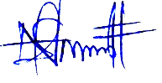

**Felix Ntutu**

**FUND ACCOUNT MANAGER**

**EMURUA DIKIRR CONSTITUENCY**

**MINUTES OF NG- CDFC MEETING HELD ON TUESDAY 26th FEBRUARY 2021 IN THE NG- CDF BOARDROOM OFFICES.**

**MEMBERS PRESENT**

|  |  |  |
| --- | --- | --- |
| **NO.** | **NAME** | **DESIGNATION** |
|  | Mr. Samwel Kipsiele Towett | Chair |
|  | Mrs. Caroline Tonui | Secretary |
|  | Mr. Kipkoech Koros | Member |
|  | Mr. Carren Chebii | Member |
|  | Mrs. Lilian Cherotich | Member |
|  | Mr. Richard Kipkose A. Cheruiyot | Member |
|  | Mr. Wesley Bii | Member |
|  | Mr. Felix Sikona Saire | Fund Account Manager |

**Agenda**

* Preliminary
* Confirmation of Previous Minutes
* Bursary Allocation
* Payment of Casual Labourers
* Reallocation of Projects
* Monitoring and Evaluation of Kibisorwet Secondary School
* A.O.B

**MIN 1/26/02/21: Preliminary.**

The Chairman called the meeting to order and requested Mr. Wesley Bii to lead with a word of prayer before the meeting started to acknowledge God’s favors during this Covid 19 pandemic.

**MIN 2/26/02/21: Confirmation of Previous Minutes.**

The secretary read out the previous minutes and was confirmed as the true minutes of the previous meeting seconded by Carren Chebii as a true record.

**MIN 3/26/02/21: Bursary Allocation**

There was a lengthy discussion on the urge to identify needy students who should benefit from the constituency development fund kitty. Members raised up concerns on aforementioned allegations of students from well off backgrounds receiving undeserving amounts at the expense of the less fortunate and investigations about such claimed will be checked on. A lot of focus was put on the importance of narrowing down to the village level so as to identify the deserving students. Caroline Tonui proposed that primary school committees and the local chiefs could also assist in fronting the genuine students deserving bursaries.

**MIN 4/26/02/21: Payment of Casual Laborers.**

Members acknowledge the work set for the landscaping of the office compound and agreed on the payment of the casual labourers hires for their service. It’s noted that the labourers had not been paid their wages for at least 3 months.

However, this happened due to delay for release of funds by the board and delay by the committee to acknowledge on the issuance of payment.

**MIN 5/26/02/21: Change of project activity.**

The NG-CDF Emurua Dikirr Constituency office and its members agreed on the importance of increasing of office land. Initially there was a project on Purchase of 0.5 acre of Land for NG-CDF office @ Kshs. 700, 000.00 17/18 (approved) however, in the same financial year Members convened a meeting and agreed to change activity from purchase of 0.5 acre of Land for NG-CDF office @ Kshs. 700, 000.00 to Fencing of 0.5-acre piece of land using concrete polls and barbed wire @ Kshs. 500,000.00 and erecting of gate at Kshs. 200,000.00. This happened since the owner have recently contacted the office and agreed to the sale of the said Parcel of the Land). Thus the change of activity on the initial project.

Also a change of projects activity at Cheramgoi Secondary School- allocated 1,650,000 (*Completion of a 200 student capacity laboratory installation of electrical works, doors and windows fitting, plastering and painting*) to; ((This was reached since there the urgent need to complete the remaining projects in the various sectors of the institutions i.e laboratory and dormitory)

1. Cheramgoi Secondary School (Completion of Laboratory (Pipping and Painting)- 450,000.00
2. Cheramgoi Secondary School (Completion of a Dormitory 600 student capacity (flooring, plastering, painting)- 1,200,000.00

**MIN 6/26/02/21: Resubmission of Projects.**

Members deliberated on re-submissions of several projects as highlighted below.

The re-submission of:

* Abossi Resource centre allocated Kshs.1,000,000.00 for the construction of resource centre to completion in 2020/21 Financial Year to:

1. Kaptololo Resource centre allocated, Kshs.400,000 for Construction of resource centre to completion (**Kshs 600,000.00 had been allocated in the 2020/21FY)**
2. St Paul Secondary school Kshs.**300,000.00** (purchase of 0.5 acre of land)
3. Chebungei primary school Kshs.**300,000.00** (purchase of 0.5 acre of land)

* Murkan rescue centre allocated 2,400,000.00

Resubmitted to:

1. Mokondo Secondary school, Kshs.2,400,000- completion of a dining hall, flooring, plastering, painting, electrical works and plumbing)

* Kiribwet Chepkulul 4 kms (Maintenance of roads heavy grading, culverts, compacting, and gravelling) allocated 3,000,000.00

Resubmitted to:

1. Dikirr Ainamoi Road (4kms), Kshs.3,000,000- heavy grading and spot patching.

**MIN 7/26/02/21: Reallocation of projects.**

The NG-CDF Emurua Dikirr Constituency office and its members agreed on the need for the reallocation of funds Kshs 1,304,993.38 meant for Environment Vote on purchase of tree seedlings to purchase of water tank. This was reached on a consensus due to the fact that the success in planting tree seedlings could not be achieved due to the ongoing Covid 19 pandemic, and the ministry of health guidelines in mitigating the spread of the virus. Also for the easier identification of the said projects by labeling and to also acknowledging the National Government in realization of the vision 2030. Moreover, many schools need water for their daily use especially during this Covid19 pandemic. It was also a request from the public that water tank filled with water will improve on health to the various public institutions users.

Also to reallocation members proposed on change of activity: the below public institution was started receiving funds from the NG-CDF in the Financial Year 2019/2020 for the said project.

* Dikirr Secondary School, Kshs.3,500,000- Drilling and equipping of water borehole and installation of a medium reservoir. there is Dikirr lev el 4 hospital adjacent to the school funds for drilling of a water borehole and the same project will benefit Dikirr secondary through piping

Reallocation to:

1. Chepkoiyet- Soiminging Road (3km), Kshs. 3,200,000.00- (heavy grading and spot patching).
2. Kulonok Primary school, Kshs.300,000- (Purchase of 0.5 acres of Land).

* Kapkwen Primary school (Renovation of two classrooms doors and windows fitting, plastering and painting) – allocated Kshs. 800,000.00 (the amount of outstanding works for the school was more than the approved funds. However, some of Kabolecho Girls Secondary School structures were developing cracks and there was urgent need for the renovation. We intend to factor in Kapkwen primary school in the next financial year)

Reallocated to:

1. Kabolecho Girls Secondary School, Kshs. 800,000.00- Completion of a 100 student capacity dining hall (doors and windows fitting, plastering and painting) (funded in the financial year 2019/2020 - Kshs. 2,400,000).

* Mara View Secondary School (construction of a laboratory to completion) allocated 3,000,000.00 (approved 2020/2021) (There was urgent need for the construction of 1 class room each for Rwandanat and Chepkebit and construction of 3 doors toilet for Kiptenden Primary Schools since the 2 schools had large population of students and the available ones were semi-permanent also Kiptenden pupils toilet had collapsed and also increase of school population, however Mara View Secondary school will be factored in in the next financial year.

Reallocated to:

1. Rwandanat Primary School (Construction of 1 Classroom to Completion) allocated Kshs. 1,200,000.00
2. Chepkebit Primary School (Construction of 1 Classroom to Completion) allocated Kshs. 1,200,000.00
3. Kiptenden Primary School (Construction of 3 doors Toilet to Completion) allocated Kshs. 600,000.00

* Bursary Tertiary Institutions allocated 14,000,000.00 towards Payment of bursary to needy students. However out of the 14,000,000.00 the NG CDFC decided to allocated 4,000,000.00 to Bursary secondary due to the high number of applicants in secondary schools.

Reallocated to:

To Bursary Secondary School Kshs. 4,000,000.00 Payment of bursary to needy students.

**MIN 8/26/02/21: Monitoring and Evaluation of Kibisorwet Secondary School**

Members visited the ongoing construction of Kibisorwet Secondary School one classroom to completion and lauded the work underway by the contractor awarded the construction. Members acknowledge on need of releasing funds fast to enable the smooth work process. Also the materials used in the construction was beyond doubt of good quality and trusted to last for a long time, hence giving assurance of a perfect work done.

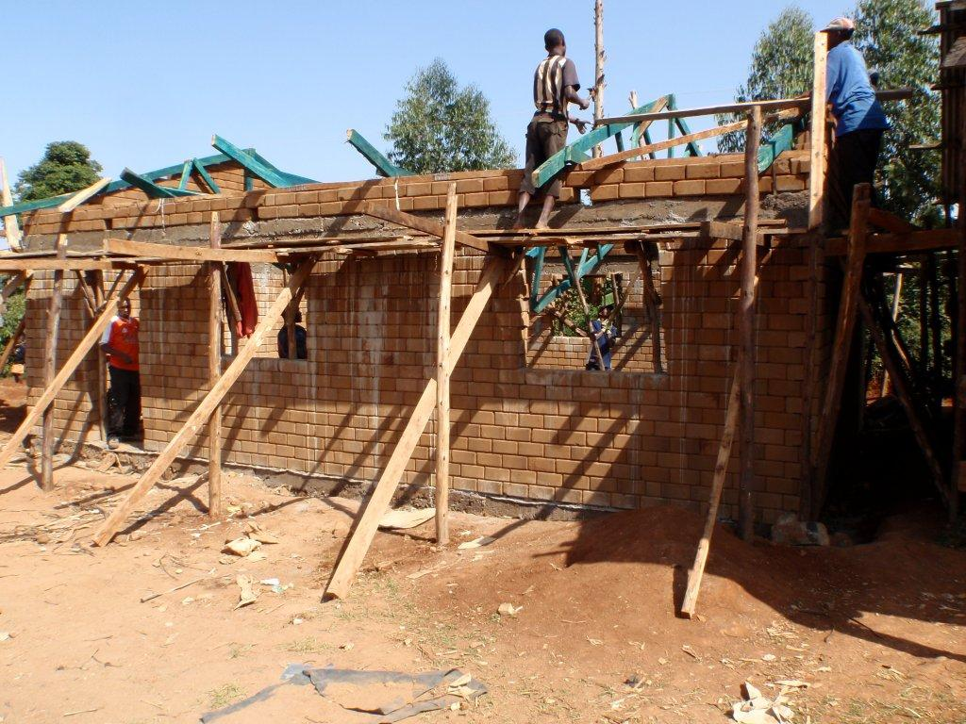

**MIN 9/26/02/21: A.O.B**

The meeting came to a closure and members were in agreement to adjourn to a later date for other pressing matters**.** There being no other business, the meeting ended at 12:05pm with a word of prayer from Ms. Carren Chebii.

**Minutes Confirmed By:**

Chairperson: **Kipsiele Towett** Secretary: **Caroline Tonui** FAM: **Felix Ntutu**

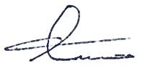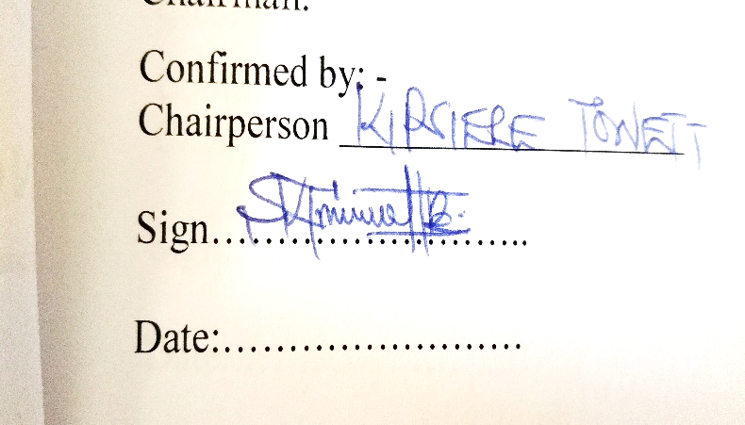

Signature: ……………………… ………………………

Date: 26/02/2021 26/02/2021 26/02/2021

*National Government Constituencies Development Fund*

**FIRST SCHEDULE (S. 6) (5)**

**CONSTITUENCY PROJECTS RE – ALLOCATION FORM**

CONSTUENCY N0: **178** CONSTITUENCY NAME: **EMURUA DIKIRR** YEAR: **2019/2020**

|  |  |  |  |  |  |
| --- | --- | --- | --- | --- | --- |
| **PROJECT NO.** | **PROJECT TITLE** | **AMOUNT ALLOCATED (KSH)** | **AMOUNT DISBURSED (KSH)** | **BALANCE (KSH)** | **UNSPENT TO BE RE – ALLOCATED (KSH)** |
| 4-033-178-2640510-110-2019/2020-001 | **Environment** | 1,304,993.38 | Nil | 1,304,993.38 | 1,304,993.38 |
|  | **TOTAL** | **1,304,993.38** | **0** | **1,304,993.38** | **1,304,993.38** |

Name:**Mr. Felix Ntutu** Position: **Fund Account Manager**

Signature………………………………..…..…… Date: 26/02/2021

907

***2019 National Government Constituencies Development Fund No. 30***

**THIRD SCHEDULE** *(s. 15)*

**CONSTITUENCY PROJECTS SUBMISSION** FORM

Constituency No **178** Constituency Name **EMURUA DIKIRR** Financial Year **2017/2018**

|  |  |  |
| --- | --- | --- |
| **SERIAL NO.** | **NAME OF PROJECT** | **AMOUNT ALLOCATED** |
| 178/3110202 | NG-CDF Office | 700,000.00 |
|  | **TOTAL** | **700,000.00** |

Name: **Mr. Felix Ntutu** Position: **Fund Account Manager**

Signature………………………………..…..……Date: 26/02/2021

907

***2019 National Government Constituencies Development Fund No. 30***

**THIRD SCHEDULE** *(s. 15)*

**CONSTITUENCY PROJECTS SUBMISSION** FORM

Constituency No **178** Constituency Name **EMURUA DIKIRR** Financial Year **2019/2020**

|  |  |  |
| --- | --- | --- |
| **SERIAL NO.** | **NAME OF PROJECT** | **AMOUNT ALLOCATED** |
| 178/2640510 | Environment | 1,304,993.38 |
|  | **TOTAL** | **1,304,993.38** |

Name:**Mr. Felix Ntutu** Position: **Fund Account Manager**

Signature………………………………..…..……Date: 26/02/2021

907

***2019 National Government Constituencies Development Fund No. 30***

**THIRD SCHEDULE** *(s. 15)*

**CONSTITUENCY PROJECTS SUBMISSION** FORM

Constituency No **178** Constituency Name **EMURUA DIKIRR** Financial Year **2017/2018**

|  |  |  |
| --- | --- | --- |
| **SERIAL NO.** | **NAME OF PROJECT** | **AMOUNT ALLOCATED** |
| 2630205 | Mara View Secondary School | 3,000,000.00 |
|  | **TOTAL** | 3,000,000.00 |

Name: **Mr. Felix Ntutu** Position: **Fund Account Manager**

Signature………………………………..…..……Date: 26/02/2021

907

***2019 National Government Constituencies Development Fund No. 30***

**FOURTH SCHEDULE (s. 16)**

**PROJECT DESCRIPTION FORM**

Constituency No: **178** Constituency Name **EMURUA DIKIRR** County: **NAROK**

Project Number **178/2640510**

Project Title **Environment Conservation/Management Projects**

**Sector: Environment**

Status of projects (tick one) New………………. Extension……………….. On-going…√…..

Rehabilitation ………………….

Brief statement on project status at time of submission

**Improvement on constituency environmental management**

Financial year **2019 1st** July to 30th June **2020**

Original Cost estimates, in Kshs1,304,993.38 **Dated 1.07.2019**

Amount allocated last financial year : **Kshs 0**

Amount allocated this financial year : **Kshs 1,304,993.38**

| **Project Name** | **Project Code** | **Project Activity** | **Amount Allocated** | **STATUS** |
| --- | --- | --- | --- | --- |
| Chepkureret Primary School | 4-033-178-2640510-110-2019/2020-001 | Purchase and Installation of 3,000 litres water tank. | 28,369.42 | New |
| Kimugut Primary Schol | 4-033-178-2640510-110-2019/2020-002 | Purchase and Installation of 3,000 litres water tank. | 28,369.42 | New |
| Kamaget Primary School | 4-033-178-2640510-110-2019/2020-003 | Purchase and Installation of 3,000 litres water tank. | 28,369.42 | New |
| Corner Olouch Primary School | 4-033-178-2640510-110-2019/2020-004 | Purchase and Installation of 3,000 litres water tank. | 28,369.42 | New |
| Kapchepomoto Primary School | 4-033-178-2640510-110-2019/2020-005 | Purchase and Installation of 3,000 litres water tank. | 28,369.42 | New |
| Maregito Primary School | 4-033-178-2640510-110-2019/2020-006 | Purchase and Installation of 3,000 litres water tank. | 28,369.42 | New |
| Angaset Primary School | 4-033-178-2640510-110-2019/2020-007 | Purchase and Installation of 3,000 litres water tank. | 28,369.42 | New |
| Chemurin Primary School | 4-033-178-2640510-110-2019/2020-008 | Purchase and Installation of 3,000 litres water tank. | 28,369.42 | New |
| Mokondo Primary School | 4-033-178-2640510-110-2019/2020-009 | Purchase and Installation of 3,000 litres water tank. | 28,369.42 | New |
| Soget Primary School | 4-033-178-2640510-110-2019/2020-010 | Purchase and Installation of 3,000 litres water tank. | 28,369.42 | New |
| Chebungei Primary School | 4-033-178-2640510-110-2019/2020-011 | Purchase and Installation of 3,000 litres water tank. | 28,369.42 | New |
| Kapsimotwo Primary School | 4-033-178-2640510-110-2019/2020-012 | Purchase and Installation of 3,000 litres water tank. | 28,369.42 | New |
| Araret Primary School | 4-033-178-2640510-110-2019/2020-013 | Purchase and Installation of 3,000 litres water tank. | 28,369.42 | New |
| Chepkisa Primary School | 4-033-178-2640510-110-2019/2020-014 | Purchase and Installation of 3,000 litres water tank. | 28,369.42 | New |
| Rwandanat Primary School | 4-033-178-2640510-110-2019/2020-015 | Purchase and Installation of 3,000 litres water tank. | 28,369.42 | New |
| Chelemei Primary School | 4-033-178-2640510-110-2019/2020-016 | Purchase and Installation of 3,000 litres water tank. | 28,369.42 | New |
| Chepkeigei Primary School | 4-033-178-2640510-110-2019/2020-017 | Purchase and Installation of 3,000 litres water tank. | 28,369.42 | New |
| Kaptololo Primary School | 4-033-178-2640510-110-2019/2020-018 | Purchase and Installation of 3,000 litres water tank. | 28,369.42 | New |
| Naisugut Primary School | 4-033-178-2640510-110-2019/2020-019 | Purchase and Installation of 3,000 litres water tank. | 28,369.42 | New |
| Kitai Primary School | 4-033-178-2640510-110-2019/2020-020 | Purchase and Installation of 3,000 litres water tank. | 28,369.42 | New |
| Kabolecho Girls High School | 4-033-178-2640510-110-2019/2020-021 | Purchase and Installation of 3,000 litres water tank. | 28,369.42 | New |
| Mokondo Secondary School | 4-033-178-2640510-110-2019/2020-022 | Purchase and Installation of 3,000 litres water tank. | 28,369.42 | New |
| Mukanget Primary School | 4-033-178-2640510-110-2019/2020-023 | Purchase and Installation of 3,000 litres water tank. | 28,369.42 | New |
| Chesogori Primary School | 4-033-178-2640510-110-2019/2020-024 | Purchase and Installation of 3,000 litres water tank. | 28,369.42 | New |
| Cheserton Primary School | 4-033-178-2640510-110-2019/2020-025 | Purchase and Installation of 3,000 litres water tank. | 28,369.42 | New |
| Kapchumbe Primary School | 4-033-178-2640510-110-2019/2020-026 | Purchase and Installation of 3,000 litres water tank. | 28,369.42 | New |
| Kabolecho Girls High School | 4-033-178-2640510-110-2019/2020-027 | Purchase and Installation of 3,000 litres water tank. | 28,369.42 | New |
| Mokondo Secondary School | 4-033-178-2640510-110-2019/2020-028 | Purchase and Installation of 3,000 litres water tank. | 28,369.42 | New |
| Abosi Girls School | 4-033-178-2640510-110-2019/2020-029 | Purchase and Installation of 3,000 litres water tank. | 28,369.42 | New |
| Chesma Secondary School | 4-033-178-2640510-110-2019/2020-030 | Purchase and Installation of 3,000 litres water tank. | 28,369.42 | New |
| Chepkisa Secondary School | 4-033-178-2640510-110-2019/2020-031 | Purchase and Installation of 3,000 litres water tank. | 28,369.42 | New |
| Chilani Secondary School | 4-033-178-2640510-110-2019/2020-032 | Purchase and Installation of 3,000 litres water tank. | 28,369.42 | New |
| Kibisorwet Secondary School | 4-033-178-2640510-110-2019/2020-033 | Purchase and Installation of 3,000 litres water tank. | 28,369.42 | New |
| Koisagat Secondary School | 4-033-178-2640510-110-2019/2020-034 | Purchase and Installation of 3,000 litres water tank. | 28,369.42 | New |
| Kibisorwet Secondary School | 4-033-178-2640510-110-2019/2020-035 | Purchase and Installation of 3,000 litres water tank. | 28,369.42 | New |
| Keloget Secondary School | 4-033-178-2640510-110-2019/2020-036 | Purchase and Installation of 3,000 litres water tank. | 28,369.42 | New |
| Keloget Secondary School | 4-033-178-2640510-110-2019/2020-037 | Purchase and Installation of 3,000 litres water tank. | 28,369.42 | New |
| Mabwaita Secondary School | 4-033-178-2640510-110-2019/2020-038 | Purchase and Installation of 3,000 litres water tank. | 28,369.42 | New |
| Kureisiet Secondary School | 4-033-178-2640510-110-2019/2020-039 | Purchase and Installation of 3,000 litres water tank. | 28,369.42 | New |
| Ndamama Girls Secondary School | 4-033-178-2640510-110-2019/2020-040 | Purchase and Installation of 3,000 litres water tank. | 28,369.42 | New |
| Ainamoi Secondary School | 4-033-178-2640510-110-2019/2020-041 | Purchase and Installation of 3,000 litres water tank. | 28,369.42 | New |
| Changina Secondary School | 4-033-178-2640510-110-2019/2020-042 | Purchase and Installation of 3,000 litres water tank. | 28,369.42 | New |
| Chepkoiyet Secondary School | 4-033-178-2640510-110-2019/2020-043 | Purchase and Installation of 3,000 litres water tank. | 28,369.42 | New |
| Chepkisa Secondary School | 4-033-178-2640510-110-2019/2020-044 | Purchase and Installation of 3,000 litres water tank. | 28,369.42 | New |
| Olpopongi Secondary School | 4-033-178-2640510-110-2019/2020-045 | Purchase and installation of 2000 litres water tank. | 28,369.42 | New |
|  |  |  |  |  |
| **TOTAL** | | | **1,304,993.38** |  |

Person completing form: Name: **Felix Ntutu** Position **Fund Account Manager**

Signature……………………………….. …..……… Date: 26/02/2021

907

***2019 National Government Constituencies Development Fund No. 30***

**FOURTH SCHEDULE (s. 16)**

**PROJECT DESCRIPTION FORM**

Constituency No: **178** Constituency Name **EMURUA DIKIRR** County: **NAROK**

Project Number **178/3110202**

Project Title **NG-CDF Office**

**Sector: NG-CDF Office**

Status of projects (tick one) New………………. Extension……………….. On-going…√…..

Rehabilitation ………………….

Brief statement on project status at time of submission

**Improvement on constituency NG-CDF Office**

Financial year **2017 1st**  July to 30th June **2018**

Original Cost estimates, in Ksh. 700,000 **Dated 1.07.2018**

Amount allocated last financial year : **Kshs 0**

Amount allocated this financial year : **Kshs 700,000**

|  |  |  |  |  |
| --- | --- | --- | --- | --- |
| **Project Name** | **Project Code** | **Project Activity** | **Amount Allocated** | **STATUS** |
| NG-CDF Office | 4-033-178-3110202-108-2017/2018-001 | Purchase of 0.5-acre Land for NG-CDF Office | 700,000.00 | New |
|  |  | **TOTAL** | **700,000.00** |  |

Person completing form: Name: **Felix Ntutu** Position **Fund Account Manager**



Signature……………………………….. …..……… Date: 26/02/2021

**EMURUA DIKIRR NG-CONSTITUENCY DEVELOPMENT FUND  
CODE LIST**

|  |  |  |  |  |  |  |
| --- | --- | --- | --- | --- | --- | --- |
| **PROJECT NAME** | **PROJECT NUMBER** | **PROJECT ACTIVITY** | **ORIGINAL COST** | **CUMULATIVE ALLOCATION** | **AMOUNT ALLOCATED** | **CURRENT STATUS** |
| **ENVIRONMENT** |  |  |  |  |  |  |
| **NG-CDF Office** | 4-033-178-3110202-108-2017/2018-001 | Purchase of 0.5-acre Land for NG-CDF Office. | 700,000.00 | **-** | 700,000.00 | New |
|  |  | **TOTAL** | **700,000.00** |  | **700,000.00** |  |

Person completing form:

**Name: Felix Ntutu**

**Position: Fund Account Manager**



Signature……………………………….. …..……… Date: 08/10/2020

**STAMP**

**EMURUA DIKIRR NG-CONSTITUENCY DEVELOPMENT FUND  
2019/20FY CODE LIST.**

|  |  |  |  |  |  |  |
| --- | --- | --- | --- | --- | --- | --- |
| **PROJECT NAME** | **PROJECT NUMBER** | **PROJECT ACTIVITY** | **ORIGINAL COST** | **CUMULATIVE ALLOCATION** | **AMOUNT ALLOCATED** | **CURRENT STATUS** |
| **ENVIRONMENT** |  |  |  |  |  |  |
| Chepkureret Primary School  Kimugut Primary Schol  Kamaget Primary School  Corner Olouch Primary School  Kapchepomoto Primary School  Maregito Primary School  Angaset Primary School  Chemurin Primary School  Mokondo Primary School  Soget Primary School  Chebungei Primary School  Kapsimotwo Primary School  Araret Primary School  Chepkisa Primary School  Rwandanat Primary School  Chelemei Primary School  Chepkeigei Primary School  Kaptololo Primary School  Naisugut Primary School  Kitai Primary School  Kabolecho Girls High School  Mokondo Secondary School  Mukanget Primary School  Chesogori Primary School  Cheserton Primary School  Kapchumbe Primary School  Kabolecho Girls High School  Mokondo Secondary School  Abosi Girls School  Chesma Secondary School  Chepkisa Secondary School  Chilani Secondary School  Kibisorwet Secondary School  Koisagat Secondary School  Kibisorwet Secondary School  Keloget Secondary School  Keloget Secondary School  Mabwaita Secondary School  Kureisiet Secondary School  Ndamama Girls Secondary School  Ainamoi Secondary School  Changina Secondary School  Chepkoiyet Secondary School  Chepkisa Secondary School  Olpopongi Secondary School  Soiminging Secondary School  purchase of 3000 litres @ Kshs. 28,369.42 | 4-033-178-2640510-110-2019/2020-001 | Purchase and Installation of 3,000 litres water tank each @ Kshs. 28,369.42 | 1,304,993.38 |  | 1,304,993.38 | New |
|  |  | **TOTAL** | **1,304,993.38** |  | **1,304,993.38** |  |

Person completing form: Name:

**Felix Ntutu**

 Position **Fund Account Manager**

Signature: ………………………………..…..……… Date: 16/09/2020