**13th MEETING OF AINABKOI CDF COMMITTEE MEMBERS HELD ON 30th May, 2018 AT AINABKOI CDF BOARD ROOM AS FROM 2.00 PM**

**MEMBERS PRESENT**

1. Mr David Kimayo Chairman
2. Ms Beatrice Bowen Fund Manager
3. Mr. Isaac Kotut Member
4. Mr Benard Boinet Member
5. Ms Zeddy Ngengoi Member
6. Mr. Njenga Muthama Member
7. Ms. Prisca Barkechir Member
8. Mr Felix Tenai Member
9. Ms Caroline Sawe Secretary – recording

**Apologies**

1. Mr. N.J Komora DCC

**Agenda**

1. Reading and confirmation of previous minutes
2. Monitoring and Evaluation report
3. Emergency Funds
4. Development Cheques
5. Benchmark activity
6. AOB

**Preliminary and introduction**

The chair welcomed the members to the meeting and started with a prayer from Mr Kotut at 3.40pm

**Agenda 1: Confirmation of previous minutes**

Previous minutes were confirmed and members agreed that they were true copy of what was discussed.

**Min 18/5/18**

**Agenda 2: Matters Arising**

1. Min 15/5/18: PMC training - 8th June at Marriott

* The new PMC in Burnt Forest to be trained later.
* All members to attend

1. Min 16/5/18 Bench marking Activity

* Date remains early July
* To get more information early June.

1. Monitoring and Evaluation

* From 11th and 12th June- Olare ainabkoi and 14th June- Kaptagat.
* 3 days activity as attached.
* Some schools around ward borders can be visited the same day.

**Min 19/5/18**

**Agenda 3. Additional CDF**

Government allocated an additional Ksh 11,379,310.34 with mandatory emergency Ksh 568,965.51. For these to be release, proposals must be made

**Proposed allocation**

1. M&E 341,379.31
2. Sports 800,000
3. Environment 900,000
4. Bursary 1.1 million
5. Administration 682,758.62
6. Emergency 0.568m

Proposed projects

1. Ngarua primary – renovate 4 classes – **Ainabkoio Olare** - 400,000
2. Ndanai primary Complete toilet - **Olare**  -50,000
3. Ndanai primary 1 classroom new **Olare** - 400,000
4. Rorigi Primary 1 classroom Olare 600,000
5. Baharini Primary 2 Floor renovation 200,000
6. Tendwo Secondary 100 desks **Kaptagat** 450,000
7. Kapsundei secondary – 2 new classes – **Kaptagat** - 1.2m
8. Naiberi Chiefs office - 1 hall - **Kaptagat** - 1 million
9. Silas Primary - 2 classrooms - **Kapsoya** - 1.2 m
10. Illula Primary 1 classroom **Kapsoya** 600,000
11. Kapsoya Primary 3 class renovation Kapsoya 300,000
12. CDF office – Renovation 1,036,200

|  |  |  |
| --- | --- | --- |
|  | | |
| **ALLOCATIONS** | ACTIVITY | AMOUNT |
| MONITORING AND EVALUATION | payment of committee allowances. | 341,379.00 |
| SPORTS | Carry out constituency sports tournament and the winning teams/schools be awarded with trophies, balls and games kits | 972,000.00 |
| ENVIROMENT | Buying and planting of trees in school land and purchase of water tanks | 528,000.00 |
| BURSARY | Fees of school fees for needy orphans and less privileged secondary schools students from the constituency | 650,000.00 |
| ADMINISTRATION | payment of committee allowances. | 682,758.62 |
| EMERGENCY | Gather for unforeseen occurrences within the constituency | 586,965.51 |
|  |  |  |
|  |  |  |
| NGARUA PRIMARY SCHOOL | RENOVATION OF 4 CLASSROOMS | 400,000.00 |
| NDANAI PRIMARY SCOOL | CONSTURCTION OF ONE CLASSROOM | 400,000.00 |
|  | COMPLETION OF TOILET | 50,000.00 |
| RURIGI PRIMARY SCHOOL | CONSTURCTION OF ONE CLASSROOM | 600,000.00 |
| BAHARINI PRIMARY SCHOOL | RENOVATION OF TWO CLASSROOMS | 200,000.00 |
| TENDWO SECONDARY SCHOOL | PURCHASE OF 100 DESKS | 450,000.00 |
| KAPSUNDEI SECONDARY SCHOOL | CONSTURCTION OF TWO CLASSROOMS | 1,200,000.00 |
| CHIEFS OFFICE KAPTAGAT | CONSTRUCTION OF AN HALL | 1,000,000.00 |
| SILAS PRIMARY SCHOOL | CONSTRUCTION OF TWO CLASSROOMS | 1,200,000.00 |
| ILULA PRIMARY SCHOOL | CONSTRUCTION OF ONE CLASSROOM | 600,000.00 |
| CDF OFFICE | FURNITURE | 400,000.00 |
|  | RENOVATION ( CEILING BOARDS,PAINTING, DOOR |  |
|  | FIXING ,ROOFING) | 400,000.00 |
|  | CURTAINS | 200,000.00 |
|  | PHOTOCOPIER | 36,200.00 |
| Kipkabus T T I | Fencing of the TTI compound | 282,007.21 |
| Brockley primary school | CONSTURCTION OF SIX DOOR TOILET | **200,000.00** |
| **TOTALS** |  | **11,379,310.34** |

**Min 20/5/18**

AOB

1. Kaptagat AIC School committee requested for the allocated Ksh 2.2 million for the land they had identified.
2. They claim former FM has the documents and current FM will follow
3. FM requested them to bargain for the owner since the 1 acre plot was going for 2.7m
4. Tinga are waiting for a valuer

There being no other business, the meeting was adjourned at 5.20 PM with a word of prayer from Ms Prisca.

**Min 21/5/18**

Approved for circulation

Chairman : _________________________________________ Date: _________________

Fund Manager: ________________________________________ Date: _________________

Secretary : _________________________________________ Date: _________________

*National Government Constituencies Development Fund*

**2015**

**THIRD SCHEDULE (ss. 25 (6), 11 and, 29(1)**

**CONSTITUENCY PROJECTS SUBMISSION FORM**

**CONSTUENCY N0:** 144 **CONSTITUENCY NAME**: AINABKOI **FINANCIAL YEAR**: 2017/2018

Chairman CDFC Committee: ……………… Date: ………………………

|  |  |  |
| --- | --- | --- |
| **SERIAL** | **NAME OF PROJECT** | **AMOUNT ALLOCATED** |
| 144/AP1 | Administration/Recurrent | 682,758.62 |
|
| 144/AP2 | Monitoring and Evaluation/Capacity Building | 341,379.00 |
|
| 144/2640100 | Bursary/CATs/Mocks | 650,000.00 |
|
| 0144/2630204 | Primary School Projects | 3,650,000.00 |
|
| 144/2630205 | Secondary School Projects | 1,650,000.00 |
|
|
| 144/2640507 | Security Projects | 1,000,000.00 |
|
| 144/2640200 | Emergency | 586,965.51 |
|
| 144/2640510 | Environment | 528,000.00 |
|
| 144/3110202 | Ng-cdf Office | 1,036,200.00 |
| 144/2640509 | Sports | 972,000.00 |
| 144/2630206 | Tertiary institution | 282,007.21 |
| **TOTAL** | | **11,379,310.34** |

Signature: ……………………………………………… Date:……………………………..

Name:……………………………………………………… Position: …………

*National Government Constituencies Development Fund*

**FOURTH SCHEDULE (s. 30)**

**PROJECT DISCRIPTION FORM**

Constituency No: 144 Constituency name  **AINABKOI** County: UASIN GISHU

**Project Number…**2630204**…………………..**

**Project Title: EDUCATION PRIMARY SCHOOLS**

**Sector: EDUCATION**

Status of projects (Tick one)

New………………….Extension…………………….Ongoing…√…………….

Rehabilitation………………………………………………….

Brief Statement on progress at time of submission

Financial year under reference **1st July 2017 – 30th June 2018**

Original Cost Estimates, in Kshs.3,450,000.00………. Date… …………

Amount allocated last financial year …Nil………….

Amount allocated this financial year……3,450,000.00……

|  |  |  |  |  |  |  |  |
| --- | --- | --- | --- | --- | --- | --- | --- |
|  | **PROJECT NAME** | **GSF CODE** | | | **ACTIVITIES** | **ALLOCATION** | **STATUS** |
| 1 | Ngarua primary school | 4-027-144-2630204-104-2017/2018-001 | | | renovation of 4 classrooms(flooring ,painting, roofing, doors and windows) | 400,000.00 | NEW |
| 2 | Ndanai Primary school | 4-027-144-2630204-104-2017/2018-002 | | | Completion of one Classroom( flooring ,painting, roofing ,doors and windows) | 400,000.00 | NEW |
| 3 | Rurigi primary school | 4-027-144-2630204-104-2017/2018-003 | | | Construction of one classroom to completion | 600,000.00 | NEW |
| 4 | Ndanai Primary school | 4-027-144-2630204-104-2017/2018-004 | | | Completion of pit latrine( painting, roofing, plastering and doors ) | 50,000.00 | NEW |
| 5 | Baharini Primary school | 4-027-144-2630204-104-2017/2018-005 | | | Renovation of two classrooms( flooring ,painting, roofing ,doors and windows) | 200,000.00 | ONGOING |
| 6 | Silas Primary Schooll | 4-027-144-2630204-104-2017/2018-006 | | | Construction of two classrooms to completion | 1,200,000.00 | NEW |
| 7 | Illula primary school | 4-027-144-2630204-104-2017/2018-007 | | | Construction of one classroom to completion. | 600,000.00 | New |
| 8 | Brockley primary school | | 4-027-144-2630204-104-2017/2018-008 | Construction of six door toilet to completion. | | 200,000.00 | New |
|  | TOTALS | |  |  | | **3,650,000.00** |  |

Signature: ……………………………………………… Date:……………………………..

Name:………………………………………………… Position: ………………………….

*National Government Constituencies Development Fund*

**FOURTH SCHEDULE (s. 30)**

**PROJECT DISCRIPTION FORM**

Constituency No: 144 Constituency name  **AINABKOI** County: UASIN GISHU

**Project Number…**2630205**………………………………..**

**Project Title: EDUCATION SECONDARY SCHOOLS**

**Sector: EDUCATION**

Status of projects (Tick one)

New………………….Extension…………………….Ongoing…√…………….

Rehabilitation………………………………………………….

Brief Statement on progress at time of submission

Financial year under reference **1st July 2017 – 30th June 2018**

Original Cost Estimates, in Kshs. …**1,650,000.00** ………. Date… …………

Amount allocated last financial year …Nil………….

Amount allocated this financial year……**1,650,000.00** ……

|  |  |  |  |  |  |
| --- | --- | --- | --- | --- | --- |
|  | **PROJECT NAME** | **GSF CODE** | **ACTIVITIES** | **ALLOCATION** | **STATUS** |
| 1 | Tendwo secondary school | 4-027-144-2630205-104-2017/2018-001 | Purchase of 100 Desks | 450,000.00 | New |
| 2 | Kapsundei Secondry school | 4-027-144-2630205-104-2017/2018-002 | construction of two classrooms to completion | 1,200,000.00 | NEW |
|  |  |  |  |  |  |
|  | **TOTALS** | | | **1,650,000.00** |  |

Signature: ……………………………………………… Date:…………………………….. Name:………………………………………………… Position: ………………………….

*National Government Constituencies Development Fund*

**FOURTH SCHEDULE (s. 30)**

**PROJECT DISCRIPTION FORM**

Constituency No: 144 Constituency name  **AINABKOI** County: UASIN GISHU

**Project Number…**2640507**………………………………..**

**Project Title: SECURITY PROJECTS**

**Sector: SECURITY**

Status of projects (Tick one)

New………………….Extension…………………….Ongoing…√…………….

Rehabilitation………………………………………………….

Brief Statement on progress at time of submission

Financial year under reference **1st July 2017 – 30th June 2018**

Original Cost Estimates, in Kshs. 1,000,000.00 ………. Date… …………

Amount allocated last financial year ……Nil……….

Amount allocated this financial year…1.000,000.00 ………

|  |  |  |  |  |  |
| --- | --- | --- | --- | --- | --- |
|  | **PROJECT NAME** | **GSF CODE** | **ACTIVITIES** | **ALLOCATION** | **STATUS** |
| 1 | KAPTAGAT CHIEFS OFFICE | 4-027-144-2640507-113-2017/2018-001 | construction of multipurpose hall to completion | 1,000,000.00 | NEW |
|  | **TOTALS** | | | **1,000,000.00** |  |

Signature: ……………………………………………… Date:……………………………..

Name:………………………………………………… Position: …………………………

*National Government Constituencies Development Fund*

**FOURTH SCHEDULE (s. 30)**

**PROJECT DISCRIPTION FORM**

Constituency No: 144 Constituency name  **AINABKOI** County: UASIN GISHU

**Project Number…AP1………………………………..**

**Project Title:** Administration/Recurrent

**Sector:** ADMINISTRATION AND RECURRENT

Status of projects (Tick one)

New………………….Extension…………………….Ongoing…√…………….

Rehabilitation………………………………………………….

Brief Statement on progress at time of submission

Financial year under reference **1st July 2017 – 30th June 2018**

Original Cost Estimates, in Kshs. …682,758.62………. Date… …………

Amount allocated last financial year …Nil………….

Amount allocated this financial year…682,758.62……………….

|  |  |  |  |  |  |
| --- | --- | --- | --- | --- | --- |
|  | **PROJECT NAME** | **GSF CODE** | **ACTIVITIES** | **ALLOCATION** | **STATUS** |
| 1 | committee expenses | 4-027-144-2210802-100-2017/2018-001 | payment of committee allowances. | 682,758.62 | ONGOING |
|  | TOTALS | | | **682,758.62** |  |

Signature: ……………………………………………… Date:……………………………..

Name:………………………………………………… Position: ………………………….

*National Government Constituencies Development Fund*

**FOURTH SCHEDULE (s. 30)**

**PROJECT DISCRIPTION FORM**

Constituency No: 144 Constituency name  **AINABKOI** County: UASIN GISHU

**Project Number…** AP2**………………………………..**

**Project Title:** Monitoring and Evaluation/Capacity Building

**Sector:** Monitoring and Evaluation

Status of projects (Tick one)

New………………….Extension…………………….Ongoing…√…………….

Rehabilitation……………………1…………………………….

Brief Statement on progress at time of submission

Financial year under reference **1st July 2017 – 30th June 2018**

Original Cost Estimates, in Kshs. …341,379.00………. Date… …………

Amount allocated last financial year ……Nil……….

Amount allocated this financial year…341,379.00………

|  |  |  |  |  |  |
| --- | --- | --- | --- | --- | --- |
|  | **PROJECT NAME** | **GSF CODE** | **ACTIVITIES** | **ALLOCATION** | **STATUS** |
| 1 | committee expenses | 4-027-144-2210802-111-2017/2018-001 | payment of committee allowances and other projects managers. | 341,379.00 | ongoing |
|  | **Total** |  |  | **341,379.00** |  |

Signature: ……………………………………………… Date:……………………………..

Name:………………………………………………… Position: ………………………….

*National Government Constituencies Development Fund*

**FOURTH SCHEDULE (s. 30)**

**PROJECT DISCRIPTION FORM**

Constituency No: 144 Constituency name  **AINABKOI** County: UASIN GISHU

**Project Number…**2640510**………………………………..**

**Project Title:** Environment Activities

**Sector: ENVIROMENT**

Status of projects (Tick one)

New………………….Extension…………………….Ongoing…√…………….

Rehabilitation………………………………………………….

Brief Statement on progress at time of submission

Financial year under reference **1st July 2017 – 30th June 2018**

Original Cost Estimates, in Kshs. …528,000.00……. Date… …………

Amount allocated last financial year …Nil………….

Amount allocated this financial year… ……… 528,000.00

|  |  |  |  |  |  |
| --- | --- | --- | --- | --- | --- |
|  | **PROJECT NAME** | **GSF CODE** | **ACTIVITIES** | **ALLOCATION** | **STATUS** |
| 1 | DCC OFFICE | 4-027-144-2640510-106-007-2017/2018-001 | Buying and planting of trees in Dcc compound | 50,000.00 | NEW |
| 2 | Illula primary school | 4-027-144-2640510-106-007-2017/2018-003 | Buying and planting of trees in school compound | 50,000.00 | NEW |
| 3 | NGATIT PRIMARY SCHOOL | 4-027-144-2640510-106-007-2017/2018-004 | Buying and planting of trees in school compound | 100,000.00 | NEW |
| 4 | LOTONYOK PRIMARY SCHOOL | 4-027-144-2640510-106-007-2017/2018-005 | Buying and planting of trees in school compound | 100,000.00 | NEW |
|  |  |  |  |  |  |
|  | UHURU PRIMARY SCHOOL | 4-027-144-2640510-106-007-2017/2018-006 | purchase and installation of water tank to avoid the spread of cholera outbreak in the school | 28,000.00 | NEW |
|  | NGARUA PRIMARY SCHOOL | 4-027-144-2640510-106-007-2017/2018-007 | Buying and planting of trees in school land | 100,000.00 | NEW |
|  | KIPTEIMET PRIMARY SCHOOL | 4-027-144-2640510-106-007-2017/2018-007 | Buying and planting of trees in school land | 100,000.00 | NEW |
|  | **TOTALS** |  |  | **528,000.00** |  |

Signature: ……………………………………………… Date:……………………………..

Name:………………………………………………… Position: ………………………….

*National Government Constituencies Development Fund*

**FOURTH SCHEDULE (s. 30)**

**PROJECT DISCRIPTION FORM**

Constituency No: 144 Constituency name  **AINABKOI** County: UASIN GISHU

**Project Number…**2640100**………………………………..**

**Project Title:** Bursary

**Sector:** EDUCATION

Status of projects (Tick one)

New………………….Extension…………………….Ongoing…√…………….

Rehabilitation………………………………………………….

Brief Statement on progress at time of submission

Financial year under reference **1st July 2017 – 30th June 2018**

Original Cost Estimates, in Kshs. 650,000.00………. Date… …………

Amount allocated last financial year …Nil………….

Amount allocated this financial year…650,000.00………

|  |  |  |  |  |  |
| --- | --- | --- | --- | --- | --- |
|  | **PROJECT NAME** | **GSF CODE** | **ACTIVITIES** | **ALLOCATION** | **STATUS** |
| 1 | SECONDARY SCHOOLS BURSARY | 4-027-144-2640101-103-2016/2017-001 | Fees of school fees for needy orphans and less privileged secondary schools students from the constituency | 650,000.00 | ONGOING |
|  | **TOTALS** |  |  | **650,000.00** |  |

Signature: ……………………………………………… Date:……………………………..

Name:………………………………………………… Position: ………………………….

*National Government Constituencies Development Fund*

**FOURTH SCHEDULE (s. 30)**

**PROJECT DISCRIPTION FORM**

Constituency No: 144 Constituency name  **AINABKOI** County: UASIN GISHU

**Project Number…144/………**2640200**………**

**Project Title:** Emergency

**Sector:** OTHERS

Status of projects (Tick one)

New………………….Extension…………………….Ongoing…√…………….

Rehabilitation………………………………………………….

Brief Statement on progress at time of submission

Financial year under reference **1st July 2017 – 30th June 2018**

Original Cost Estimates, in Kshs…. 586,965.51 ………. Date… …………

Amount allocated last financial year …nil………….

Amount allocated this financial year…586,965.51………

|  |  |  |  |  |  |
| --- | --- | --- | --- | --- | --- |
|  | **PROJECT NAME** | **GSF CODE** | **ACTIVITIES** | **ALLOCATION** | **STATUS** |
| 75 | Emergency | 4-027-144-2640200-101-2017/2018-001 | Gather for unforeseen occurrences within the constituency | 586,965.51 | NEW |
|  | TOTAL |  |  | 586,965.51 |  |

Signature: ……………………………………………… Date:……………………………..

Name:………………………………………………… Position: ………………………

*National Government Constituencies Development Fund*

**FOURTH SCHEDULE (s. 30)**

**PROJECT DISCRIPTION FORM**

Constituency No: 144 Constituency name  **AINABKOI** County: UASIN GISHU

**Project Number……………**2630206**……………………..**

**Project Title: Tertiary school projects**

**Sector:** EDUCATION

Status of projects (Tick one)

New………………….Extension…………………….Ongoing…√…………….

Rehabilitation………………………………………………….

Brief Statement on progress at time of submission

Financial year under reference **1st July 2017 – 30th June 2018**

Original Cost Estimates, in Kshs. .… 282,007.21 ……. Date… …………

Amount allocated last financial year …Nil………….

Amount allocated this financial year…282,007.21 ………

|  |  |  |  |  |  |
| --- | --- | --- | --- | --- | --- |
|  | **PROJECT NAME** | **GSF CODE** | **ACTIVITIES** | **ALLOCATION** | **STATUS** |
| 1 | Kipkabus TTI | 4-027-144-2630206-104-2017/2018-001 | Fencing of the TTI compound | 282,007.21 | NEW |
|  | Total |  |  | 282,007.21 |  |

Signature: ……………………………………………… Date:……………………………..

Name:………………………………………………… Position: ………………………….

*National Government Constituencies Development Fund*

**FOURTH SCHEDULE (s. 30)**

**PROJECT DISCRIPTION FORM**

Constituency No: 144 Constituency name  **AINABKOI** County: UASIN GISHU

**Project Number…………………………………..**

**Project Title: SPORTS**

**Sector : SPORTS**

Status of projects (Tick one)

New………………….Extension…………………….Ongoing…√…………….

Rehabilitation………………………………………………….

Brief Statement on progress at time of submission

Financial year under reference **1st July 2017 – 30th June 2018**

Original Cost Estimates, in Kshs. .… 972,000.00 ……. Date… …………

Amount allocated last financial year …Nil………….

Amount allocated this financial year…972,000.00 ………

|  |  |  |  |  |  |
| --- | --- | --- | --- | --- | --- |
|  | **PROJECT NAME** | **GSF CODE** | **ACTIVITIES** | **ALLOCATION** | **STATUS** |
| 1 | sports | 4-027-144-2640509-112-2017/2018-001 | Carry out constituency sports tournament and the winning teams/schools be awarded with trophies, balls and games kits | 972,000.00 | ongoing |
|  | **Total** |  |  | 972,000.00 |  |

Signature: ……………………………………………… Date:……………………………..

Name:………………………………………………… Position: ………………………….

907

***2015 National Government Constituencies Development Fund No. 30***

**FOURTH SCHEDULE (s. 16)**

**PROJECT DESCRIPTION FORM**

Constituency No: **1**  Constituency Name  **AINABKOI** County : **UASIN GISHU**

Project Number **144 /3110202**

Project Title **NG- CDF OFFICE**

Sector **: NG-CDF OFFICE**

Status of projects (tick one) New………………. Extension……………….. On-going…√…..

Rehabilitation ………………….

Brief statement on project status at time of submission

**To enhancing better working conditions of the office by improving the infrastructure**

Financial year **2017 1st** July To 30th June **2018**

Original Cost estimates, in Kshs. **1,036,000.00 dated**…………………

Amount allocated last financial year **NIL.**

Amount allocated this financial year **1,036,000.00**

| **Project Name** | **Project Code** | **Project Activity** | **Amount Allocated** |
| --- | --- | --- | --- |
| Ng.C.D.F office AINABKOI | 4-027-144-3110202-113-2017/2018-001 | Renovation of Ng- cdf office ainabkoi (reroofing, celling and doors) (400,000), purchase of curtains(200,000),purchase of office furniture’s(400,000) and purchase of phocopier( 36,200) | **1,036,200.00** |
| **Total** | | | **1,036,200.00** |

Person completing form: Name  **BEATRICE BOWEN** Position **Fund Account Manager**

Signature…………………… Date…………………

|  |  |  |  |  |  |  |  |  |  |  |  |  |  |  |
| --- | --- | --- | --- | --- | --- | --- | --- | --- | --- | --- | --- | --- | --- | --- |
| **NATIONAL GOVERNMENT CONSTITUENCIES DEVELOPMENT FUND** | | | | | | | | | | | | | | |
| **AINABKOI CONSTITUENCY** | | | | | | | | | | | | | | |
| **GSF CODES PROPOSALS FY 2017/208** | | | | | | | | | | | | | | |
|  | | | **PROJECT NAME** | **GSF CODE** | | | **ACTIVITIES** | | | | **ALLOCATION** | **STATUS** | | |
| 1 | | | Ngarua primary school | 4-027-144-2630204-104-2017/2018-001 | | | renovation of 4 classrooms | | | | 400,000.00 | NEW | | |
| 2 | | | Ndanai Primary school | 4-027-144-2630204-104-2017/2018-002 | | | Completion of one Classroom | | | | 400,000.00 | NEW | | |
| 3 | | | Rurigi primary school | 4-027-144-2630204-104-2017/2018-003 | | | Construction of one classroom | | | | 600,000.00 | NEW | | |
| 4 | | | Ndanai Primary school | 4-027-144-2630204-104-2017/2018-004 | | | Completion of pit latrine | | | | 50,000.00 | NEW | | |
| 5 | | | Baharini Primary school | 4-027-144-2630204-104-2017/2018-005 | | | Renovation of two classrooms | | | | 200,000.00 | ONGOING | | |
| 6 | | | Silas Primary Schooll | 4-027-144-2630204-104-2017/2018-006 | | | Construction of two classrooms | | | | 1,200,000.00 | NEW | | |
| 7 | | | Illula primary school | 4-027-144-2630204-104-2017/2018-007 | | | Construction of one classroom. | | | | 600,000.00 | New | | |
| 8 | | | Brockley primary school | | 4-027-144-2630204-104-2017/2018-008 | | Construction of six door toilet | | | | 200,000.00 | New | | |
| 9 | Tendwo secondary school | | | | 4-027-144-2630205-104-2017/2018-001 | | Purchase of 100 Desks | | | | 450,000.00 | New | |
| 10 | Kapsundei Secondry school | | | | 4-027-144-2630205-104-2017/2018-002 | | CONSTRUCTION OF TWO CLASSROOM | | | | 1,200,000.00 | New | |
| 11 | KAPTAGAT CHIEFS OFFICE | | | | 4-027-144-2640507-113-2017/2018-001 | | CONSTRUCTION OF MULTIPURPOSE HALL | | | | 1,000,000.00 | New | |
| 12 | | committee expenses | | | 4-027-144-2210802-100-2017/2018-001 | | | | payment of committee allowances. | | 682,758.62 | | ONGOING |
| 13 | committee expenses | | | | 4-027-144-2210802-111-2017/2018-001 | | | | | payment of committee allowances and other projects managers. | 341,379.00 | | ongoing |
| 14 | | DCC OFFICE | | | | 4-027-144-2640510-106-007-2017/2018-001 | | | | Buying and planting of trees in Dcc compound | 50,000.00 | | NEW |
| 15 | | Illula primary school | | | | 4-027-144-2640510-106-007-2017/2018-003 | | | | Buying and planting of trees in school compound | 50,000.00 | | NEW |
| 16 | | NGATIT PRIMARY SCHOOL | | | | 4-027-144-2640510-106-007-2017/2018-004 | | | | Buying and planting of trees in school compound | 100,000.00 | | NEW |
| 17 | | LOTONYOK PRIMARY SCHOOL | | | | 4-027-144-2640510-106-007-2017/2018-005 | | | | Buying and planting of trees in school compound | 100,000.00 | | NEW |
| 18 | | UHURU PRIMARY SCHOOL | | | | 4-027-144-2640510-106-007-2017/2018-006 | | | | purchase and installation of water tank to avoid the spread of cholera outbreak in the school | 28,000.00 | | NEW |
| 19 | | NGARUA PRIMARY SCHOOL | | | | 4-027-144-2640510-106-007-2017/2018-007 | | | | Buying and planting of trees in school land | 100,000.00 | | NEW |
| 20 | | KIPTEIMET PRIMARY SCHOOL | | | | 4-027-144-2640510-106-007-2017/2018-007 | | | | Buying and planting of trees in school land | 100,000.00 | | NEW |
| 21 | | SECONDARY SCHOOLS BURSARY | | | | 4-027-144-2640101-103-2016/2017-001 | | | | Fees of school fees for needy orphans and less privileged secondary schools students from the constituency | 650,000.00 | | ONGOING |
| 22 | Emergency | | | | | 4-027-144-2640200-101-2017/2018-001 | | Gather for unforeseen occurrences within the constituency | | | 586,965.51 | | NEW |
| 23 | | Kipkabus T T I | | | | 4-027-144-2630206-104-2017/2018-001 | | Fencing of the TTI compound | | | 282,007.21 | |  |
| 24 | | sports | | | | 4-027-144-2640509-112-2017/2018-001 | | Carry out constituency sports tournament and the winning teams/schools be awarded with trophies, balls and games kits | | | 972,000.00 | | ongoing |
| 26 | | **Ng-cdf office** | | | | 4-027-144-3110202-113-2017/2018-001 | | |  | | --- | | furnishing of ng-cdf office(400,000),reno  400,000.00  renovation 400,000.00  curtains 200,000.00  photocopier 36,200.00 | | | | 1,036,200.00 | | ongoing |
|  | | **TOTAL** | | | |  | |  | | | **11,379,310.34** | |  |

Signature: ……………………………………………… Date..:……………………………..

Name:.………………………………………………… Position…………………

CDF logo 4 MsWord

**AINABKOI CONSTITUENCY**

**IEBC NUMBER 144**

**NATIONAL GOVERNMENT CONSTITUENCY DEVELOPMENT FUND**

**WARD PROJECT PRIORITIZATION REPORT**

**FINANCIAL YEAR 2017/2018-2018/2019**

**SUBMITTED**

**FEBRUARY 2018**

TABLE OF CONTENT

1. Background about NG-CDF……………………………………………………..………………………………………………………………………….……………..3
2. Project Management/implementation………………………………..…………………………………………………………………..…………….……..…3
3. National Allocation Criteria………………………………………………………...…………………………………………………………..……………………….3
4. Constituency Allocation Criteria…………………………………………………………………………………………………..……………..…..…….………4
5. Background about Ainabkoi Constituency………………………….......................................................................................................4
6. Ward Meetings……………………………………………………..……………………………………………………………………………..…………………………..5
7. Background about NG-CDF Ainabkoi constituency………………………………..………………………………………………………………………5

Resolutions made by stakeholders from Ainabkoi/ Olare ward ………..…………………………………………………..…..…………...…5

Resolutions made by stakeholders from Kaptagat ward………………………………………………………………..………………………….…11

Resolutions made by stakeholders from Kapsoya ward…………………………..............................................................................16

8 Comments by the Chairman NGCDF Committee…………………………………………………………………………………………………………………………19

**BACKGROUND ABOUT CDF**

The Constituencies Development Fund (CDF) was established under the Constituency Development Fund (CDF) Act, 2003, amended in 2007 and repealed by the CDF Act, 2013. In 2015, the CDF Act of 2013 was declared unconstitutional and a new Act was enacted in 2015, (the National Government Constituencies Development Fund Act, NG-CDF Act, 2015. The National Government Constituencies Development Fund (NG-CDF) is under the ministry of Devolution and Planning. The objective of the fund is to provide mechanisms for supplementing implementation of the National Government development agenda at the constituency level.

**Project Management/PROJECT IMPLEMENTATION**

The projects funded under the act must be for works of services falling within the functions of the national Government. The projects must also be community based so that the prospective benefit is available to a wide spread of the members of the public. The projects proposed for funding will be managed and implemented by the Project Management Committees (PMC) who will be expected to liaise with relevant government departmental heads for technical inputs. The NG-CDFC will do project supervision, monitoring and Evaluation.

**NATIONAL Allocation Criteria**

•   The National Government Constituencies Development Fund comprises of an annual budgetary allocation equivalent to at least 2.5% of the Government ordinary revenue.

•    A maximum of 5% is allocated to NG-CDF Board for Administrative services.

The remaining funds are shared as follows;

a)     5% set aside as Emergency Reserve

b)    The balance is shared equally across the 290 Constituencies

**CONSTITUENCIES ALLOCATION CRITERIA**

The constituency allocation is shared based on the following formulae

1. 35% -Bursary, mocks ,CAT and social programmes
2. 5% Emergency reserve
3. 6% office running expenses
4. 3% Monitoring and Evaluation
5. 2% Environment
6. 2% Sports

The remaining funds will be available for projects prioritized by the NGCDFC

**BACKGROUND ABOUT AINABKOI CONSTITUENCY FUND**

Ainabkoi Constituency is in the Uasin-Gishu County-North Rift Region electoral number 144. It borders Keiyo South to the East, Moiben to the North, Kesses to south and Soy Constituency to the West.

The Constituency has three wards and ten locations

|  |  |
| --- | --- |
| **Ward** | **Location** |
| *Ainabkoi Olare* | *Kapngetuny*  *Ainabkoi*  *Olare*  *Chepngoror*  *Kipkabus* |
| *Kaptagat* | *Kipsinende*  *Chepkero*  *Plateu*  *Kaptagat* |
| *Kapsoya* | *Kapsoya* |
|  |  |

**INVITATION TO ATTEND WARD MEETINGS.**

Pursuant to the provisions of Section **27**. (1) Of the NGCDF Act 2015, the chairperson, AinabkoiConstituency Development Fund Committee invited the public to NGCDF open forum public meetings which were held as follows;

|  |  |  |  |
| --- | --- | --- | --- |
| **WARD** | **VENUE** | **DATES** | **TIME** |
| KAPSOYA | Kapsoya NGCDF office | 26/01/2018 | 10.00 am |
| KAPTAGAT | Naiberi- Cherunya market | 25/01/2018 | 10.00 am |
| AINABKOI /OLARE | Chepngoror Chiefs Office | 24/01/2018 | 10.00 am |

**RESOLUTIONS MADE BY STAKE HOLDERS FROM AINABKOI/OLARE WARD MEETING HELD ON 24th JANUARY, 2018 AT CHEPNGOROR CHIEFS OFFICE.**

The following proposals were proposed by the members of the public and various stakeholders.

|  |  |  |  |  |
| --- | --- | --- | --- | --- |
| songich ass chief office | kaptagat | kipkabus | ass chiefs office | new |
| lelek primary school | olaare/ainabkoi | kipkabus | renovation of 6 classrooms | new |
| lelek primary school | olaare/ainabkoi | kipkabus | pit latrine | new |
|  |  |  | administration block | new |
| leltot primary school | olaare/ainabkoi | kipkabus | renovation of 6 classrooms | new |
|  |  |  | 2 classrooms | new |
|  |  |  | administration block | new |
| bishop birech girls sec school | olaare/ainabkoi | kipkabus | dormitory | new |
|  |  |  | library | new |
| bishop birech girls sec school | olaare/ainabkoi | kipkabus | ablution septic tank | ongoing |
| St. peters waunifor secondary school | olaare / ainakoi | kipkabus | three classes |  |
|  |  |  | administration block |  |
| St. peters waunifor secondary school | olaare / ainakoi | kipkabus | laboratory | ongoing |
| ainabkoi kmtc | olaare / ainakoi | olaare | construction of six lecture halls |  |
| ainabkoi kmtc | olaare / ainakoi | olaare | construction of ultra-modern tuition block |  |
| kapkeno primary school | olaare/ainabkoi | olaare | special education classes | new |
|  |  |  | pit latrine | new |
| kapkeno primary school | olaare/ainabkoi | olaare | renovation of 3 classrooms | new |
| koilonget primary school | olaare/ainabkoi | olaare | 4 classrooms | new |
|  |  |  | administration | new |
|  |  |  | pit latrines; boys and girls | new |
| rurigi primary school | olaare/ainabkoi | olaare | 4 classrooms | new |
|  |  |  | school gate | new |
|  |  |  | renovation of administration block | new |
| olaare primary school | olaare/ainabkoi | olaare | administration block | new |
|  |  |  | 1 classroom | new |
|  |  |  | 1 classroom | ongoing |
| olaare secondary school | olaare/ainabkoi | olaare | 1 classroom | new |
|  |  |  | dining hall | new |
| cheplelachbei east sec school | olaare/ainabkoi | olaare | administration with library wing | new |
| cheplelachbei east sec school | olaare/ainabkoi | olaare | 1 classroom | ongoing |
| rurigi secondary school | olaare/ainabkoi | olaare | dinning hall | new |
| rurigi secondary school | olaare/ainabkoi | olaare | administration block | new |
|  |  |  | library | new |
|  |  |  | dormitory | ongoing |
| kewet primary school | olaare/ainabkoi | olaare | 2 classrooms | new |
|  |  |  | school gate | new |
| Anersens High School | olaare/ainabkoi | olaare | Construction of a dormitory | new |
| Anersens High School | olaare/ainabkoi | olaare | Construction of a tuition block | ongoing |
| arnesens primary school | olaare/ainabkoi | olaare | 2 classrooms | new |
|  |  |  | pit latrine | new |
| ngarua primary school | olaare/ainabkoi | olaare | Renovation of classrooms | new |
| chepngoror chief office | olaare/ainabkoi | olaare | furnishing | new |
|  |  |  | expansion of land | new |
|  |  |  | completion of office | ongoing |
| chepngoror secondary school | olaare/ainabkoi | chepngoror | administration block | new |
|  |  |  | 2 classrooms | new |
| chepngoror secondary school | olaare/ainabkoi | chepngoror | dormitory | ongoing |
| tingwa primary school | olaare/ainabkoi | chepngoror | 2 classrooms | new |
|  |  |  | renovation of 4 classrooms | new |
|  |  |  | 100 desks | new |
|  |  |  | portioning of office | new |
|  |  |  | school gate | new |
| kewapmoi primary school | olaare/ainabkoi | chepngoror | 4 classrooms | new |
| kewapmoi primary school | olaare/ainabkoi | chepngoror | pit latrines; boys and girls | new |
|  |  |  | 4 classrooms | ongoing |
| chepkurmum secondary school | olaare/ainabkoi | chepngoror | 4 classrooms | new |
|  |  |  | 2pit latrines | new |
|  |  |  | purchase of land | new |
| chepkurmum primary school | olaare/ainabkoi | chepngoror | 2 classrooms | new |
|  |  |  | social hall | new |
|  |  |  | pit latrine | new |
|  |  |  | administration block | new |
| salaam primary school | olaare/ainabkoi | chepngoror | 2 classrooms | new |
|  |  |  | renovation of classrooms | new |
|  |  |  | teachers pit latrine | new |
|  |  |  | furnishing adm block | new |
| usalama primary school | olaare/ainabkoi | chepngoror | field scraping | new |
| chepngoror primary school | olaare/ainabkoi | chepngoror | renovation of 4 classrooms to be used as dormitory | new |
|  |  |  | administration block | new |
| kitoroch primary school | olaare/ainabkoi | chepngoror | 3 classrooms | new |
|  |  |  | administration block | new |
|  |  |  | pit latrine | new |
|  |  |  | 3 acre land | new |
|  |  |  | 1 classroom | ongoing |
| tinga primary school | olaare/ainabkoi | chepngoror | purchase of land | ongoing |
|  |  |  | 2 classrooms | new |
|  |  |  | pit latrine | new |
| kipteimet primary school | olaare/ainabkoi | kapngetuny | pit latrine | new |
|  |  |  | 2 classrooms | new |
|  |  |  | administration | ongoing |
| skyline primary school | olaare/ainabkoi | kapngetuny | 7 classrooms | new |
|  |  |  | administration block | new |
|  |  |  | 1 classroom | ongoing |
| kapngetuny primary school | olaare/ainabkoi | kapngetuny | dormitory | new |
|  |  |  | 2 classrooms | new |
| saito primary school | olaare/ainabkoi | kapngetuny | 3 classrooms | new |
|  |  |  | water tank | new |
|  |  |  | pit latrine | new |
| kapngetuny chiefs office | olaare/ainabkoi | kapngetuny | furnishing the office | new |
|  |  |  | water tank | new |
|  |  |  | wiring | new |
| siliboi primary school | olaare/ainabkoi | kapngetuny | pit latrine | new |
|  |  |  | teachers houses | new |
| siliboi primary school | olaare/ainabkoi | kapngetuny | school gate | new |
| saito secondary school | olaare/ainabkoi | kapngetuny | 2 classrooms | new |
|  |  |  | completion 2 classrooms | new |
| soliat primary school | olaare/ainabkoi | ainabkoi | renovation of 9 classroom | new |
|  |  |  | pit latrine | new |
| soliat secondary school | olaare/ainabkoi | ainabkoi | administration block | new |
| soliat secondary school | olaare/ainabkoi | ainabkoi | field scaping | new |
| arangai primary school | olaare/ainabkoi | ainabkoi | 2 classrooms | new |
|  |  |  | pit latrines; boys and girls | new |
| ndanai primary school | olaare/ainabkoi | ainabkoi | 4 classrooms | new |
|  |  |  | 2 classrooms | ongoing |
| chelelek primary school | olaare/ainabkoi | ainabkoi | 2 classrooms | new |
|  |  |  | pit latrines; boys and girls | new |
| chelelek mixed sec school | olaare/ainabkoi | ainabkoi | 2 classrooms | new |
|  |  |  | administration block | new |
| Ainabkoi chiefs office | olaare/ainabkoi | ainabkoi | construction of boardroom | new |
| Ainabkoi chiefs office | olaare/ainabkoi | ainabkoi | ap line | new |
|  |  |  | furnishing the office | ongoing |
|  |  |  | pit latrine | new |
| arap moi primary school | olaare/ainabkoi | ainabkoi | 5 classrooms | new |
|  |  |  | dinning hall | new |
| ainabkoi secondary school | olaare/ainabkoi | ainabkoi | laboratory | new |
| ainabkoi secondary school | olaare/ainabkoi | ainabkoi | dinning hall | new |
| kimuruk primary school | olaare/ainabkoi | ainabkoi | 2 classrooms | new |
| kimuruk primary school | olaare/ainabkoi | ainabkoi | girls latrine | new |
|  |  |  | staff latrine | new |
| dry’s farm primary school | olaare/ainabkoi | ainabkoi | pit latrine | new |
|  |  |  | 4 classrooms | new |
| dry’s farm primary school | olaare/ainabkoi | ainabkoi | dinning hall | ongoing |
| ainabkoi social hall | olaare/ainabkoi | ainabkoi | social hall | new |
| dry’s girls secondary school | olaare/ainabkoi | ainabkoi | 4 classrooms | new |
|  |  |  | laboratory | new |
| dry’s girls secondary school | olaare/ainabkoi | ainabkoi | dormitory | ongoing |

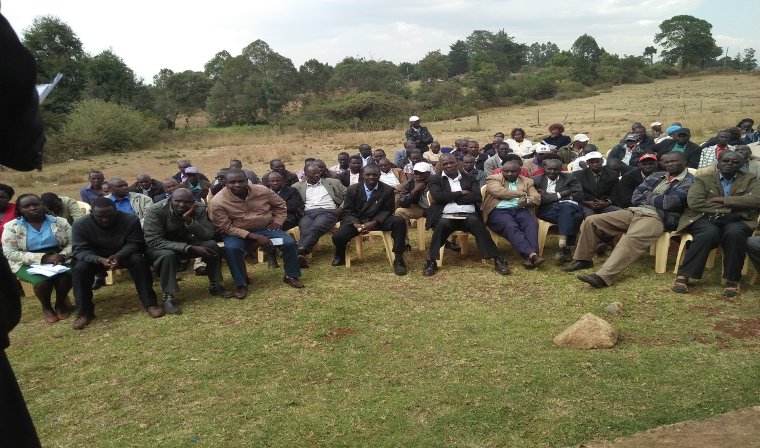

**Ainabkoi Olare wards public Participation.**

*The approach was per location focused groups where each location was required to deliberate their priorities and present in a plenary. Members of the public were given an opportunity to critique the proposals***.**

RESOLUTIONS MADE BY STAKE HOLDERS FROM KAPTAGAT WARD MEETING HELD ON 25TH JANUARY, 2018 AT CHERUNYA MARKET.

The meeting was well attended with all sub locations and schools represented.

The following were suggestions proposed for funding by the NGCDFC for the next two years. It was the wish of the public that the proposals be attained but the major limitation will be the available resources.

|  |  |  |  |  |
| --- | --- | --- | --- | --- |
| **project Name** | **Ward** | **LOCATION** | **Activities** | **Status** |
| Brockley primary school | kaptagat | kispinende | renovation of six classes | new |
|  |  | kipsinende | pit latrine |  |
| Plateau location chiefs office | kaptagat | plateau | ap staff houses | new |
| Chesogor secondary school | kaptagat | plateau | administration block | new |
| Chesogor secondary school | kaptagat | plateau | library | new |
| chesogor secondary school | kaptagat | plateau | dining hall | roofing complete |
| chepkongony primary school | kaptagat | plateau | four classes | new |
| chepkongony primary school | kaptagat | plateau | six door pit latrine | new |
| chepkongony primary school | kaptagat | plateau | administration block | ongoing |
| chepkongony primary school | kaptagat | plateau | six door pit latrine | ongoing |
| chepkongony assistant chiefs office | kaptagat | plateau | four door pit latrine | new |
|  |  |  | office | ongoing |
| chepkongony assistant chiefs office | kaptagat | plateau | furniture and electricity installation | ongoing |
| chebaon primary | kaptagat | plateau | administration block | new |
| chebaon primary | kaptagat | plateau | renovation and wiring of 8 classes | new |
| chesogor primary school | kaptagat | plateau | library | new |
| chesogor primary school | kaptagat | plateau | teachers toilet | new |
| chororget primary school | kaptagat | plateau | one classroom | new |
|  |  |  | staff toilet | new |
| katuiyo secondary | kaptagat | plateau | four new classes | new |
|  |  |  | two six door pit latrines | new |
|  |  |  | administration block | new |
| katuiyo primary school | kaptagat | plateau | two six door pit latrine | new |
|  |  |  | renovation of eight classes | new |
| Rotuga secondary school | kaptagat | plateau | four classes | new |
|  |  |  | eight door pit latrine | new |
|  |  |  | administration block | new |
| Rotuga primary school | kaptagat | plateau | one classroom | new |
|  |  |  | administration block | new |
| kipsinende primary school | kaptagat | kaptagat | admin block | new |
|  |  |  | construction of 10 door pit latrine | new |
| kipsinende primary school | kaptagat | kaptagat | Drainage of School Field |  |
| tendwo primary school | kaptagat | kaptagat | administration block | new |
| aic kaptagat children’s home primary | kaptagat | kaptagat | 8 classrooms | new |
|  |  | p | purchase of land | ongoing |
| cheseret primary school | kaptagat | kispinende | 6 classrooms | new |
|  |  |  | administration block | new |
| rcea biwott ngelel tarit | kaptagat | kispinende | 3 classrooms | new |
| rcea biwott ngelel tarit | kaptagat | kispinende | construction of administration block | ongoing |
| naiberi secondary school | kaptagat | kaptagat | 2 classrooms | new |
|  |  |  | fitting and equipping science laboratory | ongoing |
| lotonyok primary school | kaptagat | kaptagat | 3 classrooms | new |
|  |  |  | completion of classroom | new |
| chepkoilel central primary school | kaptagat | kaptagat | 10 door pit latrine | new |
|  |  |  | renovation of teachers houses | new |
| koilel primary school | kaptagat | kaptagat | 2 classrooms | new |
|  |  |  | administration block | new |
|  |  |  | completion of dormitory | new |
| naiberi primary school | kaptagat | kaptagat | administration block | new |
| naiberi primary school | kaptagat | kaptagat | 2 classrooms | new |
|  |  |  | 6 door pit latrine | new |
| Tendwo secondary school | kaptagat | kaptagat | administration block | new |
|  |  |  | 2 classrooms | new |
| Tendwo secondary school | kaptagat | kaptagat | dining hall | ongoing |
| uhuru primary school | kaptagat | kaptagat | administration block | new |
|  |  |  | 100 desks | new |
|  |  |  | school gate | new |
| kaptagat chiefs office | kaptagat | kaptagat | chiefs office | new |
|  |  |  | assistant chiefs office | new |
| kapsemwo primary school | kaptagat | chepkero | administration block | new |
|  |  |  | 10 door pit latrine | new |
| education center | kaptagat | kaptagat | construction of a hall | new |
|  |  |  | tables and chairs | new |
| kapsundei primary school | kaptagat | chepkero | 4 classrooms | new |
|  |  |  | pit latrine | ongoing |
| kapsundei secondary school |  |  | new school | new |
| kiburer primary school | kaptagat | chepkero | 4 classrooms | new |
|  |  |  | 3 pit latrines | new |
| kiburer primary school | kaptagat | chepkero | administration block | ongoing |
| kiburer primary school | kaptagat | chepkero | 2 classrooms | ongoing |
| kiluka primary | kaptagat | chepkero | 2 classrooms | new |
|  |  |  | water tank | new |
| kiluka primary | kaptagat | chepkero | renovation of 4 classrooms | new |
|  |  |  | administration block | new |
| chepkero chiefs office | kaptagat | chepkero | ap staff houses | new |
|  |  |  | wiring | new |
| kapsundei assistant chiefs office | kaptagat | chepkero | assistant chiefs office | new |
| chepkero primary school | kaptagat | chepkero | teachers houses | new |
|  |  |  | dinning hall | new |
| chepkero primary school | kaptagat | chepkero | dormitory | ongoing |
|  |  |  | renovation of classrooms | new |
| A.I.C kiluka secondary school | kaptagat | chepkero | administration block | new |
| A.I.C kiluka secondary school | kaptagat | chepkero | dining hall | new |
|  |  |  | laboratory | ongoing |
| ngatit primary school | kaptagat | chepkero | 1 classroom |  |
|  |  |  | renovation of 6 classrooms |  |
|  |  |  | administration block |  |
|  |  |  | pit latrine |  |
| ngatit secondary school | kaptagat | chepkero | new school | new |
| kileges primary school | kaptagat | chepkero | administration block | new |
| kileges primary school | kaptagat | chepkero | 2 pit latrines | new |
| kipkoriony primary school | kaptagat | chepkero | administration block | new |
|  |  |  | staff pit latrine | new |
| chepkero ass chief office | kaptagat | chepkero | assistant chiefs office(kileges sub location) | new |
| telted primary school | kaptagat | chepkero | new school | new |
| chepkongony coc sec school | kaptagat | chepkero | laboratory | new |
|  |  |  | boys dormitory | new |
| chepkongony coc sec school | kaptagat | chepkero | dinning hall | ongoing |
| cheptigit chiefs office | kaptagat | kipsinende | ass chiefs office | new |
| cheptigit primary school | kaptagat | kipsinende | 100 desks | new |
|  |  |  | pit latrine | new |
| cheptigit secondary school | kaptagat | kipsinende | dinning hall | new |
|  |  |  | 3 pit latrines | ongoing |
| cheptigit secondary school | kaptagat | kipsinende | computer laboratory | ongoing |
| kipsinende chiefs office | kaptagat | kipsinende | chiefs office | new |
|  |  |  | social hall center | new |
| kongasis primary school | kaptagat | kipsinende | administration block | new |
|  |  |  | pit latrine | new |
| plateau girls secondary sch | kaptagat | kipsinende | laboratory | new |
|  |  | kipsinende | parameter wall | new |
| plateau girls secondary sch | kaptagat | kipsinende | 7 door toilet | ongoing |
| berur primary school | kaptagat | kipsinende | renovation of classrooms | new |
|  |  |  | land | new |
|  |  |  | 100 desk | new |
|  |  |  | admiration block-furnishing | new |
| plateau primary school | kaptagat | kipsinende | administration block | new |
|  |  |  | 100 desks | new |
|  |  |  | renovation of 5 classrooms | new |
| kipsinende ass chiefs office | kaptagat | kipsinende | purchase of land | new |
| plateau f.c.s | kaptagat | kipsinende | social hall | new |
|  |  |  | football entire and boots | new |
| chepnoet primary school | kaptagat | kipsinende | land | new |
|  |  |  | wiring of classrooms | new |
| chepnoet primary school | kaptagat | kipsinende | administration block | ongoing |
| songich primary school | kaptagat | kipkabus | renovation of classrooms | new |
| songich primary school | kaptagat | kipkabus | pit latrine | new |
|  |  |  | administration block | new |
|  |  |  | pit latrine | ongoing |
| chelugui primary school | kaptagat | kipkabus | pit latrine | new |
|  |  |  | class room | new |
|  |  |  | renovation | new |
|  |  |  | administration | new |
| sirwo primary school | kaptagat | kipkabus | 2 classrooms | new |
|  |  |  | pit latrine | new |
|  |  |  | administration block | new |
| songich ass chief office | kaptagat | kipkabus | ass chiefs office | new |

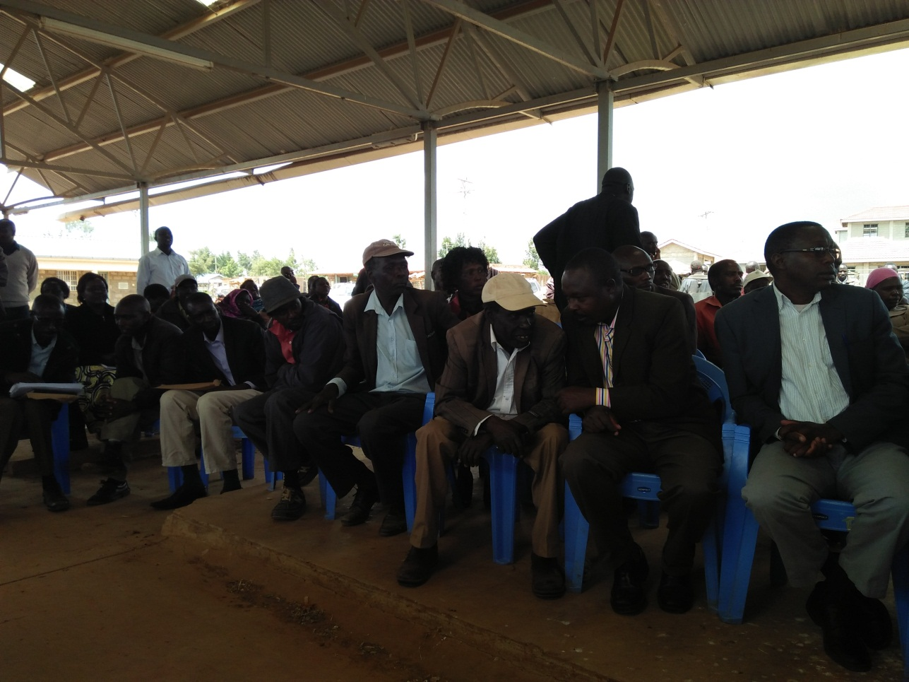

**RESOLUTIONS MADE BY STAKE HOLDERS FROM KAPSOYA WARD WARD MEETING HELD ON 26TH JANUARY 2018 LIGHTHOUSE CHURCH**.

The meeting just like the other two went on well. The participants were put into five clusters namely; kipkorgot, kapsoya, Beliomo, munyaka and illula. The decisions were based on the fact that the ward is a location and a ward at the same time. The population is high but again the infrastructure is fairly developed compared to the other two rural wards. Out of the 98 public schools, only 8 are in the ward. The three clusters are believed to have unique features.

|  |  |  |  |  |
| --- | --- | --- | --- | --- |
| kapsoya secondary school | kapsoya | kapsoya | roofing of an ongoing classes | ongoing |
| kapsoya ap line project | kapsoya | kapsoya | 12 single self-housing units | new |
|  |  |  | three , 2 bed roomed housing units for senior staff | new |
|  |  |  | Three door pit latrine. Three door bath rooms | new |
| kapsoya sports community project | kapsoya | kapsoya | buying of games kits and field infrastructure | new |
| kapsoya social hall and resource center | kapsoya | kapsoya | construction of a multipurpose hall | new |
| eldoret border farm primary school | kapsoya | kapsoya | construction of three classes | new |
|  |  |  | 32 doors pit latrine | new |
|  |  |  | 100 desks | new |
|  |  |  | 2 classrooms | ongoing |
| kapsoya primary school | kapsoya | kapsoya | pit latrine | new |
| kapsoya primary school | kapsoya | kapsoya | renovation and electrification of kapsoya zone office | new |
| kapsoya primary school | kapsoya | kapsoya | renovation of 16 classroom | new |
| kapsoya chiefs office | kapsoya | kapsoya | chiefs office | new |
|  |  |  | assistant chief offices munyaka,koibarak,illula and beliomo | new |
|  |  |  | roofing of 2 units ap line(kipkorgot) | new |
| munyaka primary school | kapsoya | kapsoya | 3 pit latrines;girls,boys and staff | new |
|  |  |  | story construction | new |
|  |  |  | 200 desks | new |
|  |  |  | 4 classrooms | ongoing |
| munyaka primary school | kapsoya | kapsoya | field scaping | new |
|  |  |  | fencing | new |
|  |  |  | wiring and electrification | new |
| kapsoya police post | kapsoya | kapsoya | fencing of police post and staff | new |
|  |  |  | police post | ongoing |
| illula cheboin | kapsoya | kapsoya | request of new primary school | new |
| illula secondary school | kapsoya | kapsoya | library | new |
|  |  |  | 2 pit latrines | new |
| illula secondary school | kapsoya | kapsoya | dinning hall | ongoing |
| illula primary school | kapsoya | kapsoya | 4 classrooms | new |
|  |  |  | administration block | new |
|  |  |  | renovation of classrooms | new |
|  |  |  | dormitory | new |
| beliomo ecd | kapsoya | kapsoya | purchase of land | new |
|  |  |  | expansion to primary | new |
| kipkorgot social hall | kapsoya | kapsoya | multipurpose hall | ongoing |
| koibarak secondary school | kapsoya | kapsoya | 3 classrooms | new |
|  |  |  | field scaping | new |
|  |  |  | administration block | new |
|  |  |  | school gate | new |
|  |  |  | water tank | new |
| koibarak primary school | kapsoya | kapsoya | 1 classroom | new |
|  |  |  | administration block | new |
|  |  |  | pit latrine | new |
|  |  |  | fencing sch compound | New |
| Ainabkoi Assistant county Commissioner Office | Olare/Aiabkoi | Olare | Plastering, Fixing of doors and windows And painting | ongo |

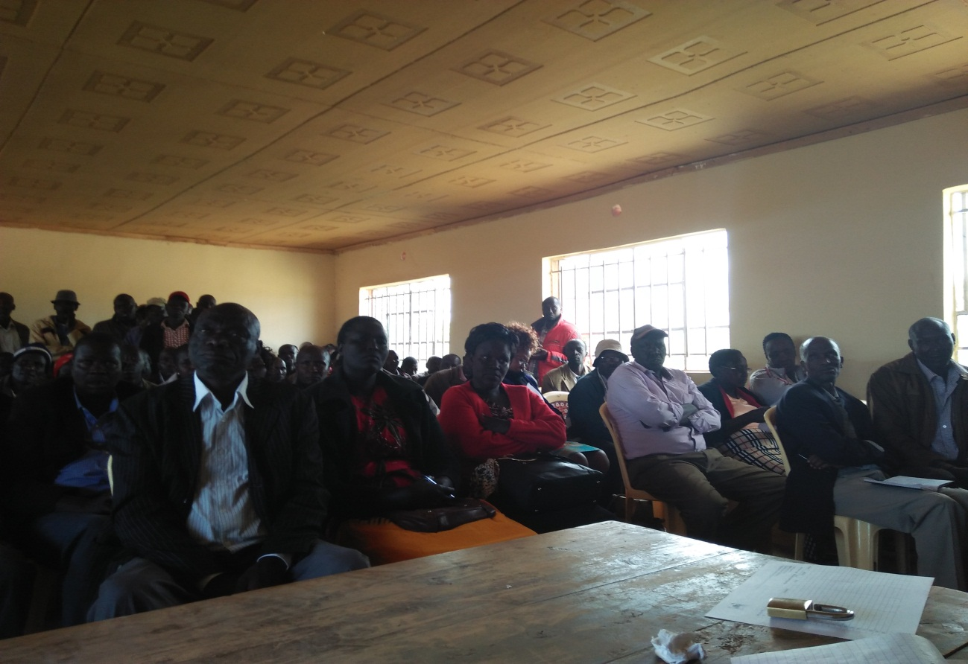

**COMMENTS BY THE CHAIRMAN NGCDFC**

The Chairman thanked the entire participant for coming and positively engaging in the discussions. He emphasized that the committee will look into all proposals and do what is achievable within the budget ceiling. The committee may not implement the proposals in entirely but will report back in subsequent meetings. He noted that some of the proposals if need be will be forwarded to the area MP sourcing of additional funds. All locations and wards will be given fair allocations to ensure equitable development.

**Chairperson**

David Chemase Sign__________________ Date______________

**Fund Account Manager**

Elias K Kimaiyo Sign__________________Date_____________

**Secretary**

Caroline Sawe Sign……………………… .Date………………

**Appendices**

1. Attendance register
2. Notice of ward meetings