NG-CDF BOARD
KINANGO CONSTITUENCY
IEBC NUMBER 010
NATIONAL GOVERNMENT CONSTITUENCY DEVELOPMENT FUND
PROJECT PROPOSAL BUDGET
2019/2020 FINANCIAL YEAR
SUBMITTED:
OCTOBER 2019

National Government Constituency Development Fund | Kinango Constituency  2019
Minutes of the Meeting held on Monday, October 14th, 2019 at Kinango NG-CDF Office Boardroom. |  | Kinango NG-CDF Committee

Present:
- Rashid Bavu Kurera – Chairman
- Beatrace Mbeyu Joto - Secretary
- Ngome Chitaphi Kidilo– Member
- Amina Hussein – Memeber
- Kimani Lemna – Member
- Lilian Nyanje – Member
- Rebecca Mwaka – Member
- Adhiban Mugandi Munyika - Member
- Beatrice Kulaphira Tembe - (FAM) - Member

In attendance:
- Richard Itambo - Constituency Manager

Agenda:
- Opening remarks by Chairman
- Reading and Confirmation of minutes of previous meeting
- FY 2019/2020 - Project Proposal Budget
- Any Other Business (A.O.B).

Preliminaries:
Meeting begun at 1130 hours with a word of prayer by Beatrice Tembe.
The chairman begun by thanking members for attending the session in time and their devotion to serve selflessly
He recognized the presence of the sub-county works officer and thanked him for finding time to attend the sitting.
He urged all to remain focused in the day's agenda as it was long and loaded with weighty matters.

Min.01/10/01/2018 – Reading and confirmation of Minutes of previous meetings
Minutes of the previous meeting were read and confirmed by NgomeKidilo seconded by Rebecca Mwaka.
All minutes were unanimously adopted by the committee as a true record of those sittings’ deliberations.
Min.03/10/01/2018 – FY 2019/2020 - Project Proposal Budget
The chairman tabled the guidelines from the NG-CDF Board on the preparation of project proposal budget for the FY 2019/2020.
Members agreed to have all the projects which were underfunded to be given the priority to complete the projects. This was in reference to construction of classrooms whose engineer's estimate cost per classroom was at 1.3M.
The Fund manager tabled the Third schedule indicating the balance available for allocation to projects after charging the statutory deductions as follows;
907
2015 National Government Constituencies Development Fund No. 30
THIRD SCHEDULE (s. 15)
CONSTITUENCY PROJECTS SUBMISSION FORM
Constituency No 010 Constituency Name KINANGO CONSTITUENCY Financial Year 2018/2019
Serial | Name of Project | Amount Allocated
010/AP1 | Administration & Recurrent (6%) | 8,242,063.45
010/AP2 | Monitoring & Evaluation and Capacity Building (3%) | 4,121,031.72
010/2640100 | Social Security Programs, Education Bursary, Mocks and Continuous Assessment Tests (35%) | 35,026,387.59
010/2630204 | Education - Primary School Projects | 82,780,000.00
010/2630205 | Education - Secondary School Projects | 82,780,000.00
010/2640507 | Security Projects | 82,780,000.00
010/2640509 | Sports (2%) | 82,780,000.00
010/2640505 | Environment (2%) | 82,780,000.00
010/2640200 | Emergency Reserve (5%) | 7,198,241.38
Total |  | 137,367,724.14
CODELIST FINANCIAL YEAR 2019/2020
NAME OF PROJECT | PROJECT NUMBER | ORIGINAL COST ESTIMATE | CUMMALATIVE ALLOCATION | ACTIVITY | AMOUNT | STATUS
ADMINISTRATION/RECURRENT
Employees’ Salaries | 4-002-010-2110000-100-2019/2020-001 | 2,587,200.00 | 0.00 | Payment of staff salaries and gratuity | 2,587,200.00 | New
Goods and Services | 4-001-010-2210000-100-2019/2020-002 | 2,500,000.00 | 0.00 | Purchase of fuel, repairs and maintenance, printing, stationery, telephone, travel and subsistence, office tea | 2,500,000.00 | New
NSSF | 4-002-010-2120101-100-2019/2020-003 | 492,800.00 | 0.00 | Payment of NSSF Deductions | 492,800.00 | New
NHIF | 4-002-010-2120201-100-2019/2020-004 | 60,000.00 | 0.00 | Payment of NHIF Deductions | 60,000.00 | New
Committee Expenses | 4-002-010-2210802-100-2019/2020-005 | 2,602,063.45 | 0.00 | Payment of Committee sitting allowances, transport, conferences | 2,602,063.45 | New
MONITORING & EVALUATION
Committee Expenses | 4-002-010-2210802-111-2018/2019-001 | 2,500,000.00 | 0.00 | Payment of Committee sitting allowances, transport, conferences | 2,500,000.00 | New
NG-CDFC, PMC & Staff Capacity Building | 4-002-010-2210700-111-2018/2019-002 | 1,621,031.72 | 0.00 | Undertake Training of the PMCs, NG- CDFCs and Office Staff on NG-CDF Related issues | 1,621,031.72 | New
EMERGENCY
Emergency | 4-002-010-2640200-101-2019/2020-001 | 7,198,241.38 | 0.00 | To cater for any unfore-seen occurrences in the constituency during the financial year | 7,198,241.38 | New
BURSARY
Secondary Schools Bursary | 4-002-010-2640101-103-2018/2019-001 | 17,026,387.59 | 0.00 | Cater for bright and needy students in secondary schools | 17,026,387.59 | New
Tertiary Institutions Bursary | 4-002-010-2640102-103-2018/2019-002 | 18,000,000.00 | 0.00 | Cater for bright and needy students in tertiary institutions | 18,000,000.00 | New
PRIMARY SCHOOL PROJECTS
Mazola Primary School | 4-002-010-2630204-104-2019/2020-001 | 2,400,000.00 | 0.00 | Construction of 2no. classroom to completion | 2,400,000.00 | New
Chizini Primary School | 4-002-010-2630204-104-2019/2020-002 | 2,400,000.00 | 0.00 | Construction of 2no. classroom to completion | 2,400,000.00 | New
Ng'onzini Primary School | 4-002-010-2630204-104-2019/2020-003 | 2,400,000.00 | 0.00 | Construction of 2no. classroom to completion | 2,400,000.00 | New
Dzivani Primary School | 4-002-010-2630204-104-2019/2020-004 | 2,400,000.00 | 0.00 | Construction of 2no. classroom to completion | 2,400,000.00 | New
Mwashanga Primary School | 4-002-010-2630204-104-2019/2020-005 | 2,400,000.00 | 0.00 | Construction of 2no. classroom to completion | 2,400,000.00 | New
Dzombo Primary School | 4-002-010-2630204-104-2019/2020-006 | 2,400,000.00 | 0.00 | Construction of 2no. classroom to completion | 2,400,000.00 | New
Kafuduni Primary School | 4-002-010-2630204-104-2019/2020-007 | 2,400,000.00 | 0.00 | Construction of 2no. classroom to completion | 2,400,000.00 | New
Mgandini Primary School | 4-002-010-2630204-104-2019/2020-008 | 2,400,000.00 | 0.00 | Construction of 2no. classroom to completion | 2,400,000.00 | New
Miyani Primary School | 4-002-010-2630204-104-2019/2020-009 | 2,400,000.00 | 0.00 | Construction of 2no. classroom to completion | 2,400,000.00 | New
Mbwaleni Primary School | 4-002-010-2630204-104-2019/2020-010 | 2,400,000.00 | 0.00 | Construction of 2no. classroom to completion | 2,400,000.00 | New
Mbita Primary School | 4-002-010-2630204-104-2019/2020-011 | 2,400,000.00 | 0.00 | Construction of 2no. classroom to completion | 2,400,000.00 | New
Mwangea Primary School | 4-002-010-2630204-104-2019/2020-012 | 2,400,000.00 | 0.00 | Construction of 2no. classroom to completion | 2,400,000.00 | New
Kituoni Primary School | 4-002-010-2630204-104-2019/2020-013 | 2,400,000.00 | 0.00 | Construction of 2no. classroom to completion | 2,400,000.00 | New
Taru Primary School | 4-002-010-2630204-104-2019/2020-014 | 2,400,000.00 | 0.00 | Construction of 2no. classroom to completion | 2,400,000.00 | New
Busho Primary School | 4-002-010-2630204-104-2019/2020-015 | 2,400,000.00 | 0.00 | Construction of 2no. classroom to completion | 2,400,000.00 | New
Kaluweni Primary School | 4/002/010/2630204/2019/2020/016 | 2,400,000.00 | 0.00 | Construction of 2no. classroom to completion | 2,400,000.00 | New
Kasageni Primary School | 4/002/010/2630204/2019/2020/017 | 2,200,000.00 | 0.00 | Renovation of 4no. classrooms to completion  - re-roofing  - plastering  - flooring | 2,200,000.00 | New
Mwalukombe Primary School | 4/002/010/2630204/2019/2020/018 | 2,200,000.00 | 0.00 | Renovation of 4no. classrooms to completion  - re-roofing  - plastering  - flooring | 2,200,000.00 | New
Gona Primary School | 4/002/010/2630204/2019/2020/019 | 2,200,000.00 | 0.00 | Renovation of 4no. classrooms to completion  - re-roofing  - plastering  - flooring | 2,200,000.00 | New
Kituu Primary School | 4/002/010/2630204/2019/2020/020 | 1,100,000.00 | 0.00 | Renovation of 2no. classrooms to completion  - re-roofing  - plastering  - flooring | 1,100,000.00 | New
Mbandi Primary School | 4/002/010/2630204/2019/2020/021 | 3,900,000.00 | 3,500,000 | Additional funds for roofing 3no classrooms to completion | 400,000.00 | On-going
Bishop Kalu Primary School | 4/002/010/2630204/2019/2020/022 | 1,000,000.00 | 0.00 | Construction of Admin block(three offices)to completion | 1,000,000.00 | New
Tumaini Primary School | 4/002/010/2630204/2019/2020/023 | 3,900,000.00 | 3,600,000.00 | Additional cost of construction of 3no classroom to completion  Additional funds for roofing | 300,000.00 | On-going
Mnyenzeni Primary School | 4/002/010/2630204/2019/2020/024 | 2,400,000.00 | 0.00 | Construction of 2no. classroom to completion | 2,400,000.00 | New
Gwadu Primary School | 4/002/010/2630204/2019/2020/026 | 140,000.00 | 0.00 | Purchase of twenty desks. | 140,000.00 | New
Bumani Primary School | 4/002/010/2630204/2019/2020/027 | 140,000.00 | 0.00 | Purchase of twenty desks. | 140,000.00 | New
Chengoni Primary School | 4/002/010/2630204/2019/2020/028 | 210,000.00 | 0.00 | Purchase of thirty desks | 210,000.00 | New
Matumbi Primary School | 4/002/010/2630204/2019/2020/029 | 200,000.00 | 0.00 | Purchase of thirty desks | 200,000.00 | New
Gandini South Primary School | 4/002/010/2630204/2019/2020/030 | 210,000.00 | 0.00 | Purchase of thirty desks | 210,000.00 | New
Pemba Primary School | 4/002/010/2630204/2019/2020/031 | 210,000.00 | 0.00 | Purchase of thirty desks | 210,000.00 | New
Mbilini Primary School | 4/002/010/2630204/2019/2020/032 | 210,000.00 | 0.00 | Purchase of thirty desks | 210,000.00 | New
Amani Primary School | 4/002/010/2630204/2019/2020/033 | 210,000.00 | 0.00 | Purchase of thirty desks | 210,000.00 | New
Mtaa Primary School | 4/002/010/2630204/2019/2020/034 | 210,000.00 | 0.00 | Purchase of thirty desks | 210,000.00 | New
Samburu Primary School | 4/002/010/2630204/2019/2020/035 | 210,000.00 | 0.00 | Purchase of thirty desks | 210,000.00 | New
Gulanze Primary School | 4/002/010/2630204/2019/2020/036 | 210,000.00 | 0.00 | Purchase of thirty desks | 210,000.00 | New
Kifyonzo Primary School | 4/002/010/2630204/2019/2020/037 | 210,000.00 | 0.00 | Purchase of thirty desks | 210,000.00 | New
Kituoni Primary School | 4/002/010/2630204/2019/2020/038 | 210,000.00 | 0.00 | Purchase of thirty desks | 210,000.00 | New
Mwanda Primary School | 4/002/010/2630204/2019/2020/039 | 210,000.00 | 0.00 | Purchase of thirty desks | 210,000.00 | New
Mulunguni Primary School | 4/002/010/2630204/2019/2020/040 | 210,000.00 | 0.00 | Purchase of thirty desks | 210,000.00 | New
Mabamani Primary School | 4/002/010/2630204/2019/2020/041 | 210,000.00 | 0.00 | Purchase of thirty desks | 210,000.00 | New
Gozani Primary School | 4/002/010/2630204/2019/2020/041 | 210,000.00 | 0.00 | Purchase of thirty desks | 210,000.00 | New
Mazeras Primary School | 4/002/010/2630204/2019/2020/042 | 210,000.00 | 0.00 | Purchase of thirty desks | 210,000.00 | New
Bofu Primary School | 4/002/010/2630204/2019/2020/043 | 210,000.00 | 0.00 | Purchase of thirty desks | 210,000.00 | New
Kibandaongo Primary School | 4/002/010/2630204/2019/2020/044 | 210,000.00 | 0.00 | Purchase of thirty desks | 210,000.00 | New
Chigutu Primary School | 4/002/010/2630204/2019/2020/045 | 210,000.00 | 0.00 | Purchase of thirty desks | 210,000.00 | New
Magale Primary School | 4/002/010/2630204/2019/2020/046 | 210,000.00 | 0.00 | Purchase of thirty desks | 210,000.00 | New
Egu Primary School | 4/002/010/2630204/2019/2020/047 | 210,000.00 | 0.00 | Purchase of thirty desks | 210,000.00 | New
SECONDARY SCHOOL PROJECTS
Vigurungani Secondary School | 4-002-010-2630205-104-2019/2020-001 | 1,600,000.00 | 0.00 | Renovation of single Science Laboratory to completion (50 seater)  -flooring  -painting  -repairs on the working tops | 1,600,000.00
Ndavaya Secondary School | 4-002-010-2630205-104-2019/2020-002 | 5,000,000.00 | 0.00 | Additional and final Cost for Purchase of 51Seater School Bus - Co-funding between school PTA and NG-CDF  Attached is the bank statement of the school account | 5,000,000.00 | New
Makamini Secondary School | 4-002-010-2630205-104-2019/2020-003 | 4,000,000.00 | 0.00 | Construction of one-bedroom Staff Twin House to completion | 4,000,000.00 | New
Taru Girls Secondary School | 4-002-010--2630205-104-2019/2020-004 | 1,200,000.00 | 0.00 | Construction of 1no. Classroom to completion | 1,200,000.00 | New
Mwavumbo Secondary School | 4-002-010-2630205-104-2019/2020-005 | 1,000,000.00 | 0.00 | Construction of Kitchen Block two rooms | 1,000,000.00 | New
NG-CDF OFFICES
NG-CDF Office | 4-002-010/2640510-108-2019/2020-001 | 1,600,000.00 |  | Renovation of the whole Office block due to the ongoing heavy rains.  - re-roofing  - re-painting  - replacement of windows and doors | 1,600,000.00
SECURITY | 4-002-010/2640510-108-2019/2020-002
Mavirivirini Police Post | 4-002-010-2640510-108-2019/2020-003 |  |  | Completion of the office block  -fixing of windows and doors  -painting  -four offices | 400,000.00 | On-going
OTHERS | 4-002-010-2640510-108-2019/2020-004
Kinango Sub-County Education Office | 4-002-010-2640510-108-2019/2020-005 | 16,000,000.00 | 0.00 | Construction of Education Office Complex(main ministry of education offices, sub county directors, TSC offices) | 9,000,000 | New
SPORTS | 4-002-010-2640510-108-2019/2020-006
Sports | 4-002-010-2640510-108-2019/2020-007 | 2,100,000.00 | 0.00 | Carry out Constituency sports tournaments and purchase of trophies, sports kits and balls for winning teams | 2,100,000.00 | New
ENVIRONMENT | 4-002-010-2640510-108-2019/2020-008
Chizini Primary School | 4-002-010-2640510-108-2019/2020-009 | 100,000.00 | 0.00 | Purchase of 200 tree seedlings and Planting them | 100,000.00 | New
Ng'onzini Primary School | 4-002-010-2640510-108-2019/2020-010 | 100,000.00 | 0.00 | Purchase of 200 tree seedlings and Planting them | 100,000.00 | New
Dzivani Primary School | 4-002-010-2640510-108-2019/2020-011 | 100,000.00 | 0.00 | Purchase of 200 tree seedlings and Planting them | 100,000.00 | New
Mwashanga Primary School | 4-002-010-2640510-108-2019/2020-012 | 100,000.00 | 0.00 | Purchase of 200 tree seedlings and Planting them | 100,000.00 | New
Dzombo Primary School | 4-002-010-2640510-108-2019/2020-013 | 100,000.00 | 0.00 | Purchase of 200 tree seedlings and Planting them | 100,000.00 | New
Kafuduni Primary School | 4-002-010-2640510-108-2019/2020-014 | 100,000.00 | 0.00 | Purchase of 200 tree seedlings and Planting them | 100,000.00 | New
Mgandini Primary School | 4-002-010-2640510-108-2019/2020-015 | 100,000.00 | 0.00 | Purchase of 200 tree seedlings and Planting them | 100,000.00 | New
Miyani Primary School | 4-002-010-2640510-108-2019/2020-016 | 100,000.00 | 0.00 | Purchase of 200 tree seedlings and Planting them | 100,000.00 | New
Mbwaleni Primary School | 4-002-010-2640510-108-2019/2020-017 | 100,000.00 | 0.00 | Purchase of 200 tree seedlings and Planting them | 100,000.00 | New
Kasageni Primary School | 4-002-010-2640510-108-2019/2020-018 | 100,000.00 | 0.00 | Purchase of 200 tree seedlings and Planting them | 100,000.00 | New
Mwalukombe Primary School | 4-002-010-2640510-108-2019/2020-019 | 100,000.00 | 0.00 | Purchase of 200 tree seedlings and Planting them | 100,000.00 | New
Gona Primary School | 4-002-010-2640510-108-2019/2020-012 | 100,000.00 | 0.00 | Purchase of 200 tree seedlings and Planting them | 100,000.00 | New
Kaluweni Primary School | 4-002-010-2640510-108-2019/2020-013 | 100,000.00 | 0.00 | Purchase of 200 tree seedlings and Planting them | 100,000.00 | New
Taru Primary School | 4-002-010-2640510-108-2019/2020-014 | 100,000.00 | 0.00 | Purchase of 200 tree seedlings and Planting them | 100,000.00 | New
Kituoni Primary School | 4-002-010-2640510-108-2019/2020-015 | 100,000.00 | 0.00 | Purchase of 200 tree seedlings and Planting them | 100,000.00 | New
Mwache Primary School | 4-002-010-2640510-108-2019/2020-016 | 100,000.00 | 0.00 | Purchase of 200 tree seedlings and Planting them | 100,000.00 | New
Busho Primary School | 4-002-010-2640510-108-2019/2020-017 | 100,000.00 | 0.00 | Purchase of 200 tree seedlings and Planting them | 100,000.00 | New
Mbita Primary School | 4-002-010-2640510-108-2019/2020-018 | 100,000.00 | 0.00 | Purchase of 200 tree seedlings and Planting them | 100,000.00 | New
Mazola Primary School | 4-002-010-2640510-108-2019/2020-019 | 100,000.00 | 0.00 | Purchase of 200 tree seedlings and Planting them | 100,000.00 | New
Amani Primary School | 4-002-010-2640510-108-2019/2020-020 | 100,000.00 | 0.00 | Purchase of 200 tree seedlings and Planting them | 100,000.00 | New

Guided by the data collected during the project proposal public participation in each ward, the committee allocated funds to projects as follows;

Projects Budget Allocations

The office was tasked to fine tune the project proposal budget as per the NG-CDF Board's standard format and submits to the NG-CDF Board as soon as possible

Min.06/10/01/2018 – Any Other Business (A.O.B)
There being no other business for deliberation, the meeting ended at 1523 hours with a word of prayer by Lilian Nyanje.
Minutes taken by:
Secretary ..………………………………………………. ………………………………………
Name Signature
Minutes confirmed by:
Chairperson ……..…….…………………………………… …………………………………………….
Name Signature

907
2015 National Government Constituencies Development Fund No. 30
THIRD SCHEDULE (s. 15)
CONSTITUENCY PROJECTS SUBMISSION FORM
Constituency No 010 Constituency Name KINANGO CONSTITUENCY Financial Year 2018/2019
Serial | Name of Project | Amount Allocated
010/AP1 | Administration & Recurrent (6%) | 8,242,063.45
010/AP2 | Monitoring & Evaluation and Capacity Building (3%) | 4,121,031.72
010/2640100 | Social Security Programs, Education Bursary, Mocks and Continuous Assessment Tests (35%) | 35.026.387.59
010/2630204 | Education - Primary School Projects | 56,080,000.00
010/2630205 | Education - Secondary School Projects | 11,700,000.00
010/2640507 | Security | 400,000.00
010/2640509 | Sports (2%) | 2,100,000.00
010/2640510 | Environment | 1,900,000.00
010/ | Others | 10,600,000.00
010/2640200 | Emergency Reserve (5%) | 7,198,241.38
Total |  | 137,367,724.14

Chairman NG- CDF Committee ……………………… Signature…………………Date………………

Fund Account Manager …………………………… Signature……………………Date………………

907
2015 National Government Constituencies Development Fund No. 30

FOURTH SCHEDULE (s. 16)

PROJECT DESCRIPTION FORM

Constituency No: 010 Constituency Name KINANGO County KWALE
Project Number 010/AP1
Project Title 6% Administration & Recurrent
Sector Administration
Status of projects (tick one) New………Extension………On-going…√…..Rehabilitation ………
Brief statement on project status at time of submission
The allocation is to cater for CDFC Allowance, staff salaries, vehicle expenses and operations expenses
Financial year 2019 1st July To 30th June 2020
Original Cost estimates, in Kshs.8,242,063.45…………………
Amount allocated last financial year Kshs. 6,542,452.53
Amount allocated this financial year 8,242,063.53
Project Name | Project Number | Activity | Amount | STATUS
Employees Salaries | 4-002-010-2110000-100-2019/2020-001 | Payment of staff salaries and gratuity | 2,587,200.00 | Ongoing
Goods and Services | 4-001-010-2210000-100-2019/2020-002 | Purchase of fuel, repairs and maintenance, printing, stationery, telephone, travel and subsistence, office tea | 2,500,000.00 | Ongoing
NSSF | 4-002-010-2120101-100-2019/2020-003 | Payment of NSSF Deductions | 492,800.00 | Ongoing
NHIF | 4-002-010-2120201-100-2019/2020-004 | Payment of NHIF Deductions | 60,000.00 | Ongoing
Committee Expenses | 4-002-010-2210802-100-2019/2020-005 | Payment of Committee sitting allowances, transport, conferences | 2,602,063.45 | Ongoing
TOTAL |  |  | 8,242,063.45

Person completing form:
Name ……………………………………….............................…………. Position Fund Account Manager

Signature…………………………………………………………… Date…………………………………………………………………
907
2015 National Government Constituencies Development Fund No. 30
FOURTH SCHEDULE (s. 16)
PROJECT DESCRIPTION FORM
Constituency No: 010 Constituency Name KINANGO County KWALE
Project Number 010/AP2
Project Title 3% Monitoring & Evaluation and Capacity Building
Sector Monitoring & Evaluation
Status of projects (tick one) New………Extension………On-going…√…..Rehabilitation ………
Brief statement on project status at time of submission
To cater for Monitoring and Evaluation of CDF projects and capacity building of CDFC, PMC and staff
Financial year 20191st July To 30th June 2020
Original Cost estimates, in Kshs. 4,121,031.72,dated…………………
Amount allocated last financial year Ksh. .3,271,226.27
Amount allocated this financial yearKsh. 4,121,031.72
Project Name | Project Number | Activity | Amount | STATUS
Committee Expenses | 4-002-010-2210802-111-2018/2019-001 | Payment of Committee sitting allowances, transport, conferences | 2,500,000.00 | Ongoing
NG-CDFC, PMC & Staff Capacity Building | 4-002-010-2210700-111-2018/2019-002 | Undertake Training of the PMCs, NG-CDFCs and Office Staff on CDF Related issues | 1,621,031.72 | Ongoing
TOTAL |  |  | 4,121,031.72

Person completing form:

Name ……........................……………………....................................Position Fund Account Manager

Signature………………………………………….…………..… Date……………………………………………………………………
907
2015 National Government Constituencies Development Fund No. 30

FOURTH SCHEDULE (s. 16)

PROJECT DESCRIPTION FORM

Constituency No: 010 Constituency Name KINANGO County KWALE
Project Number010/2640200
Project Title Emergency Reserve (5% of the fund)
Sector Emergency
Status of projects (tick one) New…………Extension………On-going…√…..Rehabilitation …………
Brief statement on project status at time of submission
Unallocated amount meant for emergencies that may occur within the Constituency
Financial year 20191st July To 30th June 2020
Original Cost estimates, in Kshs 7,198,241.38 dated…………………
Amount allocated last financial year 5,738,993.45
Amount allocated this financial year 7,198,241.38
Project Name | Project Code | Project Activity | Amount Allocated | STATUS
Emergency | 4-002-010-2640200-101-2019/2020-001 | To cater for any unforeseen occurrences in the constituency during the financial year | 7,198,241.38 | Ongoing
Total |  |  | 7,198,241.38

Person completing form:

Name ……………………………………………..…................................Position Fund Account Manager

Signature…………………………………………………………… Date……………………………………………………….…………
907
2015 National Government Constituencies Development Fund No. 30

FOURTH SCHEDULE (s. 16)

PROJECT DESCRIPTION FORM

Constituency No: 010 Constituency Name KINANGO County KWALE
Project Number010/2640100
Project Title Bursary
Sector Bursary
Status of projects (tick one) New…………Extension………………On-going…√….. Rehabilitation …………
Brief statement on project status at time of submission
Towards Bursary for payment of fees for needy students
Financial year 20191st July To 30th June 2020
Original Cost estimates, in Kshs. 35,026,387.59 dated…………………
Amount allocated last financial year 26,500,000.00
Amount allocated this financial year 35,026,387.59
Project Name | Project Code | Project Activity | Amount Allocated | STATUS
Secondary Schools | 4-002-010-2640101-103-2018/2019-001 | Cater for bright and needy students in secondary schools | 17,026,387.59 | Ongoing
Tertiary Institutions | 4-002-010-2640102-103-2018/2019-002 | Cater for bright and needy students in tertiary institutions | 18,000,000.00 | Ongoing
TOTAL |  |  | 35,026,387.59

Person completing form:

Name ………………………..................................…………………….……….. Position Fund Account Manager

Signature……………………………………………………………… Date……………………………………………………………………
907
2015 National Government Constituencies Development Fund No. 30

FOURTH SCHEDULE (s. 16)

PROJECT DESCRIPTION FORM

Constituency No: 010 Constituency Name KINANGO County KWALE
Project Number 010/2630204
Project Title Primary School Projects
Sector Education
Status of projects (tick one) New………Extension………On-going…√…..Rehabilitation …………
Brief statement on project status at time of submission
To enhancing better learning conditions in the primary schools institutions by improving the infrastructure
Financial year 20191st July To 30th June 2020
Original Cost estimates, in Kshs.56,180,000.00dated…………………
Amount allocated last financial year Kshs.44,000,000.00
Amount allocated this financial year Kshs.56,080,000.00

Project Name | Project Code | Project Activity | Amount Allocated | Status
Mazola Primary School | 4-002-010-2630204-104-2019/2020-001 | Construction of 2no. classroom to completion. | 2,600,000.00 | New
Chizini Primary School | 4-002-010-2630204-104-2019/2020-002 | Construction of 2no. classroom to completion. | 2,600,000.00 | New
Ng'onzini Primary School | 4-002-010-2630204-104-2019/2020-003 | Construction of 2no. classroom to completion. | 2,600,000.00 | New
Dzivwani Primary School | 4-002-010-2630204-104-2019/2020-004 | Construction of 2no. classroom to completion. | 2,600,000.00 | New
Mwashanga Primary School | 4-002-010-2630204-104-2019/2020-005 | Construction of 2no. classroom to completion. | 2,600,000.00 | New
Dzombo Primary School | 4-002-010-2630204-104-2019/2020-006 | Construction of 2no. classroom to completion. | 2,600,000.00 | New
Kafuduni Primary School | 4-002-010-2630204-104-2019/2020-007 | Construction of 2no. classroom to completion. | 2,600,000.00 | New
Mgandini Primary School | 4-002-010-2630204-104-2019/2020-008 | Construction of 2no. classroom to completion. | 2,600,000.00 | New
Miyani Primary School | 4-002-010-2630204-104-2019/2020-009 | Construction of 2no. classroom to completion. | 2,600,000.00 | New
Mbwaleni Primary School | 4-002-010-2630204-104-2019/2020-010 | Construction of 2no. classroom to completion. | 2,600,000.00 | New
Mbita Primary School | 4-002-010-2630204-104-2019/2020-011 | Construction of 2no. classroom to completion. | 2,600,000.00 | New
Mwangea Primary School | 4-002-010-2630204-104-2019/2020-012 | Construction of 2no. classroom to completion. | 2,600,000.00 | New
Kituoni Primary School | 4-002-010-2630204-104-2019/2020-013 | Construction of 2no. classroom to completion. | 2,600,000.00 | New
Taru Primary School | 4-002-010-2630204-104-2019/2020-014 | Construction of 2no. classroom to completion | 2,600,000.00 | New
Busho Primary School | 4-002-010-2630204-104-2019/2020-015 | Construction of 2no. classroom to completion | 2,600,000.00 | New
Kaluweni Primary School | 4/002/010/2630204/2019/2020/016 | Construction of 2no. classroom to completion | 2,600,000.00 | New
Kasageni Primary School | 4/002/010/2630204/2019/2020/017 | Renovation of 4no. classrooms  - re-roofing  - plastering  - flooring | 2,400,000.00 | New
Mwalukombe Primary School | 4/002/010/2630204/2019/2020/018 | Renovation of 4no. classrooms  - re-roofing  - plastering  - flooring | 2,400,000.00 | New
Gona Primary School | 4/002/010/2630204/2019/2020/019 | Renovation of 4no. classrooms  - re-roofing  - plastering  - flooring | 2,400,000.00 | New
Kituu Primary School | 4/002/010/2630204/2019/2020/020 | Renovation of 2no. classrooms  - re-roofing  - plastering  - flooring | 1,200,000.00 | New
Mbandi Primary School | 4/002/010/2630204/2019/2020/021 | Additional cost of construction of 3no classroom | 400,000.00 | On-going
Bishop Kalu Primary School | 4/002/010/2630204/2019/2020/022 | Construction of Admin block | 1,000,000.00 | New
Tumaini Primary School | 4/002/010/2630204/2019/2020/023 | Additional cost of construction of 3no classroom | 300,000.00 | On-going
Lutsangani Primary School | 4/002/010/2630204/2019/2020/024 | Additional cost of construction of 2no classroom | 200,000.00 | On-going
Mwache Primary School | 4/002/010/2630204/2019/2020/025 | Additional cost for renovation of 4no classroom | 400,000.00 | On-going
Primary Schools | 4/002/010/2630204/2019/2020/026 | Supply and delivery of 540 desks to schools | 3,780,000.00 | New
TOTAL |  |  | 56,080,000.00

Person completing form:
Name ………………………………….………………….....................................Position Fund AccountManager

Signature……………………………………………….………… Date………………………………………………………………..………
907
2015 National Government Constituencies Development Fund No. 30

FOURTH SCHEDULE (s. 16)

PROJECT DESCRIPTION FORM

Constituency No: 010 Constituency Name KINANGO County KWALE
Project Number 010/2630205
Project Title Secondary School Projects
Sector Education
Status of projects (tick one) New………Extension………On-going…√…..Rehabilitation …………
Brief statement on project status at time of submission
To enhancing better learning conditions in the Secondary schools institutions by improving the infrastructure
Financial year 20191st July To 30th June 2020
Original Cost estimates, in Kshs.11,700,000.00dated…………………
Amount allocated last financial year Kshs. 9,000,000.00
Amount allocated this financial year Kshs. 11,700,000.00

Project Name | Project Code | Project Activity | Amount Allocated | Status
Vigurungani Secondary School | 4-002-010-2630205-104-2019/2020-001 | Renovation of Science Lab | 1,600,000.00 | New
Ndavaya Secondary School | 4-002-010-2630205-104-2019/2020-002 | Additional Cost for Purchase of School Bus | 5,000,000.00 | New
Makamini Secondary School | 4-002-010-2630205-104-2019/2020-003 | Construction of Staff Twin House | 4,000,000.00 | New
Tsunza Secondary School | 4-002-010-2630205-104-2019/2020-004 | Completion of 2no classroom | 100,000.00 | On-going
Mwavumbo Secondary School | 4-002-010-2630205-104-2019/2020-005 | Construction of Kitchen Block | 1,000,000.00 | New
TOTAL |  |  | 11,700,000.00

Person completing form:

Name ………………………………….…………………. .................................Position Fund Account Manager

Signature……………………………………………….………… Date………………………………………………………………..………

907
2015 National Government Constituencies Development Fund No. 30

FOURTH SCHEDULE (s. 16)

PROJECT DESCRIPTION FORM

Constituency No: 010 Constituency Name KINANGO County KWALE
Project Number 010/2630206
Project Title Sub-County Education Office Complex
Sector Education
Status of projects (tick one) New………Extension………On-going…√…..Rehabilitation …………
Brief statement on project status at time of submission
To enhancing better services at the sub-county level in one stop by improving the infrastructure
Financial year 20191st July To 30th June 2020
Original Cost estimates, in Kshs.16,000,000.00dated…………………
Amount allocated last financial year Kshs. 0.00
Amount allocated this financial year Kshs. 9,000,000.00
Project Name | Project Code | Project Activity | Amount Allocated | Status
Kinango Sub-County Education Office Complex | 4-002-010-2630206-104-2019/2020-001 | Construction of Office Complex | 9,000,000.00 | New
TOTAL |  |  | 9,000,000.00

Person completing form:

Name …………………………….…………………............................................Position Fund Account Manager

Signature……………………………………………….………… Date………………………………………………………………..………

907
2015 National Government Constituencies Development Fund No. 30

FOURTH SCHEDULE (s. 16)

PROJECT DESCRIPTION FORM

Constituency No: 010 Constituency Name KINANGO County KWALE
Project Number 010/2640507
Project Title Security Projects
Sector Others
Status of projects (tick one) New………Extension……On-going…√……Rehabilitation ……
Brief statement on project status at time of submission
Projects to ensure proper security in the constituency through establishing Police Post
Financial year 20191st July To 30th June 2020
Original Cost estimates, in Kshs.400,000.00dated…………………
Amount allocated last financial year Kshs.0.00
Amount allocated this financial year Kshs. 400,000.00
Project Name | Project Number | Activity | Amount Allocated | Status
Mavirivirini Police Post | 4-002-010-2640507-108-2019-2020-001 | Completion of the office | 400,000.00 | On-going
Total |  |  | 400,000.00

Person completing form:

Name …………………………………..………….....................................….. Position Fund Account Manager

Signature…………………………………………..…………… Date………………………………………………………………..……

907
2015 National Government Constituencies Development Fund No. 30
FOURTH SCHEDULE (s. 16)
PROJECT DESCRIPTION FORM
Constituency No: 010 Constituency Name KINANGO County KWALE
Project Number 010/2640509
Project Title Kinango Constituency Sports Activities
Sector Sports
Status of projects (tick one) New…√……Extension……On-going……..Rehabilitation ……
Brief statement on project status at time of submission
Projects to harness and promote sporting talents and foster national cohesiveness through sporting activities
Financial year 20191st July To 30th June 2020
Original Cost estimates, in Kshs.2,100,000.00dated…………………
Amount allocated last financial year Kshs.1,700,0000.00
Amount allocated this financial year Kshs.2,100,000.00
Project Name | Project Number | Activity | Amount Allocated | Status
Kinango Constituency Sports Activities | 4-002-010-2640509-112-2019/2020-001 | Carry out Constituency sports tournaments and purchase of trophies, sports kits and balls | 2,100,000.00 | New
Total |  |  | 2,100,000.00

Person completing form:

Name …………………………………………...................................………….. Position Fund Account Manager

Signature……………………………………………………………….…………Date…………………………………………………………

907
2015 National Government Constituencies Development Fund No. 30

FOURTH SCHEDULE (s. 16)

PROJECT DESCRIPTION FORM

Constituency No: 010 Constituency Name KINANGO County KWALE
Project Number 010/2640510
Project Title : Environment
SectorEnvironment
Status of projects (tick one) New…√……Extension……On-going……..Rehabilitation ……
Brief statement on project status at time of submission
Projects to promote improved environmental conditions through plating tree activities
Financial year 20191st July To 30th June 2020
Original Cost estimates, in Kshs.1,900,000.00dated…………………
Amount allocated last financial year Kshs.1,500,000.00
Amount allocated this financial year Kshs.1,900,000.00
Project Name | Project Number | Activity | Amount Allocated | Status
Mazola Primary School | 4-002-010/2640510-108-2019/2020-001 | Purchase of tree seedlings and Planting of trees | 100,000.00 | New
Chizini Primary School | 4-002-010/2640510-108-2019/2020-002 | Purchase of tree seedlings and Planting of trees | 100,000.00 | New
Ng'onzini Primary School | 4-002-010-2640510-108-2019/2020-003 | Purchase of tree seedlings and Planting of trees | 100,000.00 | New
Dzivwani Primary School | 4-002-010-2640510-108-2019/2020-004 | Purchase of tree seedlings and Planting of trees | 100,000.00 | New
Mwashanga Primary School | 4-002-010-2640510-108-2019/2020-005 | Purchase of tree seedlings and Planting of trees | 100,000.00 | New
Dzombo Primary School | 4-002-010-2640510-108-2019/2020-006 | Purchase of tree seedlings and Planting of trees | 100,000.00 | New
Kafuduni Primary School | 4-002-010-2640510-108-2019/2020-007 | Purchase of tree seedlings and Planting of trees | 100,000.00 | New
Mgandini Primary School | 4-002-010-2640510-108-2019/2020-008 | Purchase of tree seedlings and Planting of trees | 100,000.00 | New
Miyani Primary School | 4-002-010-2640510-108-2019/2020-009 | Purchase of tree seedlings and Planting of trees | 100,000.00 | New
Mbwaleni Primary School | 4-002-010-2640510-108-2019/2020-010 | Purchase of tree seedlings and Planting of trees | 100,000.00 | New
Mbita Primary School | 4-002-010-2640510-108-2019/2020-011 | Purchase of tree seedlings and Planting of trees | 100,000.00 | New
Mwache Primary School | 4-002-010-2640510-108-2019/2020-012 | Purchase of tree seedlings and Planting of trees | 100,000.00 | New
Kituoni Primary School | 4-002-010-2640510-108-2019/2020-013 | Purchase of tree seedlings and Planting of trees | 100,000.00 | New
Taru Primary School | 4-002-010-2640510-108-2019/2020-014 | Purchase of tree seedlings and Planting of trees | 100,000.00 | New
Busho Primary School | 4-002-010-2640510-108-2019/2020-015 | Purchase of tree seedlings and Planting of trees | 100,000.00 | New
Kaluweni Primary School | 4-002-010-2640510-108-2019/2020-016 | Purchase of tree seedlings and Planting of trees | 100,000.00 | New
Kasageni Primary School | 4-002-010-2640510-108-2019/2020-017 | Purchase of tree seedlings and Planting of trees | 100,000.00 | New
Mwalukombe Primary School | 4-002-010-2640510-108-2019/2020-018 | Purchase of tree seedlings and Planting of trees | 100,000.00 | New
Gona Primary School | 4-002-010-2640510-108-2019/2020-019 | Purchase of tree seedlings and Planting of trees | 100,000.00 | New
Total |  |  | 1,900,000.00

Person completing form:

Name ……………………………………………………..........................Position Fund Account Manager

Signature……………………………………………………………….…………Date……………………………………………………………………..

907
2015 National Government Constituencies Development Fund No. 30

FOURTH SCHEDULE (s. 16)

PROJECT DESCRIPTION FORM

Constituency No: 010 Constituency Name KINANGO County KWALE
Project Number 010/3110701
Project Title NG-CDF Offices
Sector Others
Status of projects (tick one) New………Extension……On-going…√…..Rehabilitation ……
Brief statement on project status at time of submission
Projects to harness and promote sporting talents and foster national cohesiveness through sporting activities
Financial year 20191st July To 30th June 2020
Original Cost estimates, in Kshs.2,500,000.00dated…………………
Amount allocated last financial year Kshs.0.00
Amount allocated this financial year Kshs.1,600,000.00
Project Name | Project Number | Activity | Amount Allocated | Status
Kinango NG-CDF Office | 4-002-010/2640510-108-2019/2020-001 | Renovation of the Office | 1,600,000.00 | Ongoing
Total |  |  | 4-002-010/2640510-108-2019/2020-002
 |  |  | 4-002-010-2640510-108-2019/2020-003
 |  |  | 4-002-010-2640510-108-2019/2020-004
 |  |  | 4-002-010-2640510-108-2019/2020-005
 |  |  | 4-002-010-2640510-108-2019/2020-006
 |  |  | 4-002-010-2640510-108-2019/2020-007
 |  |  | 4-002-010-2640510-108-2019/2020-008
 |  |  | 4-002-010-2640510-108-2019/2020-009
 |  |  | 4-002-010-2640510-108-2019/2020-010
 |  |  | 4-002-010-2640510-108-2019/2020-011
 |  |  | 4-002-010-2640510-108-2019/2020-012
 |  |  | 4-002-010-2640510-108-2019/2020-013
 |  |  | 4-002-010-2640510-108-2019/2020-014
 |  |  | 4-002-010-2640510-108-2019/2020-015
 |  |  | 4-002-010-2640510-108-2019/2020-016
 |  |  | 4-002-010-2640510-108-2019/2020-017
 |  |  | 4-002-010-2640510-108-2019/2020-018
 |  |  | 4-002-010-2640510-108-2019/2020-019

Person completing form:

Name ………………………………………………...................................…….. Position Fund Account Manager

Signature……………………………………………………………….…………Date…………………………………………………………

NG-CDF BOARD
KINANGO CONSTITUENCY

PROJECT PROPOSAL - WARD REPORTS
2019/2020 FINANCIAL YEAR
OCTOBER, 2019
Kinango Constituency is geographically located in Kwale County in the southern region of Coastal Kenya. It covers a total area of 4,011 square kilometers and boarders Lunga-lunga in the South, Matuga and Changamwe in the East, Kaloleni, Ganze and Voi in the North and Mwatate constituencies in the West. Administratively, Kinango Constituency is comprised of 7 electoral wards namely: Kinango, Mwavumbo, Kasemeni, Puma, Samburu, Mackinnon road and Ndavaya wards.
Kinango Constituency – NG-CDF
National Government Constituencies Development Fund (NG-CDF) is among the National Government development funds channeled to the grassroots to fight poverty and bring equity to the constituencies. It was established by an Act of Parliament in 2003 and administered by the officer administering the fund under the direction of the NG-CDF Board. The money voted by parliament according to the Act is equal to not less than 2.5% of all government ordinary revenue collected in every financial year and any other monies accruing to or received by the NG-CDF Board from any other source.
The main role of the Constituency Development Fund Committee (CDFC) is to deliberate on projects proposals from all the wards in the constituency and any other projects which the committee considers beneficial to the constituency, including joint efforts with other constituencies.
“Projects under the Act are community based in order to ensure that the prospective benefits are availed to a widespread cross- section of the inhabitants of a particular area.”
The last few years have witnessed implementation of high impact projects which have improved Kinango citizenry livelihood and quality of lives and revolutionized development agenda in Kinango Constituency. KinangoConstituency NG-CDF is one of the most successful funds with high support rate from the locals. The constituency’s main focus has been on infrastructural improvement being in education, security, environment and sports.
KinangoNG-CDF Total Allocations since inception of the Fund in 2003
FY ALLOCATIONS | AMOUNT (KSHS)
2003/2004 | 6,000,000.00
2004/2005 | 31,214,488.00
2005/2006 | 40,693,823.00
2006/2007 | 56,373,805.00
2007/2008 | 56,721,999.00
2008/2009 | 56,721,999.00
2009/2010 | 86,620,386.00
2010/2011 | 86,620,386.00
2011/2012 | 102,102,862.00
Conditional Grant | 17,442,857.00
2012/2013 | 129,351,446.00
2013/2014 | 110,038,096.00
2014/2015 | 160,757,031.00
2015/2016 | 170,798,644.00
2016/2017  2017/2018  2018/2019 | 81,896,551.72  98,189,655.17  109,040,875.92
Total | 1,400,584,904.41
KINANGO CONSTITUENCY
NATIONAL GOVERNMENT CONSTITUENCIES DEVELOPMENT FUND
(NG-CDF)

TANGAZO! TANGAZO! TANGAZO!
KAMATI YA KINANGO NG-CDF INAWATANGAZIA MABARAZA YA KUPOKEA MAPENDEKEZO YA MIRADI (CONSTITUENCY STRATEGIC PLAN 2019-2021) KUTOKA KWA WANANCHI ITAKAYOFANYIKA KAMA IFUATAVYO:
RATIBA YA MABARAZA HAYO NI KAMA IFUATAVYO
TAREHE | KATA | MAHALI | SAA
07/10/2019 | MACKINNON ROAD  TARU  MAKAMINI | AFISI YA CHIFU- MAKAMINI  AFISI YA CHIFU -TARU  AFISI YA CHIFU - MACKINNON ROAD | MBILI ASUBUHI  SITA MCHANA  KUMI JIONI
08/10/2019 | SAMBURU  CHENGONI | NDOHIVYO PRIMARY  AFISI YA CHIFU CHENGONI | MBILI ASUBUHI  NANE MCHANA
09/10/2019 | MWATATE  MWAVUMBO | MAVIRIVIRINI PRIMARY SCHOOL  AFISI YA CHIFU KALALANI | MBILI ASUBUHI  NANE MCHANA
10/10/2019 | KASEMENI  MTAA | AFISI YA CHIFU -KASEMENI  AFISI YA CHIFU -MTAA | MBILI ASUBUHI  NANE MCHANA
11/10/2019 | VIGURUNGANI  PUMA | AFISI YA CHIFU -VIGURUNGANI  AFISI YA CHIFU-BANG’A | MBILI ASUBUHI  NANE MCHANA
12/10/2019 | NDAVAYA  NDAVAYA | AFISI YA CHIFU NDAVAYA  MWAKIJEMBE PRIMARY SCHOOL | MBILI ASUBUHI  NANE MCHANE
13/10/2019 | GANDINI  NZOVUNI  KINANGO | AFISI YA CHIFU- LUTSANGANI  NZOVUNI PRIMARY SCHOOL  BARAZA PARK | MBILI ASUBUHI  SITA MCHANA  KUMI JIONI
Asanteni.
BEATRICE TEMBE
FUND MANAGER – Kinango NG-CDF
CC:
- Hon. Benjamin Tayari, MP
- Sub-County Commissioner
- Assistant County Commissioners
- Area Chiefs & Asst. Chiefs

MACKINNON ROAD WARD
Kinango Constituency Development Fund (CDF) Project Proposals Consultative Forum for Mackinnon Road Ward Held at Makamini Chief’s Office (8:00am), Chief’s Office Taru (12:00noon) and at Chief’s OfficeMackinnon Road (4:00pm) respectively on October7th, 2019
Attendance - Guests
- Raphael Rurumo – Chief (Taru Location)
- Bakari Dani– Ag. Chief (Mackinnon Road Location)
- Salim N Chikophe – Chief (Makamini Location)
- Rashid BavuKurera– Chairman CDF Committee (Men Rep – Ndavaya Ward Member)
- Beatrice Mbeyu – Secretary CDF Committee (Youth Rep &Kinango Ward Member)
- Amina Bulle – CDFC (Mackinnon Road Ward Member)
- Stella Chaka – Constituency Office Rep (Samburu Ward)
- MgandiMnyika – CDFC (Samburu Ward)
- NgomeChitaphi – NG-CDF Rep (Kasemeni Ward Member)
- Kimani Lemna – CDFC (Constituency Office Rep – Puma Ward Member)
- Rebecca Mwaka – CDFC (Persons with Disabilities Rep)
- Beatrice Tembe – Fund Manager
- Henry Mwandary – Clerk of Works (Kinango CDF Office)

Projects Proposed
Security:
- Construction of Kilibasi Police post
- Makamini Chief’s Office
- Malomani Police Post - Offices
- Vinyunduni Assistant Chief’s Office
- Melikubwa Chief’s Office
- Kilibasi Assistant Chief’s Office
- Police post kilibasi
Education

- Dzisuhuni Primary School- classrooms, desks, office furniture, toilets
- Maiyini primary School- classrooms, desks, toilets, seedlings, fence
- Dokata Primary School – clssrooms, desks
- Kijiweni Primary School– classrooms, desks, office furniture, water tanks,
- Bumburi Primary School:classrooms,desks, toilets, fence, bookstore
- Makamini Primary School- classrooms, desks, toilets,fence,computer lab,2 water tanks
- Kituu Primary School -2 classrooms & 100 desks
- Taru secondary school – toilets, dormitory, classrooms, administration block
- Mdomo Primary School – classrooms, toilets, fence, administration block
- Chigutu primary shool – renovations,desks, 20 double deckers,
- Mulunguni Primary School: classrooms,fencing,dormitory,administration block, desks
- vinyunduni Primary School – classrooms,desks,toilets,fence, administration block
- Fuleye Primary School:classrooms,desks, renovation of the school
- Egu primary school - classrooms,desks
- Sakake Primary School – classrooms, toilets, desks
- Mgalani Primary School – classrooms, toilets, desks, fence
- Kituu Primary School – classrooms,desks, completion of the stalled cdf block, toilets
- Busho Primary School – desks,toilets
- Magale Primary School – desks,toilets, classroom
- MetiPrimary School – desks,toilets, classroom
- GwasheniPrimary School – desks,toilets, classroom
- Melikubwa Primary School:desks, toilets

Environment:
- Tree planting in all Public Institutions

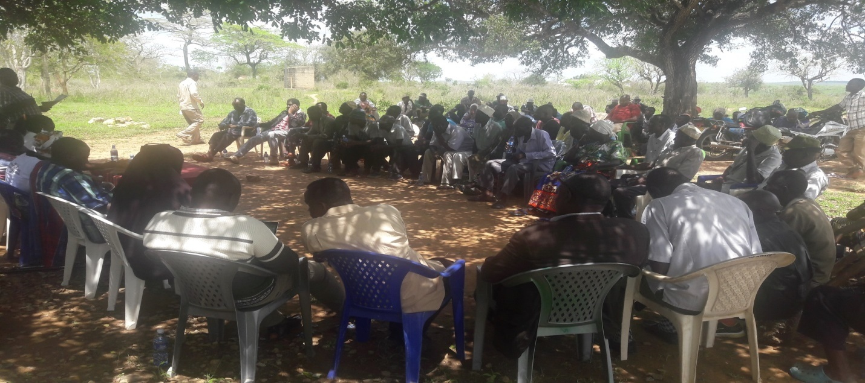Members of the public participating during the forum

SAMBURU WARD
Kinango Constituency Development Fund (CDF) Project Proposals Consultative Forum for Samburu Ward Held at Ndohivyo Primary School (8:00am) and at Chengoni Chief’s Office (2:00pm) respectively on October8th, 2019
Attendance – Guests
- Suleiman Mundu – Chief (Samburu Location)
- Lalo Lugwe - . Chief (ChengoniLocation)
- Rashid BavuKurera– Chairman CDF Committee (Men Rep – Ndavaya Ward Member)
- Beatrice Mbeyu – Secretary CDF Committee (Youth Rep &Kinango Ward Member)
- Amina Bulle – CDFC (Mackinnon Road Ward Member)
- MgandiMnyika – CDFC (Samburu Ward)
- NgomeChitaphi – NG-CDF Rep (Kasemeni Ward Member)
- Kimani Lemna – CDFC (Constituency Office Rep – Puma Ward Member)
- Rebecca Mwaka – CDFC (Persons with Disabilities Rep)
- Beatrice Tembe – Fund Manager
- Henry Mwandary – Clerk of Works (Kinango CDF Office)
Projects Proposed
Security
- Construction of toilets at Chief’s office – Chengoni
- Assistant Chief’s Office-MajiyaChumvi
- Assistant Chief’s Office- Silaloni
- Police Station at Samburu
- Police post at Majiyachumvi
- Boundary issue at majiyachumvi to be addressed
- StreetsLights Samburu – Kinango road
- Rural electrification
- Completion of Kinagoni Police Station
- Silaloni Police post staff quarters

Education
- Samburu primary school - classrooms, desks, fence
- Samburu secondary school - classrooms, dormitory, lockers
- Gora Primary School - school gate, fence
- Mwangea primary School - classrooms, desks, fence
- Mtulu Primary School - classrooms, desks, fence
- Bofu Primary School - classrooms
- Kinagoni primary School- renovation of 5no. classroom
- Mwangaza Primary School – classrooms, desks
- Mwangoloto primary School - classrooms
- Ng’onzini North Primary School – access road to school, classrooms, desks
- Marondo primary School – 2no. classroom
- Mwandoni Primary School
- Ndohivyo Primary School - classrooms, renovation of 4no. classroom
- Kituoni Primary School – 2no. classroom
- Mafufuni Primary School - school fence, desks, classrooms
- Construction of a Dormitory at Kinagoni Secondary School
- MajiyaChumvi Primary – desks
- Mwarophesa Secondary School: fence
- Kanjaocha Primary School:desks
- Chengoni Primary School:classrooms,desks
- Chanzou Primary School:desks
- Mdomo Primary School – classrooms, desks
- Kazamoyo Primary School:desks
- ShauriMoyo Primary School:desks
- Staff House at Kamale Youth Polytechnic and fencing
- Proposed construction of a university in Samburu
- Bursary funds disbursement schedule should be changed
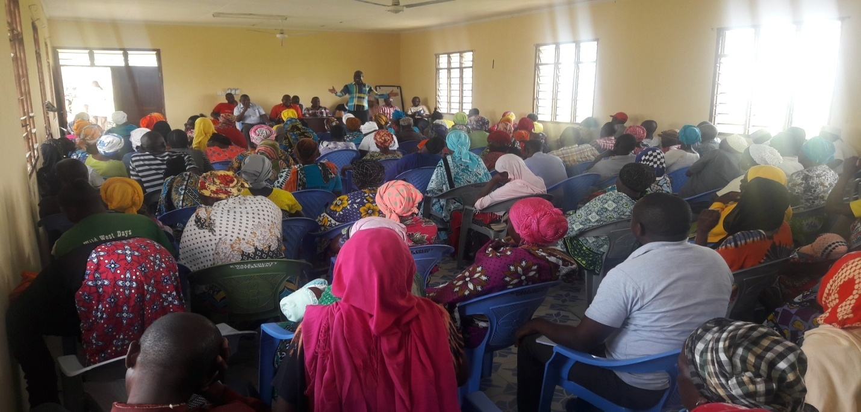
members of the public during the motions
MWAVUMBO WARD
Kinango Constituency Development Fund (CDF) Project Proposals Consultative Forum for Mwavumbo Ward Held at Mavirivirini Primary School (8:00am) and at Kalalani Chief’s Office (2:00pm) respectively on October9th, 2019
Attendance – Guests
- Samson Chale – Chief (Mwatate Location)
- Ndoro Benson - Ag. Chief (Kalalani Location)
- Rashid BavuKurera– Chairman CDF Committee (Men Rep – Ndavaya Ward Member)
- Beatrice Mbeyu – Secretary CDF Committee (Youth Rep &Kinango Ward Member)
- Amina Bulle – CDFC (Mackinnon Road Ward Member)
- MgandiMnyika – CDFC (Samburu Ward)
- NgomeChitaphi – NG-CDF Rep (Kasemeni Ward Member)
- Kimani Lemna – CDFC (Constituency Office Rep – Puma Ward Member)
- Rebecca Mwaka – CDFC (Persons with Disabilities Rep)
- Beatrice Tembe – Fund Manager
- Henry Mwandary – Clerk of Works (Kinango CDF Office)

Projects Proposed
Education
- Mubande Primary School: 8 classrooms
- Chidzipwa primary School: 2 classrooms,
- Lutsangani North primary School: administration block
- Vitsakaviri primary School: 2 classrooms
- Pemba pry Sch : classrooms, toilets, desks
- Kaluweni primary School: 5 classrooms
- Kafuduni Primary: 4 classrooms,50 desks
- Maweu Primary school: 2 classrooms
- Mavirivirini primary School: 2 Classrooms
- Mwashanga Primary School: 2 classrooms
- Mgandini primary School: 2 classrooms
- Dzombo Primary School: 4 classrooms, desks, administration block
- Kaphingo Primary School: 4 classrooms, 6 toilets, 50 desks
- Sega Primary School: 6 classrooms, 4 toilets, 50 desks
- Chigombero Primary School: 3 classrooms, 5 toilets, 50 desks
- Mlola Primary School: 4 classrooms,3 toilets, 50 desks
- Mwanda primary School: Renovation of 6 classrooms,50desks
- Gwasheni Primary School: classrooms
- Mwavumbo Secondary School: Kitchen, Dining hall
- Salim Mvurya Secondary School:Dormitory, laboratory, 4classroom, administration block
- MwabilaSeconndary School: Girls Dormitory, classrooms
- Bursary allocation should be increased
Security
- Completion of mavirivirini police station and handingover
- Construction of new Chiefs office at Mwatate
- Renovation of asst. chiefs office Kafuduni
- Construction of new Asst.Chiefs office at Matumbi
- Construction of a police post in Matumbi

Electricity
- Rural electrification
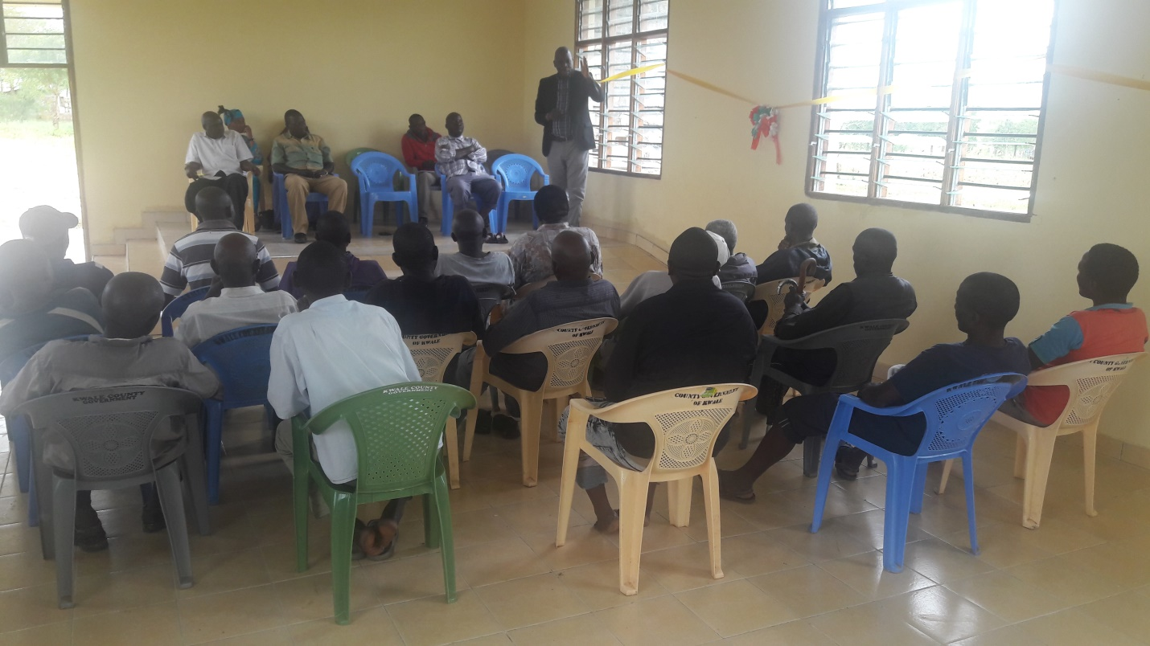
Chairman addressing issues to the public

KASEMENI WARD
Kinango Constituency Development Fund (CDF) Project Proposals Consultative Forum for Kasemeni Ward Held at Kasemeni Chief’s Office (8:00am) and at Mtaa Chief’s Office (2:00pm) respectively on October 10th , 2019
Attendance – Guests
- Benson Kokoi – Chief (Kasemeni Location)
- Joseph Nyae - Chief (Mtaa Location)
- Salim N Chikophe – Chief (Makamini Location)
- Rashid BavuKurera– Chairman CDF Committee (Men Rep – Ndavaya Ward Member)
- Beatrice Mbeyu – Secretary CDF Committee (Youth Rep &Kinango Ward Member)
- Amina Bulle – CDFC (Mackinnon Road Ward Member)
- TungwaMwamvua – Constituency Office Rep (Kasemeni Ward)
- MgandiMwakoga – Constituency Office Rep (Kasemeni Ward)
- MgandiMnyika – CDFC (Samburu Ward)
- NgomeChitaphi – NG-CDF Rep (Kasemeni Ward Member)
- Kimani Lemna – CDFC (Constituency Office Rep – Puma Ward Member)
- Rebecca Mwaka – CDFC (Persons with Disabilities Rep)
- Beatrice Tembe – Fund Manager
- Henry Mwandary – Clerk of Works (Kinango CDF Office)
Projects Proposed
Education
- Mtaa Secondary School: Administration Block, school bus, toilets, school fence, classrooms, Dormitory
- Chikwakwani primary School: classrooms, desks, toilets
- Boyani Primary School: classrooms, Toilets
- Mkulung’ombe Primary School: 4 classrooms, desks, toilets
- Mtaa primary School: Administration block, desks, renovation of classrooms
- Muungano primary school: completion of stalled cdf classrooms, toilets
- Mabesheni primary School: 4classrooms, toilets, Administration block
- Bofu Secondary school: Fencing, 2 classrooms, school bus, toilets
- Bofu Primary School: classrooms, desks, toilets
- Makuluni Primary School: 4 classrooms, toilets and desks
- GonaPrimary Schools: Renovation of 5no.Classrooms, desks
- Mkanyeni Primary School: 2 classrooms, fencing
- Proposed Day Secondary School at Miyani
- Mazeras Primary School: 2 Classrooms, desks, Fence
- Fulugani Primary School: desks
- Mazeras High School: to be upgraded to a national school
- Mazeras Girls Memorial Secondary School: Computer Laboratory, Dormitory, Twin staff House
- Mnyenzeni Primary School: classrooms, desks, toilets
- Chikuyu Primary School:classrooms, desks
- Vikolani Primary School: 4 classrooms, desks, toilets
- Miyani Primary School: 4 classrooms, desks, toilets,
- Miguneni Primary School: 2 classrooms, desks, toilets
- Mnyenzeni Secondary School: Girls Dormitory, Kitchen
- Proposed Mnyenzeni Boys Boarding School
- Majengo Primary School: desks, toilets,
- Proposed mixed day secondary School at Mazeras sub location
- Mwache Primary school: desks
- Chikomani Primary Sch: classrooms, desks,
- Bonje Primary School: 2 classroom, desks, toilets, school fence
- Bursary allocation for bodaboda riders

Security:
- Construction of Chief’s office- Kasemeni
- Construction of Assistant Chief’s office –Mabesheni
- Construction of Chief’s office- Mtaa and toilets
- Construction of a police post – Mnyenzeni
- Construction of staff quarters for bofu police post and toilets
- land demarcation and issue of title deeds
Tertiary Education/Institutions:
- technical institution to be constructed at Mazeras
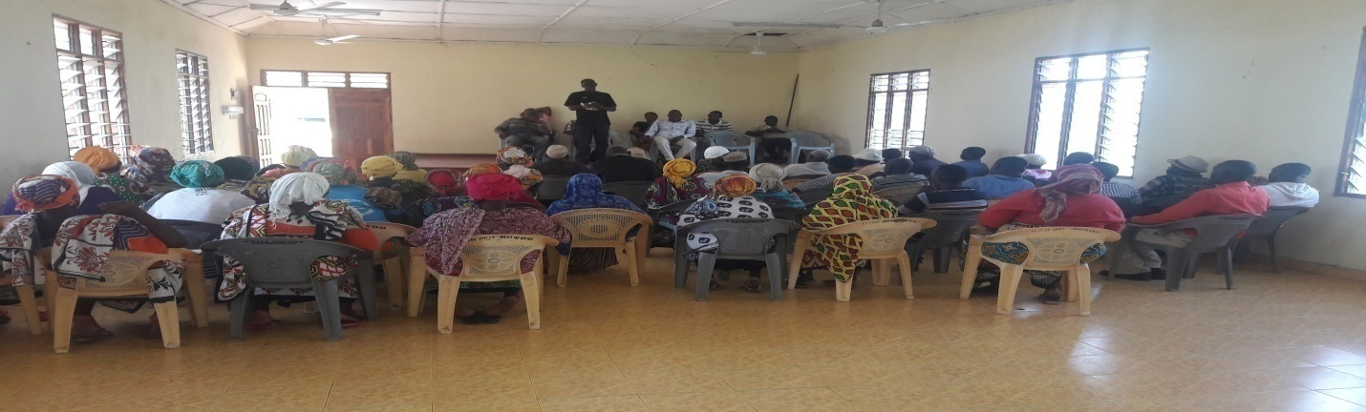

Chief addressing members of the public
PUMA WARD
Kinango Constituency (NG-CDF) Project Proposals Consultative Forum for Puma Ward Held at Vingurungani Chief’s Office (8:00am) and Bang’a Chief’s Office (2:00pm) respectively on October 11th, 2019
Attendance – Guests
1. Chikophe Mwanza – Ag.Chief (Vigurungani Location)
2. Saumkiroro- Ag. Chief (Puma Location)
3.RashidBavuKurera– Chairman CDF Committee (Men Rep – Ndavaya Ward Member)
4. Beatrice Mbeyu – Secretary CDF Committee (Youth Rep &Kinango Ward Member)
5. Amina Bulle – CDFC (Mackinnon Road Ward Member)
6. MgandiMnyika – CDFC (Samburu Ward)
7. NgomeChitaphi – NG-CDF Rep (Kasemeni Ward Member)
8. Kimani Lemna – CDFC (Constituency Office Rep – Puma Ward Member)
9. Rebecca Mwaka – CDFC (Persons with Disabilities Rep)
10. Beatrice Tembe – Fund Manager
11. Henry Mwandary – Clerk of Works (Kinango CDF Office)
Project Proposed
Education
- Magongoni Primary School -classrooms,desks
- Maendeleo Primary School -classrooms,desks
- Gangani Primary School - classrooms,desks
- Gozani Primary School-classrooms,desks
- Vigurungani Primary School:classrooms,desks
- Kisimani Primary School- classrooms,desks
- Dzimanya Primary School-classrooms,desks
- Rorogi Primary School-classrooms, desks
- Kideri Primary School – classrooms, desks
- Chidzaya Primary School – 2 classrooms, desks
- Nyango Primary School – 2classrooms, desks
- Karyaka Primary School – desks
- Kasageni Primary school – classrooms, Renovation of classrooms, desks
- Bang’a Secondary School- Laboratory, Dormitory, TSC teachers
- Malungoniprimary:classrooms,desks, Administration block
- Mazola Primary School:desks
- Chirima cha UhaPrimary:classrooms,desks
- Bishop Kalu Primary School: administration block,classrooms
- Mabamaniprimary:classrooms,desks
- Mbilini Primary School – classrooms, desks
- Tumaini Primary School:classrooms,desks
- Proposed construction of a secondary school in Dzimanya area
Security
- Construction of Police post at Kisimani / Mwamandi area
- Construction of Chief’s Office at Bang’a
- Construction of Chief’s Office at Vigurungani Centre
- Construction of Police post at Gangani / Gozani area
- Construction of Police post at Nyango
- Electricity installation of Vigurungani Police station
- Land cruiser for Vigurungani Police Station
- Construction of Chief’s Office at Busa

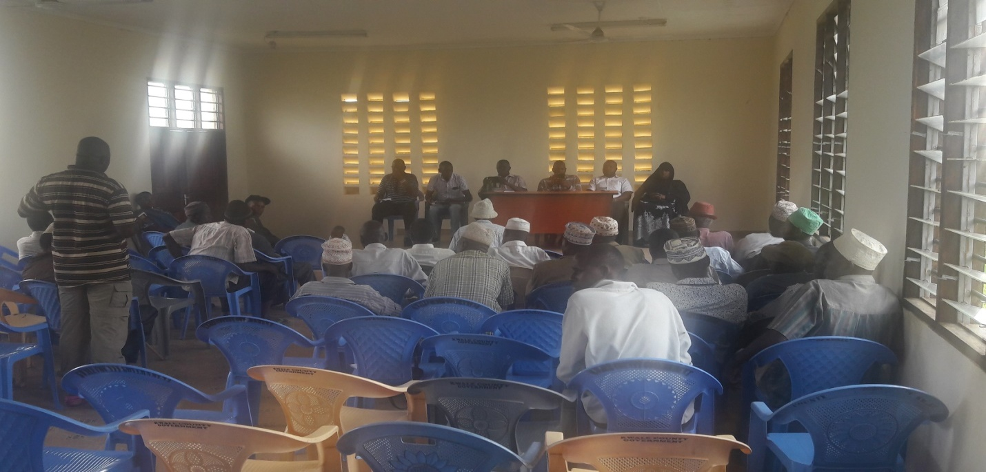
Members of the public contributing to the motion
NDAVAYA WARD
Kinango Constituency (NG-CDF) Project Proposals Consultative Forum for Ndavaya Ward Held at Ndavaya Chief’s Office (8:00am) and at Mwakijembe Primary School (2:00pm) respectively October, 12th, 2019
Attendance - Guests
- Stanley Langat – ACC (Ndavaya Location)
- Mkala Chai – Chief (Ndavaya Location)
- Rashid BavuKurera– Chairman CDF Committee (Men Rep – Ndavaya Ward Member)
- Beatrice Mbeyu – Secretary CDF Committee (Youth Rep &Kinango Ward Member)
- Amina Bulle – CDFC (Mackinnon Road Ward Member)
- MgandiMnyika – CDFC (Samburu Ward)
- NgomeChitaphi – NG-CDF Rep (Kasemeni Ward Member)
- Kimani Lemna – CDFC (Constituency Office Rep – Puma Ward Member)
- Rebecca Mwaka – CDFC (Persons with Disabilities Rep)
- Beatrice Tembe – Fund Manager
- Henry Mwandary – Clerk of Works (Kinango CDF Office)
Projects Proposed
Education
- Ndavaya Secondary School: school bus, fence
- Ndavaya Primary School: classrooms, renovation of classrooms, desks
- Mabanda primary School – classrooms, desks
- Tobora primary School - classrooms
- Bomani primary School - desks
- Gandini South primry school – classrooms, desks, toilets
- Ngauro primary School– toilets, desks, classrooms
- Bumani primary School – classrooms, desks, toilets
- Mwachanda primary School–classrooms, renovations
- Gulanze primary School - classrooms, desks
- Mwalukombe Sec School - dormitory, school fence
- Ziaradundo Primary School – classrooms, completion of cdf stalled project, desks
- Mbuluni Primary School - classrooms, desks
- Jitegemee Primary School – classrooms, desks
- Mwalukombe Primary School - classrooms, desks
- Proposed Gulanze Secondary School
- Proposed Vyogato Youth polytechnic
- Maphanga primary School
- Mafundani primary – 4no. classroom, desks
- Magodzoni Primary School - classrooms, desks
- Mbita Pry School - classrooms, desks
- Mbwaleni Pry School - classrooms, desks
- Mwakijembe Pry School - classrooms, school fence, desks
- Mwandimu Primary school - school fence, desks
- Mwakijembe Secondary School: 2 classrooms,dormitory
- Proposed Mwakijembe Youth Polytechnic

Security
- Construction of ACC staff Quarters at Ndavaya Divisional headquarters
- Construction of Asst. Chief’s Office –Mbwaleni
- Construction of Police Post –Mbwaleni
- Construction of Chief‘s offices at Mwakijembe
- Construction of Chief’s Office –Gulanze
- Construction of Chief’s Office -Mwandimu
- Construction of Chief’s Office -Kifyonzo

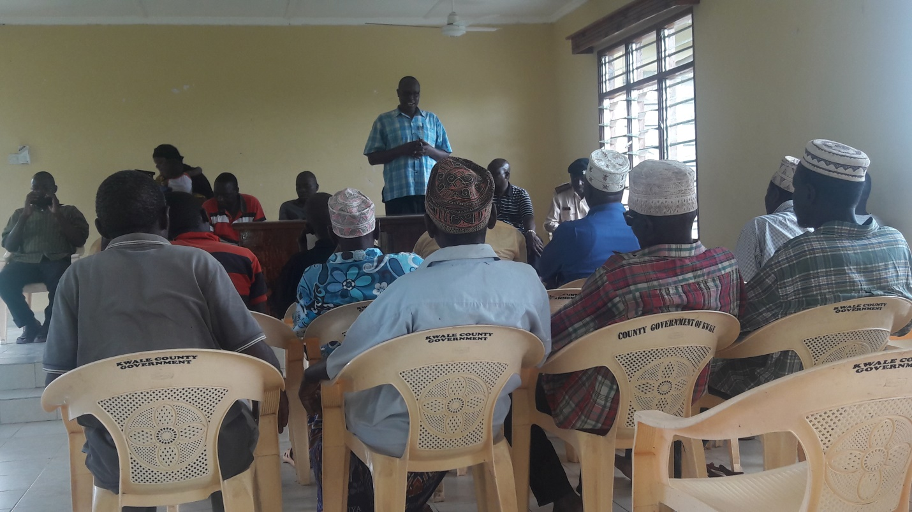
ACC addressing Members of the Public contributing to the motions.

KINANGO WARD
Kinango Constituency Development Fund (CDF) Project Proposals Consultative Forum for Kinango Ward Held at Lutsangani Chief’s Office (8:00am), Nzovuni Primary School (12:00noon) and at Moyeni Primary School (4:00pm) respectively on October13th, 2019
Attendance - Guests
- TsumaMrinzi - Chief (Kinangolocation)
- Haba Ali – Assistant Chief (Kibandaongo Sub-location)
- Rashid Bavu – Chairman CDF Committee (Men Rep – Ndavaya Ward Member)
- Beatrice Mbeyu – Secretary CDF Committee (Youth Rep &Kinango Ward Member)
- Lilian Nyanje – CDFC (Mwavumbo Ward Member)
- Amina Bulle – CDFC (Mackinnon Road Ward)
- NgomeChitaphi – CDFC (Kasemeni Ward Member Rep)
- MgandiMnyika– CDFC (Youth Rep – Samburu Ward Member)
- Kimani Lemna – CDFC (Puma Ward Member Rep)
- Rebecca Mwaka – CDFC (Persons with Disabilities Rep)
- Beatrice Tembe – Fund Manager
- Henry Mwandary – Clerk of Works (Kinango CDF Office)

Projects Proposed
EDUCATION
- Amani primary Schools – classrooms, desks, toilets
- Mbandi Primary School - classrooms, desks, toilets
- Gwadu primary School - desks
- Kinango primary School - toilets, desks
- Tsunza Secondary School: classrooms, lockers,
- Lutsangani Primary School:classrooms, toilets, desks
- Chizini Primary School:classrooms, desks
- Dzivani Primary School:classrooms,desks
- Tsunza Secondary School: classrooms, lockers,
- Lutsangani Primary School:classrooms, toilets, desks
- Chizini Primary School:classrooms, desks
- Dzivani Primary School:classrooms,desks
- Construction of Youth Polytechnic at Nzovuni Centre
- Sembe Primary School:classrooms and desks
- Nzovuni Primary School:classrooms,
- Mkilo Primary School:classrooms and desk
- Sagalato Primary School:classrooms and desks
- Bursary allocation should be twice in a year
- Dumbule Primary School: complete the stalled CDF building
- Kidogoweni Pry School- 3 classrooms
- Construction of a Boys Secondary School at Kidogoweni
- Construction of Youth Polytechnic at Moyeni Centre
- Moyeni Primary School: classrooms, school fence and renovation
- Ng’onzini Primary School: complete the stalled CDF building and new classrooms
- Moyeni Secondary School: Dormitory, toilets, dining hall and kitchen

Security
- Construct a police post in Moyeni Centre
- Assistant chief’s office in Kidogoweni area
- Chief’s office in Dumbule area
- Rural electrification of Dumbule sub – location
- Kibandaongo to be a location of its own
- Assistant chief’s office to be constructed near nzovuni secondary
- Police post to be constructed between Gandini location and nzovuni
- Chief’s office at kibandaongo
- Chief’s office and Assistant chiefs office at Gandini
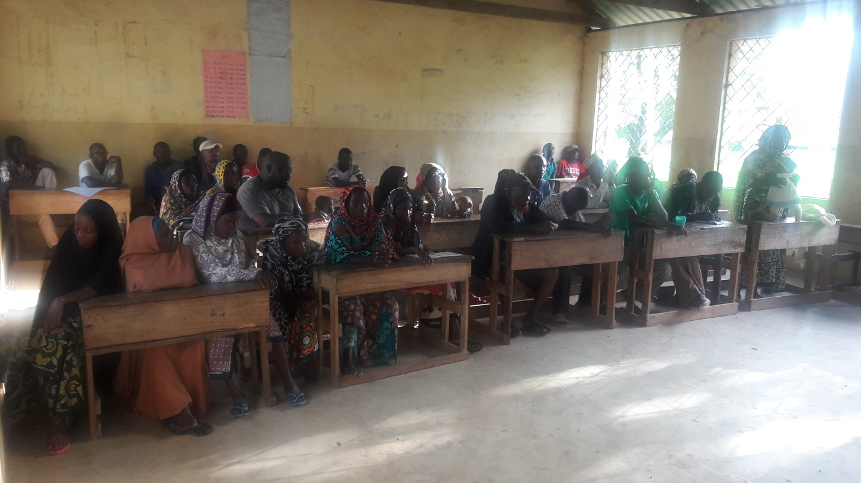
Members of the public contributing to the motions during the forum

Comments by Leaders
Leaders commented variouslytouching on a myriad of challenges but notable issues included;

- Poor education standards and inadequate skilled human resources
Poor education standards as a result of the following:
- Negative attitudes towards education by communities.
- Inadequate trained teachers
- Poor management of the schools
- Student truancy and drop-out
- Access to and quality of school infrastructure

- There’s generally very poor infrastructure for social and economic development in the constituency.
The poor infrastructure in the constituency emanate from the following:
- Poor Road Network
- Shortage of and unreliable electricity
- Unreliable Water Supply
- Poor Sanitation and Solid Waste Management

- Cross Cutting Issues
- HIV and AIDS
- Climate Change and Disasters
- Gender Equality and Youth Empowerment
- Vulnerable and excluded groups and communities
- Retrogressive cultural practices, traditions and beliefs

Way Forward
Ensure Intensive, extensive and inclusive Community Involvement and Participation in all issues facing the constituents
One of the main strategies that will be applied in the tackling of the many challenges identified includes ensuring extensive and active participation of the Community. While NG-CDFC has made efforts to engage the communities in identifying and prioritizing projects, efforts to ensure participation at every point of implementation will be ensured.

Collaboration with other development partners such as the County Government, NGOs, donors, investors, technocrats etc is another strategy of choice for application as well.
In recognition of the devolution of government to the County level,the important roles played by the donors, NGOs, investors, etc, and in response to the newNG-CDF Act 2015, that demands enhanced coordination of activities by all development stakeholders, the CDFC shall establish positive linkages and collaboration not only with County government but with all other stakeholders in matters of fighting poverty, illiteracy, diseases and uplifting of the living standards of the constituents.

Notable challenges and the way forward summarized as follows;
Summary Table
Issues | Tools for Improvement | Action Plan | Expectations
1. Education Sector | i. Primary Schools  ii. Secondary Schools  iii. Bursaries beneficiaries  iv. Tertiary Institutions  ➢ Youth Polytechnics  ➢ Kinango Technical University | • Infrastructure development &improvement of the existing ones  • Refurbishment of facilities  • Provision of Bursaries  • Provision of teachers/instructors | • Sustainability of projects  • Proper documentation& inventory control  • Good/Improved Performance in schools and colleges  • Maintenance of facilities and infrastructure
2. Natural Resources  (Environment) | Environment | • Conservation of the environment and reversal of degradation  • Control of charcoal burning and wanton destruction of environment | • Proper documentation  • Responsible utilization of natural resources  • Coordinated approach to protection of environment
4 Security Docket | (Administrative offices, Police Posts, police camps) | • Develop & construction Police posts  • Establish DO/Chiefs’ offices  • Support in equipping County Commissioners Offices | • Improved security of the area  • Care and protection of the facilities

Conclusion
We Believe in MAENDELEO KWANZA, so we remain committed to implementation as Envisaged.

Signed………………………………………… Date………………………………
Chairman CDF Committee

Signed………………………………………… Date………………………………
Fund Account Manager

Kinango National Government Constituency Development Fund
Project Proposal 2019/2020 Financial Year
Code-List
FINANCIAL YEAR...…20191ST JULY TO 30TH JUNE……2020
Project Name | Project Number | Original Cost | Cumulative Allocation | Project activity | Amount Allocated | Current Status
Employees Salaries | 4-002-010-2110000-100-2019/2020-001 | 2,587,200.00 | 0.00 | Payment of staff salaries and gratuity | 2,587,200.00 | New
Goods and Services | 4-002-010-2210000-100-2019/2020-002 | 2,500,000.00 | 0.00 | Purchase of fuel, repairs and maintenance, printing, stationery, telephone, travel and subsistence, office tea | 2,500,000.00 | New
NSSF | 4-002-010-2120101-100-2019/2020-003 | 492,800.00 | 0.00 | Payment of NSSF Deductions | 492,800.00 | New
NHIF | 4-002-010-2120201-100-2019/2020-004 | 60,000.00 | 0.00 | Payment of NHIF Deductions | 60,000.00 | New
Committee Expenses | 4-002-010-2210802-100-2019/2020-005 | 2,602,063.45 | 0.00 | Payment of Committee sitting allowances, transport, conferences | 2,602,063.45 | New
Committee Expenses | 4-002-010-2210802-111-2019/2020-001 | 2,500,000.00 | 0.00 | Payment of Committee sitting allowances, transport, conferences | 2,500,000.00 | New
CDFC, PMC & Staff Capacity Building | 4-002-010-2210700-111-2019/2020-002 | 1,621,031.72 | 0.00 | Undertake Training of the PMCs, CDFCs and Office Staff on CDF Related issues | 1,621,031.72 | New
Emergency | 4-002-010-2640200-101-2019/2020-001 | 7,198,241.38 | 0.00 | To cater for any unforeseen occurrences in the constituency during the financial year | 7,198,241.38 | New
Secondary Schools Bursary | 4-002-010-2640101-103-2019/2020-001 | 17,026,387.59 | 0.00 | Cater for bright and needy students in secondary schools | 17,026,387.59 | New
Tertiary Institutions Bursary | 4-002-010-2640102-103-2019/2020-002 | 18,000,000.00 | 0.00 | Cater for bright and needy students in tertiary institutions | 18,000,000.00 | New
Mazola Primary School | 4-002-010-2630204-104-2019/2020-001 | 2,600,000.00 | 0.00 | Construction of 2no. classroom to completion | 2,600,000.00 | New
Chizini Primary School | 4-002-010-2630204-104-2019/2020-002 | 2,600,000.00 | 0.00 | Construction of 2no. classroom to completion | 2,600,000.00 | New
Ng'onzini Primary School | 4-002-010-2630204-104-2019/2020-003 | 2,600,000.00 | 0.00 | Construction of 2no. classroom to completion | 2,600,000.00 | New
Dzivwani Primary School | 4-002-010-2630204-104-2019/2020-004 | 2,600,000.00 | 0.00 | Construction of 2no. classroom to completion | 2,600,000.00 | New
Mwashanga Primary School | 4-002-010-2630204-104-2019/2020-005 | 2,600,000.00 | 0.00 | Construction of 2no. classroom to completion | 2,600,000.00 | New
Dzombo Primary School | 4-002-010-2630204-104-2019/2020-006 | 2,600,000.00 | 0.00 | Construction of 2no. classroom to completion | 2,600,000.00 | New
Kafuduni Primary School | 4-002-010-2630204-104-2019/2020-007 | 2,600,000.00 | 0.00 | Construction of 2no. classroom to completion | 2,600,000.00 | New
Mgandini Primary School | 4-002-010-2630204-104-2019/2020-008 | 2,600,000.00 | 0.00 | Construction of 2no. classroom to completion | 2,600,000.00 | New
Miyani Primary School | 4-002-010-2630204-104-2019/2020-009 | 2,600,000.00 | 0.00 | Construction of 2no. classroom to completion | 2,600,000.00 | New
Mbwaleni Primary School | 4-002-010-2630204-104-2019/2020-010 | 2,600,000.00 | 0.00 | Construction of 2no. classroom to completion | 2,600,000.00 | New
Mbita Primary School | 4-002-010-2630204-104-2019/2020-011 | 2,600,000.00 | 0.00 | Construction of 2no. classroom to completion | 2,600,000.00 | New
Mwangea Primary School | 4-002-010-2630204-104-2019/2020-012 | 2,600,000.00 | 0.00 | Construction of 2no. classroom to completion | 2,600,000.00 | New
Kituoni Primary School | 4-002-010-2630204-104-2019/2020-013 | 2,600,000.00 | 0.00 | Construction of 2no. classroom to completion | 2,600,000.00 | New
Taru Primary School | 4-002-010-2630204-104-2019/2020-014 | 2,600,000.00 | 0.00 | Construction of 2no. classroom to completion | 2,600,000.00 | New
Busho Primary School | 4-002-010-2630204-104-2019/2020-015 | 2,600,000.00 | 0.00 | Construction of 2no. classroom to completion | 2,600,000.00 | New
Kaluweni Primary School | 4/002/010/2630204/2019/2020/016 | 2,600,000.00 | 0.00 | Construction of 2no. classroom to completion | 2,600,000.00 | New
Kasageni Primary School | 4/002/010/2630204/2019/2020/017 | 2,400,000.00 | 0.00 | Renovation of 4no. Classroom | 2,400,000.00 | New
Mwalukombe Primary School | 4/002/010/2630204/2019/2020/018 | 2,400,000.00 | 0.00 | Renovation of 4no. Classroom | 2,400,000.00 | New
Gona Primary School | 4/002/010/2630204/2019/2020/019 | 2,400,000.00 | 0.00 | Renovation of 4no. Classroom | 2,400,000.00 | New
Kituu Primary School | 4/002/010/2630204/2019/2020/020 | 1,200,000.00 | 0.00 | Renovation of Classroom | 1,200,000.00 | New
Mbandi Primary School | 4/002/010/2630204/2019/2020/021 | 400,000.00 | 0.00 | Additional cost of construction of 3no classroom | 400,000.00 | On-going
Bishop Kalu Primary School | 4/002/010/2630204/2019/2020/022 | 1,000,000.00 | 0.00 | Construction of Admin block | 1,000,000.00 | On-going
Tumaini Primary School | 4/002/010/2630204/2019/2020/023 | 300,000.00 | 0.00 | Additional cost of construction of 3no classroom | 300,000.00 | On-going
Lutsangani Primary School | 4/002/010/2630204/2019/2020/024 | 200,000.00 | 0.00 | Additional cost of construction of 2no classroom | 200,000.00 | On-going
Mwache Primary School | 4/002/010/2630204/2019/2020/025 | 400,000.00 | 0.00 | Additional cost for renovation of 4no classroom | 400,000.00 | On-going
Primary Schools | 4/002/010/2630204/2019/2020/016 | 3,780,000.00 | 0.00 | Supply and delivery of 540 desks to schools | 3,780,000.00 | New
Vigurungani Secondary School | 4-002-010-2630205-104-2019/2020-001 | 1,600,000.00 | 0.00 | Renovation of Science Lab | 1,600,000.00 | New
Ndavaya Secondary School | 4-002-010-2630205-104-2019/2020-002 | 5,000,000.00 | 0.00 | Additional Cost for Purchase of School Bus | 5,000,000.00 | New
Makamini Secondary School | 4-002-010-2630205-104-2019/2020-003 | 4,000,000.00 | 0.00 | Construction of Staff Twin House | 4,000,000.00 | New
Tsunza Secondary School | 4-002-010-2630205-104-2019/2020-004 | 100,000.00 | 0.00 | Completion of 2no classroom | 100,000.00 | On-going
Mwavumbo Secondary School | 4-002-010-2630205-104-2019/2020-005 | 1,000,000.00 | 0.00 | Construction of Kitchen Block | 1,000,000.00 | New
NG-CDF Office | 4-002-010-3110701-104-2019/2020-001 | 1,600,000.00 | 0.00 | Renovation of the Offices | 1,600,000.00 | New
Mavirivirini Police Post | 4-002-010-2640507-108-2019-2020-001 | 400,000.00 | 0.00 | Completion of the office | 400,000.00 | New
Kinango Sub-County Education | 4-002-010-2640507-108-2019-2020-002 | 9,000,000.00 | 0.00 | Construction of Education Office Complex | 9,000,000.00 | New
Kinango Constituency Sports Activities | 4-002-010-2640509-112-2019/2020-001 | 2,100,000.00 | 0.00 | Carry out Constituency sports tournaments and purchase of trophies, sports kits and balls | 2,100,000.00 | New
Mazola Primary School | 4-002-010/2640510-108-2019/2020-001 | 100,000.00 | 0.00 | Purchase of tree seedlings and Planting of trees | 100,000.00 | New
Chizini Primary School | 4-002-010/2640510-108-2019/2020-002 | 100,000.00 | 0.00 | Purchase of tree seedlings and Planting of trees | 100,000.00 | New
Ng'onzini Primary School | 4-002-010-2640510-108-2019/2020-003 | 100,000.00 | 0.00 | Purchase of tree seedlings and Planting of trees | 100,000.00 | New
Dzivwani Primary School | 4-002-010-2640510-108-2019/2020-004 | 100,000.00 | 0.00 | Purchase of tree seedlings and Planting of trees | 100,000.00 | New
Mwashanga Primary School | 4-002-010-2640510-108-2019/2020-005 | 100,000.00 | 0.00 | Purchase of tree seedlings and Planting of trees | 100,000.00 | New
Dzombo Primary School | 4-002-010-2640510-108-2019/2020-006 | 100,000.00 | 0.00 | Purchase of tree seedlings and Planting of trees | 100,000.00 | New
Kafuduni Primary School | 4-002-010-2640510-108-2019/2020-007 | 100,000.00 | 0.00 | Purchase of tree seedlings and Planting of trees | 100,000.00 | New
Mgandini Primary School | 4-002-010-2640510-108-2019/2020-008 | 100,000.00 | 0.00 | Purchase of tree seedlings and Planting of trees | 100,000.00 | New
Miyani Primary School | 4-002-010-2640510-108-2019/2020-009 | 100,000.00 | 0.00 | Purchase of tree seedlings and Planting of trees | 100,000.00 | New
Mbwaleni Primary School | 4-002-010-2640510-108-2019/2020-010 | 100,000.00 | 0.00 | Purchase of tree seedlings and Planting of trees | 100,000.00 | New
Mbita Primary School | 4-002-010-2640510-108-2019/2020-011 | 100,000.00 | 0.00 | Purchase of tree seedlings and Planting of trees | 100,000.00 | New
Mwache Primary School | 4-002-010-2640510-108-2019/2020-012 | 100,000.00 | 0.00 | Purchase of tree seedlings and Planting of trees | 100,000.00 | New
Kituoni Primary School | 4-002-010-2640510-108-2019/2020-013 | 100,000.00 | 0.00 | Purchase of tree seedlings and Planting of trees | 100,000.00 | New
Taru Primary School | 4-002-010-2640510-108-2019/2020-014 | 100,000.00 | 0.00 | Purchase of tree seedlings and Planting of trees | 100,000.00 | New
Busho Primary School | 4-002-010-2640510-108-2019/2020-015 | 100,000.00 | 0.00 | Purchase of tree seedlings and Planting of trees | 100,000.00 | New
Kaluweni Primary School | 4-002-010-2640510-108-2019/2020-016 | 100,000.00 | 0.00 | Purchase of tree seedlings and Planting of trees | 100,000.00 | New
Kasageni Primary School | 4-002-010-2640510-108-2019/2020-017 | 100,000.00 | 0.00 | Purchase of tree seedlings and Planting of trees | 100,000.00 | New
Mwalukombe Primary School | 4-002-010-2640510-108-2019/2020-018 | 100,000.00 | 0.00 | Purchase of tree seedlings and Planting of trees | 100,000.00 | New
Gona Primary School | 4-002-010-2640510-108-2019/2020-019 | 100,000.00 | 0.00 | Purchase of tree seedlings and Planting of trees | 100,000.00 | New
Total |  | 137,367,724.14 |  |  | 137,367,724.1

