IEBC NUMBER 019
GALOLE CONSTITUENCY
NATIONAL GOVERNMENT CONSTITUENCY DEVELOPMENT FUND

PROJECT PROPOSAL

2019/2020 FINANCIAL YEAR

SUBMITTED ON

22nd October, 2019

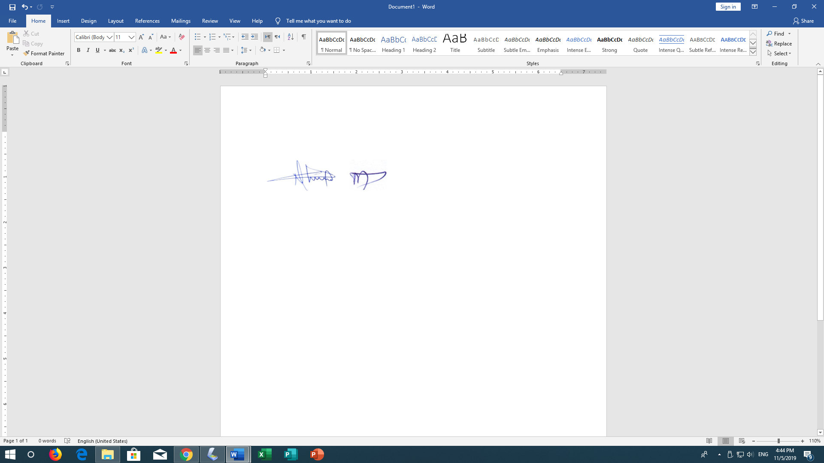

NATIONAL GOVERMENT CONSTITUENCY DEVELOPMENT FUND
GALOLE CONSTITUENCY P.O.BOX 129-70101
HOLA, KENYA
TEL: +254720020647
GALOLE NG-CDF EMAIL: galolecdf@cdf.go.ke
22ndOctober, 2019
TO: The Chief Executive Officer
National Government Constituencies Development Fund Board
P.O.BOX 46682-00100
Nairobi.

Dear Sir,

RE: SUBMISSION OF PROJECT PROPOSAL FY 2019/2020.
Attached please the project proposal for Galole National Government Constituency Development Fund for financial year 2019/2020.
Thanks in advance hoping for a positive consideration.

Yours Faithfully.

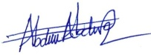
HUSSEIN M. ABDULLAHI
FUND ACCOUNT MANAGER
GALOLE NG-CDF
MINUTES OF THE MEETINGS OF GALOLE NATIONAL GOVERNMENT CONSTITUENCY DEVELOPMENT FUND COMMITTEE HELD ON 11th OCTOBER, 2019 AT CDF OFFICE HOLA AT 10.00 AM.
MEMBERS PRESENT:
- Godhana Nathan Oddo Chairman
- Hussein M. Abdullahi Fund Account Manager
- Idris Tuna Shambaro Member
- Maryam Mohamud Member
- HabhiboRahmaSalat Member
- Ali KomoraMakorani Member
- Ubah MohamedGudow Member
- Ali Mohamed Kuso Member

AGENDA:
- Chairman’s Opening Remarks.
- Reading and confirmation of the previous minutes
- Approval project proposal for financial year 2019/2020.
- AOB.
MIN CDFC.01/10/2019.CHAIRMAN’S OPENING REMARKS.
The chairman welcomed the members and thanked them for attending the meeting and being punctual. He led the opening prayer and the meeting started at 10.30am. He thanked the MP for having time to attend the meeting being a very vital one.

MIN CDFC.02/10/2019. READING AND CONFIRMATION OF THE PREVIOUS MINUTES
The secretary read the minutes of the previous meeting and they were confirmed to be a true deliberation of the day. The minutes were proposed by Ubah Mohamed and seconded by Habibo salat
MIN CDFC.003/10/2019. APPROVAL PROJECT PROPOSAL FOR FINANCIAL YEAR 2019/2020.
The members were informed that this financial year our constituency was allocated Ksh137,367,724.14 was an increased compared with last financial year where we were allocated Ksh109,040,875.52 this. Members agreed that all the ongoing projects must be given first priority as expected. The report of the community needs assessment carried out for this financial year was tabled for discussion. Members discussed the report and after a lengthy deliberation the following projects were approved for funding in during the financial year 2019/2020
PROJECT NAME | ACTIVITY | AMOUNT ALLOCATED | Status
ADMINISTRATION & RECURRENT EXPENDITURE
Employees’ Salaries | Payment of staff salaries and gratuity | 2,640,000.00 | Ongoing
Goods and Services | Purchase of fuel, repairs and maintenance, printing, stationery, telephone, travel and subsistence, office tea. | 4,271,960.45 | Ongoing
NSSF | Payment of NSSF Deductions | 38,400.00 | Ongoing
Committee Expenses | Payment of Committee sitting allowances, transport, conferences | 1,291,703.00 | Ongoing
Monitoring & Evaluation/Capacity Building
Goods And Services | Purchase of fuel, repairs and maintenance, printing, stationery, telephone, travel and subsistence, office tea. | 2,121,031.72 | Ongoing
Committee Expenses | Payment of Committee sitting allowances, transport, conferences | 1,000,000.00 | Ongoing
NG-CDFC/PMC Capacity Building | Undertake Training of the PMCs/NG-CDFCs/Staff on NG-CDF Related issues | 1,000,000.00 | Ongoing
Emergency | To cater for any unforeseen occurrences in the constituency during the financial year | 7,198,241.38 | Ongoing
Bursary
Bursary Secondary School | Payment of bursary to needy students in colleges and universities. | 40,000,000.00 | Ongoing
Bursary Tertiary School | Payment of bursary to needy students in colleges and universities. | 8,000,000.00 | Ongoing
Sports Activities | Carry out Constituency Sports tournament and the winning teams to be awarded with trophies, balls, and games kits | 2,676,387.59 | Ongoing
Environmental Activities
Kone primary school | Construction of 4 doors pit latrine block to completion | 1,500,000.00 | New
Hola treasury office | Construction of 2 doors pit latrine block to completion | 750,000.00 | New
Galole NG-CDF Office | Construction of 20m3 underground water tank | 450,000.00 | New
Primary School Projects
Hola Primary School | Completion of social Hall: Roofing, doors, floors, wall painting. | 3,600,000.00 | Ongoing
Nyangwani primary School | Completion of two classrooms (roofing, celling, doors, windows, floors) | 1,000,000.00 | Ongoing
Bultomulito Primary School | Completion of two classrooms (roofing, celling, doors, windows, floors. | 700,000.00 | Ongoing
Daku Primary School | Completion of administration block (roofing, celling, doors, windows, floors. | 1,200,000.00 | Ongoing
Majengo Primary School | Construction of Administration block | 1,600,000.00 | Ongoing
Gafuru Primary School | Construction of administration Block to completion | 3,000,000.00 | New
Gafuru Primary School | Construction of two doors of pit latrine block to completion | 700,000.00 | New
Bondeni Primary School | Completion of administration block (roofing, celling, doors, windows, floors. | 630,000.00 | Ongoing
Mikinduni Primary School | Renovation of 8 classrooms: Roofs, doors, floors, wall painting | 4,400,000.00 | New
Hola primary School | Renovation of 4 classrooms: Roofs, doors, floors, wall painting | 2,500,000.00 | New
Baksano Primary School | Renovation of 3 classrooms: Roofs, doors, floors, wall painting | 800,000.00 | New
Makere Primary School | Renovation of 8 classrooms: Roofing, doors, floors, wall painting | 4,400,000.00 | New
Kilindini Primary School | Renovation of 6 classrooms: Roofing, doors, floors, wall painting | 3,600,000.00 | New
Handampia Primary School | Renovation of 6 classrooms: Roofs, doors, floors, wall painting | 3,500,000.00 | New
Kirakungu Primary School | Renovation of 3 classrooms: Roofs, doors, floors, wall painting | 1,800,000.00 | New
Bula Sec Primary School | Construction of 2 classrooms | 2,300,000.00 | New
Ongola Primary School | Completion of 2 Classrooms Roofing, doors, Floor, Windows | 400,000.00 | Ongoing
Vukoni Primary School | Construction of 2 classrooms | 2,400,000.00 | New
Kiarukungu Primary School | Construction of 2 classrooms | 2,600,000.00 | New
Kalalani Primary School | Renovation of 3 classrooms: Roofs, doors, floors, wall painting | 1,800,000.00 | New
Jarirot Primary School | Renovation of 4 classrooms: Roofs, doors, floors, wall painting | 2,700,000.00 | New
Chewani Sec School | Construction of 2classrooms | 2,800,000.00 | New
Chanani Sec School | Construction of 2classrooms | 2,800,000.00 | New
Rafiki Sec School | Construction of 2classrooms | 2,800,000.00 | New
Daku Secondary School | Construction of 3 Self-contained Staff houses | 2,300,000.00 | New
Security projects
Hola County Commander | Purchase of Office furniture for 8 offices (see annex 1) Include in this box | 2,500,000.00 | Ongoing
Hola AP camp | Construction of two door pit latrine | 600,000.00 | New
Wenje Police Camp | Fencing of police camp – digging trench with razor wire of 30 acres land (Phase 1) | 1,700,000 | Ongoing
Others
NG-CDFC Office | Purchase of office furniture; 20 board room chairs, 1 table, 2 fire proof cabinets Kshs. 600,000.00 and interior design ksh.2,300,000.00 for boardroom, chairman and Fund Account Manager’s offices | 2,900,000.00 | New
NG-CDFC Office | Installation of 8 channels CCTV remote access system for area of 1-hectare compound. | 400,000.00 | New

ANNEX 1
LIST OF FURNITURE GALOLE COUNTY COMMANDER OFFICES
No. | DESCRIPTION | QTY
1. | OFFICE TABLE EXECUTIVE 1.6 M | 3 PCS
2. | OFFICE CHAIR HB | 3 NO.
3. | OFFICE SOFA SET 5 PAX | 2 SET
4. | SAFIRE | 1 PC
5. | VISITORS CHAIR(F57) | 2 PCS
6. | OFFICE TABLE 1.8 MTS | 1 SET
7. | OFFICE CHAIR HB | 1 PC
8. | STEEL FILLING CABINATE 4DRW | 7 PCS
9. | SECRETARIAL CHAIR WITH ARMS | 6 PCS
10. | LINK CHAIRS 2PAX/TAB | 2 PCS
11. | VISITORS CHAIR PU | 20 PCS
12. | OFFICE TABLE 1.2 MTS | 7 PCS
13. | VISITORS CHAIR WITH ARM | 2 PCS
14. | LINK CHAIRS 3 PAX | 6 PCS
15. | AIR CONDITIONER | 3 PCS
16. | RED FLOOR MAT | 100 MTS
17. | COFFEE TABLE | 2 NOS
18. | DISPENSER | 4 NO.
19. | TRAY THREE IN ONE TABLE | 5 NO.
20. | OFFICE CURTAINS | 60 MTS
21. | GAS COOKER | 1 NO.
22. | KETTLE | 1 NO.
23. | THERMOS | 2 NO.
24. | GLASSES | 2 DOZ
25. | CUPS | 2 DOZ
26. | SUFURIAS | 1 SET
27. | SERVING TRAYS | 3 NO.
Members requested the fund account manager to prepare the submission documents soonest possible since we were already late for submission
MIN CDFC.004/10/2019: A.O.B
There being no other business the meeting ended at 1.30PM with a word of prayer led by Barakatu Guyo

Minutes Taken By: - Confirmed By: -

Maryan Mohamud Nathan Oddo
CDFC Secretary Chairman

