**WUNDANYI**

**IEBC NUMBER 024**

**NATIONAL GOVERNMENT CONSTITUENCY DEVELOPMENT FUND**

**WARD REPORT**

**2019/2020 FINANCIAL YEAR**

**SUBMITTED**

**OCTOBER 2019**



**INTRODUCTION**

The National Government Constituencies Development Fund (NG-CDF) formerly Constituencies Development Fund (CDF), is a fund established in 2003 through an Act of Parliament, the CDF Act 2003. The Act was later reviewed by the CDF (Amendment) Act 2007, and repealed by CDF Act, 2013 which was subsequently succeeded by the current NG-CDF (Amendment) Act 2016.

The Fund is domiciled within the ministry in charge of national economic policy and planning, currently the Ministry of Devolution and Planning. The main purpose of the Fund is to enhance infrastructural and socio-economic development at the grass root level in order to reduce poverty by dedicating a minimum of two and half per cent (2.5%) of all National Government’s share of annual revenue towards community projects identified at constituency level by the communities.

The fund is managed by National Government Constituencies Development Fund Board (NG-CDF Board) established under Section 14(1) of the National Government Constituencies Development Fund (NG-CDF)Act, 2015. The NG-CDF Board is the organ responsible for the overall management of the Fund at the National level. It ensures that administration of the fund is done efficiently and effectively.

NGCDF Committee is established under section 43(1) of the National Government Constituencies Development Fund Act, 2015. The Committee is mandated to administer the fund at the constituency level. Key responsibilities are to identify projects, allocate funds to projects, and disburse the funds to project implementation committee, monitor the implementation of the fund and report to the NGCDF board.

**Wundanyi Constituency** is an electoral constituency in Kenya. It is one of four constituencies in Taita-Taveta County. The constituency has four wards i.e. Wundanyi /Mbale ward, Mghange/Mwanda ward, Werugha ward and Kishushe/Wumingu ward.

The Constituency is located in the Taita Hills of southern Kenya, about 20 km west of Voi town. It is also the administrative centre for Taita-Taveta County. The constituency has an approximate area of square kilometers 701.20 and a population of 56,021 (1999 census). Wundanyi is the centre of an agricultural area and the surrounding slopes are highly terraced.

The Constituency is a popular base for hiking, while local attractions include the Nagged Forest, known for its butterflies, Wesu Rock and the Cave of Skulls. Shoot Hill, across the valley from Wundanyi was the formal place of execution for the Taita.

**PROJECTS**

In the last financial year (2018/2019) the NG- CDF allocation was Ksh. 108,940,875.52. The funding was distributed to education, environment and security sectors among others. The following is the summary of completed and ongoing projects.

1. **Number/Allocation Of Ongoing Projects 2018/2019 Financial Year**

|  |  |  |  |  |
| --- | --- | --- | --- | --- |
| **Sector** | **Ward** | **Number of ongoing projects** | **Cost** | **Remarks** |
| Education | 4 | 18 | 42,300,000.00 | Projects have delayed due to late disbursement of funds |
| Security | 3 | 1 | 11,500,000.00 | Projects have delayed due to late disbursement of funds |
| Environment | 4 | 4 | 1,980,817.51 | Projects have delayed due to late disbursement of funds |
| Halls | 1 | 1 | 112,000.00 | Projects have delayed due to late disbursement of funds. |

Since the funds were not disbursed on time to the constituency account, 90% of the projects funded were not complete.

**REPORT ON WARD MEETING**

The meetings were done in every location in the Constituency and the documents used during the ward meetings can be traced in the CDFC file reference No Wundanyi/ward report 01/2019

**WUNDANYI/ MBALE WARD**

In this ward the meetings were held in the two locations (Wundanyi and Mbale Location)

**Wundanyi Location** meeting was held on 1stOctober, 2019 at the Wundanyi County council (CC) Hall.

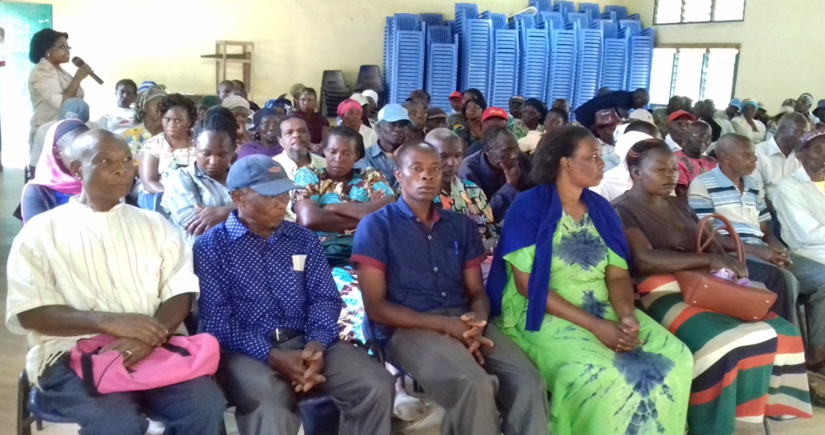

**The meeting started at 1030hrs. There was a prayer from Mrs. Dorcus Mwabili**

**IN ATTENDANCE**

1. Area M.P Hon. Danson Mwashako
2. Deputy County Commissioner
3. CDFC Members
4. Area Chief
5. Assistant chiefs
6. Wundanyi Location Community

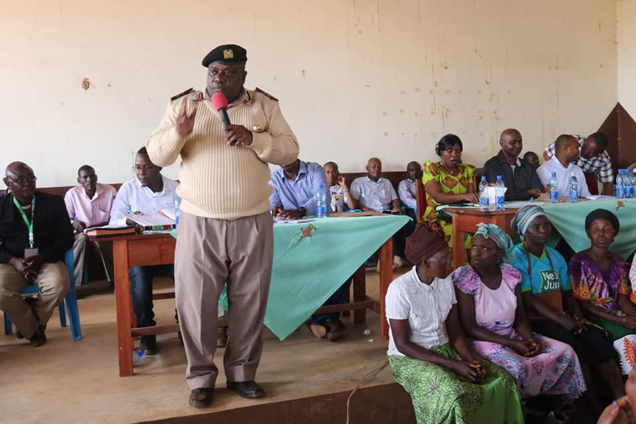

**Meeting at Mbale Location which was held on 1st October, 2019**

**CHAIRMAN’S REMARK**

The chairman welcomed all for the meeting, introduced the team of CDFCs. He thanked the area chief and assistant Chief for the support they are giving in the implementation of the NG-CDF projects in the area.

The chairman urged the community to play the oversight role on projects being implemented within their area and report to the relevant offices incase of anomalies.

He also advised the PMCs to shun corruption and see that projects are implemented to completion within the stipulated time.

**Manager’s Remarks**

FAM thanked the Public for honouring the call for the meeting. He noted that Section 27 (1) of the NG-CDF Act 2015 as amended in 2016 requires that the chairperson of the Constituency Committee shall within the first year of the commencement of new Parliament and atleast every two years thereafter, convene open forum public meetings in every ward in the constituency to deliberate on development matters.

The FAM explained on eligible and ineligible projects under the Act. He also sighted section 49 of the NG-CDF Act where part funding is allowed other than the fund. He also noted as per section 46 (2) of the Act priority will be given to ongoing projects. He informed the public the Projects to propose should be related to Education, Security, Environment and Sports.

**Area Member of Parliament**

He thanked the community for electing him and promised to work together with other elected leader in delivering the development agenda of Wundanyi Constituency. The Member of Parliament told the communities benefiting from the projects to be vigil and provide social audit on those project. He however asked the project management Committees to provide returns once the project is complete and be accountable to each and every coin funded to the project. He vowed to complete all projects he initiated and asked the CDFCs to proper monitoring and evaluation of the projects and to adhere to procurement procedures.

The Patron cautioned the County Government executive of taking over projects once funded by NG-CDF without proper handing over. He termed it illegal asked the County Government to follow the right procedures while taking over project that had initially been funded by NG-CDF.

**Projects identified**

The community through the area chief proposed the following projects numbered in order of priority.

**Wundanyi Location**

1. Kiwinda Secondary School - construction of a Girls’ Dormitory
2. Nguraru Primary School- Construction Of 2 Classrooms

**Environment Projects**

1. Tree planting on Nyambu and MbauroPri School

The Community also requested for Assistant Chief’s office at Masumbenyi area. They also requested for water harvesting in every school.

**Mbale Ward**

1. Ngilinyi Primary School –renovation of classrooms
2. PJ Mwangola Secondary School - Completion of phase two of a girls dormitory block
3. Fighinyi Primary School –construction of a toilet

Also the pastor proposed that there is need for library in the location, building of teachers quarters, installation of electricity and water supply to schools.

The following projects were proposed on **Security.**

* Police Post in Wanganga

The following projects were proposed on **Environment.**

* Tree planting on Choke,Ngilinyi and Maynard primary school

**Challenges**

* The ward has poor schools infrastructure and shortage of classrooms due to condemned buildings.
* The area also has poor terrain leading to bad roads and also heavy rains causing landslides and cutting roads.

**Way Forward**

* There is need to invest more on educational infrastructure so as to improve the level of education in the ward/constituency.
* 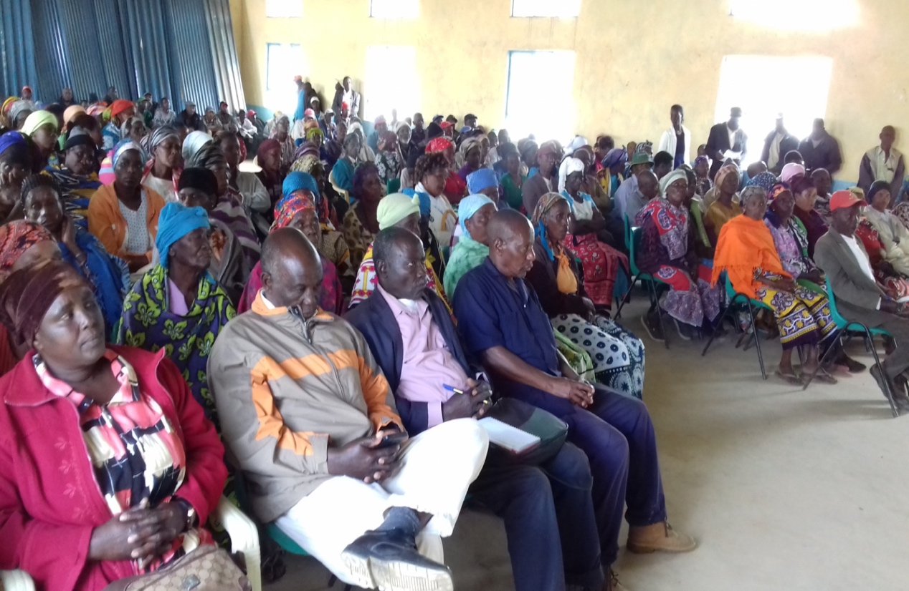There is also need to conserve water by building reservoir tanks within the ward.

**MWANDA /MGANGE WARD**

In this ward the meetings were held in the two locations (Mghange location and Mwanda location)

**MWANDA LOCATION**

The meeting was held at Mwanda location in MwandaMgange ward on 2ndOctober, 2019 at Mwanda community hall.

**MGANGE LOCATION**

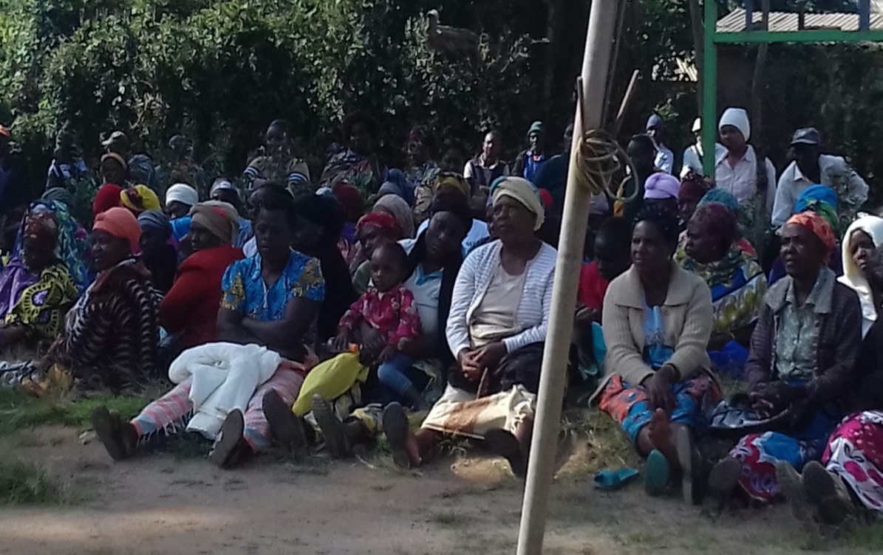

The meeting at Mgange location in Mwanda/Mgange ward on 2nd October, 2019 at the Chief’s Office.

In both meetings the following were present;

**In Attendance**

1. Area M.P Hon. Danson Mwashako
2. Deputy County Commissioner –Mr. David Kiprop
3. Fund Account Manager
4. CDFC Members
5. Area Chief
6. Assistant chiefs
7. Mwanda/Mghange Community

**FUND ACCOUNT MANAGER REMARKS**

The FAM started by introducing the NG-CDF Committee. The FAM explained the following National Government functions which are eligible for funding:

* Education
* Security
* Environment
* Sports

He also informed the members present on projects which have benefited from the fund in the previous financial year and are complete

On bursary he advised head teachers to give details of students who may pass their exams and could not proceed to the secondary schools for assistance by the CDF bursary fund. Members of the community were also advised on the same and the poor orphaned students names should be forwarded to NG- CDF office Wundanyi. He thanked the communities for being vigil and responsible in checking out their projects.

**Chairman’s Remarks**

The Chairman thanked the chiefs, community, PMCs, and the patron for the support they have had during the initiating of projects, implementation and monitoring of the projects. They urged the communities to play an oversight role in project implementation and project conclusion. Community should own the project and feel it’s their own.

He also advised the PMCs to shun corruption on projects and make sure projects are completed in the stipulated amount of time.

**Deputy County Commissioner’s Remarks**

Impressed with the community turn out for the meeting. He urged the community to be vigilant and report on security cases within their area. He acknowledged several complaints sent to his office on monkeys destroying food crops in the farm and assured the community he will bring the KWS officers to the ground to discuss on the same.

He urged the community to propose security projects to be funded by NG-CDF to improve security in their area.

**Area Member of Parliament**

The Member of Parliament thanked the community electing him to represent them in Parliament and for the support they have given to NG- CDF. He urged the community to take charge of all project being undertaken within their area to avoid double funding. He asked the PMC to account for all funds once the project is over.

He vowed to complete all projects he initiated within his tenure and also asked the CDFCs to do proper monitoring and evaluation of the projects

**Projects identified**

The community through the area chief proposed the following projects numbered in order of priority.

**Mwanda Location**

1. Marungu Pri School-Construction of classrooms
2. Mlamba Primary School - Renovation of classrooms

**Environment**

* Plants and local trees should be planted on St john’s and NdumbinyiPrimarySchool
* Rainwater harvesting at DalmasMokaSec School.

**MGANGE LOCATION**

1. Mwakiwiwi Secondary School –Dormitory
2. St. Mary High School-Lushangonyi.-Construction of 2 classrooms

**PROPOSAL GIVEN IN PART OF SECURITY**

The Community also requested for Transformer, Public Toilet, ball and Playing Garments, reduction of Eucalyptus, fencing of Mbangang’ombe water Project andCommunity topossess Vuria hill.

The FAM Thanked the Public for coming out in Large numbers to propose the public projects. The meeting ended at 1740Hrs from a word of Prayer from Mr. Austine

**Challenges**

* The ward has poor schools infrastructure and shortage of classroom due to condemned buildings.
* The area also has poor terrain leading to bad roads.
* Some of areas are dry and receive little or no rains for some times.

**Way Forward**

* There is need to construct new permanent classroom buildings in that ward
* Water projects were a priority but unfortunately the ministry is devolved.
* The projects begun some of which are devolved we all complete them as it’s a protocol of CDF act.
* The drier areas to have projects proposals that are viable to them like water tanks and construction of dams for collecting rain water.

**WERUGHA WARD**

The meeting was held at Werugha Multipurpose hall on 3rd October, 2019.

**In Attendance**

1. Area Member of Parliament Hon. Danson Mwashako
2. CDFC Members
3. Area chief
4. Assistant chiefs
5. Community of Werugha Ward

**Area Chief**

The area chief gave his opening remarks by welcoming the area M.P the CDFC members for visiting his area of work. He also thanked the M.P for working hand in hand with him. He urged the CDFC members to take into consideration the projects that the community will propose. He asked the PMCs to own their projects and involve the community members while implementing the projects.

**CDFC Chairperson**

The chairperson introduced the CDFC members and the Fund Account Manager. She thanked community for supporting the CDF projects being implemented in the community. The chairperson insisted on equality of gender while selecting members of project management committee. He urged them to check on the tenure of PMCs to elect new members once their tenure is over.

She also urged the community to give preference to ongoing projects and projects that are in the sectors of National Government.

**Fund Account Manager**

The manager asked the community members to own their projects and implement them fully and not leave the responsibility to the PMCs only. He also urged the PMCs to follow the rightful procurement procedures as provided for by the Procurement Act.

The FAM also asked the Youths and women in the area to register as groups to benefit from Uwezo Fund. He also asked them to apply for tenders reserved for youth women and persons with disability.

He highlighted that projects within devolved ministries are the responsibility of County Government. The FAM told the community that CDF does not fund individual projects, political and religious bodies but fund projects that are community based.

**Member of Parliament**

The MP thanked the community for attending the meeting he told the community to prioritize education in order to enhance the professional levels of the community. He asked members to come up with projects that are beneficial to the community and not a few individuals. Projects within the devolved ministries are the responsibility of the County Government to avoid duplication of projects.

He sighted that all projects started within his tenure shall be completed and the community should stop politicizing on the same. Werugha Multipurpose hall was sighted as one of the projects should be completed in the next financial year.

**Projects Identified**

1. Mwakishimba Primary –Construction of 2 classrooms.
2. Shimbo Secondary School – Construction of a Dormitory.

**Environment Projects**

* Tree planting on Sangenyi and NguluKiweto primary school

**Challenges**

* Politics in projects that bring delay in implementation
* The area terrain makes the cost of project to escalate
* The illiteracy level of the community is high thus while managing projects they do not understand government procedures.

**Way Forward**

* Continuous capacity building is required
* Civic education is needed

**WUMINGU/ KISHUSHE WARD**

The meeting was conducted at Wumingu location on 4thin the month of October 2019 at the Chief’s office.

**In Attendance**

1. Area Member of Parliament Hon. Danson Mwashako
2. CDFC Members
3. Area chief
4. Assistant chiefs
5. Community of Werugha ward

The meeting started at 1525hrs with a prayer from Pastor Malowa.

All village heads, Assistant Chiefs introduced themselves in the meeting. All principals from various schools were recognised.

**Chairman Remarks**

The Chairman thanked the chiefs, community, PMCs, and the patron for the support they have had during the initiating of projects, implementation and monitoring of the projects. They urged the communities to play an oversight role in project implementation and project conclusion. Community should own the project and feel it’s their own.

He also advised the PMCs to shun corruption on projects and make sure projects are completed in the stipulated amount of time.

**Fund Account Manager Remarks**

The manager asked the PMCs to be vigilant on whom they are dealing with that is the contractor supplier and they should get information from the office before beginning of the construction.

He also told them about the pre-qualification list of contractors and suppliers and members should apply so as not to be locked out. She also confirmed to the community the women, youth and people with disability will be given priority in supplies and contracts.

He reiterated that projects in the sectors that are devolved is the responsibility of the County Government. The manager explained projects should not be of personal award or beneficial to a certain group or a religion sect.

On bursary she advised head teachers and members of the community that they have the responsibility of forwarding the names of needy students to benefit on the bursary. She thanked the communities for being vigil and responsible in checking out their projects.

**Member of Parliament Remarks**

The MP thanked the public for voting him. He announced that there will be an office at Kishushe Location. He reminded the public that the politics position is over and it’s time to focus on Development

**PROJECTS IDENTIFIED**

**Wumingu Location**

1. Mghambonyi High School –Completion of a laboratory
2. Wumingu administration complex and public utility halls – Office for the Chief and Assistant Chief’s offices and public utility halls.

**Environment**

* Rainwater harvesting at Mghambonyi secondary school
* Rain water harvesting at Ngolia Primary school
* Tree planting at Kitumbi High school, Wumingu Primary School, Mchungunyi Primary School, Mwanyalo Pri School.
* Fencing water catchment areas

**Kishushe Location**

1. Mkanyatta Primary school – Construction of classrooms ,toilets and teachers office.

**Environment Projects**

* Tree planting at Kishushe primary school, Ngongondinyi Primary Sch., Shagha Primary Sch.,
* Rainwater harvesting at Mkanyata primary school

**Challenges**

The community suggested the major challenges was infrastructure of the schools within the the ward. They sited lack of laboratory in their secondary school affected the quality of education in the area. They also highlighted that most secondary school have few TSC Teachers and urged the Member of Parliament to intervene on their behalf to the ministry of education.

The other challenge was inadequate water in the lower region of Kishushe Location. They requested if Coast Water Authority can give their area a priority when piping water to other areas.

Road accessibility especially during the rainy season in Wumingu posed a major challenge especially in transportation of materials to site due to the terrain of Wumingu Location. They requested if CDF can consider that during allocations of projects within the area.

**Way Forward**

The area MP and NG-CDF affirmed to the community they will take into consideration the challenges highlighted that are within their mandate.

**Conclusion**

Time frame of projects should be taken in consideration. There continuous needed of PMC training on implementation of NG-CDF projects. CDF should prioritize projects in the National Government ministries to avoid duplication of projects

.

**______________________________ ____________________________**

**Signed (Chairman) Date**

**______________________________ ____________________________**

**Signed (Fund Account Manager) Date**

**______________________________ ____________________________**

**Signed (Sub-County Commissioner) Date**