PROPOSED DADAAB SECONDARY SCHOOL PERIMETER WALL (MASONRY WALL)

SECTION NO. 3 EXTERNAL WORKS
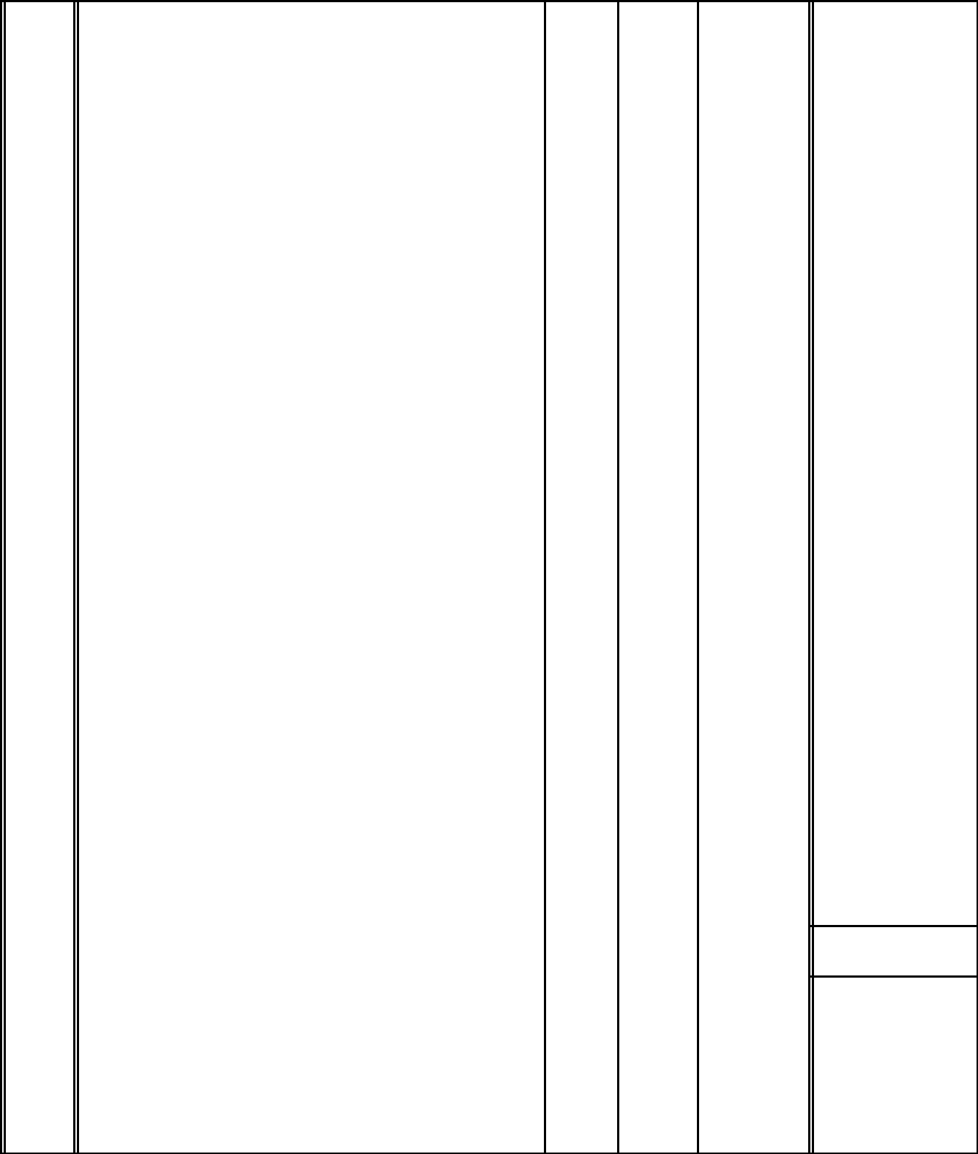
ITEM | UNITQTY | RATE KSHS. | CTS.

SECTION NO. 3

1.0 BOUNDARY WALLING

Site clearance

- Heavy bush clearing including vegetations,shrubs e.t.c and

 | burn the arising |  | S.M | 1200 | 30.00 | 36,000.00
B. | Excavate for stripe foundation not exceeding 1.50 m deep. |  | C.M | 720 | 200.00 | 144,000.00
C. | Excavate pit for columns base not exceeding 1.50 m deep. |  | C.M | 120 | 200.00 | 24,000.00
D. | Extra over for excavation in rock at any level. |  | C.M | 120 | 1,200.00 | 144,000.00
E. | Allow for necessary planking and struting. |  | ITEM | 1 | 5,000.00 | 5,000.00
F. | Keep excavations free from all water. |  | ITEM | 1 | 5,000.00 | 5,000.00
 | Concrete work
G. | Concrete class 1:3:6 in strip foundation. |  | S.M | 720 | 400.00 | 288,000.00
H. | Ditto in column bases. |  | S.M | 120 | 400.00 | 48,000.00
I. | Concrte class 1:2:4 in strip foundations. |  | C.M | 144 | 10,000.00 | 1,440,000.00
J. | Ditto in column bases. |  | C.M | 120 | 10,000.00 | 1,200,000.00
K. | Ditto in columns. |  | C.M | 66 | 10,000.00 | 660,000.00

- Extra over columns for forming 25 mm recess 1,600 mm

long in concrete. | NO. | 22 | 500.00 | 11,000.00

C/F. 4,005,000.00

3/1/2

SECTION NO. 3 EXTERNAL WORKS

ITEM |  |  | UNIT | QTY | RATE KSHS. | CTS.
 |  |  |  |  | B/F. | 4,005,000.00
 | Sawn timber formwork as described to :-
A. | Sides of strip foundation. |  | S.M | 480 | 400.00 | 192,000.00
B. | Sides of columns. |  | S.M | 1100 | 400.00 | 440,000.00
C. | Sides of bases. |  | S.M | 480 | 400.00 | 192,000.00
 | Reinforcement

- All reinforcement bars in assorted sizes to B.S. 4461 as

before. | KG. | 30000 | 150.00 | 4,500,000.00

Walling

Load bearing natural stones from approved sources
minimum crushing strength 10N/mm² built to courses

in cement/sand (1:3) mortar as described in :-

E. | 200 mm Thick machine dressed grey stone walling. | S.M | 3300 | 1,400.00 | 4,620,000.00

Construction/expansion joints

- 20 mm Thick "flexcell" or other equal and approved

expansion/ construction joint as before. | S.M | 26 | 450.00 | 11,700.00

- 20 x 30 mm Thick mastic asphalt or other equal and

approved joint sealer as before. | L.M | 79 | 2,000.00 | 158,000.00

Precast concrete class 25/20 including formwork and

finished fair on all exposed surfaces as described in :-

- 300 x 50 mm Coping twice weathered and throated with a nosing over 200 mm walling jointed in cement/sand (1:3)

 | mortar. | L.M | 1200 | 650.00 | 780,000.00
I. | 500 x 400 x 75 mm Trapered column coping ditto. | NO. | 400 | 450.00 | 180,000.00

C/F. 15,078,700.00

3/2/2

SECTION NO. 3 EXTERNAL WORKS
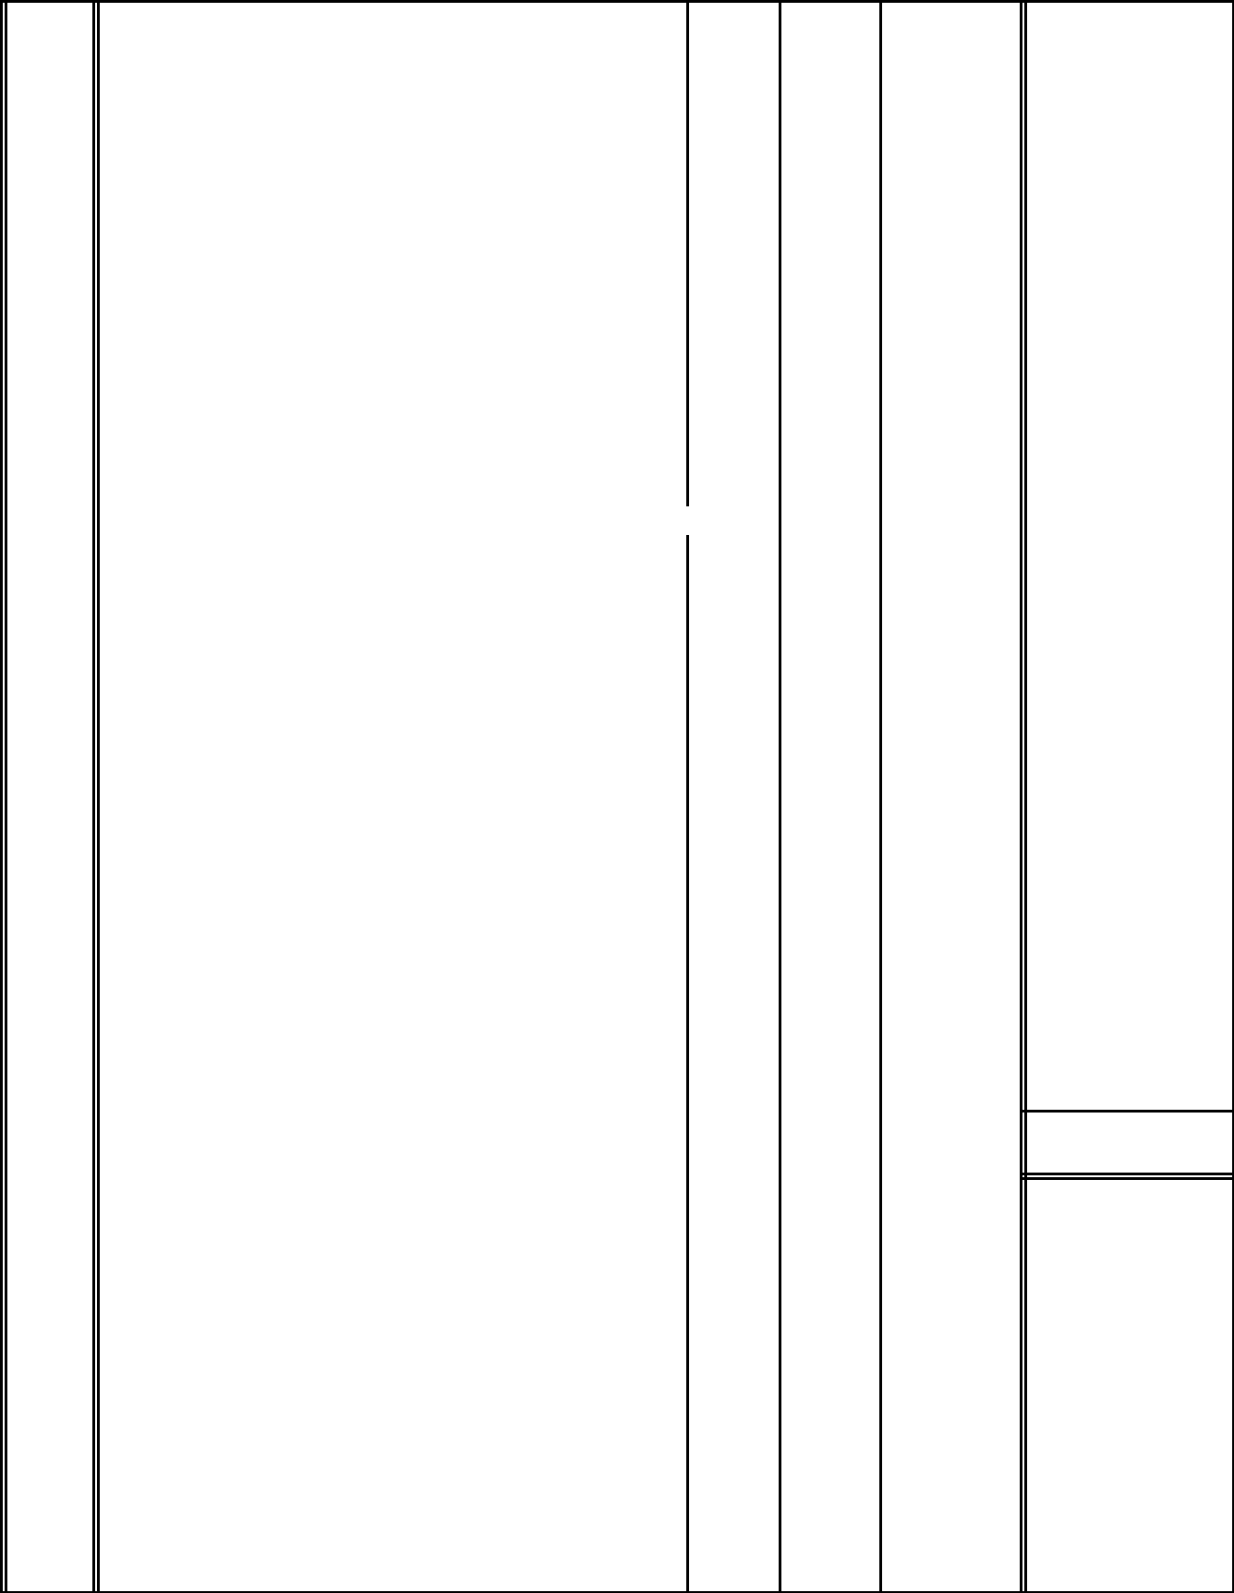
ITEM |  |  |  |  |  | UNIT | QTY | RATE KSHS. |  | CTS.
 |  |  |  |  |  |  |  | B/F. | 15,078,700.00
 | Finishes
 | Two coats cement/sand (1:3) plaster as described to :-
A. | Concrete/masonry surfaces. |  |  |  |  | S.M | 3300 | 250.00 |  | 825,000.00
B. | Extra over walling for horizontal recessed keys including
 | pointing in cement/sand (1:3) mortar 12 mm wide. |  |  |  |  | S.M | 3300 | 250.00 |  | 825,000.00
 | Mild Steel Gates

- Supply and fix a pair of ornamental gate size 6000 x 2400mm high consisting of 50mm galvanised frame with 25 x 25 x 3mm squaer hollow sections welded to frame both ways and

mesh fabric welded to frame and S.H.S sections and including 16 x 200mm long hasp and staples welded to inside of gate;fixed to reinforced concrete columns 400 x 300

 | x 3000mm high with and including excavations of columns;
 | including priming with any other ironmongery. | N.O. | 1 | 200,000.00 | 200,000.00
D. | Single pedestrian gate overall size 1000 x 2400mm high
 | with pressed metal plate at the bottom size 1000 x 600mm
 | high ditto. | N.O. | 2 | 50,000.00 | 100,000.00

TOTAL CARRIED TO SUMMARY OF
SECTION NO. 3 | KSHS. | 17,028,700.00

3/2/2

SECTION NO. 5 EXTERNAL WORKS

KSHS. CTS.

SECTION NO. 3

EXTERNAL WORKS

SUMMARY

ELEMENT NO. PAGE NO.

1.0 BOUNDARY WALLING | : | 3/1/3 | 17,028,700.00

TOTAL CARRIED TO GENERAL SUMMARY | KSHS. | 17,028,700.00

3/2/2

SECTION NO. 4 P. C. AND PROVISIONAL SUMS
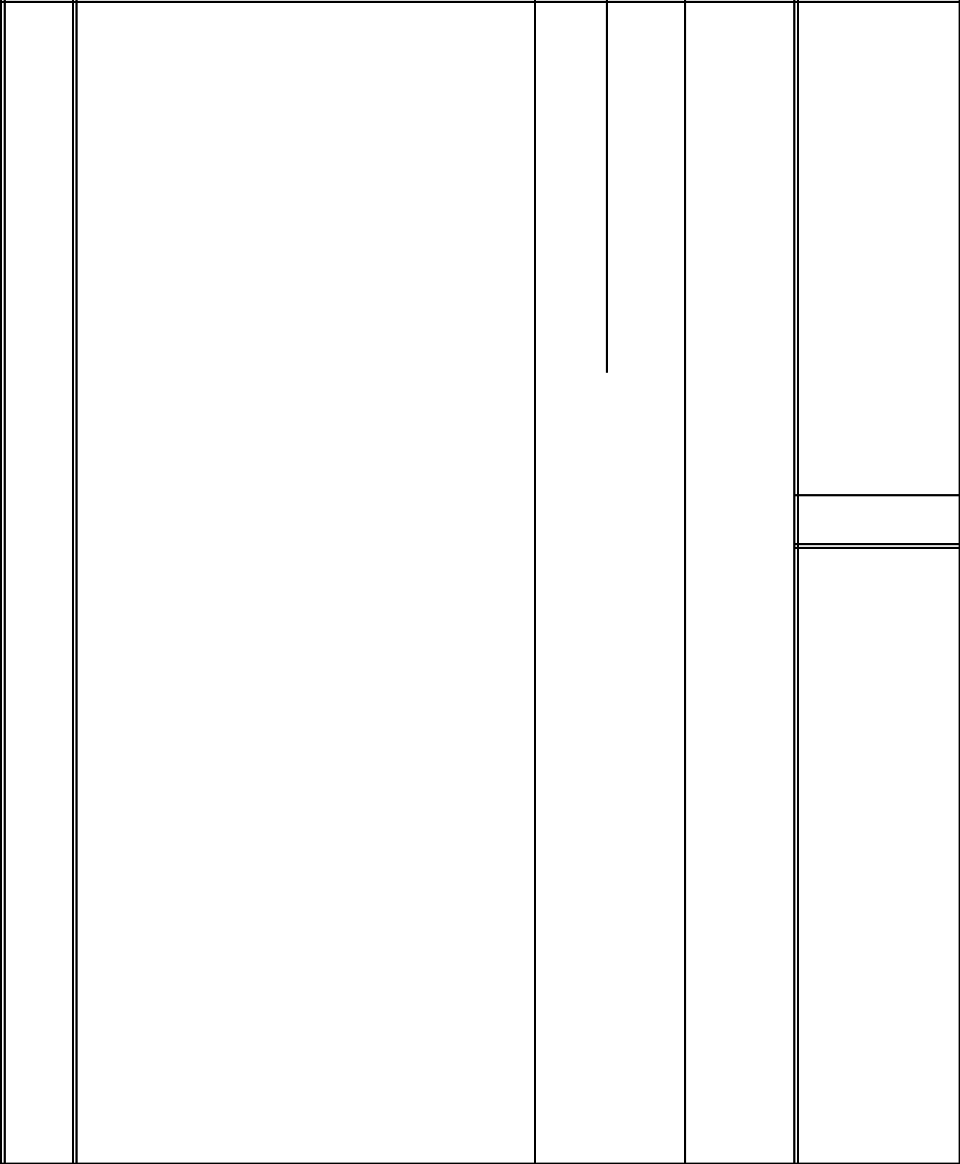

ITEM

A.

B.

UNITQTY | RATE KSHS. | CTS.

SECTION NO. 4

P. C. AND PROVISIONAL SUMS

Allow a provisional sum of Kshs. 500,000.00 for
project management. | ITEM | 500,000.00 | 500,000.00
Allow a provisional sum of Kshs. 200,000.00 for
contingencies to be expended under the discretion of the
project manager. | ITEM | 200,000.00 | 200,000.00

TOTAL CARRIED TO GENERAL SUMMARY |  | KSHS. | 700,000.00

3/S

GENERAL SUMMARY


KSHS. CTS.

GENERAL SUMMARY

SECTION NO.

1. PRELIMINARIES & CONDITIONS OF CONTRACT. | 100,000.00

- GENERAL PREAMBLES & SPECIFICATIONS OF WORKMANSHIP & MATERIALS.

3. | EXTERNAL WORKS |  | 17,028,700.00
4. | P. C. AND PROVISIONAL SUMS |  | 700,000.00
 | TOTAL |  | 17,828,700.00
 | ADD 16% V.A.T |  | 2,852,592.00
 | TOTAL CARRIED TO FORM OF TENDER
 | TOTAL CARRIED TO FORM OF TENDER | KSHS. | 20,681,292.00

Signed for and on behalf of:- |  |  |  |  | Signed for and on behalf of:-
 | (EMPLOYER) |  |  |  |  |  | (CONTRACTOR)
…………………….…………………………… |  |  |  |  | …….…………………………………….
……………………………….…………………. |  |  |  |  | …….…………………………………….
ADDRESS:- ………………………….…………ADDRESS:- ……….…………………..
…………………………………………….……… |  |  |  |  | ……….………………………………….

DATE:- ……………………….…………………. DATE:- …….………………………….

DESIGNATION:- …………….…………………. DESIGNATION:- …….……………….

…………………………….……………………….. …….…………………………………….

G/S

