**MWINGI WEST**

**IEBC NUMBER 068**

**NATIONAL GOVERNMENTCONSTITUENCY DEVELOPMENT FUND**

**WARD REPORT**

**2022/2023 FINANCIAL YEAR**

**SUBMITTED**

**13THJANUARY 2023**

1. **Background**
   1. **About NG-CDF**

The constituencies Development Fund was created by the Constituencies Development Fund Act, 2003 with the primary objective of addressing poverty at grassroots level by dedicating a minimum of 2.5% of the Government ordinary revenue to grassroots development and the reduction of poverty. The fund is managed by the Constituencies Development Fund Board (CDFB).

In January 2013, the CDF Act 2003(as amended in 2007) was repealed and replaced with CDF Act 2013 that is aligned to constitution of Kenya 2010. The enactment of the CDF Act 2013 was mainly aimed to ensure that the law governing CDF is aligned to the Constitution of Kenya 2010, specifically in compliance with the principles of.

* Transparency and accountability
* Separation of power and
* Participation of the people
* The new law was also aimed to align the operations of the Fund to the new devolved government structure.
  1. **About Mwingi West**

Mwingi west Constituency is an electoral constituency in Kenya. It is one of the eight constituencies in Kitui County. The constituency was established for the 2013 elections.

**Members of National Assembly**

|  |  |  |
| --- | --- | --- |
| **Elections** | **MP** | **Party** |
| 2013 | Hon. Bernard M. Kitungi | WDM-K |
| 2017 | Hon. Charles N. Nguna | WDM-K |

**Wards**

|  |  |
| --- | --- |
| **Ward** | **Population** |
| Migwani | 28,265 |
| Kyome/Thaana-Nzau | 28,137 |
| Nguutani | 27,267 |
| Kiomo/Kyethani | 27,914 |

1. Projects funding in the previous financial year.
   1. Sector analysis of complete and ongoing project.

Brief about projects funded and disbursement of funds.

1. **Number /Allocation of completed projects 2021/2022 financial year**

|  |  |  |  |  |  |  |  |
| --- | --- | --- | --- | --- | --- | --- | --- |
| **Sector** | **ward** | | | | **Number of completed projects** | **Cost**  **Kshs** | **Remarks** |
| Kyome/Thaana Nzau | Migwani | Nguutani | Kiomo/Kyethani |
| Education | 3,439,000 | 2,350,000 | 10,200,000 | 3,000,000 | 60 | 18,989,000 | In use |
| Security | 100,000 | 2,599,490 | 1,500,000 | 2,000,000 | 7 | 5,690,000 | In use |

1. **Number/Allocation of ongoing projects 2021/2022 financial year**

|  |  |  |  |  |  |  |  |
| --- | --- | --- | --- | --- | --- | --- | --- |
| **Sector** | **ward** | | | | **Number of un-completed projects** | **Cost**  **Kshs** | **Remarks** |
| Kyome/Thaana Nzau | Migwani | Nguutani | Kiomo/Kyethani |
| Education | 999,880 | 2,748,207 | 391,300 | 1,444,712 | 7 | 5,584,099 | On-going |
| Security | 1,299,715 | 0 | 0 | 0 | 1 | 1,299,715 | On-going |

1. **Amount of money used for bursaries, number of beneficiaries and criteria used for 2021/2022 financial year**

|  |  |  |  |
| --- | --- | --- | --- |
| **Ward** | **No. of beneficiaries** | **Amount allocated (Kshs)** | **Remarks and criteria** |
| Kyome/Thaana-Nzau | 2,330 | 10,850,000 | Members of public select needy students at the location meetings supervised by NG-CDFC members and village elders |
| Migwani | 2,317 | 12, 960,000 | Members of public select needy students at the location meetings supervised by NG-CDFC members and village elders |
| Nguutani | 2,238 | 10, 750,000 | Members of public select needy students at the location meetings supervised by NG-CDFC members and village elders |
| Kiomo/Kyethani | 1,940 | 8,980.000 | Members of public select needy students at the location meetings supervised by NG-CDFC members and village elders |

* 1. **Documentation of the ward reports**

The documents used during the ward meetings can be traced in the NG-CDFC file reference…Project Proposals 2022/2023.

* 1. **Ward Meetings**

Pursuant to the constitutional requirement of public participation in development activities, the NG-CDF Mwingi West invited members of the public from the twenty-three locations of the constituency to public forum, to give out projects they want to be carried out in their respective wards. The number of attendants was also subdivided into sub-locations.

* 1. **Migwani Ward**

**2.1.1 Date and venue**

The Migwani Ward meeting was held at Nzeluni Chiefs Office on 3rd January, 2023.

**2.1.1 Members Present**

1. Hon. Charles Ngusya Nguna - Member of National Assembly
2. Francis M. Munuve - Chairman
3. Japheth K. Musee - F A M
4. Jeremiah Mutemi Mwangangi - Secretary
5. John Duncan Kavuwa - Member
6. John Mwinzi - Member
7. Joseph Munyithya Musyoka - Member
8. Jackline Vuthi - Member
9. Rosemary W. Mutinda - Member
10. Anne Ndundu - Member
11. Mohamud Jama - DCC
12. All CDFC Staff - Main/Satellite Offices
13. Chief or Asst. chief -Respective location

2.1.2 **Participating public**

Members of the public had been mobilized by the chiefs and sub-chiefs to attend the meeting. Church leaders, opinion leaders, women and youth representatives attended.

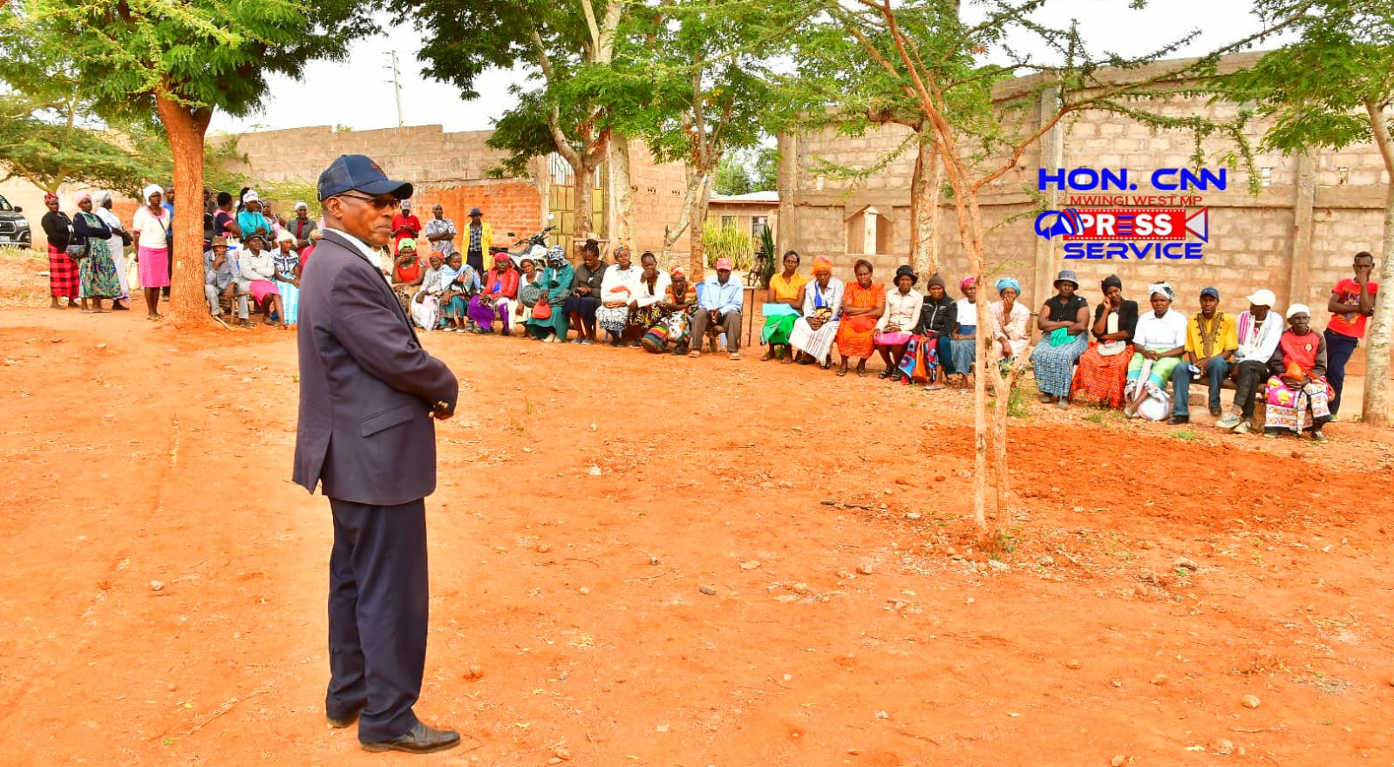

NG CDFC Chairman, Francis Munuve addressing the public at Nzeluni Chiefs Office,

to start the exercise

**2.1.3 Comments by the Member of Parliament**

The Member of Parliament informed the participants on the importance of the event. This was in line with the 2010 constitution which allows for citizenry participation in the management of their resources. He urged members to give projects that are beneficial to the larger public and feel free.

**2.1.4 Comments by Fund Account Manager**

The public was informed that proposals should capture projects that are beneficial to a wide majority of the community. Further, religious projects and those that have been devolved should not be funded.

**2.1.5 Comments by NG-CDF Chairman**

The chairman told the members that the projects should be those which are pressing and those that Mwingi West NG-CDFC can match the available funds

**2.1.6 Projects Identified in the ward**

|  |  |  |
| --- | --- | --- |
| **Name of Project** | **Activity to be done** | **Location** |
| Nzatani Secondary School | Completion of an administration block comprising of 3 offices, staff room and principals office–plastering, installation of doors, flooring, painting and labeling. | Nzatani |
| Munyange Secondary School | Completion of 401M length school compound fencing with chain link and concrete posts | Katalwa |
| Muthungue Primary School | Construction of 1 classroom to completion | Migwani |
| Kwa Kyelu Primary School | Construction of 1 classroom to completion | Nzeluni |
| Mathuma Primary School | Construction of 1 classroom to completion | Kisovo |
| Mumbuni Primary School | Construction of 2 classrooms to completion | Mumbuni |
| Kyamboo Primary School | Fencing of 440m length school compound with chain link and concrete posts | Migwani |
| Nzalae Primary School | Construction of 1 classroom to completion | Katalwa |
| Ilalambyu Chief’s office | Purchase of 300 branded Kenpoly plastic chairs @750 (225,000) and 3 branded tents of 100 people capacity each @ 125,000 (375,000) | Ilalambyu |
| Migwani DCC Baraza Park. | Renovation of the park-painting, putting up of the cabros within the compound and installation of a gate. | Migwani |
| Itheng’eli Primary School | Construction of 1 classroom to completion | Kisovo |
| Itoloni Primary School | Re-roofing of 7 Classrooms – removal of old iron sheets and replacing with new ones. | Itoloni |
| Kilungu Assistant Chief’s Office | Construction of 2-door pit latrine with a ramp to cater for persons with disability up to completion. | Nzeluni |
| Nzatani Primary School | Purchase of 10,000 litres water tank @ Kshs 90,000, construction of a tank base @ Kshs 50,000 and installation of pipes and gutters @ 60,000. | Nzatani |
|  |  |  |
| Mwanzenge Primary School | Purchase of 10,000 litres water tank @ Kshs 90,000, construction of a tank base @ Kshs 50,000 and installation of pipes and gutters @ 60,000. | Ilalambyu |
| Kisovo Primary School | Purchase of 10,000 litres water tank @ Kshs 90,000, construction of a tank base @ Kshs 50,000 and installation of pipes and gutters @ 60,000. | Kisovo |
|  |  |  |

**2.2.0 N 2. 2.0 Nguutani ward**

**2. 2.1 Date and venue**

The Nguutani Ward meeting was held at Nzawa Chiefs Office on 4th January, 2023.

1. Hon. Charles Ngusya Nguna - Member of National Assembly
2. Francis M. Munuve - Chairman
3. Japheth K. Musee - F A M
4. Jeremiah Mutemi Mwangangi - Secretary
5. John Duncan Kavuwa - Member
6. John Mwinzi - Member
7. Joseph Munyithya Musyoka - Member
8. Jackline Vuthi - Member
9. Rosemary W. Mutinda - Member
10. Anne Ndundu - Member
11. Mohamud Jama - DCC
12. All CDFC Staff - Main/Satellite Offices
13. Chief Asst. chief -Respective location

**2.2.3 Participating public**

Church leaders, opinion leaders, women and youth representatives attended the meeting which had been convened through the assistance of chiefs and sub-chiefs.

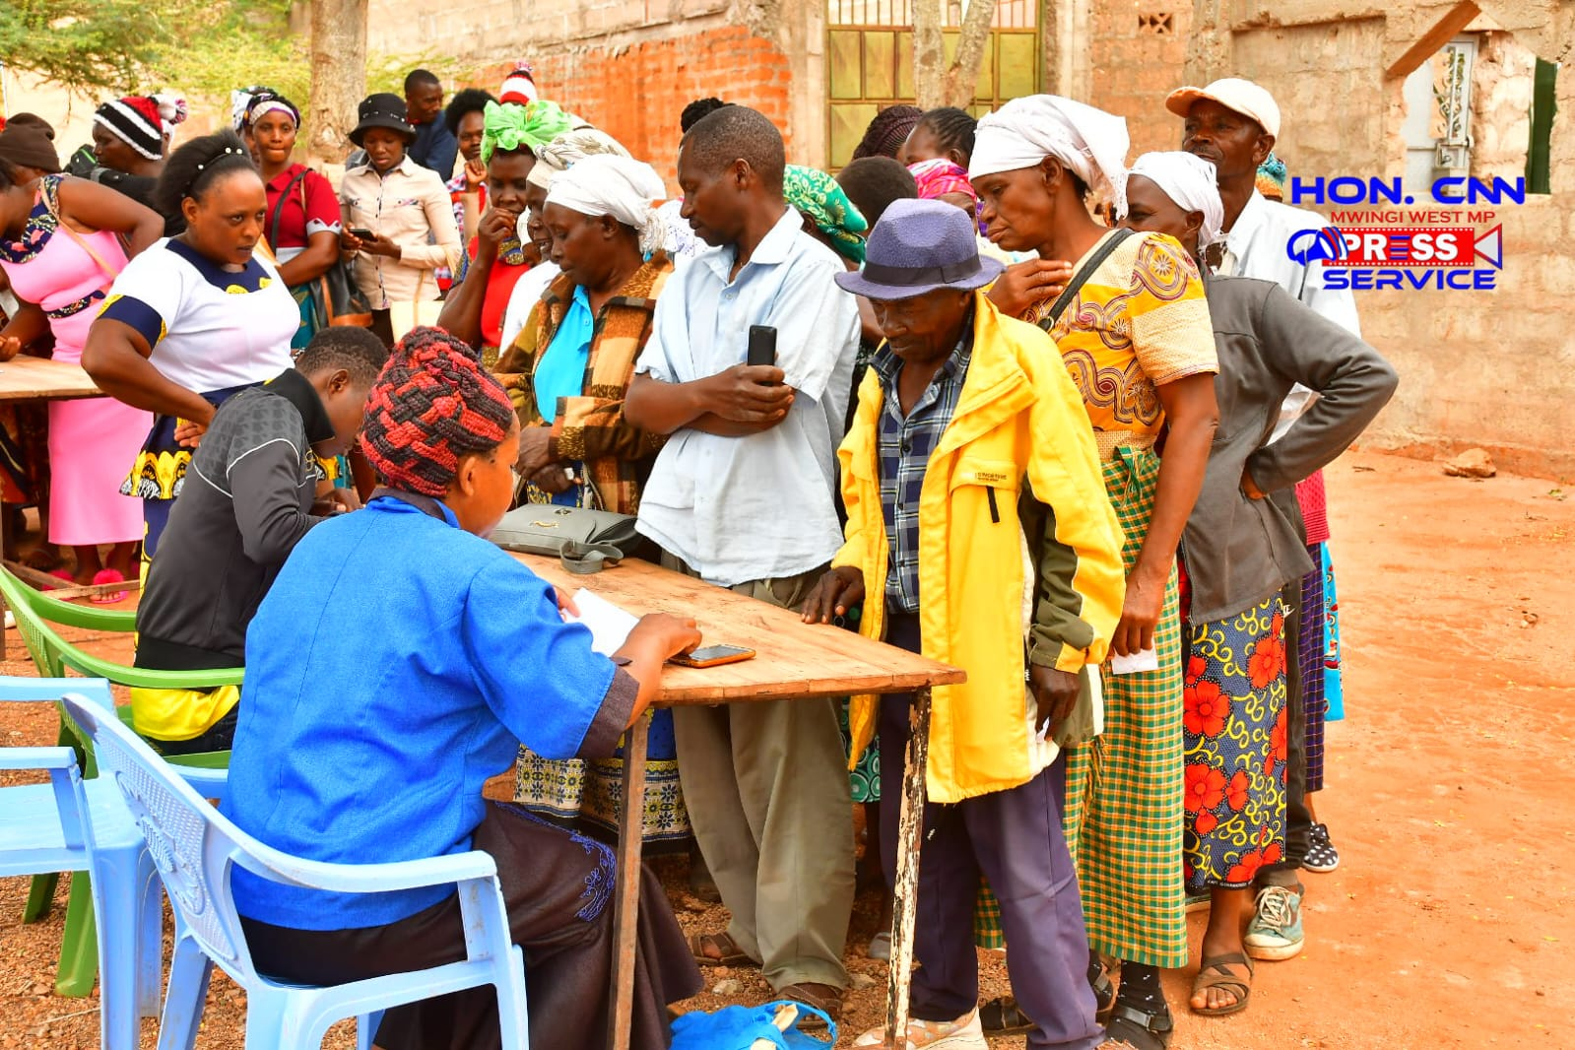

NG-CDFC Members and staff during public participation at Nzawa Chiefs Office.

**2.2.4 Comments by the Member of Parliament**

The Member of Parliament introduced the team which had accompanied him and encouraged the audience to be free as that was an important event to determine the development of their ward. This meeting was in line with the 2010 constitution which allows for citizenry participation in the management of their resources. He implored members to give projects that are beneficial to the larger public and feel free.

**2.2.5 Comments by Fund Account Manager**

The public was informed that proposals should capture projects that are beneficial to a wide majority of the community. Further, religious projects and those that have been devolved should not be funded.

**2.2.6 Comments by NG-CDF Chairman**

The chairman told the members that every year the NG-CDFC committee is overwhelmed by requests and with the limited resources available it was necessary for them to give projects which were pressing and those that Mwingi West NG-CDF can afford to fund.

**2.2.7 Projects Identified in the ward**

|  |  |  |
| --- | --- | --- |
| **Name of Project** | **Activity to be done** | **Location** |
| Thimu Primary School | Completion of 190M length School compound fencing with chain link and concrete posts. | Nzawa |
| Kikiini Secondary School | Construction of an Administrations block comprising of 3 offices and 1 staffroom up to roofing level. To complete FY 2023/24. | Nzauni |
| Kavililo Primary School | Re-roofing of 4 classrooms -removal of old iron sheets and replacing with new ones. | Nzauni |
| Kathita Nzau Primary School | Construction of 1 classroom to completion. | Ngongoni |
| Mavuni Primary School | Re-roofing of 2 classrooms -removal of old iron sheets and replacing with new ones. | Ngongoni |
| Syongoni Primary School | Construction of 1 classroom to completion | Nzawa |
| Muthioni Primary School | Re-roofing of 4 classrooms – removal of old iron sheets and replacing with new ones to completion. | Nzawa |
| Katuyu Primary School | Renovation of 3 classrooms- roofing plastering, flooring, installation of doors, windows and painting to completion. | Nguutani |
| Katoteni Primary School | Re-roofing of 4 classrooms – removal of old iron sheets and replacing with new ones to completion. | Nzawa |
| Masooni Primary School | Construction of 1 classroom to completion | Ngongoni |
| NgongoniChief’s Office | Purchase of 500 branded Kenpoly plastic chairs @750 (375,000) and 5 branded tents of 100 people capacity each @ 125,000 (625,000) | Ngongoni |
| Kakululo Primary School | Renovation of 5 classrooms- plastering, flooring, installation of doors, windows and painting to completion. | Nguutani |
| Nguutani Primary School | Purchase of 10,000 litres water tank @ Kshs 90,000, construction of a tank base @ Kshs 50,000 and installation of pipes and gutters @ 60,000. | Nguutani |
| Muthithini Primary School | Purchase of 10,000 litres water tank @ Kshs 90,000, construction of a tank base @ Kshs 50,000 and installation of pipes and gutters @ 60,000. | Ngongoni |
| St Mary’s Secondary School- Ngongoni | Purchase of 10,000 litres water tank @ Kshs 90,000, construction of a tank base @ Kshs 50,000 and installation of pipes and gutters @ 60,000. | Ngongoni |
|  |  |  |
|  |  |  |
|  |  |  |
|  |  |  |
|  |  |  |
|  |  |  |
|  |  |  |
|  |  |  |
|  |  |  |
|  |  |  |
|  |  |  |
|  |  |  |

**2.3.0 Kyome/Thaana Nzau Ward**

**2.3.1 Date and venue**

The Kyome/Thaana Nzau Ward meeting was held at Kanyaa Asst chiefs’ office on 5th January, 2023.

1. Hon. Charles Ngusya Nguna - Member of National Assembly
2. Francis M. Munuve - Chairman
3. Japheth K. Musee - F A M
4. Jeremiah Mutemi Mwangangi - Secretary
5. John Duncan Kavuwa - Member
6. John Mwinzi - Member
7. Joseph Munyithya Musyoka - Member
8. Jackline Vuthi - Member
9. Rosemary W. Mutinda - Member
10. Anne Ndundu - Member
11. Mohamud Jama - DCC
12. All CDFC Staff - Main/Satellite Offices
13. Chief / Asst. chief -Respective location

2.3.3 **Participating public**

Church leaders, opinion leaders, women and youth representatives attended the meeting which had been convened through the assistance of chiefs and sub-chiefs

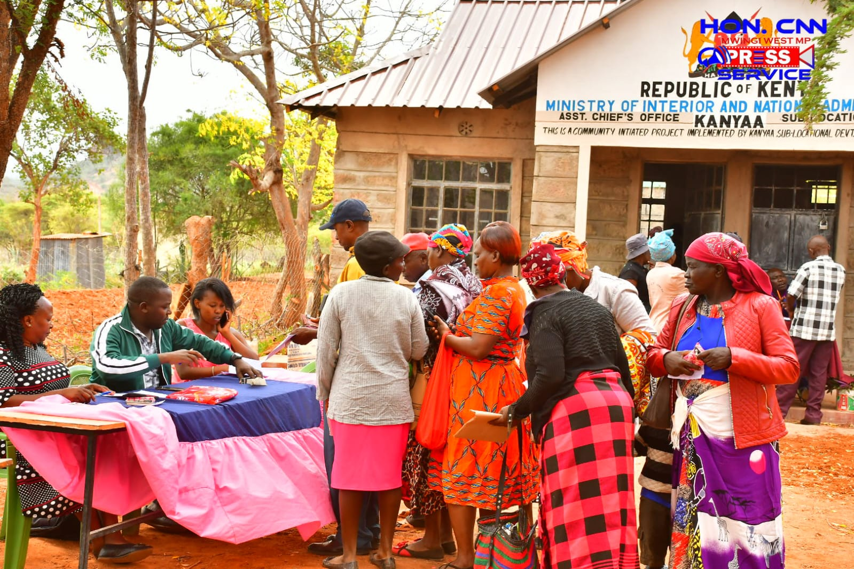 Public participation forum at Kanyaa Assistant chiefs’ office compound.

**2.3.4 Comments by the Member of Parliament**

The members of public were thanked for attending the meeting in large numbers. This was necessary as this would validate the projects that will have been selected for funding. The Member of Parliament introduced the team which had accompanied him and encouraged the audience to be free as that was an important event to determine the development of their ward. This meeting was in line with the 2010 constitution which allows for citizenry participation in the management of their resources. He implored members to give projects that are beneficial to the larger public and feel free.

**2.3.5 Comments by Fund Account Manager**

The Fund Account Manager was happy with the way projects in the ward had been implemented within the required timeline. The participants were informed that proposals should capture projects that are beneficial to a wide majority of the community. Further, religious projects and those that have been devolved should not be funded.

**2.3.6 Comments by NG-CDFC Chairman**

The chairman told the members that every year the NG-CDFC committee is overwhelmed by requests and with the limited resources available it was necessary for them to give projects which were pressing and those that Mwingi West NG-CDF can afford to fund.

**2.3.7 Projects Identified in the ward**

|  |  |  |
| --- | --- | --- |
| **Name of Project** | **Activity to be done** | **Location** |
| Kyusyani Chief’s Office | Purchase of 500 branded Kenpoly plastic chairs @750 (375,000) and 5 branded tents of 100 people capacity each @ 125,000 (625,000) | Thaana Nzau |
| Kanyaa Chief’s Office | Purchase of 3.54 Ha. Of land for the expansion of the Chief’s compound. | Kanyaa |
| Thitani Police Post | Completion of 2-roomed office with a store- roofing, plastering, flooring, installation of doors/windows, painting and labeling. | Thitani |
| Mbau Sec. School | Completion of 45 students’ capacity science laboratory - plastering, flooring, installation of doors, window glasses, painting and labeling. | Kyome |
| Kyome Boys Secondary School | Re-roofing of 5 classrooms -removal of old iron sheets and replacing with new ones. | Kyome |
| Kwa Karanga Primary School | Construction of 1 classroom to completion. | Thokoa |
| Muukuni Primary School | Putting up of floor tiles to an Administration block comprising of 3 offices and 1 staffroom. | Thokoa |
| Musuani Primary School | Renovation of 2 Classrooms- roofing plastering, flooring, installation of doors, windows and painting to completion. | Thokoa |
| Thokoa Primary School | Renovation of 1 Classroom- roofing plastering, flooring, installation of doors, windows and painting to completion. | Thokoa |
| Kanyekini Primary School | Re-roofing of 5 classrooms -removal of old iron sheets and replacing with new ones. | Thokoa |
| Masaani Primary School | Re-roofing of 5 classrooms -removal of old iron sheets and replacing with new ones. | Winzyeei |
| Thokoa Primary School | Fencing of 440m length of the school compound with chain link and concrete posts. | Winzyeei |
| Winzyeei Primary School | Renovation of 2 Classrooms- plastering, flooring, installation of doors, windows and painting to completion. | Winzyeei |
| Kyome Primary School | Purchase of 10,000 litres water tank @ Kshs 90,000, construction of a tank base @ Kshs 50,000 and installation of pipes and gutters @ 60,000. | Kyome |
| Yenzuva Primary School | Purchase of 10,000 litres water tank @ Kshs 90,000, construction of a tank base @ Kshs 50,000 and installation of pipes and gutters @ 60,000. | Winzyeei |
| Kavaini Primary School | Purchase of 10,000 litres water tank @ Kshs 90,000, construction of a tank base @ Kshs 50,000 and installation of pipes and gutters @ 60,000. | Thitani |
|  |  |  |
|  |  |  |
|  |  |  |
|  |  |  |
|  |  |  |

**2.4.0 Kiomo/Kyethani Ward**

**2.4.1 Date and venue**

The Kiomo/Kyethani ward meeting was held at Kiomo Chiefs office on 6th January, 2023.

1. Hon. Charles Ngusya Nguna - Member of National Assembly
2. Francis M. Munuve - Chairman
3. Japheth K. Musee - F A M
4. Jeremiah Mutemi Mwangangi - Secretary
5. John Duncan Kavuwa - Member
6. John Mwinzi - Member
7. Joseph Munyithya Musyoka - Member
8. Jackline Vuthi - Member
9. Rosemary W. Mutinda - Member
10. Anne Ndundu - Member
11. Mohamud Jama - DCC
12. All CDFC Staff - Main/Satellite Offices
13. Chief / Asst. Chief -Respective location

**2.4.3 Participating public**

Members of the public were all invited including Church leaders, opinion leaders, women and youth representatives attended the meeting which had been convened through the assistance of chiefs and sub-chiefs.

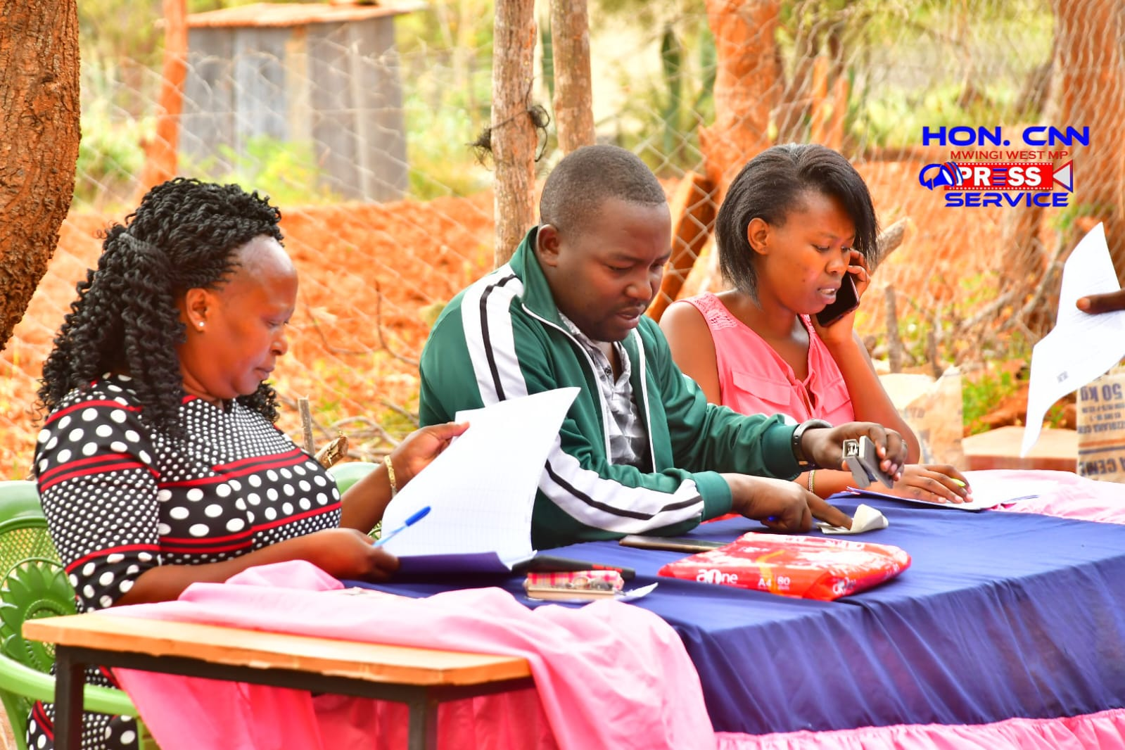

NGCDFC member and staff ready to start attending the public to record their needs.

**2.4.4 Comments by the Member of Parliament**

The Member of Parliament introduced the team which had accompanied him and encouraged the audience to be free as that was an important event to determine the development of their ward. He informed the participants that this was their event and so they were the ones to give suggestions. This meeting was in line with the 2010 constitution which allows for citizenry participation in the management of their resources. He implored members to give projects that are beneficial to the larger public and feel free. The members of public were thanked for attending the meeting in large numbers.

**2.4.5 Comments by Fund Account Manager**

The participants were informed that proposals should capture projects that are beneficial to a wide majority of the community. Further, religious projects and those that have been devolved should not be funded.

**2.4.6 Comments by NG-CDFC Chairman**

The chairman told the members that Bursary fund were predetermined and when the proposals are approved the NG-CDFC committee will come on the ground to identify the possible beneficiaries. He also indicated that very year the NG-CDFC committee is overwhelmed by requests and with the limited resources available it was necessary for them to give projects which were pressing and those that Mwingi West NG-CDF can afford to fund.

**2.4.7 Projects Identified in the ward**

|  |  |  |
| --- | --- | --- |
| **Name of Project** | **Activity to be done** | **Location** |
| Mbondoni Secondary School | Completion of 80 student’s capacity Dining Hall and Kitchen– painting, outside wall keying, skirting and labeling. | Kiomo |
| Mbondoni Secondary School | Purchase and installation of 3 boilers (640,000), 24 metallic top tables @ 10,000 (240,000), 50 wooden sitting benches @1,500 (75,000) and one (70 inch) digital smart TV set @ 40,000 | Kiomo |
| Kyethani Secondary School | Completion of school compound fencing with chain link and concrete posts | Kyethani |
| Mukuthu Secondary School | Completion of 45 students’ capacity science laboratory - plastering, flooring, installation of doors, windows, painting and labeling. | Kyethani |
| Kyethani Chief’s office | Construction of 3-roomed Chief’s office, with a waiting bay to completion. | Kyethani |
| Kairungu Chief’s office | Purchase of 500 branded Kenpoly plastic chairs @750 (375,000) and 5 branded tents of 100 people capacity each @ 125,000 (625,000). | Kairungu |
| Kiomo Secondary School | Purchase of School Bus- New Isuzu FFR90, 46-Seater, government negotiated price, exclusive of insurance premiums and other costs. | Kiomo |
| Itendeu Primary School | Re-roofing of 2 classrooms (500,000) and office block (300,000) – removal of old iron sheets and replacing with new ones to completion. | Kyethani |
| Itong’olani Primary School | Construction of 1 classroom to completion | Kairungu |
| Kairungu Chief’s office | Construction of 2-door pit latrine with a ramp to cater for persons with disability up to completion | Kairungu |
| Kwa Munyanzu  Primary School | Re-roofing of 5 classrooms – removal of old iron sheets and replacing with new ones to completion. | Kiomo |
| Ngemini Primary School | Purchase of 10,000 litres water tank @ Kshs 90,000, construction of a tank base @ Kshs 50,000 and installation of pipes and gutters @ 60,000. | Kairungu |
| Kianziani Primary School | Purchase of 10,000 litres water tank @ Kshs 90,000, construction of a tank base @ Kshs 50,000 and installation of pipes and gutters @ 60,000. | Kairungu |
| Itiliku Primary School | Purchase of 10,000 litres water tank @ Kshs 90,000, construction of a tank base @ Kshs 50,000 and installation of pipes and gutters @ 60,000. | Kiomo |
|  |  |  |
|  |  |  |

## Conclusion

Member of the community turned up was recommendable (about 45 members from each sub-location) and actively participated in identifying the projects of their choice.

In every ward, community identified a strategic and ideal centre to be funded with plastic chairs and tent. To be of use during public forums, essentially to cover them from sunny or rainy weather conditions.

Participants thanked the MP and the NG-CDFC members, especially the chairman for organizing such a consultative and participatory open public forum, to present their needs.

**Signed by**: NG-CDFC Chairman ………………………………………………Date…………………….

**Signed by:** Fund Account Manager ………………………………...…………Date……………………

**Signed by:** Deputy County Commissioner ……………………………….……Date…………………...