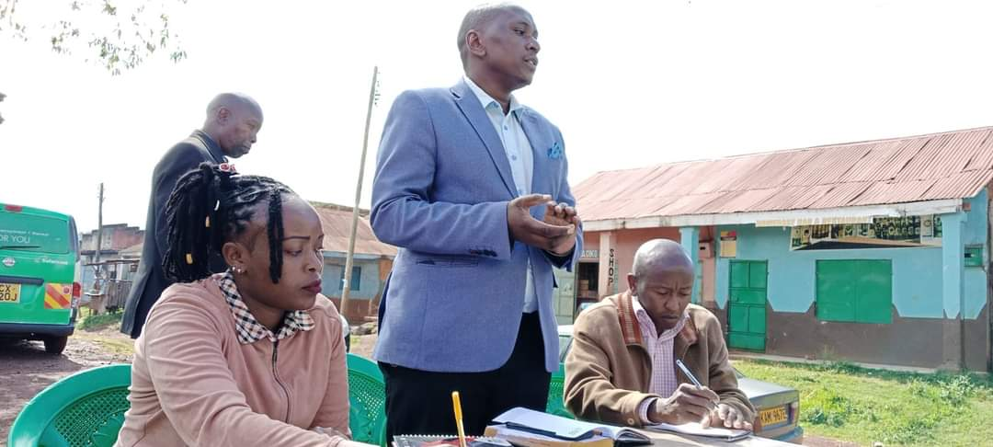

**Chairman Addressing members of Community during Projects Public participation exercise. Komothai Ward**

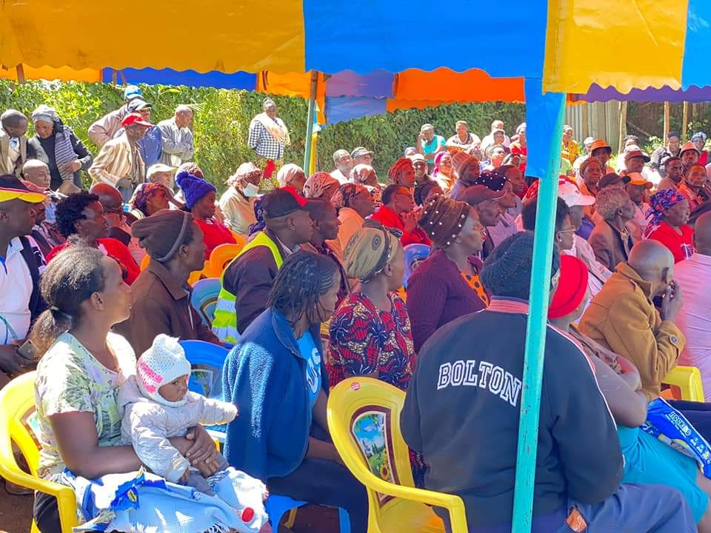

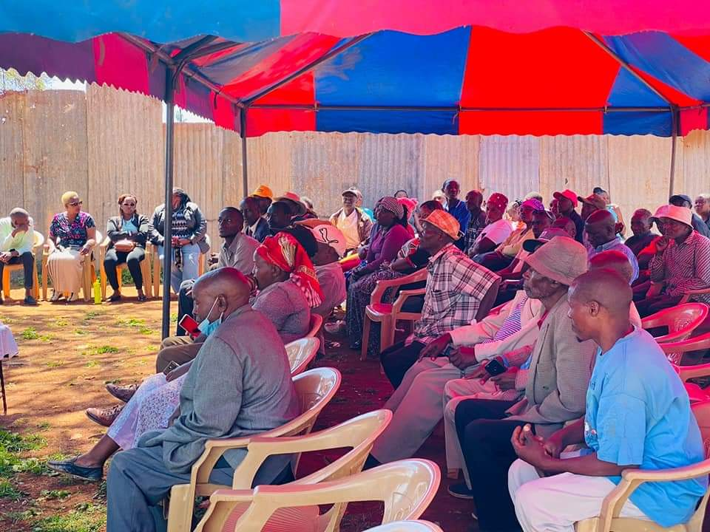

**Members of the public following public participation proceedings at Kwa Maiko, Ngewa Ward**