|  |  |
| --- | --- |
| ngcdf logo  **NG-CDF KAPSERET** | **National Government Constituencies Development Fund**  **Kapseret Constituency,**  **P.O Box 2449-30100,**  **Eldoret, Kenya.**  **Tel: …………… | Cell: 0786328173**  **Email**: [cdfkapseret@ngcdf.go.ke](mailto:cdfkapseret@ngcdf.go.ke) | **Website:** [www.ngcdf.go.ke](http://www.ngcdf.go.ke) |

**MINUTES OF KAPSERET NATIONAL GOVERNMENT CONSTITUENCY DEVELOPMENT FUND COMMITTEE MEETING HELD ON 28TH NOVEMBER 2024 AT THE NG-CDF BOADROOM OUTSPAN.**

**MEMBERS PRESENT**

1. Sammy KipchumbaRutto - Chairman
2. Mathew K. Tanui -Fund Account Manager
3. Benter Atieno Ogot -Secretary
4. Caroline Jelimo Kemboi -Member
5. Susan Jeruto Murei -Member
6. Evans Manga -Member
7. Grace Njuguna -Assistant County Commissioner
8. Hellen Jepkosgei Meresei -Member
9. Jasper Sammy Kurgat -Member
10. Edwin Kurgat -Member

**IN ATTENDANCE**

1. Julius Kabianga -Constituency Manager

**AGENDA**

1. Preliminaries.
2. Declaration of conflict of interest
3. Reading and Confirmation of previous minutes.
4. Matters arising.
5. Ward open forum public meetings report.
6. List of ongoing projects for additional funding.
7. Project proposal FY 2024/2025
8. Adjournments

**MIN 22: KAPS/NG-CDF /28/11/2024: PRELIMINARIES.**

The meeting started at 11:20AM with a word of prayer from Mathew Tanui. The Chairman then welcomed the members and thanked them for keeping time.

**MIN 23: KAPS/NG-CDF/28/11/2024:DECLARATION OF CONFLICT OF INTEREST**

The chairperson invited the members if there was any member who wishes to declare his/her interest on the agenda before the table for deliberation and there was none.

**MIN 24: KAPS/NG-CDF/28/11/2024: CONFIRMATION OF PREVIOUS MINUTES.**

The previous minutes dated 23rd October 2024 were read by the secretary. The minutes were then proposed by Jasper Kurgat and seconded by Susan Murei as true records of the stated meeting.

**MIN 25:KAPS/NG-CDF/28/11/2024: MATTERS ARISING.**

As at the date of this meeting all the projects which received funds vide the recent AIE except for Kaplelach police station and Pioneer chiefs’ office has been handed over the respective contractors for implementation. The project of Ngeria girls storey Administration block and Wareng high school at procurement stage.

Since the exams were going on, the handing over for Simat secondary school is yet to be done.

Members were requested to visit the projects which benefited from climate change mitigation funds to ascertain the success of the tree planting. Each member to submit a comprehensive report in January 2025 on the program.

The contractor of water harvesting project at the NG-CDFs office was paid.

**MIN 26:KAPS/NG-CDF/28/11/2024: WARD OPEN FORUM PUBLIC MEETINGS REPORT**

The Fund account manager thanked all the members for attending the ward open forum public meetings.

It was pointed out that the turnout was fairly good and most of the principals, head teachers and project secretaries attended in person.

The chairperson took the members through the ward open forum public meeting report. Members confirmed that the report is the true reflection of the ward meetings and adopted as attached;

|  |  |  |  |  |
| --- | --- | --- | --- | --- |
| **SNO.** | **Project Name** | **Project Activity** | **Amount Allocated** | **Current Status** |
| **1.NGERIA WARD** | | | | |
|  | Ngeria Primary School | Renovation Of 9 No Classrooms :Re-roofing to prepainted 28 gauge iron sheets on 7 classrooms, floor tiling on 9 classrooms, paving slab, installation of 4 steel doors, painting and labelling | 2,572,306 | New |
|  | Nairiri Primary School | Construction to completion of 1. No Classroom at kshs. 1,200,000 and purchase and supply of 25 desks 75,000 | 1,275,000 | New |
|  | Kanetik Primary School | Construction to completion of 1. No Classroom at kshs. 1,200,000 and purchase and supply of 25 desks 75,000 | 1,275,000 | New |
|  | Kipsamoo Primary School | Renovation Of 9 No Classrooms Re-roofing to prepainted 28 gauge iron sheets, floor tiling, plastering of internal and external walls, painting and labelling | 3,176,252 | New |
|  | Ngeria Girls | Construction to completion of a single storey administration block comprising of 14 offices. Phase 2: construction of 6 offices on the first floor: (columns, beams, roofing and walling, doors and windows) | 9,000,000 | Ongoing |
|  | Kiambaa Secondary School Laboratory | Construction Of 60 students’ capacity single science laboratory to completion; worktops mechanical works electrical works painting and labeling. | 5,231,465.08 | New |
|  | Oscar Sudi Secondary School | Construction Of 1.No Classrooms Construction to completion of 1. No Classroom at kshs. 1,200,000 and purchase and supply of 25 lockers and seats @kshs 125,000. | 1,325,000 | New |
|  | Ngeria Technical Training Institute | Electricty supply of single phase 7.0KVA service line to be installed. | 350,000 | New |
|  | Kaplelach Police Station | For electrical wiring of police station comprising of nine (9) offices and power connection. | 380,000 | New |
|  | Kapseret Sub-County Deputy County Commissioner Office | Purchase of ICT equipment. 4pieces of HP desktop 16gb RAM CORE i7@224,000,2 pieces of Epson printers/scanners 382 @116,000 ,One Smart TV 43'' LG @60,000 | 400,000 | New |
|  | **TOTAL** |  | **24,985,023.08** |  |
| 2.KAPSERET/SIMAT WARD | | | | |
|  | Inder Primary School | Renovation Of 10 No Classrooms :Re-roofing to prepainted 28 gauge iron sheets on 8 classrooms, roof painting of 2 classrooms, floor tiling, paving slab, plastering of external and internal walls, painting and labelling | 3,294,950 | New |
|  | Tuiyo Primary School | Renovation Of 9 No Classrooms :Re-roofing to prepainted 28 gauge iron sheets on 9 classrooms, floor tiling, paving slab, installation of steel doors, plastering of external and internal walls, painting and labelling | 3,176,560 | New |
|  | Kaptinga Primary School | Renovation Of 9 No Classrooms :Re-roofing to prepainted 28 gauge iron sheets on 7 classrooms, installation of 3 steel doors, roof painting of 2 classrooms, floor tiling, plastering of external walls, painting and labeling. | 3,320,550 | New |
|  | St Joseph Secondary School | Renovation Of 6 No Classrooms Re-roofing to prepainted 28 gauge iron sheets, floor tiling, plastering of internal and external walls, painting and labelling | 2,100,000 | New |
|  | Lemook Costituency digital Hub | Construction of standard digital hub as per the ministry of Information, communication and digital economy guidelines. | 5,200,000 | New |
|  | **TOTAL** |  | **16,892,060** |  |
| **3.MEGUN WARD** | | | | |
|  | Songoliet Primary School | Purchase Of 3 Acres Of Land | 6,000,000 | New |
|  | **TOTAL** |  | **6,000,000** |  |
| **4.KIPKENYO WARD** | | | | |
|  | Kimalel Primary School | Construction of a storey tuition block of 12 classrooms Storey Building Phase 2: finishes of ground floor classrooms (doors, windows, plastering, balustrading and painting), construction of 6 classrooms on the first floor: (columns, beams, roofing and walling) | 10,000,000 | Ongoing |
|  | Kipkenyo Secondary School | Construction to completion 400 students capacity dinning hall @Kshs 5,000,000 and equiping with tables and benches @kshs 1,500,000. | 6,500,000 | New |
|  | **TOTAL** |  | **16,500,000** |  |
| **5.LANGAS WARD** | | | | |
|  | Gitwe Primary School | Renovation Of 9 No Classrooms :Roof painting of 9 classrooms, floor tiling, installation of steel stanchions, plastering of external walls, painting and labelling | 2,994,000 | New |
|  | Wareng High School | Construction of a storey tuition block of 12 classrooms Storey Building Phase 2: finishes of ground floor classrooms (doors, windows, plastering, balustrading and painting), construction of 6 classrooms on the first floor: (columns, beams, roofing and walling) | 9,000,000 | Ongoing |
|  | Kapseret Sub-County Dcio Office | Construction to completion of six (6) single roomed DCIO offices. | 3,500,000 | New |
|  | **TOTAL** |  | **15,494,000** |  |

**MIN 27: KAPS/NG-CDF/28/11/2024: LIST OF ONGOING PROJECTS FOR ADDITIONAL FUNDING**

The members agreed that all the ongoing projects will take precedence. The chairperson led other members in going through the list of all the ongoing projects and after lengthy discussion the report was approved and adopted as follows;

| **Financial Year when the project was first funded** | **Project Name** | **Initial Approved Activities** | **Pending Activities/act ivities to be financed in 2024/25 F/Y** | **Contract Sum /Estimated Cost (Kshs.)** | **Cumulative allocation to the project(Kshs.)** | | **Balance To Complete (Kshs.)- Contract sum- cumulative allocation** |
| --- | --- | --- | --- | --- | --- | --- | --- |
| **Financial year** | **Amount allocated** |
| 2023/24 | Kimalel Junior secondary School | Construction of a single storey building of 12 classrooms. phase- 1~construction of 6 classrooms on the ground floor; foundation, columns, walling, beams up to first floor slab. | Construction of a storey tuition block of 12 classrooms Storey Building Phase 2: finishes of ground floor classrooms (doors, windows, plastering, balustrading and painting), construction of 6 classrooms on the first floor: (columns, beams, roofing and walling) | 31,242,400 | 2023/24 | 13,493,766 | 17,748,634 |
| 2023/24 | Ngeria Girls Secondary School | Construction to completion of a single storey administration blocks comprising of 14 offices. Phase 1~construction of 8 offices on the ground floor to completion up to suspended first floor slab. | Construction to completion of a single storey administration block comprising of 14 offices. Phase 2: construction of 6 offices on the first floor: (columns, beams, roofing and walling, doors and windows) | 24,678,040 | 2023/24 | 10,000,000 | 14,678,040 |
| 2023/24 | Wareng High School | building of 12 classrooms. phase- 1~construction of 6 classrooms onthe ground floor; foundation, columns, walling , beams up to first floor slab. | Construction of a storey tuition block of 12 classrooms Storey Building Phase 2: finishes of ground floor classrooms (doors, windows, plastering, balustrading and painting), construction of 6 classrooms on the first floor: (columns, beams, roofing and walling) | 28,551,740 | 2023/24 | 10,000,000 | 18,551,740 |

It was further notified to the members that there is an additional project to be added on the list of ongoing project.Kaplelach police station-Electrical wiring and electricity connection. It was reported to the members that the developed Bill of the Quantity for Kaplelach Police Station omitted in the list of ongoing projects earlier submitted to the NG-CDF Board at the close of the last year financial year. It was reported to the members that the developed Bill of Quantity for Kaplelach police station omitted the electrical BQ.

Members discussed and passed to fund the electrical wiring and connection Kaplelach police station with Kshs.380, 000.

Members were also informed that Kimalel junior secondary school proposal for construction of storey building of 12No. classrooms. The Fund account manager informed the members that the change in the structural designs and Bill of Quantities recommended by the NG-CDF Board has led to the increase of the project cost. The initial project cost was Kshs 26,987,520 but the proposed changes by the NG-CDF Board have increased the project cost to Kshs.31, 242,400.

Members further revisited the funding model for the three [3] multiyear projects. Members passed to fund the three ongoing projects for three years as follows;

|  |  |  |  |  |  |
| --- | --- | --- | --- | --- | --- |
| **S/NO** | **PROJECT NAME** | **TOTAL PROJECT COST**  **[kshs]** | **ALLOCATION YEAR 1**  **2023/2024**  **[kshs]** | **ALLOCATION YEAR 2**  **2024/2025**  **[kshs]** | **ALLOCATION YEAR 3**  **2025/2026**  **[kshs]** |
| **1** | Kimalel Junior secondary school | 31,242,400 | 13,493,766 | 10,000,000 | 7,748,634 |
| **2** | Wareng High school | 28,551,740 | 10,000,000 | 9,000,000 | 9,551,740 |
| **3** | Ngeria girls high school | 24,678,040 | 10,000,000 | 9,000,000 | 5,678,040 |

**MIN 28:KAPS/NG-CDF/28/11/2024: PROJECT PROPOSALS FY 2024/2025**

The chairman informed the members that the constituencies allocation table has been released and that the committee is required to prioritize its project proposals for the financial year 2024/2025.The constituency was allocated Ksh.179, 441,954.47 for the financial year 2024/2025.

The members discussed at length a list of project proposal which was captured in the ward report and passed to include under listed projects in the project proposal for consideration by the NG-CDF Board.

|  |  |  |  |  |  |  |
| --- | --- | --- | --- | --- | --- | --- |
| **FINANCIAL YEAR 2024/2025** | | | | | | |
| **Project Number** | **Project Name** | **Project Activity** | **Original Cost** | **Cumulative Allocation** | **Amount Allocated** | **Current Status** |
| **ADMINISTRATION AND RECURRENT EXPENDITURE** | | | | |  |  |
| **COMPENSATION OF EMPLOYEES** | | |  |  |  |  |
| 4-027-145-2110201-100-2024-2025-1 | Contractual Employees | Payment of 8 staff Basic salaries | 1,442,760 |  | 1,442,760 | New |
| 4-027-145-2110202-100-2024-2025-2 | Casual Labour and Internship | Payment of staff 6 Basic Wages | 876,000 |  | 876,000 | New |
| 4-027-145-2110301-100-2024-2025-3 | House Allowance | Payment of House allowances to NGCDFC staff | 402,000 |  | 402,000 | New |
| 4-027-145-2110314-100-2024-2025-4 | Transport Allowance | Payment of Transport allowances to NGCDFC staff | 240,000 |  | 240,000 | New |
| 4-027-145-2110320-100-2024-2025-5 | Leave Allowance | Payment of Leave allowances to NGCDFC staff | 20,000 |  | 20,000 | New |
| 4-027-145-2120201-100-2024-2025-6 | NSSF | Employer contribution to NSSF for both contracted staff and casual staff. | 240,000 |  | 240,000 | New |
| 4-027-145-2710102-100-2024-2025-7 | Gratuity-Contractual Employees | Payment of gratuity to contracted NGCDFC staff. | 458,713 |  | 458,713 | New |
| 4-027-145-2110301-100-2024-2025-8 | Housing Levy | Employer Contribution to Housing Levy for both contracted staff and casual staff. | 57,000 |  | 57,000 | New |
| 4-027-145-2110000-100-2024-2025-9 | National Industrial Training Authority(NITA) | Employer contribution to NITA for NGCDFC Staff and NGCDFC. | 12,000 |  | 12,000 | New |
| 2120201 | SHIF | Employer contribution to SHIF for both contracted staff and casual staff. | 108,000 |  | 108,000 | New |
| Sub-Total |  |  |  |  | **3,856,473** |  |
| **USE OF GOODS AND SERVICES** | | | |  |  |  |
| 4-027-145-2210101-100-2024-2025-1 | Electricity | Payment of Electricity charges | 180,000 |  | 180,000 | New |
| 4-027-145-2210201-100-2024-2025-2 | Telephone, Telex, Facsmile and Mobile Phone Service | Payment of Telephone Expenses | 318,000 |  | 318,000 | New |
| 4-027-145-2210202-100-2024-2025-3 | Internet Connections | Payment of Internet Connections Expenses | 69,588 |  | 69,588 | New |
| 4-027-145-2210203-100-2024-2025-4 | Courier and Postal Services | Payment of Courier and Postal Services | 200,000 |  | 200,000 | New |
| 4-027-145-2210301-100-2024-2025-5 | Travel Costs (Airlines, Bus, Railway, Mileage Allowances, etc.) | Payment of Travel Costs | 75,000 |  | 75,000 | New |
| 4-027-145-2210302-100-2024-2025-6 | Accommodation - Domestic Travel | Payment of Accommodation - Domestic Travel | 400,000 |  | 400,000 | New |
| 4-027-145-2210303-100-2024-2025-7 | Daily Subsistence Allowance | Payment of Daily Subsistence Allowance | 200,000 |  | 200,000 | New |
| 4-027-145-2210502-100-2024-2025-8 | Publishing and Printing Services | Payment of Publishing and Printing Services | 100,000 |  | 100,000 | New |
| 4-027-145-2210504-100-2024-2025-9 | Advertising, Awareness and Publicity Campaigns | Payment of Advertising, Awareness and Publicity Campaigns | 200,000 |  | 200,000 | New |
| 4-027-145-2210801-100-2024-2025-10 | Catering Services (Receptions), Accommodation, Gifts, Food and Drinks | Payment of catering Services (receptions), Accommodation, Gifts, Food and Drinks | 541,446 |  | 541,446 | New |
| 4-027-145-2210802-100-2024-2025-11 | Other Committee Expenses | Payment of Other committee expenses | 900,000 |  | 900,000 | New |
| 4-027-145-2210811-100-2024-2025-12 | NGCDFC Allowance | Payment of NGCDFC allowances | 1,128,000 |  | 1,128,000 | New |
| 4-027-145-2210904-100-2024-2025-13 | Motor Vehicle Insurance | Payment of Motor Vehicle Insurance | 200,000 |  | 200,000 | New |
| 4-027-145-2211101-100-2024-2025-14 | General Office Supplies (Papers, Pencils, Forms, Small Office Equipment etc.) | Purchase of General Office Supplies (papers, pencils, forms, small office equipment) | 950,010 |  | 950,010 | New |
| 4-027-145-3111000-100-2024-2025-21 | NG-CDF Office | Purchase of KYOCERA Taskalfa 520i(Duplex,ARDF 52-60pages per min)copier, network printer color scanner.@kshs 130,000 and HP Elite book 1040G7X360,intel corei7-10610u,16GBRAM,512 GBSSD,graphics,ultrasim tourchscreen display @Kshs 60,000. | 190,000 |  | 190,000 | New |
| 4-027-145-2211103-100-2024-2025-15 | Sanitary and Cleaning Materials, Supplies and Services | Payment of Sanitary and Cleaning Materials, Supplies and Services | 100,000 |  | 100,000 | New |
| 4-027-145-2211201-100-2024-2025-16 | Refined Fuels and Lubricants for Transport | Purchase of Refined Fuels and Lubricants for Transport | 398,000 |  | 398,000 | New |
| 4-027-145-2211301-100-2024-2025-17 | Bank Service Commission and Charges | Payment of Bank service commission and charges | 100,000 |  | 100,000 | New |
| 4-027-145-2211305-100-2024-2025-18 | Contracted Guards and Cleaning Services | Payment of Contracted Guards and Cleaning Services | 100,000 |  | 100,000 | New |
| 4-027-145-2220101-100-2024-2025-19 | Maintenance Expenses - Motor Vehicles | Payment of Maintenance Expenses - Motor Vehicles | 460,000 |  | 460,000 | New |
| 4-027-145-2220202-100-2024-2025-20 | Maintenance of Office Furniture and Equipment | Payment of Maintenance of Office Furniture and Equipment | 100,000 |  | 100,000 | New |
| Sub-Total |  |  |  |  | **6,910,044** |  |
| **MONITORING EVALUATION AND CAPACITY BUILDING** | | |  |  |  |  |
| 4-027-145-2210301-111-2024-2025-1 | Travel Costs (Airlines, Bus, Railway, Mileage Allowances, etc.) | Payment of Travel Costs | 100,000 |  | 100,000 | New |
| 4-027-145-2210302-111-2024-2025-2 | Accommodation - Domestic Travel | Payment of Accommodation - Domestic Travel | 300,000 |  | 300,000 | New |
| 4-027-145-2210303-111-2024-2025-3 | Daily Subsistence Allowance | Payment of Daily Subsistence Allowance | 100,000 |  | 100,000 | New |
| 4-027-145-2210502-111-2024-2025-4 | Publishing and Printing Services | Payment of Publishing and Printing Services | 180,097 |  | 180,097 | New |
| 4-027-145-2210504-111-2024-2025-5 | Advertising, Awareness and Publicity Campaigns | Payment of Advertising, Awareness and Publicity Campaigns | 114,627 |  | 114,627 | New |
| 4-027-145-2210701-111-2024-2025-6 | Travel Allowance | Payment of Travel Allowance,accomodation and perdiem for NG-CDF Staff & NG-CDFC,PMC during capacity building | 1,152,000 |  | 1,152,000 | New |
| 4-027-145-2210702-111-2024-2025-7 | Remuneration of Instructors and Contract Based Training Services- Drug and HIV trainings are mandatory. | Remuneration of Instructors and Contract Based Training Services during NG-CDF Staff, NG-CDFC and PMCs Training. | 445,000 |  | 445,000 | New |
| 4-027-145-2210703-111-2024-2025-8 | Production and Printing of Training Materials | Payment of Production and Printing of Training Materials | 100,000 |  | 100,000 | New |
| 4-027-145-2210704-111-2024-2025-9 | Hire of Training Facilities and Equipment | Payment of Hire of Training Facilities and Equipment | 612,000 |  | 612,000 | New |
| 4-027-145-2210801-111-2024-2025-11 | Catering Services (Receptions), Accommodation, Gifts, Food and Drinks | Payment of catering Services (receptions), Accommodation, Gifts, Food and Drinks | 455,535 |  | 455,535 | New |
| 4-027-145-2210802-111-2024-2025-12 | Other Commitee Expenses | Payment of Other committee expenses | 600,000 |  | 600,000 | New |
| 4-027-145-2210303-111-2024-2025-13 | NGCDFC Allowance | Payment of NGCDFC allowances | 824,000 |  | 824,000 | New |
| 4-027-145-2211101-111-2024-2025-14 | General Office Supplies (Papers, Pencils, Forms, Small Office Equipment etc.) | Purchase of General Office Supplies (papers, pencils, forms, small office equipment) | 200,000 |  | 200,000 | New |
| 4-027-145-2211201-111-2024-2025-15 | Refined Fuels and Lubricants for Transport | Purchase of Refined Fuels and Lubricants for Transport | 200,000 |  | 200,000 | New |
| Sub-Total |  |  |  |  | **5,383,259** |  |
| **NG-CDF OFFICE** |  |  |  |  |  |  |
| **PRIMARY SCHOOLS PROJECTS** | | | |  |  |  |
| 4-027-145-2630209-104-2024-2025-1 | Ngeria Primary School | Renovation Of 9 No Classrooms :Re-roofing to prepainted 28 gauge iron sheets on 7 classrooms, floor tiling on 9 classrooms, paving slab, installation of 4 steel doors, painting and labelling | 2,572,306 |  | 2,572,306 | New |
| 4-027-145-2630209-104-2024-2025-4 | Inder Primary School | Renovation Of 10 No Classrooms :Re-roofing to prepainted 28 gauge iron sheets on 8 classrooms, roof painting of 2 classrooms, floor tiling, paving slab, plastering of external and internal walls, painting and labelling | 3,294,950 |  | 3,294,950 | New |
| 4-027-145-2630209-104-2024-2025-6 | Tuiyo Primary School | Renovation Of 9 No Classrooms :Re-roofing to prepainted 28 gauge iron sheets on 9 classrooms, floor tiling, paving slab, installation of steel doors, plastering of external and internal walls, painting and labelling | 3,176,560 |  | 3,176,560 | New |
| 4-027-145-2630209-104-2024-2025-7 | Kaptinga Primary School | Renovation Of 9 No Classrooms :Re-roofing to prepainted 28 gauge iron sheets on 7 classrooms, installation of 3 steel doors, roof painting of 2 classrooms, floor tiling, plastering of external walls, painting and labelling | 3,320,550 |  | 3,320,550 | New |
| 4-027-145-2630209-104-2024-2025-9 | Gitwe Primary School | Renovation Of 9 No Classrooms :Roof painting of 9 classrooms, floor tiling, installation of steel stanchions, plastering of external walls, painting and labelling | 2,994,000 |  | 2,994,000 | New |
| 4-027-145-2630209-104-2024-2025-12 | Nairiri Primary School | Construction to completion of 1. No Classroom at kshs. 1,200,000 and purchase and supply of 25 desks 75,000 | 1,275,000 |  | 1,275,000 | New |
| 4-027-145-2630209-104-2024-2025-13 | Kanetik Primary School | Construction to completion of 1. No Classroom at kshs. 1,200,000 and purchase and supply of 25 desks 75,000 | 1,275,000 |  | 1,275,000 | New |
| 4-027-145-2630209-104-2024-2025-15 | Kimalel Junior Secondary School | Construction of a storey tuition block of 12 classrooms Storey Building Phase 2: finishes of ground floor classrooms (doors, windows, plastering, balustrading and painting), construction of 6 classrooms on the first floor: (columns, beams, roofing and walling) | 31,242,400 |  | 10,000,000 | Ongoing |
| 4-027-145-2630209-104-2024-2025-16 | Songoliet Primary School | Purchase Of 3 Acres Of Land | 6,000,000 |  | 6,000,000 | New |
| 4-027-145-2630209-104-2024-2025-17 | Kipsamoo Primary School | Renovation Of 9 No Classrooms Re-roofing to prepainted 28 gauge iron sheets, floor tiling, plastering of internal and external walls, painting and labelling | 3,176,252 |  | 3,176,252 | New |
| Sub-Total |  |  |  |  | **37,084,618** |  |
| **SECONDARY SCHOOLS PROJECTS** | | |  |  |  |  |
| 4-027-145-2630210-104-2024-2025-1 | Wareng High School | Construction of a storey tuition block of 12 classrooms Storey Building Phase 2: finishes of ground floor classrooms (doors, windows, plastering, balustrading and painting), construction of 6 classrooms on the first floor: (columns, beams, roofing and walling) | 28,551,740 | 10,000,000 | 9,000,000 | Ongoing |
| 4-027-145-2630210-104-2024-2025-2 | Ngeria Girls Secondary School | Construction to completion of a single storey administration block comprising of 14 offices. Phase 2: construction of 6 offices on the first floor: (columns, beams, roofing and walling, doors and windows) | 24,678,040 | 10,000,000 | 9,000,000 | Ongoing |
| 4-027-145-2630210-104-2024-2025-4 | St Joseph Secondary School | Renovation Of 6 No Classrooms Re-roofing to prepainted 28 gauge iron sheets, floor tiling, plastering of internal and external walls, painting and labelling | 2,100,000 |  | 2,100,000 | New |
| 4-027-145-2630210-104-2024-2025-6 | Kiambaa Secondary School | Construction Of 60 students capacity single science laboratory to completion; worktops mechanical works electrical works painting and labeling.. | 5,231,465 |  | 5,231,465.08 | New |
| 4-027-145-2630210-104-2024-2025-7 | Oscar Sudi Secondary School | Construction Of 1.No Classrooms Construction to completion of 1. No Classroom at kshs. 1,200,000 and purchase and supply of 25 lockers and seats @kshs 125,000. | 1,325,000 |  | 1,325,000 | New |
| 4-027-145-2630210-104-2024-2025-8 | Kipkenyo Secondary School | Construction to completion 400 students capacity dinning hall @Kshs 5,000,000 and equiping with tables and benches @kshs 1,500,000. | 6,500,000 |  | 6,500,000 | New |
| Sub-Total |  |  |  |  | **33,156,465.08** |  |
| **TERTIARY INSTITUTIONS** |  |  |  |  |  |  |
| 4-027-145-2630211-104-2023-2024-1 | Ngeria Technical Training Institute | Electricty supply of single phase 7.0KVA service line to be installed. | 350,000 |  | 350,000 | New |
| Sub-Total |  |  |  |  | **350,000** |  |
| **EDUCATION BURSARY AND SOCIAL SECURITY PROGRAMS** | | |  |  |  |  |
| 4-027-145-2640101-103-2024-2025-1 | Bursary - Secondary Schools | Fees payments for needy students in secondary schools. | 47,903,000 |  | 47,903,000 | New |
| 4-027-145-2640102-103-2024-2025-2 | Bursary -Tertiary Schools | Fees payments for needy students in tertiary institutions. | 18,721,788 |  | 18,721,788 | New |
| 4-027-145-2640106-103-2024-2025-3 | Bursary- Special Schools | Fees payments for needy students in special schools. | 1,791,994 |  | 1,791,994 | New |
| 4-027-145-2710203-103-2024-2025-4 | Social Security Programme | SHIF payment for elderly & vulnerable people(560 persons @ Kshs. 6000 | 3,360,000 |  | 3,360,000 | New |
| Sub-Total |  |  |  |  | **71,776,782** |  |
| **EMERGENCY RESERVE** |  |  |  |  |  |  |
| 4-027-145-2640204-101-2024-2025-1 | Emergency Projects | To cater for any unforeseen occurrences in the constituency during the financial year. | 9,444,313 |  | 9,444,313 | New |
| Sub-Total |  |  |  |  | **9,444,313** |  |
| **SECURITY PROJECTS** |  |  |  |  |  |  |
| 4-027-145-2640507-113-2024-2025-1 | Kaplelach Police Station | For electrical wiring of police station comprising of nine (9) offices and power connection. | 380,000 |  | 380,000 | Ongoing |
| 4-027-145-2640507-113-2024-2025-3 | Kapseret Sub-County Dcio Office | Construction to completion of six (6) single roomed DCIO offices. | 3,500,000 |  | 3,500,000 | New |
| 4-027-145-2640507-113-2024-2025-4 | Kapseret Sub-County Deputy County Commissioner Office | Purchase of ICT equipment. 4pieces of HP desktop 16gb RAM CORE i7@224,000,2 pieces of Epson printers/scanners 382 @116,000 ,One Smart TV 43'' LG @60,000 | 400,000 |  | 400,000 | New |
| Sub-Total |  |  |  |  | **4,280,000** |  |
| **CLIMATE CHANGE MITIGATION ACTIVITIES PROJECTS** | | |  |  |  |  |
| 4-027-145-2640510-110-2024-2025-1 | Climate Change Mitigation Activities | Purchase, transportation and planting of assorted 3,200 tree seedlings at Kshs.268,000 for the 6 Institutions:1.Wareng High School 2.Kipkaren Road Secondary School 3.Mwiruti Primary School 4.Gitwe Primary School 5.Yamumbi Police Post 6.Gitwe Police Post | 268,800 |  | 268,800 | New |
| 4-027-145-2640510-110-2024-2025-2 | Climate Change Mitigation Activities | Purchase, transportation and planting of assorted 1,400 tree seedlings at Kshs.118,400 for the 4 Institutions:1.Kimalel Primary School 2.Kipkaren Road Primary School 3.Kipkenyo Primary School 4.ST. Marys Chebarus Primary School . | 118,400 |  | 118,400 | New |
| 4-027-145-2640510-110-2024-2025-3 | Climate Change Mitigation Activities | Purchase, transportation and planting of assorted 3,400 tree seedlings at Kshs.285,600 for the 6 Institutions:1.Borderlands Primary School 2.Lemook Primary School 3.Tuiyo Secondary School 4.Mutwot Primary School 5.Inder Primary School 6.Tuiyobei Primary School | 285,600 |  | 285,600 | New |
| 4-027-145-2640510-110-2024-2025-4 | Climate Change Mitigation Activities | Purchase, transportation and planting of assorted 6,700 tree seedlings at Kshs.562,800 for the 9 Institutions:1.Kamuzee Primary School 2.Ngarafalls Secondary School 3.Aic Chepyakwai Secondary School 4.Kaplelach Police Post 5.Kipsamoo Primary School 6.ST. Marys Chelabal Primary School 7.Kimuri Primary School 8.Chepyakwai Primary School 9.Ngarafalls Primary School | 562,800 |  | 562,800 | New |
| 4-027-145-2640510-110-2024-2025-5 | Climate Change Mitigation Activities | Purchase, transportation and planting of assorted 9,100 tree seedlings to each institution at Kshs.764,400 for the 9 Institutions:1.Ngeria Technical Training Institute 2.Ngeria Primary School 3.Ngeria Girls Secondary School 4.Davies Primary School 5.Aic Kosirai Secondary School 6.Legetet Primary School 7.Kingwal Primary School 8.Davies Secondary School 9. Megun Assistant Chiefs Office | 764,400 |  | 764,400 | New |
| Sub-Total |  |  |  |  | **2,000,000** |  |
| **CONSTITUENCY DIGITAL HUBS** | | |  |  |  |  |
| 4-027-145-2211311-108-2024/2025-1 | Lemook Costituency digital Hub | Construction of standard digital hub as per the ministry of Information ,communication and digital economy guidelines. | 5,200,000 |  | 5,200,000.00 | New |
| Sub-Total |  |  |  |  | **5,200,000** |  |
| **GRAND TOTAL** |  |  |  |  | **179,441,955** |  |

**MIN 29:KAPS/NG-CDF/28/11/2024: ADJOURNMENT**

The Fund Account Manager notified the members that their 2 years term contract has ended. There being no any other business the meeting ended at 2.00pm with a word of prayer from Grace Njuguna.

**PREPARED BY:**

SECRETARY: ……………………………………… SIGN…………………….

DATE………………………………………………

**CONFIRMED BY:**

CHAIRPERSON …………………………………… SIGN…………………….

DATE ……………………………………………….

**ANNEX.1**

|  |  |  |  |  |  |  |
| --- | --- | --- | --- | --- | --- | --- |
| **ADMINISTRATION EXPENSES** | | | | | | |
|  | **EXPENDITURE ITEMS** |  |  |  |  |  |
| **Item** | **Description** | **Scale** | **Number** | **Rate** | **Total Amount pm** | **Total Amount pa** |
|  | **Contractual Employees** |  |  |  |  |  |
| 1 | Accounts Assistant | CSG 11 | 1 | 30,170 | 30,170 | 362,040 |
| 2 | Clerk of Works | CSG 11 | 1 | 30,170 | 30,170 | 362,040 |
| 3 | Driver | CSG 13 | 1 | 21,500 | 21,500 | 258,000 |
| 4 | Clerk | CSG 12 | 1 | 21,500 | 21,500 | 258,000 |
| 5 | Office Assistant | CSG 14 | 1 | 16,890 | 16,890 | 202,680 |
| **Sub Total** |  |  | **5** |  |  | **1,442,760** |
|  | **House Allowance** |  |  |  |  |  |
| 1 | Accounts Assistant | CSG 11 | 1 | 10,000 | 10,000 | 120,000 |
| 2 | Clerk of Works | CSG 11 | 1 | 10,000 | 10,000 | 120,000 |
| 3 | Driver | CSG 13 | 1 | 4,500 | 4,500 | 54,000 |
| 4 | Clerk | CSG 12 | 1 | 4,500 | 4,500 | 54,000 |
| 5 | Office Assistant | CSG 14 | 1 | 4,500 | 4,500 | 54,000 |
| **Sub Total** |  |  | **5** |  |  | **402,000** |
|  | **Transport Allowance** |  | 5 |  |  |  |
| 1 | Accounts Assistant | CSG 11 | 1 | 4,500 | 4,500 | 54,000 |
| 2 | Clerk of Works | CSG 11 | 1 | 4,500 | 4,500 | 54,000 |
| 3 | Driver | CSG 13 | 1 | 4,000 | 4,000 | 48,000 |
| 4 | Clerk | CSG 12 | 1 | 4,000 | 4,000 | 48,000 |
| 5 | Office Assistant | CSG 14 | 1 | 3,000 | 3,000 | 36,000 |
| **Sub Total** |  |  | **7** |  |  | **240,000** |
|  | **Leave Allowance** |  |  |  |  |  |
| 1 | Accounts Assistant | CSG 11 | 1 | 4,000 | 4,000 | 4,000 |
| 2 | Clerk of Works | CSG 11 | 1 | 4,000 | 4,000 | 4,000 |
| 3 | Driver | CSG 13 | 1 | 4,000 | 4,000 | 4,000 |
| 4 | Clerk | CSG 12 | 1 | 4,000 | 4,000 | 4,000 |
| 5 | Office Assistant | CSG 14 | 1 | 4,000 | 4,000 | 4,000 |
| **Sub Total** |  |  | 7 |  |  | **20,000** |
|  | **Gratuity-Contractual Employees** |  |  |  |  |  |
| 1 | Accounts Assistant | CSG 11 | 1 | 9,353 | 9,353 | 112,232 |
| 2 | Clerk of Works | CSG 11 | 1 | 9,353 | 9,353 | 112,232 |
| 3 | Driver | CSG 13 | 1 | 6,665 | 6,665 | 79,980 |
| 4 | Projects Clerk | CSG 12 | 1 | 7,620 | 7,620 | 91,438 |
| 5 | Office Assistant | CSG 14 | 1 | 5,236 | 5,236 | 62,831 |
| **Sub Total** |  |  |  |  |  | **458,713** |
| 2120201 | Employer Contribution to NSSF(contracted employees) |  | 5 | 2500 | 12,500 | 150,000 |
| 2120201 | Employer Contribution to NSSF(Casual labour) |  | 5 | 1500 | 7,500 | 90,000 |
| 2110301 | Employer Contribution to Housing Levy(contracted employees) |  | 5 | 650 | 3,250 | 39,000 |
| 2110301 | Employer Contribution to Housing Levy(Casual labour) |  | 5 | 300 | 1,500 | 18,000 |
| 2110000 | National Industrial Training Authority(NITA) |  | 20 | 50 | 1,000 | 12,000 |
| 2120201 | Employer Contribution to SHIF(Casual labour) |  | 5 | 600 | 3,000 | 36,000 |
| 2120201 | Employer Contribution to SHIF(contracted employees) |  | 5 | 1200 | 6,000 | 72,000 |
| **Sub Total** |  |  |  |  |  | **417,000** |
| **1** | **Casual Labour** |  | 2 | 20,000 | 40,000 | 480,000 |
| **2** | **Casual Labour** |  | 1 | 18,000 | 18,000 | 216,000 |
| **3** | **Casual Labour** |  | 1 | 15,000 | 15,000 | 180,000 |
| **Sub Total** |  |  |  |  |  | **876,000** |
|  | **USE OF GOODS AND SERVICES** |  |  |  |  |  |
|  | **Utilities, Supplies and Services** |  |  |  |  |  |
| 2210101 | Electricity |  |  |  | 15,000 | 180,000 |
|  | **Communication, Supplies and Services** |  |  |  |  |  |
| 2210201 | Telephone, Telex, Facsmile and Mobile Phone Service |  |  |  | 26,500 | 318,000 |
| 2210202 | Internet Connections |  |  |  | 5799 | 69,588 |
| 2210203 | Courier and Postal Services |  |  |  |  | 200,000 |
|  | **Domestic Travel and Subsistence & Other Transport Costs** |  |  |  |  |  |
| 2210301 | Travel Costs (Airlines, Bus, Railway, Mileage Allowances, etc.) | Persons | 5 | 5,000.00 | 25,000.00 | 75,000 |
| 2210302 | Accommodation - Domestic Travel | Persons | 10 | 10,000.00 | 100,000.00 | 400,000 |
| 2210303 | Daily Subsistence Allowance | Persons | 10 | 2,500.00 | 25,000.00 | 200,000 |
|  | **Printing, Advertising and Information Supplies & Services** |  |  |  |  |  |
| 2210502 | Publishing and Printing Services |  |  |  |  | 100,000 |
| 2210504 | Advertising, Awareness and Publicity Campaigns |  |  |  |  | 200,000 |
|  | **Hospitality Supplies and Services** |  |  |  |  |  |
| 2210801 | Catering Services (Receptions), Accommodation, Gifts, Food and Drinks |  |  |  |  | 541,446 |
| **Sub Total** |  |  |  |  |  | **2,284,034** |
|  | **Commitee Expenses** |  |  |  |  |  |
| 2210802 | Other Commitee Expenses |  |  |  |  | 900,000 |
| 2210811 | NGCDFC Allowance | Members | 8 | 10,000 | 80,000 | 960,000 |
| Chair | 1 | 14,000 | 14,000 | 168,000 |
| **Sub Total** |  |  |  |  |  | **2,028,000** |
|  | **Insurance Costs** |  |  |  |  |  |
| 2210904 | Motor Vehicle Insurance |  |  |  |  | 200,000 |
|  | **Specialised Materials and Services** |  |  |  |  |  |
|  | **Office and General Supplies and Services** |  |  |  |  |  |
| 2211101 | General Office Supplies (Papers, Pencils, Forms, Small Office Equipment etc.) |  |  |  |  | 950,010.00 |
| 3111000 | Purchase of KYOCERA Taskalfa 520i(Duplex,ARDF 52-60pages per min)copier,network printer color scanner.@kshs 130,000 and HP Elitebook 1040G7X360,intel corei7-10610u,16GBRAM,512 GBSSD,graphics,ultrasim tourchscreen display @Kshs 60,000. |  |  |  |  | 190,000.00 |
| 2211103 | Sanitary and Cleaning Materials, Supplies and Services |  |  |  |  | 100,000 |
|  | **Fuel , Oil & Lubricants** |  |  |  |  |  |
| 2211201 | Refined Fuels and Lubricants for Transport |  |  |  |  | 398,000 |
|  | **Other Operating Expenses** |  |  |  |  |  |
| 2211301 | Bank Service Commission and Charges |  |  |  |  | 100,000 |
| 2211305 | Contracted Guards and Cleaning Services |  |  |  |  | 100,000 |
| 2211310 | Contracted Professional Services - e.g. Strategic Plan |  |  |  |  |  |
| 2211311 | ICT Hubs |  |  |  |  |  |
|  | **Routine Maintenance - Vehicles and Other Transport Equipment** |  |  |  |  |  |
| 2220101 | Maintenance Expenses - Motor Vehicles |  |  |  |  | 460,000 |
|  | **Routine Maintenance - Other Assets** |  |  |  |  |  |
| 2220202 | Maintenance of Office Furniture and Equipment |  |  |  |  | 100,000 |
| **Sub Total** |  |  |  |  |  | **2,598,010** |
| **TOTAL** |  |  |  |  |  | **10,766,517** |

**ANNEX.2**

|  |  |  |  |  |  |  |
| --- | --- | --- | --- | --- | --- | --- |
| **EXPENDITURE ITEMS** | | | | | | |
| **MONITORING EVALUATION AND CAPACITY BUILDING** | | | | | | |
|  |  | **Scale** | **Number** | **Rate** | **Total Amount pm** | **Total Amount pa** |
|  | **Domestic Travel and Subsistence & Other Transport Costs** |  |  |  |  |  |
| 2210401 | Travel Costs (Airlines, Bus, Railway, Mileage Allowances, etc.) | Persons | 10 | 5,000.00 | 50,000.00 | 100,000.00 |
| 2210402 | Accommodation - Domestic Travel | Persons | 10 | 10,000.00 | 100,000.00 | 300,000.00 |
| 2210403 | Daily Subsistence Allowance | Persons | 10 | 2,500.00 | 25,000.00 | 100,000.00 |
|  | **Printing, Advertising and Information Supplies & Services** |  |  |  |  |  |
| 2210502 | Publishing and Printing Services |  |  |  |  | 180,097.00 |
| 2210504 | Advertising, Awareness and Publicity Campaigns |  |  |  |  | 114,627.00 |
|  | **Training Expenses** |  |  |  |  |  |
| 2210702 | Remuneration of Instructors and Contract Based Training Services |  |  |  |  | 445,000.00 |
| 2210703 | Production and Printing of Training Materials |  |  |  |  | 100,000.00 |
| 2210704 | Hire of Training Facilities and Equipment |  |  |  |  | 612,000.00 |
| 2210701 | Project Management Committee Members | Persons | 250 | 1,000.00 | 250,000.00 | 250,000.00 |
| 2210701 | NG-CDF Committee Staff | Persons | 10 | 6,300.00 | 63,000.00 | 252,000.00 |
| 2210701 | NG-CDF Committee Members | Persons | 10 | 10,000.00 | 100,000.00 | 500,000.00 |
| 2210701 | Relevant government technical departments(Procurement,Treasury,Public Works) | Persons | 3 | 10,000.00 | 30,000.00 | 150,000.00 |
|  | **Hospitality Supplies and Services** |  |  |  |  |  |
| 2210801 | Catering Services (Receptions), Accommodation, Gifts, Food and Drinks |  |  |  |  | 455,535.00 |
|  | **Commitee Expenses** |  |  |  |  |  |
| 2210802 | Other Commitee Expenses |  |  |  |  | 600,000.00 |
| 2210811 | Weekly Clerk of Work Visit | Persons | 1 | 2,000.00 | 2,000.00 | 104,000.00 |
| 2210811 | Monthly FAM visit | Persons | 1 | 5,000.00 | 5,000.00 | 120,000.00 |
| 2210811 | Quarterly NG-CDFC Members visits | Persons | 10 | 5,000.00 | 50,000.00 | 600,000.00 |
|  |  |  |  |  |  |  |
|  | **Office and General Supplies and Services** |  |  |  |  |  |
| 2211101 | General Office Supplies (Papers, Pencils, Forms, Small Office Equipment etc.) |  |  |  |  | 200,000.00 |
|  | **Fuel , Oil & Lubricants** |  |  |  |  |  |
| 2211201 | Refined Fuels and Lubricants for Transport |  |  |  |  | 200,000.00 |
| **TOTAL** |  |  |  |  |  | **5,383,259.00** |



**NG-CDF KAPSERET**

**IEBC NUMBER 145**

**NATIONAL GOVERNMENT**

**CONSTITUENCY DEVELOPMENT FUND**

**WARD REPORT**

**2024/2025 FINANCIAL YEAR**

**SUBMITTED**

**NOVEMBER 2024.**

1. **Background on NGCDF.**

The National Government Constituencies Development Fund (NG-CDF) is established under Section 4 of the NG-CDF Act 2015 as amended in 2023, with an objective of addressing poverty and regional development imbalances by dedicating a minimum of 2.5% of the National Government share of annual revenue as divided by the annual Division of Revenue Act enacted pursuant to Article 218 of the Constitution. The funds are geared towards community driven development projects in every constituency identified and implemented at grassroots level.

The Fund is managed by the NG-CDF Board, which is a Body Corporate established pursuant to Sections 14, 15 and 16 of Act. At the constituency level, the day to day management of the Fund is vested on the National Government Constituency Development Fund Committees that are in place in each of the 290 constituencies countrywide.

The main mandate of NG-CDF Board is to consider project proposals submitted from various constituencies in accordance with the Act, approve for funding those projects proposals that are consistent with the Act and send funds to the respective constituency fund account of the approved projects.

**Kapseret Constituency** is an electoral constituency in Kenya. It is one of the constituencies in Uasin-Gishu County

**Kapseret Constituency Details:**

**Constituency Number:** 145

**Constituency Name:** KAPSERET

**Constituency Population**: 198,499

**Constituency Area in Sq. Km (Approx.)**: 451.00

**County Assembly Wards in Kapseret Constituency:**

**Kapseret Constituency- KAPSERET / SIMAT Ward**

* County Assembly Ward No.: 0722
* County Assembly Ward Name: KAPSERET/SIMAT
* County Assembly Ward Population (Approx.): 31,030
* County Assembly Ward Area In Sq. Km (Approx.): 148.30
* County Assembly Ward locations are: Comprises of Kapseret location and Simat location

**Kapseret Constituency- KIPKENYO Ward**

* County Assembly Ward No.: 0723
* County Assembly Ward Name: KIPKENYO
* County Assembly Ward Population (Approx.): 20,800
* County Assembly Ward Area In Sq. Km (Approx.): 69.80
* County Assembly Ward Locations are**:** Comprises of pioneer location

**Kapseret Constituency-NGERIA Ward**

* County Assembly Ward No.: 0724
* County Assembly Ward Name: NGERIA
* County Assembly Ward Population (Approx.): 23,427
* County Assembly Ward Area In Sq. Km (Approx.): 106.00
* County Assembly Ward Locations are: Comprises of Ngeria location

**Kapseret Constituency- MEGUN Ward**

* County Assembly Ward No.: 0725
* County Assembly Ward Name: MEGUN
* County Assembly Ward Population (Approx.): 12,836
* County Assembly Ward Area In Sq. Km (Approx.): 80.40
* County Assembly Ward Locations Description: comprises of Megun Location

**Kapseret Constituency- LANGAS Ward**

* County Assembly Ward No.: 0726
* County Assembly Ward Name: LANGAS
* County Assembly Ward Population (Approx.):33,085
* County Assembly Ward Area In Sq. Km (Approx.): 46.50
* County Assembly Ward Locations Description: Comprises of Pioneer location

1. **Ward meetings**

**NG-CDF KAPSERET WARD OPEN FORUM PUBLIC MEETINGS REPORT FY 2024/2025- 2025/2026**

Kapseret NG- CDFC undertook Ward 0pen forum public meetings in order to identify the projects to be funded in 2024/2025-2025/2026 financial years.

**1. STAKEHOLDERS**

* NG-CDFC Members .
* NG-CDFC Staff .
* Project Management Committees.
* Sub-county Education officer.
* Ward Administrators .
* Religious organization.
* Persons with Disabilities .
* Youth and women leaders .
* General public and residents .
* Security departments

**REMARKS FROM THE NG-CDF CHAIRPERSON.**

The chairperson thanked the constituents for turning up in large numbers for the public participation and highlighted the thematic areas funded by the NG-CDF on national functions in areas of education (primary, secondary and tertiary education), security and environment .

**REMARKS FROM THE FUND ACCOUNT MANAGER**

The fund account manager welcomed the participation to open forum public meeting.

In his opening remarks, he brought to participant’s attention the importance of holding such meetings. This is in line with section 27(1) of the NG-CDF ACT OF 2015 as amended in 2023 which provides that the chairperson of the constituency committee shall within the first year of the commencement of a new parliament and at least once in every two years thereafter, convene open forum public meetings in every ward in the constituency to deliberate on the development matters in each ward and in the constituency.

The FAM urged the project management committees to priorities their project proposals according to order of priority.

He further informed the participants to ensure that the projects presented are eligible projects under the NG-CDF Act.as per section 24 of the NG-CDF Act, eligible projects are only those that are in respect of works and services falling within functions of the National government under the constitution, which must be community based in order to ensure that the benefits are available to a widespread cross section of the inhabitants of a particular area.

In conclusion, the FAM outlined to the participants ineligible projects which include

* Projects supporting political bodies or political activities.
* Projects supporting religious bodies or religious activities.
* Recurrent costs of completed projects.
* Personal awards, except education bursary for needy students, and projects on healthcare financing targeting vulnerable families under social security program.
* Projects targeting a specific club, society or a group of people to the exclusion of others.
* Projects falling within the county government functions as outlined in the fourth schedule of the constitution of Kenya.

**REMARKS FROM THE ASSISTANT COUNTY COMMISSIONER**

The county commissioner appreciated the turn up from the citizen which was all inclusive. He lauded the government for the completion of projects for the past financial year.

The ACC encouraged members to actively participate in involvement of priority projects in the community, informing the citizens that participatory aspect brings about ownership of projects, accountability and sustainability.

**REMARKS FROM THE CONSTITUENCY OFFICER**

The constituency manager welcomed all participants to the forum and lauded all the stakeholders from different institutions and members of the public for showing up to air their views and present their projects.

The project proposals from the five wards is as below

**1. KAPSERET /SIMAT WARD- KAPSERET SUB-COUNTY OFFICE**

**DATE: 17TH OCTOBER 2024**

|  |  |  |  |  |  |  |
| --- | --- | --- | --- | --- | --- | --- |
| **NO** | **School/Institution** | **POPULATION/**  **ENTROLMENT** | **STAFF ESTABLISHMENT** | **LAND ACRES** | **NO OF PERMANENT CLASSROOMS** | **PROPOSED PROJECT AS PER PRIORITY** |
|  | St.Joseph Secondary School | Boys-89  Girls-88  Total- 177 | TSC Teachers-18  Male-4  Female-14  B.O.M-1  Male-1  Female-0 | 5 acres | 8 | * Renovation of 6 classrooms * Construction of Dining hall * Construction of Laboratories * Construction of school Gate and fencing * Construction of classrooms * Construction of school kitchen. * Construction of Multi-purpose hall * Construction of boys,girls and teachers pit latrines. |
|  | Kapseret Chiefs’ Office |  |  | Land yet to be bought |  | * Assistant chiefs’ office lemook sub location * Land for police station * Land for chiefs’ office * Police car * A.C.C Car (Kapseret Division) |
|  | Lemook High School | Boys-170  Girls-65  Total-235 | TSC Teachers-13  Male-3  Female-10  B.O.M-3  Male-1  Female-3 | 10 acres | 8 | * Construction of Administration block * Construction of school library * Construction of Dinning hall * Renovation of 8 No classrooms |
|  | St. Joseph Primary School | Boys-218  Girls-227  Total- 445 | TSC Teachers-22  Male-4  Female-18  B.O.M-0  Male-0  Female-0 | 12 acres | 10 | * Renovation of 8 No classrooms * Construction of 3 classrooms * Administration block * School fence and gate * Trees for planting * Furniture for pupils and teachers * Wiring for (5) classes |
|  | St John Kabongo Primary School | Boys-162  Girls-208  Total- 370 | TSC Teachers-15  Male-7  Female-8  B.O.M-0  Male-0  Female-0 | 4.3 acres | 9 | * Renovation of 5 No classrooms * Construction of 2 No classrooms * Construction of pit latrines for boys and girls * Construction of school gate * Construction of administration block * Purchase of furniture and desk |
|  | St Georges Sinendet Primary School | Boys-238  Girls-272  Total-510 | TSC Teachers-18  Male-6  Female-12  B.O.M-2  Male-2  Female-1 | 7 acres | 12 | * Renovation of 6 classrooms * Construction of boys and girls dormitory * Construction of administration block * Construction of an ICT laboratory * Fencing * Construction of girls,boys and teachers pit latrines * Purchase of desks * leveling of playing ground * water harvesting * Electricity connection |
|  | St Georges Girls’ Secondary School | Girls-400  Total-400 | TSC Teachers-18  Male-5  Female-11  B.O.M- 8  Male-5  Female-3 | 7.1 acres | 12 | * Purchase of school bus * Construction of pit latrines * Construction of school kitchen . * Fencing of school Compound * Construction of Dining hall |
|  | Ng’aniat Primary School | Boys-86  Girls-89  Total-175 | TSC Teachers-6  Male-4  Female-2  B.O.M-3  Male-nil  Female-3 | * + - acres | 10 | * Construction of administration block * Construction of 1 classroom * Construction of dining hall * Construction of teachers, boys and girls pit latrines . * Purchase of desks and office furniture |
|  | Ack Aturei Primary School | Boys-229  Girls-251  Total-480 | TSC Teachers-14  Male-5  Female-9  B.O.M-2  Male-0  Female-2 | 7 acres | 22 | * Construction of administration block * Construction of teachers, boys and girls pit latrines. * Fencing/gate * Purchase of 60 desks * Electricity connection |
|  | AIC Lemook Primary School | Boys-213  Girls-209  Total-422 | TSC Teachers-23  Male-3  Female-20  B.O.M-nil  Male-nil  Female-nil | 5 acres | 11 | * Renovation of 14 classrooms * Construction of an ICT laboratory * Construction of storey administration block * Purchase of desks |
|  | Kapseret Primary School | Boys-83  Girls-69  Total-152 | TSC Teachers-11  Male-4  Female-7  B.O.M- Nil  Male-Nil  Female-Nil | 4.5 acres | 10 | * Construction of school gate and fencing * Renovation of 10 No classrooms * Purchase of furniture and desk * Construction of administration block * Leveling of playing ground |
|  | ACK Aturei Secondary School | Boys-70  Girls-50  Total-120 | TSC Teachers-5  Male-2  Female-3  B.O.M-4  Male-1  Female-3 | 3 acres | 4 | * Purchase of 3 acres land * Administration block * Multipurpose hall and kitchen * Electricity * Water harvesting * Fencing * Tree planting |
|  | Kapkagaron Primary School | Boys-151  Girls-148  Total-299 | TSC Teachers-11  Male-5  Female-6  B.O.M- 1  Male-1  Female-nil | 3 acres | 8 | * Construction of one classroom and renovation of eight classrooms * Construction of administration block * Construction of girls,boys and teachers pit latrines * Gate and fencing * Purchase of 200 desks * Electricity connection to five classrooms * Water harvesting |
|  | Inder Primary School | Boys-108  Girls-136  Total-244 | TSC Teachers-13  Male-5  Female-8  B.O.M-Nil  Male-Nil  Female-Nil | 7 acres | 8 | * Renovation of 10 classrooms * Purchase and repair of desks * Electricity connection * Leveling of playground * Fencing and gate |
|  | Proposed Kapkiruk Primary School | Boys-27  Girls-32  Total-59 | TSC Teachers-Nil  Male-Nil  Female-Nil  B.O.M-3  Male-1  Female-2 | 0.3 acres | None | * Purchase of 5 acres piece of land * Construction of 8 classrooms * Constructions of boys,girls and teachers pit latrines * Water tank * Fencing and gate * Tree planting |
|  | ACK Tuiyo Secondary School | Boys-137  Girls-84  Total-221 | TSC Teachers-15  Male-3  Female-12  B.O.M-2  Male-1  Female-1 | 11.5 acres | 12 | * Construction of boys pit latrines * Construction of Dining hall * Construction of 1 laboratory * Construction of Library * Construction of Administration block |
|  | Aturei Adventist Day And Boarding Primary School | Boys-184  Girls-174  Total-358 | TSC Teachers-11  Male-4  Female-7  B.O.M-3  Male-nil  Female-3 | 3 acres | 12 | * Construction of 3 classrooms and renovation of 2 classrooms * Construction of administration block * Purchase of desks * Construction of a library * Fencing and gate * Construction of teachers pit latrine * Leveling of playground * Electricity connection |
|  | Kapseret Division  Chief office |  |  |  |  | * Purchase of furniture |

|  |  |  |  |  |  |  |
| --- | --- | --- | --- | --- | --- | --- |
|  | PMCA Chepkongi Primary School | Boys-108  Girls-92  Total-200 | TSC Teachers-8  Male-3  Female-5  B.O.M-Nil | 2.5acres | 8 | * Renovation of 8 No classrooms * Administration block * Toilets for pupils and teachers * Desks and office furniture |
|  | Simat Secondary School | Boys-1008  Total-1008 | TSC Teachers-26  Male-13  Female-13  B.O.M-19  Male-9  Female-19 | 7.4acres | 15 | * Construction of school dormitory * Renovation of 12 No classrooms * Construction of 8 classrooms * Purchase of land * Construction 2 science laboratories * Construction of administration block * Construction of dining hall * Purchase of furniture and desk * Construction of library * Purchase of school bus |
|  | D.E.B Mutwot Secondary School | Boys-363  Girls-352  Total-715 | TSC Teachers-27  Male-9  Female-18  B.O.M-16  Female-1  Male-5 | 4.8 acres | 17 | * Construction of Dining hall * Construction of Administration block * Construction of Laboratories * Construction of classrooms * Construction of pit latrines * Construction of library. * Purchase of furniture and desk * Construction of Multi-purpose hall |
|  | Tuiyo comprehensive School | Boys-19  Girls-24  total-43 | TSC Teachers-1  Male-7  Female-1  B.O.M-10  Male-5  Female-5 | 10 acres | 16 | * Renovation of 9 classrooms * Construction of teachers,girls and boys pit latrines * Construction of administration block * Purchase of desks * Leveling of playing ground |
|  | Simat Primary School | Boys-282  Girls-278  Total-560 | TSC Teachers-15  Male-4  Female-11  B.O.M-6  Male-3  Female-3 | 10 acres | 13 | * Construction of girl’s dormitory * Construction of 6 teachers houses * Construction of a science laboratory * Construction of 4 classrooms |
|  | Kaptinga Primary School | Boys-113  Girls-109  Total-222 | TSC Teachers-10  Male-4  Female-6  B.O.M-2  Male-1  Female-1 | 6.8 | 6 | * Renovation of 9 No classrooms * Construction of administration block * Purchase of desks * Construction of girls toilet * Gate * Fencing |
|  | Mutwot Primary School | Boys-258  Girls-235  Total-493 | TSC Teachers-20  Male-3  Female-17  B.O.M-Nil  Male-Nil  Female-Nil | 10 acres | 10 | * Construction of boys, girls and teachers pit latrines * Construction of administration block * Purchase of desks * Construction of 3 classrooms * Fencing/Gate * leveling of play ground * Electricity connection |
|  | Proposed Koilebel Primary School | Boys-12  Girls-18  Total-30 | TSC Teachers-Nil  Male-Nil  Female-Nil  B.O.M-7  Male-5  Female-2 | Still to be purchased | none | * Purchase of land * Construction of 8 classrooms * Construction of administration block * Construction of toilets for both boys and girls * Electricity connection to school * Water harvesting tank * Fencing * Desks |
|  | St.James Leberio Primary School | Boys-149  Girls-174  Total-323 | TSC Teachers-12  Male-5  Female-7  B.O.M-1  Male-1  Female-0 | 8 acres | 11 | * Construction of administration block * Renovation of 11 No classrooms * Construction of 3 no classrooms * Purchase of furniture and desk * Construction of pit latrines * Installation of water tank |
|  | AIC Tuiyobei Primary School | Boys-407  Girls-392  Total-799 | TSC Teachers-26  Male-6  Female-20  B.O.M-2  Male-1  Female-1 | 10 acres | 12 | * Construction of 3 classrooms * Construction of girls and boys pit latrines * Grading and leveling of the field |
|  | ST. Annes primary School, Simat | Boys-145  Girls-155  Total-310 | TSC Teachers-16  Male-7  Female-9  B.O.M-nil  Male-nil  Female-nil | 1 acre | 8 | * Construction of administration block * Purchase of land * Construction of girls toilet * Water harvesting * Construction of a kitchen * Gate and fencing * Electricity connection * Purchase of 160 desks |
|  | Borderland Primary School | Boys-145  Girls-135  Total-280 | TSC Teachers-19  Male-3  Female-16  B.O.M-Nil  Male-Nil  Female-Nil | 13.5 acres | 14 | * Renovation of 3 No classrooms * Construction of boys, girls and teachers pit latrines * Purchase of desk * Installation of water tank * Construction of 2 No classrooms * Leveling of play ground |
|  | ACC Kapseret Sub county Office |  | Male officers-2  Female officers-3  Total-5 |  |  | * Purchase of office furniture * Purchase of motor vehicle |
|  | Kapseret Police Post |  | Male officers-25  Female officers 3  Total -28 |  |  | * Purchase of land * Construction of modern offices * Purchase of furniture’s * Installation of electricity * Purchase of motor vehicle * Construction of pit latrines for male and females * Installation of tanks * Construction of police quarters * Construction of gate and fencing |
|  | Simat Chief’s Office |  | Male officers-2  Female officers 3  Total -5 | 0.3acres | 6 | * Purchase of Office furniture * Installation of electricity * Installation of water tank * Construction of staff houses * Purchase of land * Construction of pit latrines for male and female |
|  | Simat Police Station |  | Male officers-16  Female officers-2  Total-18 |  |  | * Construction of Officers’ houses * Construction of modern offices * Construction of pit latrines for male and female * Purchase of furniture * Installation of water tank * Motor vehicle |
|  | Lemook constituency digital hub-Kapseret |  |  | 0.5 |  | * Construction of constituency digital hub |

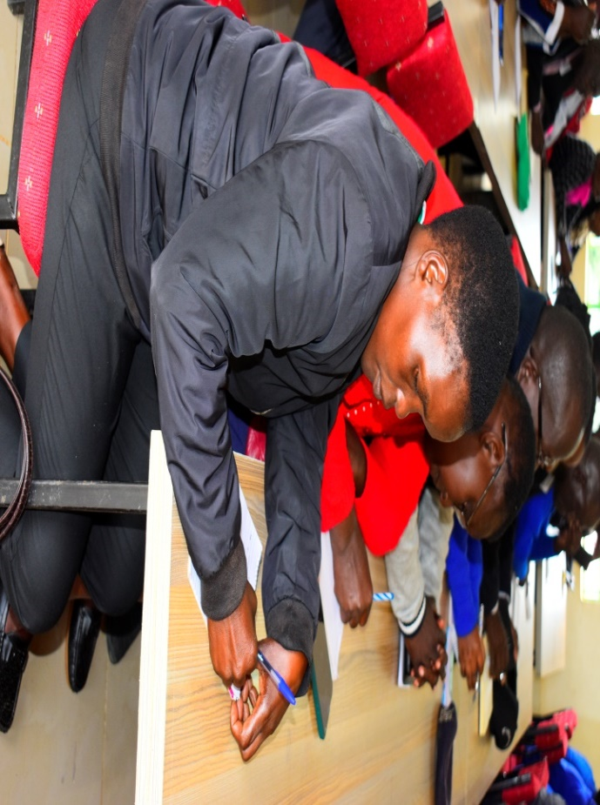 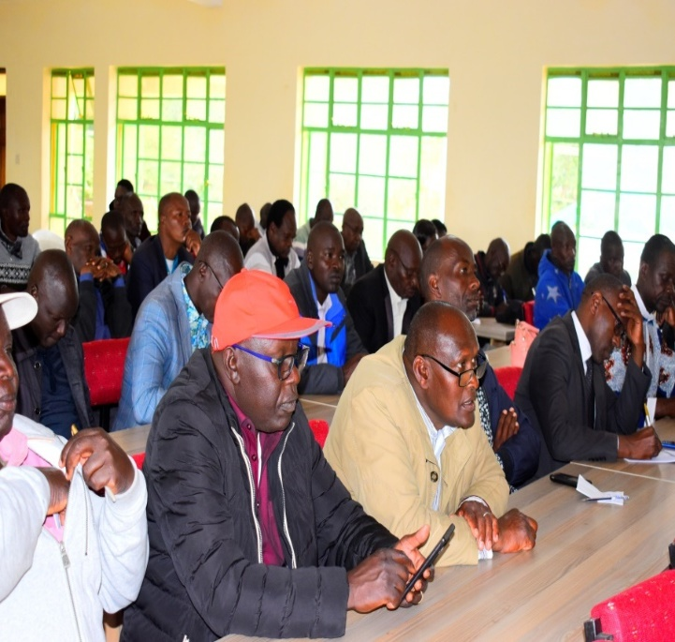

*Photos of public participation in simat/kapseret ward at kapseret sub county headquarters*

**2. LANGAS WARD- WARENG HIGH SCHOOL**

**DATE: 22ND OCTOBER 2024**

|  |  |  |  |  |  |  |  |  |  |  |  |  |  |  |  |  |  |  |  |  |  |  |  |  |  |  |  |  |  |  |  |  |  |  |  |  |  |  |  |  |  |  |  |  |  |  |  |  |  |  |  |  |  |  |  |  |  |  |  |  |  |  |  |  |  |  |  |  |  |  |  |  |  |  |  |  |  |  |  |  |  |  |  |  |  |  |  |  |  |  |  |  |
| --- | --- | --- | --- | --- | --- | --- | --- | --- | --- | --- | --- | --- | --- | --- | --- | --- | --- | --- | --- | --- | --- | --- | --- | --- | --- | --- | --- | --- | --- | --- | --- | --- | --- | --- | --- | --- | --- | --- | --- | --- | --- | --- | --- | --- | --- | --- | --- | --- | --- | --- | --- | --- | --- | --- | --- | --- | --- | --- | --- | --- | --- | --- | --- | --- | --- | --- | --- | --- | --- | --- | --- | --- | --- | --- | --- | --- | --- | --- | --- | --- | --- | --- | --- | --- | --- | --- | --- | --- | --- | --- | --- | --- |
| |  |  |  |  |  |  |  | | --- | --- | --- | --- | --- | --- | --- | | NO | SCHOOL | POPULATION/  ENTROLMENT | STAFF ESTABLISHMENT | LAND ACRES | NO OF PERMANENT CLASSROOMS | PROPOSED PROJECT AS PER PRIORITY | |  | Langas Primary School | Boys-860  Girls-877  Total-1737 | TSC Teachers-42  Male-14  Female-28  B.O.M-nil  Male-nil  Female-nil | 4.5 acres | 38 | * Construction of administration block * Construction of two classrooms * Purchase of desks and office furniture * Construction of a laboratory * Construction of a library * Construction of a kitchen * Construction of a dining hall | |  | Mwiruti Secondary School | Boys-337  Girls-247  Total-584 | TSC Teachers-33  Male-6  Female-27  B.O.M-7  Male-4  Female-3 | 6 acres | 14 | * Construction of boys,girls and staff pit latrines * Construction of classrooms * Construction of kitchen. Construction of library. * Construction of Multi-purpose hall * Purchase of furniture * Construction of school Gate * Fencing of school compound * Construction of Laboratories * Construction of Dining hall * ICT Laboratory * Administration block | |  | Mwiruti Primary School | Boys-272  Girls-235  Total-507 | TSC Teachers-26  Male-7  Female-19  B.O.M-1  Male-1  Female-0 | 7 acres | 20 | * ­Renovation of (12) No classrooms * Construction of administration block * Construction of pit latrines for boys ,girls and staff * Installation of water tanks | |  | Kapkenduiywo Primary School | Boys-349  Girls-352  Total-701 | TSC Teachers-20  Male-5  Female-15  B.O.M-Nil | 3 acres | 19 | * Construction of 2 classrooms * Construction of pit latrines for boys ,girls and staff * Furniture for both teachers and pupils * Purchase of land * Electricity connection | |  | Gitwe Primary School | Boys-164  Girls-140  Total-304 | TSC Teachers-16  Male-11  Female-5  B.O.M-1  Male-1  Female-0 | 16 acres | 10 | * Leveling of playing ground * Fencing and gate * Renovation of 9 No classrooms * Construction of 2 No classrooms * Construction of pit latrines for boys, girls and teachers. * Purchase of furniture and desk * Construction of administration block | |  | Yamumbi Police Station |  |  |  |  | * Purchase of furniture * Construction of officer’s houses * Gate with sensory box and Fencing * Construction of modern offices * Construction of male and female pit latrines * Installation of water tanks * Installation of electricity * Purchase of motor vehicle for patrol | |  | Langas Police Station |  | Male officers-180  Female officers-60  Total-240 |  |  | * Purchase of furniture * Construction of police houses * Construction of male and female pit latrines * Construction of gate and fencing * Purchase of patrol vehicles | |  | Kipkaren Road Secondary School | Boys-165  Girls-154  Total-319 | TSC Teachers-16  Male-6  Female-10  B.O.M-1  Male-1  Female-Nil | 16 acres | 11 | * Construction of laboratory * Construction of 4 No classrooms * Purchase of desk * Construction of girls, boys and teachers pit latrines * Installation of water tank * Purchase of bus * Construction of multi-purpose hall * Construction of library | |  | Wareng High school | Boys-804  Girls-1235  Total-2039 | TSC Teachers-84  Male-31  Female-53  B.O.M-3  Male-2  Female-1 | 15 acres | 32 | * Construction of classrooms * Construction of Dining hall * Construction of Laboratories * Construction of male ,female and teachers pit latrines * Fencing of school compound * Construction of kitchen * Purchase of furniture’s and desk * Purchase of school Bus | |  | Kapseret sub county DCIO office |  | 12officers |  | 25 | * Construction of modern offices * Construction of houses * Purchase of furniture * Construction of male and female pit latrines * Purchase of vehicle | |  | Gitwe police post |  | Male staff -5  Female staff-0  Total-5 |  |  | * Purchase of patrol vehicle * Purchase of land * Construction of offices and cells with armory room * Construction of police houses * Purchase of furniture * Construction of male and female pit latrines * Construction of gate and fencing * Installation of water tank * Installation of electricity | |  | Pioneer ACC Office | N/A |  | 0.5 Acres |  | * Construction of 6 Unit ACC office | |  |

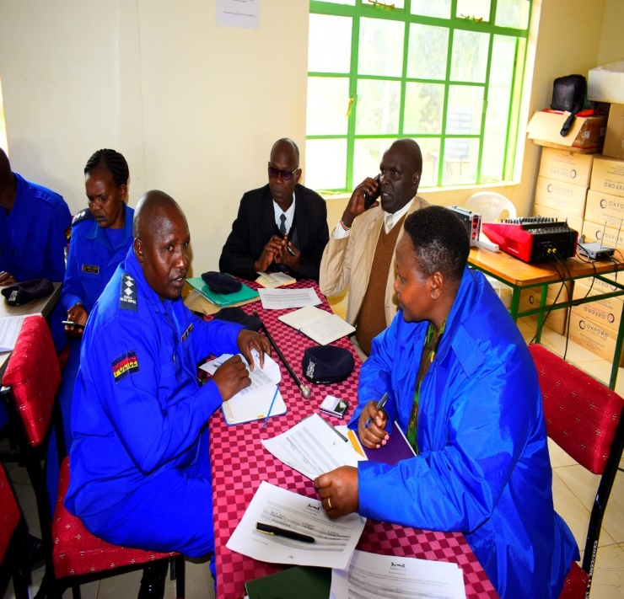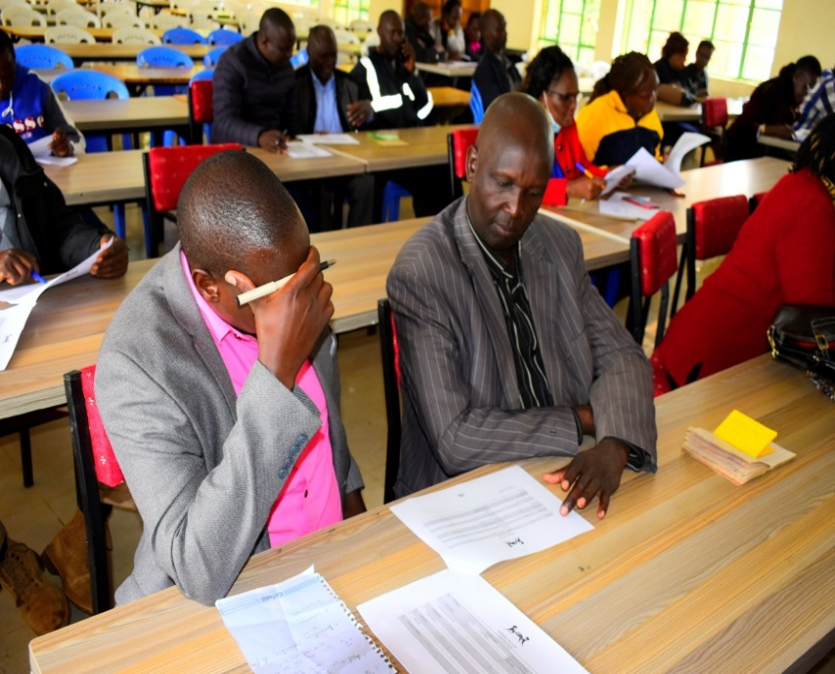

*Photos of public participation in langas ward at wareng high school*

**3. NGERIA WARD- ACK KIPSAMOO CHURCH**

**DATE: 16TH OCTOBER 2024**

|  |  |  |  |  |  |  |
| --- | --- | --- | --- | --- | --- | --- |
| **NO** | **SCHOOL** | **POPULATION/**  **ENTROLMENT** | **STAFF ESTABLISHMENT** | **LAND ACRES** | **NO OF PERMANENT CLASSROOM** | **PROPOSED PROJECT AS PER PRIORITY** |
|  | Kamuzee Primary School | Boys-130  Girls-120  Total-250 | TSC Teachers-13  Male-2  Female-11  B.O.M-nil  Male-nil  Female-nil | 5 | 10 | * Construction of boys,girls and teachers pit latrines * Construction of administration block * Construction of 2 No classrooms * Purchase of furniture and desk * Construction of school gate and fencing * Leveling of play ground * Installation of water tank |
|  | Nandi Gaa Primary School | Boys-173  Girls-182  Total-355 | TSC Teachers-16  Male-4  Female-12  B.O.M-Nil  Male-Nil  Female-Nil | 5.5acres | 8 | * Construction of 2 No classrooms * Renovation of 2 No classrooms * Installation of water tank * Construction of administration block * Construction of male ,female and teachers pit latrines |
|  | Kipsamoo Primary School | Boys-168  Girls-154  Total-322 | TSC Teachers-14  Male-6  Female-8  B.O.M-Nil  Male-Nil  Female-Nil | 8 acres | 8 | * Construction of administration block * Renovation of 9 classrooms * Construction of 1 classroom * Construction of boys ,girls and teachers pit latrines * Purchase of desk * Fencing of school compound |
|  | NgaraFalls Secondary School | Boys-79  Girls-75  Total-154 | TSC Teachers-18  Male-8  Female-10  B.O.M-0  Male-0  Female-0 | 21 acres | 8 | * Construction of library * Renovation of 7 No classrooms * Construction of 1 classroom * Construction of a laboratory * Construction of boy’s dormitory * Construction of boys, girls and staff pit latrines * Construction of a multi-purpose hall * Construction of school kitchen * Construction of administration block * Installation of water tank |
|  | Kiambaa Primary School | Boys-196  Girls-178  Total-374 | TSC Teachers-16  Male-3  Female-13  B.O.M-2  Male-1  Female-1 | 8 | 12 | * Construction of boys, girls and teachers toilet * Renovation of 2 No classrooms * Purchase of 400 lockers * Construction of administration block * Construction of five classrooms * Fencing and gate |
|  | Kipkaren Airport Primary School | Boys-7  Girls-14  Total-21 | TSC Teachers-9  Male-2  Female-7  B.O.M-nil  Male-nil  Female-nil | 10 acres | 9 | * Construction of administration block * Renovation of eight classrooms |
|  | Ngara Falls Primary School | Boys-250  Girls-233  Total- 483 | TSC Teachers-13  Male-6  Female-7  B.O.M-3  Male-1  Female-2 | 15.9 acres | 16 | * Construction of girls,boys and tecahers pit latrines * Construction of administration block * Purchase of school Furniture * Fencing and gate |
|  | Kanetik Primary School | Boys-71  Girls-75  Total-146 | TSC Teachers-5  Male-Nil  Female-5  B.O.M-nil  Male-nil  Female-nil | 3 acres | 4 | * Constructions of six classrooms * Construction of girls ,boys and teachers pit latrines * Construction of administration block * Gate and fencing of the school * Electricity connection * Purchase of land for play ground |
|  | Kiambaa Secondary School | Boys-140  Girls-170  Total-310 | TSC Teachers-12  Male-4  Female-8  B.O.M-3  Male-1  Female-2 | 3.5 acres | 8 | * Construction of science laboratory * Construction of administration block * Renovation of 8 No classrooms * Installation of water tank * Construction of girls ,boys and teachers pit latrines * Purchase of school bus * Construction of kitchen * Construction of dining hall |
|  | Chepyakwai Primary School | Boys-125  Girls-111  Total-236 | TSC Teachers-12  Male-5  Female-7  B.O.M-Nil  Male-Nil  Female-Nil | 15 acres | 8 | * Renovation of eight classrooms and construction three classrooms * Construction of administration block * Purchase of 135 lockers * Fencing and gate * Construction of boys,girls and teachers pit latrines * Leveling of play ground |
|  | Kimuri Primary School | Boys-136  Girls-158  Total-294 | TSC Teachers-9  Male-4  Female-5  B.O.M-1  Male-Nil  Female-1 | 9.5 acres | 10 | * Construction of administration block * Construction of boys ,girls and teachers pit latrines * School gate and fencing |
|  | St Mary’s Chelabal Primary School | Boys-96  Girls-101  Total- 197 | TSC Teachers-11  Male-6  Female-5  B.O.M-  Male-  Female- | 4 acres | 9 | * Purchase of furniture and Desks * Construction of school gate and fencing * Construction of boys, girls and teachers pit latrines * Installation of water tanks * Connection of electricity to classrooms |
|  | Kermetio Primary School | Boys-196  Girls-243  Total- 439 | TSC Teachers-14  Male-4  Female-10  B.O.M-Nil  Male-Nil  Female-Nil | 5 acres | 9 | * Construction of administration block * Purchase of furniture and desk * Construction of 4 No classrooms * Construction of girls,boys and teachers pit latrines |
|  | Oscar Sudi Mixed secondary school-Kapseret | Boys-70  Girls-44  Total- 114 | TSC Teachers-1  Male-0  Female-1  B.O.M-6  Male-2  Female-4 | 5 acres | 4 | * Purchase of furniture and desk * Installation of water tank * Construction of laboratory * Construction of library * Construction of kitchen * Construction of 8 NO classroom * Construction of administration block * Construction of multi-purpose hall * Construction of girls ,boys and teachers pit latrines * Purchase of school bus |
|  | Nairiri Primary School | Boys-143  Girls-181  Total-324 | TSC Teachers-8  Male-2  Female-6  B.O.M-1  Male-0  Female-1 | 2 acres | 6 | * Purchase of 3 acres piece of land * Construction of 3 classes * Installation of electricity * Purchase of desk * Construction of administration block |
|  | Kapseret sub county education office |  |  |  |  | * Repair of plumb works |
|  | Jasho Primary School | Boys-179  Girls-211  Total-390 | TSC Teachers-17  Male-6  Female-11  B.O.M-Nil  Male-Nil  Female-Nil | 3.5 acres | 9 | * Construction of administration block * Construction of 3 classrooms * Purchase of desk and furniture * Installation of water tank * Leveling play ground |
|  | Koibasui Primary School | Boys-175  Girls-165  Total-340 | TSC Teachers-11  Male-6  Female-5  B.O.M-1  Male-Nil  Female-1 | 4.5 acres | 9 | * Renovation of classrooms * Construction of 3 classroom * Construction of boys, girls pit latrine * Purchase of 2 acres for playground * Repair and purchase of 100 desks |
|  | Kosyin Ngara Primary School | Boys-68  Girls-77  Total-145 | TSC Teachers-5  Male-2  Female-3  B.O.M-nil  Male-nil  Female-nil | 2 acres | 3 | * Construction of 2 classrooms * Purchase of land for playground * Construction of administration block * Construction of boys,girls and teachers pit latrines * Gate and fencing * Electricity connection |
|  | AIC Chepyakwai Secondary School | Boys-93  Girls-75  Total-168 |  |  |  | * Construction of 5 No classrooms * Construction of laboratory * Construction of kitchen * Construction of boys, girls and teachers pit latrine * Installation of electricity * Construction of administration block * Construction of library * Purchase of school bus |
|  | Ngeria Chief’s Office |  |  |  |  | * Construction of Kaplelach assistant chief’s office * Renovation of Ngeria chief office * Purchase of a printer * Electricity connection * Tree planting |
|  | Ngeria assistant chiefs office-kabongo sub location |  |  |  |  | * Construction of offices * Purchase of furniture * Construction of male and female pit latrines * Construction of gate * Construction of staff houses * Installation of water tank * Installation of electricity |
|  | Ngeria assistant chiefs office-kaplelach sub-location |  |  |  |  | * Construction of 5 unit office * Purchase of furniture * Construction of male and female pit latrines * Construction of gate and fencing * Installation of water tank * Installation of electricity * General landscape |
|  | ACC office Ngeria Division |  |  |  |  | * Construction of offices * Construction of male and female pit latrines * Construction of staff houses * Installation of water tank * Installation of electricity |
|  | Kiambaa police station |  | Male officers- 32  Female officers -5  Total -37 | 2.5 acres | 17 | * Purchase of office furniture * Construction of offices(Gender office, children office, holding rooms/cells ,armoury room and other offices) * Construction of gate and fencing * Construction of male and female pit latrines * Construction police houses |
|  | Kaplelach police station |  |  |  |  | * Installation of Water tanks * Construction of police houses * Construction of gate and Perimeter fence |
|  | Kapseret Sub-county administrationpolice office |  | Male officers-39  Female officers-17  Total-56 |  |  | * Construction of offices * Construction of male and female pit latrines * Purchase of land * Purchase of furniture |
|  | Kapseret Sub-County DCC office |  | Male officers-6  Female officers-9  Total-15 |  |  | * ICT Equipments-computers |

**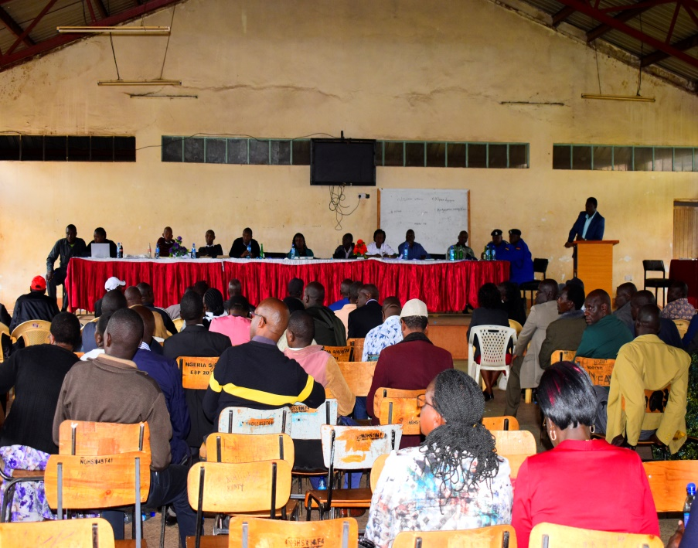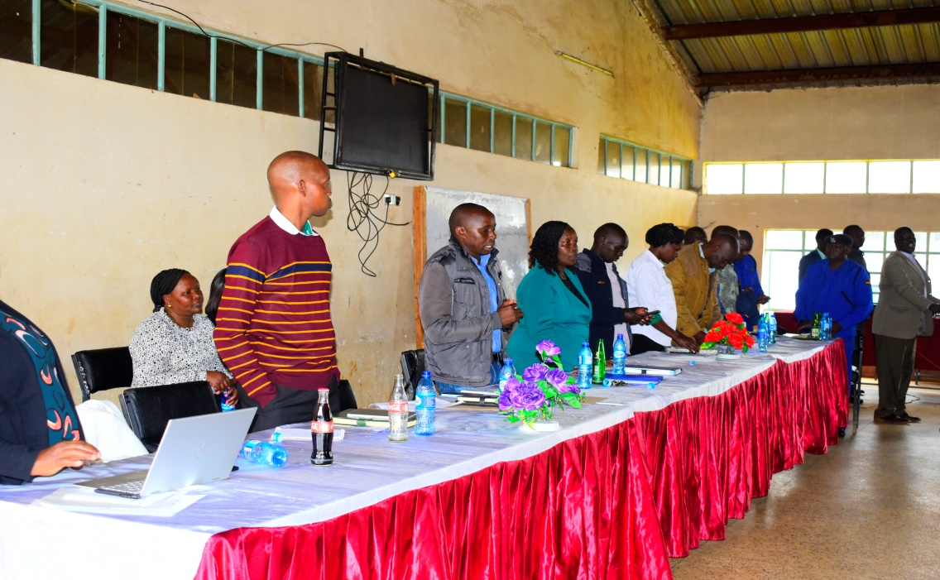***Photos of public participation of Ngeria ward in Ack Kipsamoo church*

**4. MEGUN WARD- AIC NGERIA GIRLS SECONDARY SCHOOL**

**DATE: 15TH OCTOBER 2024**

|  |  |  |  |  |  |  |
| --- | --- | --- | --- | --- | --- | --- |
| **NO** | **SCHOOL** | **POPULATION/**  **ENTROLMENT** | **STAFF ESTABLISHMENT** | **LAND ACRES** | **NO OF PERMANENT CLASSROOM** | **PROPOSED PROJECT AS PER PRIORITY** |
|  | Davies Secondary School | Boys-83  Girls-84  Total-167 | TSC Teachers-10  Male-3  Female-7  B.O.M-1  Male-1  Female-0 | 10 acres | 7 | * Purchase of school bus * Construction of permanent kitchen and dining hall * Equipping the laboratory with gas, water, electricity and piping. * Installation of tanks * Renovation of 7 No classrooms * Construction of 2 classroom * Purchase of Furniture and desk * Construction of boys ,girls and teachers pit latrines. * Construction of teacher’s quarters * Leveling of playing field |
|  | Konyit Primary School | Boys-191  Girls-116  Total-307 | TSC Teachers-12  Male-5  Female-7  B.O.M-Nil  Male-Nil  Female-Nil | 2.5 acres | 8 | * Purchase of land for play ground * Construction of two classrooms * Renovation of 9 No classrooms * Construction of administration block * Construction of boys,girls and teachers toilet * Purchase of 200 desks * Drilling of a borehole |
|  | Barnotik primary school | Boys-254  Girls-227  Total-481 | TSC Teachers-11  Male-4  Female-7  B.O.M-2  Male-1  Female-1 | 3 acres | 12 | * Construction of 2 new classrooms * Construction of administration block * Purchase of desk * Construction of permanent gate |
|  | Ngeria Primary School | Boys-160  Girls-138  Total-298 | TSC Teachers-15  Male-5  Female-10  B.O.M-0  Male-0  Female-0 | 23 acres | 8 | * Renovation of 9 No classrooms * Construction of 4 No classrooms * Purchase of furniture’s and desk * Construction of more pit latrines * Construction of administration block * Construction of school gate and fencing * Electricity connection |
|  | Proposed Cheptabach primary school | Boys-80  Girls-105 |  | 1 acre |  | * Purchase of land * Construction of new classrooms * Construction of administration block * Construction of girls,boys and teachers pit latrines * Installation of water tank * Installation of electricity |
|  | A.I.C Kosirai Secondary School | Boys-54  Girls-66  Total-120 | TSC Teachers-8  Male-3  Female-5  B.O.M-2  Male-1  Female-1 | 7 acres | 9 | * Construction of administration block * Construction of dining hall * Construction of libraries * Construction of kitchen * Construction of multi- purpose hall * Construction of school gate * Purchase of furniture’s and desk * Construction of girls, boy and teachers pit latrines |
|  | A.I.C Ngeria Girls Secondary school | Girls-700  Total-700 | TSC Teachers-29  Male-11  Female-18  B.O.M-8  Male-4  Female-4 | 60 acres | 23 | * Construction of administration block with staffroom, library, computer lab, deputy offices and boardroom * Installation of water tanks * Construction of science laboratories * Renovations of home science laboratory * Purchase of furniture and desk * Construction of girls pit latrines * Construction of school gate * Renovation of school kitchen |
|  | Koros Secondary School | Boys-53  Girls-42  Total-95 | TSC Teachers-8  Male-5  Female-3  B.O.M-Nil  Male-Nil  Female-Nil | 3 acres | 5 | * Construction of boys,girls and teachers pit latrines * Renovation of 5 No classrooms * Renovation of administration Block * Construction of Dinning hall * Construction of school library * Construction of school kitchen |
|  | Kingwal Primary School | Boys-72  Girls-99  Total-172 | TSC Teachers-9  Male-3  Female-6  B.O.M-1  Male-Nil  Female-1 | 25 acres | 10 | * Construction of boys,girls and staff toilets * Renovation of 8 No classrooms * Repair and purchase of desks * Fencing and gate of the school * Leveling of playground |
|  | Songoliet Primary School | Boys-167  Girls-140  Total-307 | TSC Teachers-15  Male-2  Female-4  B.O.M-4  Male-0  Female-4 | 5.5 acres | 11 | * Purchase of school land * Construction of 9 classrooms * Construction of boys,girls and teachers pit latrines * Construction of administration block * Purchase of furniture and desk * Construction of school gate and fencing |
|  | Megun chiefs office |  | 3 officers | 0.5 acres | 5 | * Renovation of office( re-roofing with painted iron sheets, floor tilling and wall painting) * Construction of male and female pit latrines * Purchase of furniture * Installation of water tanks * Construction of 4 offices * Fencing(chain link fence) |
|  | Ochemina Primary School | Boys-162  Girls-223  Total-385 | TSC Teachers-11  Male-4  Female-7  B.O.M-3  Male-Nil  Female-3 | 5 acres | 11 | * Renovation of 11 classrooms * Construction of 5 classrooms * Construction of girls and teachers pit latrines * Purchase of furniture * Purchase of 1 acre land |
|  | D.E.B Momoniat primary school | Boys-122  Girls-115  Total-237 | TSC Teachers-10  Male-6  Female-4  B.O.M-2  Male-2  Female-Nil | 20 acres | 11 | * Renovation of 10 No classrooms * Construction of administration block * Construction of three classrooms * Purchase of 180 desks * Construction of boys, girls and teachers pit latrines * Fencing and gate * Leveling of play ground * Electricity connection |
|  | Legetet Primary School | Boys-127  Girls-126  Total-253 | TSC Teachers-9  Male-4  Female-5  B.O.M-1  Male-Nil  Female-1 | 11 acres | 8 | * Renovation of 7 No classrooms * Construction of two classrooms * Construction of administration block * Purchase of desks |
|  | AIC Kosirai Primary School | Boys-137  Girls-135  Total-272 | TSC Teachers-11  Male-6  Female-5  B.O.M-1  Male-0  Female-1 | 10 acres | 8 | * Renovation of 9 No classrooms * Construction boys,girls and teachers pit latrines * Purchase of desk * Desks 100 pieces * Office furniture (tables and chairs) * Fencing and gate |
|  | AIC Belekenya Primary School | Boys-190  Girls-214  Total-404 | TSC Teachers-7  Male-3  Female-8  B.O.M-2  Male-1  Female-1 | 13 acres | 8 | * Constructions of pit latrines for boys, girls and teachers pit latrines * Construction of administration block * Electricity connection * Construction of 1 classroom * Installation of water tank |
|  | Kibabet Primary School | Boys-115  Girls-88  Total-203 | TSC Teachers-9  Male-3  Female-6  B.O.M-1  Male-Nil  Female-1 | 10 acres | 9 | * Renovation of 9 classrooms * Construction of administration block * Construction of pit latrines for boys ,girls and teachers pit latrines * Purchase of furniture * Construction of classrooms * Fencing and gate |
|  | Davis Primary School | Boys-126  Girls-125  Total-230 | TSC Teachers-13  Male-3  Female-9  B.O.M-Nil  Male-Nil  Female-NIL | 20 acres | 8 | * Renovation of 11 No classrooms * Construction of 4 classrooms * Construction of administration block * Construction of boys, girls and teachers pit latrines * Installation of water tanks |
|  | Songoliet Secondary School | Boys-335  Girls-415  Total-750 | TSC Teachers-18  Male-6  Female-12  B.O.M-11  Male-4  Female-7 | 2 acres | 12 | * Purchase of land * Installation of water tanks * Renovation of 8 No classrooms * Construction of 6 classrooms * Construction of boys,girls and teachers pit latrines * Construction of school library * Construction of school gate and fencing |
|  | Megun assistant Chiefs Office |  |  | 1acre |  | * Purchase of furniture * Construction of gate and fencing * Installation of tank * Construction of ICT hub * Electricity connection |
|  | Songoliet assistant chief office |  |  | 1acre |  | * Construction of chief’s office |
|  | Kabongwa Primary School | Boys-118  Girls-115  Total-233 | TSC Teachers-12  Male-3  Female-9  B.O.M-0  Male-0  Female-0 | 26 acres | 8 | * Renovation of 8 No classrooms * Construction of 2 No classrooms * Installation of water tanks * Construction of school gate and fencing * Construction of administration block * Construction of pit latrines for boys,girls and teachers |
|  | Proposed Megun Police Station |  |  |  |  | * Purchase of land * Construction of offices * Construction of pit latrines for make and female staff * Construction of gate and fencing * Purchase of motor vehicle |
|  | Ngeria TTI | Male -250  Female -196  Total-446 | Tuitors-11  Male-6  Female-5 | 20 acres | Tuition block available 90% complete | * Connection of electricity * Landscaping * Hostels * Gate/fencing * Multi-purpose hall * ICT/Computer lab * Equipment workshop |
|  | Proposed Chepkoiya SDA primary school | Boys -116  Girls-131 | Bom-8  Male-4  Female-4 | Land yet to be purchased | None | * Purchase of land * Construction of 4 new classrooms * Construction of pit latrines |

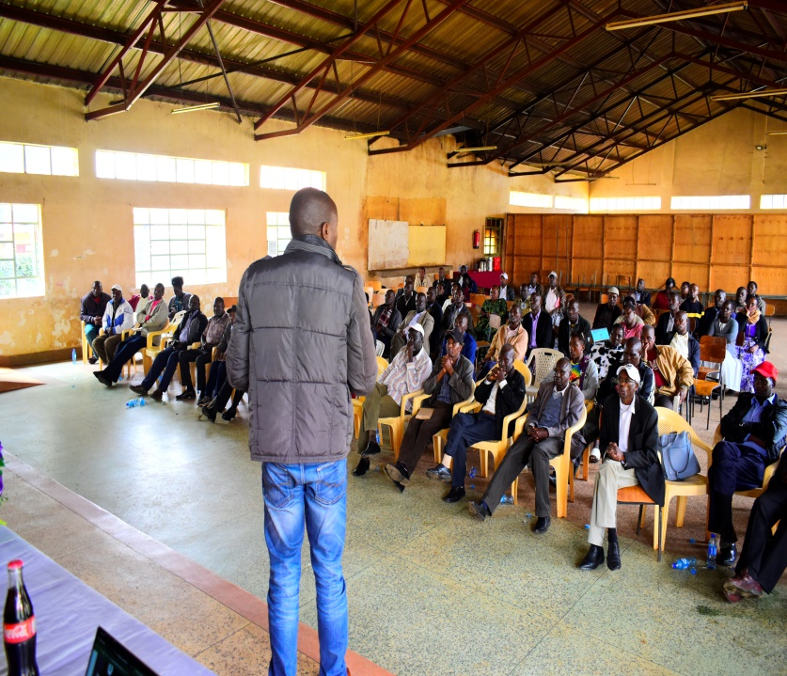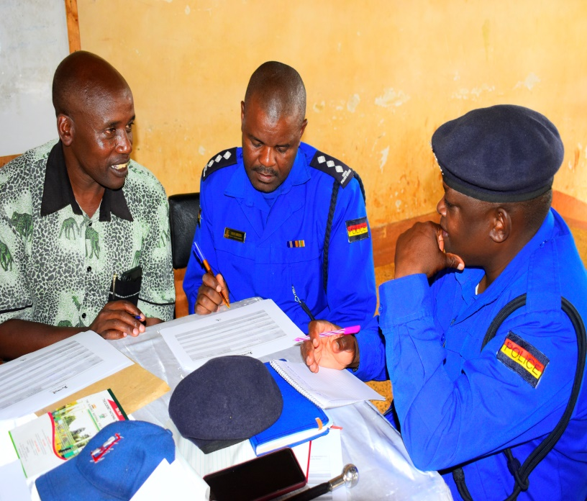

*Photos of public participation in Megun ward at AIC Ngeria Girls secondary school*

**5. KIPKENYO WARD-KIPKAREN ROAD PRIMARY SCHOOL**

**DATE: 18TH OCTOBER 2024**

|  |  |  |  |  |  |  |
| --- | --- | --- | --- | --- | --- | --- |
| **NO** | **SCHOOL** | **POPULATION/**  **ENROLMENT** | **STAFF ESTABLISHMENT** | **LAND ACRES** | **NO OF PERMANENT CLASSROOMS** | * **PROPOSED PROJECT AS PER PRIORITY** |
|  | Kipkaren Road Primary School | Boys-850  Girls-805  Total-1655 | TSC Teachers-33  Male-10  Female-23  B.O.M-nil  Male-nil  Female-nil | 9 acres | 31 | * Renovation of 19 classrooms * Construction of teachers toilet * Perimeter wall * Construction of a library * Construction of a dinning hall |
|  | Kimalel Primary School | Boys-1072  Girls-1064  Total-2136 | TSC Teachers-40  Male-8  Female-32  B.O.M-4  Male-2  Female-2 | 8 acres | 25 | * Construction of a storey building of 16 classrooms * Renovation of 13 No classrooms * Construction of girls,boys and teachers pit latrines * Construction of laboratory * Purchase of furniture * Construction of library * Construction of dinning hall |
|  | Kipkenyo Primary School | Boys-215  Girls-212  Total-427 | TSC Teachers-15  Male-4  Female-11  B.O.M-0  Male-0  Female-0 | 7 acres | 12 | * Lockers for junior secondary * Fencing of the school compound and Modern gate * Installation of Water tank 10,000litres |
|  | ACK St Barnabas Kipkenyo Secondary School | Boys-231  Girls-150  Total-381 | TSC Teachers-23  Male-12  Female-11  B.O.M-3  Male-3  Female-0 | 5.2 acres | 10 | * Construction of library. * Construction of classrooms * Purchase of furniture and desk * Construction of Administration block * Construction of Dining hall * Construction of Laboratories * Construction of kitchen * Construction of pit latrines for boys, girls and teachers * Construction of dormitory * Construction of Administration block * Purchase of land |
|  | St Marys’s Chebarus Primary School | Boys-238  Girls-228  Total-466 | TSC Teachers-23  Male-5  Female-18  B.O.M-1  Male-0  Female-1 | 1.8 acres | 8 | * Construction of 6 No classrooms * Purchase of desk * Construction of latrines for boys, girls and teachers * Construction of school gate and fencing * Construction of administration block |
|  | Pioneer Chief’s Office |  | Male officers-4  Female officesr-4  Total -8 | ¾ acre |  | * Installation of electricity to the offices and security light * Purchase of office furniture * Purchase of land * Construction of gate and fencing |
|  | ACC office pioneer Division |  |  |  |  | * Construction of modern office * Construction of houses * Purchase of furniture * Construction of male and female pit latrines |
|  | Pioneer police post |  | Male officers-22  Female offices-5  Total-  27 police officers |  |  | * Purchase of land * Construction of offices * Purchase of furniture’s * Construction of male and female pit latrines * Construction of police quaters * Purchase of Motor vehicles. * Construction of gate and fencing |

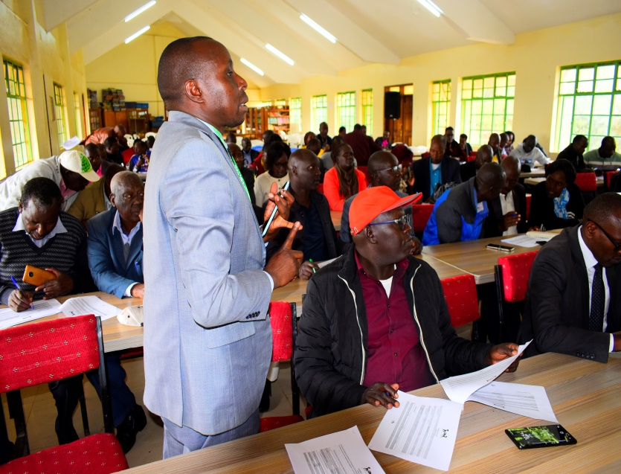 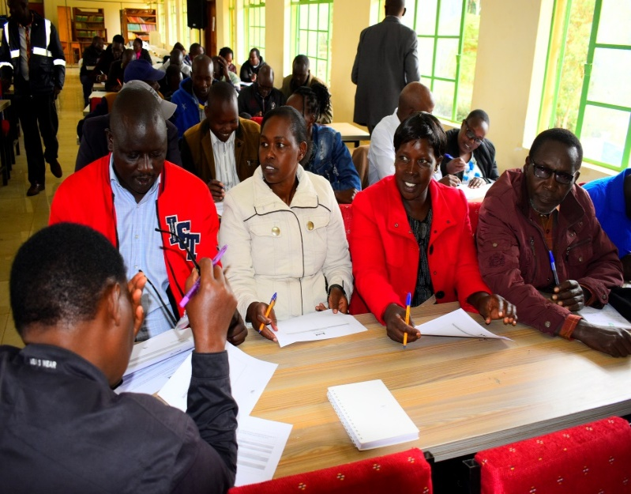

*Photos of public participation in kipkenyo ward at kipkaren road primary school*

**CONCLUSION**

The ward open forum public meeting was carried out successfully. The meetings were carried out for five (5) days each day per ward. The meetings were interactive and participatory. The Project Management Committees and other major stakeholders appreciated the good work done by the NG-CDFC for the past years.

The meetings concluded by resolving the following

* That the member of National Assembly should lobby the government to increase funding by the National Government Constituencies Development Fund and that funds should be disbursed timely to improve efficiency and effectiveness in project implementation.
* That the NG-CDFC should organize more public participation forums to help in project identification and prioritization.

**Compiled by**

1. Benter Atieno Ogot Sign…………………….. Date…………………………...

**(NG-CDFC Secretary)**

**Confirmed by**

* 1. Mathew K Tanui Sign………………………. Date…………………………....

**(Fund Account Manager)**

* 1. Sammy K Rutto Sign………………………. Date………………………….....

**(NG-CDFC Chairperson)**

* 1. Edong’a Nanok Sign………………………… Date…………………………….

**(Deputy County Commissioner)**