|  |  |
| --- | --- |
| CDF logo 4 MsWord  **NG-CDF** | **National Government Constituencies Development Fund**  **NJORO Constituency**  P.O Box 531-20107  NJORO    **Cell**:0741-406-143…………………………..  **Email**: njorocdf@yahoo.com| **Website: www.cdf.go.ke** |

**A REPORT ON MAU NAROK WARD PUBLIC PARTICIPATION MEETING HELD AT MWISHO WA LAMI CHIEF’S OFFICE ON 18TH AUGUST 2021**

**Introduction**

**MEMBERS PRESENT**

1. Joseph N. Ndungu -NG-CDFC CHAIRMAN
2. Rose Kellong - NG-CDFC SECRETARY
3. Wesley Ngeno -FUND ACCOUNT MANAGER
4. Caroline Lemiso -NG-CDFC MEMBER
5. Joseph Kimani - NG-CDFC MEMBER
6. Dominic Langat - NG-CDFC MEMBER
7. Ruth Kemunto - NG-CDFC MEMBER
8. Joseph Ndirangu - NG-CDFC MEMBER
9. Clement Kabaya - NG-CDFC MEMBER
10. Nelson B. Mwangi - NG-CDFC STAFF

Members from Mau Narok

The NG-CDF team comprising of Fund Account Manager, NG-CDFC members, NG-CDFC staff arrived at the venue at 10.30am ready to receive project proposals from the people of Mau Narok Ward. The attendance of the meeting was good and reaction of the public was positive since the agenda of the day was to involve the public in addressing the needs of the people of Mau Narok.

The meeting started at 12.30 pm with a word of prayer from one of member of the public after which the NG-CDFC chairman explained to the members present the purpose of the meeting and the specific proposals to be received.

The Fund Account Manager also encouraged the members of the public to feel free in submitting their proposals and also clarified on issues raised by the public on the role of NG-CDF.

**Submission of proposals**

Submission of proposals was guided by the NG-CDF act which clearly defines the scope of projects to be undertaken by NG-CDF. The NG-CDF Act stipulates two broad categories which include those projects falling under:

1. Education
2. Security

The following projects were proposed by people present in the meeting.

|  |  |  |
| --- | --- | --- |
| **NO** | **NAME OF THE PROJECT** | **ACTIVITY** |
| 1 | GATIMU SECONDARY SCHOOL | Construction of 2 classrooms |
|  |  | Construction of a girls toilets |
|  |  | Construction of a boys toilets |
| 2 | Sururu Primary School | Construction of a girls/boys toilets |
|  |  | Renovation of 4 Classrooms |
|  |  | Construction of 2 classrooms |
| 3 | Metta Police Patrol Base | Fencing of the compound |
|  |  | A 10,000 ltr Water Tank |
|  |  | Construction of a Patrol Office |
| 4 | Mau Narok Secondary school | Purchase of a School Bus |
|  |  | Construction of a Twin Laboratory |
|  |  | Construction of a girls/boys toilets |
|  |  | Renovation of 8 Classrooms |
| 5 | Lare Primary School | Construction of a girls/boys toilets |
|  |  | Renovation of 2 Classrooms |
| 6 | Ngwataniro Primary School | Renovation of 8 Classrooms |
|  |  | Construction of 5 classrooms |
|  |  | Construction of a boys toilets |
| 7 | Mukungugu Primary School | Renovation of 14 Classrooms |
|  |  | Construction of 2 classrooms |
|  |  | Construction of a girls/boys toilets |
| 8 | Gathima Primary School | Construction of 3 classrooms |
|  |  | Construction of a girls toilets |
| 9 | Segutiet Secondary School | Construction of 2 classrooms |
|  |  | Construction of a girls/boys toilets |
| 10 | Ngwataniro Secondary School | Completion of a Storied building 4 classrooms |
|  |  | Completion of a Girls Dormitory |
| 11 | Analat Secondary School | Construction of a Laboratory |
|  |  | Construction of 2 classrooms |
|  |  | Purchase of Land |
| 12 | Kapyemit Primary School | Construction of 4 classrooms |
|  |  | Renovation of 6 Classrooms |
|  |  | Completion of a Girls Dormitory |
|  |  | Purchase of School desks |
|  |  | Leveling of School compound |
| 13 | Mau Narok Primary School | Renovation of 6 Classrooms |
|  |  | Construction of 2 classrooms |
|  |  | Construction of a boys toilets |
| 14 | Kianjoya Primary School | Construction of 2 classrooms |
|  |  | Construction of a girls toilets |
|  |  | Purchase of a 10,000ltr Tank |
|  |  | Renovation of 6 Classrooms |
| 15 | Likia Secondary School | Construction of 2 classrooms |
|  |  | Construction of a staff toilets |
|  |  | Construction of a boys toilets |
| 16 | Mahiga Secondary School | Construction of 2 classrooms |
|  |  | Construction of a girls toilets |
|  |  | Construction of a Kitchen |
|  |  | Construction of staff Quarters |
|  |  | Leveling of School compound |
| 17 | Kianjoya Secondary School | Construction of a Dining Hall |
|  |  | Borehole |
|  |  | Fencing of the compound |
|  |  | Construction of 2 classrooms |
|  |  | Completion of a Laboratory |
| 18 | Likia Primary School | Construction of 4 classrooms |
|  |  | Construction of a girls toilets |
| 19 | Maji Mingi Primary School | Renovation of 9 Classrooms |
|  |  | Construction of 2 classrooms |
|  |  | Construction of an Administration Block |
|  |  | Purchase of a 10,000ltr Tank |
| 20 | Bidii Mau Primary School | Construction of 2 classrooms |
|  |  | Construction of a girls toilets |
| 21 | Makutano Primary School | Construction of 2 classrooms |
|  |  | Construction of a girls toilets |
| 22 | Utalii Primary School | Construction of 4 classrooms |
|  |  | Construction of a girls toilets |
|  |  | Purchase of a 10,000ltr Tank |
| 23 | Analat Primary School | Renovation of 2 Classrooms |
|  |  | Construction of a girls toilets |
| 24 | Gatimu Primary School | Renovation of 9 Classrooms |
|  |  | Construction of an Administration Block |
| 25 | Maji Moto Chief's Office | Construction of an Office |

**MWISHO WA LAMI CHIEF’S OFFICE**

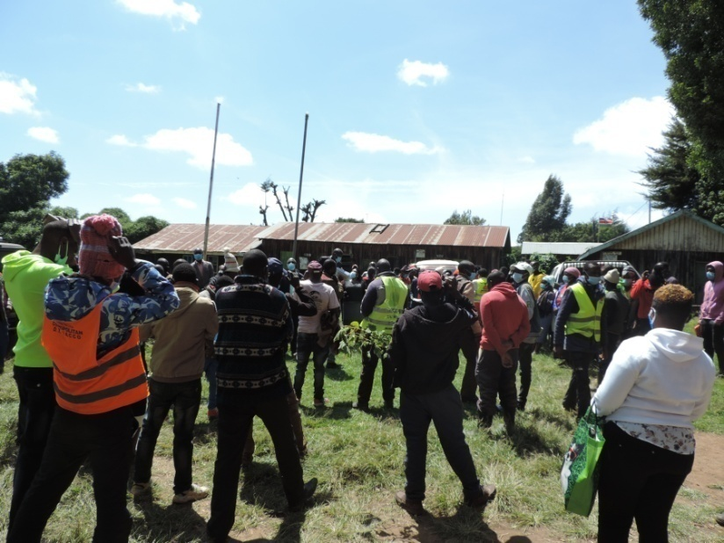

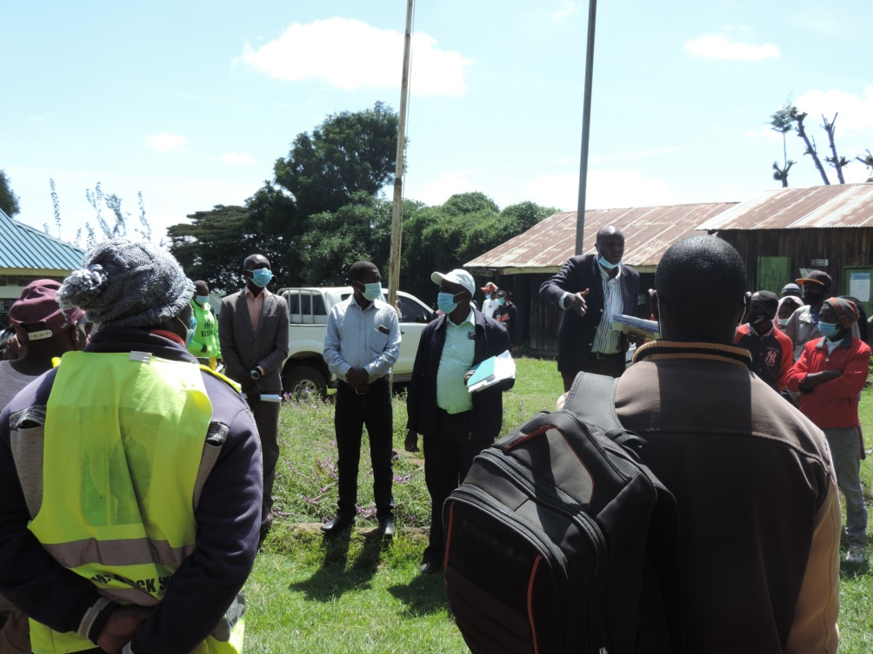

|  |  |
| --- | --- |
| CDF logo 4 MsWord  **NG-CDF** | **National Government Constituencies Development Fund**  **NJORO Constituency**  P.O Box 531-20107  NJORO    **Cell**:0741-406-143…………………………..  **Email**: njorocdf@yahoo.com| **Website: www.cdf.go.ke** |

**A REPORT ON MAU NAROK WARD COLLECTING SHORT COURSES AND DRIVING APPLICATIONS MEETING HELD AT ACC MAU NAROK OFFICE ON 18TH AUGUST 2021**

**INTRODUCTION**

**MEMBERS PRESENT**

1. Joseph N. Ndungu -NG-CDFC CHAIRMAN
2. Rose Kellong - NG-CDFC SECRETARY
3. Wesley Ngeno -FUND ACCOUNT MANAGER
4. Caroline Lemiso -NG-CDFC MEMBER
5. Joseph Kimani - NG-CDFC MEMBER
6. Dominic Langat - NG-CDFC MEMBER
7. Ruth Kemunto - NG-CDFC MEMBER
8. Joseph Ndirangu - NG-CDFC MEMBER
9. Clement Kabaya - NG-CDFC MEMBER
10. Nelson B. Mwangi - NG-CDFC STAFF

Members from Mau Narok

The NG-CDF team comprising of Fund Account Manager, NG-CDFC members, NG-CDFC staff arrived at the venue at 10.00am ready to receive project proposals from the people of Mau Narok Centre. The meeting started at 11.10 am with a word of prayer from one of member of the public after which the NG-CDFC chairman explained to the members present the purpose of the meeting which was registration of applicants for short courses and driving. The applicants had to present a letter of application and a copy of the identity card.

The courses offered by the NG-CDF Njoro bursary were Catering, Hair Dressing, Electrical, Fashion & Design and Driving.

Attached is a list of applicants:

|  |  |
| --- | --- |
| CDF logo 4 MsWord  **NG-CDF** | **National Government Constituencies Development Fund**  **NJORO Constituency**  P.O Box 531-20107  NJORO    **Cell**:0741-406-143…………………………..  **Email**: njorocdf@yahoo.com| **Website: www.cdf.go.ke** |

**A REPORT ON MAUCHE WARD PUBLIC PARTICIPATION MEETING HELD AT MAUCHE CHIEFS OFFICE ON 18TH AUGUST 2021**

**INTRODUCTION**

**MEMBERS PRESENT**

1. Joseph N. Ndungu -NG-CDFC CHAIRMAN
2. Rose Kellong - NG-CDFC SECRETARY
3. Wesley Ngeno -FUND ACCOUNT MANAGER
4. Caroline Lemiso -NG-CDFC MEMBER
5. Joseph Kimani - NG-CDFC MEMBER
6. Dominic Langat - NG-CDFC MEMBER
7. Ruth Kemunto - NG-CDFC MEMBER
8. Joseph Ndirangu - NG-CDFC MEMBER
9. Clement Kabaya - NG-CDFC MEMBER
10. Nelson B. Mwangi - NG-CDFC STAFF

Members from Mauche

The NG-CDF team comprising of Fund Account Manager, NG-CDFC members, NG-CDFC staff arrived at the venue at 2.00pm ready to receive project proposals from the people of Mauche Ward. The attendance of the meeting was good and reaction of the public was positive since the agenda of the day was to involve the public in addressing the needs of the people of Mauche Ward through NG-CDF. The meeting started at 2.15 pm with a word of prayer from one of member of the public after which the NG-CDFC chairman explained to the members present the purpose of the meeting and the specific proposals to be received.

The Fund Account Manager also encouraged the members of the public to feel free in submitting their proposals and also clarified on issues raised by the public on the role of NG-CDF

**Submission of proposals**

Submission of proposals was guided by the NG-CDF act which clearly defines the scope of projects to be undertaken by NG-CDF. The NG-CDF Act stipulates two broad categories which include those projects falling under:

1. Education
2. Security

The following projects were proposed by people present in the meeting.

|  |  |  |
| --- | --- | --- |
|  | **WARD** | **MAUCHE** |
| **NO** | **NAME OF THE PROJECT** | **ACTIVITY** |
| 1 | Kaptich Secondary School | Construction of a Laboratory |
|  |  | Construction of 3 classrooms |
| 2 | Kapkembu Secondary School | Construction of a girls toilets |
|  |  | Construction of a Staff toilets |
|  |  | Construction of a Laboratory |
| 3 | Siryat Secondary School | Construction of a Laboratory |
|  |  | Construction of a boys toilets |
|  |  | Electrification |
|  |  | Construction of 3 classrooms |
| 4 | Teret Primary School | Renovation of 6 Classrooms |
|  |  | Construction of a boys toilets |
| 5 | Ewaat Secondary school | Construction of 2 classrooms |
|  |  | Construction of a Staff toilets |
|  |  | Renovation of a Laboratory |
|  |  | Construction of a Multipurpose Hall |
| 6 | Teret Secondary School | Completion of a Science Laboratory |
|  |  | Completion of a Computer Laboratory |
| 7 | Mosop Primary School | Construction of 6 classrooms |
|  |  | Construction of an Administration Block |
|  |  | Construction of a Staff toilets |
|  |  | Construction of a girls/boys toilets |
| 8 | Kaptich Primary School | Construction of 3 classrooms |
|  |  | Construction of a girls toilets |
| 9 | Mosop Secondary School | Construction of 2 classrooms |
|  |  | Completion of a Laboratory |
| 10 | Kamungei Primary School | Construction of 3 classrooms |
|  |  | Construction of a Staff toilets |
|  |  | Renovation of 1 Classrooms |
|  |  | Purchase of Desks |
| 11 | Tebeswet Primary School | Construction of 4 classrooms |
|  |  | Construction of a girls toilets |
|  |  | Construction of a boys toilets |
| 12 | Koilonget Primary School | Renovation of 6 Classrooms |
|  |  | Construction of a girls toilets |
|  |  | Construction of an Administration Block |
| 13 | Koilonget Secondary School | Construction of 4 classrooms |
|  |  | Construction of a girls toilets |
|  |  | Construction of a boys toilets |
|  |  | Construction of a Staff toilets |
| 14 | Lelechonic Primary School | Construction of 6 classrooms |
|  |  | Construction of a girls toilets |
|  |  | Construction of a boys toilets |
|  |  | Construction of an Administration Block |
|  |  | Purchase of Land |
| 15 | Siryat Primary School | Construction of 10 classrooms |
|  |  | Construction of a girls toilets |
|  |  | Construction of a boys toilets |
|  |  | Construction of a Staff toilets |
| 16 | Likia Police Station | Construction of an Administration Block |
|  |  | Construction of ASTU Patrol Base |
| 17 | Mosop Assistant Chief's Office | Construction of an Office |
| 18 | Tuiyotich Chief's Office | Construction of toilets |
|  |  | Purchase of Furniture’s |
|  |  | Electrification and Wiring |
| 19 | Chebitet Chief's Office | Construction of an Office |
| 20 | Kaptich Assistant Chief's Office | Construction of an Office |
| 21 | Sururu Secondary School | Construction of a Dormitory |
|  |  | Purchase of a 10,000ltr Tank |
| 22 | Mauche Samoei Secondary School | Construction of an Administration Block |
|  |  | Construction of a Twin Laboratory |
| 23 | Kaplelech Primary School | Construction of 8 classrooms |
|  |  | Construction of an Administration Block |
| 24 | Kusumek Primary School | Construction of toilets |
| 25 | Bondet Primary School | Construction of 4 classrooms |
|  |  | Construction of toilets |
| 26 | Lulukwet Primary School | Construction of toilets |
| 27 | Chorwet Primary School | Construction of 3 classrooms |
| 28 | Taita Mauche Secondary School | Construction of 4 classrooms |
| 29 | Mwisho Wa Lami Chief’s office | Construction of an office |

**MAUCHE WARD**

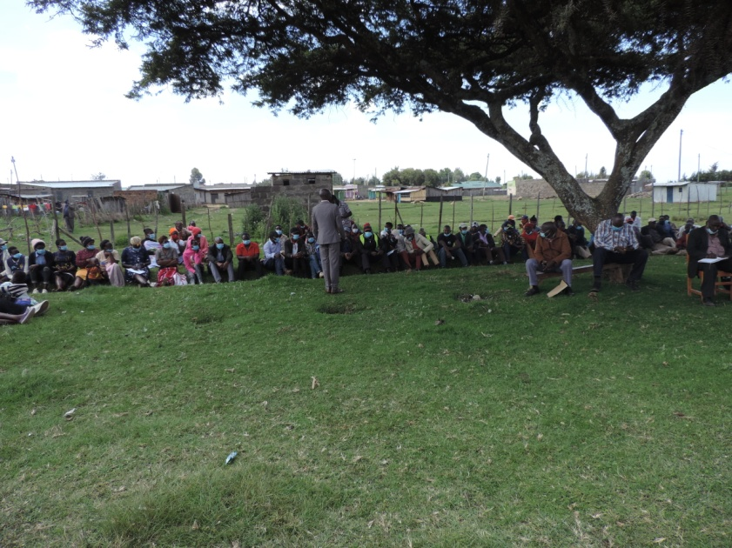

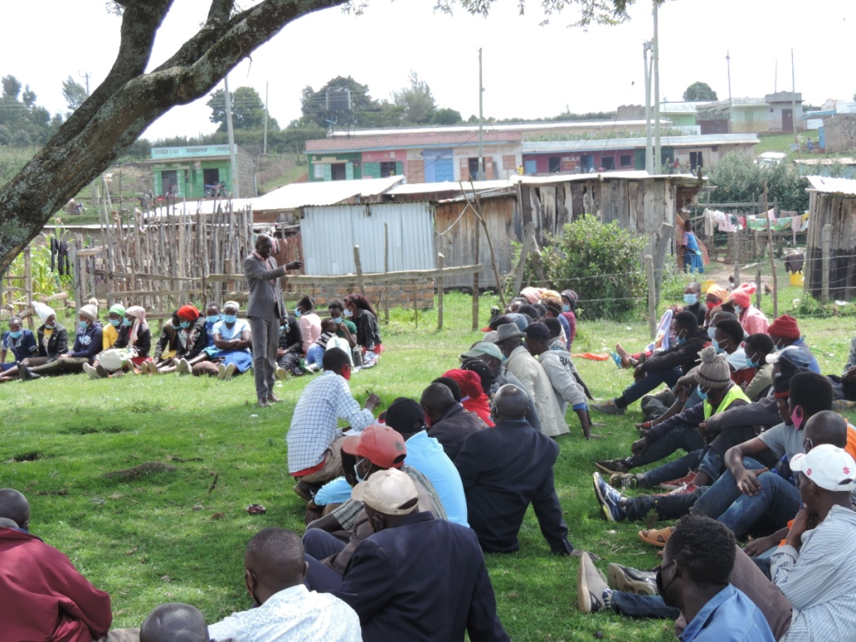

|  |  |
| --- | --- |
| CDF logo 4 MsWord  **NG-CDF** | **National Government Constituencies Development Fund**  **NJORO Constituency**  P.O Box 531-20107  NJORO    **Cell**:0741-406-143…………………………..  **Email**: njorocdf@yahoo.com| **Website: www.cdf.go.ke** |

**A REPORT ON MAUCHE WARD COLLECTION OF SHORT COURSES AND DRINING APPLICANTIONS MEETING HELD AT MAUCHE CHIEF’S OFFICE ON 18TH AUGUST 2021**

**INTRODUCTION**

**MEMBERS PRESENT**

1. Joseph N. Ndungu -NG-CDFC CHAIRMAN
2. Rose Kellong - NG-CDFC SECRETARY
3. Wesley Ngeno -FUND ACCOUNT MANAGER
4. Caroline Lemiso -NG-CDFC MEMBER
5. Joseph Kimani - NG-CDFC MEMBER
6. Dominic Langat - NG-CDFC MEMBER
7. Ruth Kemunto - NG-CDFC MEMBER
8. Joseph Ndirangu - NG-CDFC MEMBER
9. Clement Kabaya - NG-CDFC MEMBER
10. Nelson B. Mwangi - NG-CDFC STAFF

Members from Mauche

The NG-CDF team comprising of Fund Account Manager, NG-CDFC members, NG-CDFC staff arrived at the venue at 2.50pm ready to receive project proposals from the people of Mauche Centre. The meeting started at 3.10 pm with a word of prayer from one of member of the public after which the NG-CDFC chairman explained to the members presents the purpose of the meeting which was registration of applicants for short courses and driving. The applicants had to present a letter of application and a copy of the identity card.

The courses offered by the NG-CDF Njoro bursary were Catering, Hair Dressing, Electrical, Fashion & Design and Driving.

Attached is a list of applicants:

|  |  |
| --- | --- |
| CDF logo 4 MsWord  **NG-CDF** | **National Government Constituencies Development Fund**  **NJORO Constituency**  P.O Box 531-20107  NJORO    **Cell**:0741-406-143…………………………..  **Email**: njorocdf@yahoo.com| **Website: www.cdf.go.ke** |

**A REPORT ON LARE WARD PUBLIC PARTICIPATION MEETING HELD AT LARE ACC’S OFFICE ON 19TH AUGUST 2021**

**INTRODUCTION**

**MEMBERS PRESENT**

1. Joseph N. Ndungu -NG-CDFC CHAIRMAN
2. Rose Kellong - NG-CDFC SECRETARY
3. Wesley Ngeno -FUND ACCOUNT MANAGER
4. Caroline Lemiso -NG-CDFC MEMBER
5. Joseph Kimani - NG-CDFC MEMBER
6. Dominic Langat - NG-CDFC MEMBER
7. Ruth Kemunto - NG-CDFC MEMBER
8. Joseph Ndirangu - NG-CDFC MEMBER
9. Clement Kabaya - NG-CDFC MEMBER
10. Nelson B. Mwangi - NG-CDFC STAFF

Members from Lare

The NG-CDF team comprising of Fund Account Manager, NG-CDFC members, NG-CDFC staff arrived at the venue at 10.30am ready to receive project proposals from the people of Lare. The attendance of the meeting was good and reaction of the public was positive since the agenda of the day was to involve the public in addressing the needs of the people of Lare through NG-CDF. The meeting started at 12.30 pm with a word of prayer from one of member of the public after which the NG-CDFC chairman explained to the members present the purpose of the meeting and the specific proposals to be received.

The Fund Account Manager also encouraged the members of the public to feel free in submitting their proposals and also clarified on issues raised by the public on the role of NG-CDF

**Submission of proposals**

Submission of proposals was guided by the NG-CDF act which clearly defines the scope of projects to be undertaken by NG-CDF. The NG-CDF Act stipulates two broad categories which include those projects falling under:

1. Education
2. Security

The following projects were proposed by people present in the meeting.

|  |  |  |
| --- | --- | --- |
|  | **WARD** | **LARE** |
| **NO** | **NAME OF THE PROJECT** | **ACTIVITY** |
| 1 | Mugumo Primary School | Renovation of 11 Classrooms |
|  |  | Construction of a boys toilets |
| 2 | Sinendet Secondary School | Construction of a Multipurpose Hall |
|  |  | Construction of a Library |
| 3 | Kilo Secondary School | Construction of 2 classrooms |
|  |  | Construction of a Laboratory |
|  |  | Construction of an Administration Block |
|  |  | Construction of a Staff toilets |
|  |  | Construction of a girls toilets |
| 4 | Milimani Primary School | Construction of 3 classrooms |
|  |  | Construction of a boys toilets |
| 5 | Milimani Secondary School | Construction of a boys toilets |
|  |  | Construction of a girls toilets |
|  |  | Construction of a Staff toilets |
| 6 | Bagaria Primary School | Renovation of 5 Classrooms |
| 7 | Mwenyere Primary Scholl | Construction of an Administration Block |
|  |  | Renovation of 5 Classrooms |
|  |  | Construction of a boys toilets |
| 8 | Muthiga Primary School | Construction of an Administration Block |
| 9 | ACC Lare Office | Construction of ACC Office |
|  |  | Construction of a toilets |
| 10 | Sinendet Primary School | Renovation of 5 Classrooms |
|  |  | Construction of an Administration Block |
| 11 | Muthiga Secondary School | Construction of an Administration Block |
| 12 | Kiriri Primary School | Construction of a Staff toilets |
|  |  | Renovation of Administration Block |
|  |  | Renovation of 5 Classrooms |
|  |  | Construction of a Perimeter Wall |
| 13 | Nguriga Primary School | Construction of a boys toilets |
|  |  | Completion of 3 Classrooms |
|  |  | Construction of a girls toilets |
|  |  | Construction of a Staff toilets |
| 14 | Nduriri Primary School | Renovation of Administration Block |
|  |  | Construction of 4 classrooms |
|  |  | Construction of a girls toilets |
|  |  | Construction of a Staff toilets |
|  |  | A 10,000 ltr Water Tank |
| 15 | Mugumo Secondary School | Construction of 3 classrooms |
|  |  | Construction of toilets for the disabled |
|  |  | Purchase of a School Bus |
|  |  | A 10,000 ltr Water Tank |
| 16 | Lare Vision Secondary School | Construction of a science laboratory |
|  |  | Construction of an Administration Block |
|  |  | Construction of a boys toilets |
|  |  | Construction of a Multipurpose Hall |
| 17 | Bagaria Secondary School | Construction of an Administration Block |
| 18 | Kilo Assistant Chief's Office | Construction of an Office and Youth Center |
| 19 | Keriko Primary School | Renovation of 15 Classrooms |
| 20 | Gichobo Primary School | Renovation of 6 Classrooms |
|  |  | Construction of 2 classrooms |
| 21 | Naishi Police Station | Construction of a toilets |
| 22 | Muthiga Assistant Chief's Office | Construction of an Office |

**LARE WARD**

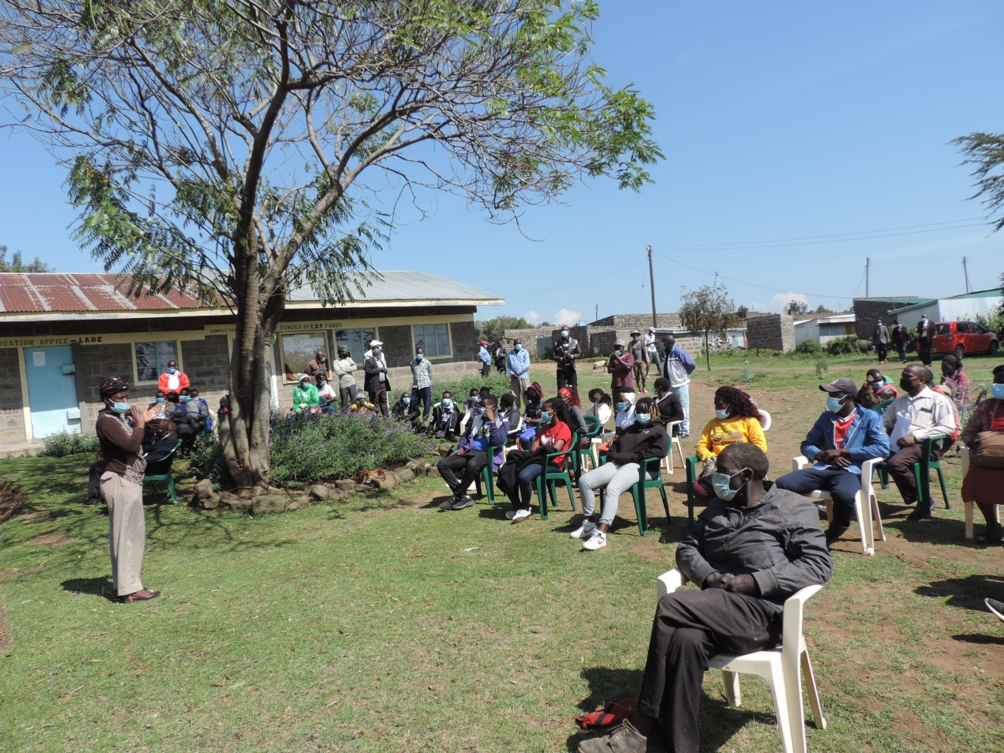

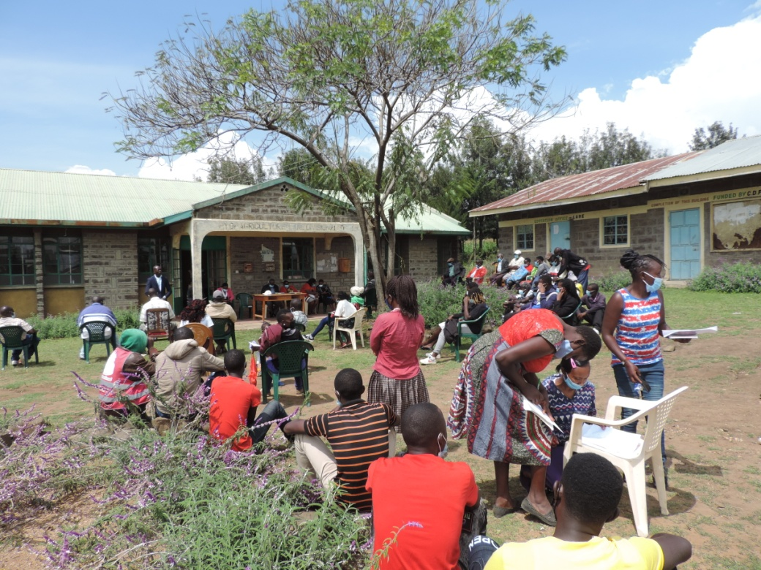

|  |  |
| --- | --- |
| CDF logo 4 MsWord  **NG-CDF** | **National Government Constituencies Development Fund**  **NJORO Constituency**  P.O Box 531-20107  NJORO    **Cell**:0741-406-143…………………………..  **Email**: njorocdf@yahoo.com| **Website: www.cdf.go.ke** |

**A REPORT ON LARE WARD COLLECTION OF SHORT COURSES AND DRINING APPLICANTIONS MEETING HELD AT LARE ACC’S OFFICE ON 19TH AUGUST 2021**

**INTRODUCTION**

**MEMBERS PRESENT**

1. Joseph N. Ndungu -NG-CDFC CHAIRMAN
2. Rose Kellong - NG-CDFC SECRETARY
3. Wesley Ngeno -FUND ACCOUNT MANAGER
4. Caroline Lemiso -NG-CDFC MEMBER
5. Joseph Kimani - NG-CDFC MEMBER
6. Dominic Langat - NG-CDFC MEMBER
7. Ruth Kemunto - NG-CDFC MEMBER
8. Joseph Ndirangu - NG-CDFC MEMBER
9. Clement Kabaya - NG-CDFC MEMBER
10. Nelson B. Mwangi - NG-CDFC STAFF

Members from Lare

The NG-CDF team comprising of Fund Account Manager, NG-CDFC members, NG-CDFC staff arrived at the venue at 11.50am ready to receive project proposals from the people of Lare Ward. The meeting started at 12.10 pm with a word of prayer from one of member of the public after which the NG-CDFC chairman explained to the members presents the purpose of the meeting which was registration of applicants for short courses and driving. The applicants had to present a letter of application and a copy of the identity card.

The courses offered by the NG-CDF Njoro bursary were Catering, Hair Dressing, Electrical, Fashion & Design and Driving.

Attached is a list of applicants:

|  |  |
| --- | --- |
| CDF logo 4 MsWord  **NG-CDF** | **National Government Constituencies Development Fund**  **NJORO Constituency**  P.O Box 531-20107  NJORO    **Cell**:0741-406-143…………………………..  **Email**: njorocdf@yahoo.com| **Website: www.cdf.go.ke** |

**A REPORT ON NESSUIT WARD PUBLIC PARTICIPATION MEETING HELD AT NESSUIT CHIEFS OFFICE ON 20TH AUGUST 2021**

**INTRODUCTION**

**MEMBERS PRESENT**

1. Joseph N. Ndungu -NG-CDFC CHAIRMAN
2. Rose Kellong - NG-CDFC SECRETARY
3. Wesley Ngeno -FUND ACCOUNT MANAGER
4. Caroline Lemiso -NG-CDFC MEMBER
5. Joseph Kimani - NG-CDFC MEMBER
6. Dominic Langat - NG-CDFC MEMBER
7. Ruth Kemunto - NG-CDFC MEMBER
8. Joseph Ndirangu - NG-CDFC MEMBER
9. Clement Kabaya - NG-CDFC MEMBER
10. Nelson B. Mwangi - NG-CDFC STAFF

Members from Nessuit

The NG-CDF team comprising of Fund Account Manager, NG-CDFC members, NG-CDFC staff arrived at the venue at 10.00am ready to receive project proposals from the people of Nessuit Ward. The attendance of the meeting was good and reaction of the public was positive since the agenda of the day was to involve the public in addressing the needs of the people of Nessuit Ward through NG-CDF. The meeting started at 10.30 am with a word of prayer from one of member of the public after which the NG-CDFC chairman explained to the members present the purpose of the meeting and the specific proposals to be received.

The Fund Account Manager also encouraged the members of the public to feel free in submitting their proposals and also clarified on issues raised by the public on the role of NG-CDF

**Submission of proposals**

Submission of proposals was guided by the NG-CDF act which clearly defines the scope of projects to be undertaken by NG-CDF. The NG-CDF Act stipulates two broad categories which include those projects falling under:

1. Education
2. Security

The following projects were proposed by people present in the meeting.

|  |  |  |
| --- | --- | --- |
|  | **WARD** | **NESSUIT** |
| **NO** | **NAME OF THE PROJECT** | **ACTIVITY** |
| 1 | Nessuit Primary School | Construction of a girls toilet |
|  |  | Renovation of 6 Classrooms |
|  |  | Purchase of a 10,000ltr Tank |
| 2 | Musegekwa Primary School | Purchase of a 10,000ltr Tank |
|  |  | Construction of 6 classrooms |
|  |  | Construction of toilets |
| 3 | Ogiek Primary School | Construction of 3 classrooms |
|  |  | Construction of toilets |
| 4 | Messipei Primary School | Construction of toilets |
|  |  | Construction of 2 classrooms |
| 5 | Masaita Primary School | Construction of 3 classrooms |
|  |  | Construction of toilets |

**NESSUIT WARD**

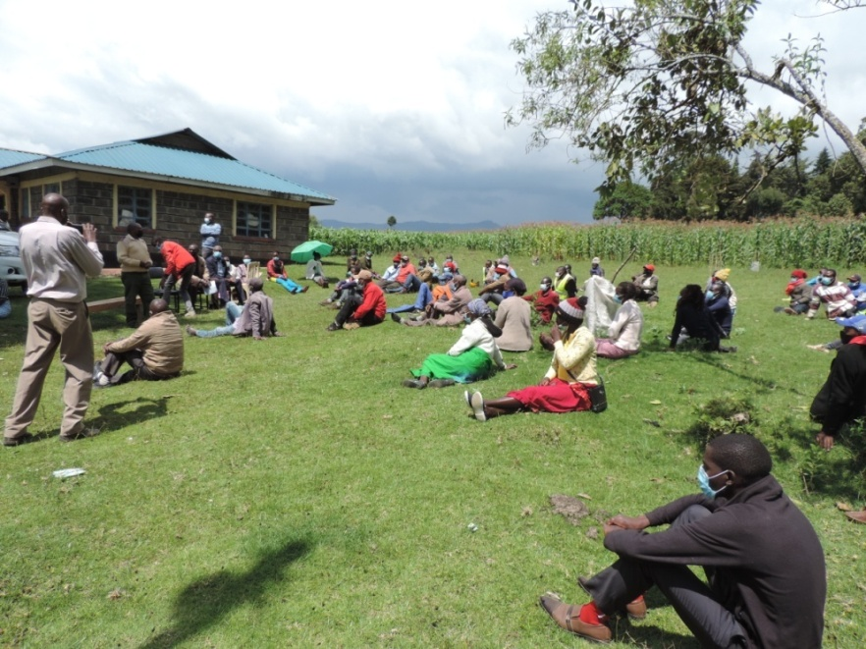

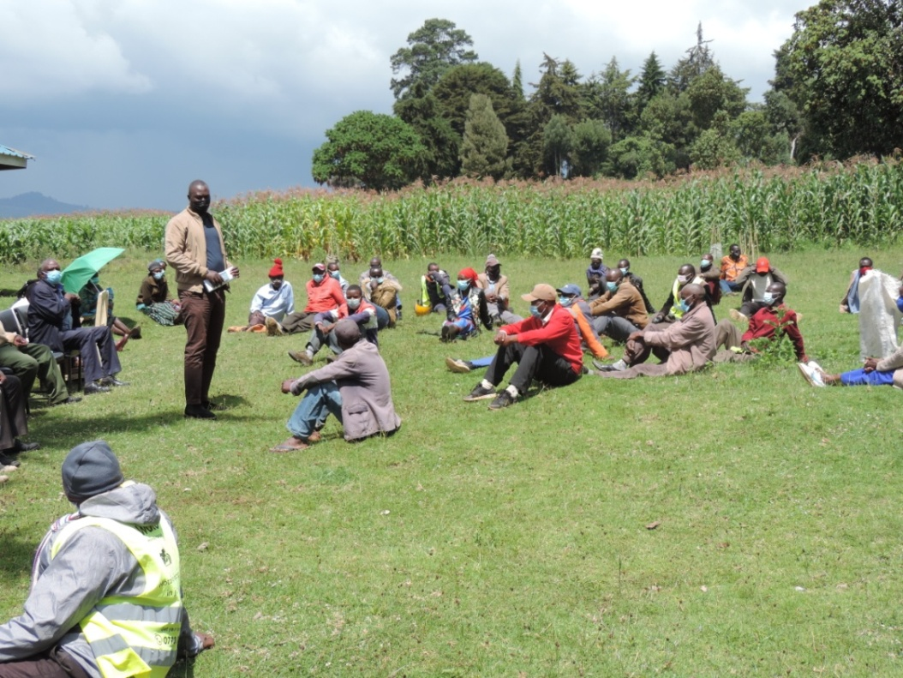

|  |  |
| --- | --- |
| CDF logo 4 MsWord  **NG-CDF** | **National Government Constituencies Development Fund**  **NJORO Constituency**  P.O Box 531-20107  NJORO    **Cell**:0741-406-143…………………………..  **Email**: njorocdf@yahoo.com| **Website: www.cdf.go.ke** |

**A REPORT ON NESSUIT WARD COLLECTION OF SHORT COURSES AND DRINING APPLICANTIONS MEETING HELD AT NESSUIT CHIEF’S OFFICE ON 20TH AUGUST 2021**

**INTRODUCTION**

**MEMBERS PRESENT**

1. Joseph N. Ndungu -NG-CDFC CHAIRMAN
2. Rose Kellong - NG-CDFC SECRETARY
3. Wesley Ngeno -FUND ACCOUNT MANAGER
4. Caroline Lemiso -NG-CDFC MEMBER
5. Joseph Kimani - NG-CDFC MEMBER
6. Dominic Langat - NG-CDFC MEMBER
7. Ruth Kemunto - NG-CDFC MEMBER
8. Joseph Ndirangu - NG-CDFC MEMBER
9. Clement Kabaya - NG-CDFC MEMBER
10. Nelson B. Mwangi - NG-CDFC STAFF

Members from Nessuit

The NG-CDF team comprising of Fund Account Manager, NG-CDFC members, NG-CDFC staff arrived at the venue at 11.50am ready to receive project proposals from the people of Nessuit Ward. The meeting started at 12.10 pm with a word of prayer from one of member of the public after which the NG-CDFC chairman explained to the members presents the purpose of the meeting which was registration of applicants for short courses and driving. The applicants had to present a letter of application and a copy of the identity card.

The courses offered by the NG-CDF Njoro bursary were Catering, Hair Dressing, Electrical, Fashion & Design and Driving.

Attached is a list of applicants:

|  |  |
| --- | --- |
| CDF logo 4 MsWord  **NG-CDF** | **National Government Constituencies Development Fund**  **NJORO Constituency**  P.O Box 531-20107  NJORO    **Cell**:0741-406-143…………………………..  **Email**: njorocdf@yahoo.com| **Website: www.cdf.go.ke** |

**A REPORT ON NJORO WARD PUBLIC PARTICIPATION MEETING HELD AT KIWANJA NDEGE HELD ON 20TH AUGUST 2021**

**INTRODUCTION**

**MEMBERS PRESENT**

1. Joseph N. Ndungu -NG-CDFC CHAIRMAN
2. Rose Kellong - NG-CDFC SECRETARY
3. Wesley Ngeno -FUND ACCOUNT MANAGER
4. Caroline Lemiso -NG-CDFC MEMBER
5. Joseph Kimani - NG-CDFC MEMBER
6. Dominic Langat - NG-CDFC MEMBER
7. Ruth Kemunto - NG-CDFC MEMBER
8. Joseph Ndirangu - NG-CDFC MEMBER
9. Clement Kabaya - NG-CDFC MEMBER
10. Nelson B. Mwangi - NG-CDFC STAFF

Members from Njoro

The NG-CDF team comprising of Fund Account Manager, NG-CDFC members, NG-CDFC staff arrived at the venue at 2.00pm ready to receive project proposals from the people of Njoro Ward. The attendance of the meeting was good and reaction of the public was positive since the agenda of the day was to involve the public in addressing the needs of the people of Njoro Ward through NG-CDF. The meeting started at 2.20 pm with a word of prayer from one of member of the public after which the NG-CDFC chairman explained to the members present the purpose of the meeting and the specific proposals to be received.

The Fund Account Manager also encouraged the members of the public to feel free in submitting their proposals and also clarified on issues raised by the public on the role of NG-CDF

**Submission of proposals**

Submission of proposals was guided by the NG-CDF act which clearly defines the scope of projects to be undertaken by NG-CDF. The NG-CDF Act stipulates two broad categories which include those projects falling under:

1. Education
2. Security

The following projects were proposed by people present in the meeting.

|  |  |  |
| --- | --- | --- |
|  | **WARD** | **NJORO** |
| **NO** | **NAME OF THE PROJECT** | **ACTIVITY** |
| 1 | Njoro DEB Primary School | Renovation of 8 Classrooms |
|  |  | Purchase of a 10,000ltr Tank |
| 2 | Chesoton Primary School | Renovation of 3 Classrooms |
|  |  | Construction of toilets |
|  |  | Construction of an Administration Block |
| 3 | Kenana Secondary School | Construction of 4 classrooms |
|  |  | Construction of toilets |
| 4 | Mukungugu Njoro Primary School | Construction of 2 classrooms |
|  |  | Construction of toilets |
| 5 | Njoro Central Primary School | Fencing of the School |
|  |  | School Gate |
|  |  | Construction of toilets |
|  |  | Construction of 2 classrooms |
| 6 | Utafiti Primary School | Construction of 3 classrooms |
|  |  | Construction of toilets |
|  |  | Construction of an Administration Block |
| 7 | Egerton Primary School | Renovation of 16 Classrooms |
|  |  | Renovation of an Administration Block |
| 8 | Mwigito Excel High School | Construction of a Laboratory |
|  |  | Purchase of a School Bus |
| 9 | Kilimo Secondary School | Construction of 4 classrooms storied |
| 10 | Ndege Primary School | Construction of toilets |
| 12 | Ngongogeri Primary School | Renovation of 12 Classrooms |
|  |  | Construction of toilets |
|  |  | Purchase of a 10,000ltr Tank |
| 13 | Ndarugu Primary School | Construction of 4 classrooms |
| 14 | Njoro Girls High School | Purchase of Beds for the Dormitory |
|  |  | Construction of 2 classrooms |
| 15 | Tengecha Secondary School | Construction of 2 classrooms |
|  |  | Construction of toilets |
|  |  | Construction of an Administration Block |
| 16 | Mwigito Primary School | Renovation of 6 Classrooms |
| 17 | Tengecha Primary School | Construction of 2 classrooms |
| 18 | Kenyatta Mixed Secondary School | Construction of an Administration Block |
| 19 | Njoro Central Secondary School | Construction of 2 classrooms |
| 20 | Cheptoroi Primary School | Construction of classrooms |
| 21 | Njoro CIPU offices | Construction of an armory, tilling, installation of heavy doors and windows, partitioning , plumbing works and furniture |

**KIWANJA NDEGE**

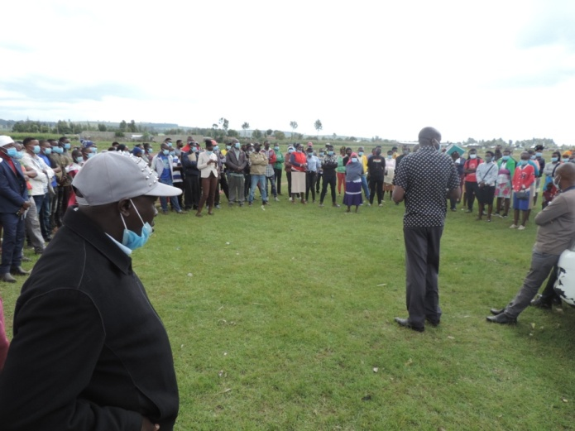

|  |  |
| --- | --- |
| CDF logo 4 MsWord  **NG-CDF** | **National Government Constituencies Development Fund**  **NJORO Constituency**  P.O Box 531-20107  NJORO    **Cell**:0741-406-143…………………………..  **Email**: njorocdf@yahoo.com| **Website: www.cdf.go.ke** |

**A REPORT ON NJORO WARD COLLECTION OF SHORT COURSES AND DRINING APPLICANTIONS MEETING HELD AT KIWANJA NDEGE ON 20TH AUGUST 2021**

**INTRODUCTION**

**MEMBERS PRESENT**

1. Joseph N. Ndungu -NG-CDFC CHAIRMAN
2. Rose Kellong - NG-CDFC SECRETARY
3. Wesley Ngeno -FUND ACCOUNT MANAGER
4. Caroline Lemiso -NG-CDFC MEMBER
5. Joseph Kimani - NG-CDFC MEMBER
6. Dominic Langat - NG-CDFC MEMBER
7. Ruth Kemunto - NG-CDFC MEMBER
8. Joseph Ndirangu - NG-CDFC MEMBER
9. Clement Kabaya - NG-CDFC MEMBER
10. Nelson B. Mwangi - NG-CDFC STAFF

Members from Njoro

The NG-CDF team comprising of Fund Account Manager, NG-CDFC members, NG-CDFC staff arrived at the venue at 2.00 Pm ready to receive project proposals from the people of Njoro Ward. The meeting started at 2.20 pm with a word of prayer from one of member of the public after which the NG-CDFC chairman explained to the members presents the purpose of the meeting which was registration of applicants for short courses and driving. The applicants had to present a letter of application and a copy of the identity card.

The courses offered by the NG-CDF Njoro bursary were Catering, Hair Dressing, Electrical, Fashion & Design and Driving.

Attached is a list of applicants:

|  |  |
| --- | --- |
| CDF logo 4 MsWord  **NG-CDF** | **National Government Constituencies Development Fund**  **NJORO Constituency**  P.O Box 531-20107  NJORO    **Cell**:0741-406-143…………………………..  **Email**: njorocdf@yahoo.com| **Website: www.cdf.go.ke** |

**A REPORT ON KIHINGO WARD PUBLIC PARTICIPATION MEETING HELD AT VOLLEY BALL PITCH HELD ON 19TH AUGUST 2021**

**INTRODUCTION**

**MEMBERS PRESENT**

1. Joseph N. Ndungu -NG-CDFC CHAIRMAN
2. Rose Kellong - NG-CDFC SECRETARY
3. Wesley Ngeno -FUND ACCOUNT MANAGER
4. Caroline Lemiso -NG-CDFC MEMBER
5. Joseph Kimani - NG-CDFC MEMBER
6. Dominic Langat - NG-CDFC MEMBER
7. Ruth Kemunto - NG-CDFC MEMBER
8. Joseph Ndirangu - NG-CDFC MEMBER
9. Clement Kabaya - NG-CDFC MEMBER
10. Nelson B. Mwangi - NG-CDFC STAFF

Members from Kihingo

The NG-CDF team comprising of Fund Account Manager, NG-CDFC members, NG-CDFC staff arrived at the venue at 3.00pm ready to receive project proposals from the people of Kihingo Ward. The attendance of the meeting was good and reaction of the public was positive since the agenda of the day was to involve the public in addressing the needs of the people of Kihingo Ward through NG-CDF. The meeting started at 3.10 pm with a word of prayer from one of member of the public after which the NG-CDFC chairman explained to the members present the purpose of the meeting and the specific proposals to be received.

The Fund Account Manager also encouraged the members of the public to feel free in submitting their proposals and also clarified on issues raised by the public on the role of NG-CDF

**Submission of proposals**

Submission of proposals was guided by the NG-CDF act which clearly defines the scope of projects to be undertaken by NG-CDF. The NG-CDF Act stipulates two broad categories which include those projects falling under:

-Education

-Security

The following projects were proposed by people present in the meeting.

|  |  |  |
| --- | --- | --- |
|  | **WARD** | **KIHINGO** |
| **NO** | **NAME OF THE PROJECT** | **ACTIVITY** |
| 1 | Mutamaiyu Primary School | Renovation of 2 Classrooms |
|  |  | Construction of 2 classrooms |
|  |  | Construction of a girls/boys toilets |
| 2 | Lusiru Secondary School | Construction of an Administration Block |
| 3 | Mutarakwa Secondary School | Construction of a Laboratory |
|  |  | Construction of 2 classrooms |
|  |  | Purchase of Desks |
|  |  | Electrification |
| 4 | Lusiru Primary School | Renovation of 7 Classrooms |
| 5 | Wendani Secondary School | Construction of a Laboratory |
| 6 | Mutumburu Primary School | Construction of 2 classrooms |
|  |  | Construction of a boys toilets |
| 7 | Kariaini Primary School | Construction of 3 classrooms |
| 8 | Mutirima Primary School | Renovation of 9 Classrooms |
| 9 | Davision Primary School | Construction of 5 classrooms |
|  |  | Construction of an Administration Block |
| 10 | Njuguini Primary School | Construction of 2 classrooms |
| 11 | Larmudiac Primary School | Renovation of 6 Classrooms |
|  |  | Construction of an Administration Block |
| 12 | Mutarakwa Primary School | Construction of a girls/boys toilets |
|  |  | Construction of a staff toilets |
|  |  | Renovation of 9 Classrooms |
| 13 | NEW SCHOOL | Kasten Primary School |
|  |  | Electrification |
| 14 | Larmudiac Mixed Secondary School | Construction of an Administration Block |
|  |  | Construction of a Multipurpose Hall |
|  |  | Purchase of a School Bus |
| 15 | Subuku Secondary School | Construction of a Twin Laboratory |
| 16 | Gichobo Secondary School | Construction of an Administration Block |
| 17 | Subuku Primary School | Renovation of 6 Classrooms |

**KIHINGO**

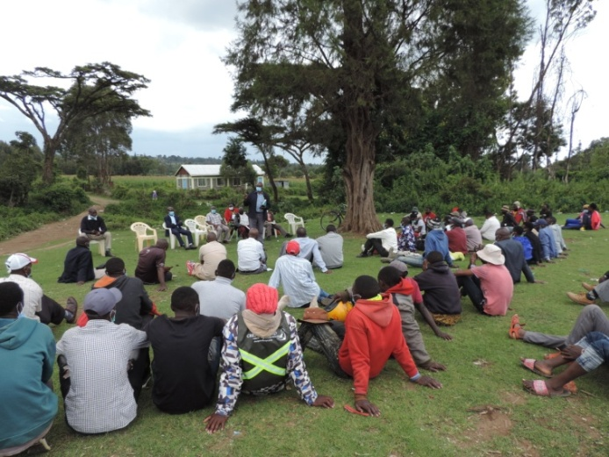 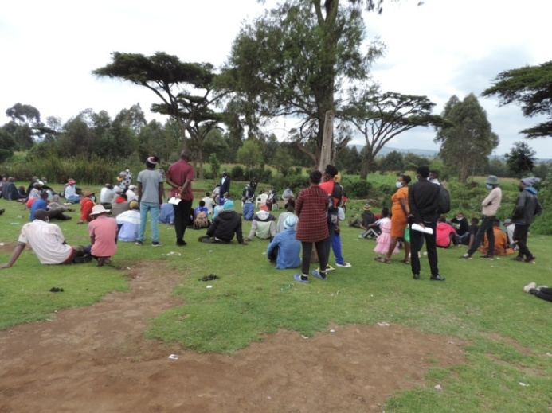

|  |  |
| --- | --- |
| CDF logo 4 MsWord  **NG-CDF** | **National Government Constituencies Development Fund**  **NJORO Constituency**  P.O Box 531-20107  NJORO    **Cell**:0741-406-143…………………………..  **Email**: njorocdf@yahoo.com| **Website: www.cdf.go.ke** |

**A REPORT ON KIHINGO WARD COLLECTION OF SHORT COURSES AND DRIVING APPLICATIONS MEETING HELD AT VOLLEY BALL PITCH ON 19TH AUGUST 2021**

**INTRODUCTION**

**MEMBERS PRESENT**

1. Joseph N. Ndungu -NG-CDFC CHAIRMAN
2. Rose Kellong - NG-CDFC SECRETARY
3. Wesley Ngeno -FUND ACCOUNT MANAGER
4. Caroline Lemiso -NG-CDFC MEMBER
5. Joseph Kimani - NG-CDFC MEMBER
6. Dominic Langat - NG-CDFC MEMBER
7. Ruth Kemunto - NG-CDFC MEMBER
8. Joseph Ndirangu - NG-CDFC MEMBER
9. Clement Kabaya - NG-CDFC MEMBER
10. Nelson B. Mwangi - NG-CDFC STAFF

Members from Kihingo

The NG-CDF team comprising of Fund Account Manager, NG-CDFC members, NG-CDFC staff arrived at the venue at 2.00 Pm ready to receive project proposals from the people of Kihingo Ward. The meeting started at 2.20 pm with a word of prayer from one of member of the public after which the NG-CDFC chairman explained to the members presents the purpose of the meeting which was registration of applicants for short courses and driving. The applicants had to present a letter of application and a copy of the identity card.

The courses offered by the NG-CDF Njoro bursary were Catering, Hair Dressing, Electrical, Fashion & Design and Driving.

Attached is a list of applicants:

**CDF logo 4 MsWord**

**NJORO**

**IEBC NUMBER 167**

**NATIONAL GOVERNMENT**

**CONSTITUENCY DEVELOPMENT FUND**

**WARD REPORTS**

**2021/2022 FINANCIAL YEAR**

**SUBMITTED**

**SEPTEMBER 2021**