MINUTES OF SUBUKIA NG CDFC HELD AT SUBUKIA CDF BOARDROOM on 7th OCTOBER 2020 AT 10:00 AM
MEMBERS PRESENT
- Shadrack Muiruri Chairman
- Winnie Njoroge Secretary
- Gloria Keitany FAM
- Erastus Chege Member
- Jared Ondiek Member
- Ann Rugaita Member
- Caroline Kiplagat Member
- Josephine Kamau Member
- Justine Chebochok Member
- Nkaduda Hiribae DCC
Agenda
- PROJECT PROPOSAL FOR FINANCIAL YEAR 2020/2021
- APPROPRIATION IN AID
- VARIATIONS
- A.O.B
The chairman welcomed the members to the meeting. Jared Ondiek opened with a word of prayer.
MIN 1/07/10/2020 PROJECT PROPOSAL FOR FINANCIAL YEAR 2020/2021
The members approved the following projects to be funded in the financial year 2020/2021 financial year.
NAME OF PROJECT | ORIGINAL COST ESTIMATE | CUMMALATIVE ALLOCATION | PROJECT ACTIVITY | AMOUNT | STATUS
ADMINISTRATION/RECURRENT
EMPLOYEES SALARIES | 1,765,968.00 | - | Payment Of Salaries And Gratuity | 1,765,968.00 | New
GOODS AND SERVICES | 3,966,964.76 | - | Purchase Of Fuel, Repairs And Maintenance, Printing, Airtime, Travel And Subsistence | 3,826,964.76 | New
NSSF | 64,800.00 | - | Payment Of NSSF Deductions | 64,800.00 | New
NHIF | 36,000.00 | - | Payment Of NHIF Deductions | 36,000.00 | New
COMMITTEE EXPENSES | 2,400,000.00 | - | Payment Of Committee Allowances, Transport And Allowances | 2,400,000.00 | New
MONITORING AND EVALUATION
GOODS AND SERVICES | 716,866.38 | - | Purchase Of Fuel, Repairs And Maintenance, Printing, Stationery, Airtime, Travel And Subsistence | 716,866.38 | New
COMMITTEE EXPENSES | 2,500,000.00 | - | Payment Of Committee Allowances, Transport And Allowances | 2,500,000.00 | New
NG-CDFC/PMC CAPACITY BUILDING | 900,000.00 | - | Undertake Training With Pmc’s/ Ng-Cdfc’s On Ng-Cdf Related Issues | 900,000.00 | New
EMERGENCY | 7,198,241.38 | - | To Cater For Any Unforeseen Occurrences In The Constituency During The Financial Year. | 7,198,241.38 | New
BURSARY
BURSARY SECONDARY | 28,607,383.45 | - | To Cater For Needy Students Within The Constituency | 28,607,383.45 | New
BURSARY TERTIARY | 15,000,000 | - | To Cater For Needy Students Within The Constituency | 15,000,000 | New
BURSARY SPECIAL | 4,422,724.31 | - | To Cater For Needy Students Within The Constituency | 4,422,724.31 | New
SPORTS | 2,744,577.59 | - | To Carry Out Constituency Sports Tournament And The Winning Teams To Be Awarded With Trophies, Balls And Games Kits. | 2,744,577.59 | New
ENVIRONMENT
WEI PRIMARY | 700,000 | - | Construction Of 8 Door Boys Toilet To Completion | 700,000 | New
WEI PRIMARY | 700,000 | - | Construction Of 8 Door Girls Toilet To Completion | 700,000 | New
SIDAI SECONDARY | 700,000 | - | Construction Of 8 Door Boys Toilet To Completion | 700,000 | New
PRIMARY SCHOOLS
KIANYORO PRIMARY | 3,200,000 | - | Renovation Of 8 Classes To Completion(Re-Roofing,Plastering,Ceiling,Flooring,Glazing,Painting,Electricity)  Why disparity in cost? | 3,200,000 | New
EDGEWOOD PRIMARY | 500,000 | - | Construction Of 4 Door pit latrine Staff Toilet To Completion | 500,000 | New
MORRO HILL PRIMARY | 3,600,000 | - | Renovation Of 8 Classes To Completion(Re-Roofing,Plastering,Ceiling,Flooring,Glazing,Painting,Electricity)  Why disparity in cost? | 3,600,000 | New
MARIGU B PRIMARY | 3,200,000 | - | Renovation Of 8 Classes To Completion(Re-Roofing,Plastering,Ceiling,Flooring,Glazing,Painting,Electricity)  Why disparity in cost? | 3,200,000 | New
GITUAMBA PRIMARY SCHOOL | 3,500,000 | - | Construction Of 5 Roomed Administration Block to Completion | 3,500,000 | New
LOOREMETA PRIMARY | 3,600,000 | - | Renovation Of 9 Classes To Completion (Re-Roofing,Plastering,Ceiling,Flooring,Glazing,Painting,Electricity)  Why disparity in cost? | 3,600,000 | New
WEI PRIMARY | 2,800,000 | - | Renovation Of 7 Classes To Completion(Re-Roofing,Plastering,Ceiling,Flooring,Glazing,Painting,Electricity) | 2,800,000 | New
WEI PRIMARY | 200,000 | - | Water piping 800 Meters(120 pipes) | 200,000 | New
GATAGATI PRIMARY | 4,400,000 | - | Construction Of 4 Classrooms To Completion | 4,400,000 | New
GATAGATI PRIMARY | 300,000 | - | Purchase Of 120 Desks | 300,000 | New
MIBARAK PRIMARY | 2,200,000 | - | Construction Of 2 Classrooms To Completion | 2,200,000 | New
OLMANYATA PRIMARY | 4,050,000 | - | Renovation Of 9 Classes To Completion(Re-Roofing,Plastering,Ceiling,Flooring,Glazing,Painting,Electricity) | 4,050,000 | New
SIDAI PRIMARY | 2,250,000 | - | Renovation Of 5 Classes To Completion(Re-Roofing,Plastering,Ceiling,Flooring,Glazing,Painting,Electricity)  Why disparity in cost? | 2,250,000 | new
MAOMBI PRIMARY | 1,150,000 | - | Renovation Of 2 Classes To Completion(Re-Roofing,Plastering,Ceiling,Flooring,Glazing,Painting,Electricity)  Why disparity in cost? | 1,150,000 | New
MAOMBI PRIMARY | 150,000 | - | Purchase Of 10,000l Water Tank And Gutters Installation | 150,000 | New
AKUISI PRIMARY | 1,600,000 | - | Renovation Of 3 Classrooms To Completion (Re-Roofing,Plastering,Ceiling,Flooring,Glazing,Painting,Electricity)  Why disparity in cost? | 1,600,000 | New
EDGEWOOD PRIMARY | 2,800,000 | - | Renovation Of 8 Classrooms To Completion(Re-Roofing,Plastering,Ceiling,Flooring,Glazing,Painting,Electricity)  Why disparity in cost? | 2,800,000 | New
NDUNGIRI PRIMARY | 2,800,000 | - | Renovation Of 8 Classes To Completion(Re-Roofing,Plastering,Ceiling,Flooring,Glazing,Painting,Electricity)  Why disparity in cost? | 2,800,000 | New
NDUNGIRI PRIMARY | 500,000 | - | Construction Of 4 Door Special Unit To Completion | 500,000 | New
MUNYAKA PRIMARY | 7,300,000 | 6,700,000 F/Y 2018/2019  Why has the number of classrooms reduced to 5 while what was approved was 8?.  There is an allocation of 700,000 in 2017/18  Submit BoQs | Completion Of 5 Classrooms  (Introduction of veranda with grills and rump of 5 classrooms.) | 600,000 | Ongoing
SECONDARY
SIMBOIYON SECONDARY SCHOOL | 2,200,000 | - | Construction Of 2 New Classrooms To Completion | 2,200,000 | New
SIDAI SECONDARY SCHOOL | 3,800,000 | 3,100,000  Project initiated in 2016/17 with an allocation of Kshs.600,000 bringing cumulative allocation to kshs.3,100,000 | Completion Of Dinning Hall  Work to retain the wall, Veranda round the building, parvings around the building | 700,000 | Ongoing
FOREST HILL SECONDARY SCHOOL | 15,400,000 | 13,300,000 F/Y 2018/2019  This project was initiated in 2014/15 with an allocation of 1,300,000. In 2015/16 the project received additional 2,000,000 some through reallocation and resubmission while in 2018/19 project received 9,000,000 bringing total allocation to 12,300,000  If the estimated cost is 11,100,000 justify need for additional funds  Submit BoQs and contract documents | Completion of twin storey laboratory.  (Introduction of Expansion joints, Introduction of Columns, Introduction of a new office and a store, Extra lab worktops, Gas chamber, New beams and extra wall pipes 500M High above beam joint) | 2,100,000 | Ongoing
SECURITY
KIRENGERO CHIEFS OFFICE | 500,000 | - | Renovation Of Chiefs Office To Completion(Re-Roofing,Plastering,Ceiling,Flooring,Glazing,Painting,Electricity)  Why are the renovation activities similar across board? Do all facilities require same renovation activities | 500,000 | New
GITURA CHIEFS OFFICE | 650,000 | 350,000 | Completion Of Chiefs Office To Completion which was funded in F/Y 2012-2013 Ksh.350,000 (Plastering, Painting, Windowing, Glazing)  The estimated cost of this project is 300,000. It already received Kshs.350,000, why does it need additional funding?  The Ksh. 350,000 disbursed in 2012/2013 Fy did upto roofing stage. Additional funding is required to do finishing works i.e plastering, ceiling, electrical works and painting. | 300,000 | Ongoing
EDGEWOOD POLICE POST | 500,000 | - | Construction Of 4 door Male oilet With Bathroom To Completion | 500,000 | New
Kabazi Police Post | 100,000 | - | Electricity Installation | 100,000 | New
MBOGOINI POLICE POST | 500,000 | - | Construction Of 4 door Male Toilet With Bathroom To Completion | 500,000 | New
ROADS
CHANIA PRIMARY SCHOOL | 3,000,000 | - | Opening Of A New Road 3 Kilometres (Bush Clearing, Grading, Murraming) | 3,000,000 | New
MWIRERI PRIMARY SCHOOL | 3,000,000 | - | Opening Of A New Road 1.5 KM and maintaining of an existing road 1.5 KMs (Bush Clearing,Grading,Murraming) | 3,000,000 | New
OLDONYO MARA PRIMARY | 4,000,000 | - | Opening Of A New Road 1 KM and maintaining of an existing road 2KMs(Bush Clearing,Grading,Murraming) Of 3 Kilometres | 4,000,000 | New
MBURU GICHUA PRIMARY | 4,505,353.44 | - | maintaining of an existing road 3.3 KM(Bush Clearing,Grading,Murraming) | 4,505,353.44 | New

MIN 2/07/10/2020 APPROPRIATION IN AID

The fam informed the Members that there was revenue of Ksh. 140,000 collected from sale of tenders. The monies were declared at NG-CDF BOARD and the monies cannot be used until we get Authority to spend from the board. The members resolved that the monies to be budgeted on used of goods and services at a cost of Ksh. 140,000
MIN 3/07/10/2020 Project Variation
The members noted that there were additional works on two projects as follows.

S/NO | PROJECT NAME | FINANCIAL YEAR | ACTIVITY | AMOUNT PREVIOSLY ALLOCATED | EXTRA WORK ACTIVITY | EXTRA WORKS
1 | SIDAI SECONDARY | 2018/2019 | COMPLETION OF DINING HALL- Walling, roofing, Electrical works, glazing, dooring, plastering and painting | 2,500,000.00 | Work to retain the wall, Veranda round the building, pavings around the building | 700,000.00
2 | MUNYAKA PRIMARY | 2018/2019 | Initial Activity was construction of 8 storey building. After the visit by public works, he found that the ground was very loose. The ground is next to GDC Geothermal project. All the buildings in the school have cracks and have been condemned by public health. The Engineer advised that 5 classrooms to be built and foundation to be properly reinforced under his strict supervision of public works officers because the building is beside the road and vibration might make the building fail. The cdfc were advised to change activity because the ground cannot hold a storey building. ( Attached is the public works report)During implementation, extra works came up and the engineer gave cdfc an estimate of 655,000.  ) | 6,700,000 | Introduction of veranda with grills and rump of 5 classrooms. | 600,000.00
2 | FOREST HILL SECONDARY | 2016/2017  2018/2019 | This project was initiated in 2014/15 with an allocation of 1,300,000.  In 2015/16 the project received additional 2,000,000  1,000,000 Audit fee Reallocation  9,000,000- Completion of twin storey laboratory(Laying of slab,Walling, Roofing, Plastering, Painting and equipping of the laboratory) | 13,300,000 | Introduction of Expansion joints, Introduction of Columns, Introduction of a new office and a store, Extra lab worktops, Gas chamber, New beams and extra wall pipes 500M High above beam joint | 2,100,000

The renovation of classrooms have disparity in costs due to the following reasons
- The structural sound of some classrooms are very weak and need to be reinforced with reinforcement bars(D8)
- The height of some classrooms are too low and there is need to increase the height of the class to enable more lighting and circulation of air. Increase of height means the ringbeams need to be done a fresh and some timber may not be re-used.
- The condition of the classrooms varies form one school to another. Some are pathetic.
- Distance from the source of materials vary from one school to another. This increases the transportation cost.
- The size of the classroom- Some classrooms were built by in 1980s were not standard. Some are small and others are big in size.
RENOVATION ACTIVITIES ARE THE SAME ACROSS THE BOARD BECAUSE OF THE FOLLOWING REASONS
- The classrooms were constructed long time ago and the roof of all the classrooms are dilapidated and leaking when it rains so, they have to be replaced with new ones.
- Some classrooms were not plastered when they were constructed due to limited funding because the schools were depending on parents contributions.
- The floors have cracks due to the type of soil and the workmanship at that time.
- Some schools have wooden windows and doors or some were not fixed with windows at all. This makes the renovation activities to be similar. Attached are sample pictures of the classrooms to be renovated.
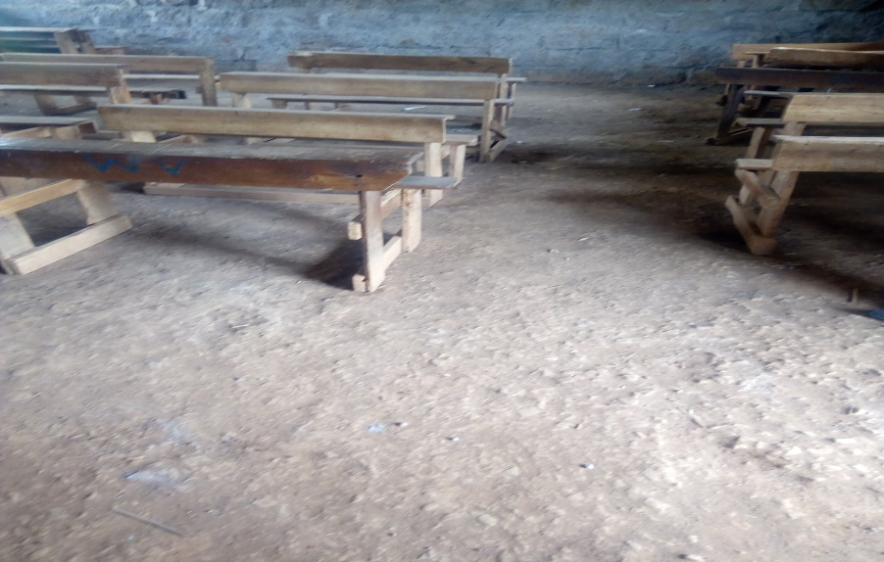 | 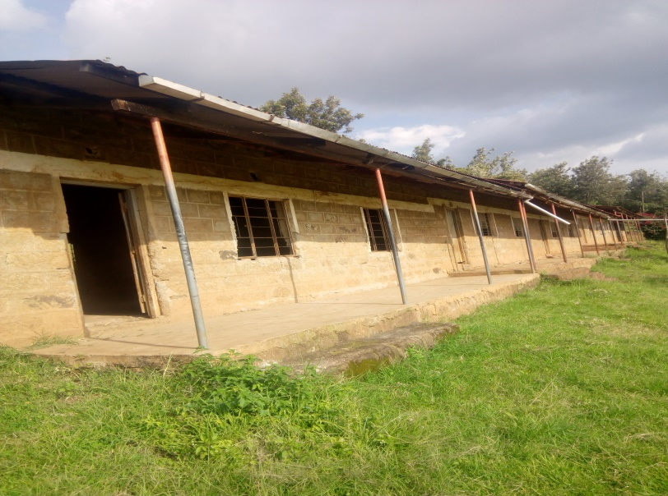
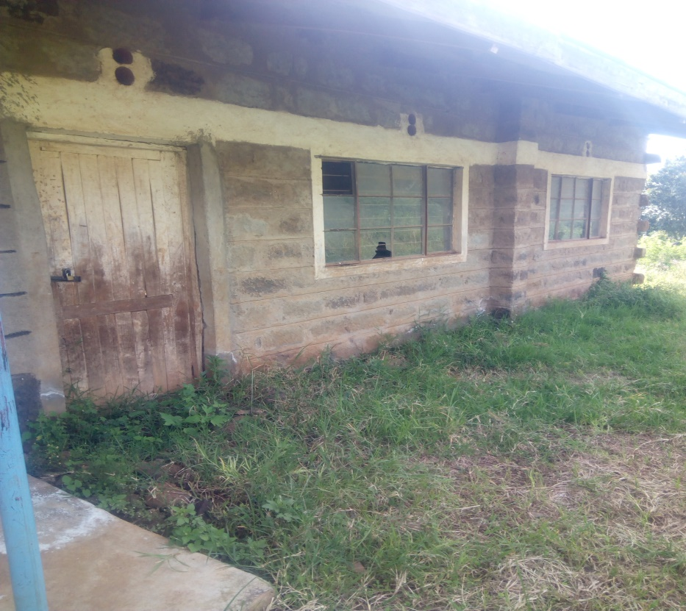 | 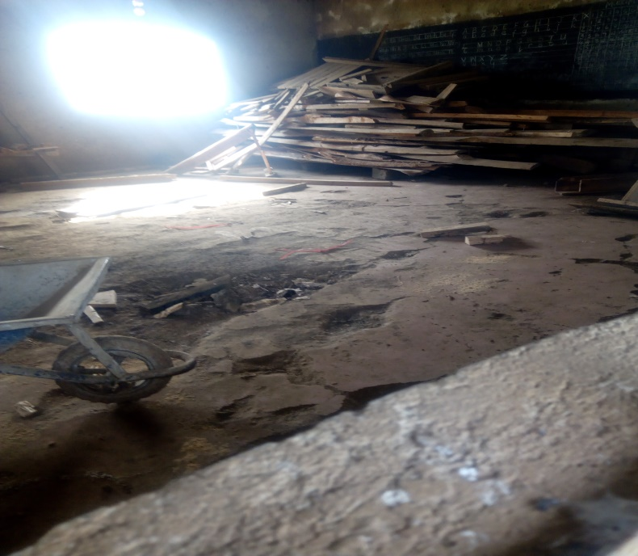
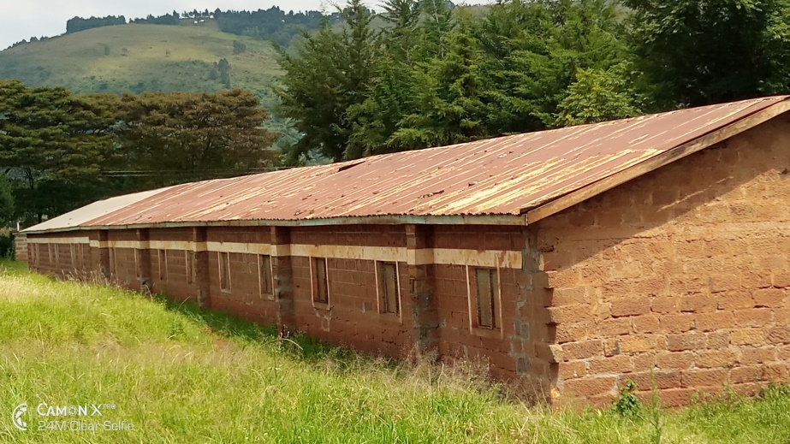 | 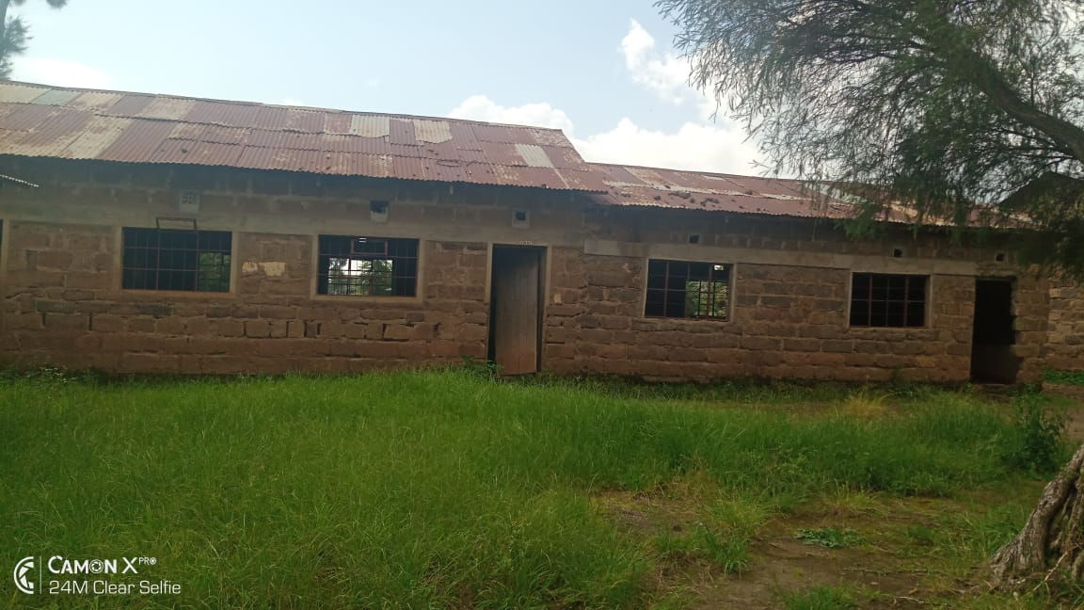

A.O.B
There being no any other business the meeting was ended with a word of prayer from Anne Rugaita.

Chairman………………………………………………….Signature………………………………….Date………………………

Secretary…………………………………………………..Signature…………………………………Date……………………..

