|  |  |  |  |
| --- | --- | --- | --- |
| |  |  | | --- | --- | | **NG-CDF** | **National Government Constituencies Development Fund Board**  **Emurua Dikirr Constituency**  **P.O Box 119**  **Chebunyo , Kenya** | |  |

Date: 12th MARCH, 2018

**TO**

**THE CHIEF EXECUTIVE OFFICER,**

**NATIONAL GOVERNMENT -CONSTITUENCIES DEVELOPMENT FUND BOARD.**

**P.O BOX 46682 -00100**

**NAIROBI.**

Dear Sir,

**RE:** PROJECT PROPOSAL 2018/2019

Reference is made to the attached minutes from NG-CDFC Emurua Dikirr dated 12th MARCH, 2018.The NG-CDFC passed a resolution to fund the attached projects based on priority from the constituents.

Kindly find attached documents supporting the same.

Yours sincerely,

F.A.M Emurua Dikirr



**National Government Constituencies Development Fund Board**

EMURUA DIKIRR CONSTITUENCY

DEPUTY COUNTY COMMISSIONER'S OFFICE

P.O Box 119-20401 Chebunyo, Kenya

**Cellphone:** 0722 774 506   
**Email:** [cdfemuruadikirr@cdf.qo.ke](mailto:cdfemuruadikirr@cdf.qo.ke)I [Website:www.cdf.qo.ke](http://Website:www.cdf.qo.ke)

**NG-CDF BOARD**

**MINUTES OF NG- CDFC MEETING HELD ON TUESDAY 12TH MARCH, 2019 IN THE NG- CDF OFFICES**

Present:

1. Mr. Samwel Kipsiele Towett Chairman
2. Mrs. Caroline Chelanget Tonui Secretary
3. Mr. Kipkoech Koros Member
4. Mr. Wesley Bii Member
5. Mrs. Lilian Cherotich Member
6. Mr. Richard Kipkoske A. Cheruiyot Member
7. Mr. Carren Chebii Member
8. Mr. Yahchanan Kipkurgat Cholio Member
9. Mr. Mohammed D. Maow Member
10. Mr. Felix Sikona Saire Fund Account Manager

**In attendance**

1. Mr. Kipsafari Toromo District Accountant

**Absent with apology**

1. Hon. Johana Ngeno Member of Parliament

**AGENDA**

1. Reading and confirmation of the previous minutes
2. Matters arising
3. Ratification and review of FY 2018/ 2019 budget Proposal
4. A.O.B

**PRELIMINARIES**

Chairman welcomed the members to the meeting at 9:30 am with a word of prayers said by Mr. Kipsiele Towett.

**MIN 06/6/3/2019. READING & CONFIRMATION OF TIE PREVIOUS MINUTES.**

The chairman invited the secretary to read through the minutes of the previous meeting. The minutes were proposed by Mr. Yahchanan Kipkurgat Cholio and seconded by Mr. Mohammed D Maow as the true picture of what was discussed in the previous meeting.

**MIN 07 /6/3/2019. MATTERS ARISING**

The members realized that the bursary cheques which were remaining have been collected. It was also raised that there are some Ng-CDF employees whom their NHIF account are dormant and the matter was left to Chairman and Fund account Manager to take to District Accountant to look into it.

MIN 08/6/3/2019. RATIFICATION AND REVIEW OF FY 2018/2019 BUDGET PROPOSAL After a lengthy discussion all members endorsed anonymously the proposed budget proposal below for the financial year 2018/2019 to be funded by National Government CDF board.

|  |  |  |  |  |
| --- | --- | --- | --- | --- |
|  | LIST OF PROPOSSED PROJECTS FOR FINANCIAL YEAR 2018/19 | | | |
|  | EMURUA DIKIRR CONSTITUENCY | | |  |
| ***S/N*** | **PROJECTS/ SCHOOL NAMES** | **PROJECT DESCRIPTION** | | **ALLOCATED** |
|  |  |  |  | **AMOUNT** |
| I. | Angaset primary school | Purchase of one acre piece of land | | 200,000 |
| 2. | Chemurin primary school | Construction of one new classroom | | 1,200,000 |
| 3. | Chepkebit primary school | Completion of two classrooms | | 700,000 |
| 4. | Chesogori primary school | Completion of two classrooms | | 700,000 |
| 5. | Emitiot primary school | Purchase of one piece of land | | 200,000 |
| 6. | Kabarak primary school | Purchase of one acre piece of land | | 200,000 |
| 7. | Kabuson central primary school | Construction of one new classroom | | 1,200,000 |
| 8. | Kenduiwo primary school | Construction of one new classroom | | 1,200,000 |
| 9. | Ketendeita primary school | Completion of two classrooms | | 700,000 |
| 10 | Tachasis primary school | Construction | of one new classroom | 1,200,000 |
| 11 | Kamaget primary school | Construction | of one new classroom | 1,200,000 |
| 12 | Kitait primary school | Construction | of one new classroom | 1,200,000 |
| 13 | Korosiot primary school | Construction | of one new classroom | 1,200,000 |
| 14 | Kibailuk primary school | Construction | of one new classroom | 1,200,000 |
| 15 | Changina primary school | Construction | of one new classroom | 1,200,000 |
| 16 | Koisagat primary school | Construction of one new classroom | | 1,200,000 |
| 17 | Soimingin primary school | Completion of one classroom | | 500,000 |
| 18 | Torochet primary school | Completion of one classroom | | 500,000 |
| 19 | Kaptarakwa primary school | Completion of one classroom | | 500,000 |
| 20 | Kaplebelit primary school | Completion of one classroom | | 500,000 |
| 21 | Kilindani primary school | Completion of one classroom | | 500,000 |
| 22 | Chepkisa primary school | Completion of one classroom | | 500,000 |

|  |  |  |  |
| --- | --- | --- | --- |
| 23 | Kibisorwet primary school | Completion of one classroom | 500,000 |
| 24 | Kipwaluk primary school | Purchase of four acre piece of land | 800,000 |
| 25 | Kulonok primary school | Purchase of one acre piece of land | 200,000 |
| 26 | Kuresiet primary school | Purchase of one acre piece of land | 300,000 |
| 27 | Lelach primary school | Purchase of one acre piece of land | 200,000 |
| 28 | Lulukwet primary school | Purchase of one acre piece of land | 200,000 |
| 29 | Merigito primary school | Purchase of one acre piece of land | 200,000 |
| 30 | Murkan primary school | Construction of a dormitory | 3,500,000 |
| 31 | Pimbiniet primary school | Construction of one new classroom | 1,200,000 |
| 32 | Reberwet primary school | Completion of four classrooms | 1,400,000 |
| 33 | Sugutek primary school | Completion of two classrooms | 700,000 |
| 34 | Torochasis primary school | Construction of one classroom | 1,200,000 |
| 35 | Torokwet primary school | Construction of one new classroom | 1,200,000 |
| 36 | Tuiyobei primary school | Construction of one new classroom | 1,200,000 |
| 37 | Tuiyobei primary school | Purchase of one piece of land | 200,000 |
| 38 | Changina Secondary School | Construction of a twin Laboratory | 3,500,000 |
| 39 | Chebitoik Secondary School | Construction of a twin Laboratory | 3,500,000 |
| 40 | Ilkerin Girls Secondary School | Construction of a dormitory | 3,500,000 |
| 41 | Ilkerin Mixed day Secondary | Construction of a twin Laboratory | 3,500,000 |
|  | School |  |  |
| 42 | Kisiara High School | Construction of a twin Laboratory | 3,500,000 |
| 43 | Kurangurik Secondary School | Construction of a twin Laboratory | 3,500,000 |
| 44 | Kuresiet Secondary School | Construction of a twin Laboratory | 2,300,000 |
| 45 | Lelechonik Secondary School | Construction of three new classrooms | 3,600,000 |
| 46 | Mokondo Secondary School | Construction of the on-going Dining | 1,000,000 |
|  |  | hall |  |
| 47 | Soiming'in Secondary School | Construction of two new classrooms | 2,400,000 |
| 48 | Kurangurik KMTC | Construction of Hostel | 3,000,000 |

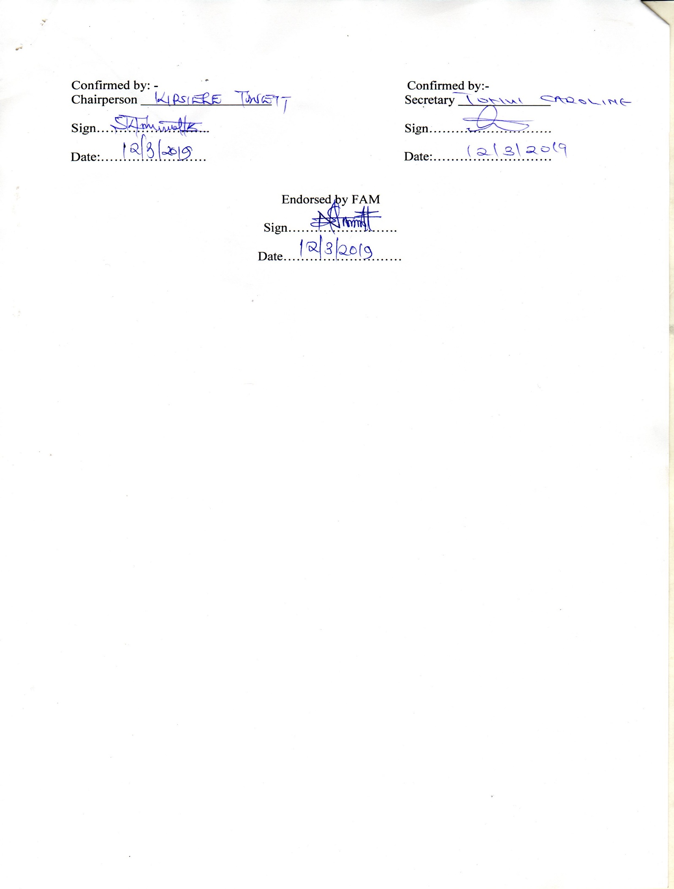

***2015 National Government Constituencies Development Fund No. 30***

**THIRD SCHEDULE** *(s. 15)*

**CONSTITUENCY PROJECTS SUBMISSION** FORM

Constituency No **178** Constituency Name **EMURUA DIKIRR** Financial Year **2018/2019**

|  |  |  |
| --- | --- | --- |
| **SERIAL** | **NAME OF PROJECT** | **AMOUNT ALLOCATED** |
| 178/AP1 | Administration & Recurrent | 6,542,452.53 |
| 178/AP2 | Monitoring & Evaluation /Capacity Building | 3,271,226.27 |
| 178/2640200 | Emergency ( 5% Of The Fund) | 5,738,993.45 |
| 178/2640510 | Environment | 2,180,817.52 |
| 178/2640509 | Sports | 2,180,817.52 |
| 178/2640100 | Bursary | 25,126,568.23 |
| 178/2630206 | Tertiary institution | 3,000,000.00 |
| 178/2630204 | Education Primary | 30,400,000.00 |
| 178/2630205 | Education Secondary | 30,600,000.00 |
| **TOTAL FOR THE FINANCIAL YEAR** | | **109,040,875.52** |

Chairman NG- CDF Committee **Samwel K Towett** Signature………………….. Date………….………

Fund Account Manager Signature…………………….Date………………