

**Homa Bay Town**

**IEBC Number 249**

**National Government Constituency Development Fund**

**PROJECT PROPOSAL**

**2019/2020 Financial Year**

**Submitted**

**October 2019**



**Homa Bay Town**

**IEBC Number 249**

**National Government Constituency Development Fund**

**PROJECT PROPOSAL**

**2019/2020 Financial Year**

**Submitted**

**October 2019**

|  |  |
| --- | --- |
| **NG-CDF BOARD** | **National Government Constituencies Development Fund** |
| **Homabay Town Constituency** |
| Kabunde Multipurpose Hall |
| P.O BOX 240 Homabay, 40300 |
| Email: [cdfhomabaytown@ngcdf.go.ke](mailto:cdfhomabaytown@ngcdf.go.ke) | Website: [www.ngcdf.go.ke](http://www.ngcdf.go.ke) |
|  | |

**REF: NGCDF/HBTC/CDFB/PROPOSAL 01/2019 October 22, 2019**

**The Chief Executive Officer,**

**NG-CDF Board,**

**Harambee Cooperative Sacco Plaza, 5th Floor**

**Junction of Haile Selassie Avenue & Uhuru Highway**

**P.O Box 46682-00100,**

**NAIROBI.**

Dear Sir,

**RE: SUBMISSION OF HOMA BAY TOWN CONSTITUENCY PROJECT PROPOSAL FOR THE YEAR 2019/2020**

Further to your letter reference NG-CDF/CEO/BOARD CIRCULARS Vol II(014) dated 24th September 2019 and programs letter reference NG-CDF BOARD/PROG/OTHERS/002 of 18th October 2019 as guided per the requirement of NG-CDF Act, I wish to submit the Homabay Town Constituency Project Proposal to the National Government Constituency Development Fund Board for approval for funding.

Kindly find the following attached documents for your expedition:

* NG-CDFC Minutes for 22nd October 2019

Yours faithfully,

…………………….

Kennedy Chacha

**Fund Account Manager**

**+254 722- 471- 936**

|  |  |
| --- | --- |
| **NG-CDF BOARD** | **National Government Constituencies Development Fund** |
| **Homabay Town Constituency** |
| Kabunde Multipurpose Hall |
| P.O BOX 240 Homabay, 40300 |
| Email: [cdfhomabaytown@ngcdf.go.ke](mailto:cdfhomabaytown@ngcdf.go.ke) | Website: [www.ngcdf.go.ke](http://www.ngcdf.go.ke) |
|  | |

**NATIONAL GOVERNMENT CONSTITUENCY DEVELOPMENT FUND COMMITTEE MEETING HELD ON 22ND OCTOBER 2019 AT THE NG-CDFC OFFICES – KABUNDE**

**MEMBERS PRESENT:**

1. Monica Nyadiero Chairperson
2. Charles Otieno Ogola Secretary
3. Joseph Obuya Ogola Member
4. Conslate Ng’onga Member
5. Isaiah Nyadiero Member
6. Pamela Andele Member
7. Teresa Adhiambo Ochieng Member
8. Hanningtone Oluoch Member
9. Kennedy Chacha Fund Account Manager
10. Alfred Langat Assistant County Commissioner

**IN ATTENDANCE**

1. Kelvin Owuor Clerk of Works
2. Scholastica Wanina Procurement Assistant
3. Suleiman Moti Programs Officer
4. Fred Odhiambo Constituency Office
5. Donald Ochieng Accounts Clerk

**AGENDA:**

1. Communication from the chair
2. Reading and confirmation of the previous Meeting Minutes
3. Submission of Project Proposal – 2019/2020 FY
4. Complains Sub Committee report
5. Pending projects issues
6. A.O.B.

**MIN.HBTC NG-CDFC 14/2019/2020: Preliminary/ Communication from the Chairperson.**

The meeting started at 9.30am with a word of prayer from Mr Hanningtone Oluoch there after the Fund Account Manager called upon the meeting in order as the chairperson Mrs Monica Nyadiero was preparing to chair the meeting. The Chair lady on her remarks thanked the members for the tireless participation during ward meetings which some went beyond official working hours. She commended the Fund Account Manager for the tireless efforts he has made to ensure Homabay Constituency have a new face in terms of project management picking from where Mr Weldon Langatt had left from. She assured the Fund Manager of her full support plus her team of NG-CDFC and asked for cooperation and proper communication when required and by appropriate channels.

Mrs Nyadiero furher thanked the Assistant County Commissioner too to helping in mobilization of members of the public during Public participation held between October 1, 2019 and October 11, 2019and the positive response and coordination also from the area Chiefs and their assistants. She further thanked the Complains Sub Committee and the FAM for their commitment in handling complain cases despite of no allowances given but promised to settle their arrears immediately the Constituency receives funding. She informed members that most times NCG –CDF work is volunteering and commitment as committee members who are selected to serve the community hence should not tire from their duty.

.

**MIN.HBTC NG-CDFC 15/2019/2020: Reading and Confirmation of the Previous Meeting Minutes and matters arising.**

The secretary read out the minutes of the previous meeting of 16th September 2019 and they were confirmed by Conslate Ngo’nga to be true minutes of the meeting with Isiah Nyadiero seconding.

On matters arising from the previous meeting minutes, the Fund Account Manager confirmed the following:

* MIN.HBTC NG-CDFC 10/2019/2020: PMC Project Implementation was being done in consultation with the relevant government line Ministries and departments wit Construction works being supervised by Public Works personnel whom are being facilitated from the project management administration cost.
* MIN.HBTC NG-CDFC 11/2019/2020: Complaints handling and Legal Matters had been handled by the respective committee and it will be tabled as an agenda of today’s meeting.
* MIN.HBTC NG-CDFC 13/2019/2020, The Assistant County Commissioner confirmed that the water tank had been supplied and fixed to the County Commissioners residence hence thankful to the committee. Further the Principal Homabay High School had not presented drawing and plan for his library/ Multi-purpose hall project to date.

**MIN.HBTC NG-CDFC 16/2019/2020; Submission of Project Proposal – 2019/2020 FY**

The Committee after a consultative ward forum submitted the following projects for funding in the financial year 2019/2020 with most of the projects being on going from previous financial years. Reference was also made to NG-CDFC minutes of 15th January 2019 Ref. minute **HBTC/NGCDF/40/15/01/2018 REVIEWOF PROJECT PROPOSAL for 2018/2019** …….project to be funded to prioritize projects that were initiated between the year 2013/2014 to 2015/2016 and are incomplete will be included in the 2019/2O20 Project Proposal. Further the ongoing projects that were started in 2016/2017 and 2017/2018 will be included in the project proposal for 2020/2021.

The handing over and taking over report of of 22nd August 2019 between the Outgoing Fund Account Manager and Incoming Fund Account Manager also stipulated on the same on page 14 of the report ..**ON-GOING PROJECTS** . The Fund Account Manager informed members that it was prudent for Committee to ensure they make good all projects that had been initiated so as to enable them completed and be in use as there could be waste of government resources if left incomplete as that was the government and NG-CDF Board policy.

Other Projects as listed in the ward report will be funded in the financial years 2021/2022. The projects are prioritized as under:

|  |  |  |  |  |
| --- | --- | --- | --- | --- |
|  | | | | |
| **PROJECT NAME** | **GFS CODE** | **PROJECT ACTIVITY** | **AMOUNT ALLOCATED** | **STATUS** |
| **OFFICE ADMINISTRATION** |  |  |  |  |
| **Employees’ Salaries** | **4-043-249-2110000-100-2019/20-001** | **Payment of staff salaries and Wages for Field Officers** | **4,560,000.00** | **Ongoing** |
| **Staff Gratuity** | **4-043-249-2110000-100-2019/20-002** | **Payment of staff gratuity** | **844,000.00** | **Ongoing** |
| **Goods and Services** | **4-043-249-2110000-100-2019/20-003** | **Payment of Security, Utilities and Purchase of fuel, hire of transport vehicle,Internet Subscription, Communication allowances,Repairs and Maintenance, printing, stationery, telephone, travel and subsistence, office tea and other office operation.** | **1,526,060.00** | **Ongoing** |
| **NHIF** | **4-043-249-2110000-100-2019/20-004** | **Payment of NHIF Deductions** | **50,000.00** | **Ongoing** |
| **NSSF** | **4-043-249-2110000-100-2019/20-005** | **Payment of NSSF Deductions** | **70,000.00** | **Ongoing** |
| **Committee Expenses** | **4-043-249-2110000-100-2019/20-006** | **Payment of Committee sitting allowances, transport, conferences** | **1,192,000.00** | **Ongoing** |
|  |  |  | **8,242,060.00** |  |
| **MONITORING AND EVALUATION** | |  |  |  |
| **Goods and Services** | **4-043-249-2210000-111-2019/20-001** | **Purchase of fuel, repairs and maintenance, printing, stationery, Airtime, hire of vehicle for M&E activities,travel and subsistence** | **707,227.00** | **Ongoing** |
| **Committee Expenses** | **4-043-249-2210802-111-2019/20-002** | **Payment of Committee sitting allowances, transport, conferences** | **1,064,000.00** | **Ongoing** |
| **CDFC/PMC & Staff Capacity Building** | **4-043-249-2210700-111-2019/20-003** | **Undertake Training of the PMCs/CDFCs and Staff on NG-CDF Related issues** | **1,937,804.70** | **Ongoing** |
| **Consituency Oversigt Committee Expenses** | **4-043-249-2210700-111-2019/20-004** | **Oversight Committee expenses: Allowances, transport costs etc** | **412,000.00** | **Ongoing** |
|  |  |  | **4,121,031.70** |  |
| **BURSARY** |  |  |  |  |
| **Bursary – Secondary Schools** | **4-043-249-2640101-103-2019/20-001** | **Bursary to cater for needy students in Secondary Schools** | **23,150,000.00** | **Ongoing** |
| **Bursary - Tertiary institutions ( Universities and Colleges)/** | **4-043-249-2640102-103-2019/20-002** | **Bursary funds to cater for needy students in tertiary Institutions.** | **4,000,000.00** | **Ongoing** |
| **Bursary - Special Schools** | **4-043-249-2640103103-2019/20-003** | **Bursary funds to cater for needy students in special Schools and Institutions.** | **400,000.00** | **Ongoing** |
|  |  |  | **27,550,000.00** |  |
| **EMERGENCY** |  |  | **-** |  |
| **Emergency (5%)** | **4-043-249-2640200-101-2019/20-001** | **Funds set aside for to cater for unforeseen occurrences during the Financial Year.** | **6,868,386.34** | **ongoing** |
| **PRIMARY SCHOOLS** |  |  |  |  |
| **Adongo Primary** | **4-043-249-2630204-104-2019/20-001** | **Completion of Administration Block: Plastering, Fitting of windows and doors and Painting** | **1,000,000.00** | **ongoing** |
| **Arujo Primary School** | **4-043-249-2630204-104-2019/20-002** | **Completion of Administration Block:Fitting of windows and doors, plastering,flooring and Painting** | **500,000.00** | **ongoing** |
| **Got Kokech Primary School** | **4-043-249-2630204-104-2019/20-003** | **Completion of 2No. Classrooms: Fitting of windows and doors, Plastering, flooring and painting** | **500,000.00** | **ongoing** |
| **Homa Bay Primary School** | **4-043-249-2630204-104-2019/20-004** | **Renovation of 8 No. Classrooms: Replacement of Roof, Floor repairs, Glazing and Painting.** | **1,000,000.00** | **New** |
| **Hon. Kaluma Kotewa Primary School** | **4-043-249-2630204-104-2019/20-005** | **Completion of 2 No. Classrooms: Plastering, Fittingof windows anddoors and Painting.** | **500,000.00** | **Ongoing** |
| **Kambeke Primary School** | **4-043-249-2630204-104-2019/20-006** | **Completion of 2No. Classrooms: Fitting of windows and doors, Plastering, flooring and painting** | **200,000.00** | **Ongoing** |
| **Kijawa Primary School** | **4-043-249-2630204-104-2019/20-007** | **Construction of a new 5 door tiolet for girls: Diggiging 30 ft pit latrine , walling, roofing, plastering and painting** | **500,000.00** | **New** |
| **Kogello Kalanya Primary School** | **4-043-249-2630204-104-2019/20-008** | **Completion of Administration Block: Roofing , Plastering, Fittingsofwindows and doors and Painting** | **1,000,000.00** | **Ongoing** |
| **Kopiyo Primary School** | **4-043-249-2630204-104-2019/20-009** | **Renovation of 8 No. Classrooms: Fitting, Plastering and Painting** | **700,000.00** | **New** |
| **Kuja Primary School** | **4-043-249-2630204-104-2019/20-010** | **Completion of 2No. Classrooms: Fitting of window panes flooring and painting** | **110,000.00** | **ongoing** |
| **Lake Primary School** | **4-043-249-2630204-104-2019/20-011** | **Completion of Administration Block: Plastering, fitting of doors and windows, flooring and painting** | **600,000.00** | **Ongoing** |
| **Lang'oromo Primary School** | **4-043-249-2630204-104-2019/20-012** | **Renovation of 10 No. Classrooms: Repair of leaking roof,Fitting of window panes and windows replacements, repair of floors and Painting** | **1,000,000.00** | **New** |
| **Lieta Kabunde Primary School** | **4-043-249-2630204-104-2019/20-013** | **Renovation of 9 No. Classrooms: Repair of leaking roof,replacement of brocken window panes, repair of floors and Painting** | **700,000.00** | **New** |
| **Lorateng Primary School** | **4-043-249-2630204-104-2019/20-014** | **Completion of 2 Classrooms: Fitting of doors and windows, plastering , flooring and Painting.** | **500,000.00** | **Ongoing** |
| **Maguje Primary School** | **4-043-249-2630204-104-2019/20-015** | **completion of 3no. Classrooms:Fitting of window panes, flooring and Painting** | **800,000.00** | **ongoing** |
| **Manga Primary School** | **4-043-249-2630204-104-2019/20-016** | **Completion of Administration Block: Roofing, Fittingof windows and doors, Plastering and Painting** | **500,000.00** | **Ongoing** |
| **Masakla Primary School** | **4-043-249-2630204-104-2019/20-017** | **Completion of 2No. Classrooms: Fitting of windows and doors, Plastering, flooring and painting** | **700,000.00** | **ongoing** |
| **Muche Primary School** | **4-043-249-2630204-104-2019/20-018** | **Completion of 2No. Classrooms: Fitting of windows and doors, Plastering, flooring and painting** | **500,000.00** | **ongoing** |
| **Ndiru Primary School** | **4-043-249-2630204-104-2019/20-019** | **Completion of Administration Block: Roofing, Fitting of windows and doors, Plastering and Painting** | **1,200,000.00** | **ongoing** |
| **Ndiru Primary School** | **4-043-249-2630204-104-2019/20-020** | **Construction of 4 No. New Classrooms: Walling , Roofing,fitting of windows and doors, Plastering,tiling and Painting** | **3,600,000.00** | **New** |
| **Nduta Primary School** | **4-043-249-2630204-104-2019/20-021** | **Fencing of school compound: Erection of fence using barbed wire and round cider poles** | **550,000.00** | **ongoing** |
| **Ngere Primary School** | **4-043-249-2630204-104-2019/20-022** | **Construction of 2 No. Classrooms: Walling, Roofing, Plastering, Fittings of windows & doors and Painting.** | **1,500,000.00** | **New** |
| **Nyanguu Primary School** | **4-043-249-2630204-104-2019/20-023** | **Construction of a new 5 door pit latrine to completin: Digging of 30 ft pit, walling, roofing, plastering and painting** | **500,000.00** | **New** |
| **Nyakune Primary School** | **4-043-249-2630204-104-2019/20-024** | **Completion of 2 No. Classrooms: Roofing, fitting of windows and doors, Fitting and Painting of both newly costructed classrooms and 3 other classrooms** | **500,000.00** | **ongoing** |
| **Nyauu Primary School** | **4-043-249-2630204-104-2019/20-025** | **Completion of 3 No. Classrooms: Roofing, Fittings, Plastering and Painting** | **1,200,000.00** | **ongoing** |
| **Ogande Special School** | **4-043-249-2630204-104-2019/20-026** | **Completion of an ongoing Dormitory: Roofing, fitting of doors and windows and painting** | **1,300,000.00** | **ongoing** |
| **Ogongo Katuma Primary** | **4-043-249-2630204-104-2019/20-027** | **Completion of 2no. Classrooms: Roofing ,Plastering, fitting of windows and doors, flooring and painting** | **500,000.00** | **ongoing** |
| **Olodo Primary School** | **4-043-249-2630204-104-2019/20-028** | **Completion of Administration Block: Fittings of window and doors, glasess and Painting** | **300,000.00** | **ongoing** |
| **Opande Rarage Primary** | **4-043-249-2630204-104-2019/20-029** | **Completion of 2no. Classrooms: Plastering, fitting of windows and doors, flooring and painting** | **500,000.00** | **Ongoing** |
| **Orego Primary School** | **4-043-249-2630204-104-2019/20-0230** | **Completion of Administration Block: Plastering, Fittings and Painting** | **500,000.00** | **Ongoing** |
| **Otaro Primary School** | **4-043-249-2630204-104-2019/20-031** | **Renovation of 8 No. Classrooms: Plastering, Fittings and Painting.** | **700,000.00** | **New** |
| **Ogande Special School** | **4-043-249-2630204-104-2019/20-032** | **Completion of Dormitory block:Roofing, Fitting of windows and doors, Plastering and Painting** | **1,300,000.00** | **ongoing** |
| **Pala Masogo Primary** | **4-043-249-2630204-104-2019/20-033** | **Renovation of 4No. Classrooms: Fitting of window panes and painting of classrooms** | **160,000.00** | **ongoing** |
| **Pap Ndege Primary** | **4-043-249-2630204-104-2019/20-034** | **Renovation of 5No. Classrooms** | **800,000.00** | **ongoing** |
| **Pedo Primary School** | **4-043-249-2630204-104-2019/20-035** | **Completion of 2 Classrooms: Fitting of doors and windows , flooring, Tiling and Painting.** | **300,000.00** | **ongoing** |
| **Pundo Kalanya Primary School** | **4-043-249-2630204-104-2019/20-036** | **Renovation of 5 No. Classrooms: Repair of Floors, Fittings of brocken glasess and Painting.** | **500,000.00** | **New** |
| **Radiro Primary School** | **4-043-249-2630204-104-2019/20-037** | **Completion of 2No. Classrooms: Fitting of windows and doors, Plastering, flooring and painting** | **500,000.00** | **Ongoing** |
| **Roba Primary School** | **4-043-249-2630204-104-2019/20-038** | **Completion of Administration Block: Plastering, Fitting of windows and doors and Painting** | **500,000.00** | **Ongoing** |
| **Rodi Primary School** | **4-043-249-2630204-104-2019/20-039** | **Construction of 2 New Classrooms: Walling, roofing, fitting of windows and doors, plastering,tiling and painting** | **1,500,000.00** | **New** |
| **Rodi Primary School** | **4-043-249-2630204-104-2019/20-040** | **Fencing of school compound using concrete posts and chain link and erection of gate** | **2,500,000.00** | **New** |
| **Shauri Yako Primary School** | **4-043-249-2630204-104-2019/20-041** | **Construction of 12 No. Classrooms: Foundation , Walling and Slab for ground floor of storey classrooms, fitting of doors and windows , plastering and painting of 6 ground floor classrooms** | **7,000,000.00** | **New** |
| **Watata Primary School** | **4-043-249-2630204-104-2019/20-042** | **Completion of Administration Block: Plastering, Fitting and Painting** | **500,000.00** | **Ongoing** |
| **Wiamen Primary School** | **4-043-249-2630204-104-2019/20-043** | **completion of 3no. Classrooms:Fitting of window panes, flooring and Painting** | **150,000.00** | **Ongoing** |
| **Wiga Primary School** | **4-043-249-2630204-104-2019/20-044** | **completion of 4no. Classrooms:Plastering,Fitting of window panes, flooring and Painting** | **500,000.00** | **Ongoing** |
| **Wiobiero Primary School** | **4-043-249-2630204-104-2019/20-045** | **Completion of an administration block: Roofing, fitting of windows & doors and Plastering.** | **1,000,000.00** | **Ongoing** |
| **Yao Primary School** | **4-043-249-2630204-104-2019/20-046** | **Construction of 2 No. Classrooms: Walling and Roofing** | **1,000,000.00** | **New** |
| **School Desks Project** | **4-043-249-2630204-104-2019/20-047** | **Purchase of 1,363 desks standard desks for 10 primary schools in the Constituency @ approx Ksh 2,500 per desk.** | **3,407,246.10** | **New** |
|  |  |  | **45,477,246.10** |  |
| **SECONDARY SCHOOLS** |  |  |  |  |
| **Anding'o Boys Boarding School** | **4-043-249-2630205-104-2019/20-001** | **Construction of a 100 bed capacity dormitory for new boys school: Walling, Roofing, Fitting of windors and doors, flooring and painting** | **3,000,000.00** | **New** |
| **Bishop Okulu Magare Girls School** | **4-043-249-2630205-104-2019/20-002** | **Completion of an ongoing dormitory block: Roofing , Fitting of windows and doors and plastering.** | **1,000,000.00** | **Ongoing** |
| **Bishop Otaro Mixed Secondary School** | **4-043-249-2630205-104-2019/20-003** | **Completion of Laboratory:Fitting of windows and doors, plastering, fiffing of worktops andflooring** | **1,000,000.00** | **Ongoing** |
| **Chiga Mixed Secondary School** | **4-043-249-2630205-104-2019/20-004** | **Construction of a library block: Walling and roofing of a new 200 Paxs library block to enhancestudents learning** | **1,500,000.00** | **New** |
| **Gogo Katuma Mixed Sec** | **4-043-249-2630205-104-2019/20-005** | **Completion of laboratory:Fitting of worktops, Water and Gas system** | **500,000.00** | **Ongoing** |
| **Homa Bay High School** | **4-043-249-2630205-104-2019/20-006** | **Construction of Library: Foundation, Walling, Slabbing of storey block Co- funded by PTA and NG-CDF to also serve as multipurpose hall** | **3,000,000.00** | **New** |
| **Kuja Mixed Secondary School** | **4-043-249-2630205-104-2019/20-007** | **Construction of 2 No. Classrooms: Walling, Roofing and Plastering and Painting** | **1,700,000.00** | **New** |
| **Lala Mixed Secondary School** | **4-043-249-2630205-104-2019/20-008** | **Completion of 2 No. Classrooms: Fitting of windows & doors, Plastering and tiling** | **500,000.00** | **Ongoing** |
| **Lang'oromo Mixed Secondary School** | **4-043-249-2630205-104-2019/20-009** | **Completion of Laboratory: Fitting of windows and doors, Plastering, fitting of work tops,flooring and Painting** | **1,500,000.00** | **Ongoing** |
| **Maguti Mixed Sec.** | **4-043-249-2630205-104-2019/20-010** | **Completion of Laboratory: Fitting of work tops, window panes, water tank & gutters and painting** | **500,000.00** | **ongoing** |
| **Ngere Mixed Secondary School** | **4-043-249-2630205-104-2019/20-011** | **Completion of Laboratory: Fitting of work tops, window panes, water tank & gutters and painting** | **500,000.00** | **ongoing** |
| **Nyagidha Mixed Secondary School** | **4-043-249-2630205-104-2019/20-012** | **Construction of 2no. Classrooms: Walling and roofing** | **1,000,000.00** | **New** |
| **Nyakahia Mixed Secondary School** | **4-043-249-2630205-104-2019/20-013** | **Completion of a new Administration Block: Fitting of windows and doors, plastering and painting** | **500,000.00** | **ongoing** |
| **Nyalkinyi Mixed Secondary School** | **4-043-249-2630205-104-2019/20-014** | **Completion of 6 No. Classrooms: Walling of first floor and floor slab of storey classrooms,fitting of windows and doors ( NG-CDF Co -funded project with PTA)** | **1,500,000.00** | **Ongoing** |
| **Ogande Girls High School** | **4-043-249-2630205-104-2019/20-015** | **Construction of Dormitory : Walling,roofing, Fitting of windows and doors, tiling and paintiing of 100 bed capacity dormitory** | **3,500,000.00** | **New** |
| **Pala Masogo Mixed Secondary School** | **4-043-249-2630205-104-2019/20-016** | **Completion of Labaratory block:Fitting of Water tank, guttering, tiling of floor and painting** | **500,000.00** | **ongoing** |
| **Pap Ndege Mixed Secondary School** | **4-043-249-2630205-104-2019/20-017** | **Completion of 2 No. Classrooms: Plastering, fittings and painting** | **200,000.00** | **ongoing** |
| **Rabuor Masawa Mixed Secondary School** | **4-043-249-2630205-104-2019/20-018** | **Construction of a new Science Laboratory: Walling and Roofing** | **1,000,000.00** | **New** |
| **Riwa Mixed Secondary School** | **4-043-249-2630205-104-2019/20-019** | **Completion of a new Administration Block: Roofing ,Fitting of windows and doors, plastering and painting** | **1,000,000.00** | **ongoing** |
| **Ruga Mixed Secondary School** | **4-043-249-2630205-104-2019/20-020** | **Completion of ongoing labaratory: Tiling of floor and worktops, fitting of overhead water tank , gattering and soak pit** | **500,000.00** | **ongoing** |
| **St. Amrose Got Rabuor Mixed Secondary School** | **4-043-249-2630205-104-2019/20-021** | **Completion of 2no. Classrooms: Fitting of doors and window panes, tiling and painting of ongoing classrooms** | **200,000.00** | **ongoing** |
| **St. Camillus Ojunge Mixed Sec School** | **4-043-249-2630205-104-2019/20-022** | **Completion of 2no. Classrooms: Fitting of doors and windows, Plastering, flooring and painting of ongoing classrooms** | **500,000.00** | **ongoing** |
| **St. Domnic Wiga Mixed Secondary School** | **4-043-249-2630205-104-2019/20-023** | **Construction of 2 No. Classrooms: Walling, Roofing, Plastering, Fittings and Painting** | **1,500,000.00** | **New** |
| **St. Joseph's Sero Mixed Sec. School** | **4-043-249-2630205-104-2019/20-024** | **Completion of ongoing labaratory: Tiling of floor and worktops, fitting of overhead water tank , gattering and soak pit** | **500,000.00** | **ongoing** |
| **St. Joseph's Sero Mixed Sec. School** | **4-043-249-2630205-104-2019/20-025** | **Construction of Administratiion Block: Walling, Roofing, Plastering, Fittings and Painting** | **2,300,000.00** | **New** |
| **St, Peters Disii Mixed Secondary School** | **4-043-249-2630205-104-2019/20-026** | **Construction of 2 Classrooms: Walling, roofing, fitting of windows and doors, plastering and painting** | **1,000,000.00** | **New** |
| **St. Pius Ndiru Secondary Schoool** | **4-043-249-2630205-104-2019/20-027** | **Completion of an ongoing Administration Block:Roofing, Fitting of doors and windows, plastering, tiling and painting** | **1,900,000.00** | **ongoing** |
| **St. Pius Ndiru Secondary Schoool** | **4-043-249-2630205-104-2019/20-028** | **Completion of 2 No. Clasrooms: Fittings of windows and doors, Plastering and Painting** | **300,000.00** | **Ongoing** |
| **St. Theresa's Nyauu Girls School** | **4-043-249-2630205-104-2019/20-029** | **Completion of Laboratory: Fitting of windows and doors, worktops and drainage/ watrer system and Painting** | **1,500,000.00** | **ongoing** |
| **Wiobiero Mixed Secondary School** | **4-043-249-2630205-104-2019/20-030** | **Construction of Laboratory: Walling, Roofing and Plastering of a new Science labaratory** | **3,000,000.00** | **New** |
|  |  |  | **37,100,000.00** |  |
| **SECURITY** |  |  |  |  |
| **Kanyabala Chief 's Office** | **4-043-249-2640507-113-2018/2019-001** | **Completion of Chief''s Office:Platering, flooring and Painting of Chiefs Office** | **300,000.00** | **ongoing** |
| **Kalanya Kanyango Chiefs Office(Rodi)** | **4-043-249-2640507-113-2018/2019-002** | **Construction of anew Chiefs Office: Walling, roofing, plastering and painting of a chiefs office at Rodi Kopany** | **800,000.00** | **New** |
| **Rodi Police Station** | **4-043-249-2640507-113-2018/2019-003** | **Construction of OCS Office: Walling, roofing, fitting of windows and doors and painting of office** | **1,000,000.00** | **New** |
| **Kabunde Chiefs Office** | **4-043-249-2640507-113-2018/2019-004** | **Construction of a new Chiefs Office for West Kanyada Location: Walling, roofing, plastering and painting** | **1,000,000.00** | **New** |
| **Homabay County Police Headquarter** | **4-043-249-2640507-113-2018/2019-005** | **Renovation of County Police Headquartes: Replacement of entire Roof,Ceiling board and Internal painting** | **1,109,000.00** | **New** |
|  |  |  | **4,209,000.00** |  |
| **SPORTS** |  |  | **-** |  |
| **Homabay Town Sports Tournament** | **4-043-249-2640509-112-2019/20-001** | **Facilitation of Constituency Teams in the National League and Purchase of Sports Kits and Facilitation of Tournament** | **1,320,000.00** | **Ongoing** |
|  |  |  | **1,320,000.00** |  |
| **ENVIRONMENT** |  |  |  |  |
| **Environmental Activities** | **4-043-249-26405010-110-2019/20-001** | **Purchase of 6,000 ltrs water tanks for 15 Primary schools, gutters and fittings for rain water harvesting** | **2,000,000.00** | **New** |
|  |  |  | **2,000,000.00** |  |
| **CONSTITUENCY PROJECTS** |  |  |  |  |
| **Purchase of Office Equipments** | **4-043-249-3111000-108-2019/20-001** | **Purchase of 1 No All In One desk top Computer, 2 No. Desktop complete computer, 1 No laptop and 1No. Laserjet Duplex Printer and Binding Machine.** | **480,000.00** | **New** |
|  |  |  | **480,000.00** |  |
|  |  |  | **137,367,724.14** |  |

**MIN.HBTC NG-CDFC 17/2019/2020:**  **Pending Project Issues**

Attention was brought to members on the required submission to the Board in respect to Ogongo –Nyagidha Road which had been allocated Ksh 2,300,000 and the board required certified cost estimates from KERRA and clear minutes of activities to be done. The Road Sub Committee chairperson informed members that Officers from the board had visited the road and were aware of the activities to be undertaken and the letter from Kerra had been sort and described as Bush clearing, light grading, gravel patching and culvert installation on 3 km road. Estimate by KERRA is Ksh 2,547,628.40. The report for estimate to be forwarded to NG-CDF projects department to enable release of funds

**MIN.HBTC NG-CDFC 18/2019/2020:**  **Complains Sub Committee report**

The Chairman of the Complains sub- committee Mr. Joseph Obuya informed members that the committee had made progress of handling the conflicts and complains addressed to the Constituency through the NG-CDF Board and referred to the Fund Account Manager. He commended the manner in which the Fund Account Manager was solving the matter thus assuring the committee of the confidence the Manager has in tackling the issues.

The cases handled and their outcomes were summarized as under with the chair informing members that a detailed report is available in the files hence will only give summary.

* The meeting was held as a result of a complain meeting resolution held at NGCDF office at kabunde on 27th September 2019, between the complaints Mr Arthur Okello Osoro , Mzee Ila Ongili and NGCDF complaint committee who resolved that a meeting be held at the site of complain on 2nd October 2019.

After deliberations in the meeting which the co complainant Mzee Ila Ongili did not attend, Arthur thanked the Assistant County Commissioner, Chiefs present, Fund Account Manager and NG-CDFC team for organizing this meeting and said that as earlier indicated in his remarks he wanted someone to pay for negligence on duty and that even if nothing will be compensated to him, the matter has been heard in the whole Country and will go in public records that a person brought this matter seeking justice. He clarified that by the matter being heard the whole country he meant that he sued the Attorney General too and a representative was sent from Nairobi to the courts, the suit also included County Government, Kenya Rural Roads Authority, NG-CDF Board, Ministry of Lands and all sent lawyers from all over the country hence the matter has been heard by the whole Republic. He concluded that he was now waiting for the NG-CDF Board communication after the Fund Account Manager submits his finding to them.

The Fund Account Manager has submitted report to NG-CDF Board awaiting communication on way forward.

* The Homabay NGCDF Committee was in receipt of demand from Healics Agency Limited **Ref:** **NGCDFB/COMP/HOMABAY TOWN 01/2019(1**) addressed through the NGCDF Board.

Healics Agencies has engaged H.O Mimba and Company Advocates claiming on their behalf the balance payment for works done at Kijawa dispensary in year 2014 being construction of staff house and erection of fence. In their notes they said that their tender was terminated and awarded to another contractor without notice.

The meeting was held at Kijawa dispensary where the then PMC members, area Assistant Chief, Officer in charge Kijawa and also Sub County officer in charge of health were present and the Contractor/ Complainant .The complainant seemed to be in such a hurry to leave claiming that he had other crucial matters to attend to. He said he could not sit to the end of the meeting and therefore left before the meeting could be adjourned.

The Fund Account Manager had indicated to the committee that Kijawa dispensary project was one among the projects which were affected by devolution where there came separation of County Government projects and National Government functions.

* Wiamen – Arujo case by Richard Odongo is scheduled for public hearing tomorrow 23rd October 2019 and the complainant was to communicate to the Fund Account Manager but he has not to date. Final report will be communicated to members once he does as he was said to be waiting for report from the Ombudsman.

**MIN.HBTC NG-CDFC 19/2019/2020: AOB**

* Bursary form to be issued to the public and also to constituency Schools for needy students to fill in readiness for vetting by December 2019.
* The FAM to do ensure Project Management Committees do returns for funds disbursed to them and ensure proper accountability of the same.
* Notice for Internship to be placed on Public notice boards for Records Management, Clerk of Works and Clerical Officer whom meet required qualifications.

There being no any other business, the meeting ended by a word of prayer from Mr. Hannington Oluoch at 3.20 Pm as members proceeded to ACK for a joint lunch with the Member of Parliament.

The date for the next meeting shall be conveyed if and when necessary.

**Signed by;**

**Chairperson:……………………………………Date:……………………………**

**Secretary:……………………………………….Date:……………………………**

|  |  |  |
| --- | --- | --- |
|  | National Government Constituencies Development Fund |  |

|  |  |  |
| --- | --- | --- |
|  | National Government Constituencies Development Fund | **No. 30** |
|  | **THIRD SCHEDULE** (ss. 25 (15) and 29(1) |  |

**CONSTITUENCY PROJECTS SUBMISSION FORM**

Constituency No: **249** Constituency Name: **Homa Bay Town** Financial Year **2019/2020**

|  |  |  |
| --- | --- | --- |
| **SERIAL** | **NAME OF PROJECT** | **AMOUNT ALLOCATED** |
| 246/AP1 | Administration/Recurrent | **8,242,060.00** |
| 246/AP2 | Monitoring and Evaluation/Capacity Building | 4,121,031.70 |
| 246/2640100 | Bursary/CATs/Mocks/Social Security | 30,350,000.00 |
| 246/2640200 | Emergency Reserve | 6,868,386.34 |
| 246/2630204 | Primary School Projects | 45,377,246.10 |
| 246/2630205 | Secondary School Projects | 34,400,000.00 |
| 246/2630206 | Tertiary School Projects | 0.00 |
| 250/2640507 | Security Projects | 4,109,000.00 |
| 246/2640509 | Sports Activities | 1,450,000.00 |
| 246/2640510 | Environmental Projects | 2,000,000.00 |
| 246/3110202 | NG-CDF Offices | 450,000.00 |
| **TOTALS** | | **137,367,724.14** |

…………………………………………… …………………………… ………………….

**Chairperson NGCDF Committee Signature Date**

…………………………………………… …………………………… ………………….

**Fund Account Manager Signature Date**

|  |  |  |
| --- | --- | --- |
|  | National Government Constituencies Development Fund | **No. 30** |

**FOURTH SCHEDULE (s. 30) PROJECT DESCRIPTION FORM**

Constituency No: **249** Constituency Name: **HOMA BAY TOWN** County: **HOMA BAY**

Project Number: **249/AP1**

Project Title: **ADMINISTRATION AND RECURRENT**

Sector: **Administration**

Status of projects (tick one) New……… Extension…… On-going…**√**….. Rehabilitation …

Brief statement on project status at time of submission

**The allocation is to cater for NG-CDFC Allowance, staff salaries, vehicle expenses and other administrative expenses.**

Financial year **July 1, 2019 to June 30, 2020**

Original Cost estimates: **Kshs. 8,242,060.00 dated** **July 1, 2019**

Amount allocated last financial year **Ksh 5,208,620.69**

Amount allocated this financial year: **Kshs. 8,242,060.00**

|  |  |  |  |  |
| --- | --- | --- | --- | --- |
| **PROJECT NAME** | **PROJECT ACTIVITY** | **PROJECT NUMBER** | **AMOUNT** | **STATUS** |
| Employees’ Salaries | Payment of staff salaries and Wages for Field Officers | 4-043-249-2110000-100-2019/20-001 | 4,560,000.00 | On-going |
| Staff Gratuity | Payment of staff gratuity | 4-043-249-2110000-100-2019/20-002 | 844,000.00 | On-going |
| Goods and Services | Payment of Security, Utilities and Purchase of fuel, hire of transport vehicle,Internet Subscription, Communication allowances,Repairs and Maintenance, printing, stationery, telephone, travel and subsistence, office tea and other office operation. | 4-043-249-2110000-100-2019/20-003 | 1,526,060.00 | On-going |
| NHIF | Payment of NHIF Deductions | 4-043-249-2110000-100-2019/20-004 | 50,000.00 | On-going |
| NSSF | Payment of NSSF Deductions | 4-043-249-2110000-100-2019/20-005 | 70,000.00 | On-going |
| Committee Expenses | Payment of Committee sitting allowances, transport, conferences | 4-043-249-2110000-100-2019/20-006 | 1,192,000.00 | On-going |
| **TOTALS** | | | **8,242,060.00** |  |

Person completing form: **Kennedy Chacha** Position: **Fund Account Manager**

Signature……………………………………..…………… Date………………………

|  |  |  |
| --- | --- | --- |
| **2015** | National Government Constituencies Development Fund | **No. 30** |

**FOURTH SCHEDULE (s. 30) PROJECT DESCRIPTION FORM**

Constituency No: **249** Constituency Name: **HOMA BAY TOWN** County: **HOMA BAY**

Project Number: **249/AP2**

Project Title: **MONITORING & EVALUATION/CAPACITY BUILDING**

Sector: **Monitoring & Evaluation**

Status of projects (tick one) New……… Extension…… On-going…**√**….. Rehabilitation ……

Brief statement on project status at time of submission

**Provision for Monitoring and Evaluation of NG-CDF projects and capacity building of NG-CDFC and**

**PMCs in the constituency**

Financial year **July 1, 2019 to June 30, 2020**

Original Cost estimates, in **Kshs 4,121,031.70** dated **July 1, 2019**

Amount allocated last financial year **Kshs 2,604,310.34**

Amount allocated this financial year **Kshs 4,121,031.70**

|  |  |  |  |  |
| --- | --- | --- | --- | --- |
| **PROJECT NAME** | **PROJECT ACTIVITY** | **PROJECT NUMBER** | **AMOUNT** | **STATUS** |
| Goods and Services | Purchase of fuel, repairs and maintenance, printing, stationery, Airtime, hire of vehicle for M&E activities,travel and subsistence | 4-043-249-2210000-111-2019/20-001 | 707,227.00 | On-going |
| Committee Expenses | Payment of Committee sitting allowances, transport, conferences | 4-043-249-2210802-111-2019/20-002 | 1,064,000.00 | On-going |
| CDFC/PMC & Staff Capacity Building | Undertake Training of the PMCs/CDFCs and Staff on NG-CDF Related issues | 4-043-249-2210700-111-2019/20-003 | 1,937,804.70 | On-going |
| Consituency Oversigt Committee Expenses | Oversight Committee expenses: Allowances, transport costs etc | 4-043-249-2210700-111-2019/20-004 | 412,000.00 | On-going |
|  |  |  | **4,121,031.70** |  |

Person completing form: **Kennedy Chacha** Position: **Fund Account Manager**

Signature……………………………………..…………… Date………………………

|  |  |  |
| --- | --- | --- |
| **2015** | National Government Constituencies Development Fund | **No. 30** |

**FOURTH SCHEDULE (s. 30) PROJECT DESCRIPTION FORM**

Constituency No: **249** Constituency Name: **HOMA BAY TOWN** County: **HOMA BAY**

Project Number: **249/2640100**

Project Title: **BURSARY/CATS/MOCKS**

Sector: **BURSARY**

Status of projects (tick one) New……… Extension……………….. On-going…√….. Rehabilitation …………

Brief statement on project status at time of submission

**Provision for Bursaries for needy students**

Financial year **July 1, 2019 to June 30, 2020**

Original Cost estimates: **Ksh 30,350,000.00** dated **July 1, 2019**

Amount allocated last financial year: **Ksh 21,702,586.20**

Amount allocated this financial year: **Ksh 30,350,000.00**

|  |  |  |  |  |
| --- | --- | --- | --- | --- |
| **PROJECT NAME** | **PROJECT ACTIVITY** | **PROJECT NUMBER** | **AMOUNT** | **STATUS** |
| Bursary – Secondary Schools | Bursary to cater for needy students in Secondary Schools | 4-043-249-2640101-103-2019/20-001 | 23,750,000.00 | On-going |
| Bursary - Tertiary institutions ( Universities and Colleges)/ | Bursary funds to cater for needy students in tertiary Institutions. | 4-043-249-2640102-103-2019/20-002 | 6,000,000.00 | On-going |
| Bursary - Special Schools | Bursary funds to cater for needy students in special Schools and Institutions. | 4-043-249-2640103103-2019/20-003 | 600,000.00 | On-going |
|  | **TOTAL** |  | **30,350,000.00** |  |

Person completing form: **Kennedy Chacha** Position: **Fund Account Manager**

Signature……………………………………..…………… Date………………………

|  |  |  |
| --- | --- | --- |
| **2015** | National Government Constituencies Development Fund | **No. 30** |

**FOURTH SCHEDULE (s. 30) PROJECT DESCRIPTION FORM**

Constituency No: **249** Constituency Name: **HOMA BAY TOWN** County: **HOMA BAY**

Project Number: **249/2630204**

Project Title: **PRIMARY EDUCATION PROJECTS**

Sector: **EDUCATION**

Status of projects (tick one) New…**√**…… Extension……………….. On-going…**√**….. Rehabilitation ………

Brief statement on project status at time of submission

***To enhance better learning conditions in the primary schools institutions by improving the infrastructure***

Financial year **July 1, 2019 to June 30, 2020**

Original Cost estimates: **Ksh 45,377,246.10 dated** **July 1, 2019**

Amount allocated last financial year: **Ksh 26,401,404.87**

Amount allocated this financial year: **Ksh 45,377,246.10**

| **PROJECT NAME** | **PROJECT ACTIVITY** | **PROJECT NUMBER** | **AMOUNT** | **STATUS** |
| --- | --- | --- | --- | --- |
| Adongo Primary | Completion of Administration Block: Plastering, Fitting of windows and doors and Painting | 4-043-249-2630204-104-2019/20-001 | 1,000,000.00 | On-going |
| Arujo Primary School | Completion of Administration Block:Fitting of windows and doors, plastering,flooring and Painting | 4-043-249-2630204-104-2019/20-002 | 500,000.00 | On-going |
| Got Kokech Primary School | Completion of 2No. Classrooms: Fitting of windows and doors, Plastering, flooring and painting | 4-043-249-2630204-104-2019/20-003 | 500,000.00 | On-going |
| Homa Bay Primary School | Renovation of 8 No. Classrooms: Replacement of Roof, Floor repairs, Glazing and Painting. | 4-043-249-2630204-104-2019/20-004 | 1,000,000.00 | New |
| Hon. Kaluma Kotewa Primary School | Completion of 2 No. Classrooms: Plastering, Fittingof windows anddoors and Painting. | 4-043-249-2630204-104-2019/20-005 | 500,000.00 | On-going |
| Kambeke Primary School | Completion of 2No. Classrooms: Fitting of windows and doors, Plastering, flooring and painting | 4-043-249-2630204-104-2019/20-006 | 200,000.00 | On-going |
| Kijawa Primary School | Construction of a new 5 door tiolet for girls: Diggiging 30 ft pit latrine , walling, roofing, plastering and painting | 4-043-249-2630204-104-2019/20-007 | 500,000.00 | New |
| Kogello Kalanya Primary School | Completion of Administration Block: Roofing , Plastering, Fittingsofwindows and doors and Painting | 4-043-249-2630204-104-2019/20-008 | 1,000,000.00 | On-going |
| Kopiyo Primary School | Renovation of 8 No. Classrooms: Fitting, Plastering and Painting | 4-043-249-2630204-104-2019/20-009 | 700,000.00 | New |
| Kuja Primary School | Completion of 2No. Classrooms: Fitting of window panes flooring and painting | 4-043-249-2630204-104-2019/20-010 | 110,000.00 | On-going |
| Lake Primary School | Completion of Administration Block: Plastering, fitting of doors and windows, flooring and painting | 4-043-249-2630204-104-2019/20-011 | 500,000.00 | On-going |
| Lang'oromo Primary School | Renovation of 10 No. Classrooms: Repair of leaking roof,Fitting of window panes and windows replacements, repair of floors and Painting | 4-043-249-2630204-104-2019/20-012 | 1,000,000.00 | New |
| Lieta Kabunde Primary School | Renovation of 9 No. Classrooms: Repair of leaking roof,replacement of brocken window panes, repair of floors and Painting | 4-043-249-2630204-104-2019/20-013 | 700,000.00 | New |
| Lorateng Primary School | Completion of 2 Classrooms: Fitting of doors and windows, plastering , flooring and Painting. | 4-043-249-2630204-104-2019/20-014 | 500,000.00 | On-going |
| Maguje Primary School | Completion of 3No. Classrooms | 4-043-249-2630204-104-2019/20-015 | 800,000.00 | On-going |
| Manga Primary School | Completion of Administration Block: Roofing, Fitting of windows and doors, Plastering and Painting | 4-043-249-2630204-104-2019/20-016 | 500,000.00 | On-going |
| Masakla Primary School | Completion of 2No. Classrooms | 4-043-249-2630204-104-2019/20-017 | 700,000.00 | On-going |
| Muche Primary School | Completion of 2No. Classrooms | 4-043-249-2630204-104-2019/20-018 | 500,000.00 | On-going |
| Ndiru Primary School | Completion of Administration Block: Roofing, Fitting of windows and doors, Plastering and Painting | 4-043-249-2630204-104-2019/20-019 | 1,200,000.00 | On-going |
| Ndiru Primary School | Construction of 4 No. New Classrooms: Walling , Roofing,fitting of windows and doors, Plastering,tiling and Painting | 4-043-249-2630204-104-2019/20-020 | 4,000,000.00 | New |
| Nduta Primary School | Fencing of school compound | 4-043-249-2630204-104-2019/20-021 | 550,000.00 | On-going |
| Ngere Primary School | Construction of 2 No. Classrooms: Walling, Roofing, Plastering, Fittings of windows & doors and Painting. | 4-043-249-2630204-104-2019/20-022 | 1,500,000.00 | New |
| Nyanguu Primary School | Construction of a new 5 door pit latrine to completion: Digging of 30 ft pit, walling, roofing, plastering and painting | 4-043-249-2630204-104-2019/20-023 | 500,000.00 | New |
| Nyakune Primary School | Completion of 2 No. Classrooms: Roofing, fitting of windows and doors, Fitting and Painting | 4-043-249-2630204-104-2019/20-024 | 500,000.00 | On-going |
| Nyauu Primary School | Completion of 3 No. Classrooms: Roofing, Fittings, Plastering and Painting | 4-043-249-2630204-104-2019/20-025 | 1,200,000.00 | On-going |
| Ogande Special School | Completion of an On-going Dormitory: Roofing, fitting of doors and windows and painting | 4-043-249-2630204-104-2019/20-026 | 1,000,000.00 | On-going |
| Ogongo Katuma Primary | Completion of 2no. Classrooms: Roofing ,Plastering, fitting of windows and doors, flooring and painting | 4-043-249-2630204-104-2019/20-027 | 500,000.00 | On-going |
| Opande Rarage Primary | Completion of 2no. Classrooms: Plastering, fitting of windows and doors, flooring and painting | 4-043-249-2630204-104-2019/20-028 | 500,000.00 | On-going |
| Orego Primary School | Completion of Administration Block: Plastering, Fittings and Painting | 4-043-249-2630204-104-2019/20-029 | 500,000.00 | On-going |
| Otaro Primary School | Renovation of 8 No. Classrooms: Plastering, Fittings and Painting. | 4-043-249-2630204-104-2019/20-030 | 700,000.00 | New |
| Ogande Special School | Completion of Dormitory block:Roofing, Fitting of windows and doors, Plastering and Painting | 4-043-249-2630204-104-2019/20-031 | 1,000,000.00 | On-going |
| Pala Masogo Primary | Renovation of 4No. Classrooms: Fitting of window panes and painting of classrooms | 4-043-249-2630204-104-2019/20-032 | 160,000.00 | On-going |
| Pap Ndege Primary | Renovation of 5No. Classrooms | 4-043-249-2630204-104-2019/20-033 | 800,000.00 | On-going |
| Pundo Kalanya Primary School | Renovation of 5 No. Classrooms: Repair of Floors, Fittings of brocken glasess and Painting. | 4-043-249-2630204-104-2019/20-034 | 500,000.00 | New |
| Radiro Primary School | Completion of 2No. Classrooms: Fitting of windows and doors, Plastering, flooring and painting | 4-043-249-2630204-104-2019/20-035 | 500,000.00 | On-going |
| Roba Primary School | Completion of Administration Block: Plastering, Fitting of windows and doors and Painting | 4-043-249-2630204-104-2019/20-036 | 500,000.00 | On-going |
| Rodi Primary School | Construction of 2 New Classrooms: Walling, roofing, fitting of windows and doors, plastering,tiling and painting | 4-043-249-2630204-104-2019/20-037 | 1,500,000.00 | New |
| Rodi Primary School | Fencing of school compound using concrete posts and chain link and erection of gate | 4-043-249-2630204-104-2019/20-038 | 2,500,000.00 | New |
| Shauri Yako Primary School | Construction of 12 No. Classrooms: Foundation , Walling and Slab for ground floor of storey classrooms, fitting of doors and windows , plastering and painting of 6 ground floor classrooms | 4-043-249-2630204-104-2019/20-039 | 8,000,000.00 | New |
| Watata Primary School | Completion of Administration Block: Plastering, Fitting and Painting | 4-043-249-2630204-104-2019/20-040 | 500,000.00 | On-going |
| Wiamen Primary | completion of 3no. Classrooms:Fitting of window panes, flooring and Painting | 4-043-249-2630204-104-2019/20-041 | 150,000.00 | On-going |
| Wiobiero Primary School | Completion of an administration block: Roofing, fitting of windows & doors and Plastering. | 4-043-249-2630204-104-2019/20-042 | 1,000,000.00 | On-going |
| Yao Primary School | Construction of 2 No. Classrooms: Walling and Roofing | 4-043-249-2630204-104-2019/20-043 | 1,000,000.00 | New |
| School Desks Project | Purchase of 1,363 desks standard desks for 10 primary schools in the Constituency @ approx Ksh 2,500 per desk. | 4-043-249-2630204-104-2019/20-044 | 3,407,246.10 | New |
| **TOTALS** | | | **45,377,246.10** |  |

Person completing form: **Kennedy Chacha** Position: **Fund Account Manager**

Signature……………………………………..…………… Date……………………

|  |  |  |
| --- | --- | --- |
| **2015** | National Government Constituencies Development Fund | **No. 30** |

**FOURTH SCHEDULE (s. 30) PROJECT DESCRIPTION FORM**

Constituency No: **249** Constituency Name: **HOMA BAY TOWN** County: **HOMA BAY**

Project Number: **249/2630205**

Project Title: **SECONDARY SCHOOL PROJECTS**

Sector: **EDUCATION**

Status of projects (tick one) New…**√**…… Extension……………….. On-going…**√**….. Rehabilitation ………

Brief statement on project status at time of submission

**Funds allocated to improve learning infrastructure in Secondary Schools to Enhance** **Learning.**

Financial year **July 1, 2019 to June 30, 2020**

Original Cost estimates: **Kshs 34,400,000.00** dated **July 1, 2019**

Amount allocated last financial year: **Ksh 37,500,000.00**

Amount allocated this financial year: **Kshs 34,400,000.00**

| **PROJECT NAME** | **PROJECT ACTIVITY** | **PROJECT NUMBER** | **AMOUNT** | **STATUS** |
| --- | --- | --- | --- | --- |
| Anding'o Boys Boarding School | Construction of a 100 bed capacity dormitory for new boys school | 4-043-249-2630205-104-2019/20-001 | 3,000,000.00 | New |
| Bishop Okulu Magare Girls School | Completion of an On-going dormitory block: Roofing , Fitting of windows and doors and plastering. | 4-043-249-2630205-104-2019/20-002 | 1,000,000.00 | On-going |
| Bishop Otaro Mixed Sec | Completion of Laboratory: Fitting of windows and doors, plastering, fiffing of worktops and flooring | 4-043-249-2630205-104-2019/20-003 | 1,000,000.00 | On-going |
| Chiga Mixed Secondary School | Construction of a library block: Walling and roofing of a new 200 Paxs library block to enhancestudents learning | 4-043-249-2630205-104-2019/20-004 | 1,500,000.00 | New |
| Gogo Katuma Mixed Sec | Completion of laboratory: Fitting of worktops, Water and Gas system | 4-043-249-2630205-104-2019/20-005 | 500,000.00 | On-going |
| Homa Bay High School | Construction of Library: Foundation, Walling, Slabbing of storey block Co- funded by PTA and NG-CDF to also serve as multipurpose hall | 4-043-249-2630205-104-2019/20-006 | 3,000,000.00 | New |
| Kuja Mixed Secondary School | Construction of 2 No. Classrooms: Walling, Roofing and Plastering and Painting | 4-043-249-2630205-104-2019/20-007 | 1,700,000.00 | New |
| Lala Mixed Secondary School | Completion of 2 No. Classrooms: Fitting of windows & doors, Plastering and tiling | 4-043-249-2630205-104-2019/20-008 | 500,000.00 | On-going |
| Lang'oromo Mixed Secondary School | Completion of Laboratory: Fitting of windows and doors, Plastering, fitting of work tops,flooring and Painting | 4-043-249-2630205-104-2019/20-009 | 1,500,000.00 | On-going |
| Maguti Mixed Sec. | Completion of Laboratory: Fitting of work tops, window panes, water tank & gutters and painting | 4-043-249-2630205-104-2019/20-010 | 500,000.00 | On-going |
| Ngere Mixed Secondary School | Completion of Laboratory: Fitting of work tops, window panes, water tank & gutters and painting | 4-043-249-2630205-104-2019/20-011 | 500,000.00 | On-going |
| Nyagidha Mixed Secondary School | Construction of 2no. Classrooms: Walling and roofing | 4-043-249-2630205-104-2019/20-012 | 1,000,000.00 | New |
| Nyakahia Mixed Secondary School | Completion of a new Administration Block: Fitting of windows and doors, plastering and painting | 4-043-249-2630205-104-2019/20-013 | 500,000.00 | On-going |
| Nyalkinyi Mixed Secondary School | Completion of 6 No. Classrooms: Walling of first floor and second floor slab of storey classrooms ( NG-CDF Co -funded project with PTA) | 4-043-249-2630205-104-2019/20-014 | 1,500,000.00 | On-going |
| Ogande Girls High School | Construction of Dormitory : Walling,roofing, Fitting of windows and doors, tiling and paintiing of 100 bed capacity dormitory | 4-043-249-2630205-104-2019/20-015 | 3,500,000.00 | New |
| Pap Ndege Mixed Secondary School | Completion of 2 No. Classrooms: Roofing, plastering, fittings and painting | 4-043-249-2630205-104-2019/20-016 | 500,000.00 | On-going |
| Rabuor Masawa Mixed Secondary School | Construction of a new Science Laboratory: Walling and Roofing | 4-043-249-2630205-104-2019/20-017 | 1,000,000.00 | New |
| Riwa Secondary School | Completion of a new Administration Block: Roofing ,Fitting of windows and doors, plastering and painting | 4-043-249-2630205-104-2019/20-018 | 1,000,000.00 | On-going |
| St. Camillus Ojunge Mixed Sec School | Completion of 2no. Classrooms: Fitting of doors and windows, Plastering, flooring and painting of On-going classrooms | 4-043-249-2630205-104-2019/20-019 | 500,000.00 | On-going |
| St. Domnic Wiga Mixed Secondary School | Construction of 2 No. Classrooms: Walling, Roofing, Plastering, Fittings and Painting | 4-043-249-2630205-104-2019/20-020 | 1,500,000.00 | New |
| St. Joseph's Sero Mixed Sec. School | Construction of Administratiion Block: Walling, Roofing, Plastering, Fittings and Painting | 4-043-249-2630205-104-2019/20-021 | 2,000,000.00 | New |
| St. Pius Ndiru Secondary Schoool | Completion of an On-going Administration Block:Roofing, Fitting of doors and windows, plastering, tiling and painting | 4-043-249-2630205-104-2019/20-022 | 1,900,000.00 | On-going |
| St. Pius Ndiru Secondary Schoool | Completion of 2 No. Clasrooms: Fittings of windows and doors, Plastering and Painting | 4-043-249-2630205-104-2019/20-023 | 300,000.00 | On-going |
| St. Theresa's Nyauu Girls School | Completion of Laboratory: Fitting of windows and doors, worktops and drainage/ watrer system and Painting | 4-043-249-2630205-104-2019/20-024 | 1,500,000.00 | On-going |
| Wiobiero Mixed Secondary School | Construction of Laboratory: Walling, Roofing and Plastering of a new Science labaratory | 4-043-249-2630205-104-2019/20-025 | 3,000,000.00 | New |
| **TOTALS** | | | **34,400,000.00** |  |

Person completing form: **Kennedy Chacha** Position **Fund Account Manager**

Signature……………………………………..…………… Date………………………

|  |  |  |
| --- | --- | --- |
| **2015** | National Government Constituencies Development Fund | **No. 30** |

**FOURTH SCHEDULE (s. 30) PROJECT DESCRIPTION FORM**

Constituency No: **249** Constituency Name: **HOMA BAY TOWN** County: **HOMA BAY**

Project Number: **249/3110104**

Project Title: **CONSTITUENCY OFFICE PROJECTS**

Sector: **CONSTITUENCY PROJECTS**

Status of projects (tick one) New…**√**…… Extension……….. On-going…**√**….. Rehabilitation ………

Brief statement on project status at time of submission

**Funds allocated for the Completion of Kabunde Hall and NGCDF Office Renovation**

Financial year **July 1, 2019 to June 30, 2020**

Original Cost estimates: **Kshs 450,000.00** dated **July 1, 2019**

Amount allocated last financial year: **8,160,000.00**

Amount allocated this financial year: **Kshs 450,000.00**

|  |  |  |  |  |
| --- | --- | --- | --- | --- |
| **PROJECT NAME** | **PROJECT ACTIVITY** | **PROJECT NUMBER** | **AMOUNT** | **STATUS** |
| Purchase of Office Equipments | Purchase of 1 No all in one desk top Computer, 2 No. Desktop complete computer, 1 No laptop and 1No. Laserjet Duplex Printer and Binding Machine. | 4-043-249-3111000-108-2019/20-001 | 450,000.00 | New |
| **TOTALS** | | | **450,000.00** |  |

Person completing form: **Kennedy Chacha** Position **Fund Account Manager**

Signature……………………………………..…………… Date………………………

|  |  |  |
| --- | --- | --- |
| **2015** | National Government Constituencies Development Fund | **No. 30** |

**FOURTH SCHEDULE (s. 30) PROJECT DESCRIPTION FORM**

Constituency No: **249** Constituency Name: **HOMA BAY TOWN** County: **HOMA BAY**

Project Number: **249/2640509**

Project Title: **SPORTS ACTIVITIES**

Sector: **SPORTS**

Status of projects (tick one) New………. Extension………. On-going…**√**….. Rehabilitation ……….

Brief statement on project status at time of submission

**Purchase of Sports Kits and organization of a constituency sports tournament**

Financial year **July 1, 2019 to June 30, 2020**

Original Cost estimates, in **Kshs 1,450,000.00**dated **July 1, 2019**

Amount allocated last financial year **Ksh 2,000,000**

Amount allocated this financial year **Kshs 1,450,000.00**

|  |  |  |  |  |
| --- | --- | --- | --- | --- |
| **PROJECT NAME** | **PROJECT ACTIVITY** | **PROJECT NUMBER** | **AMOUNT** | **STATUS** |
| Homabay Town Sports Tournament | Facilitation of Constituency Teams in the National League and Purchase of Sports Kits and Facilitation of Tournament | 4-043-249-2640509-112-2019/20-001 | 1,450,000.00 | On-going |
| **TOTALS** | | | **1,450,000.00** |  |

Person completing form: **Kennedy Chacha** Position **Fund Account Manager**

Signature……………………………………..…… Date…………………

|  |  |  |
| --- | --- | --- |
| **2015** | National Government Constituencies Development Fund | **No. 30** |

**FOURTH SCHEDULE (s. 30) PROJECT DESCRIPTION FORM**

Constituency No: **249** Constituency Name: **HOMA BAY TOWN** County: **HOMA BAY**

Project Number: **249/2640504**

Project Title: **ENVIRONMENTAL PROJECTS**

Sector: **ENVIRONMENT**

Status of projects (tick one) New…**√**…. Extension…… On-going…….. Rehabilitation ……

Brief statement on project status at time of submission

**Environmental Program**

Financial year **July 1, 2019 to June 30, 2020**

Original Cost estimates: **Kshs 2,000,000.00** dated **July 1, 2019**

Amount allocated last financial year: **Ksh 750,000.00**

Amount allocated this financial year: **Kshs 2,000,000.00**

|  |  |  |  |  |
| --- | --- | --- | --- | --- |
| **PROJECT NAME** | **PROJECT ACTIVITY** | **PROJECT NUMBER** | **AMOUNT** | **STATUS** |
| Environmental Activities | Purchase of 6000 ltrs water tanks for 15 Primary schools, gutters and fittings for rain water harvesting | 4-043-249-26405010-110-2019/20-002 | 2,000,000.00 | New |
| **TOTALS** | | | **2,000,000.00** |  |

Person completing form: **Kennedy Chacha** Position **Fund Account Manager**

Signature……………………………………..…………… Date………………………

|  |  |  |
| --- | --- | --- |
| **2015** | National Government Constituencies Development Fund | **No. 30** |

**FOURTH SCHEDULE (s. 30)**

**PROJECT DESCRIPTION FORM**

Constituency No: **249** Constituency Name: **HOMA BAY TOWN** County: **HOMA BAY**

Project Number **249/2640200**

Project Title **EMERGENCY**

Sector **EMERGENCY**

Status of projects (tick one) New………. Extension………. On-going…√….. Rehabilitation …

Brief statement on project status at time of submission

**Funds set aside for to cater for unforeseen occurrences during the Financial Year**

Financial year **July 1, 2019 to June 30, 2020**

Original Cost estimates, in **Kshs 6,868,386.34** dated **July 1, 2019**

Amount allocated last financial year **Ksh 5,738,993.45**

Amount allocated this financial year **Kshs 6,868,386.34**

|  |  |  |  |  |
| --- | --- | --- | --- | --- |
| **PROJECT NAME** | **PROJECT ACTIVITY** | **PROJECT NUMBER** | **AMOUNT** | **STATUS** |
| Emergency (5%) | Funds set aside for to cater for unforeseen occurrences during the Financial Year. | 4-043-249-2640200-101-2019/20-001 | 6,868,386.34 | On-going |
| **TOTALS** | | | **6,868,386.34** |  |

Person completing form: **Kennedy Chacha** Position **Fund Account Manager**

Signature……………………………………..…………… Date………………………

Description: CDF logo 4 MsWord

**HOMABAY TOWN NG-CDF**

**IEBC NUMBER 249**

**CONSTITUENCY DEVELOPMENT FUND**

**WARD REPORT**

**2019/2020 FINANCIAL YEAR**

**SUBMITTED**

**OCTOBER 2019**

1.0 INTRODUCTION

The NG-Constituency Development Act 2015 stipulates in part 5 section 27 subsection 1 and 2 that the chairperson of the NG-CDFC shall, within the first year of the commencement of a new Parliament and at least once every two years thereafter, convene open forum public meetings in every ward in the constituency to deliberate on development matters in the ward and in the constituency.

The NG-CDFC shall then deliberate on project proposals from all the wards in the constituency and any other projects which the Constituency Committee considers beneficial to the constituency, including joint projects with other constituencies, consider the national development plans and policies and the constituency strategic development plan, and identify a list of priority projects, both immediate and long term, out of which the list of projects to be submitted in accordance with the Act shall be drawn from.

Citizen participation in project planning, management and implementation planning requires the involvement of concerned stakeholders. This includes identifying public concerns and values and developing a broad consensus on planned initiatives. It is also about utilising the vast amount of information and knowledge that stakeholders hold to find workable, efficient and sustainable solutions.

Public participation encompasses a range of procedures and methods designed to consult, involve, and inform the public to allow those that would be potentially affected by a decision or policy to have input into the process. Community participation motivates the stakeholders to work together, recognize the benefits of their involvement and own the projects in their localities

Stakeholders play a central role in setting up priorities and objectives of development initiatives in order to ensure relevance and appropriateness. It is important that all stakeholders are involved in the development of projects and not just direct beneficiaries of an initiative.

1.1 ABOUT NG-CDF

The Constituencies Development Fund (CDF) was established under the Constituencies Development Fund (CDF) Act, 2003, amended in 2007 and repealed by the CDF Act of 2013. In 2015, the CDF Act of 2013 was declared unconstitutional and a new Act was enacted in 2015, being the National Government Constituencies Development Fund Act, NG-CDF Act, 2015. The National Government Constituencies Development Fund (NG-CDF) is under the Ministry of Planning and National Treasury.

The Constituency Development Fund (CDF) was introduced in Kenya in 2003 with the passage of the CDF Act 2003 by the 9th Parliament of Kenya which was repealed in 2013 by the CDF Act 2013. The CDF Act provides that the government set aside at least 2.5% of its ordinary revenue for disbursement under the NG-CDF program.

The fund was designed to support Constituency-level, grass-root development projects. It was aimed to achieve equitable distribution of development resources across regions and to control imbalances in regional development brought about by partisan politics. It targeted all constituency-level development projects, particularly those aiming to combat poverty at the grassroots and entrench equitable distribution of development.

The objective of the Fund is to provide mechanisms for supplementing implementation of the National Government development Agenda at the constituency level.

The NG-CDF program has facilitated the putting up of new water systems in National Government Institutions, Security and Education facilities in all parts of the country, including remote areas that were usually overlooked during funds allocation in national budgets.

The enactment of the CDF Act 2013 was mainly aimed to ensure that the law governing CDF is aligned to the Constitution of Kenya 2010, specifically in compliance with the principles of:

* Transparency and accountability,
* Separation of powers; and
* Participation of the people.

The new law was also aimed to align the operations of the Fund to the new devolved government structure.

* 1. **About Homabay Town Constituency**

Homabay Town **Constituency** is an electoral constituency in Kenya. It is one of the constituencies in Homabay County whose current Member of Parliament is Honorable Peter Opondo Kaluma.

Homabay Town **Constituency Details:**

* **Constituency Number:** 249
* **Constituency Population**: 112,264
* **Constituency Area In 179 Sq. Km (Approx.)**:

**County Assembly Wards in**Homabay Town **Constituency:**

* Arujo Ward
* East Ward
* West Ward
* Central Ward

**Economic Activities**

* **Farming, Agriculture and trade with Fishing occupying majority of the economic activities in the region.**

**Main Problems**

* **Infrastructure- lack of infrastructure development in roads, school structures, and Security sector – lack of chief offices, Security officers houses and also NG-CDF Offices**
* **Education-poor education standards, lack of school fees for needy and bright students, improved learning conditions in learning institutions, early teenage pregnancies among others..**
* **Agriculture-Climatic change and lack of competitive market for the cash crop.**

The **Homabay Town** NG-CDFC has received funding from CDF Board for all the previous financial years and the funds have mainly been used in the following areas with percentages varying from year to year depending on the budget ceiling, CDF Board guide and priorities of the wards;

1. Bursary
2. Education
3. Health before devolution
4. Sports
5. Environment
6. Roads
7. Provincial Administration

The Health and roads sector have since been devolved and are no longer a function of the National Government hence not being undertaken**.**

**Vision**

Equitable social-economic development within the Homabay Town Constituency.

**Mission**

To involve all the stakeholders in the development process of the Constituency in order to achieve the development standards.

**Core Values**

* Accountability
* Transparency
* Integrity
* Honesty
* Equality
* Equity
  + 1. **Overview of Fundable Projects under NG-CDF by Homabay Town Constituency**

**Eligible Projects Fundable by Homabay Town NG-CDF**

The eligible projects fundable by NG-CDF as stipulated in section 24 of the NG-CDF (Amendment) Act, 2016 as those that are in:

* Respect of works and services falling within the functions of the National Government under the constitution
* Must be community based to ensure that the prospective benefits are available to a widespread cross-section of the inhabitants of a particular area.

**The ineligible projects include:**

* Projects supporting religious bodies or religious activities
* Projects supporting political bodies or political activities
* Projects falling under the devolved functions and they fall under C
* Recurrent costs of completed projects
* Personal awards
* Projects targeting a specific club or group of people to the exclusion of others
* Projects addressing devolved functions as outlined in the fourth schedule of the constitution of Kenya

2.0 **Documentation of the Ward Reports**

The documents used during the ward meetings can be traced in the NG-CDFC file namely **Homabay Town NG-CDF 2019/2020 Public Projects identification and proposals forum.**

**3.0 Ward Meetings**

The exercise was carried out for five days covering all the four (4) wards in the constituency namely Arujo, Homabay East, Homabay West and Homabay Central Wards

**3.1 Notice of the Meetings**

**PUBLIC NOTICE**

This is to notify the general public that as per the requirement of NG-CDF Act 2015 and Provisions of Section 27(1) which requires that the Chairperson of the Constituency Committee shall, within the first year of the commencement of a new Parliament and at least once every two years thereafter, convene open forum public meetings in every ward in the Constituency to deliberate on development mattes in the ward and in the Constituency……….’, the Committee will be holding the said meetings for the purpose of identifying projects for funding in 2019/2020 financial year.

The program of events will be as follows:

**PUBLIC NOTICE**

**WARD MEETINGS FOR PUBLIC SENSITIZATION AND IDENTIFICATION OF PROJECTS FOR 2019/2020 AND 2020/2021**

|  |  |  |  |  |  |  |  |
| --- | --- | --- | --- | --- | --- | --- | --- |
| THE OFFICE OF THE MEMBER OF NATIONAL ASSEMBLY and the CHAIRMAN, HOMABAY TOWN NG-CDF  pursuant to the Sec 27 of the NGCF Act (2015) invites members of public to attend ward meetings to deliberate on | | | | | | | development |
| matters as per the schedule below | |  |  | | |  |  |
|  |  |  |  | | |  |  |
| DATE | WARD | LOCATION | | VENUE | TIME | |  |
| 1/10/2019 | Central ward | Kalanya kanyango | | Wiobiero Central | * 1. am | |  |
|  |  | Homabay | | Rangwena | 2.00 pm | |  |
| 02/10/2019 | Arujo ward | Arujo | | Got Kochungo  Primary school | 10.00 am | |  |
|  |  | West kanyada | | Ngere Market Centre | 2.00 pm | |  |
| 03/10/2019 | West ward | kanyabala | | Kanyabala Chiefs Camp | 10.00 am | |  |
| 04/10/209 | East ward | Komollo and kothidha | | Orego Chiefs Camp | 10.00 am | |  |
|  |  | Kanyach  Kachar and kogwang kobuola | | Marindi Centre | 2.00 pm | |  |
| 11/10/2019 | Arujo ward | Arujo | | Kabunde Multipurpose hall | 10.00 am | |  |

|  |  |  |
| --- | --- | --- |
|  | **KINDLY TAKE NOTE OF THE VENUE AND TIME** | |
| **Fund Account Manager** |  | **Constituency Office Manager** |
| **HOMABAY TOWN Constituency** | |
| **HOMABAY TOWN Constituency** |
| **NGCDF** |  |
|  | **NGCDF** |
| **P.O. Box 61-40300** |  |
|  | **P.O. Box 61-40300** |
|  |  |

**3.3 WARD I: HOMABAY CENTRAL WARD**

The meeting took place on Wednesday October 1 2019, at Wiobiero Centre at 10:00am.

**3.3.1 Members Present**

* NG-CDF Committee Members
* Constituency Oversight Committee Mebers
* Assistant County Commissioner
* Area Chiefs
* Area Elders
* Secondary Schools Heads Representative
* Primary Schools Heads Representative
* Invited Stakeholders
* Members of the Public

**3.3.2 Preliminaries**

The area chief welcomed members to the meeting after an opening prayer, he thanked the NG-CDFC , DCC and Member of Parliament for presenting the constituents with an opportunity of identifying projects to be funded by NG-CDF, for this was going to promote ownership of the projects before, during and after implementation. The Chief told members that NG-CDF had proved to be the only entity whose projects can be singled as having been fully implemented and help the entire community and urged the Members of Parliament to try and increase its share to 5%in order to reach all ends of the community.

**3.3.3 Comments by the Fund Account Manager**

The Fund Account Manager informed the meeting the relevance of the forum as stipulated in the NG-CDF ACT 2015, and the nature of projects fundable by NG-CDF to include projects that are communal and benefit a wide cross section of the inhabitants, leaving out project that benefit individuals, supporting political and religious bodies and those that are in respect of works and services falling within the devolved functions of the County Government. He further informed members of the guidelines and the requirement of NG-CDF Act 2015 and Provisions of Section 27(1) which requires that the Chairperson of the Constituency Committee shall, within the first year of the commencement of a new Parliament and at least once every two years thereafter, convene open forum public meetings in every ward in the Constituency to deliberate on development mattes in the ward and in the Constituency……….’, hence the Committee will be holding the said meetings for the purpose of identifying projects for funding in 2019/2020 financial year in various venues and indicated in the announcements and Public Notices for same purposes.

**3.3.4** **Comments by the NG-CDFC Secretary**

Mr Charles Kamboka enlightened the meeting of the various devolved funds in the constituency, and stressed the need of all the stakeholders to come together during planning to avoid duplication and double funding of projects. He called upon the County Government and KeRRA to share their development projects publicly to enable the constituents be aware of projects being implemented in their areas. He also mentioned about bursary program which was being offered by both Affirmative Action fund, Ward bursary by County Government, Children’s Office and NG –CDF, a fund which if all partied shared their ideas will benefit a wide cross section of the constituents needy cases in terms of School fees. He thanked members’ of the public for showing up during the meeting in honor of the invite and public notice so as to participate in project identification process as required by NG-CDF regulations and guidelines.

**3.3.5 Comments by the Chairperson of NG-CDFC.**

The Chairman impressed upon the members present gave them greetings from the Member of Parliament and informed them of his commitment in serving the people of Homabay Town Constituency. She stressed on the committees commitment on sensitizing the public on bursary applications and vetting process which will be done in November and focus on development issues by putting politics at bay. She further informed the members that all the projects cannot be implemented at once but gradually hence the need of setting priorities. The law requires that ongoing projects take first priority before starting new ones and they should have that positive impact to the society. The meeting for Arujo ward community will also help in identifying their needs as guided by the Act hence urged members to be free to mention all projects they felt were of importance to them.

Mr Fred Odhiambo representing the Constituency Oversight informed members of Honorable Kalumas commitment to Homa bay Town Constituency where he mentioned that the Member of Parliament in collaboration with NG-CDFC had ensures a wide spread and even distribution of projects across all the wards in the Constituency. He thanked the Assistant County Commissioner and the Chiefs Present for their commitment to attend the meeting and their commitment to serve the wananchi of Homabay Town Constituency

**3.3.6** **Comments by the Assistant County Commissioner**

Mr Alfred Langatt thanked members of the public for showing up as per the notices sent through the chiefs offices as this gives them that opportunity of participating on matters of development. He informed the members on the Government’s commitment on service delivery to its citizens and more so taking into consideration of the four big Agendas of the County. The 100% transition had become a successful story in the Constituency hence affecting the infrastures in the institutions. He cited areas where a classroom was accommodation up to 100 pupils and students compared to the Ministry of education standard of less than 50 pupils/ students in a single classroom. Mr. Lanagtt said that him being a representative of the Deputy County Commissioner who sits in the NG-CDF Committee, he can attest that Homabay Town Constituency had done a lot in ensuring that Schools are improved for the betterment of learning of the children of the Constituency through construction of classrooms, dormitories, laboratories etc without forgetting access roads to schools done in collaboration and in conjunction with Kenya Rural Roads Authority. Security sector also was being considered from this financial year and he assured members of the public of the government commitment towards ensuring a peaceful nation which is being enjoyed through the handshake.

He urged the constituents to take advantage of the bursary program so as to ensure their children got the best education for their future as the committee will be issuing bursary forms to members of the Public and there after public vetting will be done in the various locations where the members of public will be involved.

The summary of project for the ward as highlighted in the venues is listed as under;

|  |  |  |  |
| --- | --- | --- | --- |
| **PROJECT PROPOSED** | **SECTOR** | **ACTIVITY** | **LOCATION** |
| Ogande Girls Secondary School | Education | Construction of dormitory | Kalanya Kanyango |
| Ogande Girls Secondary School | Education | Construction of Storey classrooms | Kalanya Kanyango |
| Ogande Mixed Secondary School | Education | Construction of Multipurpose Hall | Kalanya Kanyango |
| Ogande Complex Water Project | Education | Drilling of borehole and water secondary Supply to Ogande Girls Secondary School, Ogande Mixed School, Ogande Special School and Ogande Primary School | Kalanya Kanyango |
| Pap Ndege Mixed Secondary School | Education | Completion of 2classrooms and Construction of an administration block | Kalanya kanyango |
| Pap Ndege Primary School | Education | Renovation of 10 classrooms to modern standards including replacement of roof to coloured couragated iron sheets. |  |
| St. Camilus Ojunge Secondary School | Education | Completion of classrooms, Administration block and maintenance including murraming of Ila Ongili – Ojunge- Wirakuom road | Kalanya kanyango |
| St. Domnic Wiga Secondary School | Education | Construction of adminisration block, dining hall, Teachers quarters and Labaratory building | Kalanya kanyango |
| St. Joseph Sero Mixed Secondary School | Education | Construct on of administration block | Kalanya kanyango |
| Wiobiero Secondary School | Education | Construction of Laboratory block, Construction of Storey Classrooms and an administer ation block | Kalanya kanyango |
| Wiobiero Primary Scool | Education | Completion of ongoing administration block, renovation of 10 classrooms | Kalanya kanyango |
| Rodi Primary School | Education | Fencing of school compound with chain link and completion of ongoing classrooms and building of at least 4 more classrooms | Kalanya Kanyango |
| Homabay Primary school | Education | Renovation of classrooms in the entire school, Construction of modern toilets | Homabay |
| Pundo Kalanya Primary School | Education | Renovation of classrooms | Kalanya Kanyango |
| Rangwena Primary School | Education | Construction of Classrooms, Plastering, flooring and Painting of 6 classrooms, Construction of an administration block | Homabay |
| Makongeni Primary School | Education | Construction of 4 Classrooms, Plastering, flooring and Painting, | Homabay |
| Kogelo Kolanya primary | Education | Construction of Classrooms, Plastering, flooring and Painting, Construction of modern pit latrines for girls. | Kalanya Kanyango |
| Rodi Kopany Police Station | Security | Fencing of police station and completion to be done on the OCS Office, Construction of full-fledged Police Station and staff quarters | Kalanya Kanyango |
| Rodi Kopany Primary School | Education | Construction of 6 classrooms and fencing of School compound to be done including renovation of existing classrooms. | Kalanya Kanyango |
| Pundo Kalanya Primary School | Education | Construction of Classrooms, Plastering, flooring and Painting | Kalanya Kanyango |
| St. Camilus Ojunge Sec | Environment | Water tanks for rain harvesting and laboratory equipment. | Kalanya Kanyango |
| Sero, Wiobiero | Electricity | Rural Electrification |  |
| Rodi Market | Electricity | Floodlights required | Kalanya Kanyango |  |
| Muche Primary School | Road | Grading and murraming of the road | Kalanya Kanyango |  |
| Ogande Special School | Education | Special needs vocational materials | Kalanya Kanyango |  |
| Kuja Mixed Secondary School | Education | Tiling of the laboratory | Kalanya Kanyango |  |
| Homabay High School | Education | Construction of Library, Plastering, flooring and Painting | Homabay |  |
| Shauri Yako Primary School | Education | Construction of 12 No. Classrooms, Plastering, flooring and Painting | Homabay |  |
| Kenya Police Service | Security | Renovation of police station office block | Homabay |  |
| County Commissioner | Security | Renovation of county commissioner residential house. | Homabay |  |
| Sero, Wiobiero | Electricity | Rural Electrification | Kalanya Kanyango |  |
| Ogande Special School | Education | Consider special case during bursary and water drilling for schools | Kalanya Kanyango |  |
|  |  |  |  |  |

**3.3.7 Challenges**

Late disbursement of project funds leads to projects not being implemented in time which lead to rise in project costs due to factors like inflation due to time value f money and bursaries not awarded to students when the schools open, hence students and pupils retention in learning institutions is greatly affected negatively.

**3.3.8 Way Forward**

The NG-CDF Board should facilitate timely disbursement of funds to constituencies in order to fast track development initiatives

**3.3.9 Closing Remarks**

The NG-CDFC Chairperson request the Constituency Chaplain to order for prayer at 3:45p.m

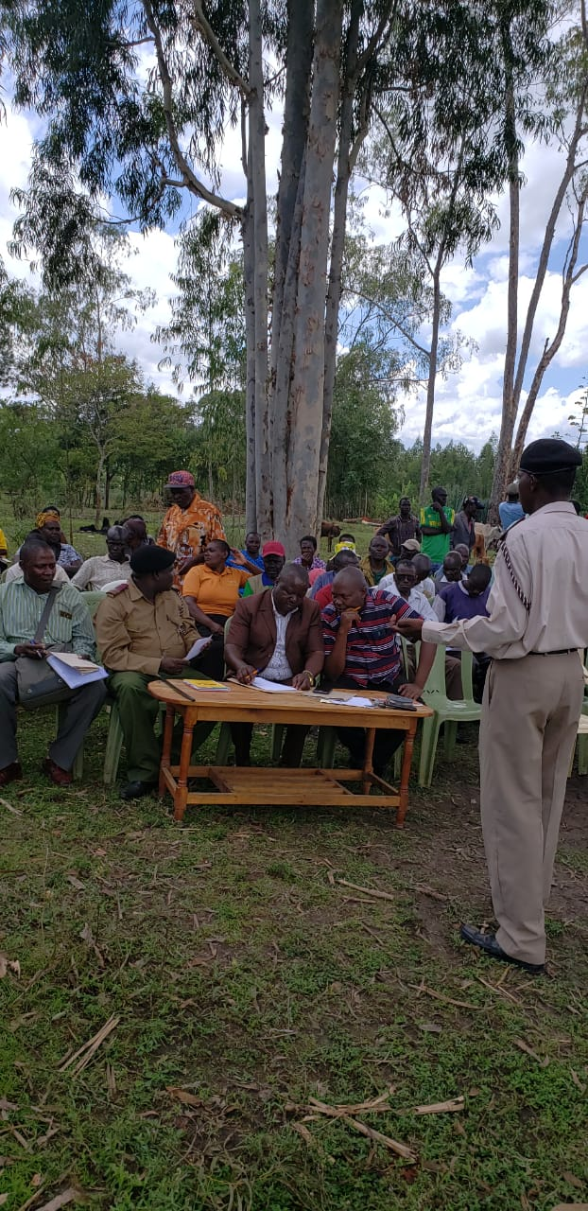

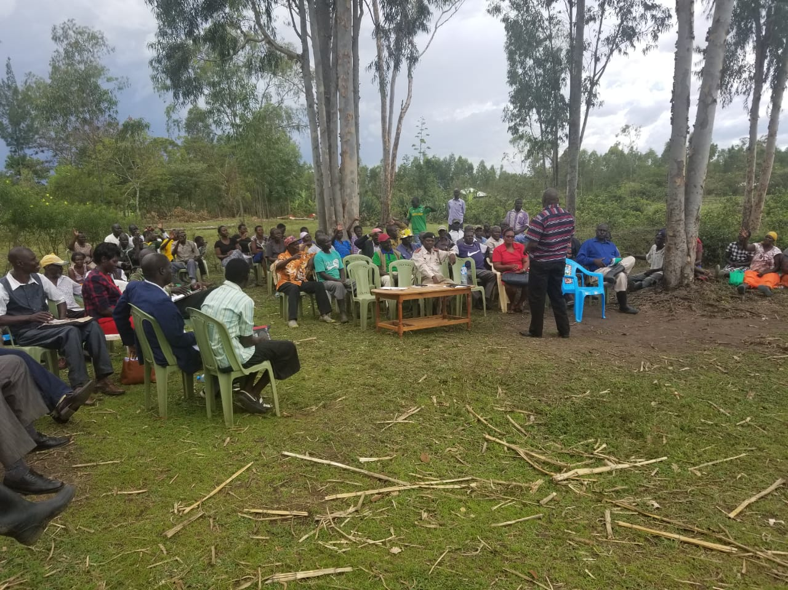



**3.4.0 WARD 2: ARUJO WARD**

The meeting took place on Thursday 02 October 2019, at Got Kochungo Priamary School at 10 am and Ngere Market centre at 2 pm

**3.4.1 Members Present**

* NG-CDF Committee Members
* Assistant County Commissioner
* Area Chiefs and Assistant Chiefs
* Area Elders
* Secondary Schools Heads Representatives
* Primary Schools Heads Representatives
* Invited Stakeholders
* Members of the public

**3.4.2 Preliminaries**

The Chairperson introduced the Assistant County Commissioner who called the meeting to order and called upon one volunteer to lead in opening prayer and request the Area Chief to welcome visitors in his jurisdiction.

**3.4.3 Comments by the area Chief**

The meeting was attended by one chief from Arujo Location, with two Assistant chiefs in Arujo Location who jointly thanked the NG-CDF through Area Mp and MCA for organising a forum where the public have the opportunity to front the projects that they would like NG-CDF to implement within their framework.

**3.4. 4 Comments by the Assistant County Commissioner**

Mr. Alfred Langat commended the participants for their attendance and appealed to all development stakeholders to have a positive attitude and dedication towards development, since development cannot be initiated and owned by foreigners but by the residents themselves. He again urged chiefs to forward their proposals for better structures within their sub location locations to the NG-CDF Office to ensure proper capturing of every single aspect that required attention of the Office.

**3.4. 5 Comments by the Fund Account Manager**

The Fund Account Manager informed the meeting on the nature of eligible projects fundable by NG-CDF as community based to ensure that the prospective benefits are available to a widespread cross-section of the inhabitants of a particular area and those in respect of works and services falling within the functions of the National Government under the constitution.

Further to this he also highlighted the ineligible projects which include: Projects supporting religious bodies or religious activities, projects supporting political bodies or political activities, recurrent costs of a completed projects, personal projects, private projects and projects targeting a specific club or group of people to the exclusion of others

**3.4. 6 Comments by the NG-CDFC representative**

The chairman thanked the constituents for attending the meeting, she explained the relevance of the meeting and the need for NG-CDFC to convene open forum public meetings at in every ward in the constituency to deliberate on development matters and project priorities in the ward and the constituency.

**3.4.7 comments by the area member of national assembly**

He thanked all members in Arujo Ward in general for turning up to vote for him and instead he reiterated on the need of equitable distribution of resources as opposed to equal distribution, to enable all the areas in the constituency get the requisite development initiatives for better livelihood and stressed on stewardship of funds by the community members since they are the development consumers and community watch dogs. He praised the Fund Account Manager for his effort to coordinate the team through ward coordinators for successful of the ward report project proposal.

He further requested the representative of Arujo ward to ensure that there is free and fair in eligible projects irrespective of those who did not support the regime.

**3.4.8 Project priorities identified in Arujo Ward**  at Got kochungo Primary school and Ngere Market

The project priorities were presented per location as tabled below

|  |  |  |  |
| --- | --- | --- | --- |
| **PROJECT PROPOSED** | **SECTOR** | **ACTIVITY** | **LOCATION** |
| Lala Secondary School | Education | Construction of Classrooms, Plastering, flooring and Painting | Arujo |
| St. Ambrose Sec | Education | Construction of Classrooms, Plastering, flooring and Painting | Arujo |
| Nyagidha Secondary | Education | Construction of 12 No. Classrooms, Plastering, flooring and Painting | Arujo |
| Lala Primary School | Education | Fencing of school compound to avoid trespass, construction of toilets and renovation of classrooms. | Arujo |
| Arujo Chiefs Office | Security | Completion of Chiefs office | Arujo |
| Homabay Police Station | Security | Renovation of Police Station |  |
| Ngere Sec. School | Education | Construction of 2 No. Classrooms, Plastering, flooring and Painting | Arujo |
| Arujo – Ogongo Road | Road | Grading and opening of the road | Arujo |
| Bursary To All Needy Students | Education | Forms for bursary for 2019-2020 | Arujo/West Kanayada |
| Kochungo Primar School | Education | Fencing of primary school | Arujo |
| Matago Primary School | Education | Administration block |  |
| Roba, Wiga, Pap Ndege,Sero Primary Schools | Education | Fencing of primary schools | Arujo/West Kanayada |
| Arunda Primary School | Education | Construction of two classrooms | Arujo |
| Arujo Primary School | Education | Construction of administration block | Arujo |
|  |  |  |  |
| Lieta Kabunde Primary School | Education | Construction of toilets, renovation of classrooms and purchase of desks. | Arujo |
| Nyagidha Mixed Sec | Education | Construction of classes, Pit latrines | Arujo |
| Ngere Primary School | Education | Construction of classes, Pit latrines | Arujo |
| Arujo Assistant Chief | Security | Construction of Assistant Chief office | Arujo |
| Kabunde Chiefs Office | Security | Construction of Assistant Chief office Arujo Sub-location | Arujo |
| Katuma Sub-location Ass | Security | Construction of Assistant Chief office Katuma Sub-location | Arujo |
| Kabunde Social Hall | Security | Installation of Security lights | Arujo |

**3.4. 9 Challenges**

Members expressed concern on the restrictive nature of the projects fundable by NG-CDF, especially in the agricultural, health and roads sectors, but the area member of national assembly urged them to forward the projects to the area member of county assembly who was also present in the meeting.

**3.4.10 Way Forward**

The meeting resolved that all the funds disbursed to projects be spent judiciously to promote value for money and boost the livelihood of the residents.

3.4.11 **Closing Remarks**

The Area Chief commended the involvement of members of the public by NG-CDF on development agendas and wished these could continue in the preceding years. He then requested the Pastors present to offer a closing prayer at 3:40p.m

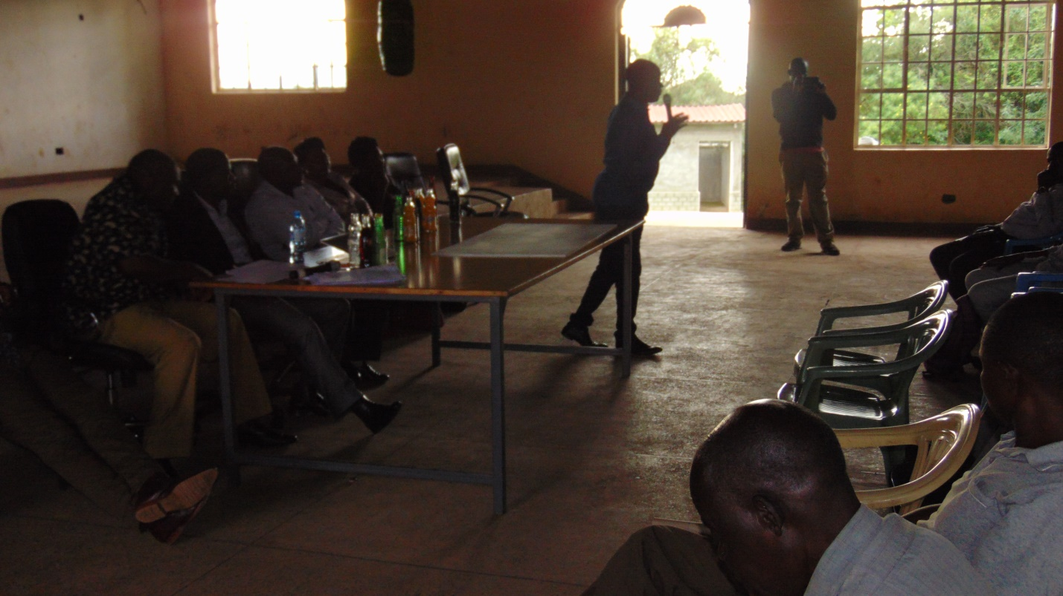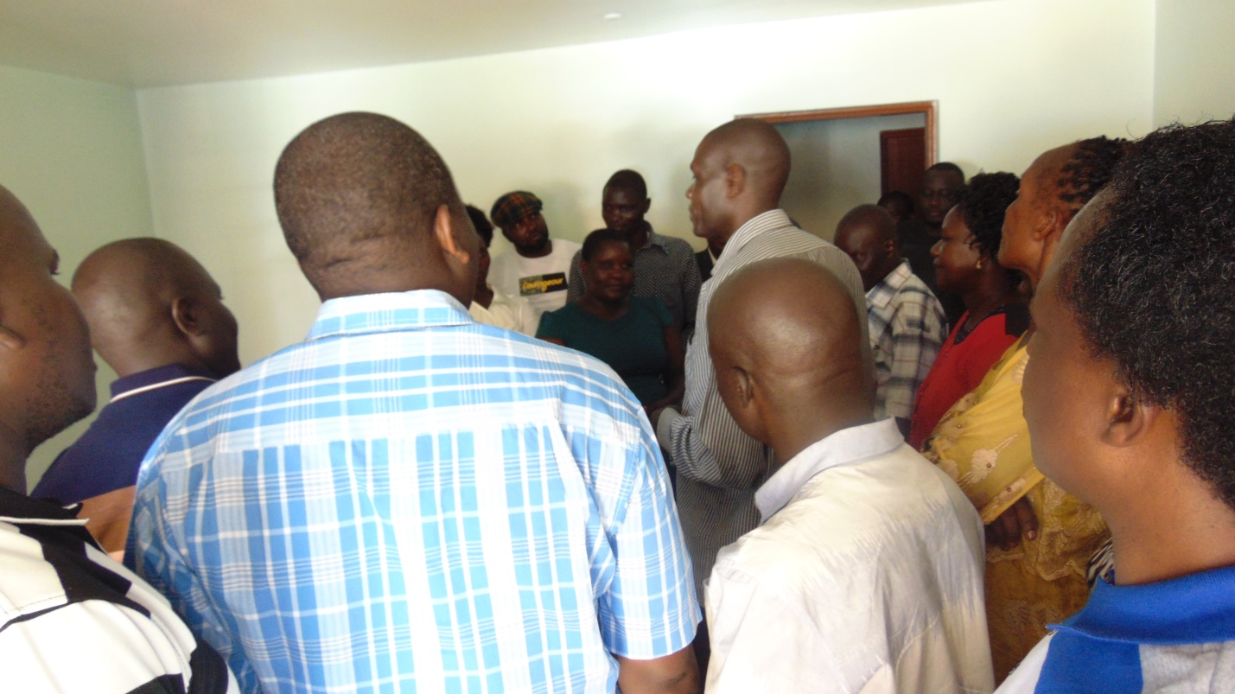

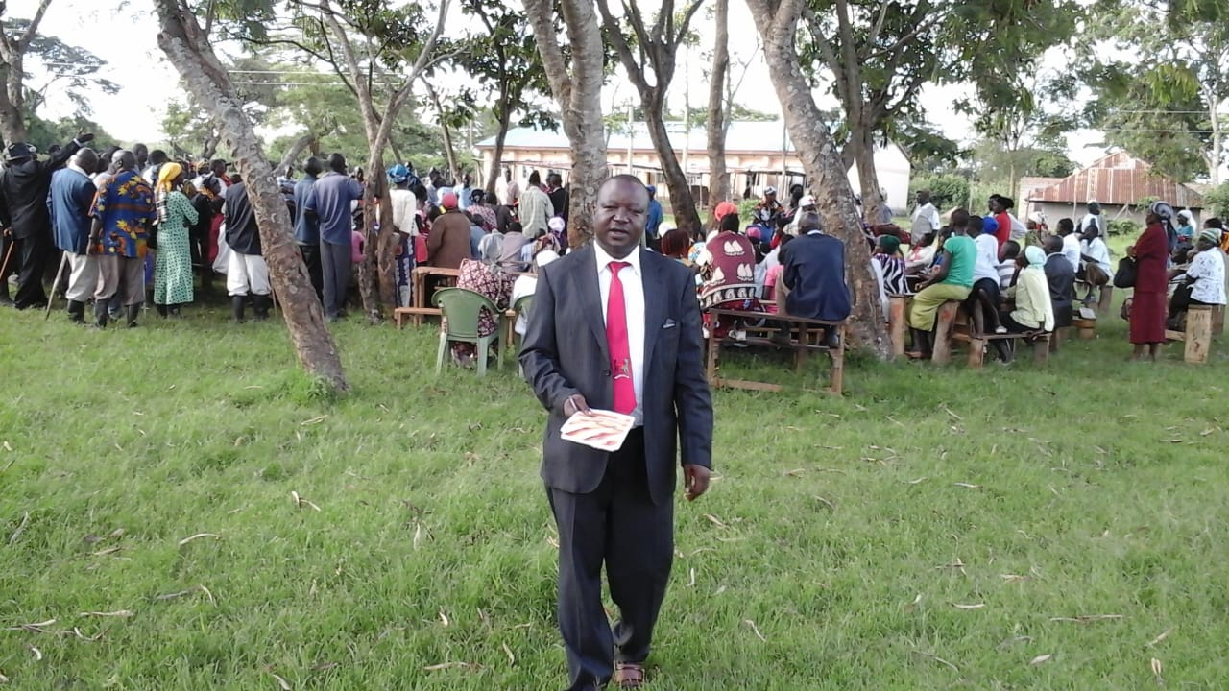

**3.5.0 WARD III: WEST WARD**

The meeting took place on Thursday 03 October 2019, at Kanyabala Chiefs camp at 10:00am.

3.5.1 **Members Present**

* NG-CDF Committee
* Area Member of National Assembly Representatives
* Deputy County Commissioner
* Area Chiefs
* Area Elders
* Secondary Schools Heads Representative
* Primary Schools Heads Representative
* Invited Stakeholders
* Community members

**3.5.2 Preliminaries**

The meeting began with a word of prayer; thereafter area chief welcomed members to the meeting and introduced the members of the ward development committee.

**3.5.3 Comments by the Assistant County Commissioner**

He welcomed members to the meeting and pointed out the importance of community involvement in any development process and the benefits of bottom up projects identification process.

**3.5.4 Comments by the Fund Account Manager**

The Fund Account Manager informed the meeting on the nature of eligible projects fundable by NG-CDF as community based to ensure that the prospective benefits are available to a widespread cross-section of the inhabitants of a particular area and those in respect of works and services falling within the functions of the National Government under the constitution. He further informed the ward coordinators to help in bursary form distribution in the ward.

**3.5.5 Comments by the NG-CDFC Secretary**

He asserted that, decentralized funds are established based on the belief that implementing bodies at the local level have a better understanding of community needs. Decentralized funds are established to increase community participation in local decision making, enhance government transparency, speed up government responsiveness, and improve quality of service delivery.

**3.5.6 Comments by theRepresentative of area Member of National Assembly**

He pointed out that the impact of NG-CDF cannot be underrated in transforming people’s lives in the country. In the education sector, NG-CDF has facilitated construction of various infrastructural developments in schools, and this has assisted in increasing student enrolment and offering of condusive learning environment. The NG-CDF bursary has helped retain in schools students from low income families. Hence, the public should champion for the protection and retention of the fund as much as possible.

3.5.7 PROJECT PRIORITIES IDENTIFIED IN THE WARD at Kanayabala chiefs office

The project priorities were presented per location as tabled below:

|  |  |  |  |
| --- | --- | --- | --- |
| **PROJECT PROPOSED** | **SECTOR** | **ACTIVITY** | **LOCATION** |
| Bishop Okullu Magare Sec | Education | Completion of dormitory | Kanyabala |
| Langoromo Secondary School | Education | Completion of laboratory | Kanyabala |
| Nyakahia Secondary School | Education | Completion of admin block | Kanyabala |
| Riwa Mixed Sec | Education | Completion of admin block | West |
| Nyakune Primary School | Education | Completion of classrooms | Kanyabala |
| Radiro Primary School | Education | Construction of admin block | West |
| Watata Primary School | Education | Completion of admin block | West |
| Kijawa Primary School | Education | 4 door latrine.  Fencing of school by chain link wire  Drilling of water to use | west |
| Yao Primary School | Education | Completion of classrooms | West |
| Nyagidha Primary School | Education | Renovation of classes | West |
| Adongo PrimarySchool | Education | Completion of admin block | West |
| Pedo Primary school | Education | Construction of Classrooms, Plastering, flooring and Painting | Kanyabala |
| Maguti Primary School | Education | Construction of administration block, completion of ECDE building, fencing of the school compound. | Kanyabala |
| Nyagidha Primary School | Education | Completion of special unit | West |
| Ruga Primary School | Education | Construction of 7 pit latrines doors and urinal pit/renovation of classroom/construction of admin block | Kanyabala |
| Kanyabala Chiefs Camp | Security |  | Kanyabala |

**3.5.8 Challenge**

Members expressed concern on the restrictive nature of the projects fundable by NG-CDF, especially in the agricultural, health and roads sectors, but the area member of national assembly urged them to forward the projects to the area member of county assembly who was also present in the meeting.

**3.5.9 Way Forward**

The meeting resolved that all the funds disbursed to projects be spent judiciously to promote value for money and boost the livelihood of the residents.

3.5.10 CLOSING REMARKS

The Area Member of Parliament request the Constituency Chaplain to order for prayer at 3:42p.m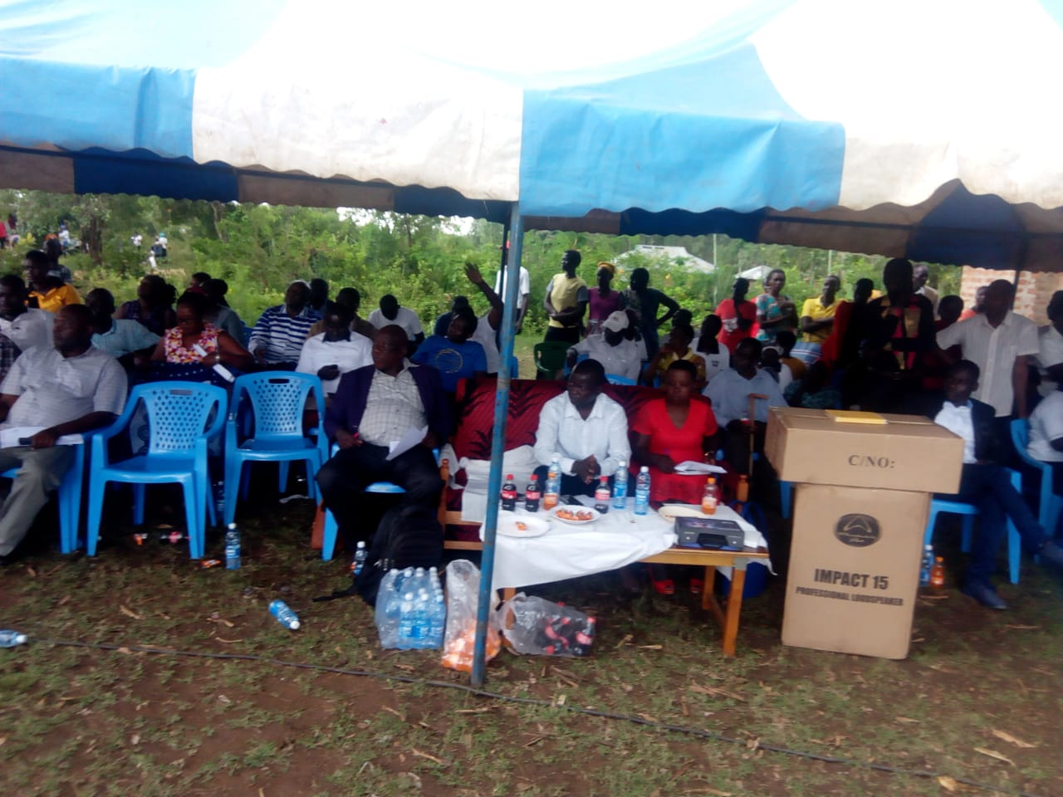

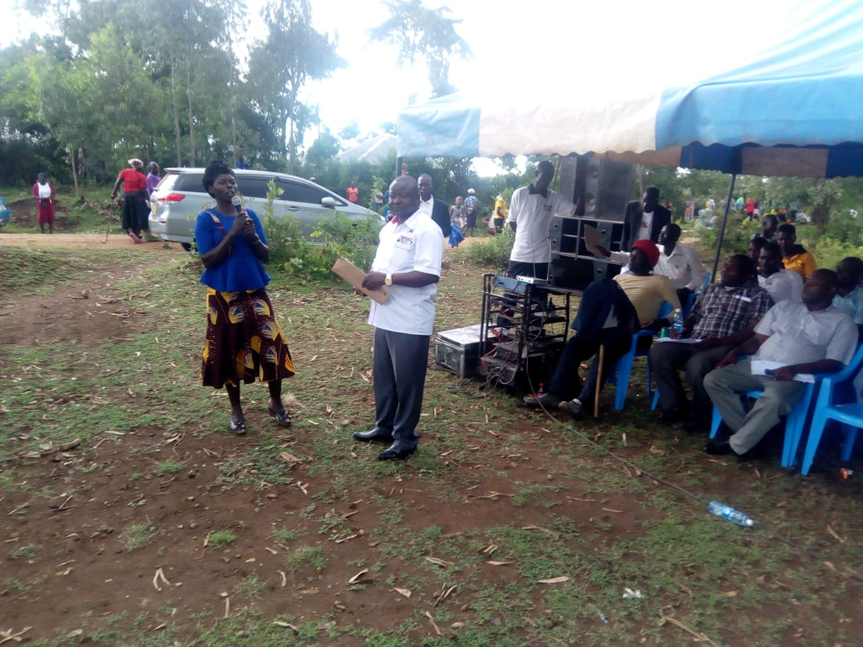

**3.5 WARD IV: EAST WARD**

The meeting took place on Thursday 10, 2019, at Orego Chiefs camp and Marindi centre.

**3.5.1 Members Present**

* NG-CDF Committee
* Representative of Area Member of National Assembly
* Assistant County Commissioner
* Area Chiefs
* Area Elders
* Secondary Schools Heads Representative
* Primary Schools Heads Representative
* Invited Stakeholders
* Community members

**3.5.2 Preliminaries**

The meeting began with a word of prayer, thereafter area chief welcomed members to the meeting and introduced the members of the ward development committee.

**3.5.3 Comments by the Assistant County Commissioner**

He welcomed members to the meeting and pointed out the importance of community involvement in any development process and the benefits of bottom up projects identification process.

3.5.4 **Comments by the Fund Account Manager**

The Fund Account Manager informed the meeting on the nature of eligible projects fundable by NG-CDF as community based to ensure that the prospective benefits are available to a widespread cross-section of the inhabitants of a particular area and those in respect of works and services falling within the functions of the National Government under the constitution. He requested the NG-CDFC and the Member of Parliament through the ward cordinators to jointly work and share together ideas that may best improve the livelihood of the community members of Homabay Town.

**3.5.5 Comments by the NG-CDFC Representative**

He encouraged Youth, Disabled, and Women to participate in tendering to avoid idling that may lead to arrest.

**3.5.6 Comments by the NG-CDFC Chairperson**

He pointed out that the impact of NG-CDF cannot be underrated in transforming people’s lives in the country. In the education sector, NG-CDF has facilitated construction of various infrastructural developments in schools, and this has assisted in increasing student enrolment and offering of conducive learning environment. The NG-CDF bursary has helped retain in schools students from low income families. Hence, the public should champion for the protection and retention of the fund as much as possible.

**3.5.7 Project Priorities Identified in East Ward**

The project priorities were presented per location as tabled below:

|  |  |  |  |
| --- | --- | --- | --- |
| **PROJECT PROPOSED** | **SECTOR** | **ACTIVITY** | **LOCATION** |
| Got Kokech Primary | Education | Construction of classrooms | Kothidha |
| Lower Kanyach | Water | Driling of water for community | Kanyach Kachar |
| Wahambla –Kotewa road | Road | Spot Murraming of the road | Kanyada |
| Nyalkinyi Seconadry School | Education | Completion of administration block | Kanyada |
| Otaro Primary School | Education | Renovation of classrooms, pit latrines and fencing of school | Kanyada |
| Ngere Secondary School | Education | Laboratory completion | Kanyada |
| Gogo katuma Secondary school | Education | Laboratory completion | Kanyada |
| Wahambla Primary School | Education | Renovation of classrooms | Kanyada |
| School Desks for primary | Education | Purchase of school desks for various primary schools within the constituency. | Various |
| Pala masogo Mixed Sec | Education | Completion of dormitory | Kothidha |
| St. Pius Ndiru Mixed Sec | Education | Completion of Administration block | Kanyach Kachar |
| St. Teresa Nyauu Girls | Education | Completion of dormitory | Komollo |
| Ndiru primary school | Education | Completion of classes and administration block | Kanyach Kachar |
| Hon. Kaluma Kotewa Primary | Education | Completion of 2No. Classrooms | Kothidha |
| Lorateng Primary | Education | Completion of classrooms | Kothidha |
| Manga Primary School | Education | Completion of administration block | Kanyada |
| Nyauu Primary school | Education | Completion of classrooms | Komollo |
| Otaro Primary School | Education | Renovation of classrooms | Komollo |
| Kopiyo Primary School | Education | Renovation of classrooms | Kothidha |
| Roba Primary School | Education | Construction of two modern classrooms | Komollo |  |
| Imbo-Otaro- Nyalkinyi secondary school road | Education | Gravelling of roads connecting the schools | Kanyach Kachar |
| Junction Kogelo Kalanya-kaluma Kotewa roads | Education | Gravelling of roads connecting the schools | Kanyach Kachar |
| St. Peters Disii Secondary School | Education | Construction of two classrooms and administration block | Komollo |
| Masakla Primary School | Education | Construction of administration block, renovation of 8 classrooms | Kothidha |
| Kambeke Primary school | Education | Fencing and administration block | Kanyach Kachar |
| Ogande Chiefs Office | Security | Renovation of chies office | Kanyach Kachar |
| Kolanya Kanyango Chief’ office | Security | Construction of a new chief office | Kanyach Kachar |
| Akech Police Post | Security | Construction of police post | Kanyach Kachar |
| Kothidha Assistant Chief office | Security | Construction of a new assistant chief’s office | Kothidha |
| Kothidha Assistant Chief office | Security | Construction of a pit latrine at assistant chief’s office | Kothidha |
| Imbo Police Post | Security | Construction of proposed police post | Kothidha |
| East kanyanda Chief’s office | Security | Construction of a new chief office | Kanyanda |
| Nyatago Primary Road | Road | Murraming of the road | Kothidha |
| Ogande Mixed Primary School | Education | Construction of three classrooms | Kanyach Kachar |
| St. Mary’s Marindi Girls Sec | Education | Purchase of school bus | Kanyach Kachar |

**3.5.8 Challenge**

Members expressed concern on the restrictive nature of the projects fundable by NG-CDF, especially in the agricultural, health and roads sectors, but the area member of national assembly representative urged them to forward the projects to the area member of county assembly whose representatives was also present in the meeting.

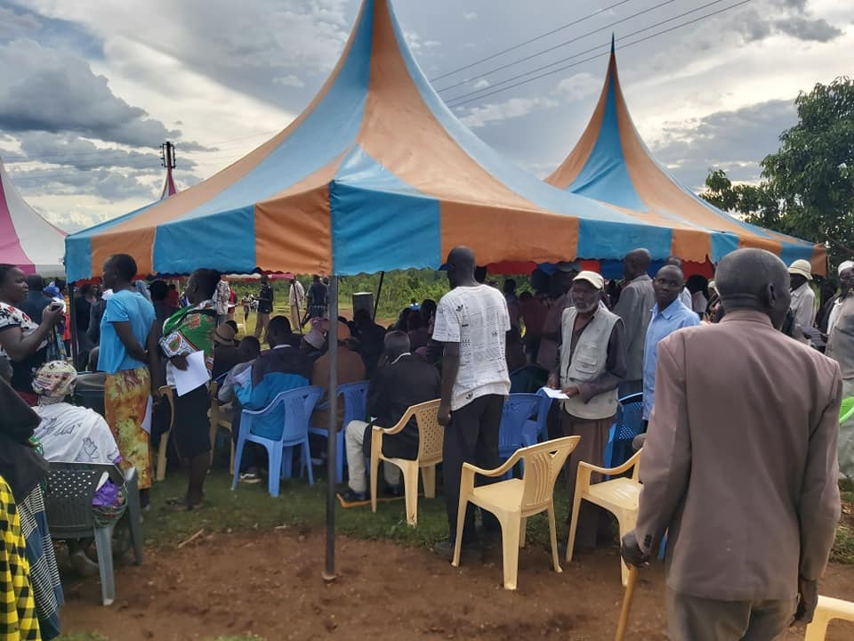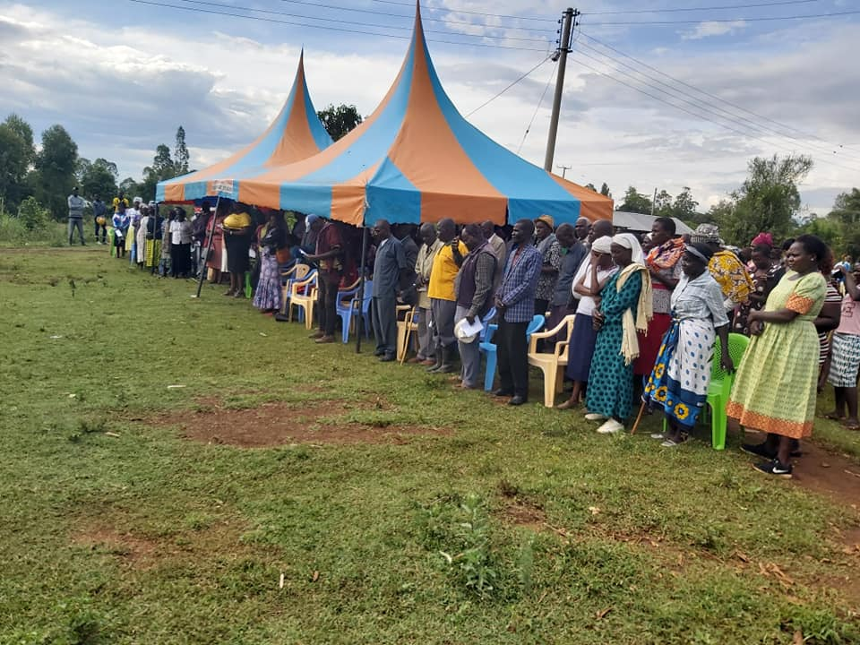

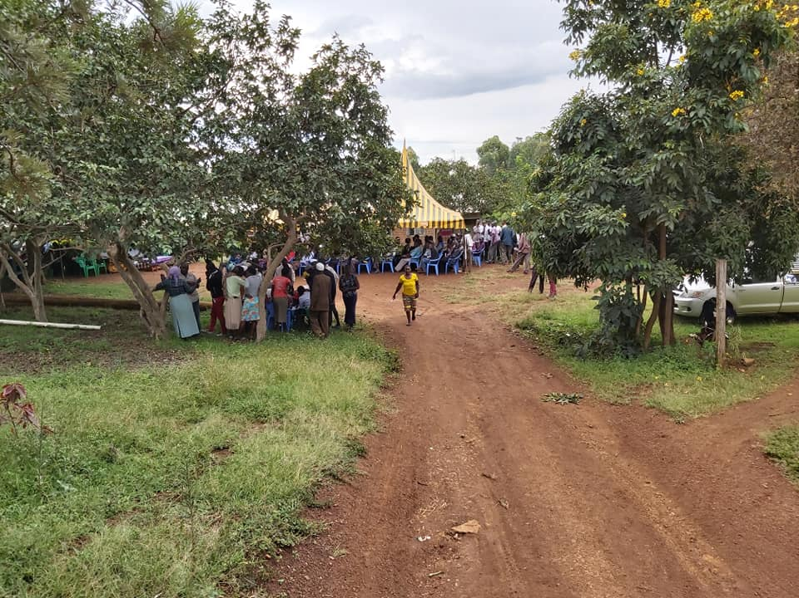

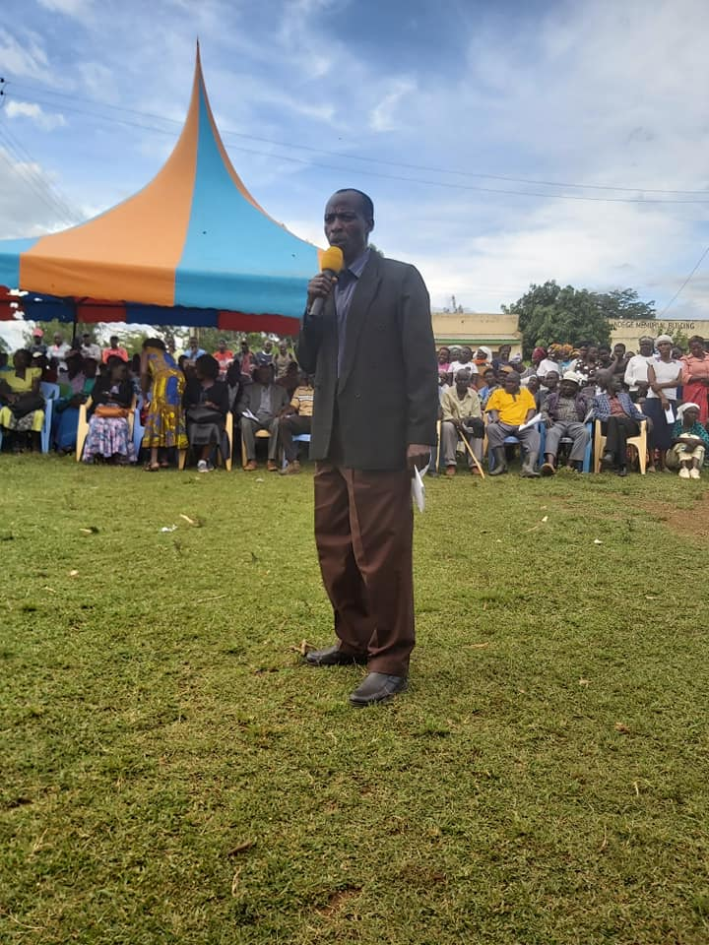

**3.5.9 Way Forward**

The meeting resolved that all the funds disbursed to projects be spent judiciously to promote value for money and boost the livelihood of the residents. Youths and women registered including persons living with disability were challenged to apply for various tenders so as to sustain their lives.

**3.5.10 Closing Remarks**

The Assistant County Commissioner commended on theprocess undertaken by the NG-CDFC team as it will guide ways in which projects will be implemented in the constituency in the next two years. He thanked me,bers of public for showing up acreoss the constituency to give their view on development matters. He finally requested the clergy present for closing prayer prayer at 4:50p.m

**3.6 WARD IV: ARUJO WARD**

The meeting took place on Friday, 11, 2019, at Kabunde Multipurpose hall .

**3.6.1 Members Present**

* NG-CDF Committee
* Representative of Area Member of National Assembly
* Assistant County Commissioner
* Area Chiefs
* Area Elders
* Secondary Schools Heads Representative
* Primary Schools Heads Representative
* Invited Stakeholders
* Community members

**3,6.2 Preliminaries**

The meeting began with a word of prayer, thereafter area chief welcomed members to the meeting and introduced the members of the ward development committee.

**3.6.3 Comments by the Assistant County Commissioner**

He welcomed members to the meeting and pointed out the importance of community involvement in any development process and the benefits of bottom up projects identification process.

**3.6.4 Comments by the Fund Account Manager**

The Fund Account Manager informed the meeting on the nature of eligible projects fundable by NG-CDF as community based to ensure that the prospective benefits are available to a widespread cross-section of the inhabitants of a particular area and those in respect of works and services falling within the functions of the National Government under the constitution. He requested the NG-CDFC and the Member of Parliament through the ward cordinators to jointly work and share together ideas that may best improve the livelihood of the community members of Homabay Town.

**3.6.5 Comments by the NG-CDFC Representative**

He encouraged Youth, Disabled, and Women to participate in tendering to avoid idling that may lead to arrest.

3**.6.6 Comments by the area member of National ASsembly Representative**

He pointed out that the impact of NG-CDF cannot be underrated in transforming people’s lives in the country. In the education sector, NG-CDF has facilitated construction of various infrastructural developments in schools, and this has assisted in increasing student enrolment and offering of conducive learning environment. The NG-CDF bursary has helped retain in schools students from low income families. Hence, the public should champion for the protection and retention of the fund as much as possible. NG-CDF Homabay Town Constituency has now embarked to do Security projects with Chiefs Offices being given preference and OCS Office to enhance security in the region.

**3.6.7 Project priorities identified in Arujo Ward**

|  |  |  |  |
| --- | --- | --- | --- |
| **PROJECT PROPOSED** | **SECTOR** | **ACTIVITY** | **LOCATION** |
| Lala Secondary School | Education | Construction of Classrooms, Plastering, flooring and Painting | Arujo |
| St. Ambrose Sec | Education | Construction of Classrooms, Plastering, flooring and Painting | Arujo |
| Nyagidha Secondary | Education | Construction of 12 No. Classrooms, Plastering, flooring and Painting | Arujo |
| Lala Primary School | Education | Fencing of school compound to avoid trespass, construction of toilets and renovation of classrooms. | Arujo |
| Arujo Chiefs Office | Security | Completion of Chiefs office | Arujo |
| Homabay Police Station | Security | Renovation of Police Station |  |
| Ngere Sec. School | Education | Construction of 2 No. Classrooms, Plastering, flooring and Painting | Arujo |
| Arujo – Ogongo Road | Road | Grading and opening of the road | Arujo |
| Wiamen –Arujo Road | Road | Grading and opening of the road | Arujo |
| Bursary To All Needy Students | Education | Forms for bursary for 2019-2020 | Arujo/West Kanayada |
| Kochungo Primar School | Education | Fencing of primary school | Arujo |
| Matago Primary School | Education | Administration block |  |
| Roba, Wiga, Pap Ndege,Sero Primary Schools | Education | Fencing of primary schools | Arujo/West Kanayada |
| Arunda Primary School | Education | Construction of two classrooms | Arujo |
| Arujo Primary School | Education | Construction of administration block | Arujo |
|  |  |  |  |
| Lieta Kabunde Primary School | Education | Construction of toilets, renovation of classrooms and purchase of desks. | Arujo |
| Nyagidha Mixed Sec | Education | Construction of classes, Pit latrines | Arujo |
| Ngere Primary School | Education | Construction of classes, Pit latrines | Arujo |

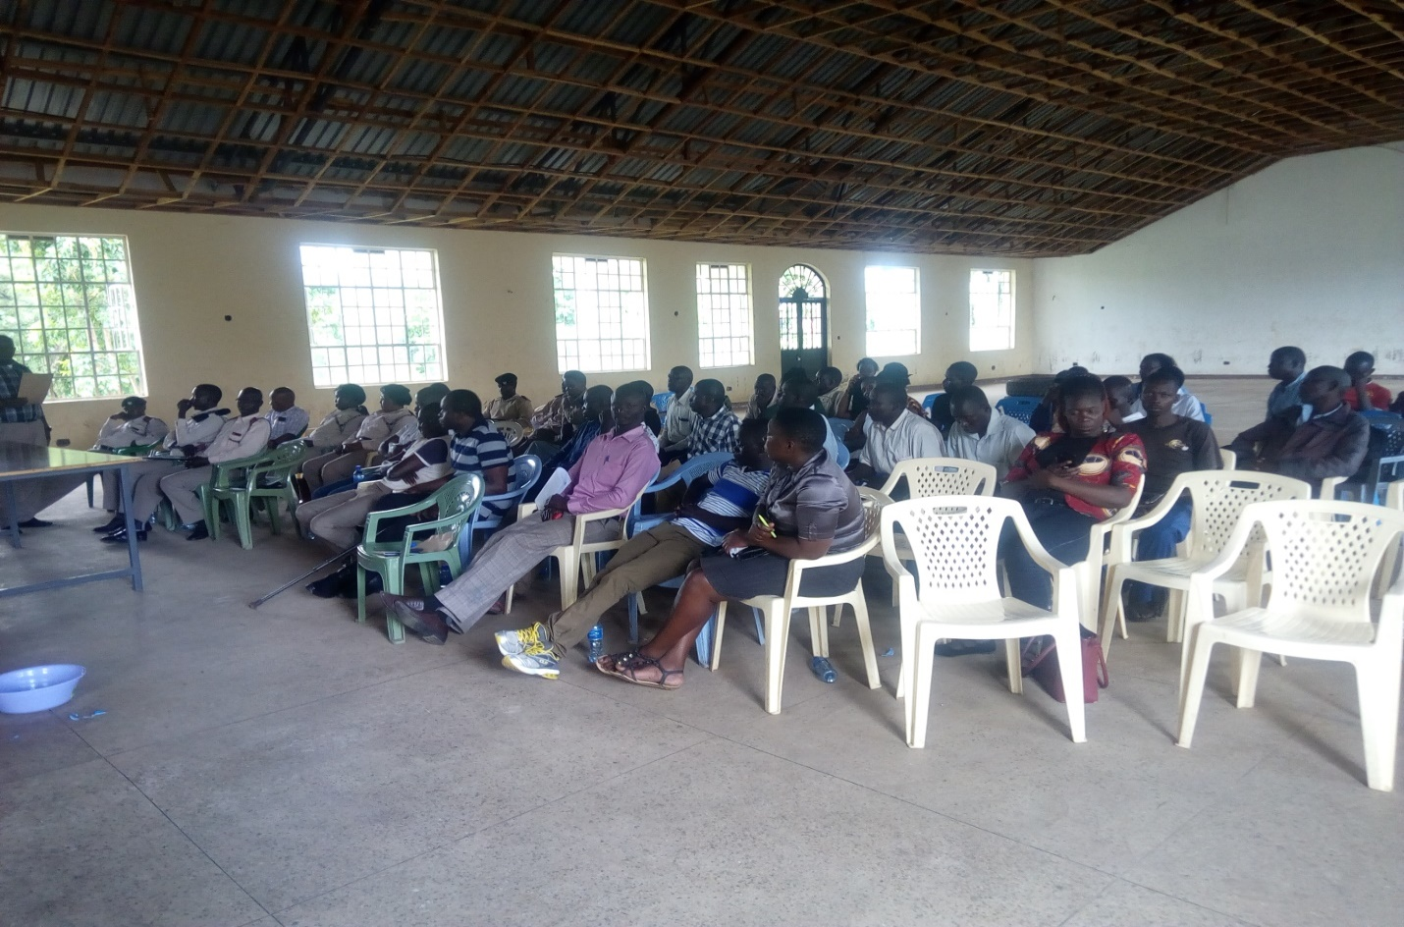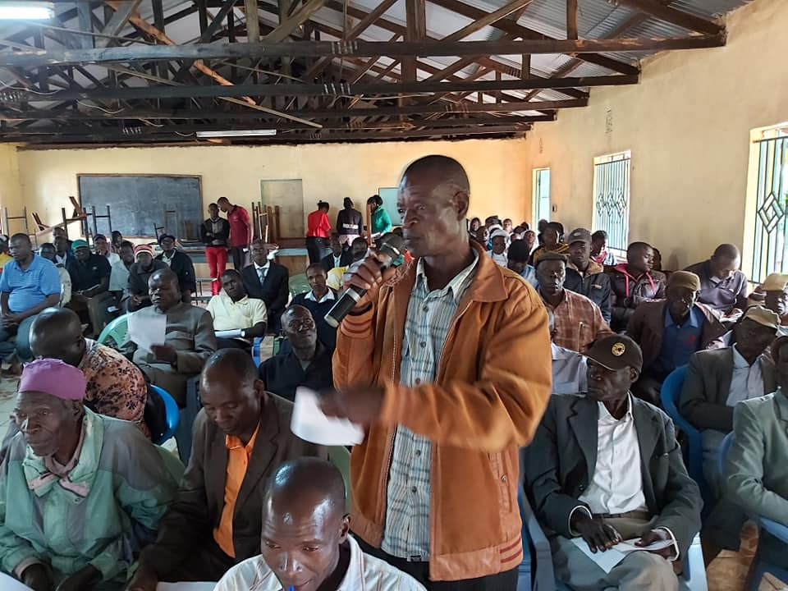

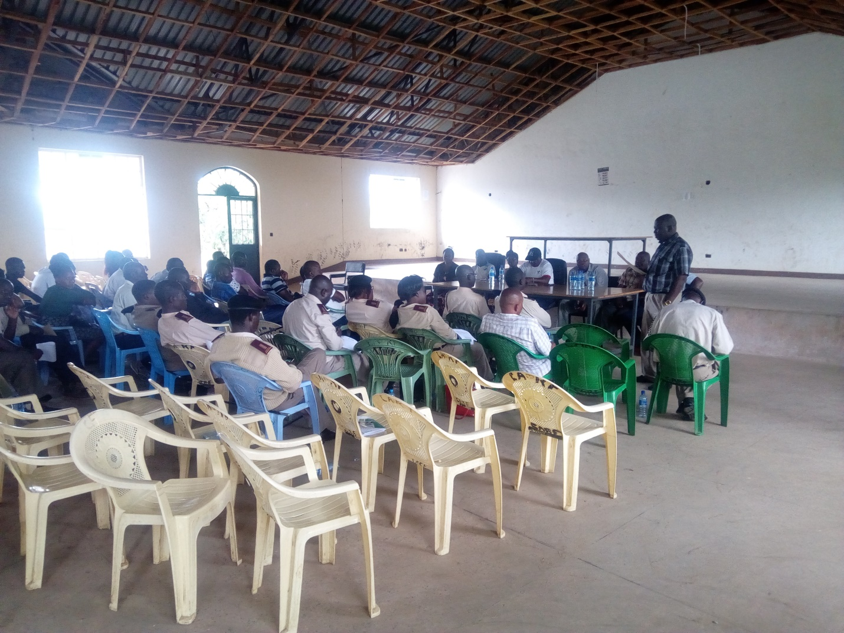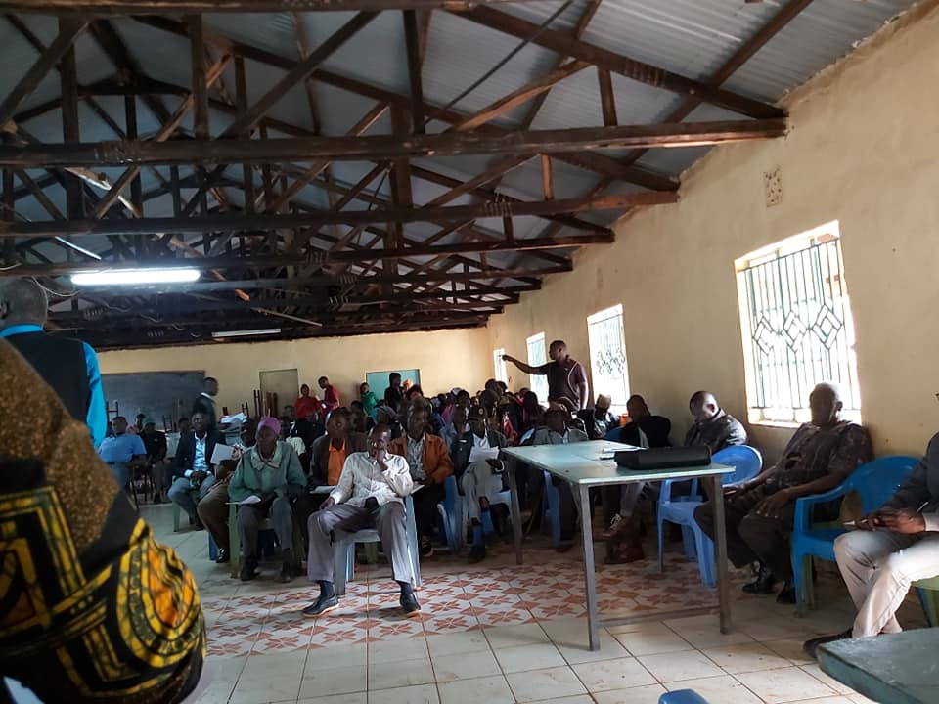

**SUMMARY**

The Member of Parliaments representaive took the opportunity to thank all leaders especially the Members of public for taking their time and showing commitment towards developing Homabay Town Constituency. He urged the members of the public to cooperate with the NG-CDFCs so as to make the Constituency the best in terms of development in the County and Region.

The Assistant County Commissioner 1 thanked officials of the Provincial administration for the quick response they made to mobilize members of the public to attend the forums. He urged them to ensure peace prevails in their area of jurisdiction without forgetting to mention the illicit brew menace.

The Chairman NG-CDFC praised hardworking members of the Project Management Committees and urged others to follow examples of best managed projects. He informed the public that he will ensure through Monitoring and Evaluation by NG-CDFC team that all Projects show value for money at the end of the project period. He thereafter called upon Chaplain to close the meeting with a word of prayer.

.

**______________________________ ____________________________**

**Signed (Chairperson) Date**

**______________________________ ____________________________**

**Signed (Fund Account Manager) Date**

**______________________________ ____________________________**

**Signed (Deputy County Commissioner) Date**

**Homa Bay Town National Government Constituency Development Fund**

**PROJECT PROPOSAL 2019/2020 FINANCIAL YEAR**

**CODE LIST**

|  |  |  |  |  |  |  |  |
| --- | --- | --- | --- | --- | --- | --- | --- |
|  | | | | | | | |
| **PROJECT NAME** | **GFS CODE** | | **ORIGINAL COST** | **CUMULATIVE ALLOCATION** | **PROJECT ACTIVITY** | **AMOUNT ALLOCATED** | **STATUS** |
| **OFFICE ADMINISTRATION** |  | |  |  |  |  |  |
| **Employees’ Salaries** | **4-043-249-2110000-100-2019/20-001** | | **4,560,000.00** | **-** | **Payment of staff salaries and Wages for Field Officers** | **4,560,000.00** | **On-going** |
| **Staff Gratuity** | **4-043-249-2110000-100-2019/20-002** | | **844,000.00** |  | **Payment of staff gratuity** | **844,000.00** | **On-going** |
| **Goods and Services** | **4-043-249-2110000-100-2019/20-003** | | **1,526,060.00** | **-** | **Payment of Security, Utilities and Purchase of fuel, hire of transport vehicle,Internet Subscription, Communication allowances,Repairs and Maintenance, printing, stationery, telephone, travel and subsistence, office tea and other office operation.** | **1,526,060.00** | **On-going** |
| **NHIF** | **4-043-249-2110000-100-2019/20-004** | | **50,000.00** | **-** | **Payment of NHIF Deductions** | **50,000.00** | **On-going** |
| **NSSF** | **4-043-249-2110000-100-2019/20-005** | | **70,000.00** | **-** | **Payment of NSSF Deductions** | **70,000.00** | **On-going** |
| **Committee Expenses** | **4-043-249-2110000-100-2019/20-006** | | **1,192,000.00** | **-** | **Payment of Committee sitting allowances, transport, conferences** | **1,192,000.00** | **On-going** |
|  |  | |  |  |  | **8,242,060.00** |  |
| **MONITORING AND EVALUATION** | | |  |  |  |  |  |
| **Goods and Services** | | **4-043-249-2210000-111-2019/20-001** | **707,227.00** | **-** | **Purchase of fuel, repairs and maintenance, printing, stationery, Airtime, hire of vehicle for M&E activities,travel and subsistence** | **707,227.00** | **On-going** |
| **Committee Expenses** | | **4-043-249-2210802-111-2019/20-002** | **1,064,000.00** | **-** | **Payment of Committee sitting allowances, transport, conferences** | **1,064,000.00** | **On-going** |
| **CDFC/PMC & Staff Capacity Building** | | **4-043-249-2210700-111-2019/20-003** | **1,937,804.70** | **-** | **Undertake Training of the PMCs/CDFCs and Staff on NG-CDF Related issues** | **1,937,804.70** | **On-going** |
| **Consituency Oversigt Committee Expenses** | | **4-043-249-2210700-111-2019/20-004** | **412,000.00** |  | **Oversight Committee expenses: Allowances, transport costs etc** | **412,000.00** | **On-going** |
|  | |  |  |  |  | **4,121,031.70** |  |
| **BURSARY** | |  |  |  |  |  |  |
| **Bursary – Secondary Schools** | | **4-043-249-2640101-103-2019/20-001** | **23,750,000.00** | **-** | **Bursary to cater for needy students in Secondary Schools** | **23,750,000.00** | **On-going** |
| **Bursary - Tertiary institutions ( Universities and Colleges)/** | | **4-043-249-2640102-103-2019/20-002** | **6,000,000.00** | **-** | **Bursary funds to cater for needy students in tertiary Institutions.** | **6,000,000.00** | **On-going** |
| **Bursary - Special Schools** | | **4-043-249-2640103103-2019/20-003** | **600,000.00** | **-** | **Bursary funds to cater for needy students in special Schools and Institutions.** | **600,000.00** | **On-going** |
|  | |  |  |  |  | **30,350,000.00** |  |
| **EMERGENCY** | |  |  |  |  | **-** |  |
| **Emergency (5%)** | | **4-043-249-2640200-101-2019/20-001** | **6,868,386.34** | **-** | **Funds set aside for to cater for unforeseen occurrences during the Financial Year.** | **6,868,386.34** | **On-going** |
| **PRIMARY SCHOOLS** | |  |  |  |  |  |  |
| **Adongo Primary** | | **4-043-249-2630204-104-2019/20-001** | **2,000,000.00** | **1,000,000.00** | **Completion of Administration Block: Plastering, Fitting of windows and doors and Painting** | **1,000,000.00** | **On-going** |
| **Arujo Primary School** | | **4-043-249-2630204-104-2019/20-002** | **2,000,000.00** | **1,000,000.00** | **Completion of Administration Block:Fitting of windows and doors, plastering,flooring and Painting** | **500,000.00** | **On-going** |
| **Got Kokech Primary School** | | **4-043-249-2630204-104-2019/20-003** | **1,500,000.00** | **1,000,000.00** | **Completion of 2No. Classrooms: Fitting of windows and doors, Plastering, flooring and painting** | **500,000.00** | **On-going** |
| **Homa Bay Primary School** | | **4-043-249-2630204-104-2019/20-004** | **1,000,000.00** |  | **Renovation of 8 No. Classrooms: Replacement of Roof, Floor repairs, Glazing and Painting.** | **1,000,000.00** | **New** |
| **Hon. Kaluma Kotewa Primary School** | | **4-043-249-2630204-104-2019/20-005** | **1,500,000.00** | **1,000,000.00** | **Completion of 2 No. Classrooms: Plastering, Fittingof windows anddoors and Painting.** | **500,000.00** | **On-going** |
| **Kambeke Primary School** | | **4-043-249-2630204-104-2019/20-006** |  |  | **Completion of 2No. Classrooms: Fitting of windows and doors, Plastering, flooring and painting** | **200,000.00** | **On-going** |
| **Kijawa Primary School** | | **4-043-249-2630204-104-2019/20-007** | **500,000.00** |  | **Construction of a new 5 door tiolet for girls: Diggiging 30 ft pit latrine , walling, roofing, plastering and painting** | **500,000.00** | **New** |
| **Kogello Kalanya Primary School** | | **4-043-249-2630204-104-2019/20-008** | **2,000,000.00** | **1,000,000.00** | **Completion of Administration Block: Roofing , Plastering, Fittingsofwindows and doors and Painting** | **1,000,000.00** | **On-going** |
| **Kopiyo Primary School** | | **4-043-249-2630204-104-2019/20-009** | **700,000.00** |  | **Renovation of 8 No. Classrooms: Fitting, Plastering and Painting** | **700,000.00** | **New** |
| **Kuja Primary School** | | **4-043-249-2630204-104-2019/20-010** | **1,500,000.00** | **1,390,000.00** | **Completion of 2No. Classrooms: Fitting of window panes flooring and painting** | **110,000.00** | **On-going** |
| **Lake Primary School** | | **4-043-249-2630204-104-2019/20-011** | **2,500,000.00** | **2,000,000.00** | **Completion of Administration Block: Plastering, fitting of doors and windows, flooring and painting** | **500,000.00** | **On-going** |
| **Lang'oromo Primary School** | | **4-043-249-2630204-104-2019/20-012** | **1,000,000.00** |  | **Renovation of 10 No. Classrooms: Repair of leaking roof,Fitting of window panes and windows replacements, repair of floors and Painting** | **1,000,000.00** | **New** |
| **Lieta Kabunde Primary School** | | **4-043-249-2630204-104-2019/20-013** | **700,000.00** |  | **Renovation of 9 No. Classrooms: Repair of leaking roof,replacement of brocken window panes, repair of floors and Painting** | **700,000.00** | **New** |
| **Lorateng Primary School** | | **4-043-249-2630204-104-2019/20-014** | **1,500,000.00** | **1,000,000.00** | **Completion of 2 Classrooms: Fitting of doors and windows, plastering , flooring and Painting.** | **500,000.00** | **On-going** |
| **Maguje Primary School** | | **4-043-249-2630204-104-2019/20-015** |  |  | **Completion of 3No. Classrooms** | **800,000.00** | **On-going** |
| **Manga Primary School** | | **4-043-249-2630204-104-2019/20-016** | **1,500,000.00** | **1,000,000.00** | **Completion of Administration Block: Roofing, Fittingof windows and doors, Plastering and Painting** | **500,000.00** | **On-going** |
| **Masakla Primary School** | | **4-043-249-2630204-104-2019/20-017** |  |  | **Completion of 2No. Classrooms** | **700,000.00** | **On-going** |
| **Muche Primary School** | | **4-043-249-2630204-104-2019/20-018** |  |  | **Completion of 2No. Classrooms** | **500,000.00** | **On-going** |
| **Ndiru Primary School** | | **4-043-249-2630204-104-2019/20-019** | **2,528,200.00** | **1,328,200.00** | **Completion of Administration Block: Roofing, Fitting of windows and doors, Plastering and Painting** | **1,200,000.00** | **On-going** |
| **Ndiru Primary School** | | **4-043-249-2630204-104-2019/20-020** | **4,000,000.00** |  | **Construction of 4 No. New Classrooms: Walling , Roofing,fitting of windows and doors, Plastering,tiling and Painting** | **4,000,000.00** | **New** |
| **Nduta Primary School** | | **4-043-249-2630204-104-2019/20-021** | **550,000.00** |  | **Fencing of school compound** | **550,000.00** | **On-going** |
| **Ngere Primary School** | | **4-043-249-2630204-104-2019/20-022** | **1,500,000.00** |  | **Construction of 2 No. Classrooms: Walling, Roofing, Plastering, Fittings of windows & doors and Painting.** | **1,500,000.00** | **New** |
| **Nyanguu Primary School** | | **4-043-249-2630204-104-2019/20-023** | **500,000.00** |  | **Construction of a new 5 door pit latrine to completin: Digging of 30 ft pit, walling, roofing, plastering and painting** | **500,000.00** | **New** |
| **Nyakune Primary School** | | **4-043-249-2630204-104-2019/20-024** | **1,500,000.00** | **1,000,000.00** | **Completion of 2 No. Classrooms: Roofing, fitting of windows and doors, Fitting and Painting** | **500,000.00** | **On-going** |
| **Nyauu Primary School** | | **4-043-249-2630204-104-2019/20-025** | **2,200,000.00** | **1,000,000.00** | **Completion of 3 No. Classrooms: Roofing, Fittings, Plastering and Painting** | **1,200,000.00** | **On-going** |
| **Ogande Special School** | | **4-043-249-2630204-104-2019/20-026** | **3,500,000.00** | **1,500,000.00** | **Completion of an On-going Dormitory: Roofing, fitting of doors and windows and painting** | **1,000,000.00** | **On-going** |
| **Ogongo Katuma Primary** | | **4-043-249-2630204-104-2019/20-027** | **1,500,000.00** | **500,000.00** | **Completion of 2no. Classrooms: Roofing ,Plastering, fitting of windows and doors, flooring and painting** | **500,000.00** | **On-going** |
| **Opande Rarage Primary** | | **4-043-249-2630204-104-2019/20-028** | **2,000,000.00** | **1,500,000.00** | **Completion of 2no. Classrooms: Plastering, fitting of windows and doors, flooring and painting** | **500,000.00** | **On-going** |
| **Orego Primary School** | | **4-043-249-2630204-104-2019/20-029** | **400,000.00** |  | **Completion of Administration Block: Plastering, Fittings and Painting** | **500,000.00** | **On-going** |
| **Otaro Primary School** | | **4-043-249-2630204-104-2019/20-030** | **700,000.00** |  | **Renovation of 8 No. Classrooms: Plastering, Fittings and Painting.** | **700,000.00** | **New** |
| **Ogande Special School** | | **4-043-249-2630204-104-2019/20-031** | **3,450,000.00** | **1,000,000.00** | **Completion of Dormitory block:Roofing, Fitting of windows and doors, Plastering and Painting** | **1,000,000.00** | **On-going** |
| **Pala Masogo Primary** | | **4-043-249-2630204-104-2019/20-032** |  |  | **Renovation of 4No. Classrooms: Fitting of window panes and painting of classrooms** | **160,000.00** | **On-going** |
| **Pap Ndege Primary** | | **4-043-249-2630204-104-2019/20-033** |  |  | **Renovation of 5No. Classrooms** | **800,000.00** | **On-going** |
| **Pundo Kalanya Primary School** | | **4-043-249-2630204-104-2019/20-034** | **500,000.00** |  | **Renovation of 5 No. Classrooms: Repair of Floors, Fittings of brocken glasess and Painting.** | **500,000.00** | **New** |
| **Radiro Primary School** | | **4-043-249-2630204-104-2019/20-035** | **1,500,000.00** | **1,000,000.00** | **Completion of 2No. Classrooms: Fitting of windows and doors, Plastering, flooring and painting** | **500,000.00** | **On-going** |
| **Roba Primary School** | | **4-043-249-2630204-104-2019/20-036** | **500,000.00** |  | **Completion of Administration Block: Plastering, Fitting of windows and doors and Painting** | **500,000.00** | **On-going** |
| **Rodi Primary School** | | **4-043-249-2630204-104-2019/20-037** | **1,500,000.00** |  | **Construction of 2 New Classrooms: Walling, roofing, fitting of windows and doors, plastering,tiling and painting** | **1,500,000.00** | **New** |
| **Rodi Primary School** | | **4-043-249-2630204-104-2019/20-038** | **3,000,000.00** |  | **Fencing of school compound using concrete posts and chain link and erection of gate** | **2,500,000.00** | **New** |
| **Shauri Yako Primary School** | | **4-043-249-2630204-104-2019/20-039** | **16,000,000.00** |  | **Construction of 12 No. Classrooms: Foundation , Walling and Slab for ground floor of storey classrooms, fitting of doors and windows , plastering and painting of 6 ground floor classrooms** | **8,000,000.00** | **New** |
| **Watata Primary School** | | **4-043-249-2630204-104-2019/20-040** | **1,500,000.00** | **1,000,000.00** | **Completion of Administration Block: Plastering, Fitting and Painting** | **500,000.00** | **On-going** |
| **Wiamen Primary** | | **4-043-249-2630204-104-2019/20-041** |  |  | **completion of 3no. Classrooms:Fitting of window panes, flooring and Painting** | **150,000.00** | **On-going** |
| **Wiobiero Primary School** | | **4-043-249-2630204-104-2019/20-042** | **2,000,000.00** | **1,000,000.00** | **Completion of an administration block: Roofing, fitting of windows & doors and Plastering.** | **1,000,000.00** | **On-going** |
| **Yao Primary School** | | **4-043-249-2630204-104-2019/20-043** | **1,000,000.00** |  | **Construction of 2 No. Classrooms: Walling and Roofing** | **1,000,000.00** | **New** |
| **School Desks Project** | | **4-043-249-2630204-104-2019/20-044** | **3,407,276.00** |  | **Purchase of 1,363 desks standard desks for 10 primary schools in the Constituency @ approx Ksh 2,500 per desk.** | **3,407,246.10** | **New** |
|  | |  |  |  |  | **45,377,246.10** |  |
| **SECONDARY SCHOOLS** | |  |  |  |  |  |  |
| **Anding'o Boys Boarding School** | | **4-043-249-2630205-104-2019/20-001** | **3,000,000.00** |  | **Construction of a 100 bed capacity dormitory for new boys school** | **3,000,000.00** | **New** |
| **Bishop Okulu Magare Girls School** | | **4-043-249-2630205-104-2019/20-002** | **3,000,000.00** | **2,000,000.00** | **Completion of an On-going dormitory block: Roofing , Fitting of windows and doors and plastering.** | **1,000,000.00** | **On-going** |
| **Bishop Otaro Mixed Sec** | | **4-043-249-2630205-104-2019/20-003** | **3,500,000.00** | **1,750,000.00** | **Completion of Laboratory:Fitting of windows and doors, plastering, fiffing of worktops andflooring** | **1,000,000.00** | **On-going** |
| **Chiga Mixed Secondary School** | | **4-043-249-2630205-104-2019/20-004** | **3,000,000.00** |  | **Construction of a library block: Walling and roofing of a new 200 Paxs library block to enhancestudents learning** | **1,500,000.00** | **New** |
| **Gogo Katuma Mixed Sec** | | **4-043-249-2630205-104-2019/20-005** | **3,500,000.00** | **2,000,000.00** | **Completion of laboratory:Fitting of worktops, Water and Gas system** | **500,000.00** | **On-going** |
| **Homa Bay High School** | | **4-043-249-2630205-104-2019/20-006** | **8,000,000.00** |  | **Construction of Library: Foundation, Walling, Slabbing of storey block Co- funded by PTA and NG-CDF to also serve as multipurpose hall** | **3,000,000.00** | **New** |
| **Kuja Mixed Secondary School** | | **4-043-249-2630205-104-2019/20-007** | **1,700,000.00** |  | **Construction of 2 No. Classrooms: Walling, Roofing and Plastering and Painting** | **1,700,000.00** | **New** |
| **Lala Mixed Secondary School** | | **4-043-249-2630205-104-2019/20-008** | **1,500,000.00** | **1,000,000.00** | **Completion of 2 No. Classrooms: Fitting of windows & doors, Plastering and tiling** | **500,000.00** | **On-going** |
| **Lang'oromo Mixed Secondary School** | | **4-043-249-2630205-104-2019/20-009** | **4,000,000.00** | **2,000,000.00** | **Completion of Laboratory: Fitting of windows and doors, Plastering, fitting of work tops,flooring and Painting** | **1,500,000.00** | **On-going** |
| **Maguti Mixed Sec.** | | **4-043-249-2630205-104-2019/20-010** | **4,000,000.00** | **2,500,000.00** | **Completion of Laboratory: Fitting of work tops, window panes, water tank & gutters and painting** | **500,000.00** | **On-going** |
| **Ngere Mixed Secondary School** | | **4-043-249-2630205-104-2019/20-011** | **4,000,000.00** | **2,500,000.00** | **Completion of Laboratory: Fitting of work tops, window panes, water tank & gutters and painting** | **500,000.00** | **On-going** |
| **Nyagidha Mixed Secondary School** | | **4-043-249-2630205-104-2019/20-012** | **1,500,000.00** |  | **Construction of 2no. Classrooms: Walling and roofing** | **1,000,000.00** | **New** |
| **Nyakahia Mixed Secondary School** | | **4-043-249-2630205-104-2019/20-013** | **2,000,000.00** | **1,000,000.00** | **Completion of a new Administration Block: Fitting of windows and doors, plastering and painting** | **500,000.00** | **On-going** |
| **Nyalkinyi Mixed Secondary School** | | **4-043-249-2630205-104-2019/20-014** | **3,000,000.00** | **1,500,000.00** | **Completion of 6 No. Classrooms: Walling of first floor and second floor slab of storey classrooms ( NG-CDF Co -funded project with PTA)** | **1,500,000.00** | **On-going** |
| **Ogande Girls High School** | | **4-043-249-2630205-104-2019/20-015** | **3,500,000.00** |  | **Construction of Dormitory : Walling,roofing, Fitting of windows and doors, tiling and paintiing of 100 bed capacity dormitory** | **3,500,000.00** | **New** |
| **Pap Ndege Mixed Secondary School** | | **4-043-249-2630205-104-2019/20-016** | **2,000,000.00** | **1,000,000.00** | **Completion of 2 No. Classrooms: Roofing, plastering, fittings and painting** | **500,000.00** | **On-going** |
| **Rabuor Masawa Mixed Secondary School** | | **4-043-249-2630205-104-2019/20-017** | **4,000,000.00** | **1,000,000.00** | **Construction of a new Science Laboratory: Walling and Roofing** | **1,000,000.00** | **New** |
| **Riwa Secondary School** | | **4-043-249-2630205-104-2019/20-018** | **3,000,000.00** | **1,000,000.00** | **Completion of a new Administration Block: Roofing ,Fitting of windows and doors, plastering and painting** | **1,000,000.00** | **On-going** |
| **St. Camillus Ojunge Mixed Sec School** | | **4-043-249-2630205-104-2019/20-019** | **2,000,000.00** | **1,000,000.00** | **Completion of 2no. Classrooms: Fitting of doors and windows, Plastering, flooring and painting of On-going classrooms** | **500,000.00** | **On-going** |
| **St. Domnic Wiga Mixed Secondary School** | | **4-043-249-2630205-104-2019/20-020** | **1,500,000.00** |  | **Construction of 2 No. Classrooms: Walling, Roofing, Plastering, Fittings and Painting** | **1,500,000.00** | **New** |
| **St. Joseph's Sero Mixed Sec. School** | | **4-043-249-2630205-104-2019/20-021** | **2,800,000.00** |  | **Construction of Administration Block: Walling, Roofing, Plastering, Fittings and Painting** | **2,000,000.00** | **New** |
| **St. Pius Ndiru Secondary Schoool** | | **4-043-249-2630205-104-2019/20-022** | **3,900,000.00** | **1,000,000.00** | **Completion of an On-going Administration Block:Roofing, Fitting of doors and windows, plastering, tiling and painting** | **1,900,000.00** | **On-going** |
| **St. Pius Ndiru Secondary Schoool** | | **4-043-249-2630205-104-2019/20-023** | **1,500,000.00** | **1,200,000.00** | **Completion of 2 No. Clasrooms: Fittings of windows and doors, Plastering and Painting** | **300,000.00** | **On-going** |
| **St. Theresa's Nyauu Girls School** | | **4-043-249-2630205-104-2019/20-024** | **4,000,000.00** | **2,000,000.00** | **Completion of Laboratory: Fitting of windows and doors, worktops and drainage/ watrer system and Painting** | **1,500,000.00** | **On-going** |
| **Wiobiero Mixed Secondary School** | | **4-043-249-2630205-104-2019/20-025** | **3,000,000.00** |  | **Construction of Laboratory: Walling, Roofing and Plastering of a new Science labaratory** | **3,000,000.00** | **New** |
|  | |  |  |  |  | **34,400,000.00** |  |
| **SECURITY** | |  |  |  |  |  |  |
| **Kanyabala Chief 's Office** | | **4-043-249-2640507-113-2018/2019-001** | **1,800,000.00** | **1,500,000.00** | **Completion of Chief''s Office:Platering, flooring and Painting of Chiefs Office** | **300,000.00** | **On-going** |
| **Kalanya Kanyango Chiefs Office** | | **4-043-249-2640507-113-2018/2019-002** | **800,000.00** |  | **Construction of anew Chiefs Office: Walling, roofing, plastering and painting of a chiefs office at Rodi Kopany** | **800,000.00** | **New** |
| **Rodi Police Station** | | **4-043-249-2640507-113-2018/2019-003** | **1,000,000.00** |  | **Construction of OCS Office: Walling, roofing, fitting of windows and doors and painting of office** | **1,000,000.00** | **New** |
| **Kabunde Chiefs Office** | | **4-043-249-2640507-113-2018/2019-004** | **1,000,000.00** |  | **Construction of a new Chiefs Office: Walling, roofing, plastering and painting** | **900,000.00** | **New** |
| **Homabay County Police Headquarter** | | **4-043-249-2640507-113-2018/2019-005** | **1,109,000.00** |  | **Renovation of County Police Headquartes: Replacement of entire Roof,Ceiling board and Internal painting** | **1,109,000.00** | **New** |
|  | |  |  |  |  | **4,109,000.00** |  |
| **SPORTS** | |  |  |  |  | **-** |  |
| **Homabay Town Sports Tournament** | | **4-043-249-2640509-112-2019/20-001** | **1,550,000.00** | **-** | **Facilitation of Constituency Teams in the National League and Purchase of Sports Kits and Facilitation of Tournament** | **1,450,000.00** | **On-going** |
| **ENVIRONMENT** | |  |  |  |  |  |  |
| **Environmental Activities** | | **4-043-249-26405010-110-2019/20-002** | **2,000,000.00** |  | **Purchase of 6000 ltrs water tanks for 15 Primary schools, gutters and fittings for rain water harvesting** | **2,000,000.00** | **New** |
|  | |  |  |  |  | **2,000,000.00** |  |
| **CONSTITUENCY PROJECTS** | |  |  |  |  |  |  |
| **Purchase of Office Equipments** | | **4-043-249-3111000-108-2019/20-001** | **450,000.00** |  | **Purchase of 1 No all in one desk top Computer, 2 No. Desktop complete computer, 1 No laptop and 1No. Laserjet Duplex Printer and Binding Machine.** | **450,000.00** | **New** |
|  | |  |  |  |  | **450,000.00** |  |
|  | |  |  |  |  | **137,367,724.14** |  |