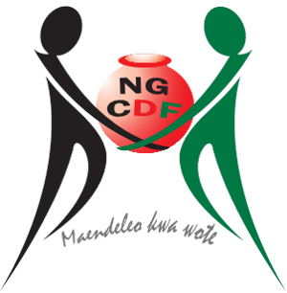

ROYSAMBU NATIONAL GOVERNMENT CONSTITUENCIES DEVELOPMENT FUND

STRATEGIC PLAN
(2018-2022)

Table of Contents
ACKNOWLEDGEMENT: STATEMENT BY HONOURABLE MEMBER OF PARLIAMENT iii
MESSAGE FROM THE CHAIRMAN iv
ABBREVIATION AND ACRONYMS v
EXECUTIVE SUMMARY vii
CHAPTER ONE : INTRODUCTION 1
1.0 Introduction 1
1.1 NG-CDF Background Information 1
1.2 NG-CDF Roysambu Constituency Background 1
1.3 Justification for the preparation of the Strategic Plan 4
1.4 Strategic Plan Development Methodology 4
1.5 Organization of the strategic plan 5
CHAPTER TWO: LINKAGE WITH KENYA’S DEVELOPMENT AGENDA 6
2.0 Introduction 6
2.1 The Kenya Constitution, 2010 6
2.2 The Kenya Vision 2030 and the Medium-Term Plans 6
2.3 Sustainable Development Goals 7
2.4 NG-CDF Act 2015 7
2.5 The Big Four Agenda 8
2.6 NG-CDF Roysambu Constituency Funds Allocations per vote 9
2.7 Key Achievements 10
2.7.1 Education 10
2.7.2 Youth, women and persons with disability 17
CHAPTER THREE: SITUATIONAL ANALYSIS 19
3.0 Introduction 19
3.1 SWOT Analysis 19
3.2 PESTEL Analysis 21
3.3 Stakeholder Analysis 22
3.4 Risk Analysis and Management 23
CHAPTER FOUR: STRATEGIC MODEL 24
4.0 Introduction 24
4.1. Vision Statement 24
4.2. Mission Statement 24
4.3. Strategic Goals, Objectives and Strategies 24
CHAPTER FIVE: RESOURCE MOBILIZATION AND IMPLEMENTATION FRAMEWORK 27
5.0 Introduction 27
5.1. The Roysambu National Government Constituency Development Fund Committee 27
5.2. The Roysambu National Government Constituency Development Fund Management Secretariat 27
5.3. The NG-CDFC Staff 27
5.4. Resource Mobilization 27
5.5. Partnerships and Collaboration 28
5.6. Monitoring and Evaluation Framework 28
5.7. Monitoring and Evaluation 28
5.8. Implementation Plan 28
5.9. Financial Projections for Roysambu NG-CDF in the next five years 29
5.10. ANNEX 1: Five Year Project Implementation Matrix 30
5.11. ANNEX 2: Monitoring and Evaluation Matrix 33


ACKNOWLEDGEMENT: STATEMENT BY HONOURABLE MEMBER OF PARLIAMENT
On behalf of Roysambu National Government Constituency Development Fund Committee, it is my pleasure to present the 2018- 2022 Strategic Plan for our Constituency This strategic plan is the culmination of a long process that have taken us months of bold conversations and thought-provoking work sessions based on careful research and assessment of current initiatives and previous goals. My expectation is that we will now focus our energy to assess and adjust our direction in response to a very fast changing environment and to ensure all of us are working towards the same goals. Needless to say that the Strategic Plan provides the framework and serves as an important guide to help our Constituency succeed in the face of any challenges and find opportunities for strengthening our institutional capacity and support innovation within the Constituency.
Special thanks goes to the people of Roysambu Constituency for giving me a second opportunity to serve them as the area Member of Parliament (M.P). Indeed it is a pleasure working and serving the nation together as a team.This Strategic Plan will provide a clear road map to the achievement of development goals in our Constituency. For it to be successfully implemented, we all need to focus on several critical factors which include: Performance Management, Strategic Leadership and Partnership, Mobilization of resources, Increased Public Awereness and transparency.
The Constituency cannot achieve its goals and objectives in isolation without making reference to the Country’s national development agenda as articulated in the Country’s long-term development blueprint, the VISION 2030, the Country’s Constitution 2010 and other key development policies, latest being the Government’s big four agenda that revolve around four key pillars — Manufacturing, Universal Healthcare, Affordable Housing, and Food Security which the Government is deeply committed to. The Constitution of Kenya further advocates for community participation in project formulation and implementation for ownership and sustainability, and it is to this regards that the NG-CDF Roysambu constituency involved both the internal and external stakeholders as much as it was necessary by putting the community at the forefront in this entire planning process.
My sincere appreciation and gratitude goes the NG-CDFC members for the commitment, sacrifice, dedication and contribution towards the development and drafting of this plan.All stake holders who participated and contributed in the planning process, facilitated by our able professionals and consultants. The participation from the various stakeholders made the information gathering and analysis process very broad and defined by its inclusiveness thereby providing invaluable feedback and ensuring the development goals are realistic, focused and aligned to the needs of our constituents.

Hon. WaihenyaNdirangu
M.P, ROYSAMBU CONSTITUENCY

MESSAGE FROM THE CHAIRMAN
The Roysambu NG-CDFC Strategic plan 2018-2022 was developed to provide the residents of Roysambu Constituency with a holistic view of the interventions by the NG-CDFC for the next five years. The Strategic Plan is anchored on six key areas which form the main objectives of the plan namely: Improving infrastructure development in all public education institutions, Increased retention and transition rate of both secondary and tertiary education through education bursaries, provision of security, promote environment conservation and sustainability, promote participation of youths and vulnerable groups and poverty eradication within the Constituency.
A key reform in our current constitution is the premium placed on service delivery to the citizens of this country and in particular, the country's Supreme law demands for public participation in all key areas of development and particularly in all policy formulation and implementation by state organs.
Therefore, Roysambu NG-CDFC Strategic Plan was developed through a participatory process that involved the NG-CDFC members, NG-CDF staff, Constituents, and other stakeholders who gave their worthwhile contributions. I am confident that this final product represents our crystallized thoughts arising from the process. My NG-CDF Committee pledge that, it will continue to provide that enabling environment to meet the transformation agenda of our Constituency and ultimately meet our objectives.
I would like to convey my gratitude and appreciation to all who participated to make this document a reality and particularly our M.P, Hon.Waihenya Ndirangu, and his team for providing the leadership in the entire process, the NG-CDFC Secretariat led by the Fund Account Manager Ms Mary Wanyika for their contribution and working for long hours to ensure that this plan was developed and completed on time.
Our consulting team from Fine Consulting Services who gave that valuable guidance and professional touch and other stakeholders for their invaluable contribution, dedication, commitment and team work at all levels. I have no doubt whatsoever in mind that we shall be successful in implementing this blue print because we have what it takes to achieve our objectives as clearly set out in this Strategic Plan.

DAVID MWANGI
CHAIRMAN, ROYSAMBU NG-CDF

ABBREVIATION AND ACRONYMS

MP - Member of Parliament
AP - Administration Police
CDF - Constituency Development Fund
CDFC - Constituency Development Fund Committee
NG-CDF - National Government Constituencies Development Fund
NG-CDFC - National Government Constituencies Development Fund Committee
KU - Kenyatta University
USIU - United States International University
M&E - Monitoring and Evaluation
NEMA - National Environment Management Authority
PLWD - Persons Living with Disabilities
SWOT - Strengths, Weaknesses, Opportunities and Threats
FY - Financial Year
GoK - Government of Kenya
CSR - Corporate Social Responsibility
HOD - Heads of Department
IEBC - Independent Electoral and Boundaries Commission
KCPE - Kenya Certificate of Primary Education
KCSE - Kenya Certificate of Secondary Education
KeNHA - Kenya National Highways Authority
KeRRA - Kenya Rural Roads Authority
KPI - Key Performance Indicators
NHIF - National Hospital Insurance Fund
PAC - Public Accounts Committee
PESTEL - Political, Economic, Technological, Environmental and Legal (Analysis)

EXECUTIVE SUMMARY
This is the first comprehensive strategic plan for Roysambu NG-CDF after separating off from the larger Kasarani Constituency. It was prepared in a participatory manner and benefitted from the contributions of the key stakeholders from its inception through the final production.
The process started with a critical analysis of the strengths and weaknesses of Roysambu NG-CDF, as well as the opportunities and threats that are pivotal in reaffirming the constiyuency’s objectives as regards its vision, mission, core values and guiding principles.
The strategic plan is built on four overarching key result areas: (1) Education; (2) Security; (3) Youth and Sports; and (4) Environmental Conservation. These goals will be served by five strategic objectives;
- Improving infrastructural development in all public education institutions within the Constituency,
- Increase retention and transition rate of both secondary and tertiary education through education bursaries,
- Promote security in the Constituency through infrastructural development,
- Promote youth talents and skills through sporting activities in the constituency, and
- Promotion of environmental conservation and sustainability through planting of trees, water harvesting and enhancing waste management in the constituency
This plan provides a framework for the comprehensive implementation and monitoring of the constituency projects and other initiatives which are aimed to achieve financial accountability and sustainability, resource mobilization and effective project implementation, monitoring and evaluation.
To guarantee proper implementation of the strategic plan, roles and responsibilities have been clearly defined along with a formal process for monitoring and evaluation as well as reporting and accountability. The implementation of the SP 2018-2022 will be the responsibility of all, but more importantly the NG-CDFC members, the NG-CDFC staff and the Constituency Funds Account Manager whose knowledge, skills, experience and leadership are integral to the success of its full implementation.

CHAPTER ONE : INTRODUCTION

Introduction

NG-CDF Background Information
The Constituency Development Fund(CDF) was created by the Constituencies Development Fund Act 2003 with the primary objective of addressing poverty at grassroots levels by dedicating a minimum of 2.5% of the Government’s ordinary revenue to grassrootsdevelopments. The name changed to National Government Contituency Development Fund (NG-CDF) following the enactment of the NG-CDF Act 2015 which was meant to align the fund with the Constitution of Kenya. The Fund is domiciled within the Ministry in charge of National Economic Policy and Planning, currently the Ministry of Treasury and Planning.
The main purpose of the Fund is to enhance infrastructural and socio-economic development at the grass root level in order to reduce poverty by dedicating a minimum of two and half per cent (2.5%) of all National Government’s share of annual revenue towards community projects identified at Constituency level by the communities through public participation.
The NG-CDF Board is responsible for the overall management of the Fund at the national level. It ensures that administration of the fund is observes efficiency and effectiveness.

NG-CDF Roysambu Constituency Background
Roysambu Constituency is a political unit derived from the larger Kasarani Constituency and one of the seventeen Constituencies that make up Nairobi County. It neighbours Westlands Constituency on the west, Ruaraka Constituency on the south, Ruiru Constituency on north eastern, Kasarani Constituency on the east, Kiambu Constituency on North west and Dagoretti North on south west.
Fig 1.1: Map of Nairobi County showing Constituencies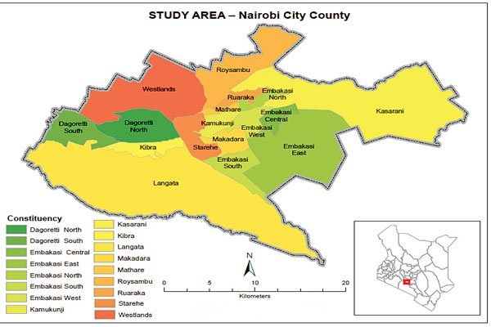
Roysambu Constituency occupies a total area of 48.80 km with a population of 202,284 (Population Census, 2009). It has 5 wards namely; Githurai, Kahawa West, Zimmerman, Roysambu and Kahawa as shown here below;
Table 1.1: Roysambu Constituency County Assembly Wards

 | Description | Ward Number | Area (Sq.Km) | Sub location
1. | Githurai | 1391 | 2.00 | Githurai
2. | Kahawa West | 1392 | 13.90 | Kiwanja,Kahawa West
3. | Zimmerman | 1393 | 7.10 | Zimmerman, Njathaini
4. | Roysambu | 1394 | 22.40 | Roysambu, Garden Estate
5. | Kahawa | 1395 | 3.40 | Kongo Soweto,Kamuthi, part of Githurai

Source:Independence Electroral and Boundaries Commission (IEBC)
Roysambu Constituency is mainly concentrated in Githurai, Roysambu and Kahawa West with shopping centres mainly at Githurai, Kiwanja, Njathaini, Ngomongo and Kongo Soweto. Most of the residents are immigrants from other parts of the former Central Province and a small number from other parts of the country. The population is densely populated with approximately 4000 people per square Kilometre.
The main economic activities includes businesses which offer goods and services to the large population that reside in this Constituency.
There are various markets like Githurai that sell farm produce to the residents. This has been made easy by Thika superhighway connectivity to both Central ands Eastern Provinces.
Roysambu Costituency is also a home to a number of higher learning institutions both private and public namely,Kenyatta University (KU), United States International University (USIU) , all which accommodate students both from National and International levels.
On the part of affordable health, ,the upcoming KU Referal hospital will greatly contribute to the health sector and ease the congestion and pressure on the neigbouring Kiambu Hospital in Kiambu County where majority of the residents seek health services from.

Fig 1.2 : Map showing Roysambu constituency and ward Boundaries
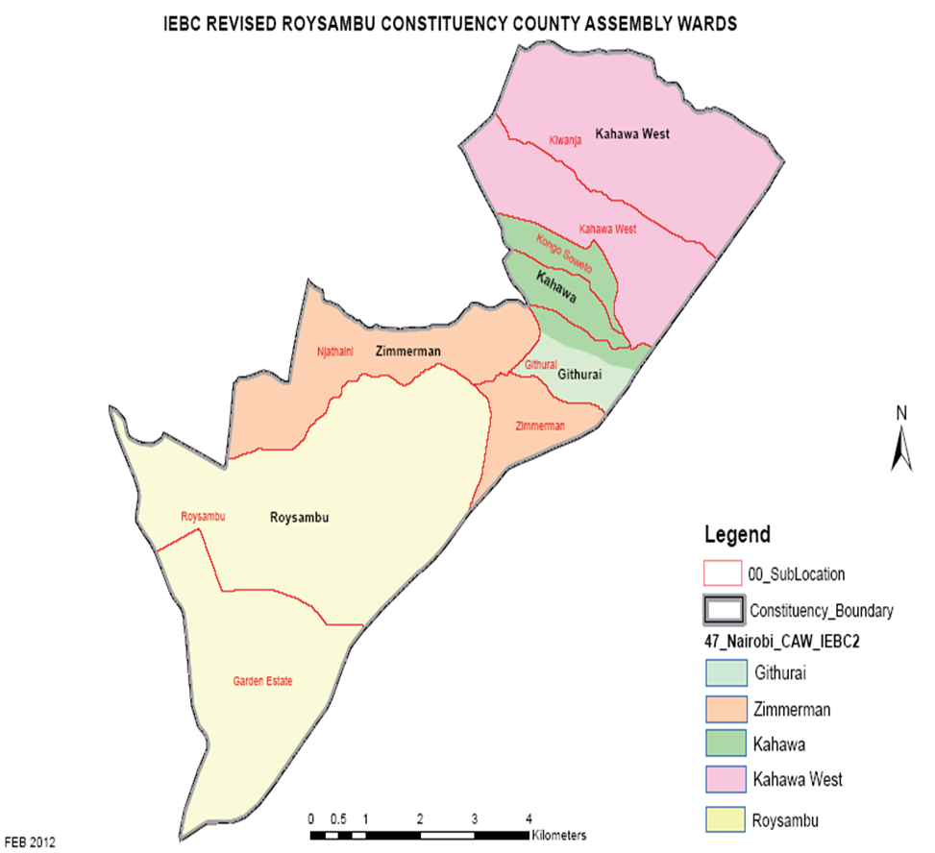
Source: IEBC Boundaries Report(2017)
Roysambu Constituency strategic plan development seeks to address a 5 year development plan aimed at addressing key development issues in all wards.The plan seeks to identify, promote and implement strategies on a consolidated M&E framework, organizational structure, budget and resource mobilization.

The strategic plan seeks to address the following key result areas;
- Education
- Improving infrastructural development in all public education institutions within the Constituency.
- Increase retention and transition rate of both secondary and tertiary education through education bursaries.
- Security
- Promote security in the Constituency through infrastural development.

- Youth and sports
- Promote youth talents and skills through sporting activities in the constituency

- Environmental conservation
- Promotion of environmental conservation and sustainability through planting of trees, water harvesting and enhancing waste management in the constituency.

Justification for the preparation of the Strategic Plan
This Strategic Plan prepared through an all round participatory process provides the Constituency with a roadmap for delivery of quality services to its electorate. The plan is aligned to the Country’s blue print Vision 2030 and seeks to addresses the challenges the Constituency is currently experiencing which includes: declining standards of education, unemployment, inadequate infrastructure, insecurity especially with the increased terror scares and cyber crimes.
The Plan covers a period of five 5 years with an overall goal of the Constituency development needs within the stipulated period. It envisions to transform the current Constituency status and seek to provide leadership and policy direction through efficienct and effective management of available resources.

Strategic Plan Development Methodology
The drawing of this strategic plan has been well compounded and all inclusive. Key and relevant institutions and stakeholders who included the Roysambu M.P, Chairman of Roysambu NG-CDFC, Fund Account Manager who is the officer of the Board, representatives from the Sub County departments who included Sub County Education officer, Principals and Head teachers for Secondary and Primary schools respectively, Sub County Security Committees represented by D.C.C, OCPD and DAPC, Sub County Employment office, KERRA, Sub County Gender and Social Services Officer, Sub County Rergistration Office as well as banks representatives. Represented from each ward were the youth, women, religious institutions, village elders, business community, learning institutions as well as People Living with Disabilities (PLWD’s).
In order to develop strategic objectives that would have meaningful impact, the consultants engaged the partcipants in key informative sessions that involved group discussions before the draft report was produced. This was done through an open participatory process conducted using situational assessment by identifying Stengths, Weaknesses, Opportunities and Threats (SWOT) analysis within the organization.
All the leaders within the Constituency were consulted and have been involved in the development. Through continuous meetings of both internal and external stake holders, the draft has been subjected to revisions that have resulted to the current document that represents the thinking and aspirations of Roysambu Constituency.

Organization of the strategic plan
This Strategic Plan is expounded and discussed in the following five chapters.
Chapter One Introduces the background,mandate,and the function of Roysambu NG CDFC, the need, process, rationale and justifification of the Strategic Plan.
Chapter Two discusses the linkages with Kenya’s Development Agenda in consideration of the Vision 2030 blueprint, the Kenya Constitution 2010, the sustainable development goals, the NG-CDF Act 2015 and the latest Big Four agenda of the Government. This chapter as well discusses the development projects and initiatives and key achievements for last five years which have already been implemented through the fund.
Chapter Three discusses the situational analysis which includes the SWOT, PESTEL and Stakeholders Analysis
Chapter Four discusses the Strategic Model and the key result areas that Roysambu Constituency gears to improve.
Finally, Chapter Five discusses Resource Mobilization and Implementation Framework of the identified Key result areas. It also provides for performance monitoring and evaluation on the status of the implemented projects.
.

CHAPTER TWO: LINKAGE WITH KENYA’S DEVELOPMENT AGENDA

Introduction
This chapter presents the linkage of the Roysambu NG-CDF with the national development agenda as guided by the country’s long term blue print, Vision 2030, the Medium Term Plan, Constitution of Kenya 2010, NG CDF Act 2015, the big four agenda and other policy documents aimed at steering growth and development in the country. It also reviews Kenya’s alignment with regional and global guidelines.

The Kenya Constitution, 2010
The Constitution 2010 established two tier levels of government, that are interdependent-National and 47 County Gvernments. The Constitution embedded national values, including; (a) patriotism, national unity, sharing and devolution of power, the rule of law, democracy and participation of the people; (b) human dignity, equity, social justice, inclusiveness, equality, human rights, non-discrimination and protection of the marginalized; (c) good governance, integrity, transparency and accountability; and (d) sustainable development.
A strong Bill of Rights anchored rights to quality of services e.g. education and security. It anchored citizen centered development, with citizen participation at the center of all decision making.
The Chapter on Public Finance entrenched equity, inclusion, distribution of resources and development, transparency and accountability. Fiscal decentralization becomes a key tool of channeling resources to local levels, through different mechanisms like devolution and NG-CDF.

The Kenya Vision 2030 and the Medium-Term Plans
Vision 2030 aims at transforming Kenya into a newly industrializing, middle income country, providing a high quality of life to all citizens in a clean and secure environment’ by the year 2030. The delivery of the Vision is driven by a series of successive five-year Medium-Term Plans, with the first plan (MTP I) having been implemented from 2008 to 2012. Currently, the country is implementing the Second Medium Term Plan which runs from 2013 to 2017. GoK is in the final stages of developing Medium Term Plan Three (MTP III) which runs from 2018-2022. The plan has not been officially released by GoK. The Big four agenda which include improving manufacturing, improving food security, universal health coverage, and affordable housing form the central pillars of MTP III.
The Vision is anchored on three pillars which are analysed below.
The Economic Pillar: The government identified six priority sectors with high potential of spurring the country’s economic growth and development. These sectors will contribute towards pushing the economy up the value chain. These are Tourism; Agriculture, Livestock & Fisheries; Trade; Manufacturing; Business Process Outsourcing (BPO)/ IT Enabled Services; Financial Services; and Oil & Other Mineral Resources.
The Social Pillar: The government commits to contribute towards prosperity and building a just and cohesive society that enjoys equitable social development in a clean and secure environment. The Pillar focuses on Education and Training; Health; Environment, Water and Sanitation; Population, Urbanization and Housing; Gender, Youth &Vulnerable Groups; and Sports, Culture & Arts.
The Political Pillar: Under this pillar, the government commits to transform the country into an issue-based, people-centred, results-oriented and accountable democratic political system. The pillar focuses on two sectors Devolution and Governance & the Rule of Law.

Sustainable Development Goals
The Sustainable Development Goals (SDGs) commonly known as the Global Goals, are a universal call to action to end poverty, protect the planet and ensure that all people enjoy peace and prosperity. These 17 Goals build on the successes of the Millennium Development Goals, while including new areas such as climate change, economic inequality, innovation, sustainable consumption, peace and justice, among other priorities. The goals are interconnected – often the key to success on one will involve tackling issues more commonly associated with another.
The strategic plan focuses on key areas including poverty alleviation, democratic governance and peacebuilding, climate change and disaster risk, and economic inequality. NG-CDF works with County Government and National Government among other partners to integrate the SDGs into their development plans and policies. This work is already underway, as NG-CDF align its projects/programmes to ensure they work towards accelerating progress to the Millennium Development Goals.
Achieving the SDGs requires the partnership of governments, private sector, civil society and citizens alike to make sure we leave a better planet for future generations.

NG-CDF Act 2015
The National Government Constituencies Development Fund (NG-CDF) formerly Constituencies Development Fund (CDF), is a fund established in 2003 through an Act of Parliament, the CDF Act 2003. The Act was later reviewed by the CDF (Amendment) Act 2007, and repealed by CDF Act, 2013 which was subsequently succeeded by the current NG-CDF (Amendment) Act 2015.
The main purpose of the Fund is to enhance infrastructural and socio-economic development at the grass root level to reduce poverty by dedicating a minimum of two and half per cent (2.5%) of all National Government’s share of annual revenue towards community projects identified at Constituency level by the communities. The Fund is managed by the NG-CDF Board at the National level, the NG-CDF committees at the Constituency level and the Project Management Committees (PMC) at the community level.
Since 2003/04, the Fund supported projects mainly in the areas of education, health, agriculture, roads, security, environment and sports.
However, the NG-CDF (Amendment) Act 2016 introduced a major shift in the scope of projects eligible for funding. Under this Act only projects falling within the functions of the National Government as outlined in the Constitution of Kenya will be funded.
This effectively means that moving forward, the Fund will concentrate primarily on education, security, sports, environment sectors and other National Government residual functions. This new amendment has informed the development of 2018-2022 Roysambu Constituency strategic plan.

The Big Four Agenda
On 12th December 2017, His Excellency President Uhuru Kenyatta announced his new plan, “the Big Four” which will guide the development agenda of the country in the period 2018-2022. It focuses on key basic needs that are critical in uplifting the standard of living of Kenyans on the path to becoming an upper middle-income country by 2030. Prioritized is affordable and decent housing, affordable healthcare, food and nutritional security, and employment creation through manufacturing. These four areas are expected to bolster strong inclusive economic growth. As the Constituency focuses on education, security, sports, environment sectors the project complement the Agenda Several initiatives are being undertaken to enhance the performance.
The GoK read the 2018/19 budget, and it reinforced GoK’s commitment of resources to the Big 4 agenda. The big four were allocated 460 billion out of total budget of 3.1 trillion. Counties were allocated 314 billion as county equitable share, and 62 billion as county government conditional grants, signifying grassroots development.
The economy grew by 4.9% in 2017, with projection of growth to reach 5.8% in 2018. The GoK in the medium term looks to grow the economy to 7%, by anchorage on big 4 agenda. The GoK emphasized the enablers of the big 4 being: (i) continued macro-economic stability; (ii) enhanced security; (iii) targeted infrastructure; (iv) expanded technical training; (v) technology innovation; (vi) and finally addressing vigorously the cancer of corruption.

NG-CDF Roysambu Constituency Funds Allocations per vote

The Other Expenditures included the following:
- Roads which were part of the cdf fund initiatives before the amendment of the Act, to exclude them from the projects to be undertaken by the NG-CDF Board.
- The cost of preparation of the Strategic Plan (2018-2022)
- The constituency ICT innovation hub

Key Achievements

Education
Education is among the main focus of development within Roysambu Constituency with the main aim to provide education for all and improve the general standards of performance. This entails improving infrastructure in public secondary and primary schools in all the wards within the Constituency. Examples include renovations of existing infrastructure, building modern ablution and administration blocks, laboratories, libraries increasing bursaries schemes, investing in education for the special cases and provision of social amenities as evidenced here below;

Garden Estate Secondary School
Building of a modern gate and classrooms to cater for the increasing population of students enrollment.This has been made possible by effective fund management, quality leadership and policy direction guidance from Roysambu NG-CDF.
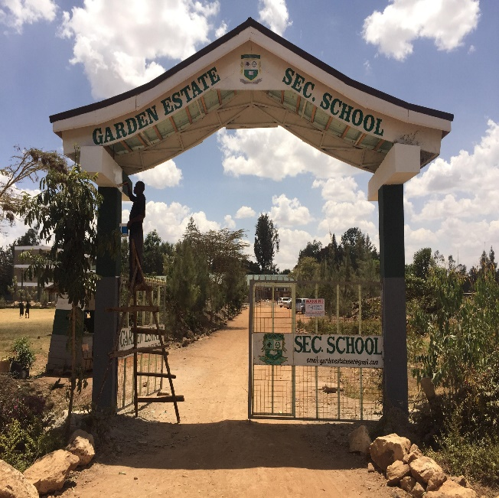

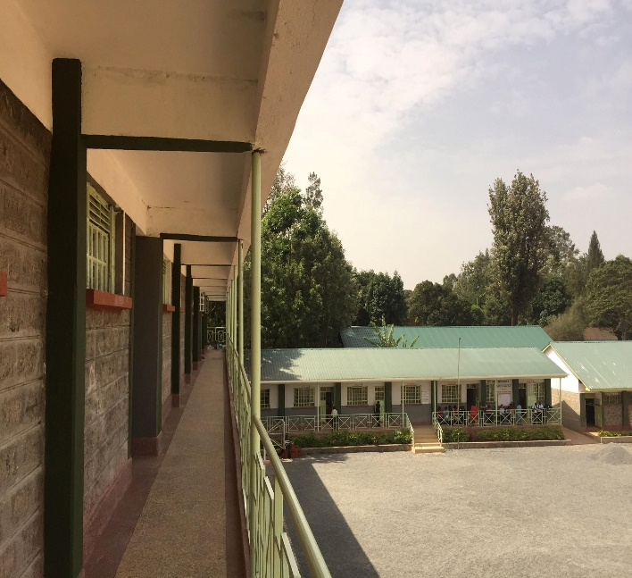

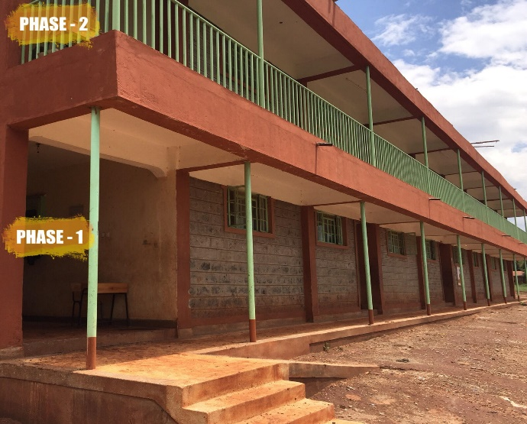
Kiwanja Secondary school
8NO. Classrooms at Kiwanja Secondary School

Kiwanja Primary School
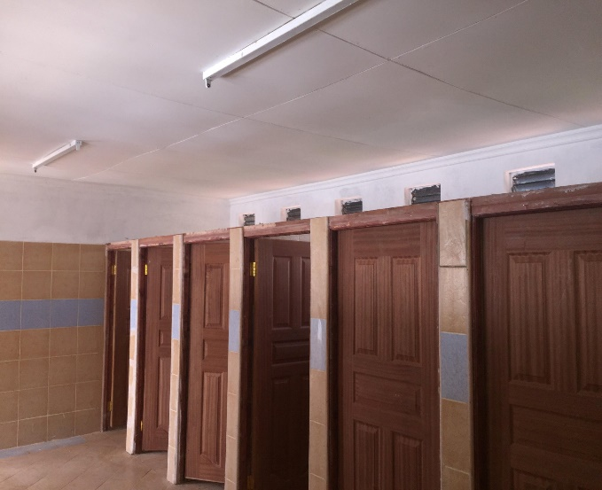
Ablution block at Kiwanja Primary School.

Njatha-ini Primary School
Completion and commissioning of new classrooms in line with the projection and resources distibution.
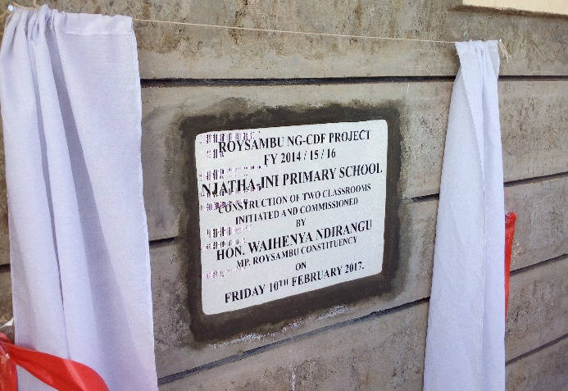
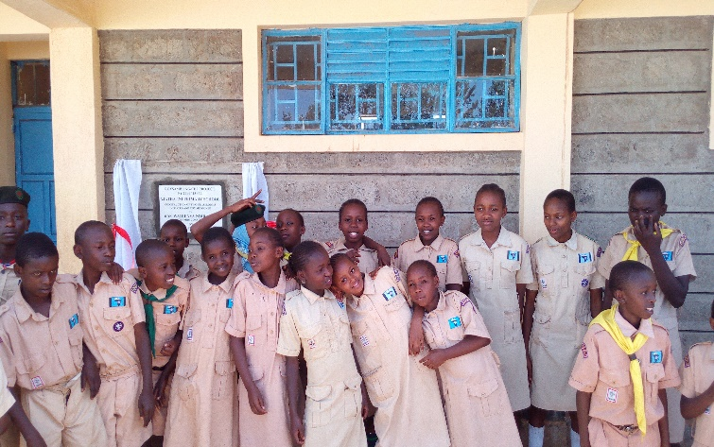

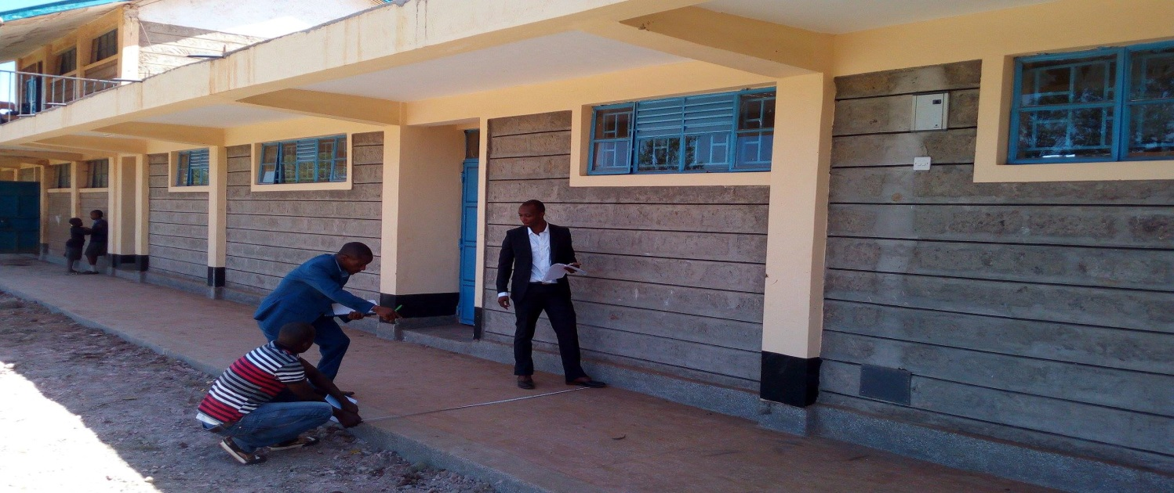

Bursary Allocation Function
The allocation is done to needy students from humble backgrounds giving them an equal opportunity to compete and advance holistically in education.
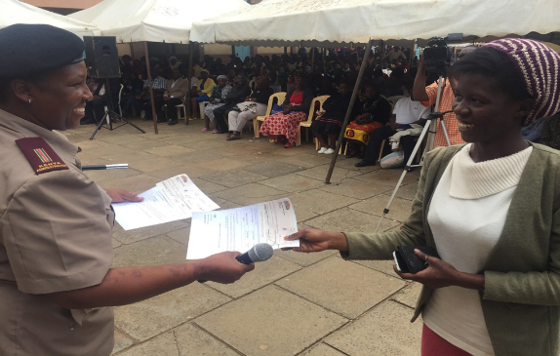

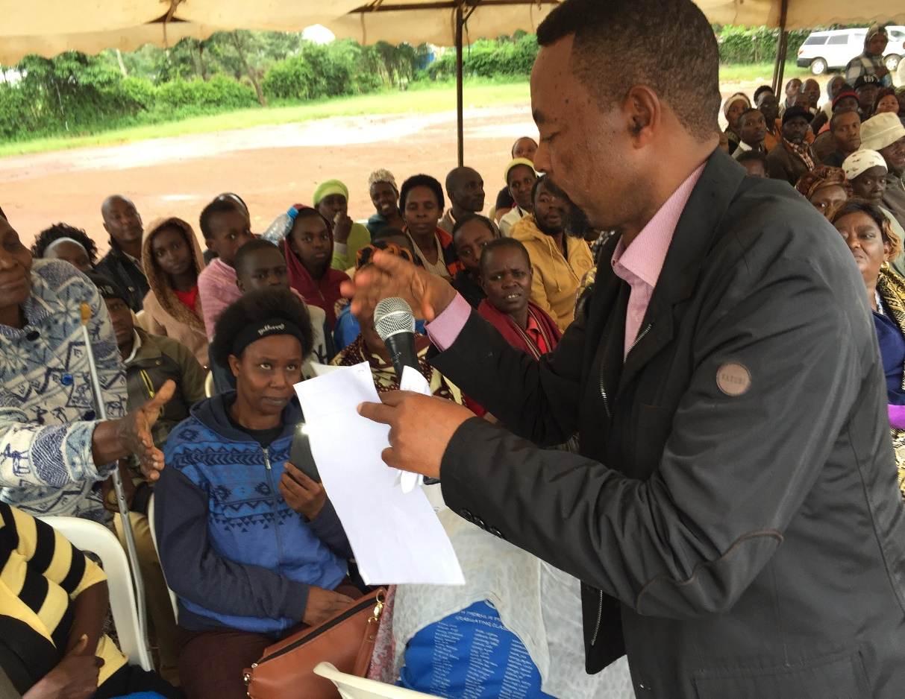
Area MP Hon.Waihenya Ndirangu issuing Bursary Awards to beneficiaries

Security
The main objective is to promote security within Roysambu Constituency. This entails provision of high masts within the Constituency to improve lighting with an aim of eradicating insecurity issues. Construction of perimeter walls mostly on schools and tertiary vocational institutions. More so ground levelling in schools and recreational centres.

Fig 1.4: Perimeter wall at Kiwanja Secondary and Primary School
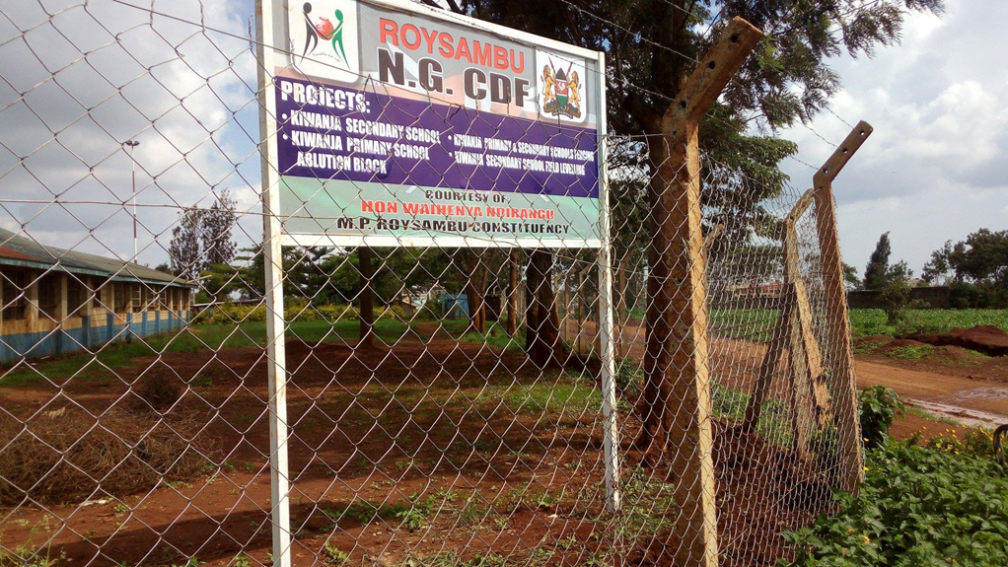

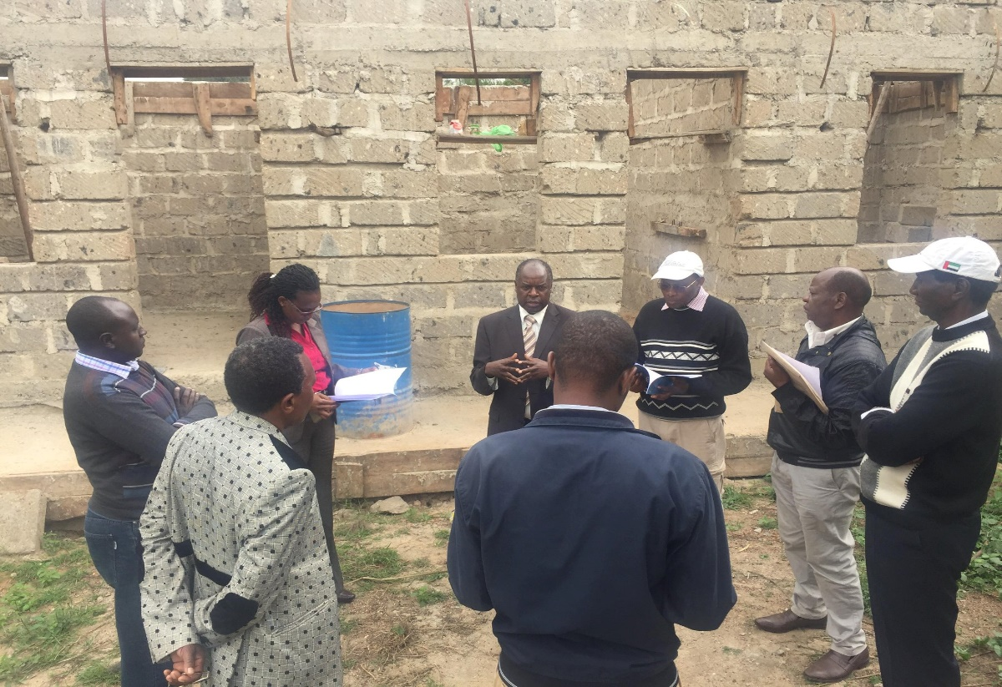
Thome Police Post PMC meeting discussing on the progress so far made

Youth, women and persons with disability
This entails promoting and developing sports and other related activities among the youth including empowering women and PWDS inorder to improve the livelihood and eradicate poverty.This overally promotes cohesion among the youth whereas the women engage in income generating activity thus raising the standard of living ar grass root level.
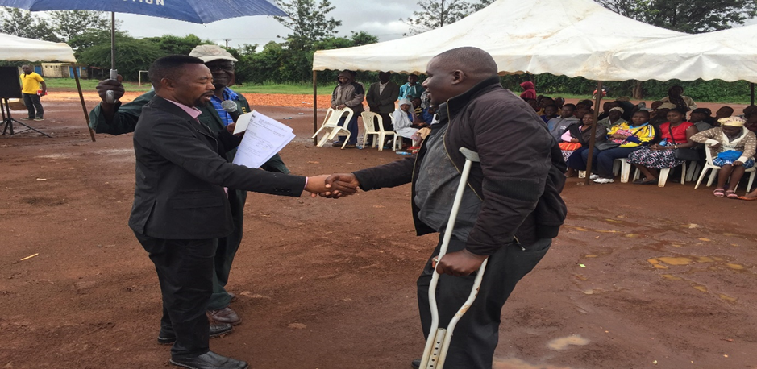
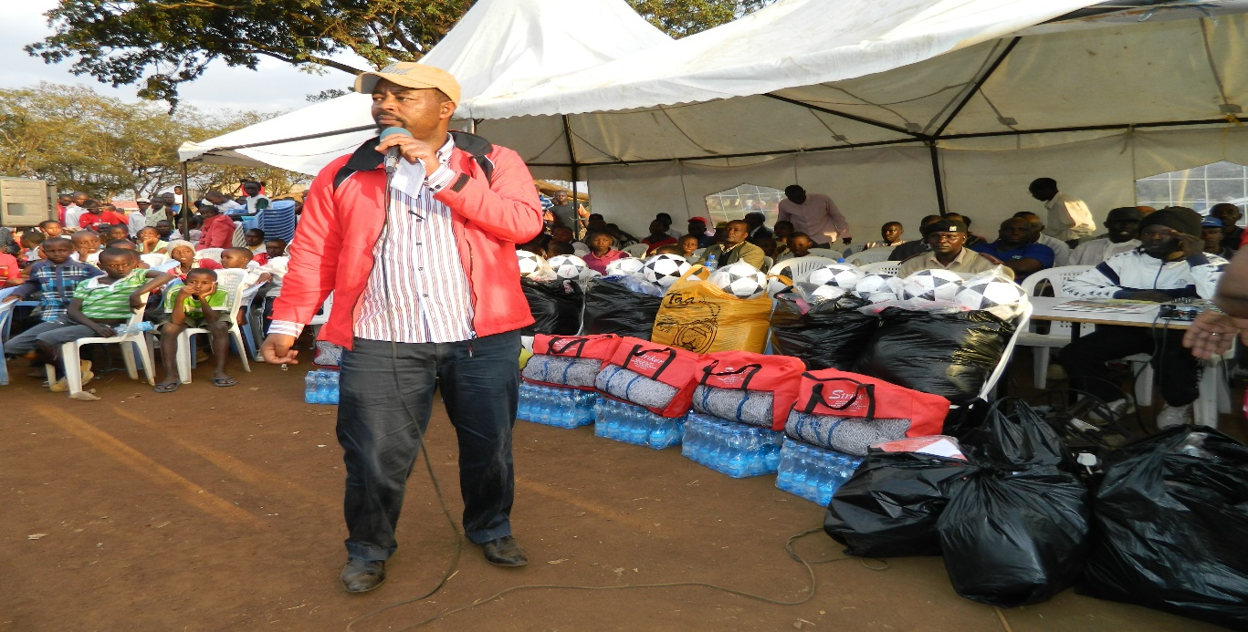
Fig 1.5: Hon. Waihenya awarding bursary to the PWD in Kahawa West Ward and distributing sports kits to the youths in support of sporting activities among the youths

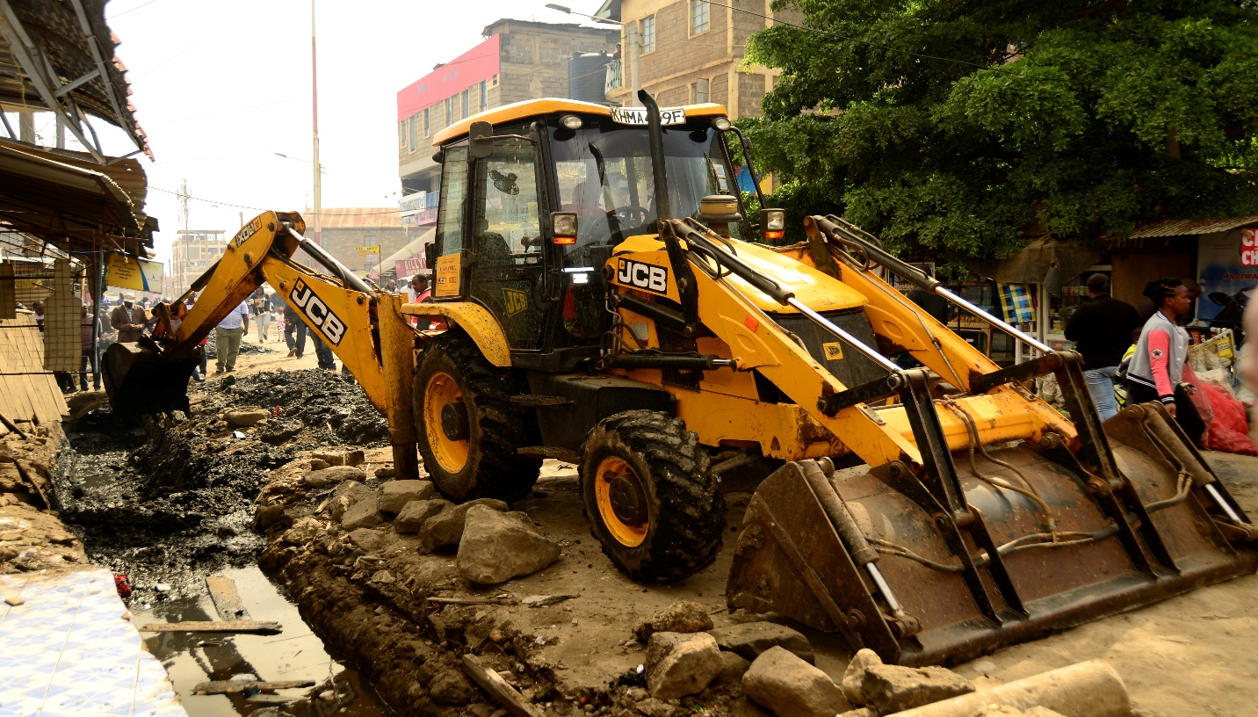
At Zimerman Ward at power base road. Construction works going on
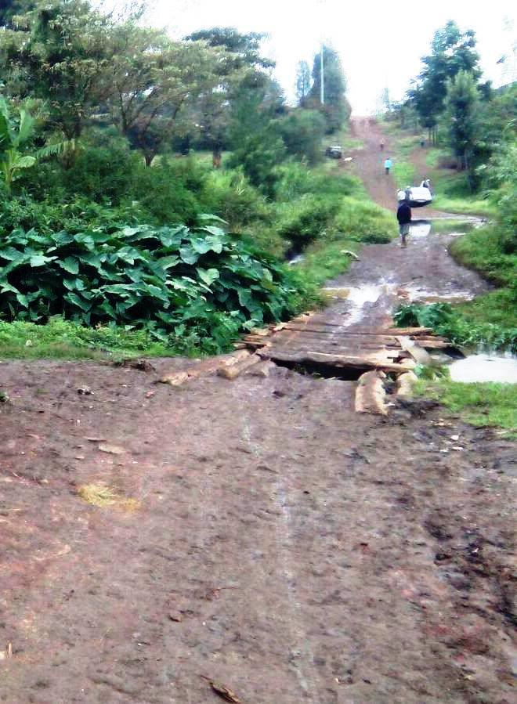
Kamuthi –Githurai Bridge in its state before Funding by Roysambu NG-CDF

Kamuthi-Githurai Bridge after being funded by Roysambu NG-CDF F/Y 2014-15
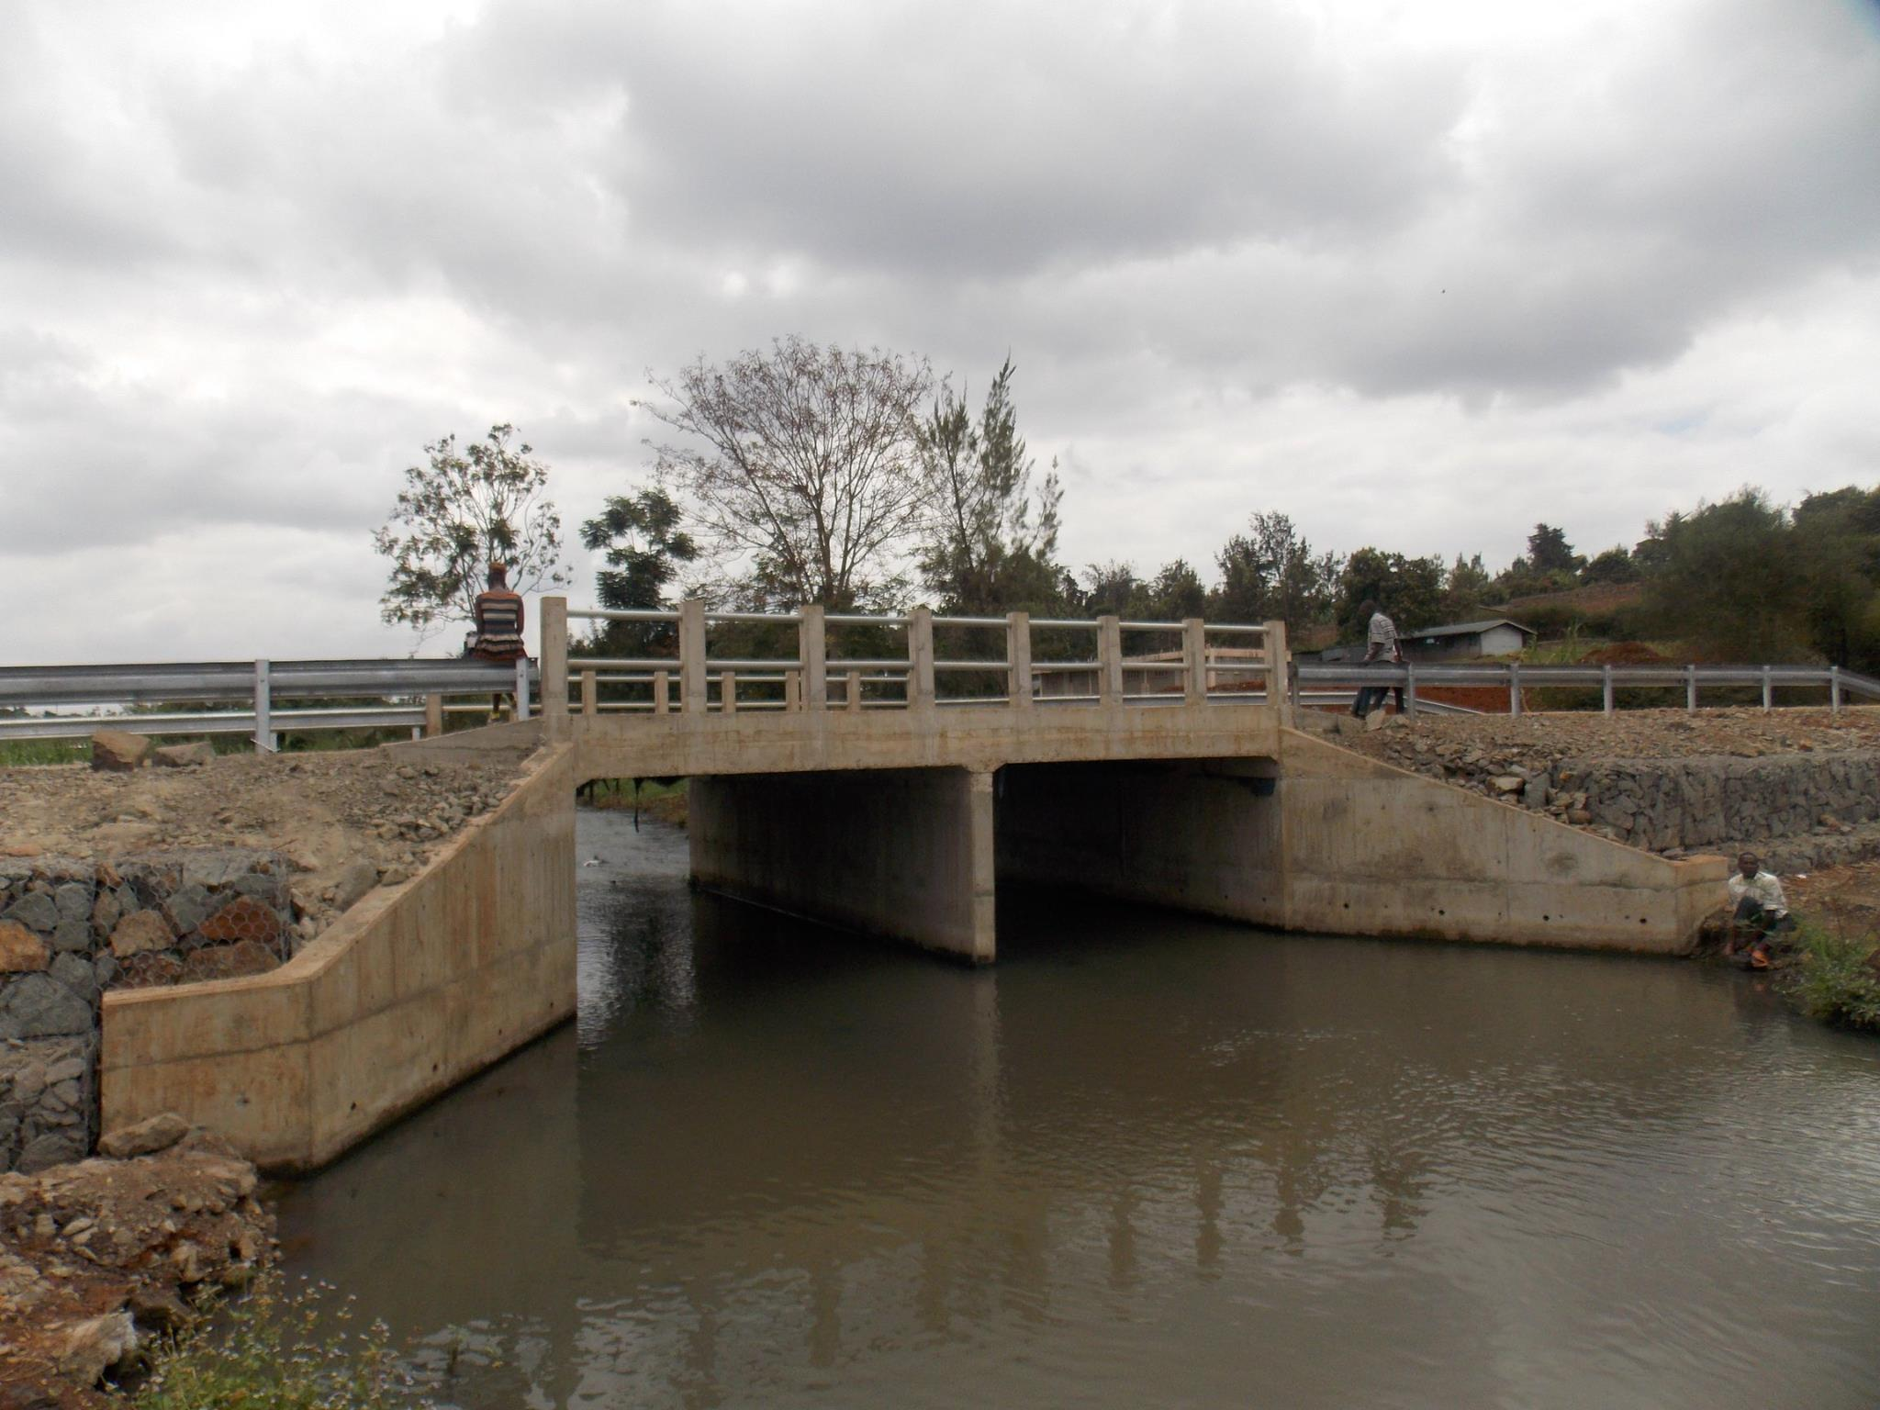

An aerial view of the busineess community that forms the main activity in Roysambu Constituency with exception of the middle level income earners who are employed in variuos organizations within Nairobi County
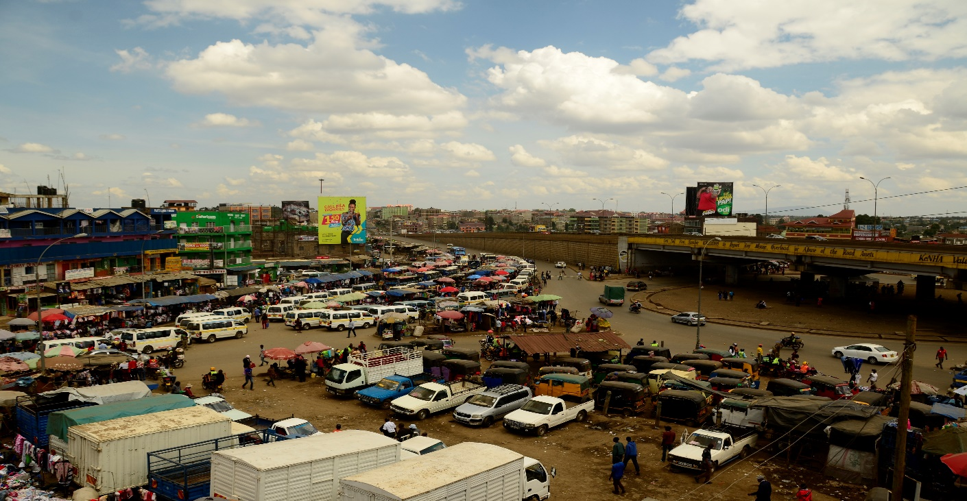
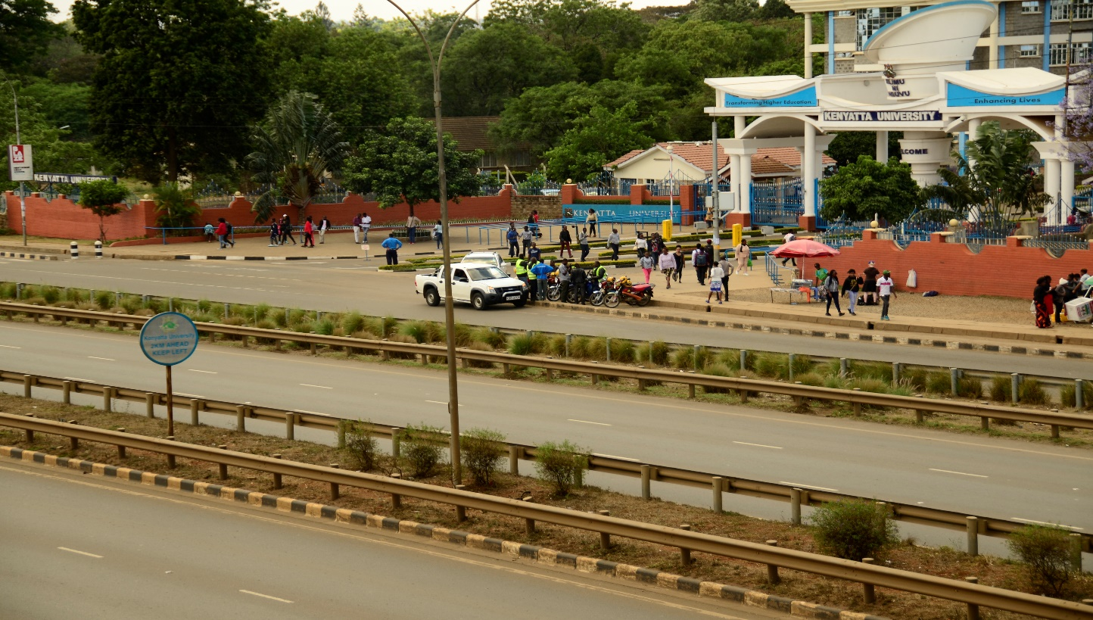
Kenyatta University is located within the constituency.

Inorder to encourage and appreciate the candidates in all public schools within Roysambu, the Constituency has a motivational programme spearheaded by Hon.Waihenya Ndirangu. We distribute geometrical sets and success cards to all the candidates as an effort to reward them for having walked the journey as well as standing with them during the examination period.

Fig 1.6: Roysambu NG-CDFC Issuing and distributing geometrical sets and success cards at Githurai primary School

CHAPTER THREE: SITUATIONAL ANALYSIS

Introduction
The situational analysis of the current operating situation presents Roysambu NG-CDF into the internal analysis through the SWOT as well as PESTEL analysis which looks into both external and internal operating environment.

SWOT Analysis
The SWOT analysis presents the strengths, weaknesses, as well as opportunities and threats. Detailed results of the SWOT analysis through a participatory approach and extensive consultations was undertaken through key stakeholder’s participation.
The outputs and the stakeholder analysis have resulted in the identification of the strategic issues that the Constituency will address during the planning period, key concerns and issues raised by stakeholders will be defined in their respective functional relationships and roles.
The achievement of this Strategic Plan’s objectives will largely depend on how the Constituency enhances its internal strengths, exploits the existing opportunities and manages the weaknesses in its operations while controlling those factors that pose a threat to the achievement of its planned activities.
Outlined here below is the SWOT analysis which was undertaken through an extensive and participatory approach.

Table 1.2: SWOT Analysis
Strenghts | Weaknesses
- High literacy levels in the constituency  - Visionary and able leadership in the constituency  - Considerable energetic middle class population ready to contribute to the development of the consituency  - Rich history of education achievement  - Able and pro-Active NG-CDF Committee  - Strong and sustainable partnership with stakeholders  - Support from Nairobi county government  - The legislative establishment of NG-CDF through an Act of parliament  - Well regulated bursary allocation within the constituency catering for the needy | - Dilapidated infrastructure in schools  - Social challenges such as crimes, drug abuse and insecurity hampering develop[pment  - Inadequate vocational learning and resource centres  - Inadequate public and modern facilities and services such as street lighting, toilets, drainage & sewer systems, perimeter walls in schools, kitchens, ablution blocks etc  - Inadequate land and space for developments and expansion  - Increasing rates of school drop outs due to high rates of teenage pregnancies in highly populated areas leading to increase in unemployment and insecurity  - Overcrowding in classes due inadequate space to expand the facilities leading to reduced transitin rates
Opportunities | Threats
- Abundant human rersource for use in the development projects  - Established reliable transport network such as Thika Road and eastern by-pass opening up the constituency to investment and business  - Proximity to neighboring big towns e.g Nairobi, Thika, Machakos and Kiambu towns, presenting attractive business opportunities and incentives  - Demographic dividend from the high and vibrant youth population  - Good distribution of security system within the constituency  - Proximity to Kenyatta University and hospital offering quality & easily accessible educational needs, services and employment opportunities | - Increase in incidents of drug and substance abuse among the productive youth populate in the constituency  - Cases of public land grabbing leaving inadequate or no land for use for the constituency development projects  - Increase in the unemployed and unskilled workforce posing danger with respect to crime and insecurity  - External economic shocks and uncertainties hampering country’s growth and consequently the constituency’s development agenda  - Conflict of interest among the stakeholders

PESTEL Analysis
A PESTLE analysis is a management tool that provides a broad environmental scan within which ROysambu NG-CDF operates in. It revolves around six dimensions: Political, Economic, Social-Cultural, Technological, Legal, and Environmental. The tool allows distillation of key factors in these areas that may support or hinder the implementation of the Strategic Plan.
Table 1.3: PESTEL Analysis
PESTEL ANALYSIS
Factor | Issues | Implication on Strategy
Political | Political goodwill | No control on public as they may fail to participate during the selection of Roysambu NG-CDF projects
 | Changes in Government | Changing statutes and jurisdictions
 | Governance and corruption | Poor governance and corruption allegations in management of the constituency funds which presents major challenges to the fund
 | Regional and global political stability | Regional conflicts and terrorism, negatively impacting the country’s performance
Economic | Poor economic performance | Reduction of funds for NG-CDF projects
 |  | Increased demands for NG-CDF interventions
Social | Increasing youth population | High population levels putting demand on NG-CDF projects
 | Low literacy levels | Increased demand for bursary applications, increased demands for projects like security in schools and other educational needs
Technological | Social media explosion | Negative publicity, fake news, more accessible as a huge number of people can be reached easily.
Environmental | Climate change | Global warming and climate change has affected key sectors such as agriculture, forestry, water catchments etc and thus increasing dependency
Legal | Change in laws | The provision of NG-CDF Act 2015 between the National government and county governments helping in litigation reductions

Stakeholder Analysis
This strategic plan takes cognisance of the constituency’s many stakeholders and their varied expectations which it intends to meet. In implementing this strategic plan, Roysambu NG-CDF is expected to work with a number of stakeholders in order to achieve its intended objectives.
The table Below represents stakeholder analysis that identifies the different categories with their roles and expectations towards the fund.

Table 1.4: Stakeholder Analysis
Stakeholder | Role of Stakeholders /Functions
National Assembly Select Committee (NASC) | Guidance on policy direction and enactment of relevant laws relating to the fund
Ministry of Treasury | Allocation of funds  Leadership in the implementation of economic projects
National Government Consttuency Development Fund Board | Disbursement of financial resources to the constituency  Provide policy guidance on the running of the fund  Ensure efficient and effective management of the fund  Promotes accountability
National Government Constituency Development Fund Committee(NG-CDFC) | Implementation of sector development strategies and providing statistical information  Disbursement of funds to PMCs for project implementation on the approved project.  Monitoring and evaluation of the ongoing projects
Project Management Committee (PMC) | Project management and overseeing  Implementation of projects  Accountability of funds allocated to the projects
Technical Department | Provides technical expertise and opinions in sector development and project implementation
Member of Parliament | Provides leadership, policy direction and network building and seeking funding partners for the constituency.  Advocacy and community resource mobilization
Private Sector | Advocacy, technical support, provision of business information and funding
Donors and funding agencies | Compliments funding, technical support, capacity building and advocacy
Suppliers | Provision of goods and services
Citizens/Public | Tax payers  Beneficiaries of NG-CDF projects  Provision of feedback on project implementation

Risk Analysis and Management
Risk management forms an integral part in the effective and efficient management of the fund alongside ensuring the achievement of the set constituency objectives. In compliance with the Government directive requiring that all state corporations and departments implement enterprise risk management framework, Roysambu NG-CDF has from 2016 adopted the principles of risk management in its day to day operations. Through the guidance of the Board secretariat, a comprehensive constituency risk assessment was done and the following risks were identified to affect the full rrealization of the Constituency’s target goals;
- Unavailability of land to put up NG-CDF office and other community projects
- High levels of unemployment among the increasing youth population.
- Political conflicts, infightings and negativity.
- Shortage of the technical staff to conduct inspections and offer supervision to the engaged contractors.
- Insecurity arising from increasing youth unemployment and indulgence in drugs
- Low literacy among the project management committee members.
- Low public participation during NG-CDF forums.
- Inadequate boarding facilities in the available public primary and secondary schools in the Constituency
- Inadequate funds to carry out every project identified by the constituents
- Inefficient Sub County treasury hindering timely service delivery
- Inefficient Monitoring and Evaluation systems
- Poor road network and water.
- Skills gap among NG-CDFC and staff members in areas to do with project management accounting and ICT

There is need to develop mitigation and treatment measures for the above identified risks to avert any uncertainties on the achievements of Roysambu NG-CDF goals and Objectives.

CHAPTER FOUR: STRATEGIC MODEL

Introduction
This chapter outlines Roysambu NG-CDF vision and the mission statement as the road map, indicating the strategic objectives and the strategies identified to guide the Constituency on the strategic direction in the execution of its mandate.

Vision Statement
An equitable socially and economically empowered Mwananchi.

Mission Statement
To provide leadership on effective and efficient implementation of NG-CDF programmes.

Strategic Goals, Objectives and Strategies
The NG-CDF Act 2015 provides for NG-CDFCs to implement projects that are listed as National Government functions under the Constitution of Kenya, 2010. The National Government functions are listed under the Fourth Schedule. NG-CDF therefore restricts itself on the implementation of projects to the following areas of focus:
- Education
- Security
- Youth and Sports
- Environmental Conseravtion and Sustainbility
Strategic goals;
- Improving infrastructural development in all public education institutions within the Constituency on the education sector
- Increase retention and transition rate of both secondary and tertiary education through education bursaries
- Enhance status of security in the Constituency
- Promote environmental conservation and sustainability.
- Promote sporting activities among the youths in Roysambu Constituency.
Each of the strategic objective and subsequent strategies are aligned to the strategic golas geared towards realization of each of the Key result areas as outlined below.

Table 1.5: STRATEGIC GOAL VIS –A-VIS OBJECTIVE AND STRATEGIES
KEY RESULT AREA 1 - EDUCATION

STRATEGIC GOAL | OBJECTIVE | STRATEGIES
1.Infrastructure Development | 1. To Improve infrastructure on the education sector in Roysambu Constituency | - Constructing of new classroons.  - Renovation of existing classrooms  - Rehabilitating road networks to the schools for ease accessibility  - Provision of social amenities in public schools e.g. water and electricity.  - Construction of modern ablution block for health and sanitation  - Construction and equip laboratories and libraries  - Construction of Dining Halls  - Construction of Administration Blocks  - Revamping and levelling of play ground for extracurricular activities
2. Retention and Transition rate | 2. To improve the retention and transition rate of pupils. | - Award of bursaries to the needy students to allow for retention and continuous learning.  - Supply of desks and furniture to allow comfort during learning

EY RESULT AREA 2 - SECURITY
3.Security | 3. To raise and improve the standard of security and safety in Roysambu Constituency | - Construction of wall perimeters /chain link fences in all education instituitons  - Construction of Chiefs/ Police Posts offices.  - Ensure all schools have only one exit point.  - Install fire extinguishers in all the public schools.  - Removal of high voltage/system power lines in school.  - Provision of adequate lighting.

KEY RESULT AREA 3 - ENVIRONMENTAL CONSERAVTION
4.Environment Conservation | 4. Adoption of environmental friendly practices | - Continous planting of trees in all public places.  - Provision of dust bins and incinerators in all the schools.  - Encourage water harvesting by removal of asbestos roof and adopt iron sheet and installation of water tanks.

KEY RESULT AREA 4 - YOUTH AND SPORTS
5.Youths , PWDs and Sports | 5. Promote sports and PWD related activities | - Establish a youth resource center  - Promote youth income generating activities through the available revolving funds (UWEZO Fund, Youth Fund and Women Enterprise Fund) initiatives  - Put up special schools and introduce special units in the existing schools.  - Awareness programmes for the youth and PWDS through other partners UWEZO fund, YOUTH fund and WEF programs.

CHAPTER FIVE: RESOURCE MOBILIZATION AND IMPLEMENTATION FRAMEWORK

Introduction
This chapter provides the framework that will enable Roysambu NG-CDF use different mechanisms to implement the strategic objectives alongside the strategies. It outlines the structure of the committee, as well as other key operation areas including staff establishment, resource mobilization, risk management and monitoring & evaluation.
The NG-CDFC will engage tenets of good management in order to meet the set objectives. The Board will continue addressing structural issues, capacity building gaps and pursue the appropriate budgetary support for the effective implementation of the plan.

The Roysambu National Government Constituency Development Fund Committee
The Roysambu National Government Constituency Development Fund Committee is mandated in providing policy direction, making decisions and providing oversight role on the NG-CDFC secretariat. Their commitment, dedication and collaboration with the FAM is geared to ensure smooth rollout of the strategic plan goals.

The Roysambu National Government Constituency Development Fund Management Secretariat
The Roysambu NG-CDF Secretariat is responsible for the day to day running of the affairs of the Constituency through provision of administrative and technical support in the implementation of Committee’s decisions and directives.

The NG-CDFC Staff
The secretariat is very key to ensure that the set strategies are achieved on behalf of the NG-CDFC.In this regard, it is imperative that the staff are capacitated and enabled in terms of numbers, skills and competences. Any gap should be identified to ensure they have the right skills, attitude and drive for their optimum functioning.

Resource Mobilization
The Roysambu NG-CDF Committee receives its funding mainly from the NG-CDF Board but endeavors to seek partnership with other development partners for the attainment of the Strategic Plan objectives. Enhanced strategic collaboration with Nairobi City County Government would leverage more resources and enhance service delivery to citizens. Leveraging partnerships with stakeholders like private sector, financial institutions, academic institutions, NGOs and Faith Based Organizations would enhance resources and skills thus improve on service delivery.

Partnerships and Collaboration
The key partners identified through the stakeholder analysis in the table 2.4 include: Education Institutions, Religious Institutions, Large Investors/ private companies, Security Actors, NGO/CBO/civil society, Youth groups/women groups, Nairobi City County Government, NG- CDF Board, Roysambu Constituents, Line Government ministries, Media and Local Leaders. The Area Member of Parliament Hon. Waihenya Ndirangu has been engaging with different stakeholders in different sectors to achieve the desired objectives on improving the lives of the residents within the Constituency. This will in return improve the living conditions of the constituents at different levels
In order to eradicate poverty which has been the key objective of the fund, patnering with other actors wil greatly improve the livelihoods of the constituencts and the county at large. Partnering with County Government too in improving food nutrition and health will positively impact the constituents. This function lies with County Government but partnerships are possible.

Monitoring and Evaluation Framework
A clear framework is essential to guide monitoring and evaluation. It explains how the programme is supposed to work by laying out the components of the initiatives and the order of the steps needed to achieve the desired results. A framework increases understanding of the goals and objectives of the strategic plan, defines the relationships between factors key to implementation, and articulates internal and external elements that could affect the success of the Plan. Roysambu NG-CDFC will encourage effective participation of citizens in continous monitoring and evaluation of the programmes. It will also develop mechanisms for periodic review and reporting of performance at all levels.

Monitoring and Evaluation
The successful implementation of this Plan will depend on how effectively the expected objectives and subsequent projects are monitored and evaluated. Roysambu NG-CDF will strengthen the monitoring and evaluation function by building capacity of Committee members and the secretariat in M&E, develop a project tracking and sustainability matrix, deepen citizen engagement in monitoring and ownership of projects.

Implementation Plan
The implementation plan is summarized in Annex 1.which outlines the period projection,expected output and the project location as well as the expected year of implementation. It outlines analysis and rationale that clearly inform the Committee on policy options and why make decisions of investment in a specific manner. The will display a clear picture of the resource constraints and implications of decision making in specific manner.
Monitoring and Evaluation will be done to ensure timely implementation of the plan in pursuit of broad performance indicators of the strategies. It will be done through periodic reviews and stakeholder meetings to consider progress made so far. The Monitoring and Evaluation Committee will organize for visits by NG-CDFC to monitor projects implemented by PMCs within their respective jurisdictions. The M $ E committee will prepare and submit status reports indicating any deviations, their causes and corrective measures to be taken. The NG-CDFC will then adopt the report and make recommendations or comments for consideration in future.

Financial Projections for Roysambu NG-CDF in the next five years
Using 2017/18 as the base year, it is projected that Roysambu NG-CDF would receive a total of Kshs. 490 Million allocated as per the vote heads below.

Fig 1.7: Share allocation per vote head

Source: Roysambu NG-CDF

ANNEX 1: Five Year Project Implementation Matrix
EDUCATION
 |  |  |  | Target Per Financial Year
 | OBJECTIVE | STRATEGIES | Target | Yr1 | Yr2 | Yr3 | Yr4 | Yr5
 | Improve infrastructural development and Increase retention and transition rate in both primary and secondary schools in the constituency | Construction of new classrooms | 55 | 20 | 15 | 10 | 5 | 5
 |  | Construction of school halls | 6 | 2 | 1 | 1 | 1 | 1
 |  | Construction of modern Staffroom/administration block | 7 | 2 | 2 | 1 | 1 | 1
 |  | Construction of Ablution Blocks | 14 | 4 | 4 | 3 | 2 | 2
 |  | Construction of Staff houses/quarters | 3 | - | 1 | 1 | 1 | -
 |  | Purchase of School Bus | 3 | - | 1 | 1 | 1 | -
 |  | Renovation of school classrooms | 121 | 50 | 36 | 15 | 15 | 5
 |  | Construction of wall perimeter fences | 10 | 3 | 2 | 2 | 2 | 1
 |  | Construction of modern laboratories | 10 | 4 | 3 | 1 | 1 | 1
 |  | Construction of Library | 3 | 1 | 1 | 1 | - | -
 |  | Equipping of the computer lab and hairdressing and dressmaking classes | 2 | 1 | 1
 |  | Construction of dormitories | 6 | - | 2 | 2 | 1 | 1
 |  | Construction of modern kitchen | 6 | 2 | 1 | 1 | 1 | 1
 |  | Rehabilitation of feeder roads connecting to schools | 5 | 1 | 1 | 1 | 1 | 1
 |  | Rehabilitation and landscaping of playgrounds | 4 | 1 | 1 | 1 | 1 | -
 |  | Construction and renovation of  swimming pools | 3 | - | 1 | 1 | 1 | -
 |  | Supply of lockers and chairs, plastic chairs and lab stools | 7750 | 2250 | 2500 | 1500 | 1250 | 500

SECURITY
 |  |  |  | Target Per Financial Year
 | OBJECTIVE | STRATEGIES | Target | Yr1 | Yr2 | Yr3 | Yr4 | Yr5
 | Promote security in the Constituency through infrastural development. | Construction Chiefs Camps/Offices. | 7 | 2 | 1 | 2 | 1 | 1
 |  | Installation of High mast Security lights | 5 | 2 | 1 | 1 | 1 | -
 |  | Construction of Police Posts and Administration blocks. | 2 | 1 | - | 1 | - | -
 |  | Improvement of Access/feeder roads to Cabro standards. | 9 | 2 | 2 | 2 | 2 | 1
 |  | Removal of high voltage line along schools and sewage lines | 1 | 1 | - | - | - | -

ENVIRONMENTAL CONSERVATION
 |  |  |  | Target Per Financial Year
 | OBJECTIVE | STRATEGIES | Target | Yr1 | Yr2 | Yr3 | Yr4 | Yr5
 | Promote environmental conservation and sustainability through planting of trees, water harvesting and enhancing waste management in the constituency. | Installation of water tanks for water harvesting
 |  | Construction of borehole | 1 | - | 1 | - | - | -
 |  | Supply and connection of water | 2 | 1 | - | 1 | - | -
 |  | Landscaping of school compounds | 2 | - | 1 | 1 |  | --
 |  | Acquisition of dams and converting it to a fish pond | 1 | - | 1 | - | - | -

YOUTH ,SPORTS AND PWDs
 |  |  |  | Target Per Financial Year
 | OBJECTIVE | STRATEGIES | Target | Yr1 | Yr2 | Yr3 | Yr4 | Yr5
 | Promote youth talents and skills through sporting activities and capacity building in the constituency | Sponsorship of Co-Curricular activities
 |  | Disability mainstreaming of all school facilities | 3 | 1 | 1 | 1 | - | -
 |  | Facilitate youth and special persons football team with football management skills, support them to participate in different league levels, entrepreneurship skills and link them with other financial institutions. | 5 | 1 | 1 | 1 | 1 | 1
 |  | Facilitate capacity building and awareness training for youth | 5 | 1 | 1 | 1 | 1 | 1
 |  | Establishment of a youth resource centre | 4 | 1 | 1 | 1 | 1 | -
 |  | Upgrade one sport centre at an identified location of choice | 1 | - | - | - | 1 | -

ANNEX 2: Monitoring and Evaluation Matrix
PROJECT TITLE AND | PROJECT PROPOSAL AND RANK IN PRIORITY | KEY PERFORMANCE INDICATOR
CARTEGORY | PROJECT | COMPLIANCE | PRIORITY
 |  |  | 1 | 2 | 3 | 4 | 5 | 6 | 7 | 8 | 9 | 10
Roysambu Primary
 | Construction of school hall and equip with furniture. |  | √
 | Construction of wall perimeter fence. |  |  | √
 | Installation of water tanks for water harvesting. |  |  |  | √
 | Construction of 5NO. classrooms. | 100% |  |  | √
 | Supply of desks and chairs |  |  |  |  | √
 | Construction of a modern staffroom. |  |  |  |  | √
 | Landscaping, roofing and renovation of classes. |  |  |  |  |  | √
 | Removal of high voltage line along the school line and sewerage systems. |  |  |  |  |  |  | √
 | Purchase of school buses |  |  |  |  |  |  |  | √
 | Rehabilitation of the feeder road connecting the school from Kamiti Road. |  |  |  |  |  |  |  |  | √
 | Construction of an ablution block. |  |  |  |  |  |  |  |  |  | √
 | Construction of staff houses. |  |  |  |  |  |  |  |  |  |  | √
Njathaini Primary school
 | Construction of 4NO. classrooms | 100% | √
 | Construction of a vocational hall. |  |  | √
 | Supply of 200NO desks. | 100% |  |  | √
 | Rehabilitation of the playground. |  |  |  |  | √
Mahiga Primary School
 | Construction of 2NO. additional classrooms | 100% | √
 | Supply of 700NO. desks. | 100% |  | √
 | Renovation of existing classrooms . | 100% |  |  | √
 | Construction of wall perimeter. |  |  |  |  | √
 | Grading and gravelling of the schools playground |  |  |  |  |  | √
 | Construction of an ablution block. | 100% |  |  |  |  |  |  | √
 | Construction of a modern kitchen. |  |  |  |  |  |  |  |  | √
Kiwanja Primary School
 | Renovation of 16NO. classrooms. | 100% | √
 | Supply of 200NO. desks | 100% |  | √
 | Construction of 2NO. staff toilets. | 100% |  |  | √
Kahawa Primary School
 | Supply of 500NO. desks. | 100% | √
 | Construction of an ablution block. |  |  | √
 | Renovation of 16NO. classrooms | 100% |  |  | √
 | Construction of a Perimeter wall. |  |  |  |  | √
 | Construction of 8NO. Classrooms | 100% |  |  |  |  | √
Muthaiga Primary
 | Renovation of 21NO. classrooms | 100% | √
 | Supply of desks for 1200 pupils | 100% |  | √
 | Renovation of school canteen. |  |  |  | √
 | Renovation and equipping of school hall with 1500 plastic chairs |  |  |  |  | √
 | Construction of an ablution block for staff. | 100% |  |  |  |  | √
 | Renovation of the schools swimming pool |  |  |  |  |  |  | √
 | Expansion of the Schools existing gate. |  |  |  |  |  |  |  | √
 | Construction of 12NO. Classrooms. | 100% |  |  |  |  |  |  |  | √
Marurui Primary School
 | Acquiring the dam next to the school to turn it into a fish pond |  | √
 | Construction of a swimming pool. |  |  | √
Thika road primary
 | Construction of a Borehole. |  | √
 | Rehabilitation of 16NO. classrooms. | 100% |  | √
 | Construction of boarding facilities to accommodate 400 pupils (both boys and girls.) |  |  |  | √
 | Construction of a wall perimeter fence. |  |  |  |  | √
 | Construction of a Modern dining hall |  |  |  |  |  | √
 | Construction of staff quarters |  |  |  |  |  |  | √
Garden Estate Primary School
 | Renovation of 14NO. Classrooms. | 100% | √
 | Supply of 200NO. desks. | 100% |  | √
 | Tarmacking of the school’s drive way (100M) from the main road. |  |  |  | √
 | Rehabilitation of 3NO. pupils flushable block toilets and sewer system. | 100% |  |  |  | √
 | Renovation of School Adnministaration Block. |  |  |  |  |  | √
 | Construction and equipping of Computer lab |  |  |  |  |  |  | √
G.S.U Primary School
 | An ablution block (10 toilets for girls and 8 for boys). | 100% | √
 | Renovation of 13NO. Classrooms | 100% |  | √
 | Construction of staff quarters |  |  |  | √
 | Construction of a modern administration block. |  |  |  |  | √
 | Construction of a modern kitchen. |  |  |  |  |  | √
 | Renovation of hostels. | 100% |  |  |  |  |  | √
 | Construction of 2NO. Classrooms. | 100% |  |  |  |  |  |  | √
 | Construction of a swimming pool. |  |  |  |  |  |  |  |  | √
K.U Primary
 | Construction of a multipurpose hall with a modern kitchen. |  | √
 | Grading and levelling the Schools playground. |  |  | √
 | Supply of desks and for 1300 pupils. | 100% |  |  | √
 | Installation of highmast security lights. | 100% |  |  |  | √
 | Construction of a perimeter wall. |  |  |  |  |  | √
Githurai Primary school
 | Construction of a Perimeter wall. |  | √
 | Renovation of 15NO. Classrooms. | 100% |  | √
 | Construction of an ablution block. | 100% |  |  | √
Kamiti Primary school
 | Supply of desks. | 100% | √
 | Construction of a Perimeter wall. |  |  | √
 | Renovation of existing classes. | 100% |  |  | √
 | Rehabilitation of schools Playground. | 100% |  |  |  | √
 | Construction of 6NO. Classrooms. | 100% |  |  |  |  | √
SECONDARY SCHOOLS
Kiwanja youth polytechnic
 | Equipping a hairdressing and dressmaking class. |  | √
 | Equipping the computer lab. |  |  | √
 | Rehabilitation of the institutions ground by land scaping. |  |  |  | √
 | Construction of wall perimeter wall. |  |  |  |  | √
 | Award more bursaries to the needy students. | 100% compliance |  |  |  |  | √
 | Installation of water tanks. |  |  |  |  |  |  | √
Kamiti secondary school
 | Construction of 6NO. Claasrooms. | 100% compliance | √
 | Construction of an ablution block. | 100% compliance |  | √
 | Construction of a multipurpose hall and a moder kitchen. |  |  |  | √
 | Construction of an administration block . | 100% compliance |  |  |  | √
 | Construction of a resource centre. |  |  |  |  |  | √
 | Installation of security highmast in the school compound. | 100% compliance |  |  |  |  |  | √
 | Grading and gravelling the feeder road from main road to the school. |  |  |  |  |  |  |  | √
 | Supply of 250NO. laboratory stools. |  |  |  |  |  |  |  |  | √
 | Construction of a secondary school boarding for girls. |  |  |  |  |  |  |  |  |  | √
 | Supply of 600NO. lockers and chairs. |  |  |  |  |  |  |  |  |  |  | √
Kahawa Garrison Secondary School
 | Construction of 4NO. Classrooms. | 100% compliance | √
 | Construction of Modern twin laboratory. | 100% compliance |  | √
 | Supply of 200 lockers and chairs. | 100% compliance |  |  | √
 | Installation of water tank |  |  |  |  | √
 | Construction of an ablution block. |  |  |  |  |  | √
Garden Estate Secondary School
 | Construction of 4NO. Classrooms. | 100% compliance | √
 | Supply of 200NO. lockers and chairs. | 100% compliance |  | √
 | Construction of modern twin laboratory. |  |  |  | √
 | Construction of a modern kitchen. |  |  |  |  | √
 | Construction of an ablution block. | 100% compliance |  |  |  |  | √
 | Construction of an administration block. |  |  |  |  |  |  | √
 | Construction of a Perimeter wall. |  |  |  |  |  |  |  |  | √
 | Sponsorship of co-curricular activities. |  |  |  |  |  |  |  |  |  | √
 | Construction of a Library. |  |  |  |  |  |  |  |  |  |  | √
Kiwanja Secondary School
 | Construction of 4NO. Classrooms. | 100% compliance | √
 | Supply of 500NO. lockers and chairs. | 100% compliance |  | √
 | Supply and water connection. | 100% compliance |  |  | √
 | Construction of an ablution block. | 100% compliance |  |  |  | √
 | Construction of a modern twin laboratory. |  |  |  |  |  | √
 | Construction of a Library. |  |  |  |  |  |  | √
 | Construction of a modern Kitchen. |  |  |  |  |  |  |  | √
 | Construction of a Computer lab. |  |  |  |  |  |  |  |  | √
 | Construction of an administration block. | 100% compliance |  |  |  |  |  |  |  |  | √
 | Purchase of a school bus. |  |  |  |  |  |  |  |  |  |  | √
Starehe Girls
 | Grading and gravelling the connecting road from the main road |  | √
 | Construction of a wall perimeter | 100% compliance |  |  | √
 | Construction of dormitories. |  |  |  |  | √
 | Purchase of a school bus. |  |  |  |  |  | √
 | Disability mainstreaming of all the facilities. |  |  |  |  |  |  | √
 | Construction of an A P post. |  |  |  |  |  |  |  | √ | √
 | Construction of a modern administration block and conference units. |  |  |  |  |  |  |  |  |  |  | √
Security
 | Construction of Marurui Chiefs camp. |  | √
 | Installation of Highmast Security at Roysambu roundabout. |  |  | √
 | Construction of Githurai Chief Office. |  |  |  | √
 | Construction of Zimmerman chiefs Camp. |  |  |  |  | √
 | Highmast security light at Rurie. |  |  |  |  |  | √
 | Construction of Njathaini Police Post Administration block. |  |  |  |  |  |  | √
 | Construction of Police houses in Thome. |  |  |  |  |  |  |  | √
 | Construction of Kiwanja Chief’s office. |  |  |  |  |  |  |  |  | √
 | Njathaini police post. |  |  |  |  |  |  |  |  |  | √
Access Roads
 | Improvement of Canopy PCEA to Midas (500m) to cabro standards. |  | √
 | Improvement of Kamae road in Kahawa west to 100m to cabro standards. |  |  | √
 | Improvement of the road connecting Cooperative bank to Deliverance church (200M) to cabro standards. |  |  |  | √
 | Improvement of Zimmerman base road to soft road (200m). |  |  |  |  | √
 | Improvement of Babel road to Njathaini road. |  |  |  |  |  | √
 | Improvement of Githurai Rurii road to Kamiti road. |  |  |  |  |  |  | √
 | Improvement of Ngumba road in Githurai 45 (600M) to cabro standards. |  |  |  |  |  |  |  | √
 | Improvement of access from Kamiti road to Roysambu primary school to cabro standards. |  |  |  |  |  |  |  |  | √
 | Improvement of Access to Thome AP camp Road. |  |  |  |  |  |  |  |  |  | √
Youth and the disadvantaged
 | Establishment of a youth resource centre at Githurai, Kahawa West, Marurui Chief's Camp, Roysambu Primary School. |  | √
 | Upgrade one sport centre at either of these identified location( Githurai sports or Mahiga Primary or Garden Estate) |  |  | √
 | Establish special units in existing schools or special schools |  |  |  | √
 | Partnership with Uwezo fund, Youth fund, Women Enterprise fund and other organizations. | 100% compliance |  |  |  | √
 | Internship programs. The NG-CDF office intends to engage 3NO. youths for an internship programme for one year. |  |  |  |  |  | √
 | Skills development. The youth propose equipping and facilitation of the only existing vocational training, Kiwanja Vocational training centre. T |  |  |  |  |  |  | √
 | Facilitate capacity building for youth to participate in Urban Agriculture example rabbit keeping. |  |  |  |  |  |  |  | √
 | Awareness programmes for the youth and intervulnerable groups on HIV/AIDS, drug and substance abuse, reproductive health. | 100% compliance |  |  |  |  |  |  |  | √
 | Facilitate youth and special persons football team with football management skills, support them to participate in different league levels, entrepreneurship skills and link them with other financial institutions. | 100% compliance |  |  |  |  |  |  |  |  | √

ANNEX ………
Strategic plan stake holders meeting held at Blue Spring Hotel on 2nd October 2018
(scan attendance register)

