National Government Constituencies Development Fund

Kamukunji Consitituency Kamukunji Sub County Office's Along Digo Road,

P.O Box 6403-00300

NG-CDF KAMUKUNJI

Nairobi, Kenya

Tel: 020 - 2616403

Email:cdfkamukunji@ngcdf.go.ke I Website: www.kamukunjicdf.com

Ref: NGCDFB 2022/2021_v01. 1 (03) 26th January, 2023

The Chief Executive Officer

National Government Constituencies

Development Fund Board

P.O. Box 46682-00100 NAIROBI

Dear Sir,

# RE: ING-KAMUKUNJI CDF PROPOSAL FOR THE FINANCIAL YEAR 2022/2023

The above subject refers.

The National Government Kamukunji Constituency Development Fund committee on its meeting held on Monday 9Th January,2023. Prioritized projects to be submitted to the NG-CDF Board for funding during the financial year 2022/2023; after the public participations f011tms held between 4th to 6th January, 2023. Attached are the necessary schedules and reports.



Yours

faithfully,

FUND ACCOUNT MANAGER

NATIONAL GOVERNMENT KAMUKUNJI CONSTITUENCY DEVELOPMENT FUND

Vision: To be a leading public institution in the effective and efficient management of devolved funds



KAMUKUNJI

IEBC NUMBER 288

NATIONAL GOVERNMENT CONSTITUENCY DEVELOPMENT FUND

# WARD REPORT

FINANCIAL YEAR

2022/2023 & 2023/2024

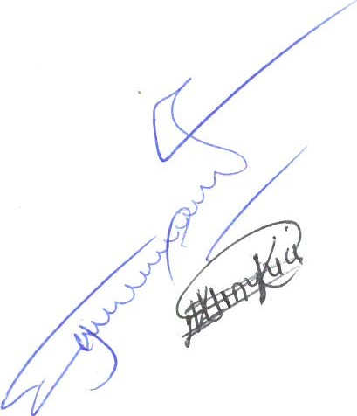SUBMITTED

JANUARY, 2023

Introduction

The Constituencies Development Fund was created by the Constituencies Development Fund Act, 2003 with the primary objective of addressing poverty at grassroots level by dedicating a minimum of 2.5% of the Government ordinary revenue to grassroots development and the reduction of poverty. The fund is managed by the Constituencies Development Fund Board (CDFB)

In January 2013, the CDF Act 2003 (as amended in 2007) was repealed and replaced with NG-CDF Act 201 5 that is aligned to the constitution of Kenya 2010.

The enactment of the CDF Act 2015 was mainly aimed to ensure that the law governing CDF is aligned to the Constitution of Kenya 2010, specifically in compliance with the principles of:

transparency and accountability,

1. separation of powers; and
2. Participation of the people.
3. The new law was also aimed to align the operations of the Fund to the new devolved government structure.

KAMUKUNJI CONSTITUENCY

Kamukunji Constituency consists of central to eastern area of Nairobi County Kenya. The entire constituency is located within the jurisdictions of Nairobi County. It borders Starehe Constituency on the North and West,Makadara on the East and Southern part, Embakasi on a corridor stretch to the East and a narrow section of Kasarani constituency. The constituency has an area of 1 1.7sq km of which half of the space is occupied by Moi Airbase. This leaves about only 5.8sq km space for human occupation, commercial centres and other social amenities. Before assuming District status Kamukunji District was known as Pumwani Division of Nairobi N01th District and prior to 1969 as Nairobi Central Constituency. The population of Kamukunji is estimated at 261,855 (as per the 2009 population census) of which 124,935 are female while 136,920 are male. The region has an average population density of 45,147 people per sq.km. Kamukunji is divided into three administrative divisions: Pumwani, Bahati and Eastleigh divisions which are further subdivided into 9

(nine) administrative Locations and 18 Sub-locations.

WARD MEETINGS REPORT

Amount of money used for bursaries, number of beneficiaries and criteria used for 2021/2022 financial year

|  |  |  |  |
| --- | --- | --- | --- |
| Ward | No. of beneficiaries | Amount allocated | Remarks (mention creteria |
| KAMUKUNJI  CONSTITUENCY | 2670 |  | Forms distributed through chiefs, filled, signed by the area chiefs.  Completed |

0.1 Ward I: Eastleigh North Ward

Number/allocation of completed projects 2021/2022 financial year

|  |  |  |  |  |
| --- | --- | --- | --- | --- |
| Sector | Ward | Number of completed projects | Cost | Remarks |
| Education | Eastleigh North | 2 |  | Completed |



0.1.01 The meeting was held at New Eastleigh Primary School. It started at 10.00am on 6 t January,2023

0.1.02 The meeting was attended by area leaders and residences. It was also attended by Head teacher of New Eastleigh Primary School, deputy Principal of Eastleigh High School, Officer In charge of the area Police Station, Ward Administrator, area Chief and his Assistance, Constituency Manager, P.A. to Hon. Yusuf Hassan, F.A.M and all members of CDFC.

0.1 .03 The area Chief graced the occasion and opened floor the community to forward their proposal. He advised the participants to propose what the people of Pumwani/Shauri would like to be done by CDF in priority bases.

1. I .04 The Ward Administrator praised the participants for their contributions which touched the needs of the people of Eastleigh North. He noted that some of the projects proposed were touching other institutions like those which were funded by Central and County Governments. He promised to look into the projects not funded by the CDF and make sure they are implemented by the relevant institutions.

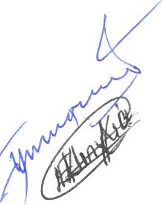0.1.05 The F.A.M. to the participants through CDF Act 2015 and pointed out what can be funded by CDF in line with the act.

0.1.06 The F.A.M. informed participants the issue of bursary was very challenging and requested them since the bursary was meant for bright and poor students to make sure they try to abide with that requirement. On environment, F.A.M. informed participants that although funds allocated to this sector was very little he will make sure they are used were they deserved.

0.1.07 Participants requested the committee to put in considerations projects touching education and securities since these the areas touching on the lives of the people of Eastleigh North. The following to be funded for eatleigh north ward

l . Purchase of schools furniture's- some parents reported children sitting on classrooms floors due to lack of desks

* + - 1. Renovations of 8 classrooms at St teresas Primary
      2. Renovation of 5 classrooms at Eastleigh High School
      3. Easleigh North police Station — construction of offices
    1. People present agreed that there were many challenges especially when it comes to finance since the CDF funds were very little and could not fund big projects. They requested CDF Board to allocate more funds since only projects funded by CDF were visible on ground.
    2. Participants resolved that during this financial year projects touching education and securities (high mast lights) should be funded.
  1. Ward Il:-Airbase Ward.

Number/allocation of completed projects 2021/2022 financial year

|  |  |  |  |  |
| --- | --- | --- | --- | --- |
| Sector | Ward | Number of completed projects | Cost | Remarks |
| Education | California . | 1 |  | Completed |

* + 1. The meeting took place at Airbase chief camp on 5 th January,2023 starting at 2.00pm
    2. The meeting was attended by Deputy Sub County Commissioner, area Chief and the Assistants, Ward Administrator, Principal Maina Wanjigi secondary School, Head Teachers of Moi Air force and Airport View Primary School, DDO and all members of CDFC. Also present were Constituency Manager and P.A. to Hon. Yusuf Hassan Abdi.
  1. 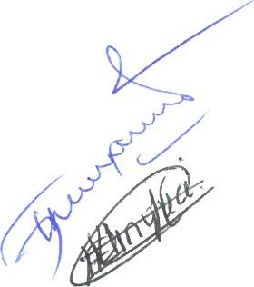The occasion was graced by Deputy Sub County Commissioner who requested the participants to give views 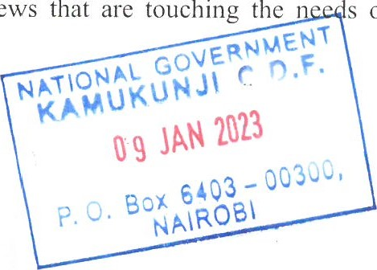that s of the people of Eastleigh Airbase. He also cautioned them from blaming leaders and refrains from politics and concentrates on development ideas.
  2. As stated above, the Deputy Sub County Commissioner advised people present to give proposal that touching the interests of the residences of the area.
     1. F.A.M. took participants through the CDF Act and informed them projects that are funded by us and also the amount available for projects this financial year.
     2. Participants proposed many projects and lastly narrowed their priorities to those touching education and security lights. The said if CDF could fund projects in those sectors they would appreciate most. The following projects were proposed

l. School desks for all the schools in the ward

* + - 1. Construction of administration block at Moi airbase primary school
      2. Renovation of the entire school at moi forces academy
      3. Construction of school hall Eastleigh Airport primary school
      4. Construction of 2 classrooms and dining hall at St Teresa's Boys secondary school

02.07 People in the meeting observed that education and security in Kamukunji was wanting and needs a lot of attention from the authorities.

0.2.08 Participants unanimous agreed that funds for projects touching (renovation and construction of classrooms) in schools and security lights should be approved and funded.

2.3. Ward Ill:-Eastleigh South.

Number/allocation of completed projects 2021/2022financial year

|  |  |  |  |  |
| --- | --- | --- | --- | --- |
| Sector | Ward | Number of completed projects | Cost | Remarks |
| Education | Eastleigh South. | 2 | 2,996,389.00 | Completed |

* + 1. The meeting was held at Calvary Church in Madiwa Location at 5 th January, 2023 9.00am
    2. The area Chief and his Assistant, the DIDO, P.A. to Hon. Yusuf Hassan Abdi, and all CDFC members attended the meeting.
    3. The area Chief graced the occasion and urged the residences to wisely give proposals touching the needs of the people of Eastleigh South in large.
    4. The area Chief urged the participants to wisely give proposals that will be of

Imponance to the people of Kiambiu regardless where they leave and put aside their political differences.

|  |
| --- |
| GOVERNMENT  2023  6403 - 00300,  ROBI |

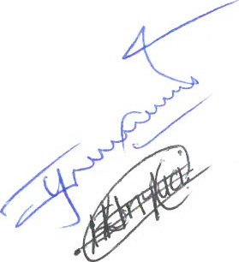NATiONAL

## KAMUKUNJI

JAN

P. O. Box

NAI

2.3.05 The F.A.M. took participants through the Section of CDF Act 2015 which outlines the projects that are funded by the CDF.

2.3.06 The Chairmen of the CDFC informed people present that the committee faced a lot challenges in identifying students to benefit from bursary. He requested the residences to carefully vet the students' inorder to benefit the right people.

2.3.07 Although Eastleigh South was unique ward, the residents unanimously agreed to channel their allocation to only school and security lights. They said they were happy that CDF has completed a perimeter wall in Zawadi Primary School and the it now in need of classrooms to ease the burden of parents being involved in construction of the same. The community leaders requested completion of zawadi Mixed Secondary School and Purchase of school furniture's for the schools in the neighborhood

2.3.08 Challenges facing this ward is that of many slum dwelling in the area. The needs of each group are deferent from each one. However they put their differences as advised by their leader and come up with proposals touching all them.

2.3.09 As noted above, Eastleigh South abhors the largest slum in the area. The needs of the residences are different from each area. However they all agreed that whatever affects people of slums and other residences in terms of education and security is common and should be addressed by all people regardless where you live.

2.4. Ward IV:- California Ward

Number/allocation of completed projects 2021/2022financial year

|  |  |  |  |  |
| --- | --- | --- | --- | --- |
| Sector | Ward | Number of completed projects | Cost | Remarks |
| Education | California Ward | 1 |  | Completed |

2.4.01 The meeting took place at California Resource Centre situated at California Estate at

2.()()pm on 4th January, 2023

2.4.02 The area Chief and her Assistant, Ward Administrator, DO, Constituency Manager, area leaders and all CDFC members were present in the meeting.

2.4.03 The area Chief gave opening speech and requested participants to choose projects that of value to them regardless of their environmental



aspects

2.4.04 Ward Administrator informed members present that with devolved government some

Projects were being undertaken by other arms of government. He said that he will guide them on projects that are fundable by county government and those carried out by CDF.

2.4.05 The CDF Act was read to participants by the F.A.M. who explained the projects that are fundable by CDF and those which are not.

2.4.06 The issue of bursary was brought up and the CDFC Chairman informed participants that the amount allocated by the Board is never enough but we try our best to distribute equally without favour. On environment he advised the residences to try and keep their areas clean as no one will clean your area. However with little money allocated we try to clean a few places.

2.4.07 Participants noted that although ICT Resource Centre was being constructed in their area, they also needed to be considered for projects like renovation of existing toilets, fire hydrants to fight frequent fires in the slum and also if possible construction of storm water draining in Kinyago and Kanuku.

2.4.08 Challenges are very were and affects each and every one. California Ward is composed of large slum dwelling and issue of clean environment is a problem to the residences. This is brought about because of lack of enough toilets to cater for the large population in the area. However the residences were promised that CDF will to their level best assist were they can.

2.4.09 The residences agreed to put aside their differences to channel their allocation in assisting the projects in the slum area. They proposed that the renovation of toilets and erection of high mast security lights be undertaken in the area. This will reduce crime and also create clean environment in the slum.

The following projects were proposed.

l . Purchase of schools furniture's

1. Construction of California police post
2. Rehabilitation of new Pumwani primary school
3. Electrification of new Pumwani primary school
4. Renovation of California Desa football grounds

2.5 Ward V: Pumwani/Shauri Moyo Ward

Number/allocation of completed projects 2021/2022financial year

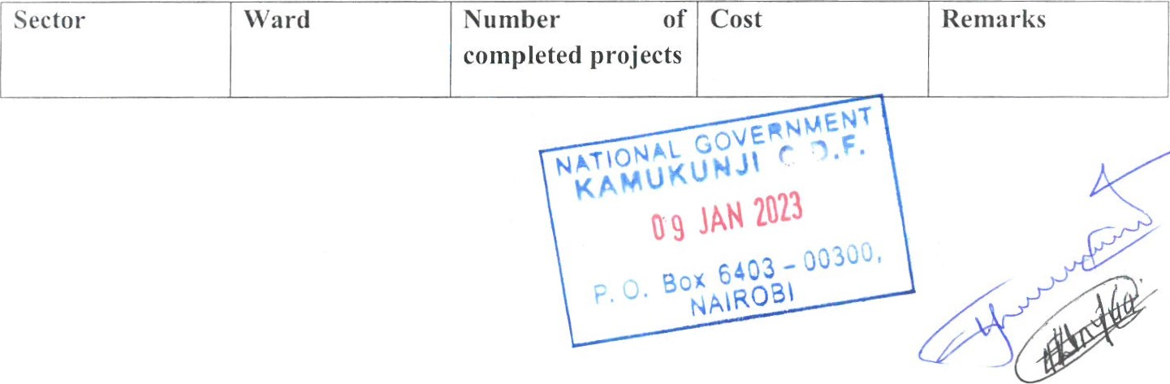

|  |  |  |  |  |
| --- | --- | --- | --- | --- |
| Education | Pumwani ward | 5 |  | Completed |

Meetings in this ward were conducted in two areas and in different time as follows;

PUMWANI LOCATION:

* + 1. Meeting this location was conducted on 4St January,2023 at 8.00am at Pumwani Social Hall.
    2. The area Chief, Ass. Chief,A.P. base Commandant, Social Service Officer, DDO CDFC members, Constituency Manager, leaders and residences were in attendance.
    3. The area Chief graced the occasion on behalf of Sub County Commission who was said to away on official business.

2.5.04 Chailperson of the CDFC on his opening speech advised residences forward proposals which are going to assist the residences of this area.

* + 1. The Funds Account Manager explained to the participants the CDF Act 2015 so that they may understand which projects are fundable by CDF and which are not.
    2. The CDFC Chairman touched on bursary and informed the participants that we are trying to balance the issuance of the bursaries to the needy and bright students. He said that if a student benefits in first term he will not be eligible to benefit the following term. This was because funds are not enough for all to get, but we try our best to balance the system. He advised the leaders involved in identifying the needy students to carry out the excise without favoring any one.
    3. Pumwani Location is home of the largest open air Market in the Country. The needs of the people is quite different since a big number of people come for business only. However those who permently live in Pumwani made their proposals in accordance with their needs. A lot was said about a need to construct a public primary school. Security lights and construction of clean water points was also proposed.
    4. The participants pointed out that Pumwani Location is the home For Gikomba Open Air Market which deals with second hand clothing. The population is quit big during the day and at night very low. Roads are very bad and not passable during the day due to human traffic. The human settlements in the area were constructed during the colonial era. A lot needs to be done and residences requested Hon. Yusuf to intervene for the construction of the High Rise Phase 3.
    5. Participants unanimously agreed that water points and security was their priority fòr the time being.

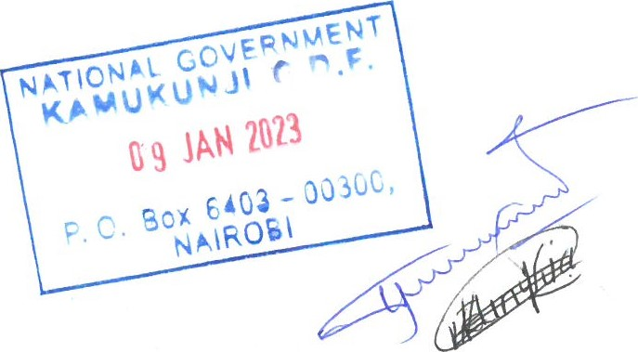

SHAURI MOYO LOCATION:

* + 1. The meeting took place at Shauri Moyo Chiefs Camp on 4 th January, 2023 at 12.00pm
    2. The area Chief, Ass. Chief, Constituency Manager, P.A to Hon. Yusuf Hassan, DIDO, leaders, area residences and CDFC members were in attendance.
    3. The area Chief graced the occasion and the meeting proceeded smoothly.
    4. After the introduction of those present, the Constituency Manager advised the pafticipants the need to identify the projects that will uplift their day to day life and stay away from politics since where there are politics development is slow.
    5. Funds Accounts Manager took participants through a section of CDF Act 201 5 which outlines the projects that are fundable by DCF.
    6. Bursary issues were addressed by the CDFC Chairman who informed participants that the amount allocated by the Board was not enough and we try our best to make sure it reaches nearly everyone who manages to get application form.
    7. Residence of Shauri Moyo agreed that toilets in the area were in pathetic situation and needed to be renovated. They also said water was not enough for their needs and requested whether something could be done to increase the pressure in order to reach all areas the location.
    8. People of Shauri Moyo were living in fear after the County Government announced that buildings will be demolished to give way for modern high rise buildings. The area also is a home of the wholesale Market for meat in the city (Burma Market). They said dirty water from the market was polluting their environment and requested authorities to address the situation.
    9. People of Shauri Moyo voted with one voice that their need was renovation of public toilets and supply of water to reach all areas. They also said toilets of Heshima Primary need to be renovated among other things if funds are available.

The following projects were proposed

Purchase School desks and chairs in; Our Lady of Mercy girls Primary School, Our Lady of Mercy girls Secondary School, Kamukunji Secondary School, Heshima Primary school and Muthurwa primary school

1. Kamukunji subcounty headquarters office (Renovations and cabro parking)
2. Shauri Moyo Police Station (Renovation of staff houses and completion cabro parking)

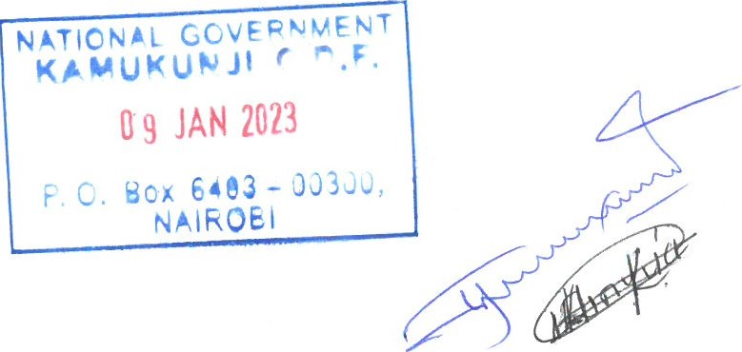

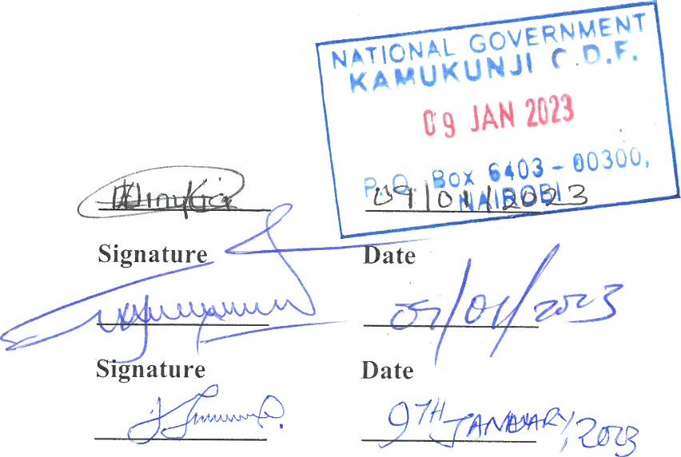0.3 Conclusion/way forward

### ESÃHEC

Signed (Chairman)

ÃÃ/4(Zf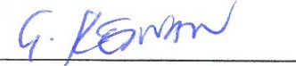

Signed (Fund Account Manager)

#### J' Q /Z0moJJ

Signed (Deputy County Commissioner) Signature Date

I Website:www.ngcdféÅQ_.ke/KamuIauuÍi

NATIONAL GOVERNMENT KAMUKUNJI CONSTITUENCY DEVELOPMENT FUND COMMITTEE MEETING HELD ON MONDAY 9TH JANUARY, 2023 STARTING IOAM AT KAMUKUNJI CDP OFHCE IN PUMWANI ALONG DIGO ROAD.

##### IN ATTENDANCE

|  |  |  |
| --- | --- | --- |
| 1. | Esther Wairimu Kinyua | -Chairperson |
| 2. | Brian Makuba Ingalula | -Secretary |
| 3. | Farah Gabane Keinan | -Pund Account Manager |
| 4. | Ali Joram Juma | -Member |
| 5. | Elsie Adhiambo Ounga | -Member |
| 6. | Dickens Otieno Okode | -Member |
| 7. | Rapheal Maini Kimilu | -Member |
| 8. | Ann Muthoni Kuria | -Member |
| 9. | Zeitun Mohamed Essman | -Member |
| 10. James G. Kariuki | | -Deputy County Commissioner |

Agenda

l . Preliminaries

1. Reading and confirmation of' the previous minutes
2. Matters arising
3. Summarv Of the Ward Report



t). Kamukunji NIG-COY Strategic Plan 

G. Submission of project proposals for the financial year 2022/2023

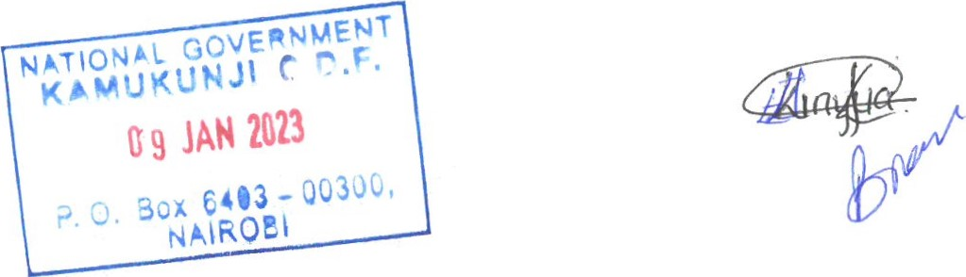

Page

I Website:www.ngcdf.go.ke/KamLlkunji

KAMU/CDF/MIN 1/09/01/2023 PRELIMINARY

The meeting started at 02:15 PM with a word of prayer by Ann Kuria

KAMU/CDF/MIN 2/09/01/2023 READING AND CONHRMATION OF THE PREVIOUS MINUTES

The NG-CDFC chairman read the minutes of the previous meeting held on 23 rd December, 2022 and was confirmed as true deliberation of the day after being proposed and seconded by Brian Lingalula and

Dickens Okode respectively.

KAMU/CDF/MIN 3/09/01/2023 MATTERS ARISING

There were no matters arising from the previous meeting. The committee noted low turnout during the public participation forums held on 4th January, 2023 to 6th January, 2023.

KAMU/CDF/MIN 4/09/01/2023 SUMMARY OF WARD MEETINGS REPORT

The Committee deliberated on the ward report and agreed to prioritize the most urgently needed projects in the education sector. The committee ensured that projects to be funded are shared equitably amongst all the five wards. Additionally, considering the matters raised during the public participation forums by the community leadership, the following are prioritized projects per ward. Since all projects funded falls under education sector all the 1 7 schools in the 5 wards will benefit.

|  |  |  |  |
| --- | --- | --- | --- |
| NO | PROJECT NAME AND ACTIVITIES | | WARD |
| 1 | I.  2.  3. | Eastleigh High School- Purchase of desks and chairs  New Eastleigh Primary School- Purchase of desks and chairs  St Teresas Boys Primary School- Purchase of desks and chairs | Eastleigh North |
| 2. | 1.  2. | Kamukunji Sec School- Purchase of desks and chairs  New Pumwani Primary School- Purchase of desks and chairs | California Ward |

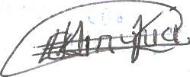

I Website:www_.L1gç_df:go.ke/Kamukuyyjj

|  |  |  |  |
| --- | --- | --- | --- |
| 3 | l .  2.  3.  4.  5.  G. | St Teresas Boys Sec School- Purchase of desks and chairs  Eastleigh Aiport Primary School- Purchase of  desks and chairs and construction of a multipurpose hall  Moi Airbase Primary School- Purchase of desks and chairs  Moi Forces Academy-Primary- Purchase of desks and chairs  Moi Forces Academy-Secondary - Purchase of desks and chairs  Maina Wanjigi Sec School- Purchase of desks and chairs | Airbase Ward |
| 4. | l .  2. | Zawadi Primary School- Purchase of desks and chairs  Zawadi Mixed Secondary SchoolConstruction of classrooms, Toilets,  Laboratories and civils works | Eastleigh South Ward |
| 5 | l .  2.  3.  4. | OLM Girls Secondary School - Purchase of desks and chairs and construction of access diasbilty ramp  Heshima Primary School- Purchase of desks and chairs  OLM Girls Primary School- Purchase of desks and chairs  Muthurwa Primary School- Purchase of desks and chairs | Pumwani/Shauri Moyo Ward |

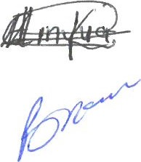The Committee also confirmed that there no Igoing projects related to the previous years.

KAMU/CDF/ }aMtJku 1 NG-CDF STRATEGIC PLAN

ge

I Website:www.ngcdf.go.ke/Kamukunji

The Committee unanimously agreed not to factor Kamukunji's National Government Constituency Development Fund Strategic Plan in 2022/2023 F/ Y proposals since, the current Strategic plan is still valid and it will expire in 2023. Kamukunji National Government Constituency Development Fund Strategic Plan was developed and adopted from Financial Year 2018/ 2019 running up to Financial Year

2022/2023

KAMU/CDF/MIN 6/09/01/2023 SUBMISSION OF PROJECT PROPOSALS FOR THE FINANCIAL YEAR

2022/2023

The committee deliberated on the final project list for the financial year 2022/2023 and unanimously agreed the list to be submitted to NG-CDF board for approval.

|  |  |  |  |  |  |  |  |
| --- | --- | --- | --- | --- | --- | --- | --- |
| No. | Project  Number | Project Name | Project Activity | Original Cost | Cumula  five Allocati on | Amount  Allocated | Curren  t Status |
|  | ADMINISTRATION AND RECURRENT | | |  |  |  |  |
| 1 | 4-0047288-  2210402-  100-20222023-1 | Accommodation | Payment of  Accommodation  Expenses | 200,000.00 |  | 200,000.00 | New |
| 2 | 4-0047-  288-  28822105 04-1 oo2022-  2023-2 | Advertising,  Awareness and  Publicity Campaigns | Payment of  Advertising,  Awareness and  Publicity Campaigns | 1 oo,ooo.oo |  | 1 oo,ooo.oo | New |
| 3 | 288-  2211301-  100-20222023-3 | Bank service commission and charges | Payment of Bank service commission and charges | 33,950.00 |  | 33,950.00 | New |

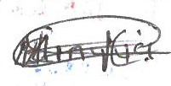



Website:www.ngcdf.g0.ke/Kamukunjj



|  |  |  |  |  |  |  |  |  |
| --- | --- | --- | --- | --- | --- | --- | --- | --- |
| No. | Project  Number | Project Name | Project Activity | | Original Cost | Cumula  five Allocati on | Amount  Allocated | Curren  t Status |
| 4 | 4-0047288-  21 10201-  100-20222023-4 | Contractual employees- | Payment of 5  employees' staff  Basic salaries | | 2,283 720.00 |  |  | New |
| 5 | 4-0047-  21 10202-  100-20222023-5 | Casual labour and Internship | Payment of I casual staff Basic Wages | | 144,000.00 |  |  | New |
|  | 288-  2210203-  100-20222023-6 | Courier and  Postal Services | Payment of Courier and Postal Services | | 19,000.00 |  | 19,000.00 | New |
| 7 | 4-004728822  100-20222023-7 | Daily  Subsistence  Allowance | Payment  Subsistence  Allowance | of Daily | 1 oo,ooo.oo |  | 100,000.00 | New |
| 8 | 288-  221 1 101-  IOO-20222023-8 | General Office  Supplies  (papers, pencils,  forms, small  office equipment) | Purchase  General Supplies pencils, small equipment) | of  Office  (papers, forms, office | 50,000.00 |  | 50,000.00 | New |

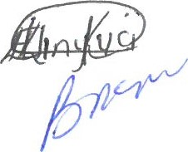

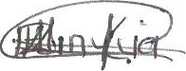  Div



|  |  |  |  |  |  |  |  |
| --- | --- | --- | --- | --- | --- | --- | --- |
| No. | Project  Number | Project Name | Project Activity | Original Cost | Cumula  five Allocati on | Amount  Allocated | Curren  t Status |
| 9 | 4-0047288-  2710102-  100-20222023-9 | Gratuitycontractual employees | Payment of 5  employees' gratuity to NG-CDFC staff | 458,713.20 |  | 458,713.20 | New |
| 10 | 4-0047288-  2210704-  100-20222023-10 | Hire of Training Facilities and  Equipment | Hire of Training Facilities and  Equipment | 200,000.00 |  | 200,000.00 | New |
| 1 1 | 4-0047288-  2210202-  100-20222023-1 1 | In ternet  Connections | Payment of Internet  Connections | 30,000.00 |  | 30,000.00 | New |
| 12 | 4-004728821  100-20222023-12 | Leave allowance | Payment of Leave allowances to 5  ING-CDFC staff | 50,000.00 |  | 50,000.00 | New |
| 13 | 4-4-0047288-  221081 1-  100-20222023-13 | NGCDFC  allowance | Payment of NGCDFC allowance charges | 1, 1 oo,ooo.oo |  |  | New |
| 14 | 4-4-0047288-  2120201- | NSSF | Employer contribution to  NSSF | 64,800.00 |  | 64,800.00 | New |

I-IQ

Digo



|  |  |  |  |  |  |  |  |  |
| --- | --- | --- | --- | --- | --- | --- | --- | --- |
| No. | Project  Number | Project Name | Project Activity | | Original Cost | Cumula  tive Allocati on | Amount  Allocated | Curren  t Status |
|  | 100-20222023-14 |  |  | |  |  |  |  |
|  | 288-  2210502-  100-20222023-16 | Publishing and  Printing Services | Payment of  Publishing and Printing Services | | 85,000.00 |  | 85,000.00 | New |
|  | 4-4-0047288-  2210503-  100-20222023-1 7 | Subscriptions to Newspapers, Magazines and  Periodicals | Payment  Subscriptions Newspapers, Magazines  Periodicals | of to  and | 42,000.00 |  | 42,000.00 | New |
|  | TOTALS |  |  |  |  |  |  |  |
|  | CONSTITUENCY OVERSIGHT  COMMITTEE EXPENSES | |  |  |  |  |  |  |
|  | 288-  2210303-  I OO-20222023- 1 | Daily  Subsistence  Allowance | Payment of  Subsistence  Allowance | Daily | 650,000.00 |  | (350,000.00 | New |
| 2 | 288-  21 10314-  100-20222023-2 | Transport allowance | Payment of  Transport allowances | | 350,000.00 |  | 350,000.00 | New |
| 3 | 28822 | Other committee expenses | Payment of Other committee expenses | | 300,000.00 |  | 300,000.00 | New |

###### I-IQ

Digo

I 

|  |  |  |  |  |  |  |  |  |
| --- | --- | --- | --- | --- | --- | --- | --- | --- |
| No. | Project  Number | Project Name | Project Activity | | Original Cost | Cumula  tive Allocati on | Amount  Allocated | Curren  t Status |
|  | 2023-3 |  |  | |  |  |  |  |
|  | TOTAL |  |  | |  |  |  |  |
|  | MONITORING EVALUATION AND CAPACIIY BUILDING | | | | |  |  |  |
| 1 | 4-4-0047288-  2210710-  1 1 1-20222023-1 | Accommodation  Allowance | Payment of  Accommodation  Allowance of NGCDFC, National Government officers and PMC  (NG-CDFC and PMC induction  Training) | |  |  |  | New |
| 2 | 4-4-0047288-  2210303-  1 1 1-20222023-2 | Daily  Subsistence  Allowance | Payment  Subsistence  Allowance | of Daily | 300,000.00 |  | 300,000.00 |  |
|  | 4-4-0047288221 1  11 1-20222023-3 | General Office  Supplies  (papers, pencils,  forms, small  office equipment | Purchase  General Supplies pencils, small equipment) | of  Office  (papers, forms, office | 156,000.00 |  | 156,000.00 | New |
| 4 | 288-  2210811- | NGCDFC  allowance | Payment of NGCDFC allowance | | 300,000.00 |  | 300,000.00 | New |

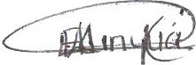



G403Q0300

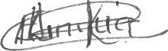Nairobi, Kenya

Cell:020-2GIG403



|  |  |  |  |  |  |  |  |
| --- | --- | --- | --- | --- | --- | --- | --- |
| No. | Project  Number | Project Name | Project Activity | Original Cost | Cumula  tive Allocati on | Amount  Allocated | Curren  t Status |
|  | 1 1 1-2022-  2023-4 |  |  |  |  |  |  |
|  | 4-4-0047288-  2210802-  1 1 1-20222023-5 | Other committee expenses | Payment of Other committee expenses | 150,000.00 |  | 150,000.00 | New |
|  | TOTALS | | |  |  | 2,206,000.00 |  |
|  | BURSARY AND SOCIAL SECURIIY PROGRAMS | | |  |  | |  |
|  | 4-0472882640101103-  2022/2023 | Bursary  Secondary  Schools | Payment of bursary to needy students in secondary schools |  |  |  | New |
| 2 | 4-0472882640102103-  2022/2023 | Bursary Tertiary  Institutions | Payment of bursary to needy students in tertiary institutions |  |  |  | New |
| 3 | 4-0470288-  2640103-  103-20212022-2 | ING-CDFC Social  Security  Programme | Provision of annual medical insurance  cover for 500  vulnerable families including Orphans and Vulnerable Children (OVCS), |  |  |  | New |



## NGCDF

I

|  |  |  |  |  |  |  |  |  |
| --- | --- | --- | --- | --- | --- | --- | --- | --- |
| No. | Project  Number | Project Name | Project Activity | | Original Cost | Cumula  five Allocati on | Amount  Allocated | Curren  t Status |
|  |  |  | poor older persons,  Persons with Disabilities (PWDs)  and destitute families in partnership with NHIF as shall be identified within the Constituency. | |  |  |  |  |
|  | TOTALS | |  | |  |  | 36,485,822.80 |  |
|  | EMERGENCY RESERVE | |  | |  |  |  |  |
|  | 288-  2640200-  101-20222023-1 | Emergency  Reserve | To cater for unforeseen occurrences in constituency during financial year | any  the  the |  |  |  | New |
|  | TOTALS | |  |  |  |  |  |  |
|  | SPORTS | |  |  |  |  |  |  |
| 1 | 4-4-0047-  288-  2640509-  1 12-20222023-1 | Constituency  Sports  Tournament | Organization of  Constituency  Football Sports tournament where by the winning  teams/ schools to be  awarded with trophies, balls, goal nets and games kits | | 2, 150,000.00 |  | 2, 150,000.00 | New |



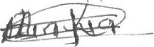Website:www.ngcdf*QEke(Ka„mu.ku nji



|  |  |  |  |  |  |  |  |
| --- | --- | --- | --- | --- | --- | --- | --- |
| No. | Project  Number | Project Name | Project Activity | Original Cost | Cumula five Allocati on | Amount  Allocated | Curren t Status |
|  | 4-4-0047288-  2640509-  1 12-20222023-1 | Regional Sports Tournament | To facilitate regional sports tournament in partnership with other constituencies within the region | 520,000 |  | 520,000 | New |
|  | TOTALS | |  |  |  |  |  |
|  | PRIMARY SCHOOL PROJECTS | |  |  |  | |  |
| 1 | 4-4-0047288-  2630209-  104-20222023-1 | ST. Teresas Boys Primary School | Purchase of 200 pair of lockers and chairs |  |  |  | New |
| 2  3 | 4-4-0047288-  2630209-  104-20222023-2 | Eastleigh Airport Primary School | Purchase of 200 pair of lockers and chairs |  |  |  | New |
|  | 288-  2630209-  104-20222023-3 | Our lady of  Mercy Primary  School | Purchase of 200 pair of lockers and chairs |  |  |  | New |
| 4 | 4-4-0047288 -  2630209- | Zawadi Primary  School | Purchase of 200 pair of lockers and chairs |  |  |  | New |

I-IQ

Digo



|  |  |  |  |  |  |  |  |
| --- | --- | --- | --- | --- | --- | --- | --- |
| No. | Project  Number | Project Name | Project Activity | Original Cost | Cumula  tive Allocati on | Amount  Allocated | Curren  t Status |
|  | 104-20222023-4 |  |  |  |  |  |  |
| 5 | 288-  2630209-  104-20222023-5 | Moi Airbase  Primary School | Purchase of 200 pair of lockers and chairs |  |  |  | New |
|  | 288-  2630209-  104-20222023-6 | Moi Forces  Academy  Primary | Purchase of 200 pair of lockers and chairs | 1400,000.00 |  |  | New |
| 7 | 288-  2630209-  104-20222023-7 | Muthurwa  Primary School | Purchase of 200 pair of lockers and chairs |  |  | 1400,000.00 | New |
| 8 | 4-4-0047288-  2630209-  104-20222023-8 | New Pumwani  Primary School | Purchase of 300 pair of lockers and chairs |  |  | 2, 1 oo,ooo.oo | New |
| 9 | 4-4-0047288-  2630209-  104-20222023-9 | New Eastleigh  Primary School | Purchase of 300 pair of lockers and chairs |  |  |  | New |

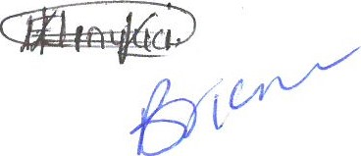

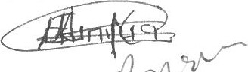I-IQ

Digo



|  |  |  |  |  |  |  |  |
| --- | --- | --- | --- | --- | --- | --- | --- |
| No. | Project  Number | Project Name | Project Activity | Original Cost | Cumula  five Allocati on | Amount  Allocated | Curren  t Status |
|  | 4-4-0047288-  2630209-  104-20222023-10 | Heshima Road  Primary School | Purchase of 300 pair of lockers and chairs |  |  |  | New |
|  | 4-4-0047288-  2630209-  104-20222023-1 1 | Eastleigh Airport  Primary School | Construction to completion of 500 capacity School  non -storey multiPurpose Hall |  |  |  | New |
|  | TOTALS | | |  |  | 23,730,658.00 |  |
|  | SECONDARY SCHOOL PROJECTS | | |  |  | |  |
|  | 4-4-0047288-  2630210-  104-2022- | Moi Forces  AcademySecondary | Purchase of 300 pair of lockers and chairs | 2, 1 oo,ooo.oo |  | 2, 1 oo,ooo.oo | New |
|  | 4-4-0047288-    104-20222023-2 | Eastleigh High  School | Purchase of 200 pair of lockers and chairs |  |  | 1400,000.00 | New |
| 3 | 288-  26302 IO-  104-20222023-3 | Zawadi Mixed  Secondary  School | Purchase of GOO pair of lockers and chairs |  |  |  | New |

HQ

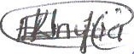Digo

I

|  |  |  |  |  |  |  |  |
| --- | --- | --- | --- | --- | --- | --- | --- |
| No. | Project  Number | Project Name | Project Activity | Original Cost | Cumula  five Allocati on | Amount  Allocated | Curren  t Status |
| 4 | 4-4-0047288-  2630210-  104-20222023-4 | St Teresas Boys  Sec School | Purchase of 300 pair of lockers and chairs |  |  |  | New |
| 5 | 4-4-0047288-  2630210-  104-20222023-5 | Kamukunji  Secondary  School | Purchase of 200 pair of lockers and chairs |  |  |  | New |
| G | 4-4-0047288-  2630210-  104-20222023-6 | OLM Girls  Secondary  School | Purchase of 300 pair of lockers and chairs | 2, oo,ooo.oo |  |  | New |
| 7 | 288-  2630210-  104-20222023-7 | Maina Wanjigi  Secondary  School | Purchase of 300 pair of lockers and chairs |  |  |  | New |
| 8 | 288-  26302 IO-  104-20222023-8 | OLM Girls  Secondary  School | Construction of access ramp for three storey building that consists of 15 classrooms, 5 offices, 2  staffrooms, 3 |  |  |  | New |

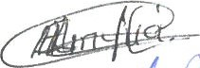HQ

Digo



Website:www.ngcdf.go.ke/Kamuku

|  |  |  |  |  |  |  |  |
| --- | --- | --- | --- | --- | --- | --- | --- |
| No. | Project  Number | Project Name | Project Activity | Original Cost | Cumula  tive Allocati on | Amount  Allocated | Curren t Status |
|  |  |  | laboratories, 3  dormitories and 42 door toilets from ground floor to 3rd floor for school main block to completion |  |  |  |  |
| 9 | 288-  2630210-  104-20222023-9 | Zawadi Mixed  Secondary  School | Construction of three storey  building 2 nd phase consisting of;  basemen t (kitchen and 115 students capacity dining hall), ground floor (2 Laboratories 45 capacity 5door toilets) 1 st floor (7 offices, staffroom, kitchen and 5 door toilets with one to cated for PWDs), 2 nd floor (45 students capacity  art room, 45 students capacity computer lab, 80 students capacity | 42,003,749.0 |  |  | New |

I-IQ

Digo

cdfkamukunji@ngcdf.go.ke I

|  |  |  |  |  |  |  |  |
| --- | --- | --- | --- | --- | --- | --- | --- |
| No. | Project  Number | Project Name | Project Activity | Original Cost | Cumula  tive Allocati  on | Amount  Allocated | Curren  t Status |
|  |  |  | library and 7 door toilets with I to cater for PWDs)  and 3 rd floor ( 2 80 capacity exam hall and 7 door toilets with 1 door to cater for PWDs) |  |  |  |  |
|  | TOTALS | |  |  |  |  |  |
|  | TOTAL ALLOCATION | |  |  |  | 145,087,603.00 |  |

### KAMU/CDF/MIN 7 09/01/2023 A.O.B

There being no other b

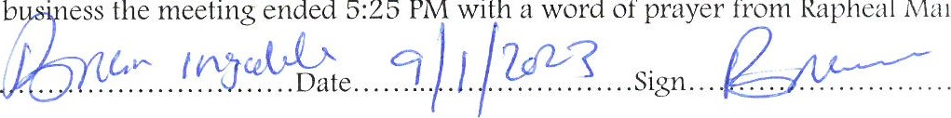

PM

with

a

word

of

prayer

from

Rapheal

Maingi

Minutes compiled by . Sign..

#### CDFC SECRETARY

Minutes Approved by. 

#### CDFC CHAIRMAN

|  |  |  |
| --- | --- | --- |
| |  | | --- | | NATIONAL GOVERNMENT KAMUKUNJI C.O.F.  JAN 2023  P. D.  - 00300,  NAIROBI | |  |

Project Reports Date: 01/26/2023

THIRD SCHEDULE(ss. and 29(1))

CONSTITUENCY PROJECTS SUBMISSION FORM

CONSTITUENCY NO. 288 CONSTITUENCY NAME: KAMUKUNJI FINANCIAL YEAR: 2022-2023

|  |  |  |
| --- | --- | --- |
| SERIAL | NAME OF PROJECT | AMOUNT ALLOCATED (KSHS) |
| 288/AP1 | Administration/Recurrent | 4,961,183.20 |
| 288/AP2 | Monitoring and evaluation/Capacity Building |  |
| 288/2640100 | Bursary/Mocks/Cats | 36,629,822.80 |
| 288/2640200 | Emergency Projects |  |
| 288/2630204 | Primary School Projects |  |
| 288/2630205 | Secondary School Projects |  |
| 288/2640509 | Sports Activities |  |
| 288/2210303 | Oversight (COC) |  |
|  | TOTAL |  |

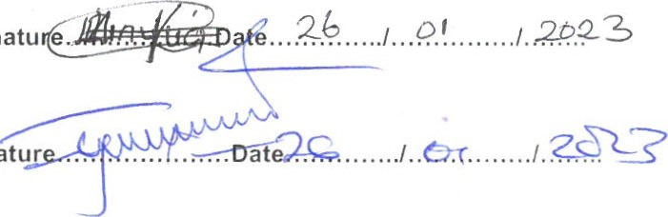Chairman. . . ...... ...Signatu e

Fund Manager...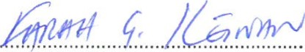....................Sign tur

|  |
| --- |
| GOVERNMENT  JAN  6403 - 00300,  C. |
|
|
|

1 / 1

|  |  |  |
| --- | --- | --- |
| Constituency KAMUKUNJI  Name  Project Number  Project Title Administration/Recurrent  Sector Administration & Recurrent  Status of projects  Brief statement on project status at time of submission | County | Nairobi |
| Financial year 2022-07-01 | to | 2023-07-31 |
| Original Cost 4,961 , 183.20 Estimates, in Ksh | dated |  |
| Amount allocated | dated |  |

last financial year

Sub projects

|  |  |  |  |  |
| --- | --- | --- | --- | --- |
| Project Name | Project Code | Activity | Original Status | Amount (Ksh) |
| Accommodation | 4-0047-288-2210402-100-2022-2023-1 | Payment of Accommodation Expenses | New Project | 200,000.00 |
| Advertising,  Awareness and  Publicity  Campaigns | 4-0047-288-2210504-100-2022-2023-2 | Payment of Advertising,  Awareness and Publicity Campaigns | New Project | 100,000.00 |
| Bank service commission and charges | 4-0047-288-221 1301-100-2022-2023-3 | Payment of Bank service commission and charges | New Project | 33,950.00 |
| Contractual employees- | 4-0047-288-21 10000-100-2022-2023-4 | Payment of 5 employees staff Basic salaries | New Project |  |
| Casual labour and Internship | 4-0047-288-21 10202-100-2022-2023-5 | Payment of 1 casual staff Basic  Wages | New Project | 144,000.00 |
| Courier and Postal Services | 4-0047-288-2210203-100-2022-2023-6 | Payment of Courier and Postal Services | New Project | 19,000.00 |
| Daily Subsistence Allowance | 4-0047-288-2210403-100-2022-2023-7 | Payment of Daily Subsistence Allowance | New Project | 100,000.00 |
| General Office Supplies (papers, pencils, forms, small office equipment) | 4-0047-288-221 1 101-100-2022-2023-8 | Purchase of General Office  Supplies (papers, pencils, forms, small office equipment) | New Project | 50,000.00 |
|  | 0047 —288-2710102-100-2022-2023-9 | Payment of 5 employees gratuity to NG-CDFC staff | New Project | 458,713.20 |

1 12

|  |  |  |  |  |
| --- | --- | --- | --- | --- |
| Hire of Training  Facilities and Equipment | 4-0047-288-2210704-100-2022-2023-10 | Hire of Training Facilities and Equipment | New Project | 200,000.00 |
| Internet  Connections | 4-0047-288-2210202-100-2022-2023-1 1 | Payment of Internet  Connections | New Project | 30,000.00 |
| Leave allowance | 4-0047-288-2110320-100-2022-2023-12 | Payment of Leave allowances to 5 NG-CDFC staff | New Project | 50,000.00 |
| NGCDFC allowance | 4-0047-288-221081 1-100-2022-2023-1 3 | Payment of NG-CDFC allowance charges | New Project |  |
| NSSF | 4-0047-288-2120101-100-2022-2023-1 4 | Employer contribution to NSSF | New Project | 64,800.00 |
| Publishing and  Printing Services | 4-0047-288-2210502-100-2022-2023-15 | Payment of Publishing and Printing Services | New Project | 85,000.00 |
| Subscriptions to  Newspapers,  Magazines and  Periodicals | 4-0047-288-2210503-100-2022-2023-16 | Payment of Subscriptions to  Newspapers, Magazines and  Periodicals | New Project | 42,000.00 |
|  | | | TOTAL: | 4,961,183.20 |

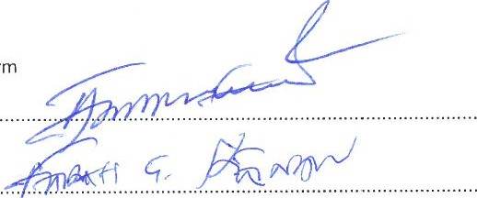Person completing form

ac / c-u-¿-s—

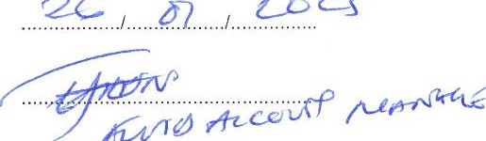

/ú/TØ

SIGNATURE:DATE:

NAME:POSITION:

2/2

|  |  |  |  |
| --- | --- | --- | --- |
| Constituency Name | KAMUKUNJI | County | Nairobi |
| Project Number | API |  |  |
| Project Title | Monitoring and Evaluation |  |  |
| Sector  Status of projects | Monitoring & Evaluation |  |  |
| Brief statement on project status at time of submission | |

|  |  |  |
| --- | --- | --- |
| Financial year | 2022-07-01 | to |
| Original Cost  Estimates, in Ksh | 2,256,000.00 | dated |
| Amount allocated |  | dated |

2023-07-31

last financial year

Sub projects

|  |  |  |  |  |
| --- | --- | --- | --- | --- |
| Project Name | Project Code | Activity | Original Status | Amount (Ksh) |
| Accommodation Allowance | 4-0047-288-2210402-1 1 1-2022-2023-1 | Payment of Accommodation  Allowance of NG-CDFC,  National Government officers and PMC (NG-CDFC and PMC induction Training) | New Project |  |
| Daily Subsistence Allowance | 4-0047-288-2210403-1 1 1-2022-2023-2 | Payment of Daily Subsistence Allowance | New Project | 300,000.00 |
| General Office Supplies (papers. pencils, forms, small office equipment | 4-0047-288-2211 101-11 1-2022-2023-3 | Purchase of General Office  Supplies (papers, pencils, forms, small office equipment) | New Project | 156,000.00 |
| NGCDFC allowance | 4-0047-288-221081 1-1 1 1-2022-2023-4 | Payment of NG-CDFC allowance | New Project | 300,000.00 |
| Other committee expenses | 4-0047-288-2210802-1 11-2022-2023-5 | Payment of Other committee expenses | New Project | 200,000.00 |
| TOTAL: | | | | 2,256,000.00 |

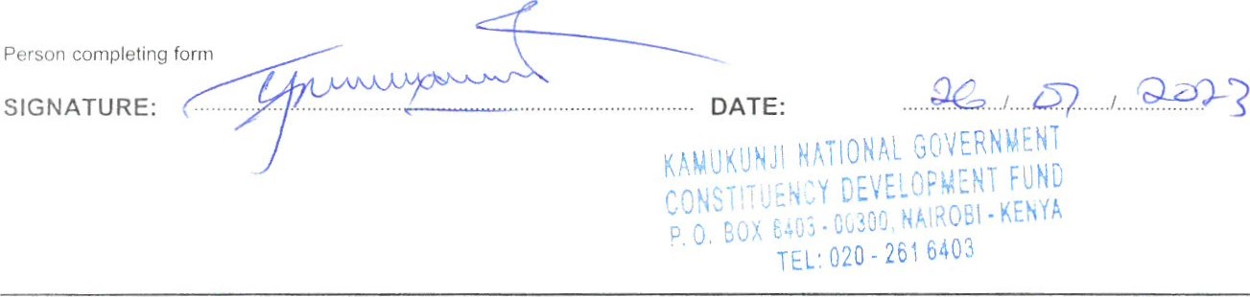

1 /2

NAME: 



TEC:

2/2

|  |  |  |
| --- | --- | --- |
| Financial year | 2022-07-01 | to |
| Original Cost  Estimates, in KSh | 36,629,822.80 | dated |
| Amount allocated |  | dated |

2023-07-31

last financial year

|  |  |  |  |
| --- | --- | --- | --- |
| Constituency  Name  Project Number  Project Title  Sector  Status of projects | KAMUKUNJI  2640100  Bursary/Mocks/Cats  Bursary | County | Nairobi |
| Brief statement on project status at time of submission | |

Sub projects

|  |  |  |  |  |
| --- | --- | --- | --- | --- |
| Project Name | Project Code | Activity | Original Status | Amount (Ksh) |
| Bursary  Secondary  Schoois | 4-0047-288-2640101-103-2022-2023-1 | Payment of bursary to needy students in secondary schools | New Project |  |
| Bursary Tertiary Institutions | 4-0047-288-2640102-103-2022-2023-2 | Payment of bursary to needy students in tertiary institutions | New Project |  |
| NG-CDFC Social  Security  Programme | 4-0047-288-2640103-103-2022-2023-3 | provision of annual medical insurance cover for 500 vulnerable families including Orphans and Vulnerable  Children (OVCs), poor older persons, Persons with  Disabilities (PWDs) and destitute families in partnership with NHIF as shall be identified within the Constituency. | New Project |  |
|  | | | TOTAL: | 36,629,822.80 |

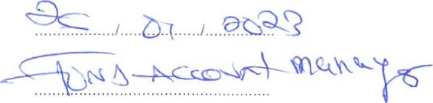SIGNAT DATE:

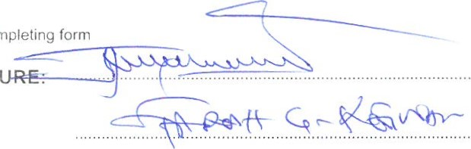

Person

completing

NAME: POSITION:

1

|  |  |  |  |
| --- | --- | --- | --- |
| Constituency  Name  Project Number  Project Title  Sector  Status of projects | KAMUKUNJI  2640200  Emergency projects  Emergency | County | Nairobi |
| Brief statement on project status at time Of submission | |

|  |  |  |
| --- | --- | --- |
| Financial year | 2022-07-01 | to |
| Original Cost  Estimates, in Ksh | 7,636,190.00 | dated |
| Amount allocated |  | dated |

2023-07-31

last financial year

Sub projects

|  |  |  |  |  |
| --- | --- | --- | --- | --- |
| Project Name | Project Code | Activity | Original Status | Amount (Ksh) |
| Emergency Reserve | 4-0047-288-2640200-101-2022-2023-1 | To cater for any unforeseen occurrences in the constituency during the financial year | New Project | 7,636,190.00 |
|  |  |  | TOTAL: | 7,636,190.00 |

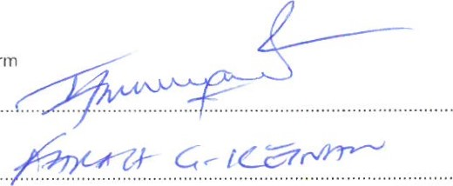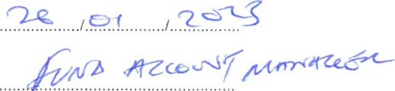Person completing form

SIGNATURE:DATE:

NAME:POSITION:

I

Status of projects

Brief statement on project status at time of submission

|  |  |  |  |
| --- | --- | --- | --- |
| Financial year | 2022-07-01 | to | 2023-07-31 |
| Original Cost  Estimates, in Ksh | 23,730,658.00 | dated |  |
| Amount allocated last financial year |  | dated |  |

|  |  |  |  |
| --- | --- | --- | --- |
| Constituency Name | KAMUKUNJI | County | Nairobi |
| Project Number | 2630209 |  |  |
| Project Title | Capital Grants to Primary Schools |  |  |
| Sector | Transfer to Other Government Entities |  |  |

Sub projects

|  |  |  |  |  |
| --- | --- | --- | --- | --- |
| Project Name | Project Code | Activity | Original Status | Amount (Ksh) |
| ST. Teresas Boys primary School | 4-0047-288-2630209-263-2022-2023-1 | Purchase of 200 lockers and chairs | New Project |  |
| Eastleigh Airport Primary School | 4-0047-288-2630209-263-2022-2023-2 | Purchase of 200 pair of desks  and chairs | New Project |  |
| Our lady of Mercy Primary School | 4-0047-288-2630209-263-2022-2023-3 | Purchase of 200 pair of desks  and chairs | New Project |  |
| Zawadi Primary School | 4-0047-288-2630209-263-2022-2023-4 | Purchase of 200 pair of desks  and chairs | New Project |  |
| Moi Forces  Academy Primary | 4-0047-288-2630209-263-2022-2023-5 | Purchase of 200 lockers and chairs | New Project |  |
| Muthurwa Primary  School | 4-0047-288-2630209-263-2022-2023-6 | Purchase of 200 lockers and chairs | New Project |  |
| New Pumwani primary School | 4-0047-288-2630209-263-2022-2023-7 | Purchase of 300 lockers and chairs | New Project |  |
| New Eastleigh  Primary School | 4-0047-288-2630209-263-2022-2023-8 | Purchase of 300 lockers and chairs | New Project |  |
| Heshirna Road  Primary School | 4-0047-288-2630209-263-2022-2023-9 | Purchase of 300 lockers and chairs | New Project | 2, 100.000.oo |
| Eastleigh Airport Primary School | 4-0047-288-2630209-263-2022-2023-10 | Construction 500 capacity  School non-storey multi-Purpose Hall to completion | New Project |  |
| Moi Airbase  Primary School | 4-0047-288-2630209-263-2022-2023-11 | Purchase of 200 lockers and  chairs | New Project |  |

2

Status of projects

Brief statement on project status at time of submission

|  |  |  |  |
| --- | --- | --- | --- |
| Financial year | 2022-07-01 | to | 2023-07-31 |
| Original Cost  Estimates, in Ksh |  | dated |  |
| Amount allocated tast financial year |  | dated |  |

|  |  |  |  |
| --- | --- | --- | --- |
| Constituency Name | KAMCJKUNJI | County | Nairobi |
| Project Number | 2630210 |  |  |
| Project Title | Capital Grants to Secondary Schools |  |  |
| Sector | Transfer to Other Government Entities |  |  |

Sub projects

|  |  |  |  |  |
| --- | --- | --- | --- | --- |
| Project Name | Project Code | Activity | Original Status | Amount (Ksh) |
| Moi Forces Acade my-Secondary | 4-0047-288-2630210-263-2022-2023-2 | Purchase of 300 lockers and chairs | New Project |  |
| Eastleigh High School | 4-0047-288-2630210-263-2022-2023-3 | Purchase of 200 lockers and chairs | New Project |  |
| Zawadi Mixed  Secondary School | 4-0047-288-2630210-263-2022-2023-4 | Purchase of 600 lockers and chairs | New Project |  |
| St Teresas Boys Sec School | 4-0047-288-2630210-263-2022-2023-5 | Purchase of 300 lockers and chairs | New Project |  |
| OLM Girls  Secondary School | 4-0047-288-2630210-263-2022-2023-7 | Purchase of 300 lockers and chairs | New Project | 2, 1 oo,ooo.oo |
| Maina Wanjigi  Secondary School | 4-0047-288-2630210-263-2022-2023-9 | Purchase Of 300 lockers and chairs | New Project |  |
| OLM Girls  Secondary School | 4-0047-288-2630210-263-2022-2023-10 | Construction of access ramp for three storey building that consists of 15 classrooms, 5 offices, 2 staffrooms, 3 laboratories, 3 dormitories and  42 door toilets from ground floor to 3rd floor for school main block to completion | New Project |  |
| Zawadi Mixed  Secondary School | 4-0047-288-2630210-263-2022-2023-11 | Construction of three storey building 2nd phase consisting of basement(kitchen and 115 students capacity dining hall), ground floor (2 Laboratories 45 | New Project |  |

2

Constituency KAMUKUNJI County Nairobi

Name

Project Number 2640509

Project Title Sports Activities

Sector Sports

Status of projects

Brief statement on project status at time of submission

|  |  |  |  |
| --- | --- | --- | --- |
| Financial year | 2022-07-01 | to | 2023-07-31 |
| Original Cost  Estimates, in Ksh |  | dated |  |
| Amount allocated last financial year |  | dated |  |

Sub projects

|  |  |  |  |  |
| --- | --- | --- | --- | --- |
| Project Name | Project Code | Activity | Original Status | Amount (Ksh) |
| Constituency  Sports  Tournament | 4-0047-288-2640509-112-2022-2023-1 | Organization of Constituency  Football Sports tournament where by the winning teams/schools to be awarded with trophies, balls, goal nets and games kits | New Project |  |
|  | | | TOTAL: |  |

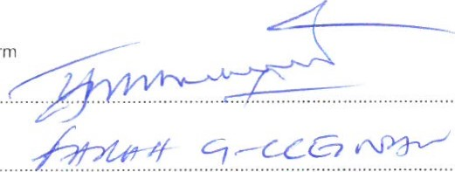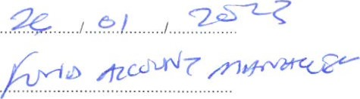Person completing form

SIGNATURE:DATE:

NAME:POSITION:

1 / 1

### FOURTH SCHEDULE (s. 30) PROJECT DESCRIPTION FORM

Constituency No 288

County Nairobi

Constituency KAMUKUNJI

Name

Project Number API

Project Title Oversight Committee expenses

Sector Oversight Committee expenses

Status of projects

Brief statement on project status at time of submission

|  |  |  |
| --- | --- | --- |
| Financial year |  | to |
| Original Cost  Estimates, in Ksh  Amount allocated |  | dated |

2022-07-01 2023-07-31

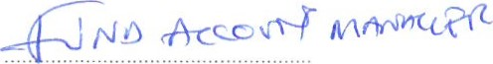dated

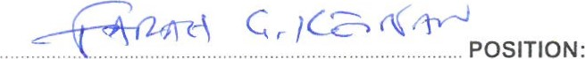last financial year Sub projects

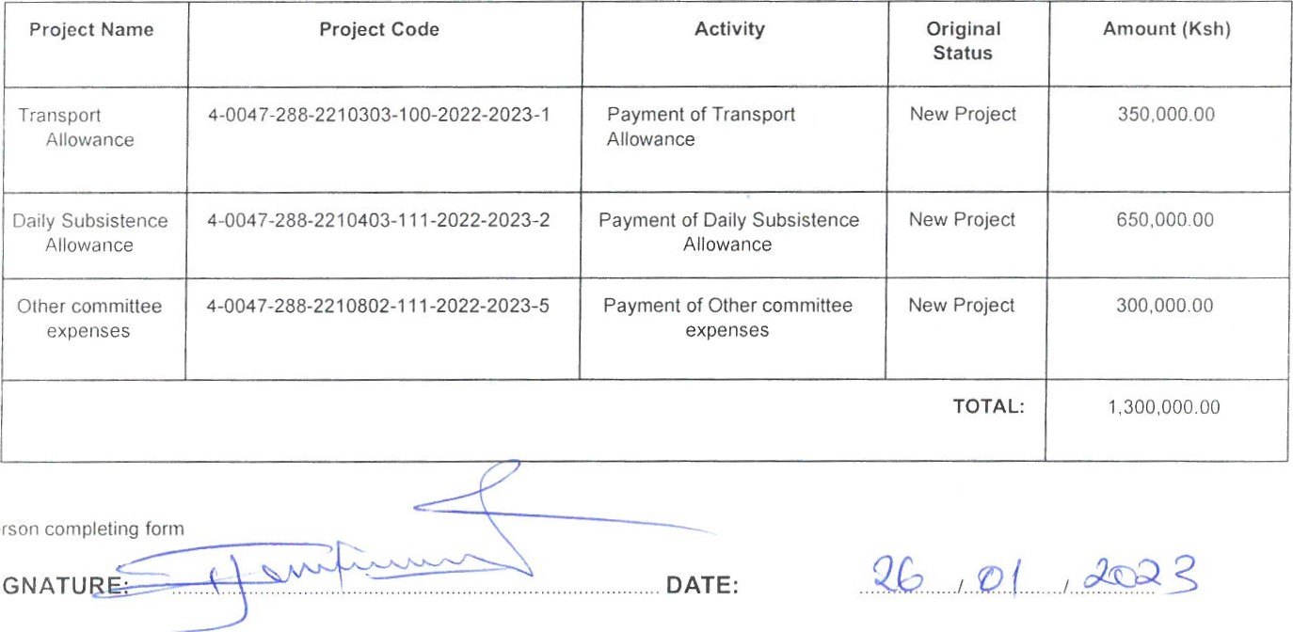

Person

SIGNATU

NAME: