TO ASSESS THE CONTRIBUTION OF STAKEHOLDERS ON PERFORMANCE OF CONSTITUENCIES DEVELOPMENT FUND PROJECTS IN KENYA.
A CASE OF GARSEN CONSTITUENCY

ABDULHAKIM ALI MOHAMED

A RESEARCH PROJECT SUBMITTED IN PARTIAL FULFILLMENT FOR THE AWARD OF THE DEGREE OF MASTER OF BUSINESS ADMINISTRATION OF
MOUNT KENYA UNIVERSITY

OCTOBER, 2014

DECLARATION

This Research project is my original work and has not been presented for a degree in any other University.

Name: Abdulhakim Ali Mohamed
MBA/MSA/11/0021

Signature:………………………………….. Date: …………………………..

This research project has been submitted for examination with our approval as the University Supervisors.

Name: FLORENCE KATHAMBI

MT. Kenya University

Signature: …………………………….. Date: ………………………….

Name: DR. EMMA ANYIKA
Lecturer –

Signed ………………………………….… Date………………………….

DEDICATION
This research project is dedicate to my family and friends for the cheerful support.

Allah bless them all.

ACKNOWLEDGEMENTS
I would like to first give thanks to the Almighty God who has seen me through this project. I also acknowledge and recognize the support of all those who availed their opinion and advice during the period of writing my proposal. Special thanks to my supervisor Ms. Florence Kathambi, who tirelessly guided me from the beginning to the end, May the Almighty God bless you abundantly.

ACRONYMS AND ABBREVIATIONS
BF Bursary Fund
CDF Constituencies development fund
CDFC Constituency Development Fund Committee
CFC Constituency Fund Committee
DAO District Agricultural Officer
DDO District Development Officer
DEO District Education Officer
HIV/AIDs Human Immunodeficiency Virus/ Acquired Immune Deficiency Syndrome
KIPPRA Kenya Institute of Public Policy Research and Analysis
LA’s Local Authorities
LASDAP Local Authorities Service Delivery Action Plan
LATF Local Authorities Transfer Fund
NARC National Rainbow Coalition
NGO Non Governmental Organization
PAYE Pay As You Earn
PEF Poverty Eradication Fund
PIP Project Implementation Plan
PIR Project implementation review
PMC’s Project Management Committees
SPSS Statistical Package for Social Scientists
VAT Value Added tax

TABLE OF CONTENT
CONTENT PAGE
DECLARATION ii
DEDICATION iii
ACKNOWLEDGEMENTS iv
ACRONYMS AND ABBREVIATIONS v
TABLE OF CONTENT vi
LIST OF TABLES x
LIST OF FIGURES xi
DEFINITION OF TERMS xii
ABSTRACT xiv
CHAPTER ONE 1
INTRODUCTION 1
1.0 Introduction 1
1.1 Background of the Study 1
1.1.1 Project Performance 3
1.1.2 Constituency Development Fund 4
1.1.3 Garsen Constituency 7
1.2 Statement of the Problem 8
1.3 Purpose of the Study 9
1.4 Objectives of the Study 9
1.5 Research Questions 10
1.6 Significance of the Study 10
1.7 Scope of the Study 11
1.8 Limitations of the Study 12
1.9 Assumptions 13
CHAPTER TWO 14
2.0 LITERATURE REVIEW 14
2.1 Introduction 14
2.1.1 Stakeholder Theory 14
2.2 General Project Management Overview 15
2.3 CDF Project Life Cycle 16
2.3.1 Stakeholders in CDF Operations 19
2.4 Stakeholders Involvement and Performance of CDF Projects 24
2.4.1 Stakeholders contribution in Projects Identification 25
2.4.2 Stakeholders contribution in Project Planning 26
2.4.3 Stakeholders’ contribution in Project Implementation 29
2.4.4 Stakeholders’ contribution in Project Monitoring &Evaluation 32
2.5 Conceptual Framework 35
2.6 Empirical Review ………………………………………..……………………………….36
2.7 Research Gaps 37
CHAPTER THREE 38
RESEARCH METHODOLOGY 38
3.1 Introduction 38
3.2 Research Design 38
3.3 Target population 38
3.4 Sampling Design 39
3.5 Data Collection Techniques 40
3.6 Reliability and Validity 41
3.6.1 Reliability of Research Instruments 41
3.6.2 Validity of Research Instruments 41
3.7 Ethical consideration 42
3.8 Data Analysis and Presentation 42
3.9 Operational Definition of Variables 44
CHAPTER FOUR 46
RESEARCH FINDINGS 46
4.1 Introduction 46
4.1.1 Response Rate and the Rate of Return 46
4.2 Demographic Characteristics of Respondents 46
4.2.1 Age of the respondents 47
4.2.2 Gender of the respondents 47
4.2.3 Highest academic qualification of the respondents 48
4.2.4 Organizations funding projects in the constituency 48
4.2.5 Awareness of CDF projects 49
4.2.6 Project the respondents were involved in 50
4.3 Performance of CDF projects 50
4.3.1 Project identification 50
4.3.2 Project planning 54
4.3.3 Project implementation 57
4.3.4 Project monitoring and evaluation 59
4.4 Factors influencing performance of CDF projects 61
4.4.1 Project Initiation 61
4.4.1.1. Effect of project initiation 62
4.4.2 Project Planning 62
4.4.2.1. Effect of project planning 62
4.4.3 Project Implementation 63
4.4.3.1. Effect of Project Implementation 63
4.4.4 Monitoring and Evaluation 64
4.4.4.1. Effect of Project Monitoring & Evaluation 65
4.4.5 CDFC, PMC and Government Officials Role 66
4.4.5.1. CDFC, PMC and Government Officials Role in Project Initiation 66
4.4.5.2 CDFC, PMC and Government Officials Role in Project Planning 66
4.4.5.3 CDFC, PMC and Government Officials Role in Project Implementation 67
4.4.5.4 CDFC, PMC and Government Officials Role in Monitoring and Evaluation 68
4.5 Regression Analysis 69
CHAPTER FIVE 72
SUMMARY OF FINDINGS, DISCUSSIONS, CONCLUSIONS AND RECOMMENDATIONS 72
5.1 Introduction 72
5.2 Summary 72
5.3 Conclusion 74
5.4 Recommendations 75
5.5 Recommendation for Further Studies 75
REFERENCES 76
APPENDICES 81
Appendix I: Introductory letter to the questionnaire 81
Appendix II: Questionnaire For Projects Representatives And CDF Committee Members 82
Appendix III: Interview Guide For Departmental Heads/Government Officers 90

LIST OF TABLES
Table 3. 1: Target Population 39
Table 3. 2: Sampling Frame 40
Table 3. 3: Operationalization Of Variables 44
Table 4. 1: Response Rate and the Rate of Return ……………………………………………46
Table 4. 2: Age of respondents 47
Table 4. 3: Organizations funding projects 49
Table 4. 4: Project the respondents were involved in 50
Table 4. 5: Criteria Used to Identify Project 51
Table 4. 6: Effectiveness of Projects Identification Criteria 52
Table 4. 7: Selection of CDFC Members 54
Table 4. 8: Factors that influence the completion of the projects 54
Table 4. 9: Phases that government technicians were involved 56
Table 4. 10: Approximate money spent in undertaking the CDF project the respondents were involved in 57
Table 4. 11: Effectiveness of Projects Implementation Criteria Used in the Constituency 58
Table 4. 12: Extent that performance evaluation dimensions was used to assess the performance of the CDF projects 59
Table 4. 13: Usefulness of CDF projects Completed 60
Table 4. 14: Initiation 62
Table 4. 15: Planning 63
Table 4. 16: Implementation 64
Table 4. 17: Monitoring &Evaluation 65
Table 4. 18: CDFC, PMC AND GOVERNMENT OFFICIALS ROLE IN PROJECT INITIATION 66
Table 4. 19: CDFC, PMC AND GOVERNMENT OFFICIALS ROLE IN PROJECT PLANNING 67
Table 4. 20: CDFC, PMC AND GOVERNMENT OFFICIALS ROLE IN PROJECT IMPLEMENTATION 67
Table 4. 21: CDFC, PMC AND GOVERNMENT OFFICIALS ROLE IN MONITORING AND EVALUATION 68
Table 4. 22: Model Summary 69
Table 4. 23: ANOVA 69
Table 4. 24: Model Summary: Coefficient of determination 70

LIST OF FIGURES
Figure 2. 1: CDF Project cycle 18
Figure 2. 2: Project life cycle 19
Figure 2. 3: Institutions manning CDF 22
Figure 2.4: Conceptual framework 35

Figure 4.1: Gender of respondents ………………………………………………………..….48
Figure 4. 2: Highest academic qualification of the respondents 48
Figure 4. 3: If the respondents were aware of CDF projects 50
Figure 4. 4: If respondents were directly involved in making decisions on which projects were to be funded by CDF 52
Figure 4. 5: Kind of Projects the Committee Recommend for Funding 53
Figure 4. 6: If government technicians were involved in CDF projects at all levels 55
Figure 4. 7: If the respondents were involved in planning 57
Figure 4. 8: Whether Funds Disbursed were Sufficient 58
Figure 4. 9: Extent that the projects were completed 59
Figure 4. 10: Rating of Quality of the CDF Projects 61

DEFINITION OF TERMS
Critical success factors: These are those fundamental issues inherent in the project, which must be maintained in order for team working to take place in an efficient and effective manner. They require day-to-day attention and operate throughout the life of the project.

Monitoring: Supervising activities in progress to ensure they are on-course and on-schedule in meeting the objectives and performance targets

Evaluation: Evaluation is the process of examining a project and rating is based on its important features. It is the systematic assessment of the worth or merit of the project

Performance: The accomplishment of a given task measured against preset known standards of accuracy, completeness, cost, and speed. In a contract, performance is deemed to be the fulfillment of an obligation, in a manner that releases the performer from all liabilities under the contract

Project It is a temporary endeavour undertaken by people who work cooperatively together to create a unique product or service within an established period of time and within and established budget to produce identifiable deliverables.

Project implementation: Project implementation involves mobilization, utilization and control of resources and project operation

Project team: This is usually a function of an aggressive team or a task force consisting of members draw from various functional specialist departments of the client led by a mature multidisciplinary generalist

Fund: Sum of money set aside and earmarked for a specified purpose.

Politics: The art or science of government or governing, especially the governing of a political entity, such as a nation and the administration and control of its internal and external affairs.
Stakeholder: Stakeholders are individuals, groups or organizations who, directly or indirectly, stand to gain or lose from a given development activity or policy. In this case, the stakeholders in the CDF projects are many but the study will focus on CDFC, PMC and government officials since they are the key stakeholders in the projects.

ABSTRACT
Stakeholder management is critical to the success of every project in every organization. As such, a project manager is required to develop sufficient understanding of such characteristics, which are in fact changing variables within the various stakeholders in a project environment. The Constituency Development Fund (CDF) was an initiative to combat poverty and promote equitable growth and development around the country leading to achievement of Vision 2030. It targets all constituency-level development projects, particularly aimed at combating poverty at the grassroots. To assess the contribution of various stakeholders in the performance of CDF funded projects and use the findings to come up with recommendations on how to improve the management of CDF funds to finance development projects. The objectives of the Study are; to determine the contribution of stakeholders’ in project planning on CDF project performance in Garsen Constituency; to investigate the influence of stakeholders’ in project implementation towards CDF project performance in Garsen Constituency and to assess the contribution of stakeholders’ in monitoring and evaluation to CDF project performance in Garsen Constituency. The study used a descriptive research design. The research was descriptive in nature. The target population for this study was 3 representatives from each of the one hundred and twenty CDF projects (120) in Garsen Constituency comprising 360 possible respondents. In addition there was ten (10) CDF committee members and four (4) government representatives (departmental Heads). Stratified proportionate random sampling technique was used to select the sample from the project representatives. Each sector was considered as strata therefore simple random sample will use to pick actual sample from each strata. Hence, this study sampled 30% of the Garsen constituency CDF projects to determine number of projects sample for the study coming up with a sample size of 159 respondents from the projects. The data to be collected was both qualitative and quantitative. The research was conducted through interviews and use of questionnaires. Data was analyzed by use of measures of central tendency. Data was analyzed and presented by use of frequency tables and percentages. Quantitative data was analyzed using descriptive statistics such as mean scores, frequencies and percentages. Statistical package for social sciences (SPSS) was used to aid in analysis. Results of quantitative data analysis were presented in tables and charts. Qualitative data was analyzed using content analysis. It was established that time, quality and cost was used by the committees to assess the performance of the CDF projects to a very great extent. The study found that initiation of new projects is a collective responsibility that involves all stakeholders and initiation helps managers identify the precise problem areas that need improved. The study also found that identifying roles and responsibilities and that project team estimate work needed to effectively manage risk. This study concludes that project performance and CDFC, PMC and government officials’ role in projects identification show a positive coefficient 0.571, with p-value of 0.02. Further, the study concludes that there is a positive association between CDFC, PMC and government officials’ role in monitoring and evaluation and project performance where the correlation coefficient is 0.681, with a p-value of 0.017. The study therefore recommends that enough funds and skills should be allocated to projects. The study therefore recommends that the constituents’ should play a critical role in decision making because they are the beneficiaries of the projects and know well projects are beneficial to them The committee should encourage community participation, cooperation among committee members and auditing of complete project to access their worth.

CHAPTER ONE

INTRODUCTION

1.0 Introduction
In this chapter the researcher highlights the background information of the contribution of stakeholder’s on the performance of constituency development funds projects in Kenya in Garsen constituency. The background information leads to statement of the problem researcher objective, scope, assumption and limitation of the study are outlined.

1.1 Background of the Study
A project is a temporary endeavour undertaken by people who work cooperatively together to create a unique product or service within an established time frame and within and established budget to produce identifiable deliverables (Filicetti, 2009). Project success has been defined by the criteria of time, budget and deliverables, (Flaman & Gallagher, 2001). Antill (2004) reported that a project is only successful if it comes on schedule, on budget, it achieves the deliverables originally set for it and it is accepted and used by the clients for whom the project was intended.

Eliminating poverty, reducing inequity, and improving opportunity for people in low- and middle-income countries are the World Bank Group's central objectives. The Comprehensive Development Framework is an approach by which countries can achieve these objectives. It emphasizes the interdependence of all elements of development—social, structural, human, governance, environmental, economic, and financial. The CDF is the foundation for the new partnership between developed and developing countries to achieve improvements in sustainable growth and poverty reduction that will help countries achieve the MDGs (Harvey 2003).

Project success depends on time, budget and deliverables (Rao, 2001.) Definitions on project management are flooded with various scholarly contributions. One of the vital torrents is by association of project manager which defines project management as planning, organizing, monitoring and controlling of all involved to achieve project objective safely and within well defined time, cost and performance (Fleming, 2005).

The governance process is defined, stake holders identified and reporting frequency and channels agreed. The most common tools or methodologies used in the planning stage are project Plan and Milestones Reviews. The third stage is implementation stage which ensures projects’ activities are properly executed and controlled. The planned solution is implemented to solve the problem specified in the project's requirements. The most common tools or methodologies used in the implementation phase are an update of Risk Analysis and Score Cards, in addition to project Plan and Milestones Reviews. The final stage (commissioning), project manager ensures that the project is brought to its proper completion (Graham, 1997).

Stakeholder management is critical to the success of every project in every organization. Stakeholders are defined as any group or individual who can affect or is affected by the achievement of the organization's objectives, (Freeman 1984). In a project environment, these stakeholders are usually numerous, and can vary significantly in the degree of influence in both directions. Mitchell, Agle and Wood (1997) suggest that power, legitimacy and urgency are key stakeholder characteristics.
As such, a project manager is required to develop sufficient understanding of such characteristics, which are in fact changing variables within the various stakeholders in a project environment.
The number and nature of stakeholders will vary with the life of the project; it would therefore make sense to carry out the review of identification throughout the project (Moodley 2002).
Participation can take place in different places of the project cycle and at different levels of society, and take many different forms. These can range along a continuum from contribution of inputs to predetermined projects and programmes, to information sharing, consultation, decision-making, partnership and empowerment. Participation is both a means and an end. As a means, it is a process in which people and communities cooperate and collaborate in development projects and programmes. As an end, participation is a process that empowers people and communities through acquiring skills, knowledge and experience, leading to greater self-reliance and self-management.

1.1.1 Project Performance
Project performance can be measured and evaluated using a large number of performance indicators that could be related to various dimensions (groups) such as time, cost, quality, client satisfaction, client changes, business performance, health and safety (Cheung et al. 2004). Time, cost and quality are, however, the 3 predominant performance evaluation dimensions. Another interesting way of evaluating project performance is through 2 common sets of indicators (Pheng & Chuan 2006). The first set is related to the owner, users, stakeholders, and the general public; the groups of people, who will look at project performance from the macro viewpoint. The second set comprises the developer and the contractor; the groups of people who will look at project performance from the micro viewpoint.

The CDF social audit project entitled, “Towards Improved Accountability and Transparency in Constituency Development Fund through Social audit” sought to entrench a democratic culture in the management of Kenya’s Constituency Development Fund (CDF) so as to improve its efficacy. It sought to enhance community participation in the management of the fund and to build their capacity to play their watchdog role. This was premised upon the reality that there was insufficient community participation in CDF processes and that efforts to monitor CDF were haphazard and uncoordinated.

The Kenya Vision 2030 recommends that to contain costs, the education ministry can seek to collaborate more effectively with the different devolved funding mechanisms (SEBF, Constituencies Development Fund [CDF] and Local Authorities Transfer Fund [LATF]) to address this issue by working out a disbursement strategy that is informed by existing gender disparities in different regions, i.e., differences in enrolment, retention, performance, transition and available infrastructure.

1.1.2 Constituency Development Fund
The Constituency Development Fund (CDF) was established in 2003 through an Act of Parliament as contained in The Kenya Gazette Supplement No. 107 (Act No. 11) of 9th January 2004.The Act was amended through the CDF (Amendment) Act, 2007 in the Kenya Gazette Supplement No. 112 (Act No. 16) of 22nd October 2007. In January 2013, parliament enacted CDF act 2013, hence effectively repealing CDF act 2003 as amended in 2007.
The fund aims to control imbalances in regional development brought about by partisan and sectarian politics. In January 2013, parliament enacted CDF Act 2013, hence effectively repealing CDF Act 2003 as amended in 2007 in Kenya Gazette supplement no45{acts N0. 30} of January, 2013.{date of assent 14th January 2013}
The Constituency Development Fund (CDF) was an initiative to combat poverty and promote equitable growth and development around the country leading to achievement of Vision 2030. It targets all constituency-level development projects, particularly aimed at combating poverty at the grassroots.

The fund comprises an annual budgetary allocation equivalent to 2.5% of the government’s ordinary revenue. A motion seeking to increase this allocation to 7.5% of government’s revenue was recently passed in parliament. 75% of the fund is allocated equally amongst all the current 290 constituencies. The remaining 25% is allocated as per constituency poverty level. A maximum per centum of each constituency’s annual allocation may be used for other projects as follows: 5% emergency funds, 25% education bursaries, 2% monitoring and evaluation of projects, 3% recurrent expenses, 2% sports, 2% environment and 3% administration. The CDF core values include: Transparency, Accountability, Equity in resource distribution and Participatory approaches by all stakeholders. According to the CDF Act, expenses for running constituency project offices should not exceed 3% of annual constituency allocations.

Each constituency is required to keep aside 5% as an emergency reserve. All CDF project proposals are submitted by the chairman of the constituency development fund committee to the board after approval by the constituency development fund committee for that constituency. The board received and compile the list of proposed constituency projects who in turn forward them to the parliamentary committee for approval. The approved projects list is reviewed by the National CDF committee, which presents final recommendation to the Finance Minister (Kippra,
There are other funds channelled to grass root level development that include: The Local Authorities Transfer Fund (LATF), Bursary Fund (BF), Poverty Eradication Fund (PEF), Constituency HIV/AIDS Fund and Road Maintenance Levy Fund. All these funds are aimed at poverty alleviation, narrow regional imbalances in resource distribution; improve the quality life and the general level of economic development. CDF comes from ordinary government revenue that is generated by collecting Value Added Tax (VAT) on food items, clothes and, books, from statutory deductions such as Pay As You Earn (PAYE); withholding tax; from taxation on manufactured goods, export and import items through the customs and excise taxes, and among others. In this way, each and every Kenyan contributes towards CDF and it is, therefore, the
responsibility of every Kenyan to ensure that CDF are well managed.

Table 0.1: National CDF Allocation 2003-2014
Year | Total Annual CDF allocations
2003/4 | 1.26 billion
2004/5 | 5.6 billion
2005/6 | 7.245 billion
2006/7 | 10.038 billion
2007/8 | 10.1 billion
2008/9 | 10.1 billion
2009/10 | 12.329 billion
2010/11 | 14.283 billion
2011/12 | 17.515 billion
2012/13 | 21.763 billion
2013/14 | 23 billion
Source: www.cdf.co.ke

1.1.3 Garsen Constituency
Garsen is a town in the coast Province, Kenya, in the Tana River county boundering lamu, Magarini and voi district. Garsen constituency geographically lies between attitude 30.4 and 30 east of the prime meridian. Longitudinally, its placement is between 4 and 30 south of equator. The predominant population of Garsen is the Oroma-speaking orama and warde and other Cushitic communities and pokomo-speaking pokomos who are historical farmers and cattle keepers respectively. Extensive farming is carried out along the river while cattle keeping are major economic activities.
The implementation of the fund is marked by uncoordinated and haphazard initiation of local projects without regard for constituency development projections. Indeed, very few constituencies have developed strategic plans and Garsen has a Strategic Plan. The synchronization of activities being undertaken by various funds is not done and hence the problem of duplication is pronounced.

Table 0.2: CDF Disbursement to Garsen Constituency
Year | Total Annual CDF allocations
2003/4 | 6,000,000.00
2004/5 | 22,480,418.00
2005/6 | 31,133,333.00
2006/7 | 43,129,393.00
2007/8 | 43,395,783.00
2008/9 | 43,395,783.00
2009/10 | 52,974,220.00
2010/11 | 66,647,471.00
2011/12 | 80,775,421.00
2012/13 | 100,366,285.00
TOTAL | 490,298,107.00
Source: www.cdf.co.ke

1.2 Statement of the Problem
Since its introduction CDF has made a great impact, with numerous CDF projects coming up in the country. However, it is evident that CDF money is not managed in a transparent manner and that communities are not sufficiently involved in its management leading to loss of funds, numerous incomplete, low quality and irrelevant project across the constituencies in the country (CEDGG, 2011). Some constituencies have performed well, while some poorly.
Studies conducted on the effectiveness of CDF have shown that various forms of corruption were found to be reducing its efficiency and effectiveness. The CDF Project cycle consists of several stages: Identification, planning, implementation and monitoring. It’s worth noting that equal representation irrespective of political, gender, tribal, racial affiliations among others is vital for successful implementation of CDF projects.
For the last five years, Garsen constituency projects being funded by the CDF have experienced challenges such as constituent complaining that there is lack of consultation or they have not been involved in identification of the projects and in decision making. Water and education projects are taking too long to be completed while other projects such as irrigation schemes have stalled due to lack of funds. It is due to this reason the researcher seeks to identify the role of CDFC, PMC and Government Officials on the performance of CDF projects in Garsen constituency.

1.3 Purpose of the Study
To assess the contribution of various stakeholders in the performance of CDF funded projects and use the findings to come up with recommendations on how to improve the management of CDF funds to finance development projects.

1.4 Objectives of the Study
- To investigate the influence of stakeholders’ contribution in project identification on CDF project performance.
- To determine the contribution of stakeholders’ in project planning on CDF project performance.
- To investigate the influence of stakeholders’ contribution in project implementation on CDF project performance.
- To assess the contribution of stakeholders’ in monitoring and evaluation on CDF project performance.

1.5 Research Questions
The study sought to answer the following research questions:
- What is the contribution of stakeholders in project identification on CDF project performance?
- What is the contribution of stakeholders in project planning on CDF project performance?
- What is the influence of stakeholders’ contribution in project implementation towards CDF project performance?
- To what extent does stakeholders’ contribution in monitoring and evaluation affect CDF project performance?

1.6 Significance of the Study
The findings of the study would be of significance to the following:-
CDF board: the study would be invaluable to the national CDF board in that it would provide an insight on how various stakeholders’ involvement can affect the performance of the fund and also provide them with recommendations on the way forward.

CDFC Garsen: The information collected through this project would enhance capacity and response by some PMCs leading to improvement in their performance. The consequent awareness and information among the PMCs would lead to positive engagements and follow up with CDFCs for resources as well as improvement in management.
This would be manifested by their enhanced capacity to timely account for allocated funds and present subsequent work plans for further funding.

Government:-The government channels the funds through the Treasury with a purpose of empowering the lives of its citizens. The study would provide documentary evidence to enable the government to put in place strategies that facilitate effective performance of CDF projects hence amendment of CDF Act to more efficiently and effectively alleviate poverty ensure that the taxpayers’ funds are well utilized.

Garsen constituents: - The investigation of the contribution of stakeholders in CDF projects within the constituency would enhance performance of CDF projects within the county. They are the most important parties in that they are the tax payers and as such their sacrifices should be converted into sustainable development projects in the areas in which they inhabit.

Change agents: this project would provide an insight on the area that need to be addressed to make a break from the past trend when several projects were initiated and awarded funds but took many years before completion.

Researchers:-They would gain theoretical and practical experience on role of stakeholders’ on performance of CDF projects hence enable the researcher to make recommendations on enhanced performance of CDF projects and also to indicate various areas in CDF that needs to be addressed and studied further by future researchers.

1.7 Scope of the Study
The research study was within Garsen Constituency. The purpose of the study was to investigate contribution of stakeholders in performance of CDF projects. The stakeholders were many but for the purpose of this study, the study was limited to the role of CDFC, PMC and government officials in the CDF project performance. The CDF Projects so far carried out in the constituency includes: Bursary Fund Awards projects; Education Projects; Health Projects, Roads projects, irrigation, Security and Water Projects for the study. The respondents included CDFC/PMC members and government departmental heads.

1.8 Limitations of the Study
Information disclosed was not completed due to conflict of interest. Some PMCs was hostile to the data collection process which they viewed as a witch hunt exercise. This was mainly caused by a misunderstanding of the whole process. Some PMCs therefore chose not to cooperate with the data collectors especially where they might be serious doubts in their management standards. To counter this, the researcher presented to the respondents an introduction letter from the university and assured them that the data would only be used for academic purposes.
There are other two areas of limitations namely time and finance. Given that this is a research project, there was timeframe meaning the beginning and the end of the project is defined hence might be insufficient to comprehensively study the factors to minute details required. To deal with this, the researcher concentrated only on Garsen constituency. Garsen being the large constituencies in terms of geographical coverage, substantial amount of finance might be required to conduct the study. The researcher dropped the questionears and collected them latter; this helped to save on time. The floods and tribal clashes also made data collection hard. The researcher collected the data during dry season to be able to deal with floods.

1.9 Assumptions
The researcher assumed that sampling was not biased and the chosen sample population participated voluntarily. This was possible due to positive perspective of the project by the CDF staff. There was also an assumption that there would be availability of current information/ current data.

The researcher assumed that the respondents understood questions in interview and they were willing to answer the research question intended to accomplish the purposes of the study. All factors facilitating the accomplishment of the study did not change and hence the researcher finished the study within stipulated time frame.
The researcher assumed that the CDFC, PMC and Government Officials are the key stakeholders in the success of the implementation of CDF funded projects.

CHAPTER TWO

2.0 LITERATURE REVIEW

2.1 Introduction
This chapter critically analyzed literature of stakeholders’ involvement on performance of CDF projects while focusing on theoretical review, summary of the literature review and main gaps to be filled. Literature regarding stakeholders involvement in project identification, project planning, project implementation and project monitoring and evaluation will be the main focus for this chapter.

2.1.1 Stakeholder Theory
The study was based on the stakeholder theory. The stakeholder theory is a theory of organizational management and business ethics that addresses morals and values in managing an organization. It identifies and models the groups which are stakeholders of a project, and both describes and recommends methods by which management can give due regard to the interests of those groups. In short, it attempts to address the "Principle of Who or What Really Counts (Freeman, 1984). The stakeholder view of strategy is an instrumental theory of the CDF projects, integrating both the resource-based view as well as the market-based view, and adding a socio-political level. This view of the firm is used to define the specific stakeholders of a CDF project of stakeholder identification as well as examine the conditions under which these parties should be treated as stakeholders.

The importance of stakeholders from a strategy development and service planning perspective is well acknowledged (Ackermann and Eden, 2001). Still, the role of stakeholders and performance measurement has been little discussed. The issue of who is seen as the end user of the performance measurement information generated has received little attention and yet, particularly in the public sector especially in CDF projects, is of critical importance.

Applying a stakeholder conception of projects as opposed to the more traditional input-output perspective implies adhering to a belief where all actors are involved with CDF projects in order to obtain benefits. This differs from the input-output model that illustrates how certain actors contribute input which the black box of an organization converts to benefits for its customers (Donaldson and Preston, 1995).

Stakeholder theory is primarily a management instrument. The attributes power, urgency and legitimacy of claims define CDF projects stakeholders. Power and urgency must be attended to if managers are to serve the legal and moral interests of legitimate stakeholders. Stakeholder theory thus contains methods for identifying and managing stakeholders. In addition, a substantial amount of work has been done on identifying the relative influence of different stakeholders (Yee-Chin, 2004).

2.2 General Project Management Overview
According to Gary (2007), project management is vital in realization of any project. Experienced companies use project management routinely, however many of these companies do not achieve success in meeting project purposes (John, 2004). Project management is a discipline for planning, leading, organizing, and controlling a well-defined collection of work (Harvey, 2003).

According to Harvey, the discipline of project management must be repeated and explainable. It is not an art form invented by each practitioner, nor is it a science with explicit formulas and rules. Despite these restrictions, organizational approach to project management must be consistent so that knowledge and experience may be shared across project boundaries (Charles, 2009).

A typical project management life cycle consists of initiation, planning, executing, and completing phases (Maylor, 1999). In the typical project management life cycle, the phases of initiating and planning may include similar activities conducted in prediction phase in disaster related public project management. Similar to activities conducted in executing phase in the project management, warning, emergency relief, and rehabilitation (short-term) activities as well as reconstruction (long-term) activities are carried out in the disaster related public project management. Therefore, a private-public project management includes project life cycle phases of prediction, which includes the initiation and planning which are required for the predication phase. After onset of occurrence, executing involves warning, emergency relief, rehabilitation, and reconstruction. Completion tasks are done when completing and transferring reconstruction outputs to stakeholders or clients (Rosario, 2000).

2.3 CDF Project Life Cycle
The project typically has a life cycle; the Project Life Cycle refers to a logical sequence of activities to accomplish the project’s goals or objectives. Project goes through a series of stages during its life. Since projects are unique undertakings and involve a degree of uncertainty, organizations performing projects usually divide each project into several project phases in order to provide better management control and appropriate links to the on-going operations of the performing organization. The idea of development projects as the time-bound creation of physical assets led to the recognition of phases within the project process and from there to the concept of the project cycle (Cusworth and Franks, 1993). Each project cycle is marked by completion of one or more deliverables. Duncan (2006) defines deliverables as a tangible, verifiable work product such as feasibility study, a detailed design or a working prototype. Phases are said to be part of a generally sequential logic designed to ensure proper definitions of the product/service from the project (Morsman, 1993).

At the same time, a conclusion of a project phase is marked by a review of both key deliverables and project performance in orders to determine if the project should continue into the next phase and to detect and correct errors cost effectively.

The project life cycle serves to define the beginning and the end of a project. The project cycle definition also determines which transitional actions at the end of the project are included and which are not. Therefore a project life cycle can be used to link the project to the on-going operations of the performing organization.
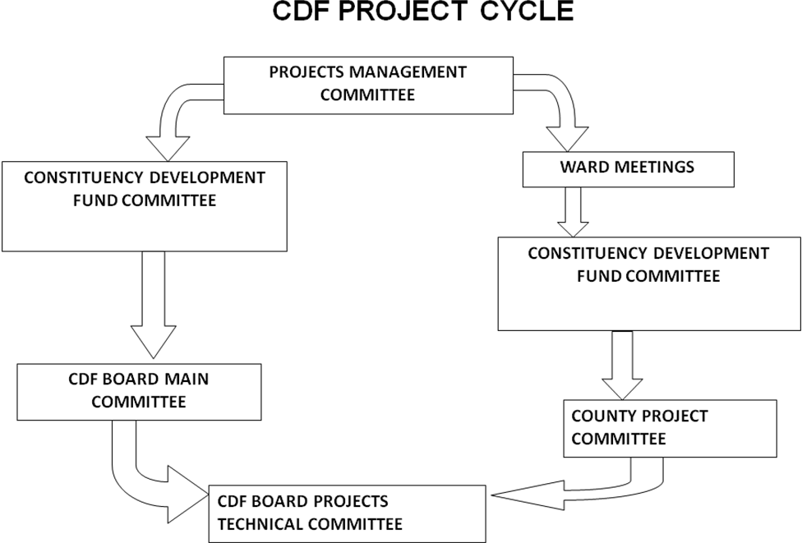

(Source: cdf resource)
Figure 2. 1: CDF Project cycle

Project life cycle
Initiation

Monitoring& Evaluation Planning

Implementation

(Source: Cusworth and Franks, 1993)

Figure 2. 2: Project life cycle

2.3.1 Stakeholders in CDF Operations
Stakeholders are individuals, groups or organizations who, directly or indirectly, stand to gain or lose from a given development activity or policy. The Constituency development fund (CDF), which was established in Kenya through the constituency fund Act of 2003 (The Kenya Gazette supplement no. 107 (Act no. 11) of 9th January, 2004, is one of igneous innovations of the National Rainbow Coalition (NARC) Government of Kenya. While there are several rules that govern the utilization of the fund (CDF Act, 2003) to ensure transparency and accountability, decisions over the utilization of the funds are primarily by the constituencies. Unlike other funds from the Central Government (KIPPRA, 2006) through large and more layers administrative organs and bureaucracies, the funds under these programmes go directly to local levels. In essence the CDF provides individuals at the grassroots the opportunity to make expenditure decisions that maximize their welfare in line with their needs and preferences to the extent that the local population is better informed about their priorities.
The choices made can be expected to be aligned to their problems and circumstances, thus the CDF can be considered a decentralized scheme that provides communities with the opportunities to make spending decisions that maximize social welfare.

The CDF is not used in support of political bodies/activities or personal award projects. A sitting MP is not a signatory to the CDF bank account but convenes the constituency CDF committees in respective constituency in CDF ACT 2003 but CDF ACT 2013 within forty-five days of being sworn in, each Member of Parliament for a particular constituency shall convene open public meetings of registered voters in each of the elective wards in the constituency; each ward shall then elect five persons whose names shall be forwarded to the officer of the Board in the constituency; upon receiving the names from all the wards in the constituency, the Member of Parliament in consultation with the officer of the Board and the sub county administrator for the constituency, shall appoint eight persons to the Board, taking into account the geographical diversity within the constituency, communal, religious, social and cultural interests in the constituency and the requirements of gender, youth and representation of persons with disabilities; the eight persons appointed shall elect from among themselves one person to be the, chairperson of the Constituencies Development Fund Committee for the constituency; (CDF Act, 2013). The penalty for misappropriation of the fund (CDF) is a prison term of five years or Kenya shillings two hundred thousand ( Kshs. 200,000) fine or both.
Although the CDF takes relatively small amount of national resources (2.5% of the Government’s ordinary revenue collected every year), its impact can be significant if the funds are efficiently utilized, because the funds benefit the communities directly, it stimulates local involvement in development projects and as a result constituents are expected to have more information about the projects funded under this programme.

Key project stakeholders on CDF project include; Government, project manager, constituents, contractors, PMC, CDFC, NGOs, CDF board, government departmental heads from the relevant departments. The constituents should play a critical role in decision making because they are the beneficiaries of the projects and know well projects are beneficial to them (Flaman and Gallagher, 2001). Those projects should be projects that are beneficial to them hence community based. Thus the constituents should be involved at all stages of the project from initiation through planning, implementation and monitoring and evaluation be done at every of this stages.

Feedback should be on the use of the project. The Constituencies Development Fund Act, 2003 and Constituencies Development Fund (Amendment) Act, 2007 and CDF ACT 2013 an act of parliament repeal and replace CDF ACT 2007 have created several official bodies to carry out specific functions to ensure the smooth running of the CDF, as shown in figure 2.2 below
Chart 1: Institutions created under CDF Act 2003 and CDF Revised Act 2007 and CDF ACT 2013 an act of parliament repeal and replace CDF ACT 2007

The National assembly select committee (NASC) The CDF parliamentary committee oversees implementation of CDF

The Constituency Development Fund Committee (CDFC) elected in every wards to manage CDF in the Constituency
Project Management Committee (PMC) Committee comprising members of the public who manage and oversee an individual CDF project
The county Projects Committee (CPC) Coordinate the implementation of projects
financed through the Fund.
The Board of Management of CDF Responsible for national Coordination of CDF

State of defence to oversee CDF

Figure 2.3: Institutions manning CDF
Governmental Bodies Dealing with CDF
The CDF law states clearly that the district government has an important role to play in the implementation of CDF projects. According to the Act, the departmental head of the relevant ministry should oversee CDF projects under his/her docket and maintain records of disbursements and progress of projects.

Under the CDF ACT 2003 and amendment Act 2007 the District Development Officer (DDO) is the development officer under the Ministry of Planning and National Development. The DDO was the one who issues the Authority to Incur Expenditure (AIE).But under new CDF Act 2013 the fund account manager (FAM) who is the officer of the board issue the Authority to Incur Expenditure (AIE).

The District Accountant is a mandatory signatory on all CDF cheques. The District Accountant must maintain separate CDF books of accounts in accordance with government audit regulations. The District Accountant must also ensure compliance with procurement guidelines. He/she must also ensure that all projects have a Project Committee and that they have the capacity to handle procurement and maintain proper records.

The duplication of roles of the Member of Parliament (MP) in CDF has become one of the most controversial aspect of the fund. The role of the MP, and the composition and lack of clarity on the roles and powers of the CDF institutions raise fundamental challenges in the implementation of the Fund.

2.4 Stakeholders Involvement and Performance of CDF Projects
The CDF Project cycle consisted of several stages: Identification, planning, implementation and monitoring. It’s worth noting that equal representation irrespective of political, gender, tribal, racial affiliations among others is vital for successful implementation of CDF projects.
There is need for gender balance at every stage a project undergoes to ensure the concerns and experiences of women as well as of men are addressed in the design, implementation, monitoring and evaluation of policies and programmes, so that women and men benefit equally, and inequality is not perpetuated.

In Kenya, Kinyoda (2009) did a study on the level of participation in project identification and selection by constituents a case of Makadara CDF. The study recommended that the government & civil society should facilitate public awareness campaigns. Further there should also be guidelines in how public participation should take place. Mochiemo (2007) did a study on the contribution of the community in successful completion of CDF projects in Kitutu Chache constituency Kisii central District and found that the government NGO’s, CDF and any other body which would like to start a project in a community should involve and encourage contributions of the community form the initial identification of a project to end and ensure successful completion and sustainability. Further, Kairu (2010) did an analysis of the factors that influence successful management of the CDF. The case of Gatanga constituency and recommended that there should be adequate transportation at the constituency level for effective M & E of the projects. There is need for strict enforcement of the provisions of CDF act in CDC formation to reduce problems in implementation of the CDF projects.

2.4.1 Stakeholders contribution in Projects Identification
The CDF Act provides that the Chairperson of the CDFC in consultation with the elected Member of Parliament for every constituency, the sub-county administrator for the constituency, and the ward administrator for every ward shall, within the first year of a new parliament and at least once every two years thereafter, convene open forum public meetings at every ward in the constituency to deliberate on development matters in the ward and the constituency. Each ward shall come up with a list of priority projects to be submitted to the Constituency Development Fund Committee which shall deliberate on project proposals from all the wards in the constituency. Projects shall be community based in order to ensure that the prospective benefits are available to a widespread cross-section of the inhabitants of a particular area. Any funding shall be for a complete project or a defined phase, unit or element of a project and may include the acquisition of land and buildings. PMC’s initiate a request for funding based on a felt need.
The PMC can be of several types; an existing institution committee, a registered development group. Or can be formed solely for the purpose of the project. Relevant government departmental heads e.g. D.E.O, D.A.O, District Water Engineer are also involved in project identification in their areas.

The most common tools or methodologies used in the initiation stage are Project Charter, project plan, project framework, project Justification, and project milestones reviews (Lewis, 2000). Project Preparation includes resource planning, various inputs/clearances, resettlement and infrastructure development. It is necessary to develop mechanisms for the selection of projects that ensure fairness and avoid conflicts of interest.

The initiation processes determine the nature and scope of the project. If this stage is not performed well, it is unlikely that the project will be successful in meeting the community needs (Nijkamp et al., 2002). The key project controls needed here are an understanding of the project environment and making sure that all necessary controls are incorporated into the project. According to Albert (2004) any deficiencies should be reported and a recommendation should be made to fix them. The initiation stage should include a plan that encompasses the following areas: Analyzing the needs/requirements in measurable goals, Reviewing of the current operations, Financial analysis of the costs and benefits including a budget , Stakeholder analysis, including users, and support personnel for the project, Project charter including costs, tasks, deliverables, and schedule.
This study will enlighten the stakeholders and encourage them to help to define the project concept and project design/research strategy, including identifying useful outcomes; identify other stakeholders and possible roles; help define the best governance approach for stakeholder engagement; identify possible scope of their own contributions, including motivation, and associated limitations; highlight possible risks and potential for conflicts to arise; and advise on knowledge exchange requirements.

2.4.2 Stakeholders contribution in Project Planning
After the initiation stage, the project is planned to an appropriate level of detail. The main purpose is to plan time, cost and resources adequately to estimate the work needed and to effectively manage risk during project execution. As with the Initiation process group, a failure to adequately plan greatly reduces the project's chances of successfully accomplishing its goals (Nijkamp et al., 2002). It define the mature the project scope, develop the project scope, develop the project management plan, and identify and schedule the project activities that occur within the project.
Rao (2001) defines planning as a common thread that intertwines all the activities from conception to commissioning and handing over the clockwork to client. This shows that planning encompasses the essential activities such as scheduling, break down structures, time estimates and statement of work. Harold (2003) argues that project management is planning, directing and controlling of company resources for a relatively short – term project which has been established for the completion of specific goal.

Project planning generally consists of: determining how to plan, developing the scope statement; selecting the planning team; identifying deliverables and creating the work breakdown structure; identifying the activities needed to complete those deliverables and networking the activities in their logical sequence; estimating the resource requirements for the activities; estimating time and cost for activities; developing the schedule; developing the budget; risk planning; gaining formal approval to begin work (Rosario, 2000).

In Additional processes, such as planning for communications and for scope management, identifying roles and responsibilities, determining what to purchase for the project and holding a kick-off meeting are also generally advisable.

The most common tools or methodologies used in the planning stage are project Plan and Milestones Reviews. The C.D.F.C, P.M.C and government official are involved fully in the planning stage. At this level, the PMC prepare the project budget, work plan and open a bank account for the project funds to be channelled through. The District Works Officer who is a Government official assists in preparation of bill of quantity for the project. The other relevant departmental heads e.g. D.E.O, D.A.O and District Water Engineer will approve the budget and work plan for the projects in their relevant fields.

The objectives of planning include analyzing, anticipating, scheduling, coordinating and controlling and information management. According to Rao (2001) the benefits of systematic planning as being breaking down complex activities into manageable chunks, determining logical sequences of activities, providing a logical basis for making decisions, showing effects on other systems, providing framework for the assessment of programmes, allowing lessons to be learned from practice and facilitating communication of ideas in a logical form to its use.

In CDF projects, CDFC implement participatory and accountable planning framework similar to the LATF/LASDAP. The CDFC also adopt a clear calendar of public meetings. For example twice annual constituency meetings, quarterly location/ward meetings. These meetings would then be the basis for planning, status updates and monitoring the progress of CDF at constituency and ward level.

The CDFC should undertake participatory strategic planning and establish close collaboration with civil society/public. A well prepared strategic plan and close collaboration between council and resident groups resulted in increased council revenues of 100%. This includes weekly income and revenue meetings, liaison office, improvement of accounting and reporting process. Strategic planning should identify comparative advantages and resource potentials of the constituency.
This study will help stakeholders to establish agreements on access to study sites; provision of resources – for example, equipment, funding, staff time; defining project plans, including stakeholder engagement planning; co-design and development of conflict resolution approaches, if relevant; and networking and awareness raising with non-contributory stakeholders.

2.4.3 Stakeholders’ contribution in Project Implementation
Implementation stage is where all the planned activities are put into action. Before the implementation stage of a project, the implementers, spearheaded by the project committee or executive, should identify their strength and weaknesses, which are internal forces, as well as opportunities and threats, which are the external forces (Wee, 2000). The strength and opportunities are positive forces that should be exploited to implement a project efficiently. The weaknesses and threats are hindrances that can hamper project management and implementation. Monitoring is important at this stage to ensure that the project is implemented as per schedule (Rosario, 2000). This continuous process should be put in place before project starts. As such, the monitoring activities should appear on the work plan and should involve all stakeholders. If activities are not going well, arrangements should be made to identify the problem so that they can be corrected.

This is the stage at which the institutions are established and facilities constructed. It is the stage which involves the disbursement of the largest portion of the project funds. For example, the procurement of materials and equipment for constructing a water project and the actual construction works. This phase ensures projects’ activities are properly executed and controlled (Rosario, 2000).

The planned solution is implemented to solve the problem specified in the project's requirements. The most common tools or methodologies used in the implementation phase are an update of Risk Analysis and Score Cards, in addition to project Plan and Milestones Reviews. Implementation phase consists of the processes used to complete the work defined in the project management plan to accomplish the project's requirements. Implementation process involves coordinating people and resources, as well as integrating and performing the activities of the project in accordance with the project management plan.

Clearer guidance and increased incentives for programme managers are therefore required if these projects are to be mainstreamed' in donor agencies. Country programming could focus more on delivering benefits to the poor and actual results should be monitored. Good project implementation is essential. An individual or group of people should be given responsibility to drive success in project implementation (Rosario, 2000). First, scope should be established (Rosario, 2000; Holland et al., 1999) and controlled. The scope must be clearly defined and be limited. This includes the amount of the systems implemented and amount of projects process reengineering needed. Any proposed changes should be evaluated against projects benefits and, as far as possible, implemented at a later phase (Sumner, 1999; Wee, 2000). Additionally, scope expansion requests need to be assessed in terms of the additional time and cost of proposed changes (Sumner, 1999). According to Holland et al., 1999, the project must be formally defined in terms of its milestones. The critical paths of the project should be determined. Timeliness of project and the forcing of timely decisions should be also be managed (Rosario, 2000).
Deadlines should be met to help stay within the schedule and budget and to maintain credibility (Wee, 2000). Project implementation should be disciplined with coordinated and active human resource involvement (Falkowski et al., 1998). Additionally, there should be planning of well-defined tasks and accurate estimation of required effort.

According to Wee, (2000), delivering early measures of success focus on results and constant tracking of schedules and budgets against targets are important. Project sponsor commitment is critical to drive consensus and to oversee the entire life cycle of management (Rosario, 2000). Someone should be placed in charge and the project leader should "champion" the project throughout the organization (Sumner, 1999). Falkowski et al., 1998, there should be a high-level executive sponsor, who has the power to set goals and legitimize change. Sumner (1999), states that a projects leader should be in charge, so there is the project perspective. The leader must continually strive to resolve conflicts and manage resistance. Project implementation often constitutes the most important stage in project development (Wayne and Wittig, 2002).

Depending on how it is managed, the project thus contributes to the economic development. Project implementation is the principal means through which government and private sector meet in order to focus on developmental needs such as the provision of physical infrastructure and the supply of essential health facilities (Rege, 1999). Because the deployment of the project implementation system to pursue these developmental goals, it therefore entails governmental exercise of enormous discretion. Project implementation is often an extremely controversial subject matter. This is especially the case where “the ability to exercise discretion in the award of government contracts has been a source of valued political patronage” and procurement has been “a means for the illicit transfer of funds from governmental responsibility to private hands”, (Rege, 1999).

The CDF law provides that the Project Management Committees (PMCs) will implement projects with support from the CDFC and technical advice from the relevant Government department. For successful implementation of the CDF projects, democratic values and ethos should be entrenched at the local level. These can be realized through creation of efficient channels of participation and information. Community members should be free to voice their comments without fear of intimidation or victimization. Similarly, officials to CDF bodies at the grassroots should follow a free and fair electoral process so that legitimate offices are mandated to run the CDF activities.
This study will help stakeholders to train – delivery or participation; data provision, including capturing new data (monitoring); prediction and modelling – informing development of scenarios and models, or participation in data analysis; define and help develop tools; and conflict resolution, if relevant.

2.4.4 Stakeholders’ contribution in Project Monitoring &Evaluation
Monitoring is also important to ensure that activities are implemented as planned. This helps the managers to measure how well they are achieving their targets. This is based on the understanding that the process through which a project is managed has a lot of effect on its use, operation and maintenance, (Albert, 2004). Based on the reports, the Monitoring and Evaluation team will be able to come up with an evaluation check list which would guide its assessment of each project visited. Evaluation tools include a standard pre-set questionnaire. The methodologies used include direct observation, project files document perusal (where available), photographic recordings, and interviews with people on site. In conducting monitoring and evaluation, the teams should look at: Project Work plans, Activity Progress Report and Project financial, procurement and overall management. Emphasis must be given to participatory monitoring with actors being: The community, Project Management Committee, CDFC Constituency Development Fund Committee, CPC and Relevant Government Departments, and the community. The following are the key prerequisites in community project monitoring: Must be Community friendly monitoring; Measure the achievement against the work plan and cost estimates; All PMCs must be advised to keep record of materials, Equipment, Funds received and utilized; All PMCs must prepare progress reports on project implementation; All PMCs must be advised to identify problems and bottlenecks. The advantages of participation in monitoring include: (a) a common undertaking, (b) enhancing accountability, (c) better decisions, (d) performance improvement, (e) improved design, and (f) more information.

Regardless of whether the project audit is conducted mid-term on a project or at its conclusion, the process is similar. It is generally recommended that an outside facilitator conduct the project audit. This ensures confidentiality, but also allows the team members and other stakeholders such as the CDFC, PMC and government officials to be candid. They know that their input will be valued and the final report will not identify individual names, only facts (Arndt and Oman, 2006). Often, individuals involved in a poorly managed project will find that speaking with an outside facilitator during a project audit allows them to openly express their emotions and feelings about their involvement in the project and/or the impact the project has had on them.
This "venting" is an important part of the overall audit. A successful project audit consists of three phases: Success Criteria, Questionnaire, and Audit Interview Development; In-depth Research and Report Development. This stage consists of investigation and reviewing the effects of the completed or ongoing projects to see whether the benefits which were planned to flow from the project have indeed been realized and whether these benefits have had their intended consequences.

This phase ensures sustainability of the project or recommends changes in the project to ensure the goals and objectives are achieved (Love et al., 2005). Monitoring and Evaluation consists of those processes performed to observe project Implementation so that potential problems can be identified in a timely manner and corrective action can be taken, when necessary, to control the implementation of the project. The key benefit is that project performance is observed and measured regularly to identify variances from the project management plan. Monitoring and Evaluation includes: Measuring the ongoing project activities ('where we are'); Monitoring the project variables (cost, effort, scope, etc.) against the project management plan and the project performance baseline (where we should be); Identify corrective actions to address issues and risks properly (How can we get on track again); Influencing the factors that could circumvent integrated change control so only approved changes are implemented (Wayne and Wittig, 2002).
This study will help stakeholders to define, develop and help deliver knowledge exchange activities and publications; implementation of results – testing outputs of the research (e.g. tools, new methodologies, strategies); and advise on data exchange requirements. It will also help in dissemination – for example publicity, promotion, via channels such as websites, academic materials, research reports, newsletters, books, guidelines and the general media (newspapers, radio and television); review project success, including stakeholder engagement approach; identify future information, tools and research needs; develop stakeholder-led monitoring and networking beyond life of funded project.

2.5 Conceptual Framework
The research relates Stakeholder involvement in project identification, project planning, project implementation, monitoring and evaluation (Independent variables) with level of performance of CDF projects (dependent variable).
Stakeholders’ contribution
Independent variables Dependent variable
Project planning
Number of inputs and outputs

Project Implementation
Budget variance

Project Monitoring &Evaluation
Level of adherence to Monitoring schedule/Checklist

Performance

Project identification
Number of successful projects identified

Figure 2.4: Conceptual framework
2.6 Empirical Review
Kimenyi (2005) conducted a study on the efficiency and efficacy of Kenya’s CDF, he noted that unlike other development funds that filter from the central government through longer and more layers of administration organs and bureaucracies, this fund goes directly to the local people. He highlighted some characteristics that determine efficiency and efficacy of CDF among them, citizen demand and constituency characteristics, size and population density and dispersion of a constituency and strategic choice of projects among others. The fund in the constituency is bogged with numerous challenges including lack of stakeholders’ involvement, lack of capacity of CDFC, poor succession planning/ transition, and poor monitoring and evaluation.

On other hand, Wamae (2009) in his study on contribution of CDF in employment creation recommended that there should be constant awareness creation for the community members and training for personnel involved in implementation of CDF projects and community participation should be increased as well as stronger links with line government ministries. Further, Ntuala (2010) conducted a study on factors affecting the implementation of CDF funded projects in Tigania East constituency and recommended that a regulation to be enforced to block the involvement of the politicians in the activities of CDF implementation. He said that their role should be limited to legislative and oversight. Kanua (2009) also did a study on the role of community participation in successful completion of CDF projects in Imenti constituency and found that their involvement goes a long way in making sure that the project objectives are achieved and recommended that the community should be involved in project identification to enhance ownership. Kinyoda (2009) did a study on the level of participation in project identification and selection by constituents a case of Makadara CDF, Mochiemo (2007) did a study on the contribution of the community in successful completion of CDF projects in Kitutu Chache constituency Kisii central District while Kairu (2010) did an analysis of the factors that influence successful management of the CDF the case of Gatanga constituency, Kenya.

2.7 Research Gaps
Given that CDF uses a relatively new concept to the funding of projects in Kenya, the population around Garsen Constituency may not accept the move as most of the projects are seen as avenues to enrich the committees. Several study has been done Kinyoda (2009) did a study on level of community participation in project identification and selection a case of Makadara Constituency, Kanua (2009) also did a study on the role of community participation successful completion of CDF project despite the many study done on CDF the is gap exist on stakeholders role on CDF projects
The study sought to answer question on the role of various stakeholder’s such as CDFC, PMC and Government Officials involvement when identifying, planning, implementing, monitoring or evaluating CDF projects. Most of the studies cited in the literature are conducted on projects in the developing countries or other areas whose strategic approach and financial footing is different from that of Garsen Constituency.
Thus there exists a research gap on the role of CDFC, PMC and Government Officials in performance of CDF projects in Garsen constituency in Tana River County. This study therefore seeks to fill this gap by establishing the role of CDFC, PMC and Government Officials in performance of CDF projects in Garsen Constituency.

CHAPTER THREE

RESEARCH METHODOLOGY

3.1 Introduction
This chapter outlines the methods that used in this study to collect the data and analyse the data. It discusses the research design, target population, sampling procedure, data collection methods, validity and reliability, ethical consideration and definition of variables. Lastly, the chapter consists of data analysis methods and their justification.

3.2 Research Design
The study used a descriptive research design. The research was descriptive in nature. Descriptive research design is one that describes the situation as it is (Mugenda and Mugenda 2008). This involved collecting information from a larger number of cases using questionnaires. The study entailed studying participants in their natural setting aiming at maximizing realism. The research design is preferred so as to save time and the cost of research

3.3 Target population
A population, sometimes referred to as a target population is defined as a complete set of elements with some common observable characteristics, Mugenda and Mugenda (1999). The target population for this study was 3 representatives from each of the one hundred and twenty CDF projects (120) in Garsen Constituency comprising 360 possible respondents. In addition there were ten (10) CDF committee members and four (4) government representatives (departmental Heads).

Table 3. 1: Target Population
Sector | Complete project | Population
Education | 50 | 150
Roads | 8 | 24
Agriculture and irrigation | 13 | 39
Health | 20 | 60
Others | 10 | 30
Security | 7 | 35
Water | 15 | 21
Subtotal from projects representative | 120 | 369
CDFC committee members |  | 10
Departmental Heads |  | 4
Total |  | 383
Source: Garsen CDF Office (2013)

3.4 Sampling Design
Sampling is the process of selecting a number of individuals for a study in such a way that the individual selected represents the large group from which they are selected. According to Dooley (2007), a sample size of between 10% and 40% is considered adequate for detailed or in-depth studies. Stratified proportionate random sampling technique was used to select the sample from the project representatives. Each sector was considered as strata therefore simple random sample will use to pick actual sample from each strata. Hence, this study sampled 30% of the Garsen constituency CDF projects to determine number of projects sample for the study coming up with a sample size of 111 respondents from the projects. Further, the study will use a census approach in picking all the 10 (10) CDF committee members and four (4) government representatives (departmental Heads) making a total population of 125 respondents.

Table 3.2: Sampling Frame
Sector | No of complete projects | Target population | Sample size  30%
Education | 50 | 150 | 45
Roads | 8 | 24 | 7
Agriculture and irrigation | 13 | 39 | 12
Health | 20 | 60 | 18
Others | 10 | 30 | 9
Security | 7 | 21 | 6
Water | 15 | 45 | 14
Subtotal from the projects representatives | 120 | 369 | 111
CDF committee members |  | 10 | 10
Departmental Heads |  | 4 | 4
Total sample |  |  | 125

3.5 Data Collection Techniques
Data collection is the actual process of attaining the information from primary or secondary sources. The data to be collected was both qualitative and quantitative. The research was conducted through interviews and use of questionnaires. The researcher used questionnaire consisting of open and closed ended questions alongside the Likert scale. Orodho (2009) defines a questionnaire as an instrument used to gather data which allows measurements for or against a particular viewpoint. The researcher used questionnaires due to the convenience of facilitating collection of large amount of data in a given sector of the economy.
In addition, an unstructured interview guide with open-ended questions was used to collect in depth information from the departmental heads/government officers through in-depth discussion. This was administered by using face to face interviews. With unstructured questions, a respondent’s response may give an insight to his feelings, background, hidden motivation, interests and decisions and give as much information as possible without holding back (Mayring 2007).

3.6 Reliability and Validity

3.6.1 Reliability of Research Instruments
Reliability of an instrument is the measure of the degree to which a research instrument yields consistent results or data after repeated trials. In order to test the reliability of the instrument to be used in the study, a pilot study was carried out and a reliability coefficient computed. This established the extent to which the questionnaires elicited the same responses every time it was administered. A correlation coefficient of 0.5 if arrived at was considered reliable for the study (Paton, 2001). The results obtained from the pilot study assisted the researcher in revising the questionnaire to make sure that it covers the objectives of the study.

3.6.2 Validity of Research Instruments
According to Paton (2001) validity is quality attributed to proposition or measures of the degree to which they conform to establish knowledge or truth. It refers to the extent to which an instrument asks the right questions in terms of accuracy. Mugenda and Mugenda (1999) define validity as the accuracy and meaningfulness of inferences which are based on research results. The content validity of the instrument was determined through piloting, where the responses of the subjects were checked against the research objectives. We can estimate the proportion of true score variance that is captured by the items by comparing the sum of item variances with the variance of the sum scale.
Specifically, we can compute: a = (k/(k-1)) * [1- S(s2i)/s2sum]. This is the formula for the most common index of reliability, namely, the Cronbach’s coefficient Alpha (a) (Neuman, 2000). In this formula, the s2i's denote the variances for the k individual items; s2sum denotes the variance for the sum of all items. If there is no true score but only error in the items (which is esoteric and unique, and, therefore, uncorrelated across subjects), then the variance of the sum is the same as the sum of variances of the individual items. Therefore, coefficient Alpha equals to zero. If all items are perfectly reliable and measure the same thing (true score), then coefficient Alpha is equal to 1.
Cronbach's alpha is the most common form of internal consistency reliability coefficient. It is normally used when the research instrument is of likert-type scale. By convention, a lenient cut-off of .60 is common in exploratory research; alpha should be at least .70 or higher to retain an item in an "adequate" scale; and many researchers require a cut-off of .80 for a "good scale." Regarding the above explanation, in this research, Cronbach’s alpha will be used in order to test the reliability of items at the pilot study, after calculating this; the researcher will make the relevant changes in order to make the questionnaire reliable and bring the Cronbach’s alpha to a minimum of .70.

3.7 Ethical consideration
The researcher handled the data collection with highly level of confidentiality and did not use the information for any purpose other than that for which it was intended. This was to avoid misuse of privilege information. The researcher also respected people’s onion on the duty.

3.8 Data Analysis and Presentation
After collecting the data was edited and coded following the variables in the study. This coded data was then classified and tabulated for efficient analysis. Data coding was assigned symbols to answers and it classify responses. Data classification reduces data into homogeneous attributes that enables the researcher to get meaningful relationships.
Data was analyzed by use of measures of central tendency. This is because data is anticipated to scatter around means. Data was analyzed and presented by use of frequency tables and percentages. Quantitative data was analyzed using descriptive statistics such as mean scores, frequencies and percentages. Statistical package for social sciences (SPSS) was used to aid in analysis. Results of quantitative data analysis were presented in tables and charts. Qualitative data was analyzed using content analysis. Results of qualitative data analysis was presented using prose format.
A multivariate regression model was applied to determine the relative importance of each of the four variables with respect to the performance of CDF funded projects. This was in an effort to establish the extent to which each independent variable affect the dependent variable as shown by the size of the beta coefficients. The regression model is as follows:
Y = β₀ + β₁X₁ + β₂X₂ + β₃X₃ + β₄X₄ +ɛ
Where:
Y = performance of CDF funded projects
β₀ = Constant Term
β₁= Beta coefficients
X₁= Project planning
X₂= Project Implementation
X₃= Project Monitoring &Evaluation
X₄= Project identification
ɛ = Error Term

3.9 Operational Definition of Variables
The operationalization of variables is as shown in table 3.3
Table 3. 3: Operationalization Of Variables
Objectives | Variables | Indicators | Scale | Tools of analysis | Type of analysis
To establish whether CDFC, PMC and Government officials’ contribution in projects identification contributes to project performance | Participatory projects identification | - Members meetings minutes  - Working group  - Stakeholders  Analysis  - Alternative analysis  - Objective analysis  - PRA report | Nominal ordinal | Frequency distribution tables & percentages | Descriptive
To determine the contribution of CDFC, PMC and Government officials’ in project planning on project performance | Participatory projects planning | - Definition of pre- requisites, inputs, outputs, participants, costs  - Availability of financial plan  - SWOT analysis  - Project documents preparation, BQs, drawings, work plans, log frame  - Community appraisal meetings minutes  - Analysis of expected results | Nominal ordinal | Frequency distribution tables & percentages | Descriptive
To investigate the influence of CDFC, PMC and Government officials’ contribution in project implementation towards project performance | Participatory project implementation | - Stakeholders meetings  - Implementation plan  - A system of measurement  - Work schedule, progress & budget  - Results reports & review procedures  - Good management of resources  - Involvement in procure of goods & service | Nominal ordinal | Frequency distribution tables & percentages | Descriptive
To assess the contribution of CDFC, PMC and Government officials’ in monitoring and evaluation to project performance | - Participatory projects M & E | - Physical verification  - Regular site visit  - Regular group discussion  - Development of a workable monitoring & evaluation system  - Review of achievements against set objectives. | Nominal ordinal | Frequency distribution tables & percentages | Descriptive

CHAPTER FOUR

RESEARCH FINDINGS

4.1 Introduction
The main objective of the study was to assess the contribution of various stakeholders in the performance of CDF funded projects and use the findings to come up with recommendations on how to improve the management of CDF funds to finance development projects. Qualitative data was analyzed through quantitative analysis. Graphs, pie charts and tables were used to present the data. The questionnaires were dropped and later picked at a later date to allow the respondents to feel the questionnaires at their own time. Once the respondents answered the questionnaire, data was then coded and analyzed using SPSS.

4.1.1 Response Rate and the Rate of Return
Table 4.1: Response Rate and the Rate of Return
Questionnaires distributed | 125
Returned questionnaires | 96
Response rate | 76.80%
Source: Researcher, 2013
The study targeted 125 respondents in collecting data with regard to contribution of various stakeholders in the performance of CDF funded projects at Garsen. From the study, 96 respondents out of the 125 sample respondents filled-in and returned the questionnaires making a response rate of 76.8%. This reasonable response rate was achieved after the researcher made personal calls and physical visits to remind the respondent to fill-in and return the questionnaires.

4.2 Demographic Characteristics of Respondents
This is the information describing the characteristic of the respondents. They included the gender, age, education level, organizations funding projects, awareness of CDF projects and project the respondents were involved in.

4.2.1 Age of the respondents
The study required to know the respondents’ age.
Table 4.2: Age of respondents
 | Frequency | Percentage
26 to 30 years | 4 | 4
30 to 35 years | 8 | 8
36 to 40 years | 23 | 24
41 to 45 years | 42 | 44
46 to 50 years | 19 | 20
Total | 96 | 100
Source: Researcher, 2014
From the findings, 44% of the respondents were aged 41 to 45 years, 24% were aged 36 to 40 years, 20% were aged 46 to 50 years, 8% were aged 30 to 35 years and 4% were aged 26 to 30 years. This implies that CDF projects employed young and old.

4.2.2 Gender of the respondents
The study sought to find out the gender of the respondents. This was done to ensure that gender equality was considering while collecting data.
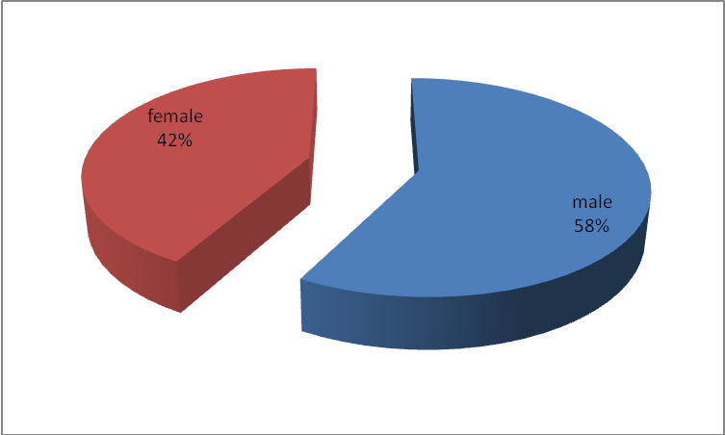
Source: Researcher, 2014
Figure 4.1: Gender of respondents
Results revealed that majority of the respondents were male comprising 58 percent while 42 percent were female. This implies that CDF funded projects observed gender equality.

4.2.3 Highest academic qualification of the respondents
The study wanted to find out the highest level of education of the respondents.
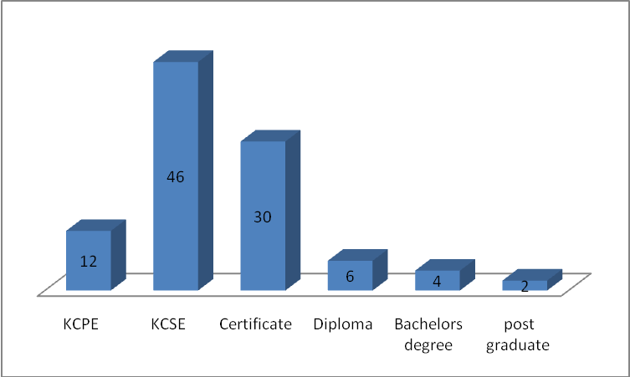
Source: Researcher, 2014
Figure 4. 2: Highest academic qualification of the respondents
According to the findings, 46% had KCSE, 30% of the respondents had certificate, 12% had KCPE, 6% had diploma, 4% had bachelors degree and 2% had post graduate. This implies that the CDF funded projects committee members were not well educated thus could face problems in decision making.

4.2.4 Organizations funding projects in the constituency
The study hunted to find out the organizations funding projects in the constituency.
Table 4. 3: Organizations funding projects
 | Frequency | Percentage
NGOs | 42 | 43.8
LATF | 21 | 21.9
Roads levy | 19 | 19.8
Bursary fund | 10 | 10.4
TEAM $ TEAM | 4 | 4.2
Total | 96 | 100
Source: Researcher, 2014
Results revealed that 43.8% of the projects were funded by NGOs, 21.9% of the projects were funded by LATF, 19.8% of the projects were funded by Roads levy, 10.4% of the projects were funded by Bursary fund and 4.2% of the projects were funded by TEAM $ TEAM.

4.2.5 Awareness of CDF projects
The study sought to find out if the respondents were aware of CDF projects in the area.
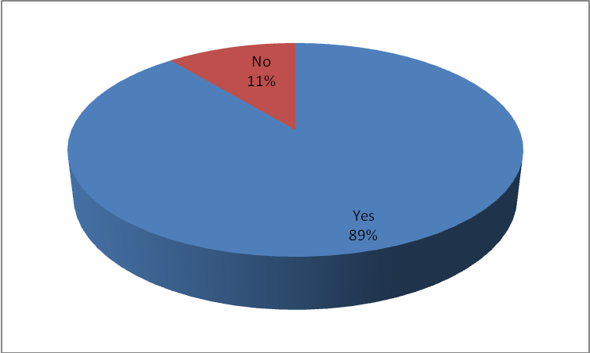
Source: Researcher, 2014
Figure 4.3: If the respondents were aware of CDF projects
From the findings, 89% of the respondents were aware of CDF projects in the area while 11% of the respondents were not aware. This implies that the respondents chosen had knowledge on the main objective of the study.

4.2.6 Project the respondents were involved in
The respondents were requested to indicate the projects they were involved in.
Table 4.4: Project the respondents were involved in
 | Frequency | Percentage
Education | 20 | 20.8
Health | 15 | 15.6
Electricity | 5 | 5.2
Roads | 34 | 35.4
Water | 12 | 12.5
Irrigation | 10 | 10.4
Total | 96 | 100
Source: Researcher, 2014
According to the findings, 35.4% of the respondents were involved with roads, 20.8% of the respondents were involved with education, 15.6% of the respondents were involved with health, 12.5% of the respondents were involved with water, 10.4% of the respondents were involved with irrigation and 5.2% of the respondents were involved with electricity. This shows that the study was not biased on any project but rather considered all types of projects in the area.

4.3 Performance of CDF projects

4.3.1 Project identification
The initiation processes determine the nature and scope of the project. This includes defining the project concept and project design/research strategy, including identifying useful outcomes; identify other stakeholders and possible roles.
4.3.1.1 Criteria used to Identify Project
The study sought to find out the criteria used to identify project
Table 4. 5: Criteria Used to Identify Project
 | Frequency | Percentage
Ward meeting | 5 | 5.2
Local Baraza | 3 | 3.1
Brainstorming | 13 | 13.5
Identify by the member of parliament | 29 | 30.2
Identify by CDFC | 46 | 47.9
Total | 96 | 100
Source: Researcher, 2014
From the findings, 47.9% of the respondents indicated that criteria used to identify project was identify by CDFC, 30.2% of the respondents indicated that criteria used to identify project was identify by the member of parliament, 13.5% of the respondents indicated that criteria used to identify project was brainstorming, 3.1% of the respondents indicated that criteria used to identify project was local baraza, 5.2% of the respondents indicated that criteria used to identify project was ward meeting.
4.3.1.2 Involvement in Decisions Making
The respondents were requested to indicated if they were directly involved in making decisions on which projects were to be funded by CDF
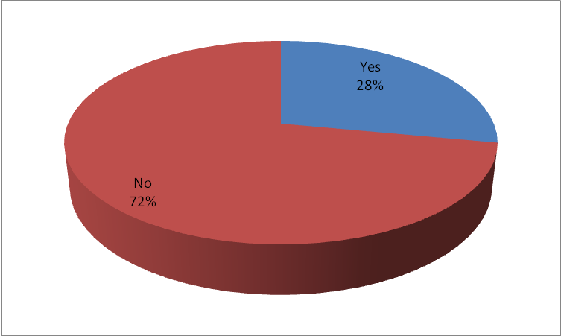
Source: Researcher, 2014
Figure 4. 4: If respondents were directly involved in making decisions on which projects were to be funded by CDF
According to the findings, 72% of the respondents were not directly involved in making decisions on which projects were to be funded by CDF while 28% were directly involved.
4.3.1.3 Effectiveness of Projects Identification Criteria Used
The study sought to find out the rate of effectiveness of projects identification criteria used in the constituency
Table 4.6: Effectiveness of Projects Identification Criteria
 | Frequency | Percentage
Very satisfactory | 3 | 3.1
Satisfactory | 18 | 18.8
Good | 33 | 34.4
Not satisfactory | 42 | 43.8
Total | 96 | 100
Source: Researcher, 2014
According to the findings, 43.8% of the respondents rated effectiveness of projects identification criteria used in the constituency as not satisfactory, 34.4% of the respondents rated effectiveness of projects identification criteria used in the constituency as good, 18.8% of the respondents rated effectiveness of projects identification criteria used in the constituency as satisfactory and 3.1% of the respondents rated effectiveness of projects identification criteria used in the constituency as very satisfactory.
4.3.1.4 Kind of Projects the Committee Recommend for Funding
On the kind of projects the committee recommended for funding, the study findings are as presented below.
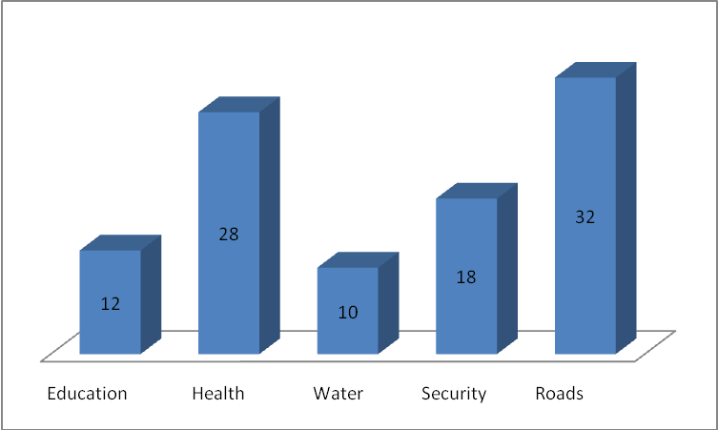
Source: Researcher, 2014
Figure 4. 5: Kind of Projects the Committee Recommend for Funding
From the findings, 32% of the respondents indicated that the kind of projects the committee recommended for funding was roads, 28% of the respondents indicated that the kind of projects the committee recommended for funding was health, 18% of the respondents indicated that the kind of projects the committee recommended for funding was security, 12% of the respondents indicated that the kind of projects the committee recommended for funding was education and 10% of the respondents indicated that the kind of projects the committee recommended for funding was water.
4.3.1.5 Selection of CDFC Members
The study sought to find out how CDFC members were selected
Table 4.7: Selection of CDFC Members
 | Frequency | Percentage
Interviews | 4 | 4.2
Elected | 15 | 15.6
Nominated | 29 | 30.2
Appointed | 48 | 50.0
Total | 96 | 100
Source: Researcher, 2014
According to the findings, 50.0% of the respondents indicated that CDFC members were selected by being appointed, 30.2% of the respondents indicated that CDFC members were selected by being nominated, 15.6% of the respondents indicated that CDFC members were selected by being elected and 4.2% of the respondents indicated that CDFC members were selected by interviews.

4.3.2 Project planning
4.3.2.1 Factors that Influence the Completion of the Projects
The respondents were requested to indicate the factors that influence the completion of the projects.
Table 4.8: Factors that influence the completion of the projects
 | Frequency | Percentage
Insufficient funds | 57 | 59.4
Insufficient technical skills | 12 | 12.5
Change of priorities | 24 | 25.0
Total | 96 | 100
Source: Researcher, 2014
From the findings, 59.4% of the respondents indicated that insufficient funds influenced the completion of the projects, 25.0% of the respondents indicated that change of priorities influenced the completion of the projects and 12.5% of the respondents indicated that insufficient technical skills influenced the completion of the projects.
4.3.2.2 Government Technicians Involvement in CDF Projects
The study sought to find out if government technicians were involved in CDF projects at all levels.
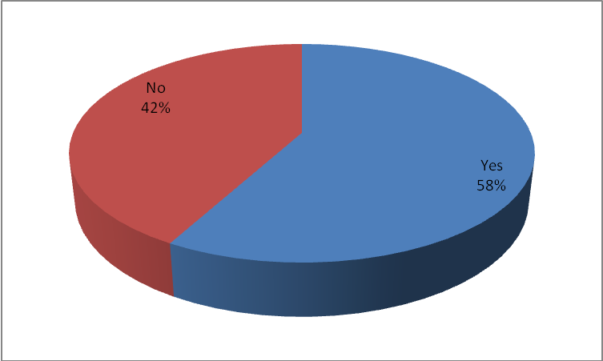
Source: Researcher, 2014
Figure 4.6: If government technicians were involved in CDF projects at all levels
According to the findings, 58% of the respondents indicated that government technicians were involved in CDF projects at all levels while 42% indicated that government technicians were not involved in CDF projects at all levels.
4.3.2.3 Phases that government technicians were involved
The respondents were requested to indicate the phases that government technicians were involved at.
Table 4.9: Phases that government technicians were involved
 | Frequency | Percentage
Initiation | 14 | 14.6
Planning | 16 | 16.7
Implementation | 27 | 28.1
Monitoring $ evaluation | 24 | 25.0
None | 15 | 15.6
Total | 96 | 100
Source: Researcher, 2014
From the findings, 28.1% of the respondents indicated that government technicians were involved in implementation, 25.0% of the respondents indicated that government technicians were involved in monitoring $ evaluation, 16.7% of the respondents indicated that government technicians were involved in planning, 15.6% of the respondents indicated that government technicians were not involved in any of the phases and 14.6% of the respondents indicated that government technicians were involved in initiation.
4.3.2.4 Involvement in planning
The study sought to find out if the respondents were involved in planning
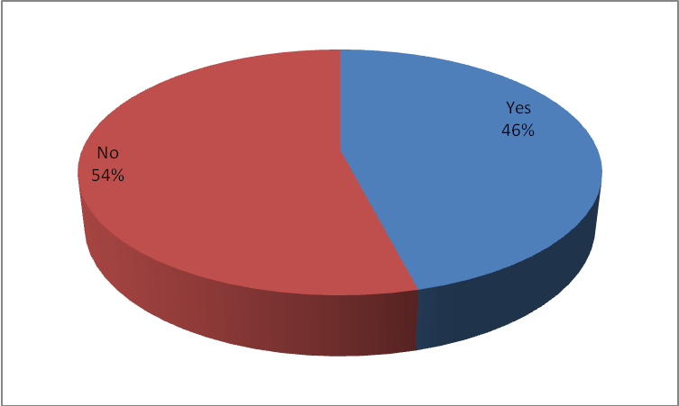
Source: Researcher, 2014
Figure 4.7: If the respondents were involved in planning
According to the findings, 54% of the respondents were not involved in planning while 46% were involved in planning.

4.3.3 Project implementation
4.3.3.1 Funds allocation
The study sought to determine the amount of money that had been spent on the CDF projects.
Table 4.10: Approximate money spent in undertaking the CDF project the respondents were involved in
 | Frequency | Percentage
1-500,000 | 4 | 4.2
500001-1,000,000 | 18 | 18.8
1000001-2,000,000 | 39 | 40.6
Over 2,000,000 | 35 | 36.5
Total | 96 | 100
Source: Researcher, 2014
From the results above, 40.6% indicated that the project had spent between 1000001 and 2,000,000 shillings while 4.2% indicated that they had spent between 1and 500,000. This shows that majority of the projects had spent between 1000001 and 2,000,000 shillings.
4.3.3.2 Sufficiency of Funds Disbursed
The study sought to find out whether funds disbursed were sufficient.
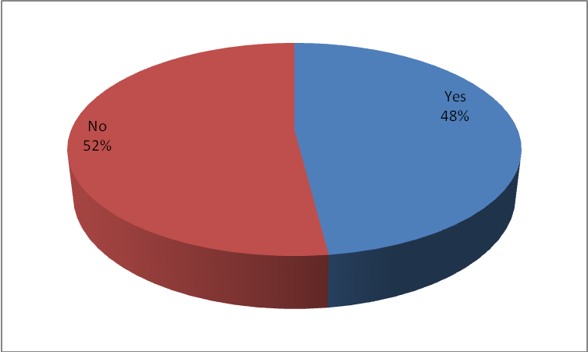
Source: Researcher, 2014
Figure 4.8: Whether Funds Disbursed was Sufficient
From the findings, 48% of the respondents indicated that the funds disbursed were sufficient while 52% indicated that the funds were not sufficient. This clearly shows that the funds disbursed were not sufficient.
4.3.3.3 Effectiveness of Projects Implementation Criteria Used
The respondents were requested to indicate the effectiveness of projects implementation criteria used in the Constituency.
Table 4.11: Effectiveness of Projects Implementation Criteria Used in the Constituency
 | Frequency | Percentage
Very satisfactory | 2 | 2.1
Satisfactory | 12 | 12.5
Good | 33 | 34.4
Not satisfactory | 49 | 51.0
Total | 96 | 100
Source: Researcher, 2014
According to the findings, 51.0% of the respondents rated the effectiveness of projects implementation criteria used as not satisfactory, 34.4% of the respondents rated the effectiveness of projects implementation criteria used as good, 12.5% of the respondents rated the effectiveness of projects implementation criteria used as satisfactory and 2.1% of the respondents rated the effectiveness of projects implementation criteria used as very satisfactory.

4.3.4 Project monitoring and evaluation
4.3.4.1 Performance Evaluation Dimensions
The study sought to find out the extent that performance evaluation dimensions was used to assess the performance of the CDF projects.
Table 4.12: Extent that performance evaluation dimensions was used to assess the performance of the CDF projects
 | Mean | Stdev
Time | 3.6 | 0.4
Cost | 3.1 | 0.8
Quality | 4.4 | 0.1
Source: Researcher, 2014
According to the findings, quality and time were to a great extent used to assess the performance of the CDF projects as shown by a mean of 4.4 and 3.6 respectively. In addition, cost was to a moderate extent used to assess the performance of the CDF projects as shown by a mean of 3.1.
4.3.4.2 Completion of Projects
The respondents were requested to indicate the extent that the projects were completed.
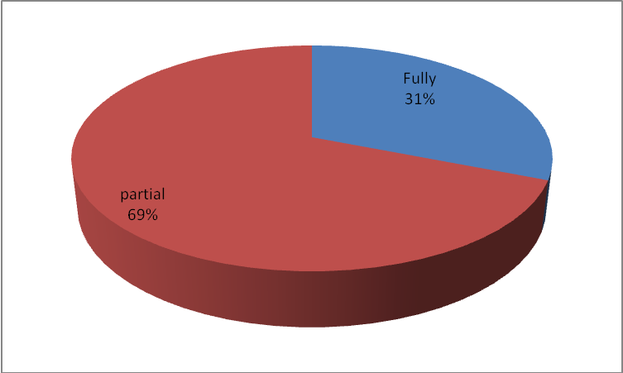
Source: Researcher, 2014
Figure 4.9: Extent that the projects were completed
From the findings, 69% of the projects were partially completed while 31% were fully completed.
4.3.4.3 Usefulness of CDF Projects Completed
The study sought to find out the usefulness of CDF projects completed
Table 4.13: Usefulness of CDF projects Completed
 | Frequency | Percentage
Very much | 54 | 56.3
Useful | 42 | 43.8
Total | 96 | 100
Source: Researcher, 2014
According to the findings, 56.3% of the respondents indicated that the CDF projects completed were very much useful and 43.8% of the respondents indicated that the CDF projects completed were useful.
4.3.4.4 Quality of the CDF Projects
The respondents were requested to rate the quality of the CDF projects.
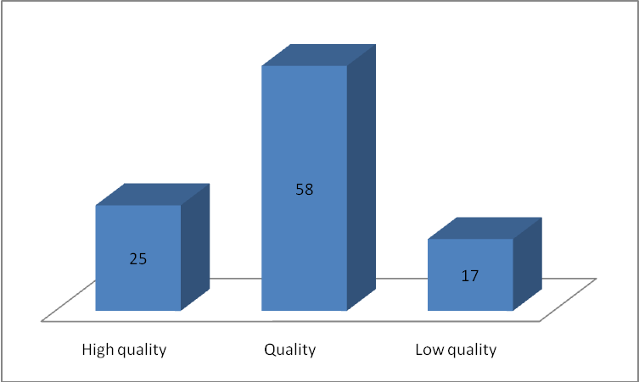
Source: Researcher, 2014
Figure 4.10: Rating of Quality of the CDF Projects
From the findings, 58% of the respondents rated the quality of the CDF projects as quality, 25% rated the projects as of high quality and 17% rated the projects as of low quality.

4.4 Factors influencing performance of CDF projects

4.4.1 Project Initiation
In an effort to determine the factors influencing performance of CDF projects, the researcher requested the respondents to indicate how project initiation was affecting the performance of
CDF projects in their constituency.

4.4.1.1. Effect of project initiation
The study sought to find out project initiation influence on performance of CDF projects. The study therefore presents the above statement to seek the respondents’ level of agreement.
Table 4.14: Initiation
Statements | Mean | Stdev
I am fully aware of projects undertaken | 4.3 | 0.4
Initiation of new projects is a collective responsibility that involves all stakeholders | 4.6 | 0.8
Initiation of new projects ideas/identification come from community of the area | 4.5 | 0.6
Initiation provides immediate short-run feedback on whether quality improvement efforts are succeeding | 4.2 | 0.3
Source: Researcher, 2014
The respondents strongly agreed to the statement that initiation of new projects is a collective responsibility that involves all stakeholders as shown by a mean score of 4.6 and that initiation helps managers identify the precise problem areas that need improved as shown by a mean score of 4.5. They also agreed to the statement that they were fully aware of projects undertaken as shown by a mean score of 4.3 and initiation provides immediate short-run feedback on whether quality improvement efforts are succeeding as shown by a mean score of 4.2.

4.4.2 Project Planning
The findings presented in Table 4.15 below indicate the extent to which project planning influence performance of CDF projects across the sampled projects.

4.4.2.1. Effect of project planning
The study sought to find out project planning influence on performance of CDF projects. The study therefore presents the above statement to seek the respondents’ level of agreement.
Table 4.15: Planning
Statements | Mean | Stdev
The project team takes time to plan time, cost and resources adequately during project execution. | 4.5 | 0.1
The project team estimate the work needed and to effectively manage risk during project execution | 4.3 | 0.2
The Project Planning Roadmap tackles that process, providing one with the tools needed to plan definition tasks and activities, considering all the requirements, issues and deliverables needed to produce successful results | 4.1 | 0.6
Failure to adequately plan greatly reduces the project's chances of successfully accomplishing its goals | 4.4 | 0.3
Planning of new projects is a collective responsibility that involves all stakeholders | 3.9 | 0.9
Source: Researcher, 2014
Table 4.15 above shows the extent to which project planning influence performance of CDF projects across the sampled projects. The respondents also agreed with a mean of 4.5 that project team takes time to plan time, cost and resources adequately. In addition, it was agreed among the respondents with a mean of 4.4 that failure to plan adequately reduces project’s chances of successfully accomplishing its goals. The respondents also agreed with a mean of 4.3 that project team estimate work needed to effectively manage risk. The respondents further agreed with a mean of 4.1 that project planning Roadmap tackles process providing tools needed to plan define tasks and activities considering requirements, issues and deliverables to produce successful results. The study also found that planning of new projects is a collective responsibility that involves all stakeholders as shown by a mean of 3.9.

4.4.3 Project Implementation
The findings presented in Table 4.23 below indicate the extent to which project implementation influence performance of CDF projects across the sampled projects.

4.4.3.1. Effect of Project Implementation
The study sought to find out project implementation influence on performance of CDF projects. The study therefore presents the above statement to seek the respondents’ level of agreement.
Table 4.16: Implementation
Statements | Mean | Stdev
Implementation of new projects is a collective responsibility that involves all stakeholders | 4.4 | 0.8
Implementation process involves coordinating people and resources, and performing the activities of the project in accordance with the project management plan. | 4.2 | 0.5
An individual or group of people should be given responsibility to drive success in project implementation | 3.9 | 0.4
During implementation deadlines should be met to help stay within the schedule and budget and to maintain credibility | 4.3 | 0.1
Project implementation should be disciplined with coordinated and active human resource involvement | 4.1 | 0.3
Source: Researcher, 2014
The study further inquired on the extent to which project implementation influence performance of CDF projects across the sampled projects. According to the findings, the respondents agreed with a mean of 4.4 that implementation of new projects is a collective responsibility that involves all stakeholders. It was also established that during implementation deadlines should be met to help stay within the schedule and budget and to maintain credibility as shown by a mean of 4.3. The respondents further agreed with a mean of 4.2 that implementation process involves coordinating people and resources, and performing the activities of the project in accordance with the project management plan. It was revealed that project implementation should be disciplined with coordinated and active human resource involvement as shown by a mean of 4.1. The respondents also agreed with a mean of 3.9 that an individual or group of people should be given responsibility to drive success in project implementation.

4.4.4 Monitoring and Evaluation
The findings presented in Table 4.17 below indicate the extent to which monitoring and evaluation influence performance of CDF projects across the sampled projects.

4.4.4.1. Effect of Project Monitoring & Evaluation
The study sought to find out project monitoring and evaluation influence on performance of CDF projects. The study therefore presents the above statement to seek the respondents’ level of agreement.
Table 4.17: Monitoring &Evaluation
Statements | Mean | Stdev
Monitoring and Evaluation projects is a collective responsibility that involves all stakeholders | 4.7 | 0.6
Monitoring is also important to ensure that activities are implemented as planned and help the project managers to measure how well they are achieving their targets | 3.9 | 0.4
Outside facilitator conduct the project audit ensuring confidentiality thus allowing the team members and other stakeholders to be candid | 4.5 | 0.1
Frequent investigation and reviewing the effects of the completed or ongoing projects to see whether the benefits which were planned to flow from the project have indeed been realized | 4.2 | 0.9
This phase ensures sustainability of the project or recommends changes in the project to ensure the goals and objectives are achieved. | 4.3 | 0.2
Source: Researcher, 2014
The study further sought to determine the extent to which monitoring and evaluation influence performance of CDF projects across the sampled projects. According to the findings, the respondents strongly agreed with a mean of 4.7 that monitoring and evaluation projects are a collective responsibility that involves all stakeholders. The respondents also agreed with a mean of 4.5 that outside facilitator conduct the project audit ensuring confidentiality thus allowing the team members and other stakeholders to be candid. The respondents further agreed with a mean of 4.2 that frequent investigation and reviewing the effects of the completed or ongoing projects to see whether the benefits which were planned to flow from the project have indeed been realized. In addition, the respondents agreed with a mean of 4.3 that this phase ensures sustainability of the project or recommends changes in the project to ensure the goals and objectives are achieved. Lastly, the respondents agreed with a mean of 3.9 that monitoring is also important to ensure that activities are implemented as planned and help the project managers to measure how well they are achieving their targets

4.4.5 CDFC, PMC and Government Officials Role

4.4.5.1. CDFC, PMC and Government Officials Role in Project Initiation
Table 4.18 below shows the extent to which the respondents agreed with the stated CDFC, PMC and Government Officials roles in project initiation.
Table 4.18: CDFC, PMC AND GOVERNMENT OFFICIALS ROLE IN PROJECT INITIATION
Statements | Mean | Stdev
Analyzing the needs in measurable goals | 4.3 | 0.3
Reviewing of current operations | 3.9 | 0.6
Financial analysis of the costs and benefits including a budgets | 4.1 | 0.8
Stakeholder analysis, including users and support personnel | 4.2 | 0.4
Source: Researcher, 2014
From the findings, the respondents agreed with a mean of 4.3 that CDFC, PMC and Government Officials were analyzing the needs in measurable goals. In addition, the respondents agreed with a mean of 4.2 that CDFC, PMC and Government Officials were doing stakeholder analysis, including users and support personnel. It was also established that CDFC, PMC and Government Officials were doing financial analysis of the costs and benefits including a budgets as shown by a mean of 4.1. The respondents also agreed with a mean of 3.9 that CDFC, PMC and Government Officials were reviewing of current operations.

4.4.5.2 CDFC, PMC and Government Officials Role in Project Planning
Table 4.19 below shows the extent to which the respondents agreed with the stated CDFC, PMC and Government Officials roles in project planning.
Table 4.19: CDFC, PMC AND GOVERNMENT OFFICIALS ROLE IN PROJECT PLANNING
Statements | Mean | Stdev
Identifying the activities needed to complete the deliverables | 4.1 | 0.1
Estimating the resource requirements for the activities | 3.6 | 0.4
Risk planning | 4.0 | 0.2
Identifying roles and responsibilities | 4.4 | 0.7
Source: Researcher, 2014
According to the findings, the respondents agreed with a mean of 4.4 that CDFC, PMC and Government Officials were playing the role of identifying roles and responsibilities. The respondents also agreed with a mean of 4.1 that CDFC, PMC and Government Officials were identifying the activities needed to complete the deliverables. The respondents also agreed with a mean of 3.6 that CDFC, PMC and Government Officials were playing the role of estimating the resource requirements for the activities and risk planning as shown by a mean of 4.0.

4.4.5.3 CDFC, PMC and Government Officials Role in Project Implementation
Table 4.20 below shows the extent to which the respondents agreed with the stated CDFC, PMC and Government Officials roles in project implementation.
Table 4.20: CDFC, PMC AND GOVERNMENT OFFICIALS ROLE IN PROJECT IMPLEMENTATION
Statements | Mean | Stdev
Procurement of materials and equipment | 4.5 | 0.8
Coordinating people and resources | 4.4 | 0.9
Performing activities of project in accordance with project management plan | 4.3 | 0.3
Update of Risk Analysis | 3.7 | 0.1
Source: Researcher, 2014
As indicated in the findings, the respondents strongly agreed with a mean of 4.5 that CDFC, PMC and Government Officials were playing a role of procurement of materials and equipment. The respondents also agreed with a mean of 4.4 that CDFC, PMC and Government Officials were coordinating people and resources. The respondents further agreed with a mean of 4.3 that CDFC, PMC and Government Officials were performing activities of project in accordance with project management plan. In addition, the respondents agreed with a mean of 3.7 that CDFC, PMC and Government Officials were doing the update of risk analysis.

4.4.5.4 CDFC, PMC and Government Officials Role in Monitoring and Evaluation
Table 4.21 below shows the extent to which the respondents agreed with the stated CDFC, PMC and Government Officials roles in monitoring and evaluation.
Table 4.21: CDFC, PMC AND GOVERNMENT OFFICIALS ROLE IN MONITORING AND EVALUATION
Statements | Mean | Stdev
Measuring the ongoing activities | 4.4 | 0.1
Monitoring project variables (cost, scope, effort etc) against the project management plan and project performance baseline | 4.3 | 0.2
Identify corrective actions to address issues and risks properly | 4.0 | 0.5
Influencing the factors that could circumvent integrated change control | 3.9 | 0.6
Source: Researcher, 2014
From the findings, as shown by table 4.21 above, the respondents agreed with a mean of 4.4 that CDFC, PMC and Government Officials were playing the role of measuring the ongoing activities. In addition, the respondents agreed with a mean of 4.3 that CDFC, PMC and Government Officials were monitoring project variables (cost, scope, effort etc) against the project management plan and project performance baseline. The respondents also agreed with a mean of 4.0 that CDFC, PMC and Government Officials were identifying corrective actions to address issues and risks properly. Lastly, the respondents agreed with a mean of 3.9 that CDFC, PMC and Government Officials were influencing the factors that could circumvent integrated change control.

4.5 Regression Analysis
In addition, the researcher conducted a linear regression analysis so as to test relationship among variables (independent) on the performance of CDF funded projects. The researcher applied R to code, enter and compute the measurements of the linear regressions for the study.
Coefficient of determination explains the extent to which changes in the dependent variable can be explained by the change in the independent variables or the percentage of variation in the dependent variable (performance of CDF funded projects) that is explained by all the four independent variables (project planning, project implementation, project monitoring &evaluation and project identification).
Table 4.22: Model Summary
Model | R | R Square | Adjusted R Square | Std. Error of the Estimate
1 | .924ª | .854 | .716 | .419
The five independent variables that were studied, explain only 71.6% of the performance of CDF funded projects as represented by the adjusted R². This therefore means that other factors not studied in this research contribute 28.4% of the performance of CDF funded projects. Therefore, further research should be conducted to investigate the other factors (28.4%) that affect performance of CDF funded projects.
Table 4.23: ANOVA
Model | Sum of Squares | df | Mean Square | F | Sig.
Regression | 2.434 | 4 | 1.103 | 6.294 | .012
Residual | 7.307 | 363 | 2.452
Total | 4.326 | 367
The significance value is .012 which is less that 0.05 thus the model is statistically significance in predicting performance of CDF funded projects. The F critical at 5% level of significance was 2.17. Since F calculated is greater than the F critical (value = 6.294), this shows that the overall model was significant.
Table 4.24: Model Summary: Coefficient of determination
Model |  | Unstandardized Coefficients |  | Standardized Coefficients | t | Sig.
 |  | B | Std. Error | Beta
1 | (Constant) | 3.203 | 1.036 |  | 0.842 | 0.247
 | Project identification | 0.571 | 0.096 | 0.215 | 0.342 | 0.02
 | Project Monitoring &Evaluation | 0.681 | 0.145 | 0.087 | 0.578 | 0.017
 | Project planning | 0.651 | 0.068 | 0.155 | 0.96 | 0.027
 | Project Implementation | 0.971 | 0.104 | 0.157 | 1.081 | 0.025
Dependent variable: Performance of CDF funded projects
The researcher conducted a linear regression analysis so as to determine the effect of the independent variables (project planning, project implementation, project monitoring &evaluation and project identification) on the dependent variable (performance of CDF funded projects). As per the R generated table above, the equation (Y = β₀ + β₁X₁ + β₂X₂ + β₃X₃ + β₄X₄ + ε) becomes:
Y= 3.203 + 0.651X₁+ 0.971X₂+ 0.681 X₃+ 0.571X₄ + 0.736 X₅
According to the regression equation established, taking all factors into account (project planning, project implementation, project monitoring &evaluation and project identification) constant at zero, performance of CDF funded projects will be 3.203. The data findings analyzed also shows that taking all other independent variables at zero, a unit increase in organizational project implementation will lead to a 0.971 increase in performance of CDF funded projects; a unit increase in project monitoring &evaluation will lead to a 0.681 increase in performance of CDF funded projects, a unit increase in project planning will lead to a 0.651 increase in performance of CDF funded projects, a unit increase in project identification will lead to a 0.571 increase in performance of CDF funded projects. This infers that project implementation contributes more to the performance of CDF funded projects followed by the project monitoring &evaluation, then project planning then project identification, with customer values contributing the least.
At 5% level of significance and 95% level of confidence, project implementation had a 0.025 level of significance; project monitoring &evaluation showed a 0.017 level of significance, project planning showed a 0.027 level of significance, project identification showed a 0.02 level of significance; hence the most significant factor is project planning.

CHAPTER FIVE

SUMMARY OF FINDINGS, DISCUSSIONS, CONCLUSIONS AND RECOMMENDATIONS

5.1 Introduction
The chapter outlines the summary of findings derived from the study. The purpose of this study was to assess the contribution of various stakeholders in the performance of CDF funded projects and use the findings to come up with recommendations on how to improve the management of CDF funds to finance development projects.

5.2 Summary
The study found that majority of the respondents were aware of CDF project and were involved in organizing them and therefore were best suited to give information being sought by the study. It was established that time, quality and cost was used by the committees to assess the performance of the CDF projects to a very great extent. The study also established that factors influencing completion of projects were insufficient funds and insufficient skills. The study showed that majority of the projects had spent between 500,001 and 1,000,000 shillings.
The study found that initiation of new projects is a collective responsibility that involves all stakeholders and initiation helps managers identify the precise problem areas that need improved. The study also found that the respondents were fully aware of projects undertaken and initiation provides immediate short-run feedback on whether quality improvement efforts are succeeding. The study also found that CDFC, PMC and Government Officials were analyzing the needs in measurable goals, were doing stakeholder analysis, including users and support personnel, were doing financial analysis of the costs and benefits including budgets and were reviewing current operations.
The study established that project team takes time to plan time, cost and resources adequately. In addition, the study found that failure to plan adequately reduces project’s chances of successfully accomplishing its goals. The study also found that identifying roles and responsibilities and that project team estimate work needed to effectively manage risk. The study also found that project planning Roadmap tackles process providing tools needed to plan define tasks and activities considering requirements, issues and deliverables to produce successful results. Further, the study established that identifying the activities needed to complete the deliverables. The study also found that CDFC, PMC and Government Officials were playing the role of identifying roles and responsibilities, were identifying the activities needed to complete the deliverables and were playing the role of estimating the resource requirements for the activities and risk planning.
The study revealed that project implementation entails procurement of materials and equipment. Further, the study found that project implementation entails coordinating people and resources. In addition, the study found that implementation of new projects is a collective responsibility that involves all stakeholders. The study also found that project implementation entails Performing activities of project in accordance with project management plan. It was also established that during implementation deadlines should be met to help stay within the schedule and budget and to maintain credibility. The study also found that implementation process involves coordinating people and resources, and performing the activities of the project in accordance with the project management plan. It was revealed that project implementation should be disciplined with coordinated and active human resource involvement. The study also found that an individual or group of people should be given responsibility to drive success in project implementation.
The study established that monitoring and evaluation projects are a collective responsibility that involves all stakeholders. The study also found that outside facilitator conduct the project audit ensuring confidentiality thus allowing the team members and other stakeholders to be candid.
The study also found that frequent investigation and reviewing the effects of the completed or ongoing projects to see whether the benefits which were planned to flow from the project have indeed been realized. The study also established that this phase ensures sustainability of the project or recommends changes in the project to ensure the goals and objectives are achieved. The study established that CDFC, PMC and Government Officials were playing the role of measuring the ongoing activities, were monitoring project variables (cost, scope, effort etc) against the project management plan and project performance baseline, were identifying corrective actions to address issues and risks properly and were influencing the factors that could circumvent integrated change control.

5.3 Conclusion
This study concludes that project performance and CDFC, PMC and government officials’ role in projects identification show a positive coefficient 0.571, with p-value of 0.02. It indicates that the result is significant at α=5% and that if the CDFC, PMC and government officials role in projects identification increase it will have a positive impact on project performance. The study also found that CDFC, PMC and Government Officials were analyzing the needs in measurable goals, were doing stakeholder analysis, including users and support personnel, were doing financial analysis of the costs and benefits including a budgets and were reviewing of current operations.
The study also concludes that between CDFC, PMC and government officials role in projects planning and project performance there exists a positive relationship with a coefficient 0.651 and a p-value of 0.027 which significant at α= 5%. The study also found that CDFC, PMC and Government Officials were playing the role of identifying roles and responsibilities, were identifying the activities needed to complete the deliverables and were playing the role of estimating the resource requirements for the activities and risk planning.
The study further concludes that there is a positive association between CDFC, PMC and government officials’ role in project implementation and project performance where the correlation coefficient is 0.971, with a p-value of 0.025. The study also established that CDFC, PMC and Government Officials were playing a role of procurement of materials and equipment, were coordinating people and resources, were performing activities of project in accordance with project management plan and were doing the update of risk analysis.
Further, the study concludes that there is a positive association between CDFC, PMC and government officials’ role in monitoring and evaluation and project performance where the correlation coefficient is 0.681, with a p-value of 0.017. The study established that CDFC, PMC and Government Officials were playing the role of measuring the ongoing activities, were monitoring project variables (cost, scope, effort etc) against the project management plan and project performance baseline, were identifying corrective actions to address issues and risks properly and were influencing the factors that could circumvent integrated change control.

5.4 Recommendations
The study also established that factors influencing completion of projects were insufficient funds and insufficient skills. The study therefore recommends that enough funds and skills should be allocated to projects.
The study found that stakeholder involvement influence performance of CDF projects. The study therefore recommends that the constituents’ should play a critical role in decision making because they are the beneficiaries of the projects and know well projects are beneficial to them.
There is need for change of system to computerized systems, avoidance of political differences and interference if the CDF projects are to be successful. Proper bidding of tenders should be encouraged and tenders should be awarded to deserving persons. Transparency during awarding of tenders (avoidance of long bureaucratic tendering process) is key to the success of the CDF projects. The committee should encourage community participation, cooperation among committee members and auditing of complete project to access their worth.

5.5 Recommendation for Further Studies
From the study and related conclusions, the researcher recommends further research in the area of the influence of stakeholders’ involvement on performance of CDF Projects. Further studies should be done on the factors influencing performance of Constituency Development Fund projects in other constituencies. This will help in knowing which factors should be considered for performance of CDF Projects to excel. A study should also be done on the factors influencing performance of other projects funded by for example Kazi kwa Vijana funds and other funds. Kazi kwa Vijana funds was introduced improve the lives of young people but this have not been fully achieved.

REFERENCES
Ackermann, F. and Eden, C. (2001). Stakeholders Matter: Techniques for Their Identification and Management. Department of Management Science Research Paper No 2001/20, Strathclyde Business School, Glasgow.
Albert, H. (2004). Handbook of Project Management Procedures. England: TTL publishing Ltd.
Antill, V. (2004). Making projects a success, Communications of the ACM, Vol. 43 NO.3, pp. 57-61.
Arndt, F. & Oman, R. (2006). Bet On Governance To Manage Outsourcing Risk. Business Trends Quarterly.
Carley, E. (2006). Entprojectsrise Resource Planning-Integrating Application and Projects Process Across the Entprojectsrise, Computer Technology Research Corporation, Charleston, SC. computing, pp.44-5.
CDF Act, 2003 Act of Parliament as contained in The Kenya Gazette Supplement No. 107 (Act No. 11) of 9th January 2004.The Act was amended through the CDF (Amendment) Act, 2007 in the Kenya Gazette Supplement No. 112 (Act No. 16) of 22nd October 2007
Centre For Enhancing Democracy And Good Governance (CEDGG) (2011). CDF Social Audit Project – II. “Towards Improved Accountability and Transparency in Constituency Development Fund through Social Audit”. Final Narrative Report, Nakuru Town and Rongai Constituencies. November 2009 to February 2011.
Cusworth, J. and Franks, T. (1993). Managing projects in developing countries. Longman Scientific & Technical, Harlow, UK and J. Wiley & Sons, New York, USA.
John (2004) Building capacity to manage protected areas in an era of global change. In: Barber, C.V., Miller, K.R. and Boness, M. (Eds) Securing Protected Areas in the Face of Global Change. Issues and Strategies. IUCN, Gland, Switzerland and Cambridge, UK.
Charles (2009).WWF: Rapid Assessment and Prioritization of Protected Area Management (RAPPAM) Methodology. WWF, Gland, Switzerland.
Cheung, H., Baker, T. & Traeger, C. (2004). Risk matrix: an approach for prioritizing risks and tracking risk mitigation progress, Proceedings of the 30th Annual Project Management Institute, Philadelphia: PA, October 10-16
Donaldson, T. and Preston, L. E. (1995). The Stakeholder Theory of the Corporation: Concepts, Evidence and Implications. Academy of Management Review. Vol 20, No 1, pp 65 – 91.
Dooley, D. (2007), Social Research Methods. New Delhi: Prentice Hall.
Duncan, R.(2006). State and local government performance: it's time to measure up , The Government Accountants' Journal, Vol. 48 No.1, pp.40-6.
Falkowski, G., Pedigo, P., Smith, B. & Swanson, D. (1998).“A recipe for PROJECTS success”, Retrieved February 20th 2011fromhttp://www.projectsnews.com
Filicetti, J. (2009). Project Planning Overview. PM Hut Last accessed 8 November 2009.
Flaman, G. & Gallagher, U. (2001). Assessment and Control of project Risks. Englewood Cliffs: Prentice-Hall.
Fleming, Q. (2005). Earned Value Project Management. (3rd ed.) Project Management Institute.
Freeman, R.E. (1984) Strategic Management: A Stakeholder Approach, Pitman Press, Boston, Ma p46
Gary, (2007). MRPII implementation: key factors for success, Computer Manage Project Management. San Francisco: Jossey-Bass.
Gikonyo, W. (2008). The CDF Social Audit Guide- A Handbook for Communities, The Open Society Initiative of East Africa, Nairobi, Kenya.
Graham , R.L. (1997). Creating an Environment for Successful Projects: The Quest to Manage Project Management. San Francisco : Jossey-Bass.
Harvey, M. (2003). Project Management. (3rd ed). Englewood Cliffs: Prentice Hall.
Holland, P., Light, B. & Gibson, N. (1999). “A critical success factors model for projects rise resource planning implementation”, Proceedings. (7th ed ).European Conference on Information Systems, Vol, pp. 273-97
Juran, M. (1999). Juran on Leadership for Quality. London: Collier Macmillan.
Kairu R. N. (2010). An analysis of the factors that influence successful management of the CDF. The case of Gatanga constituency, Kenya. Unpublished MA project. University of Nairobi.
Kanua J. K. (2009). An assessment of the role of community participation in successful completion of CDF projects in Imenti constituency. Unpublished M A project. University of Nairobi.
Kenya Human Rights Commission (KHRC) and Social and Public Accountability Network (SPAN) (2010). Harmonization of Decentralized Development in Kenya: Towards Alignment, Citizen Engagement and Enhanced Accountability. A Joint Collaborative Research Report.
Kimenyi. (2005). The efficiency and efficacy of Kenya’s CDF. Unpublished MBA project University of Nairobi
KIPPRA (2006). The Kenya Institute for Public Policy Research and Analysis Bill.
Kinyoda E. J. (2009). Level of participation in project identification and selection by constituents. A case of Makadara CDF. Unpublished MA project. University of Nairobi.
Love, H., MacKinnon, D., Cumbers, A., Chapman, K. (2005), Learning, innovation and regional development: a critical appraisal of recent debates , Progress in Human Geography, Vol. 26 No.3, pp.293-311.
Maylor, C. & Vessey, I. (1999). "TRP Implementation approaches toward a contingency framework",
Mitchell, R. K., Agle, B. R. and Wood, D. J. (1997). Toward a Theory of Stakeholder Identification and Salience: Defining the Principle of Who and What Really Counts. Academy of Management Review. Vol 22, No 4, pp 853 – 886.
Mochiemo C. J. (2007). Contribution of the community in successful completion of CDF projects in Kitutu Chache constituency Kisii central District. Unpublished MA project University of Nairobi.
Moodley, K. (2002). Project Stakeholders, Engineering Project Management, Edited by N. J. Smith, 2nd Edition. Blackwell Publishing p. 127-136
Morsman, E. (1993). Commercial Loan Portfolio Management. Philadelphia: Robert Morris Associates.
Mosley, P., Hudson, J. & Horrell, S. (1986). ‘Aid, the Public Sector and the Market in Less reform and privatization : West view press.
Mosley, P., Hudson, J. & Horrell, S. (1986). ‘Aid, the Public Sector and the Market in Less reform and privatization boulder: Westview press.
Mugenda, O. & Mugenda, A. (2003). Research methods: Quantitative and qualitative approaches. Nairobi: Laba graphics services.
Nijkamp, M.L. & Tanis, C. (2000). “The entprojectsrise system experience – from adoption of success”,
Ntuala (2010). Factors affecting the implementation of CDF funded projects in Tigania East constituency. Unpublished MA project, University of Nairobi
Pheng, W. & Chuan, T. (2006). An integrative contingency model of software project risk management , Journal of Management Information Systems, Vol. 17 No.4, pp.37-69.
Rao, P., C., K. (2001) Project Management and Control Sultan Chad & Sons New Delhi India
Rao, K. (2001). Project Management and Control. New Delhi: Sultan Chad & Sons.
Rosario, J., G. (2000). On the leading edge: critical success factors in PROJECTS implementation.
Sumner, M. (1999). Critical success factors in entprojectsrise wide information management systems projects, Proceedings of the Americas Conference on Information Systems (AMCIS)
Wamae, D., N. (2009). An evaluation of the contribution of implementation of CDF projects in employment creation in Kenya.
Wayne, A. & Wittig, K. (2002). Building Value through Project implementation: A Focus on Africa 3.
Wee, S. (2000). Juggling toward PROJECTS success keep key success factors high, PROJECTS News,
Yee-Chin, L. C. (2004). Performance Measurement and Adoption of Balanced Scorecards. A Survey of Municipal Governments in the USA and Canada. The International Journal of Public Sector Management, Vol 17, No 3, pp 204 – 221.

APPENDICES

Appendix I: Introductory letter to the questionnaire

Dear Sir/ Madam
RE: REQUEST TO COLLECT RESEARCH DATA
I am a student of Mt. Kenya University, Mombasa Campus pursuing an MBA (Strategic Management) course. As part of the course requirements, I am required to conduct research in my area of specialization and my research title is “Stakeholders role on the performance of CDF projects in Kenya.” A case of Garsen constituency.
I therefore request for your assistance and participation in the research by providing the data through filling the questionnaire attached to this letter. I wish to reassure you that is purely an academic research and the information collected will be handled with utmost confidentiality.
I look forward to your assistance and participation in this matter.
Thank you in advance.
Yours faithfully,

ABDULHAKIM ALI MOHAMED

Appendix II: Questionnaire For Projects Representatives And CDF Committee Members

THE ROLE OF STAKEHOLDERS IN PERFORMANCE OF CDF PROJECTS
The purpose of this questionnaire is to help collect data for an MBA project in Mt kenya University. All respondents and information provided will be treated as confidential.
Respondent no……………………………………………….

SECTION A: Background of respondents
Please answer the following questions by placing a tick ( ) where necessary in the spaces provided

1. What is your age?
18 - 25 [ ] 26 – 35 [ ]
36 – 45 [ ] 46 – 55 [ ]
56 and above [ ]

2. What is your gender? Male [ ] Female [ ]

3. What is your highest academic qualification?
KCPE [ ] KCSE [ ]
Certificate [ ] Diploma [ ]
Bachelors degree [ ] post graduate [ ]

4. Which other professional training do you have?.............................................
5. i. In your constituency which organizations are funding projects?
NGOs [ ] LATF [ ]
Roads levy [ ] Bursary fund [ ]
TEAM $ TEAM [ ]
Others( please specify)......................................................
ii. Are you aware of CDF projects?
Yes [ ] No [ ]
6. What project are you involved in?
Education [ ] Health [ ]
Electricity [ ] Roads [ ]
Water [ ] Irrigation [ ]
Specify your appointment in the project...........................................................

SECTION B: Performance of CDF projects
Project identification
7.What are the criteria used to identify project? (Tick appropriate)
a)Ward meeting [ ]
b)Local baraza [ ]
c)Brainstorming [ ]
d)Identify by the member of parliament [ ]
c)Identify by CDFC [ ]
f) Any other........................................
8. a) Are you directly involved in making decisions on which projects are to be funded by CDF?
Yes [ ] No [ ]
b) If yes, state your role……………………………………………………………………
9.Rate the effectiveness of projects identification criteria used in you constituency?
a)very satisfactory
b) satisfactory
c)good
e) not satisfactory

10. i) What kind of projects does the committee recommend for funding?
Education [ ] Security [ ]
Health [ ] Roads [ ]
Water [ ] others (specify)...............................
11. How are CDFC members selected?
(a) Interviews [ ] (b) Elected [ ] (c) Nominated [ ]
(d) Appointed

Project planning
12. What factors influence the completion of the projects?
Insufficient funds [ ]
Insufficient technical skills [ ] Change of priorities [ ]
13. i) Are Government technicians involved in CDF projects at all levels?
Yes [ ] No [ ]
ii) At what phases are they involved?
Initiation [ ] Planning [ ]
Implementation [ ] Monitoring $ evaluation [ ]
None [ ]
14.Are you involved in planning?
Yes [ ] No [ ]
If the answer above is yes after how long do you make the plan.....................................
........................................................................................................................................

Project implementation
15. i) Approximately how much has been spent in undertaking the CDF project you are involved in?
1 - 500,000
500,001 - 1000,000
100,001 - 2000,000
Over - 2000,000
ii) In your own opinion are funds disbursed sufficient?
Yes [ ] No [ ]
Comment................................................................................................................
iii) Highlight any challenges faced in the process of undertaking the project
............................................................................................................................
............................................................................................................................
16.Rate the effectiveness of projects implementation criteria used in you constituency?
a)very satisfactory
b) satisfactory
c)good
e) not satisfactory
Project monitoring and evaluation
17. To what extent are the following performance evaluation dimensions used to assess the performance of the CDF projects? Use a scale of 1-5 where 1= very great extent, 2=great extent, 3=Moderate extent, 4=minimal extent and 5= Not at all

 | 1 | 2 | 3 | 4 | 5
Time
Cost
Quality

ii) To what extent are the projects completed?
Fully [ ] partial [ ]
iii) How useful are those CDF projects that have been completed?
Very much [ ] Useful [ ] Not useful [ ]
iii) How would you rate the quality of the CDF projects?
High quality [ ] Quality [ ] Low quality [ ]

SECTION C: THE ROLE OF CDFC, PMC AND GOVERNMENT OFFICIALS IN PERFORMANCE OF CDF PROJECTS
18. The following table indicates various statements on how stakeholders involvement, project initiation, project planning, project implementation, monitoring and evaluation influence the performance of CDF projects .You are required to express your level of agreement by placing a tick in appropriate columns named
SD = Strongly Disagree (5) D = Disagree (4) N = Neutral (3) A = Agree (2) SA = Strongly
Agree (1)

Statements | SA (1) | A (2) | N (3) | D (4) | SD(5)
Factors influencing performance of CDF projects
Initiation
- I am fully aware of projects undertaken
- Initiation of new projects is a collective responsibility that involves all stakeholders
- Initiation of new projects ideas/identification come from community of the area
- Initiation provides immediate short-run feedback on whether quality improvement efforts are succeeding
Planning
- The project team takes time to plan time, cost and resources adequately during project execution.
- The project team estimate the work needed and to effectively manage risk during project execution
- The Project Planning Roadmap tackles that process, providing one with the tools needed to plan definition tasks and activities, considering all the requirements, issues and deliverables needed to produce successful results
- Failure to adequately plan greatly reduces the project's chances of successfully accomplishing its goals
- Planning of new projects is a collective responsibility that involves all stakeholders
Implementation
- Implementation of new projects is a collective responsibility that involves all stakeholders
- Implementation process involves coordinating people and resources, and performing the activities of the project in accordance with the project management plan.
- An individual or group of people should be given responsibility to drive success in project implementation
- During implementation deadlines should be met to help stay within the schedule and budget and to maintain credibility
- Project implementation should be disciplined with coordinated and active human resource involvement
Monitoring &Evaluation
- Monitoring and Evaluation projects is a collective responsibility that involves all stakeholders
- Monitoring is also important to ensure that activities are implemented as planned and help the project managers to measure how well they are achieving their targets
- Outside facilitator conduct the project audit ensuring confidentiality thus allowing the team members and other stakeholders to be candid
- Frequent investigation and reviewing the effects of the completed or ongoing projects to see whether the benefits which were planned to flow from the project have indeed been realized
- This phase ensures sustainability of the project or recommends changes in the project to ensure the goals and objectives are achieved.

19. In relation to the CDF projects in the constituency to what extent does the involvement of the CDFC, PMC and government officials in the following levels influence project performance? Use a scale of 1-5 where 1= very great extent, 2=great extent, 3=Moderate extent, 4=minimal extent and 5= Not at all

 | 1 | 2 | 3 | 4 | 5
CDFC, PMC AND GOVERNMENT OFFICIALS ROLE IN PROJECT INITIATION
Analyzing the needs in measurable goals
Reviewing of current operations
Financial analysis of the costs and benefits including a budgets
Stakeholder analysis, including users and support personnel
CDFC, PMC AND GOVERNMENT OFFICIALS ROLE IN PROJECT PLANNING
Identifying the activities needed to complete the deliverables
Estimating the resource requirements for the activities
Risk planning
Identifying roles and responsibilities
CDFC, PMC AND GOVERNMENT OFFICIALS ROLE IN PROJECT IMPLEMENTATION
Procurement of materials and equipment
Coordinating people and resources
Performing activities of project in accordance with project management plan
Update of Risk Analysis
CDFC, PMC AND GOVERNMENT OFFICIALS ROLE IN MONITORING AND EVALUATION
Measuring the ongoing activities
Monitoring project variables (cost, scope, effort etc) against the project management plan and project performance baseline
Identify corrective actions to address issues and risks properly
Influencing the factors that could circumvent integrated change control
20. In your opinion what should be done to improve CDF project performance within your constituency?
............................................................................................................................................................
............................................................................................................................................................
THANK YOU VERY MUCH FOR YOUR CO-OPERATION

Appendix III: Interview Guide for Departmental Heads/Government Officers

- What project are you involved in?
- Are you directly involved in making decisions on which projects are to be funded by CDF? If yes, state your role.
- Are Government technicians involved in CDF projects at all levels?
- In what ways are you involved in project initiation? How does this affect the performance of the projects?
- What are the planning activities for CDF projects?
- What is your role in CDF project planning? How does this affect the performance?
- What are the various steps involved in CDF project execution?
- Are you involved in project implementation? What is your role?
- How does your participation in project implementation affect the performance of CDF projects?
- How frequently are CDF projects evaluated? What is the Evaluation criteria used?
- What is your role in the monitoring and evaluation of CDF projects? In what ways does your participation affect performance?

