ITEM | DESCRIPTION |  |  |  |  |  |  |  |  |  |  | QTY | UNIT | RATE | K.SHS
 |  | PROPOSED EDUCATIONAL CENTRE IN LAFEY
 |  | CONSTITUENCY
 |  | ELEMENT NO. 1
 |  | SUBSTRUCTURES (ALL PROVISIONAL)
 |  | Site clearance
A |  | Clear the site off bushes, grass, shrubs and all vegetation; cart |  |  |  |  |  |  |  |  |  | 155 | sm | 40.00 | 6,200.00
A |  | away as directed.
 |  | Destroy termite nests within site works, take out and destroy
B |  | queens, impregnate holes and tunnels with insecticide and fill |  |  |  |  |  |  |  |  |  | 180 | sm | 30.00 | 5,400.00
B |  | voids with approved material
 |  | Oversite excavation
C |  | Excavate oversite to remove top soil average 150mm deep and
C |  | wheel away from site approximately 50mts |  |  |  |  |  |  |  |  |  | 155 | sm | 100.00 | 15,500.00
 |  | Excavation and earthworks
D |  | Excavate to reduce levels not exceeding 1.5 m deep comencing
D |  | from sripped level |  |  |  |  |  |  |  |  |  | 200 | cm | 200.00 | 40,000.00
E |  | Excavate for strip foundation trenches not exceeding 3 m deep
E |  | commencing from stripped level |  |  |  |  |  |  |  |  |  | 200 | cm | 500.00 | 100,000.00
F |  | Excavate pits for column bases starting from ground level not
F |  | exceeding 1.50 meters. |  |  |  |  |  |  |  |  |  | 60 | cm | 150.00 | 9,000.00
G |  | Ditto exceeding 1.5 but not exceeding 3.0metres |  |  |  |  |  |  |  |  |  | 60 | cm | 200.00 | 12,000.00
H |  | Extra-over all excavation for excavating in rock irrespective of |  |  |  |  |  |  |  |  |  | 40 | cm | 1,000.00 | 40,000.00
H |  | class
I |  | Return, fill-in and rum selected excavated materials around
I |  | foundations |  |  |  |  |  |  |  |  |  | 300 | cm | 200.00 | 60,000.00
J |  | Remove and cart away from site surplus excavated materials. |  |  |  |  |  |  |  |  |  | 200 | cm | 200.00 | 40,000.00
 |  | Diposal of water
K |  | Keeping all excavations free from all water including |  |  |  |  |  |  |  |  |  | 1 | Item | 30,000.00 | 30,000.00
K |  | spring or running water
 |  |  |  | Carried to Collection |  |  |  |  |  |  |  |  |  |  | 358,100.00

 | Planking and strutting
A | Uphold the sides of all excavations |  |  | 1 |  |  | Item | 120,000.00 | 120,000.00
 | Filling
B | 300mm thick hardcore filling in making up levels, well compacted
B | and rolled to layers of 150mm maximum thickness
 |  |  |  | 60 |  |  | cm | 1,750.00 | 105,000.00
C | 50mm thick murram blinding to surfaces of fill |  |  | 155 |  |  | sm | 200.00 | 31,000.00
 | Antitermite treatment
 | Termidor' or other equal and approved anti-termite insecticide
D | treatment with ten years guarantee, applied strictly in accordance
 | with manufacturer's instructions, to tops of fill and foundation
 | walls |  |  | 155 |  |  | sm | 50.00 | 7,750.00
 | Insitu concrete works; mass concrete 1:3:6/20/12mm |  |  |  | aggregate
E | 50mm thick blinding under foundations |  |  | 155 |  |  | sm | 300.00 | 46,500.00

Vibrated reinforced concrete (1:2:4-20-20 aggregate) as

described in

F | Strip foundation | 10 | cm | 13,000.00 | 130,000.00
G | Column bases | 7 | cm | 13,000.00 | 91,000.00
H | Columns | 16 | cm | 13,000.00 | 208,000.00
I | 150mm thick ground slab | 203 | sm | 1,800.00 | 365,400.00
J | Extra; splayed thicknessing to underside of bed size 300mm
J | average wide x 150mm thick; forming sinking in hardcore;
 | dressing polythene sheeting to profile and
 | any additional fabric reinforcement | 55 | lm | 200.00 | 11,000.00
K | Ditto size 600mm wide x 150mm thick including ditto | 55 | lm | 200.00 | 11,000.00
 | Carried to Collection |  |  |  | 1,126,650.00

Steel reinforcement

Supply and fix high tensile D-bars to B.S
 |  | 4661reinforcement bars including bending hooks tying
A |  | 16mm diameter bars |  |  |  |  |  |  |  | 450 | kg | 150.00 | 67,500.00
B |  | 12mm ditto |  |  |  |  |  |  |  | 300 | kg | 150.00 | 45,000.00
C |  | 8mm ditto |  |  |  |  |  |  |  | 200 | kg | 150.00 | 30,000.00
 |  | Fabric; B.S. 4483
D |  | Reference A142 mesh 200 x 200 mm , weight 2.22 kgs per square
D |  | meter ( measured net - no allowance made for laps) inclunding
 |  | bends, tying wire and distance
 |  | blocks |  |  |  |  |  |  |  | 155 | sm | 350.00 | 54,250.00
 |  | Sawn formwork to insitu concrete as described:-
E |  | To vertical sides of columns |  |  |  |  |  |  |  | 30 | sm | 800.00 | 24,000.00
F |  | To sides of columns bases |  |  |  |  |  |  |  | 30 | sm | 800.00 | 24,000.00
G |  | To edges of ground floor slab; 150mm girth |  |  |  |  |  |  |  | 250 | lm | 500.00 | 125,000.00
 |  | Walling
H |  | 200mm thick approved local natural stone; chisel dressed square;
H |  | bedding, jointing and pointing in cement sand (1:4) mortar
 |  |  |  |  |  |  |  |  |  | 155 | sm | 1,800.00 | 279,000.00
 |  | Damp proofing
 |  | Polythene sheet; 500 gauge, 200mm welted laps (no allowance
J |  | made to laps), horizontal; 1 no. layer laid on compacted quarry |  |  |  |  |  |  |  | 155 | sm | 200.00 | 31,000.00
J |  | dust blinding
 |  | 200mm wide; B.S. 743 Type A bitumen hessian base 150 mm laps
K |  | (no allowance made for laps); horizontal, 1 no. layer, bedded in |  |  |  |  |  |  |  | 110 | lm | 200.00 | 22,000.00
K |  | cement sand (1:3) mortar
 |  |  |  |  |  |  | Carried to Collection |  |  |  |  |  | 701,750.00
 |  | Plinth areas
 |  | Insitu Finishings

A | 14mm thick 2 No. coatwork cement sand (1:3) render; wood
 | floated to concrete or blockwork base to walls; external
 |  |  |  |  |  | 18 | sm | 320.00 | 6,900.00
 | Painting and Decorations
 | Prepare and apply three coats bituminous paint to:
B | Wood floated rendered plinths over 300mm girth |  |  |  |  | 18 | sm | 300.00 | 4,600.00
 | Paved area around the perimeter of each building block
C | 'Dragnet FT'' or other equal and approved chemical insecticide
C | treatment prepared and applied according to the manufacturer's
 | printed instructions.
 |  |  |  |  |  | 36 | sm | 100.00 | 4,600.00
D | 600 x 600 x 50mm Thick precast concrete paving slabs |  |  |  |  | 36 | sm | 1,200.00 | 55,200.00
 |  | Carried to Collection |  |  |  |  |  |  | 71,300.00
 | COLLECTION
 | From page BW / 1 |  |  |  |  |  |  |  | 358,100.00
 | From page BW / 2 |  |  |  |  |  |  |  | 1,126,650.00
 | From page BW / 3 |  |  |  |  |  |  |  | 701,750.00
 | From above
 |  |  |  |  |  |  |  |  | 71,300.00

 | TOTAL FOR SUBSTRUCTURES CARRIED TO SUMMARY
 |  |  |  |  |  |  |  |  | 2,257,800.00
 | ELEMENT NO. 2
 | FRAME
 | Insitu concrete; reinforced; class 20 / (20mm); vibrated
ABeams (Lintel) |  |  |  |  |  | 10 | cm | 13,000.00 | 130,000.00

B |  | Columns |  |  |  |  | 8 | cm | 13,000.00 | 104,000.00
C |  | Steps, staircases or strings |  |  |  |  | 8 | cm | 13,000.00 | 104,000.00
D |  | In 150mm suspended landing |  |  |  |  | 9 | sm | 2,000.00 | 18,000.00
E |  | In 150mm thick suspended slab |  |  |  |  | 122 | sm | 2,000.00 | 244,000.00
F |  | In 150mm thick sloping ramp |  |  |  |  | 22 | sm | 2,000.00 | 44,000.00
 |  | Reinforcement
 |  | Bars; high yield steel; cold worked to B.S. 4461
 |  | including bends, hooks, tying wire and distance blocks
G |  | 16mm diameter bars |  |  |  |  | 520 | kg | 160.00 | 83,200.00
H |  | 12mm ditto |  |  |  |  | 140 | kg | 160.00 | 22,400.00
I |  | 10mm Ditto |  |  |  |  | 932 | kg | 160.00 | 149,120.00
J |  | 8mm Ditto |  |  |  |  | 132 | kg | 160.00 | 21,120.00
 |  | Sawn formwork to insitu concrete as described:-
K |  | To sides and soffits of beams |  |  |  |  | 280 | sm | 750.00 | 210,000.00
L |  | To vertical sides of columns |  |  |  |  | 100 | sm | 750.00 | 75,000.00
M |  | To soffits of suspended slab and landings |  |  |  |  | 420 | sm | 750.00 | 315,000.00
N |  | To sloping soffits of suspended staircase over 15⁰ from horizontal |  |  |  |  | 25 | sm | 750.00 | 18,750.00
O |  | Ditto to ramp not exceeding15⁰ from horizontal. |  |  |  |  | 44 | sm | 750.00 | 33,000.00
P |  | Edges of suspended slab, landings and ramp, 75 to 150mm wide |  |  |  |  | 228 | lm | 300.00 | 68,400.00
 |  |  | Carried to Collection |  |  |  |  |  |  | 1,639,990.00
A |  | Edge of risers; 75 to 150mm wide |  |  |  |  |  | lm |  | 43,000.00
A |  |  |  |  |  |  | 172 | lm | 250.00 | 43,000.00
B |  | Edge of open strings of staircase 225 to 300mm including forming
B |  | profiles of treads and risers |  |  |  |  | 88 | lm | 250.00 | 22,000.00
 |  |  | Carried to Collection |  |  |  |  |  |  | 65,000.00

 |  | COLLECTION
 |  | From page BW / 5 |  |  |  |  |  |  |  |  |  |  |  |  |  |  |  |  |  |  |  |  |  |  |  |  |  | 1,639,990.00
 |  | From above |  |  |  |  |  |  |  |  |  |  |  |  |  |  |  |  |  |  |  |  |  |  |  |  |  | 65,000.00
 |  | TOTAL FOR FRAME CARRIED TO SUMMARY |  |  |  |  |  |  |  |  |  |  |  |  |  |  |  |  |  |  |  |  |  |  |  |  |  | 1,704,990.00
 |  | WALLING ELEMENT NO.3
 |  | Precast concrete grade 20(20mm aggregate) including
 |  | formwork, finishing fair on all exposed surfaces and
 |  | hoisting and placing in position, bedding, jointing and
 |  | pointing in cement and sand (1:4) mortar
A |  | WINDOW CILL; 250 x 50 mm extreme height; once weathered;
A |  | once throated; reinforced as necessary for handling; surface fair
 |  | finish 275 mm girth; bedding, jointing and pointing in cement
 |  | sand (1:3) mortar |  |  |  |  |  |  |  |  |  |  |  |  |  |  |  |  |  |  |  |  |  |  | 57 | lm | 650.00 | 37,050.00
 |  | NATURAL STONE WALLING
 |  | Fine chiselled natural stone walling bedded and jointed
 |  | in cement and sand (1:3) mortar and reiforced with and
 |  | including 20swg x 25mm wide hoop iron at alternate courses.
B |  | 200 mm thick approved local; chisel dressed both sides; bedding, |  |  |  |  |  |  |  |  |  |  |  |  |  |  |  |  |  |  |  |  |  |  | 584 | sm | 1,400.00 | 817,600.00
B |  | jointing and pointing in cement sand (1:3) mortar
 |  | Sundries
C |  | Form opening for ventilation 150mm in diameter and build in
C |  | ventilating gratings |  |  |  |  |  |  |  |  |  |  |  |  |  |  |  |  |  |  |  |  |  |  | 12 | No. | 400.00 | 4,800.00
 |  | Labour and material
 |  | Extra over horizontal and vertical pointing in 10mm thick rod in
D |  | cement and sand (1:3) mortar; one coat of bituminous paint. |  |  |  |  |  |  |  |  |  |  |  |  |  |  |  |  |  |  |  |  |  |  | 684 | sm | 300.00 | 205,200.00
 |  | TOTAL FOR WALLING |  |  |  |  |  |  |  |  |  |  |  |  |  |  |  |  |  |  |  |  |  |  |  |  |  | 1,064,650.00
 |  | ELEMENT NO. 4
 |  | DOORS
 |  | EXTERNAL
 |  | Standard steel casement door

 | Metal casement steel door in 50 x 45mm RHS bottom, middle and
 | top rails, 50 x 45mm RHS stiles infilled with cranked steel panels
A | welded to frames or glazing (m/s); all framed to deatail; overall | 20 | No. 25,120.00 | 502,400.00
A | size 900 x 2400mm high; single leaf | 20 | No. 25,120.00 | 502,400.00

 | INTERNAL
 | Doors, frames and finishing in wrought cypress
 | Wrot Cypress framed frames and framings
B | 150 x 50 mm; 2 No. labours; plugged door frame |  |  |  |  |  |  |  |  |  | 80 | lm | 650.00 | 52,000.00
C | 150 x 50 mm transome |  |  |  |  |  |  |  |  |  | 80 | lm | 650.00 | 52,000.00
D | 40 x 35 mm moulded architrave |  |  |  |  |  |  |  |  |  | 80 | lm | 350.00 | 28,000.00
E | 25 x 25mm moulded quadrants |  |  |  |  |  |  |  |  |  | 13 | lm | 300.00 | 3,900.00
F | 45mm solid core flush door faced both sides with 3mm plywood
F | veneered and hardwood lipped all round, size 900 x 2100mm.
 | Including fanlight 600 x 600mm. |  |  |  |  |  |  |  |  |  | 14 | No. | 9,500.00 | 133,000.00
 | Sundries
 | Iron mongery
 | Supply and fix the following to UNION catalogue or
 | other equal and approved
 | To softwood, hardwood or the like fixing with screws
G | 3 lever satin chrome lockcase 57mm centres with Phoenix |  |  |  |  |  |  |  |  |  | 14 | No. | 5,000.00 | 70,000.00
G | aluminium handle on plate.
H | 100mm steel butt hinges |  |  |  |  |  |  |  |  |  | 21 | prs | 500.00 | 10,500.00
 |  |  |  | Carried to collection |  |  |  |  |  |  |  |  |  | 851,800.00
 | To concrete or blockwork; fixing with bolts; plugging
A | Rubber door stop; oval satin anodised aluminium - floor |  |  |  |  |  |  |  |  |  | 18 | No. | 350.00 | 6,300.00
 |  |  |  |  |  |  |  |  |  |  |  |  |  | -
 | Painting and Decorations |  |  |  |  |  |  |  |  |  |  |  |  | -

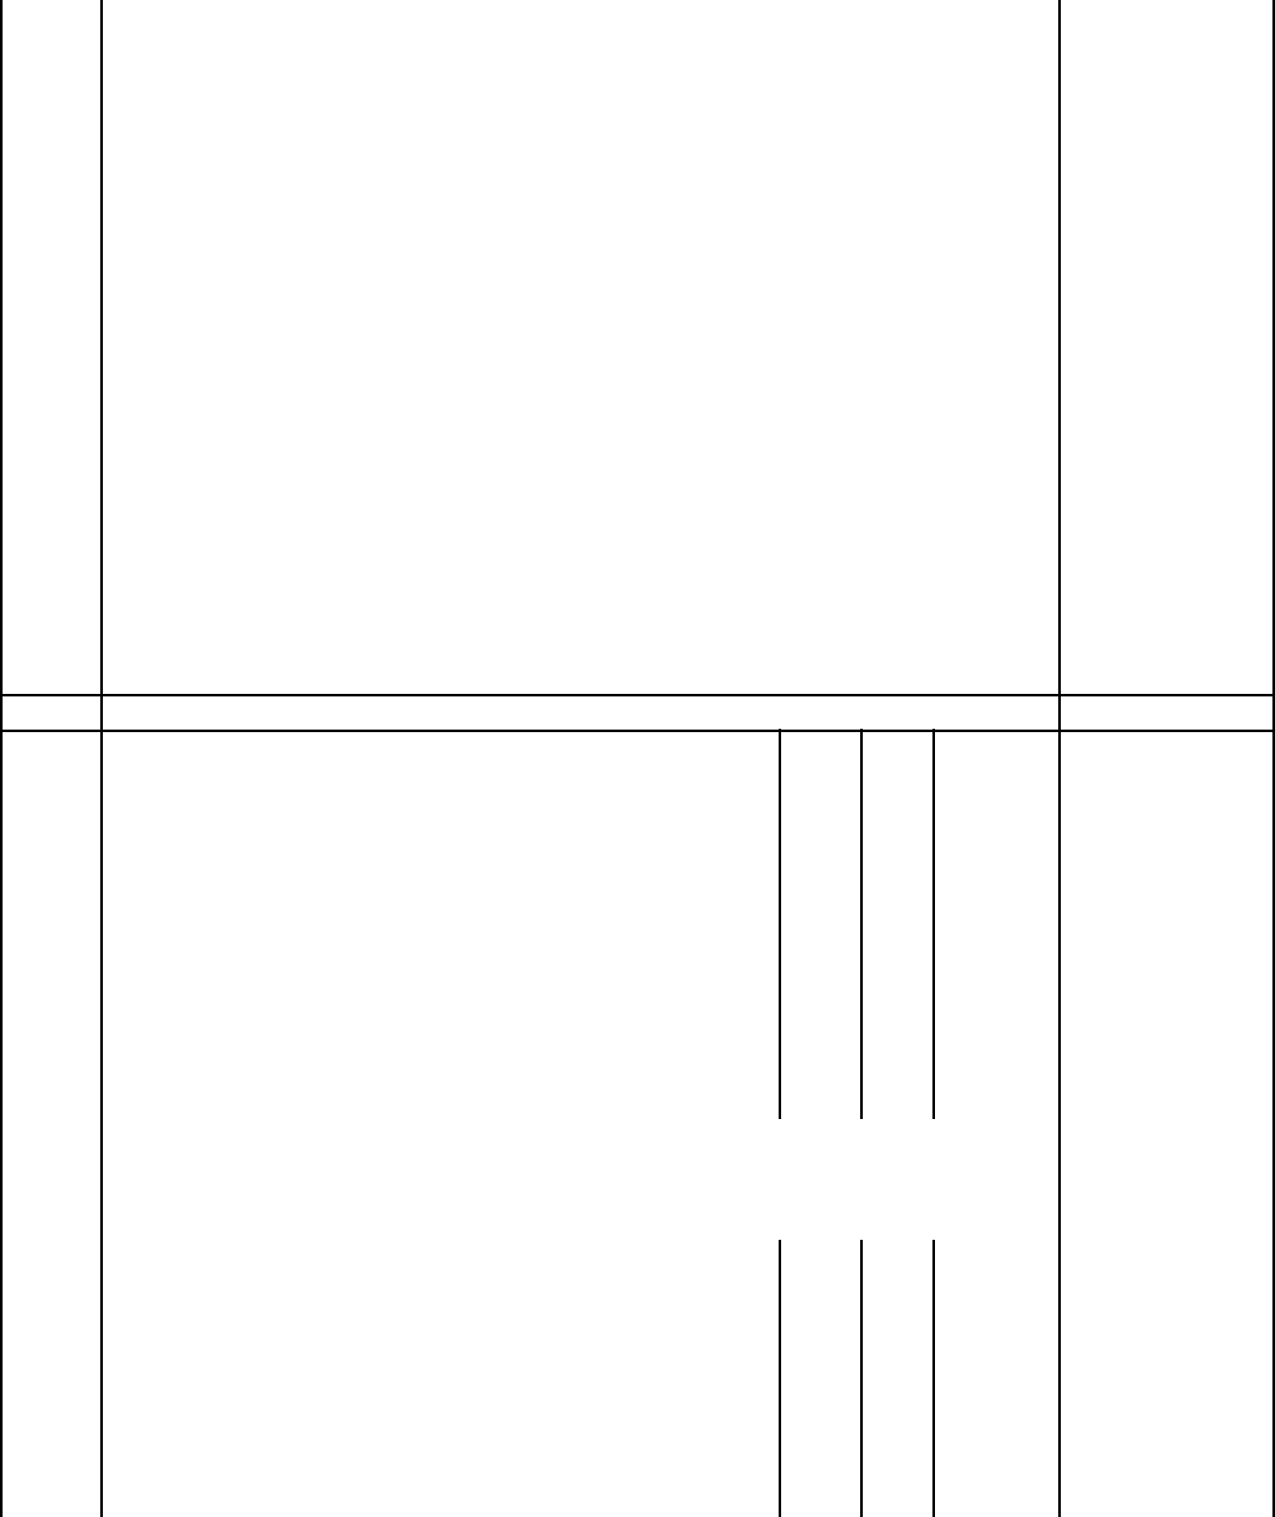 | Prepare and apply one coat etching primer, one
 | undercoat and two coats gloss oil paint to Crown Solo or |  |  |  |  |  |  |  |  |  |  |  | -
 | other equal and approved to: - |  |  |  |  |  |  |  |  |  |  |  | -
B | General surfaces of glazed casement metal doors; over 300mm |  |  |  |  |  |  |  |  |  |  |  | -
B | girth internal |  |  |  |  |  |  |  |  | 16 | sm | 700.00 | 11,200.00
 |  |  |  |  |  |  |  |  |  |  |  |  | -
 | On wood |  |  |  |  |  |  |  |  |  |  |  | -
 | Aluminium primer or other equal and approved wood |  |  |  |  |  |  |  |  |  |  |  | -
 | primer before fixing: - |  |  |  |  |  |  |  |  |  |  |  | -
C | Backs of frame, board, etc over 100mm but not exceeding 200mm |  |  |  |  |  |  |  |  | 80 | lm | 150.00 | 12,000.00
C | girth
 | Knot, prime and stop; prepare and apply one undercoat |  |  |  |  |  |  |  |  |  |  |  | -
 | and two coats of gloss oil paint |  |  |  |  |  |  |  |  |  |  |  | -
 |  |  |  |  |  |  |  |  |  |  |  |  | -
D | General surfaces of timber doors over 300mm girth; external |  |  |  |  |  |  |  |  |  |  |  | -
D |  |  |  |  |  |  |  |  |  | 53 | sm | 300.00 | 15,900.00
 |  |  |  |  |  |  |  |  |  |  |  |  | -
 |  | Carried to Collection |  |  |  |  |  |  |  |  |  |  | 45,400.00

COLLECTION

From page BW / 7 | 851,800.00

From above | 45,400.00
TOTAL FOR DOORS CARRIED TO SUMMARY | 897,200.00

ELEMENT NO. 5

WINDOWS

Bull-nosed burnt clay, finishing fair on all exposed

surfaces and hoisting and placing in position, bedding,

jointing and pointing in pigmented cement and sand (1:3) mortar
A | 150 x 25mm thick clay window sill |  | 30 | lm | 100.00 | 3,000.00
B | 6mm thick ceramic tiles finish to internal surfaces of window
B | sills; 150mm girth |  | 30 | lm | 200.00 | 6,000.00
 | Wrot Mahogany
C | 150 x 25 mm thick window boards including bull-nosed edges and
C | 25 x 25 mm bearer; plugged, counter sinking |  | 30 | lm | 100.00 | 3,000.00
 | Curtain Tracks;

 |  | Carried to Collection |  |  |  |  |  |  |  |  |  |  |  |  |  |  |  | 12,000.00
 | METAL WORK
 | PURPOSE - MADE UNITS
 | Supply, assemble and fix the following purpose-made
 | mild steel casement windows; standard metal section
 | from approved manufacturer complete with frames,
 | transomes, mullions and with and including permanent
 | ventilators comprising "T" bar, gauze and 16 gauge
 | sheet metal hood 50mm high x 50mm projection to full
 | width of window, coupling mullions, approved
 | ironmongery and one coat manufacturer's primer; all
 | welding ground to smooth finish.
 | Steel; for glazing with putty, lugs to two jambs, cutting and
 | pinning to concrete or blockwork, fixing to head and sill with
 | screws; plugging
A | Window, overall size 2500 x 1500mm high. |  |  |  |  |  |  |  |  |  |  |  |  |  | 3 | No | 9,000.00 | 27,000.00
B | Window, overall size 2000 x 1500mm high. |  |  |  |  |  |  |  |  |  |  |  |  |  | 3 | No | 7,800.00 | 23,400.00
C | Window, overall size 2000 x 1900mm high. |  |  |  |  |  |  |  |  |  |  |  |  |  | 9 | No | 7,000.00 | 63,000.00
D | Window, overall size 1800 x 1500mm high. |  |  |  |  |  |  |  |  |  |  |  |  |  | 3 | No | 6,000.00 | 18,000.00
E | Window, overall size 800 x 900mm high . |  |  |  |  |  |  |  |  |  |  |  |  |  | 9 | No | 3,000.00 | 27,000.00
F | Window, overall size 1000 x 1900mm high . |  |  |  |  |  |  |  |  |  |  |  |  |  | 4 | No | 5,150.00 | 20,600.00

 |  | Grills
 |  | High tensile steel burglar proof bars at 300mm cross
 |  | centres horizontal and vertical; ends lugged in masonry.
K |  | 12mm diameter bars welded and ground smooth to approval. |  |  |  |  |  |  |  |  |  | 50 | sm | 6,000.00 | 300,000.00
 |  | Glazing
L |  | 4mm Thick clear sheet glass panes over 0.1 but not exceeding 0.5 |  |  |  |  |  |  |  |  |  | 50 | sm | 1,200.00 | 60,000.00
L |  | square meters; fixing with putty
M |  | Ditto but obscured panes ditto |  |  |  |  |  |  |  |  |  | 8 | sm | 2,200.00 | 17,600.00
 |  |  |  |  |  | Carried to Collection |  |  |  |  |  |  |  |  | 556,600.00
 |  | Painting and Decorations
 |  | On Metal work
 |  | Prepare and apply three coats oil paint full gloss to
 |  | Crown Solo or other equal and approved to: -
A |  | General window surfaces; over 300mm girth. |  |  |  |  |  |  |  |  |  | 40 | sm | 300.00 | 12,000.00
B |  | Surfaces of metal over 300mm girth (burglar proofing grills) |  |  |  |  |  |  |  |  |  | 40 | sm | 300.00 | 12,000.00
 |  |  |  |  |  | Carried to Collection |  |  |  |  |  |  |  |  | 24,000.00
 |  | COLLECTION
 |  | From page BW / 9 |  |  |  |  |  |  |  |  |  |  |  |  | 12,000.00
 |  | From page BW / 10 |  |  |  |  |  |  |  |  |  |  |  |  | 556,600.00
 |  | From above |  |  |  |  |  |  |  |  |  |  |  |  | 24,000.00

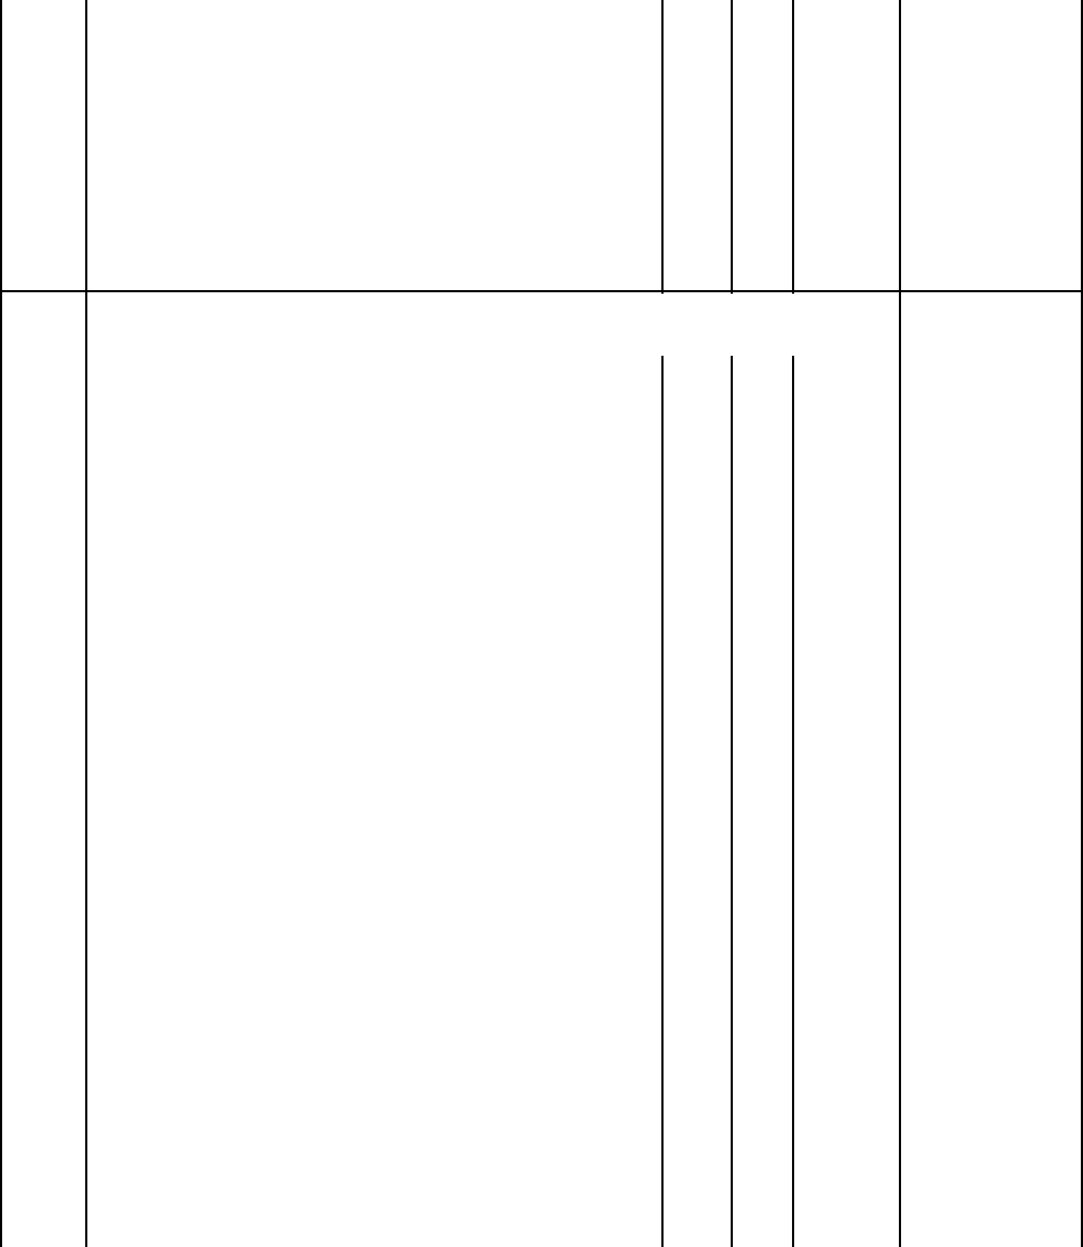

TOTAL FOR WINDOWS CARRIED TO | 592,600.00
SUMMARY | 592,600.00

ELEMENT NO. 6

FINISHES

Wall finishes

Insitu finishes

Render; 18mm thick, 1 No. coatwork of cement and

sand (1:3); wood floated to concrete or blockwork base

generally to: -

A | Walls, beams and columns; external | 46 | sm | 700.00 | 32,200.00

Plaster; 18mm thick, 2 No. coatwork, 12mm first coat

of cement sand (1:3); 3mm second coat of cement and

B | Walls, beams and columns; internal |  |  | 1423 | sm | 900.00 | 1,280,700.00
 | Ceramic Floor tiles
C | Supplly and fix ceramic tiles approved by Client and Architect |  |  | 456 | sm | 3,150.00 | 1,436,400.00
 | Skirting.
D |  |  |  | 742 | lm | 1,150.00 | 853,300.00
D | 100x50mm thick wood perquette skirting

Beds or Backings

Render; cement and sand (1:3)
 |  | 14mm thick one coat backings; wood floated to receive ceramic
F |  | tiles (m/s) to concrete or blockwork base; to walls internal |  |  |  |  |  |  |  |  |  |  |  |  |  |  |  |  | 34 | sm | 550.00 | 18,700.00
 |  | Painting and decorations
 |  | Prepare and apply one undercoat and three coats of first
 |  | quality plastic emulsion paint to: -
G |  | Plastered walls |  |  |  |  |  |  |  |  |  |  |  |  |  |  |  |  | 1623 | sm | 300.00 | 486,900.00
 |  |  | Carried to Collection |  |  |  |  |  |  |  |  |  |  |  |  |  |  |  |  |  |  | 4,108,200.00
A |  | Wood floated rendered surfaces |  |  |  |  |  |  |  |  |  |  |  |  |  |  |  |  |  | sm |  | 13,800.00
A |  |  |  |  |  |  |  |  |  |  |  |  |  |  |  |  |  |  | 46 | sm | 300.00 | 13,800.00
 |  | Floor finishes (Wet Areas)
 |  | Tile, Slab or Block Finishings
 |  | Imported porcelein tiles as supplied by "Tiles and Carpet
 |  | Centre" or other equal and approved supplier; approved
 |  | colour to regular or other approved pattern; bedding and
 |  | jointing in cement sand (1:4) mortar
B |  | 330 x 330 x 8mm thick; butt joints both ways; to cement sand base
B |  | (m/s); to walls and floors; internal |  |  |  |  |  |  |  |  |  |  |  |  |  |  |  |  | 78 | sm | 1,100.00 | 85,800.00
C |  | 100 mm thick skirting; straight junction with wall and floor finish. |  |  |  |  |  |  |  |  |  |  |  |  |  |  |  |  | 48 | lm | 250.00 | 12,000.00
 |  | Ceiling finishes ( Gypsum)
 |  | 12mm (minimum) two-coat plaster; 9mm first coat of
 |  | cement sand (1:6), 3mm second coat of cement and lime
 |  | putty (1:10); steel trowelled to: -
D |  | Concrete soffits |  |  |  |  |  |  |  |  |  |  |  |  |  |  |  |  | 50 | sm | 300.00 | 15,000.00
 |  | Wrot cypress
E |  | 75 x 25mm moulded cornice |  |  |  |  |  |  |  |  |  |  |  |  |  |  |  |  | 103 | lm | 180.00 | 18,540.00
 |  | Approved sawn softwood; second grade; pressure impregnated.
F |  | 75 x 50mm brandering |  |  |  |  |  |  |  |  |  |  |  |  |  |  |  |  | 700 | lm | 350.00 | 245,000.00
G |  | 75 x 50mm ditto; plugged |  |  |  |  |  |  |  |  |  |  |  |  |  |  |  |  | 70 | lm | 550.00 | 38,500.00

 |  | GYSPSUM FINISHINGS
H |  | 18mm thick ceiling board fixed to aluminum hanges (m/s);
H |  | punched and puttied |  |  |  |  |  |  |  |  |  |  |  |  | 139 | sm | 2,950.00 | 410,050.00
 |  |  |  | Carried to Collection |  |  |  |  |  |  |  |  |  |  |  |  |  | 838,690.00
 |  | Extra; access panels 600 x 600mm, 50 x 50mm softwood framing
A |  | all round; fixing with chromium plated screws and cup washers |  |  |  |  |  |  |  |  |  |  |  |  | 3 | No. | 1,800.00 | 5,400.00
 |  |  |  |  |  |  |  |  |  |  |  |  |  |  |  |  |  | -
 |  | Painting and Decorations |  |  |  |  |  |  |  |  |  |  |  |  |  |  |  | -
 |  | Prepare and apply one undercoat and three coats of first |  |  |  |  |  |  |  |  |  |  |  |  |  |  |  | -
 |  | quality emulsion paint to the following surfaces |  |  |  |  |  |  |  |  |  |  |  |  |  |  |  | -
 |  |  |  |  |  |  |  |  |  |  |  |  |  |  |  |  |  | -
B |  | Steel trowelled surfaces |  |  |  |  |  |  |  |  |  |  |  |  | 165 | sm | 1,800.00 | 297,000.00
C |  | ceiling boards |  |  |  |  |  |  |  |  |  |  |  |  | 139 | sm | 1,800.00 | 250,200.00
D |  | Moulded cornice not exceeding 100mm girth |  |  |  |  |  |  |  |  |  |  |  |  | 207 | lm | 290.00 | 60,030.00
 |  | Plaster; 18mm thick, 2 No. coatwork, 12mm first coat
 |  | of cement sand (1:3); 3mm second coat of cement and |  |  |  |  |  |  |  |  |  |  |  |  |  |  |  | -
 |  | lime putty (1:9); steel trowelled to concrete or |  |  |  |  |  |  |  |  |  |  |  |  |  |  |  | -
 |  | blockwork base generally to: -
 |  |  |  |  |  |  |  |  |  |  |  |  |  |  |  |  |  | -
G |  | Soffits of sloping staircase |  |  |  |  |  |  |  |  |  |  |  |  | 18 | sm | 320.00 | 5,760.00
 |  | Prepare and apply one undercoat and three coats of first |  |  |  |  |  |  |  |  |  |  |  |  |  |  |  | -
 |  | quality plastic emulsion paint to: - |  |  |  |  |  |  |  |  |  |  |  |  |  |  |  | -
H |  | Soffits of sloping staircase |  |  |  |  |  |  |  |  |  |  |  |  | 18 | sm | 300.00 | 5,400.00
 |  |  |  |  |  |  |  |  |  |  |  |  |  |  |  |  |  | -
 |  | Balustrades |  |  |  |  |  |  |  |  |  |  |  |  |  |  |  | -
 |  | Allow a provisional sum of Kenya shillings of Two hundred and |  |  |  |  |  |  |  |  |  |  |  |  |  |  |  | -
I |  | fifty thousand for stain-less steel balustrading |  |  |  |  |  |  |  |  |  |  |  |  | 1 | item | 250,000.00 | 250,000.00
 |  |  |  | Carried to Collection |  |  |  |  |  |  |  |  |  |  |  |  |  | 873,790.00
 |  | COLLECTION
 |  | From page BW / 12 |  |  |  |  |  |  |  |  |  |  |  |  |  |  |  | 4,108,200.00
 |  | From page BW / 13 |  |  |  |  |  |  |  |  |  |  |  |  |  |  |  | 838,690.00

 |  | From page above |  |  |  |  |  |  |  |  |  |  |  |  |  | 873,790.00
 |  |  | TOTAL FOR FINISHES CARRIED TO SUMMARY |  |  |  |  |  |  |  |  |  |  |  |  | 5,820,680.00
 |  | ELEMENT NO.8
 |  | ROOFING CONSTRUCTION
 |  | Clay tiles roof covering at 30 degrees pitch
 |  | Roof covering; 150mm laps on one end and one and a half
A |  | corrugation side lap; and nailing to 75 x 50mm celcured sawn |  |  |  |  |  |  |  |  |  |  | 242 | sm | 3,650.00 | 883,300.00
A |  | cypress purlins (m/s) to receive interlocking tiles (m/s)
B |  | Extra over for raking cutting |  |  |  |  |  |  |  |  |  |  | 46 | lm | 450.00 | 20,700.00
 |  | Accessories, fixing as necessary to roof sheets
 |  | CARPENTRY
 |  | The following in sawn celcured cypress timber trusses;
 |  | nailed connections, spanning, hoisting 14.40m above
 |  | ground
C |  | 150 x 50mm rafters and tie beam |  |  |  |  |  |  |  |  |  |  | 777 | lm | 450.00 | 349,650.00
D |  | 100 x 50mm struts and ties |  |  |  |  |  |  |  |  |  |  | 308 | lm | 300.00 | 92,400.00
E |  | 150 x 50mm king-post |  |  |  |  |  |  |  |  |  |  | 91 | lm | 350.00 | 31,850.00
F |  | 150 x 25mm nailing plates |  |  |  |  |  |  |  |  |  |  | 217 | lm | 320.00 | 69,440.00
 |  | The following in sawn celcured cypress
G |  | 100 x 50mm wall plate rag-bolted at 1200mm centres with 12mm |  |  |  |  |  |  |  |  |  |  | 84 | lm | 200.00 | 16,800.00
G |  | diameter bolts (m/s)
H |  | 200 x 40mm ridge board |  |  |  |  |  |  |  |  |  |  | 49 | lm | 350.00 | 17,150.00
I |  | 75 x 50mm purlins |  |  |  |  |  |  |  |  |  |  | 134 | lm | 180.00 | 24,120.00
 |  |  |  |  | Carried to Collection. |  |  |  |  |  |  |  |  |  |  | 1,505,410.00
 |  | The following in wrot cypress
A |  | 200 x 25mm thick facsia/barge board |  |  |  |  |  |  |  |  |  |  | 49 | lm | 400.00 | 19,600.00
 |  | 25 x 100mm Tongue & Grooved boarding secret nailed to and
B |  | including 50 x 50mm celcured wrot cypress bearers or brandering |  |  |  |  |  |  |  |  |  |  | 92 | sm | 1,300.00 | 119,600.00
B |  | at 600mm centres

 |  | Labour and material (Provisional)
C |  | 12mm diameter rag bolt, 200mm long complete with and
C |  | including head, nut and two washers; cast into and including
 |  | mortice in stone or concrete and run with cement and sand (1:3)
 |  | mortar |  |  |  |  |  |  |  |  |  |  |  | 62 | No | 100.00 | 6,200.00
D |  | Drill 50mm thick timber to receive 12mm dia. Bolt |  |  |  |  |  |  |  |  |  |  |  | 62 | No. | 50.00 | 3,100.00
 |  | RAINWATER DISPOSAL
 |  | 26g Galvanised mild steel sheeting
 |  | Raking flashing overall 400mm girth with top end turned and
E |  | wedged into and including 50 x 50mm mortice in stone or |  |  |  |  |  |  |  |  |  |  |  | 74 | lm | 350.00 | 25,900.00
E |  | concrete and rin in with cement and sand (1:3) mortar and bottom
 |  | edge dressed over roofing
 |  | 24g Galvanised mild steel sheeting; all welds ground smooth
 |  | 150 x 100mm box gutter including soldered joints in the running
E |  | length fixed to fascia board with and including brackets at |  |  |  |  |  |  |  |  |  |  |  | 74 | lm | 450.00 | 33,300.00
E |  | approved centers
F |  | Extra; ends |  |  |  |  |  |  |  |  |  |  |  | 12 | No | 350.00 | 4,200.00
G |  | Extra; 100mm dia.outlet 100mm long |  |  |  |  |  |  |  |  |  |  |  | 12 | No | 300.00 | 3,600.00
H |  | 100mm dia. rainwater downpipe fixed with and including mild
H |  | steel straps at 900mm centres, plugged and screwed to wall
 |  |  |  |  |  |  |  |  |  |  |  |  |  | 178 | lm | 400.00 | 71,200.00
I |  | Extra; swanneck bend with 1135mm projection |  |  |  |  |  |  |  |  |  |  |  | 6 | No | 300.00 | 1,800.00
J |  | Extra; horse shoe bend |  |  |  |  |  |  |  |  |  |  |  | 6 | No | 300.00 | 1,800.00
 |  |  | Carried to Collection. |  |  |  |  |  |  |  |  |  |  |  |  |  | 290,300.00
 |  | Painting and Decorations
 |  | On Woodwork
 |  | Prepare and apply one zinc plumbate primer and three
 |  | coats of 'CROWN SOLO' or other equal and approved
 |  | super gloss oil paint to:-
A |  | Fascias; 200 to 300mm girth; external |  |  |  |  |  |  |  |  |  |  |  | 48 | lm | 150.00 | 7,200.00

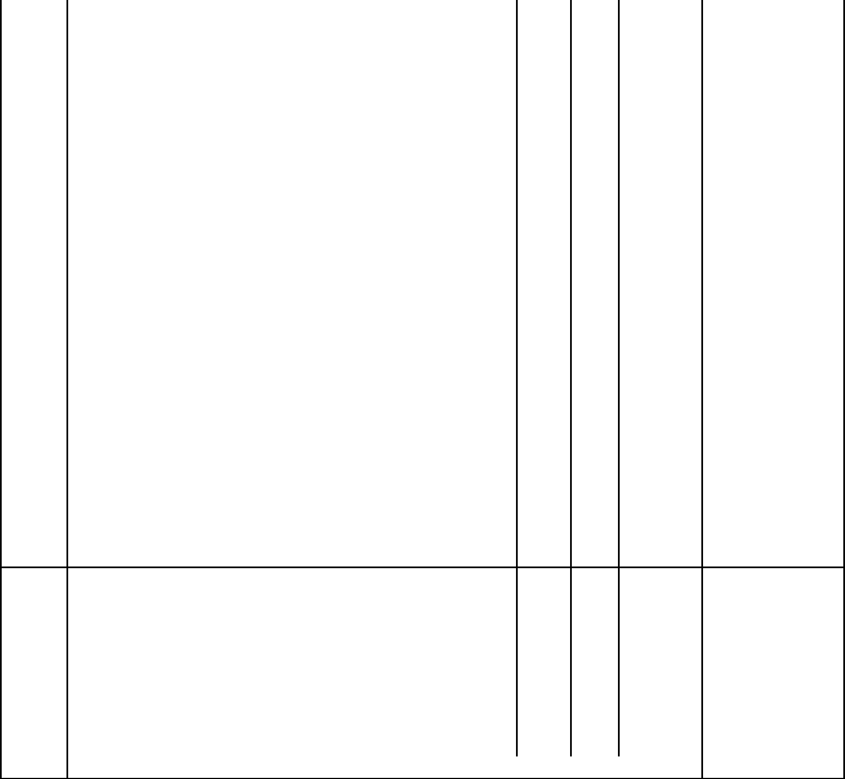 | On Metal work
B | General surfaces of gutters; over 300mm girth external |  |  |  |  | 76 | sm | 300.00 | 22,800.00
C | Small pipes |  |  |  |  | 36 | lm | 150.00 | 5,400.00
 | Tongue & Grooved timber surfaces
 | Prepare and apply three coats of 'CROWN SOLO' or
 | other equal and approved polyurethane varnish to:-
D | Surfaces of eaves; over 300mm girth external |  |  |  |  | 92 | sm | 300.00 | 27,600.00

 | Carried to collection |  | 63,000.00
 | COLLECTION
 | From page BW / 14 |  | 1,505,410.00
 | From page BW / 15 |  | 290,300.00
 | From above |  | 63,000.00
 | TOTAL FOR ROOF CONSTRUCTION. |  | 1,858,710.00

ITEM |  | DESCRIPTION |  | QTY | UNIT | RATE | K.SHS
 |  | SUMMARY
1 |  | SUBSTRUCTURES (PROVISIONAL) |  |  |  |  | 2,257,800.00
2 |  | FRAME |  |  |  |  | 1,704,990.00
3 |  | WALLING |  |  |  |  | 1,064,650.00
5 |  | DOORS |  |  |  |  | 897,200.00
6 |  | WINDOWS |  |  |  |  | 592,600.00
7 |  | FINISHES |  |  |  |  | 5,820,680.00
8 |  | ROOF CONSTRUCTION |  |  |  |  | 1,858,710.00
9 |  | ALLOW FOR ELECTRICAL WORKS |  |  |  |  | 450,000.00
10 |  | ALLOW FOR PLUMBING & DRAINAGE WORKS |  |  |  |  | 200,000.00
11 |  | ALLOW FOR CONTINGENCIES |  |  |  |  | 200,000.00
 |  |  | TOTAL EXPENDITURE |  |  |  | 15,046,630.00

