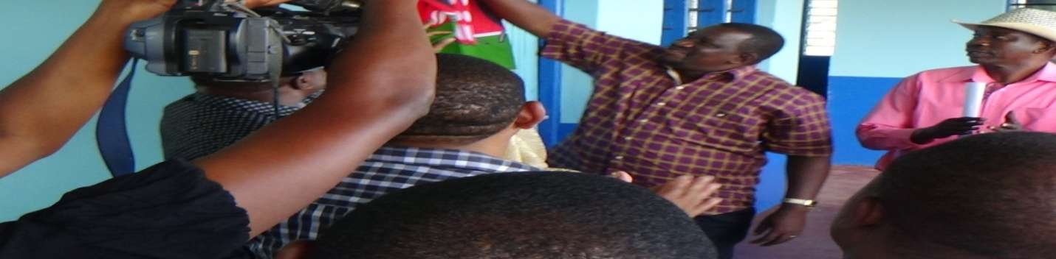

OFFICIAL OPENING OF MBITA DISPENSARY BY HIS EXCELLENCY HON. SALIM MVURYA – GOVERNOR, KWALE COUNTY

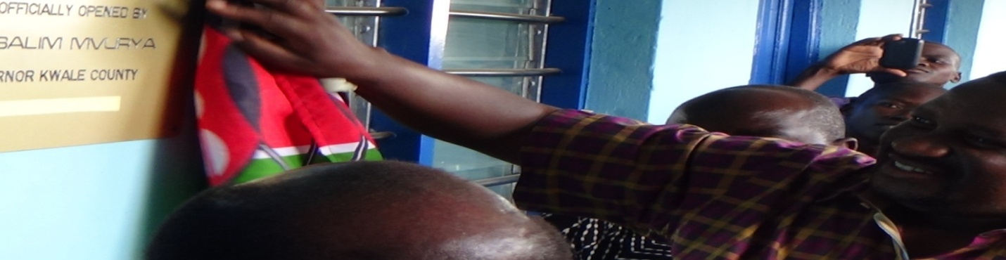

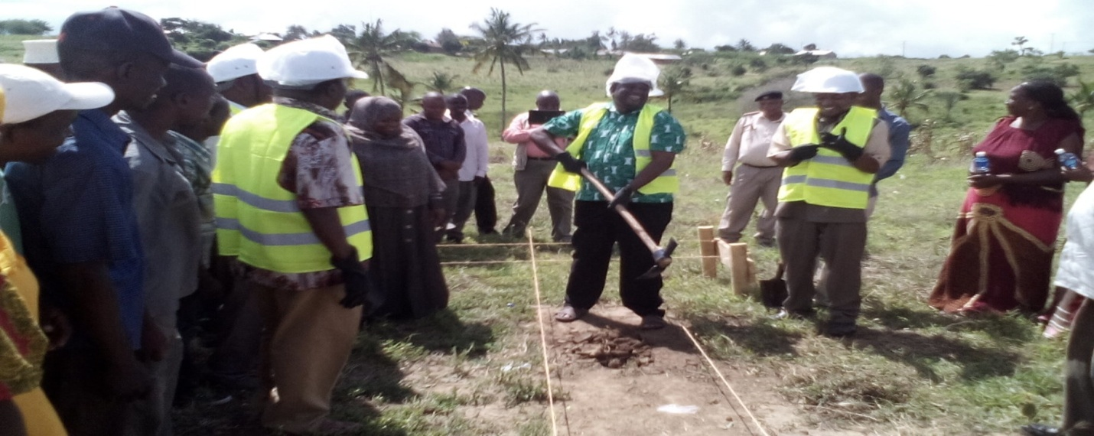

GROUND BREAKING CEREMONY FOR THE CONSTRUCTION OF SALIM MVURYA SECONDARY SCHOOL BY HIS EXCELLENCY HON. SALIM MVURYA – GOVERNOR, KWALE COUNTY

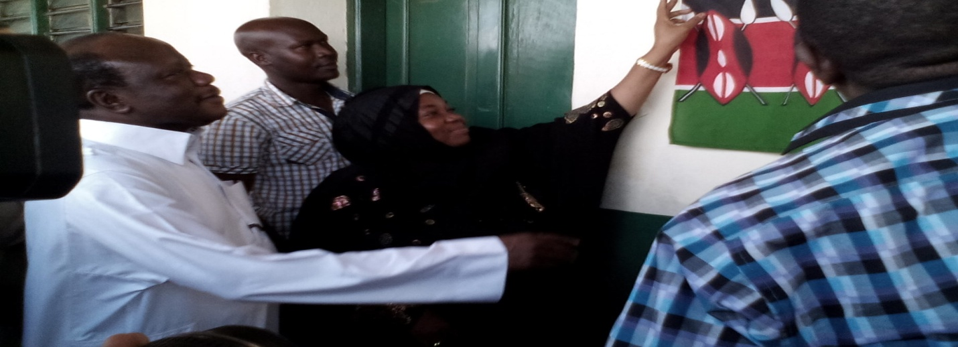

OFFICIAL OPENING OF TARU GIRLS SECONDARY SCHOOL BY HER EXCELLENCY HON. ACHANI – DEPUTY GOVERNOR, KWALE COUNTY

