**Constituencies Development Fund Management Information System**

**(CDFMIS)**



Project Management Module

Operations User Manual

Version 1.2

2014

TABLE OF CONTENTS

INTRODUCTION 1

ACRONYMS 1

CHANGE TRACKING 2

SYSTEM OVERVIEW 3

**OPERATIONS ENVIRONMENT** 4

**OPERATIONS RESPONSIBILITIES** 5

**SYSTEM LOG-IN** 7

**DATA MAINTENANCE ACTIONS** 10

**SYSTEM LOG-OFF** 11

SYSTEM SETUP 11

**REGIONS SETUP** 12

**COUNTIES SETUP** 15

**CONSTITUENCIES SETUP** 19

**USER ACCOUNTS SETUP** 22

EMPLOYEES SETUP 23

MEMBERS SETUP 26

**LOCATIONS AND INSTITUTIONS SETUP** 32

CONSTITUENCY LOCATIONS SETUP 32

SUB LOCATIONS SETUP 34

ACADEMIC INSTITUTIONS SETUP 35

**FINANCIAL YEAR SETUP** 38

**SECTORS SETUP** 40

PROJECTS SYSTEM SECTORS SETUP 40

**CONTRACTORS/SUPPLIERS SETUP** 42

**GFS CODES SETUP** 44

**COMPLAINTS SETUP** 45

FUNDS MANAGEMENT 50

ALLOCATIONS 50

**DISBURSEMENTS** 54

PROJECT MANAGEMENT 55

**PROJECT LIFE CYCLE** 55

**ADDING A NEW PROJECT** 58

**SUBMITTING PROPOSALS TO THE HEADQUARTERS** 63

**APPROVING PROJECT PROPOSALS: HEADQUARTERS** 64

APPROVING A PROPOSAL 66

PROJECT APPROVAL PROCESS 67

**APPROVE PROJECT** 69

**REJECTION** 71

HEADQUARTERS PROJECT CYCLE 75

CONSTITUENCY PROJECT MANAGEMENT 79

**PROJECT DISBURSEMENT** 81

PMC Bank Accounts 82

Project Disbursement Process 82

**PROJECT TENDERING** 83

**BIDDING** 84

**AWARD TENDER** 86

**PROJECT REALLOCATION** 87

PROCESSING REALLOCATION AT HEAD OFFICE 90

EVALUATION 91

**PROJECT PAYMENTS** 92

**MONITORING AND EVALUATION** 94

TENDERS MENU 96

PROJECTS BY SECTOR MENU 96

**BURSARIES MENU** 97

NEW BURSARY APPLICATION 98

PAYMENTS 102

BURSARY ALLOCATIONS 104

BUDGET AND FINANCE MENU 104

**FINANCE ALLOCATIONS MENU** 107

**DISBURSEMENTS** 108

**OFFICE PAYMENTS** 109

COMPLAINTS 111

**COMPLAINTS REGISTER** 111

**NEW COMPLAINT** 112

**VIEW COMPLAINT DETAILS** 113

APPENDIX 114

**PROJECTS REPORTS CHECKLIST** 114

**PROJECT SECTOR CODES** 117

**OPERATIONS POLICIES** 119

# INTRODUCTION

This document aims to provide guidelines for operating the projects module of the CDFMIS in a consistent manner. It excludes procedures for other modules.

There is a change tracking table which serves to record changes to the document and capture the version in use at any given time.

The main operations processes fall under System Setup, Funds Management, Project Management and Complaints Management. This document provides step by step procedures for these processes to guide users. It is expected that these procedures may be updated to ensure consistency between the systems applications design and CDF operations requirements often guided by the Government. The appendix section captures essential references which again could be updated from time to time to ensure relevance.

# ACRONYMS

|  |  |
| --- | --- |
| FAM | Fund Account Manager |
| UAT | User Acceptance Test |
| CDFC | Constituency Development Fund Committee |
| PMC | Project Management Committee |
|  |  |

# 

# CHANGE TRACKING

An operation manual such as this one must be a live document that is reviewed from time to time to ensure it is in line with operations changes that may need to be introduced. The reviews need to be tracked as regards sources, changes incorporated and authorisations. This ensures that visibility and controls are maintained. The table below provides the tool for the said tracking. The latest version should be inserted above the earlier ones, thus should always be at the top.

|  |  |  |  |  |
| --- | --- | --- | --- | --- |
| **Current document version** | **Replaced document version** | **Changes incorporated** | **Effective date** | **Authority** |
| Version 1.1 | Initial draft used during the previous User Acceptance Test (UAT) | 1. Corrections requested by the UAT team. 2. Correction of typos 3. Introduction of this tracking template |  | Chief ICT Officer – Jack Odhoch |
| Version 1.2 | Second Draft after UAT | 1. Inserted and updated Screen Shots 2. Corrected Typos | 13/02/2014 | Chief ICT Officer – Jack Odhoch |

# SYSTEM OVERVIEW

**CDFMIS: WHAT IT DOES**

CDFMIS stores, organizes and makes access to project and financial information easy. It not only stores all the information relating to current and past years’ projects, but also stores the approved budgets for these years, details on inflows and outflows of funds.

CDFMIS will:

* Provide timely, accurate, and consistent data for management and budget decision-making;
* Support government-wide policy decisions;
* Integrate budget and project execution data, allowing greater financial control and reducing opportunities for discretion in the use of public funds;
* Provide information for budget planning, analysis and government-wide reporting;
* Provide a complete audit trail to facilitate audits.

The CDFMIS Projects database is composed of four different functional aspects, each corresponding to a set of tasks the constituency must carry out as a part of its mission.

These sections include:

* Project Information;
* Bursaries Information
* Budget and Finance Information; and
* Complaints Information.

1. The Project Information portion of the database allows the user to:

* Enter and track all of the projects under its guidance;
* Monitor the progress of major milestones for each project;
* Track the various documents used to conceptualize, authorize, establish, fund, amend, etc.; a project;
* and monitor the performance audit and project evaluation information gathered.

1. The Bursaries Information portion of the database allows the user to:

* Enter and track all of bursary applications under its guidance;
* Monitor the payments for each student and institution.

1. The Budget and Finance Information portion of the database allows the user to:

* Plan and monitor project funding at the project level
* Monitor the funding levels/FY obligations from the Government

1. The Complaints Information portion of the database allows the user to:

* Enter and track all the complaints brought to it under its guidance
* Monitor the progress of the complaint and any resolutions done on it

## **OPERATIONS ENVIRONMENT**

Data and Applications Software are stored in servers at the computer centre located at CDF Headquarters in Nairobi. Operations data are entered at the various user locations at the Constituencies and Head office.

Interconnectivity of the system is through Wide Area Network between the constituencies and the Servers; and through Local Area Network between the Servers and Head Office workstations.

CDFMIS is operated the basis of on-line real-time; that is to say that updates occur immediately a transaction is completed; thus making information as current as the last transaction.

Access to the system will be done via the internet/intranet through use of a web browser (Internet Explorer, Mozilla Firefox, etc.). Unique user-names and passwords are given by System Administrator.

**SYSTEM SECURITY - ACCESS CONTROLS**

Security measures to protect the integrity of the data contained in the CDF MIS database are established through access controls through three complementing approaches.

* Establishing user IDs and passwords that are unique and identify with each CDF MIS user so that access and operations can linked to respective users.
* Enabling operations of only relevant and position-authorized functions through assigning appropriate access rights to the users. By design of the system security system this action will deny users access to functions that they are not authorized to perform.
* By design the system maintains records of all user log-ins that are auditable for surveillance purposes.

**Note:** It is recommended that you log-off whenever you are to step away from the workstation you logged on to avoid someone else using your access. Remember that your access right also means your responsibility for the system security.

## **OPERATIONS RESPONSIBILITIES**

**Fund Account Managers:**

They are responsible for generating, posting and maintaining projects information in the system. This covers entering the proposed funding levels for each project in their constituency. During the operating year, the Fund Manager will monitor the various documents required throughout the life-cycle of a project and, forward these documents on schedule to the CDF Head Office for approval; enter the proposed budget information for their individual constituencies; enter data from the approved funding documents for each project; and update all related information.

**Head Office Programmes Staff**

They are responsible for processing projects proposals and thereafter allocate and submit funds for approved to constituencies. The Project Management team at the Headquarter will review and evaluate records for each project coming from all constituencies and forward this data to the CDF Board for final evaluation and approval.

**ICT team at the Head Office:**

They are responsible for maintaining the system so that it operates at acceptable uptime level to support the on-line and real-time mode. They are also responsible for providing user support and access rights to the users. Users may request for support through email: [support@cdf.go.ke](mailto:support@cdf.go.ke)

## **SYSTEM LOG-IN**

To log in to the system you must have and use your unique User ID and Password. Refer to section on System Security – Access Control. If you have problems and/or want to be set up then you contact the ICT team at the Head Office.

**CDFMIS LOGIN MENU**

You log on through the Log-in menu shown below.

At the constituency, using the dropdown, select/choose your constituency

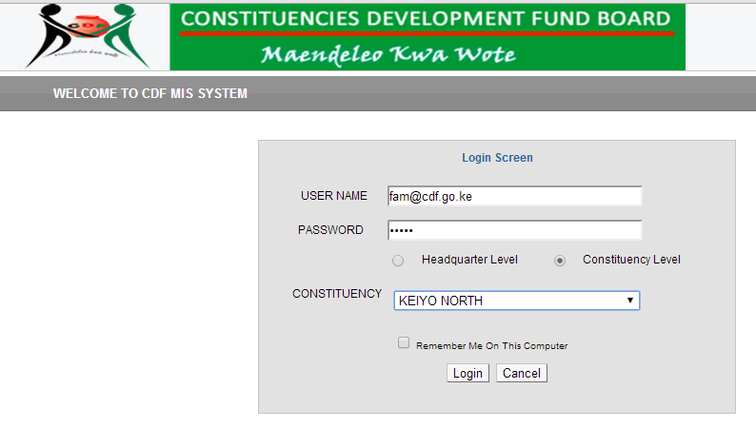

At the Head Office, select ‘Headquarter Level

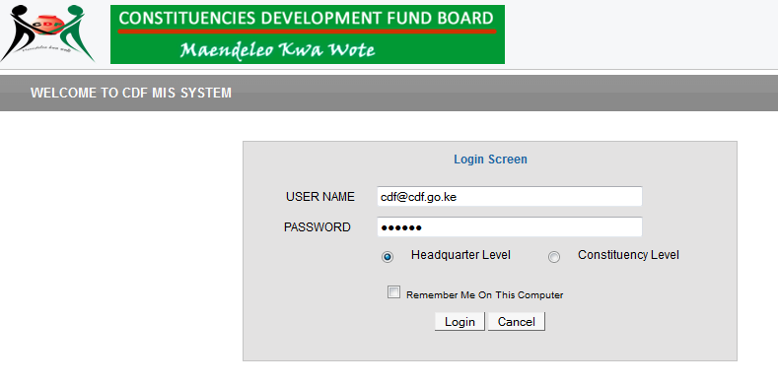

* Type your username followed by your password.
* Select your location by clicking either Headquarter Level or Constituency Level.
* If at Constituency Level select your constituency from the dropdown menu.
* Click the login or press enter

To change your password

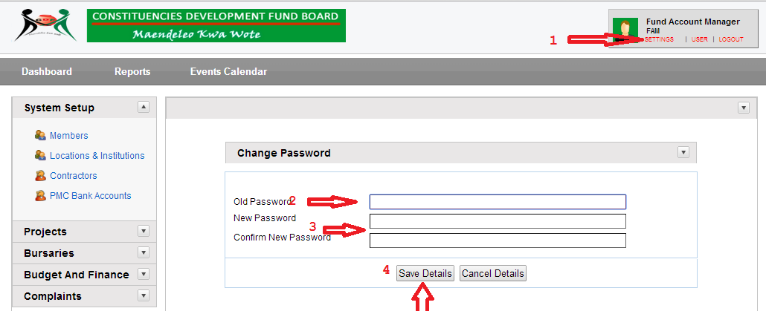

* Click on Settings
* Type your Old Password, then type and confirm your new password
* Click Save Details

From this menu users may access and perform various operations functions depending on their access rights.

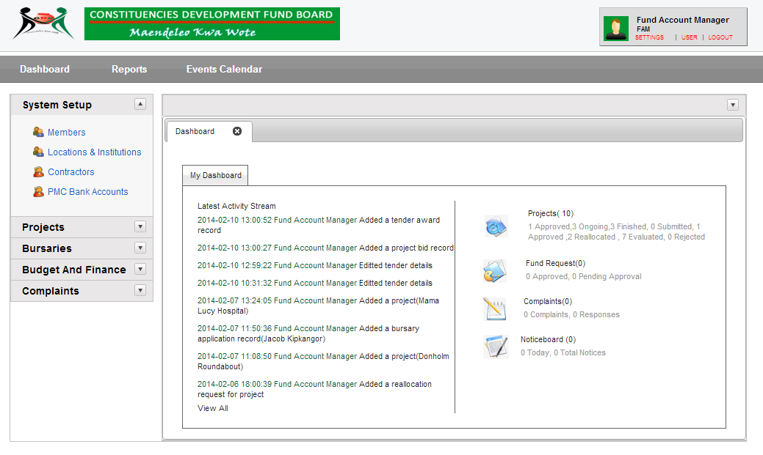

**DASHBOARD**

The system automatically, by default opens the Dashboard menu (as above) which displays status of all on-going activities in the system on real time basis.

1. **REPORTS**

This menu is used for generating and printing standard reports. Refer to Appendix section for list of the reports.

1. **EVENTS CALENDAR**

It is a diary of events for both the Head Office and at the Constituencies Levels.

1. **SYSTEM**

This is the menu through which all system configurations and settings are done.

1. **PROJECTS**

This is the menu through which projects data is entered, maintained and tracked.

1. **BURSARIES**

This is the menu through which bursaries data is entered, maintained and tracked.

1. **BUDGET AND FINANCE**

This is the menu through which data about projects budgets and funding is entered, maintained and tracked.

1. **COMPLAINTS**

This is the menu through which complaints data is entered, maintained and tracked.

## **DATA MAINTENANCE ACTIONS**

Data maintenance in the system is done through **Add, Edit,** and **Delete** actions.

For example in figure below

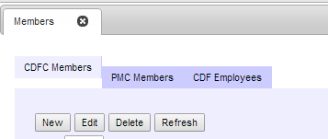

***Add/New***

The **Add** action allows authorized users to add a record to the database. When adding a record to the CDF MIS database, there are mandatory fields that must contain data before the system will process the addition. If you leave any of these fields blank, the system will prompt you and prevent you from proceeding further before data is entered in the said field.

***Edit***

The Edit action allows authorized users to make changes to data in an existing record.

To modify data in a specific field, type “New data”

When you have made all of the modifications, press the Save button.

***Delete***

The Delete action allows authorized users to delete records from the CDF MIS database. To delete a record select the record you want to delete, press the Delete button. If the system is able to successfully delete the record, the system will display a message on your screen.

***Refresh***

The Refresh action allows the user to refresh records in the CDF MIS database so that the screen gets updated with the new data.

## **SYSTEM LOG-OFF**

When you are ready to **log off** the system, click the logout button on the top right corner on the main CDF MIS screen



# SYSTEM SETUP

The System Menu comprises 6 sub-menu items as listed below: -

* Regional Settings
* User Accounts
* Financial Year
* Sectors
* GFS Codes
* Complaints Setup

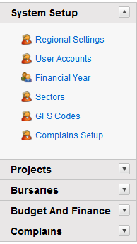

These are all contained in an Accordion style menu to make it easy to maneuver and visual style

## **REGIONS SETUP**

The Regions Setup Menu allows the Database Administrator (DBA) to access the various functions required to browse, create, edit, and delete the Regions, Counties and Constituencies.

It is divided into three tabs: -

* Regions - for defining and maintaining data for Regions.
* Counties - for defining and maintaining data for Counties which fall within Regions.
* Constituencies - for defining and maintaining data for Constituencies which fall within Counties.

On clicking ***System Setup*** screen below appears.

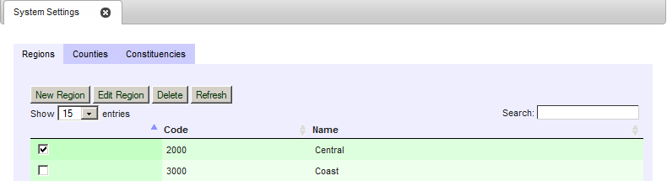

**Regions**

These are the geographical regions that define administrative boundaries of CDF management.

**Adding a New Region**

Click on **New Region** Button on the Regions Menu.

The following screen will appear.

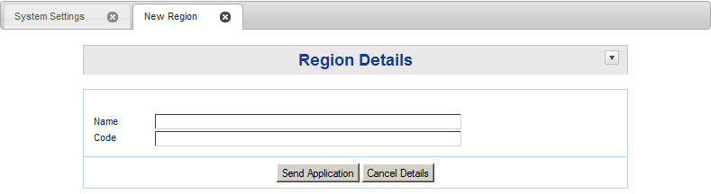

1. Enter the Name of the Region
2. Enter the unique Code for the Region. This is the primary key for the record.
3. If you want to clear the details and enter afresh, click on the Cancel Details. The screen will become blank and you can start afresh.
4. Click on Send Application to save the record in the database. If all of the data you entered passed the various edit checks built into the system, you will see the message ***“RECORD* SAVED** SUCCESSFULLY" on your screen.
5. To close the screen, click on the X button next to New Regions. This will return you to the **System Setup** Menu
6. If the record you have added does not appear on the screen click the ***REFRESH*** button on the Regions Screen for the record should appear.

**Editing a Region**

In the Regions Setup menu click the check box of the Region you want to edit.

A screen such as the one below will appear.

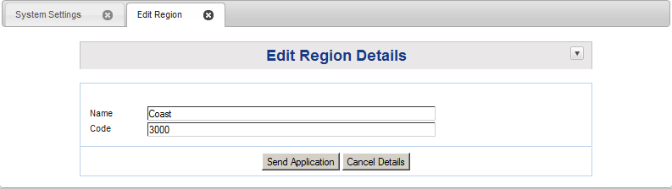

**IMPORTANT**: The system does not allow the Code of the Region to change. This is because it is a unique code specific to a region.

1. Enter the New Name of the Region
2. If you want to clear the details and enter afresh, click on the ***Cancel Details***. The Name field will become blank and you can enter it afresh.
3. Click on ***Send Application*** to save the record to the database. If all of the data you entered passed the various edit checks built into the system, you will see the message ***“RECORD* SAVED** SUCCESSFULLY" on your screen.
4. To close the screen, click on the **X** button next to Edit Regions on the screen. This will return you to the **System Setup** Menu
5. If the record you have added does not appear on the screen click the ***REFRESH*** button on the Regions Screen for the record should appear.

**Deleting a Region**

The delete action allows the authorized users to remove a record from the database. In the Regions Setup menu click the check box of the Region you want to delete and then click the ***Delete*** button.

The confirmation dialog window will appear.

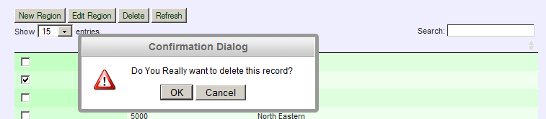

Click OK to delete the selected Region

If the system successfully deletes the record, the message **RECORD DELETED SUCCESSFULLY" will** appear on your screen**.**

Some records cannot be deleted due to data integrity if they have other data associated with it.

If the system is not able to delete the record, the following message will appear.

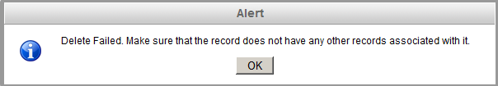

## **COUNTIES SETUP**

Back to the System Settings menu you click on the Counties tab and the following screen appears.

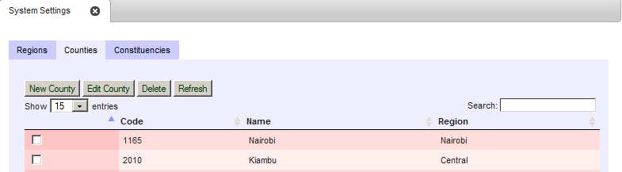

**Adding a New County**

Click **New County**.

The following screen below will appear.

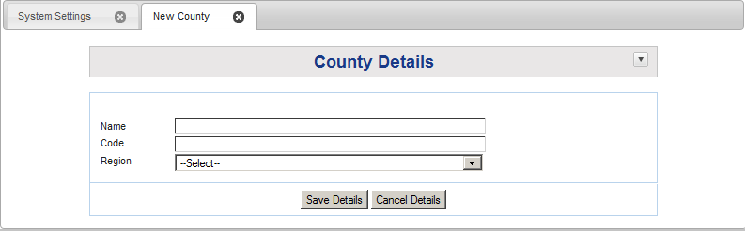

1. Enter the Name of the County
2. Enter the unique Code for the County. This is the primary key for the record.
3. From the ***Region drop down menu*** select the Region in which the County lies.
4. If you want to clear the details and enter afresh, click on the ***Cancel Details***. The screen will become blank and you can start afresh.
5. Click on ***Save Details*** to save the record to the database. If all of the data you entered passed the various edit checks built into the system, you will see the message ***“RECORD* SAVED** SUCCESSFULLY" on your screen.
6. To close the screen, click on the X button next to New County. This will return you to the ***Counties*** Menu
7. If the record you have added does not appear on the screen click the ***REFRESH*** button on the Counties Screen for the record should appear.

**Editing a County**

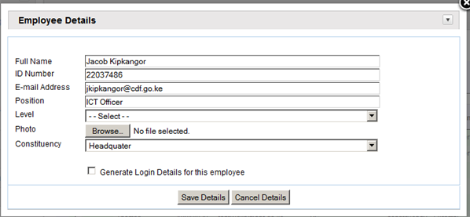

In the Counties Setup menu click the check box of the County you want to edit and a screen such as the one below will appear

.

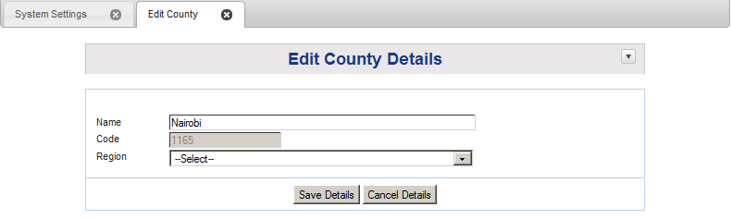

**IMPORTANT**: The system does not allow the ***Code*** of the County to change. This is because it is a unique code specific to a County.

1. Enter the New Name of the County
2. Select a new Region for the County from the ***Region*** drop down list.
3. If you want to clear the details and enter afresh, click on the Cancel Details. The Name field and Region field will become blank and you can enter them afresh.
4. Click on Save Details to save the record to the database. If all of the data you entered passed the various edit checks built into the system, you will see the message ***“RECORD* SAVED** SUCCESSFULLY" on your screen.
5. To close the screen, click on the **X** button next to Edit County. This will return you to the **Counties** Menu
6. After closing the screen and the record still reads like the old one, click on the ***REFRESH*** button on the ***Counties*** Screen. This will refresh the data and the record should show the now altered record.

**Deleting a County**

The delete action allows the user to remove a record from the database. In the Counties Setup menu click the check box of the County you want to delete and then click on the ***Delete*** button.

The confirmation dialog window will appear.

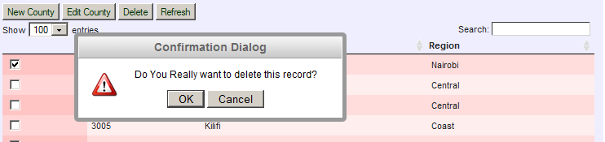

Click OK to delete the selected County.

If the system successfully deletes the record, the message **RECORD DELETED SUCCESSFULLY” will** appear on your screen**.**

Some records cannot be deleted due to data integrity if they have other data associated with it.

If the system is not able to delete the record, the following message will appear



## **CONSTITUENCIES SETUP**

Back to the System Settings menu you click on the **Constituency tab and** the screen below appears.

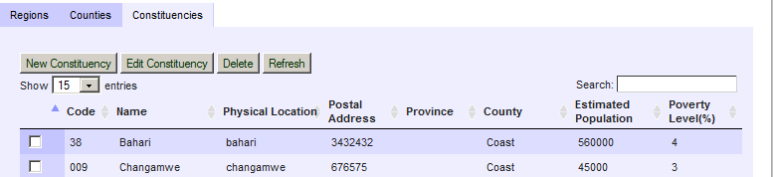

**Adding a New Constituency**

Click on **New Constituency** Button and the screen below will appear.

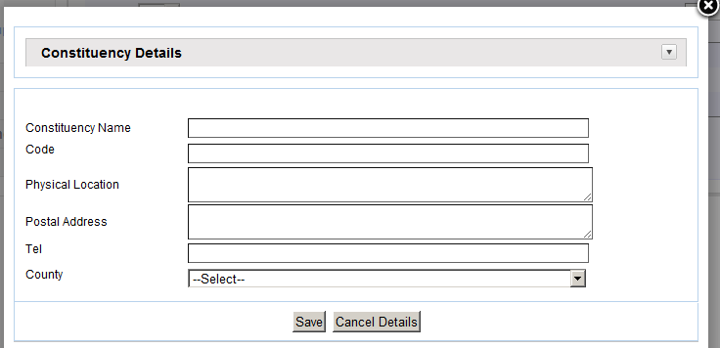

1. Enter the Name of the Constituency
2. Enter the unique Code for the Constituency. This is the primary key for the record
3. Enter the Physical location where the Constituency Office is located.
4. Enter the Postal Address of the Constituency Office.
5. Enter the Telephone number of the Constituency Office.
6. From the County drop down box, select the County in which the Constituency lies.
7. If you want to clear the details and enter afresh, click on the ***Cancel Details***. The screen will become blank and you can start afresh.
8. Click on ***Save*** to save the record to the database. If all of the data you entered passed the various edit checks built into the system, you will see the message ***“RECORD* SAVED** SUCCESSFULLY" on your screen.
9. To close the screen, click on the X button next to Edit County. This will return you to the ***Constituencies*** Menu
10. After closing the screen and the record you have added does not appear on the screen, click on the ***REFRESH*** button on the ***Constituencies*** menu. This will refresh the data and the record should appear.

**Editing a Constituency**

In the Constituencies Setup menu click the check box of the Constituency you want to edit and a screen such as the one below will appear

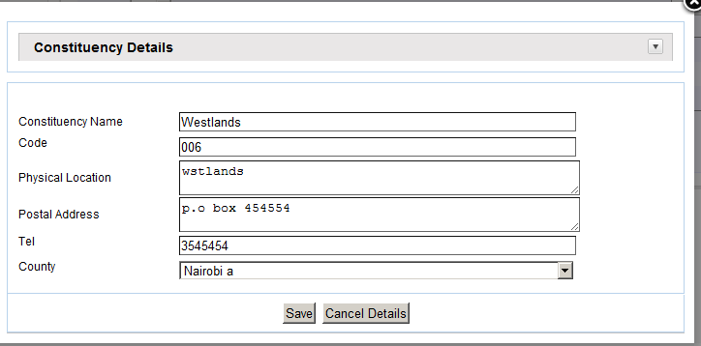

**IMPORTANT**: The system does not allow the ***Code*** of the Constituency to change. This is because it is a unique code specific to a Constituency would interfere with the data integrity of the database.

1. Type over data in the field you want to change
2. If you want to clear the details and enter afresh, click on the Cancel Details
3. Click on Save to save the record to the database. If all of the data you entered passed the various edit checks built into the system, you will see the message ***“RECORD* SAVED** SUCCESSFULLY" on your screen.
4. To close the screen, click on the **X** button on the screen. This will return you to the **Constituency** Menu
5. After closing the screen and the record still reads like the old one, click on the ***REFRESH*** button on the Constituency Menu. This will refresh the data and the record should show the now altered record.

**Deleting a Constituency**

The delete action allows an authorized user to remove a record from the database. In the Constituencies Setup menu click the check box of the Constituency you want to delete and then click on the ***Delete*** button.

The confirmation dialog window will appear.

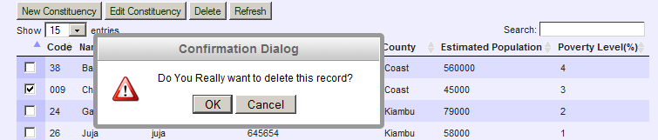

Click OK to delete the selected Constituency.

If the system successfully deletes the record, the message **RECORD DELETED SUCCESSFULLY" will** appear on your screen**.**

Some records cannot be deleted due to data integrity if they have other data associated with it.

If the system is not able to delete the record, the following message will appear



## **USER ACCOUNTS SETUP**

The User Accounts menu is used by the Database Administrator (DBA) to maintain records of the users of the CDF MIS system. A user’s roles and permissions will determine what activity they can do in the system

The User Accounts menu is divided into 3 tabs: -

* **Employees** - These are employees of the CDF who the DBA has given rights to access and use the CDF MIS system.
* **CDFC Membership** - These are the names of the various CDFC members
* **PMC Membership** - These are the names of various PMC members

In the Setup menu click on User Accounts and a screen such as the one below will appear; defaults to Employees Setup menu.

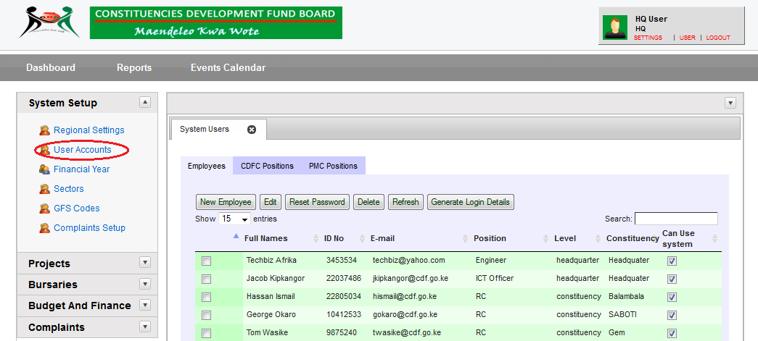

### EMPLOYEES SETUP

This is used to setup Employees of CDF.

Here you can

* Add a new employee
* Edit an employee’s details
* Reset an employee’s password
* Delete an employee
* Refresh the page
* Generate login details for the employees

To add employee click on New Employee

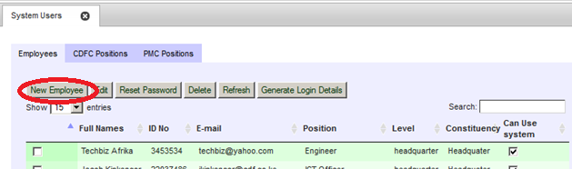

And the screen below will appear.

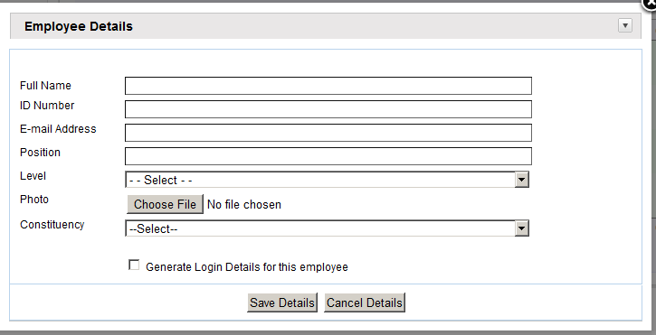

1. Enter the Full Names of the Employee
2. Enter ID Number of the Employee. This is used as the primary key for this data.
3. Enter Email address of the employee
4. Enter Position of the employee e.g. Procurement officer, IT Officer etc.
5. Select the ***Level*** *from the* ***level*** drop down list. Options are Headquarter level or Constituency level. If employee level is constituency, select the **constituency** from the constituency drop down list else move to next step.
6. Attach a photo for the employee by clicking on the **browse** button
7. Click on Generate Login Details check box **to automatically generate the password** for this employee
8. If you want to clear the details and enter afresh, click on the Cancel Details.
9. Click on Save Details to save the record to the database. If all of the data you entered passed the various edit checks built into the system, you will see the message ***“RECORD* SAVED** SUCCESSFULLY" on your screen.



**Editing an Employee record**

You may want to change some details of an employee. To do so, click Edit

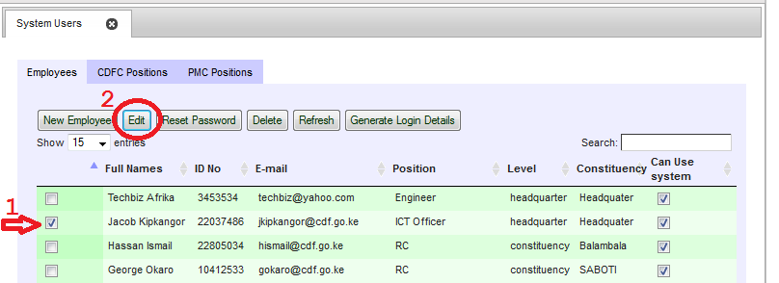

And a screen such as the one below appears



1. Type over data in the field you want to change
2. Click on Save Details to save the record to the database. If all of the data you entered passed the various edit checks built into the system, you will see the message ***“RECORD* SAVED *SUCCESSFULLY"*** on your screen.

**NOTE**: This setup is **ONLY** done by the **System Administrator** to the system

The System administrator can.

1. **Reset Password:** - This option is used when a system user has forgotten their password. This restores the password to its original format.
2. **Generate Login details**: - If a user/employee has been created, but no log in details have been assigned, click on this button and the system will create login details for this employee

### MEMBERS SETUP

*This menu is only available at the constituency level.*

Click on Members tab and the screen below will appear.

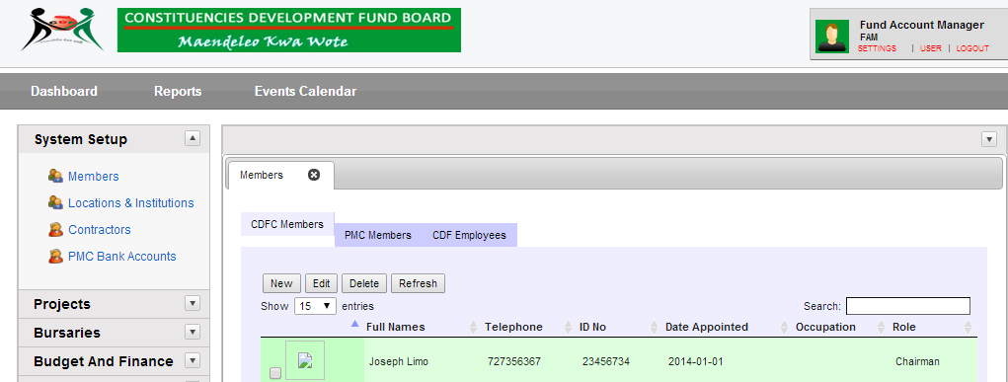

The screen is divided into two tabs, namely

* Constituency Development Fund Committee Members which is the default screen ; and
* Project Management Committee Members

#### CDFC COMMITTEE MEMBERS SETUP

In the CDFC Members menu click New Member.

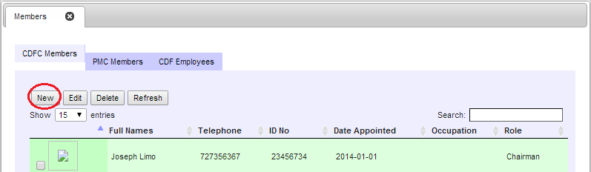

The screen below will appear;

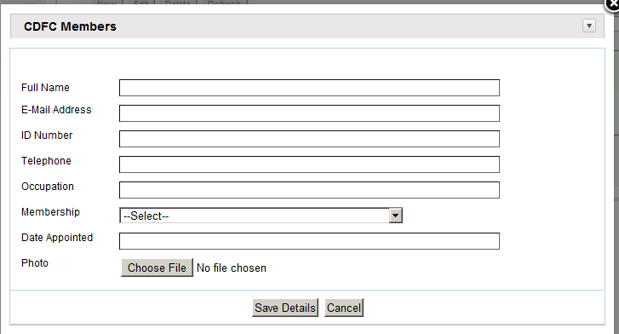

1. Enter the Full Names of the new CDFC Member
2. Enter the E-mail Address of the member. This is optional.
3. Enter ID Number of the Employee. This is used as the unique key for this data
4. Enter new Telephone number for the CDFC member
5. Enter Occupation for the CDFC member e.g. teacher
6. Select a role from the ***Role*** drop down list. E.g. Patron, Fund Manager, etc.
7. Select the Date appointed to the committee
8. Upload the CDFC member’s photo by clicking on browse. It opens Windows Explorer
9. If you want to clear the details and enter afresh, click on the Cancel Details.
10. Click on Save Details to save the record to the database. If all of the data you entered passed the various edit checks built into the system, you will see the message ***“RECORD* SAVED** SUCCESSFULLY" on your screen.

**EDITING A CDFC MEMBER’S RECORD**

Click in the check box for the member whose details you need to edit.

Click View/Edit Member and a screen such as the one below will appear.

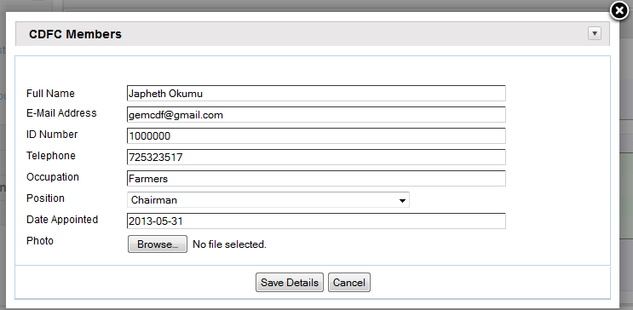

1. Type over data in the field you want to change. If you want to clear the details and enter afresh, click on the Cancel Details.
2. Click on Save Details to save the record to the database. If all of the data you entered passed the various edit checks built into the system, you will see the message ***“RECORD* SAVED** SUCCESSFULLY" on your screen.

#### PMC MEMBERS SETUP

Click the PMC Members tab and a screen such as the one below will appear.

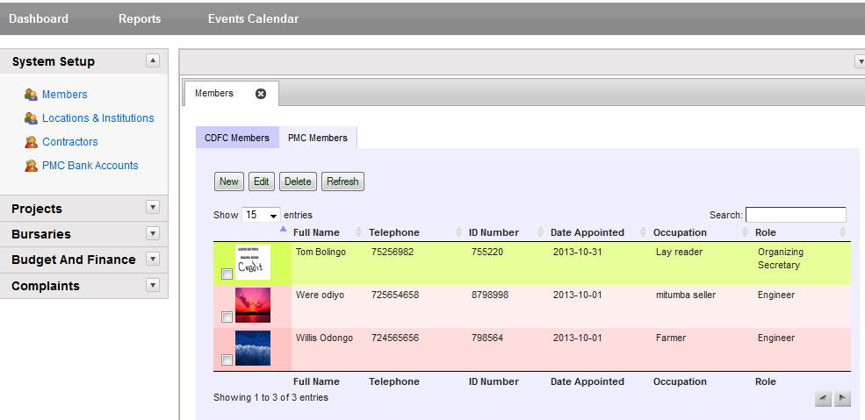

**Entering a New PMC Member Details**

Click New Member and the screen below will appear.

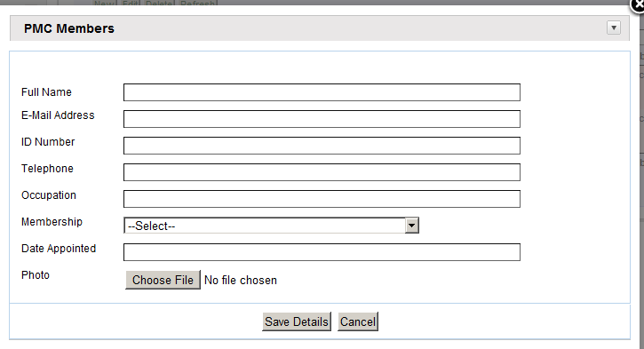

1. Enter the Names of the new PMC Member
2. Enter the E-mail Address of the member. This is optional.
3. Enter ID Number of the Employee. This is used as the unique key for this data
4. Enter new Telephone number for the PMC member
5. Enter Occupation for the PMC member e.g. teacher
6. Select a membership from the ***Membership*** drop down list. E.g. Project Manager, Project Director Etc.
7. Select the Date appointed to be a member
8. Upload the PMC’s member’s photo by clicking on browse. It opens Windows Explorer
9. If you want to clear the details and enter afresh, click on the Cancel Details.
10. Click on Add Member to save the record to the database. If all of the data you entered passed the various edit checks built into the system, you will see the message ***“RECORD* SAVED** SUCCESSFULLY" on your screen.

**Editing an PMC record**

Click in the check box for the member whose details you need to edit.

Click View/Edit Member and a screen such as the one below will appear.

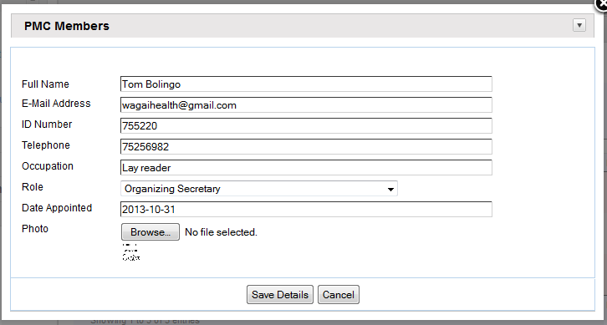

1. Type over data in the field you want to change, if you want to clear the details and enter afresh, click on the Cancel Details.
2. Click on Save Details to save the record to the database. If all of the data you entered passed the various edit checks built into the system, you will see the message ***“RECORD* SAVED** SUCCESSFULLY" on your screen.

## **LOCATIONS AND INSTITUTIONS SETUP**

These are geographical locations within the constituency. Also included are the sub-locations and the institutions located within the constituency.

You click the locations/institutions and the screen below will appear.

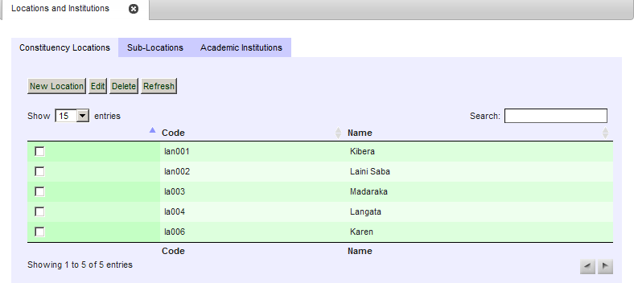

The default menu is Constituency locations and the others are Sub-Locations and Academic institutions

### CONSTITUENCY LOCATIONS SETUP

**ADD A NEW CONSTITUENCY LOCATION**

Click New Location to open the screen below for adding a location.

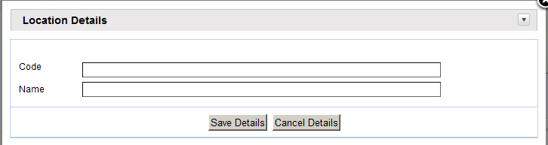

1. Enter the location code; this is a unique code given for this location per constituency. It is recommended that a prefix of the constituency code precede this for uniqueness.
2. Enter the location name
3. If you want to clear the details and enter afresh, click on the Cancel Details.
4. Click on Save Details to save the record to the database. If all of the data you entered passed the various edit checks built into the system, you will see the message ***“RECORD* SAVED** SUCCESSFULLY" on your screen.

**EDITING A CONSTITUENCY LOCATION**

Click Edit Locations and a screen such as the one below will appear.

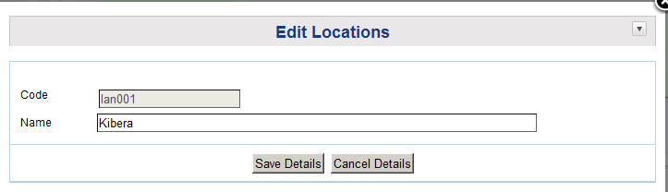

**NOTE**: The **CODE** is unique and cannot be edited because it would interfere with data integrity of the database. It is thus disabled

1. Edit the location name
2. If you want to clear the details and enter afresh, click on the Cancel Details.
3. Click on Save Details to save the record to the database. If all of the data you entered passed the various edit checks built into the system, you will see the message ***“RECORD* SAVED** SUCCESSFULLY" on your screen.

### SUB LOCATIONS SETUP

Click on the Sub-locations tab and a screen such as the one below will appear.

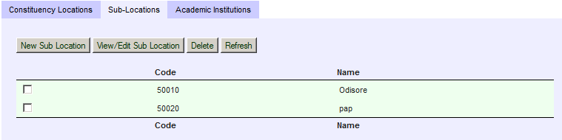

**ADD NEW SUB-LOCATION**

Click New Sub-Location and the screen below will appear.

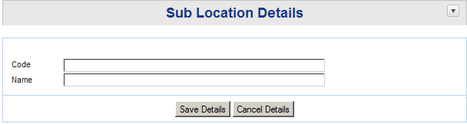

1. Enter the sub location code - this is a unique code given for this sub location per constituency. It is recommended that a prefix of the constituency code precede this for uniqueness.
2. Enter the sub location name
3. If you want to clear the details and enter afresh, click on the Cancel Details.
4. Click on Save Details to save the record to the database. If all of the data you entered passed the various edit checks built into the system, you will see the message ***“RECORD* SAVED** SUCCESSFULLY" on your screen.

**EDITING A SUB-LOCATION**

Click View/Edit Sub-Location and a screen like the one below will appear.

**NOTE**: The **CODE** is unique and cannot be edited because it would interfere with data integrity of the database. It is thus disabled

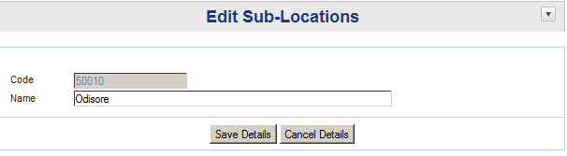

1. Type new data over the Sub-Location name to make the necessary changes
2. If you want to clear the details and enter afresh, click on the Cancel Details.
3. Click on Save Details to save the record to the database. If all of the data you entered passed the various edit checks built into the system, you will see the message ***“RECORD* SAVED** SUCCESSFULLY" on your screen.

### ACADEMIC INSTITUTIONS SETUP

These are used when tracking **BURSARY** applications. The institutions entered here are entered by all FAM’s and are shared by all constituencies.

This is meant to create a list of Academic Institutions within the whole country and no duplication is done.

While a student may reside in one constituency e.g. Embakasi, he/she might be schooling in another constituency e.g. Gem. There is therefore a need to have Academic Institutions entered by the FAM for institutions within his/her jurisdiction.

When you click on academic institutions tab, the screen below appears

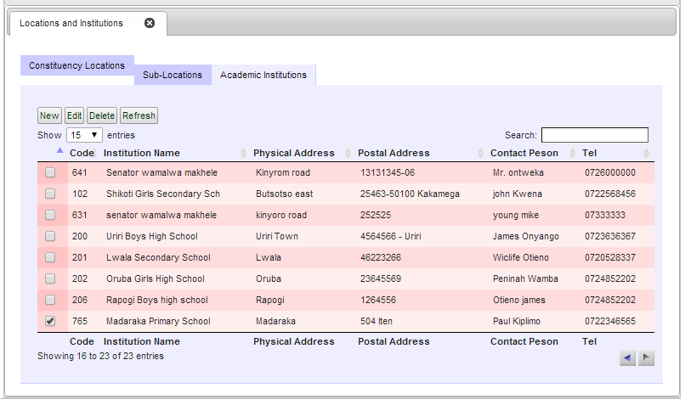

The screen shows ALL institutions entered into the database from ALL constituencies. It will be a growing list reducing the risk of duplication. The CODE will be unique for each institution.

**ADD NEW ACADEMIC INSTITUTION**

Click New institution and the screen below is displayed

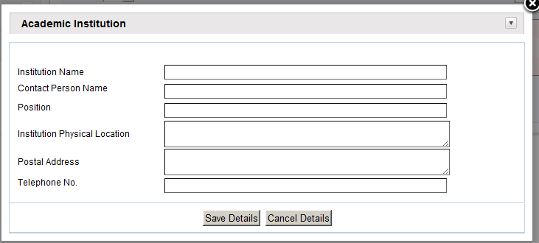

1. Enter the Institution name
2. Enter the Institution’s Contact person’s name
3. Enter the position of the contact person
4. Enter the physical location of the institution
5. Enter the postal address of the institution
6. Enter the telephone number for the institution
7. If you want to clear the details and enter afresh, click on the Cancel Details.
8. Click on Save Details to save the record to the database. If all of the data you entered passed the various edit checks built into the system, you will see the message ***“RECORD* SAVED** SUCCESSFULLY" on your screen.

**EDITING INSTITUTIONS DETAILS**

Click View/Edit Institution and a screen like the one below will appear.

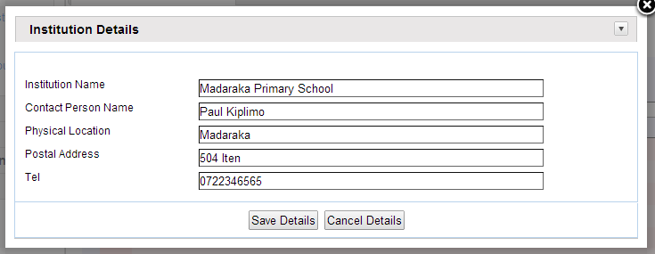

1. Click the field that you would want to change then type new data over the old.
2. If you want to clear the details and enter afresh, click on the Cancel Details.
3. Click on Save Details to save the record to the database. If all of the data you entered passed the various edit checks built into the system, you will see the message ***“RECORD* SAVED** SUCCESSFULLY" on your screen.

## **FINANCIAL YEAR SETUP**

The System Administrator will also be in charge of setting up the financial year’s module. These years are used to track the projects per year.

When you click on financial year’s button the screen below appears.

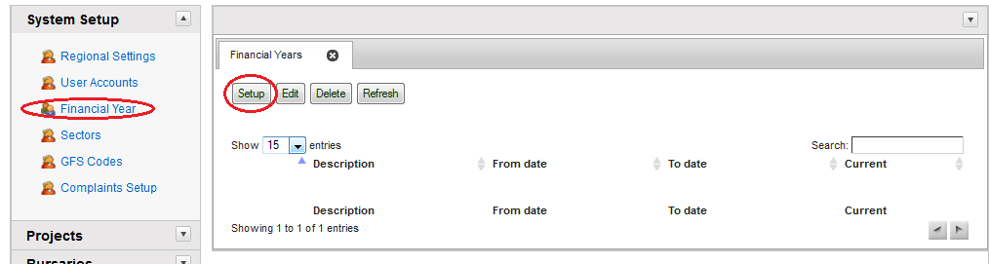

**NEW FINANCIAL YEAR SETUP**

Click Setup for the screen below to appear.

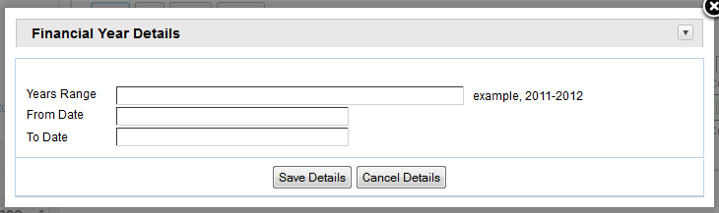

1. Enter the Year range e.g. 2013-2014
2. Click to Enter the starting date of year
3. Click to Enter the ending date of year
4. Click on save details to save the record into the database
5. Click on the x button to close the form and click on refresh to display the data

**EDITING A FINANCIAL YEAR**

Click Edit and a screen such as the one below will appear

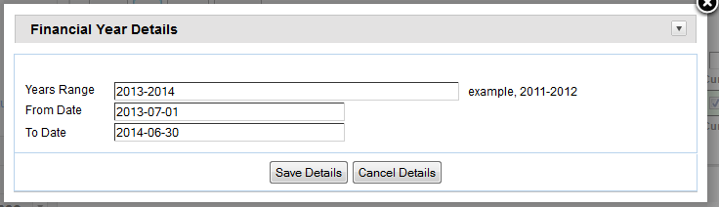

1. Select the field you want to edit and enter new data
2. Click on save details to save the record into the database
3. Click on the x next to Financial Year to close the form.
4. Click Refresh to display the data

## **SECTORS SETUP**

This menu is used to setup the various sectors that will be in use throughout the system. There are basically two system sectors that will be used: -

**System sectors**: - these are the general sectors under which projects lie. Example: Health, Education etc.

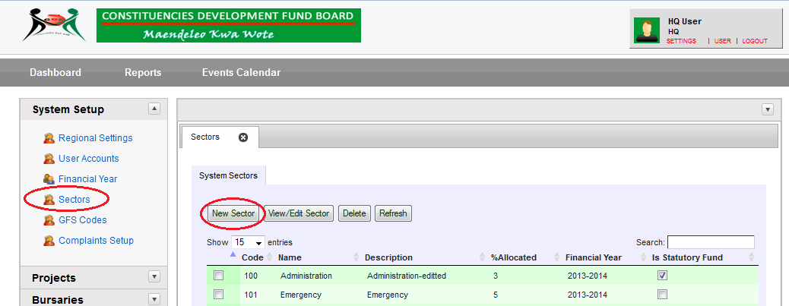

### PROJECTS SYSTEM SECTORS SETUP

*This is done at the constituency level*

This process is used to indicate under which sector the proposal/project falls. They are usually pre-determined by the government and a recommended percentage allowable to be set is given.

Refer to Appendix section for the Sector Codes.

**ADD NEW PROJECTS SYSTEM SECTOR**

Click New Sector for the screen below to appear.

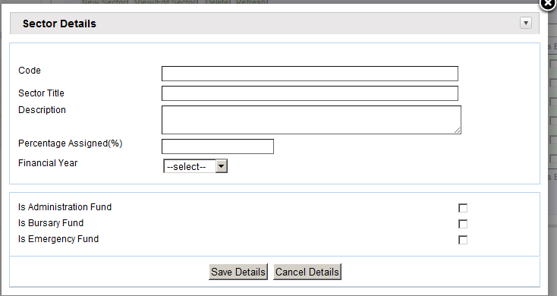

1. Enter the Code for the sector. These are usually given by the government
2. Enter the Sector Title e.g. Health
3. Give a description of the sector
4. Select the financial year that this applies for.
5. Click Save details to send the new record to the database

**NB: DO THIS ONLY: -**

* If the Sector is **Administration** click on Is Administration fund checkbox
* If the Sector is **Bursary** click on Is Administration fund checkbox
* If the Sector is **Emergency** click on Is Administration fund checkbox

Select the pre-defined sector and click on it. The changes will apply throughout the system.

**EDITING A PROJECT SECTOR**

Click on the check box of the Constituency you want to edit.

A screen such as the one below will appear.

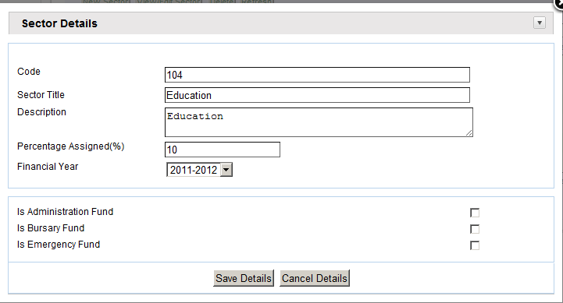

NOTE: You cannot change the sector code because it is disabled. Altering it would cause serious harm to the database.

1. Select the field you want to edit and enter new data
2. Click on Save Details to save the record to the database. If all of the data you entered passed the various edit checks built into the system, you will see the message ***“RECORD* SAVED** SUCCESSFULLY" on your screen.

## **CONTRACTORS/SUPPLIERS SETUP**

These will be used in the tendering process and for any payments done to a supplier via the basis of the project.

When you click on Contractors the screen below should appear

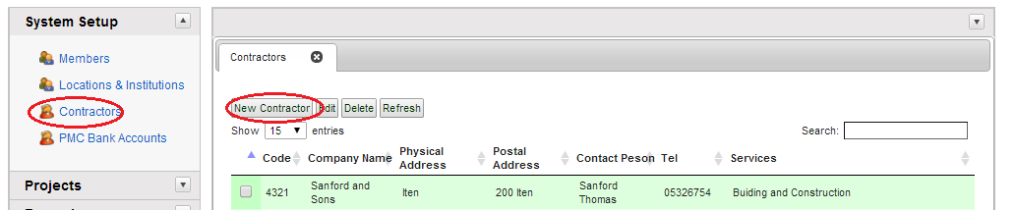

**ADD NEW CONTRACTOR**

When you click on New contractor button, the screen below appears

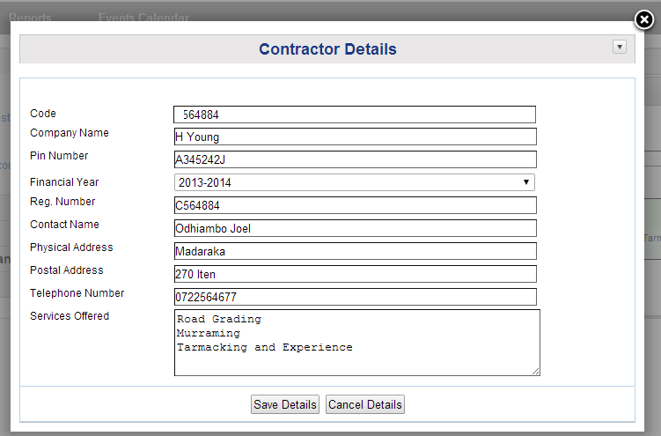

1. Enter the supplier code. This is a unique code for the supplier.
2. Enter the Company name
3. Enter the Pin Number of the supplier company
4. Enter the Sector under which the contractor operates within
5. Enter the Contact person of the supplier
6. Enter the physical location of the supplier
7. Enter a postal address
8. Enter the telephone number of the supplier
9. Give a summary of the services they give
10. If you want to clear the details and enter afresh, click on the Cancel Details.
11. Click on Save Details to save the record to the database. If all of the data you entered passed the various edit checks built into the system, you will see the message ***“RECORD* SAVED** SUCCESSFULLY" on your screen.

**EDITING A CONTRACTOR RECORD**

Click View/Edit Contractor and a screen such as the one below appears

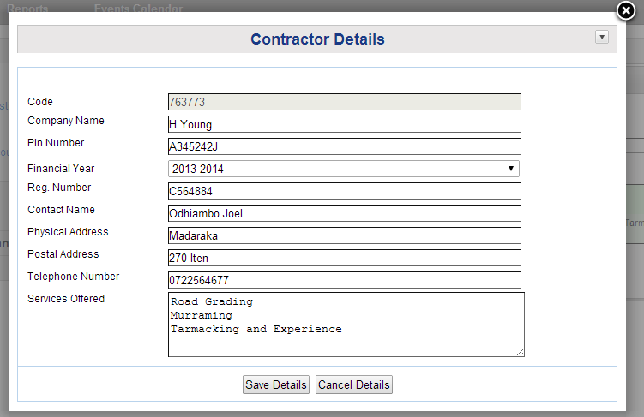

**NOTE**: The Contractor code cannot be edited as it is unique to the contractor

1. Select the field you want to edit and enter new data
2. Click on Save Details to save the record to the database. If all of the data you entered passed the various edit checks built into the system, you will see the message ***“RECORD* SAVED** SUCCESSFULLY" on your screen. Select the field you want to edit and enter new data

## **GFS CODES SETUP**

GFS are Government Finance Statistics Codes that are used throughout the program. The initial setup is done through this menu.

To setup GFS Codes, click on the GFS Codes button. The following screen below will appear: -

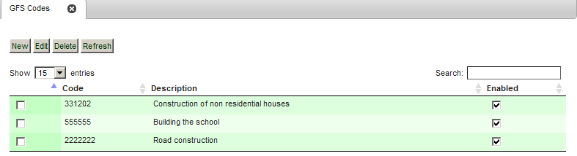

**ADD NEW GFS CODE**

To setup a new GFS code, click new for the following screen to appear.

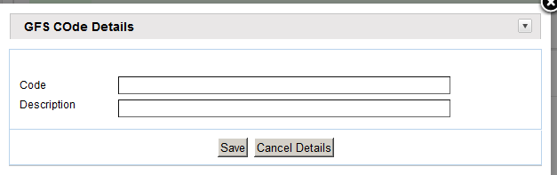

1. Enter the GFS Code
2. Enter the Description
3. Click on Save to enter the record into the database

## **COMPLAINTS SETUP**

Click Complaints for the screen below to appear.

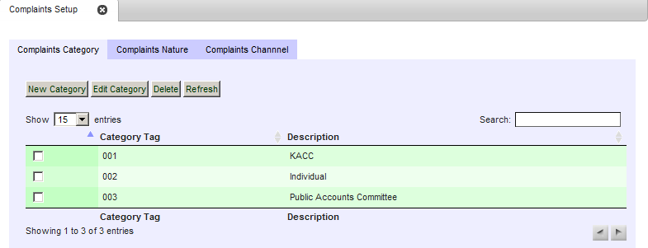

The Complaints setup is composed of three tabs: -

1. Complaints category
2. Complaints nature
3. Complaints channel

**COMPLAINTS CATEGORY**

These could be individuals or organizations.

**ADD COMPLAINTS CATEGORY**

To enter a new category, click on the new category button. The screen below will appear: -

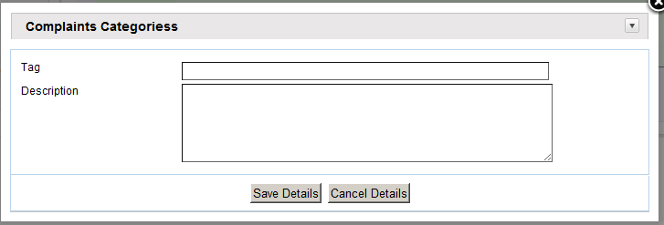

1. Enter the Tag
2. Enter the Description
3. Click on Save to enter the record into the database

**EDITING A CATEGORY**

To edit a category, click Edit Category. The screen below will appear: -

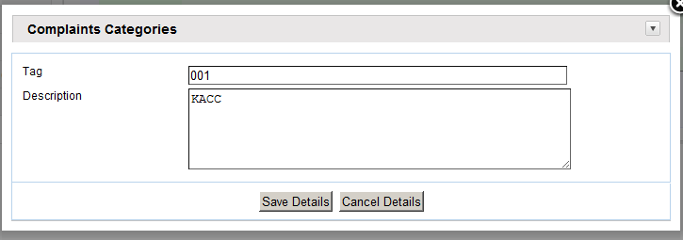

1. Select the field you want to edit and enter new data
2. Click on Save to enter the record into the database
3. Click the x button to close the screen

**COMPLAINTS NATURE**

These are the issues concerning the complaint e.g. misuse of public funds. To setup complaints nature click on the complaints nature tab. The screen below will appear: -

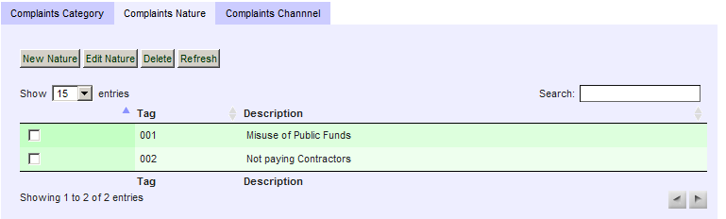

**ADD NEW COMPLAINTS NATURE**

To setup a new complaints nature, click on the new nature button. The screen below will appear: -

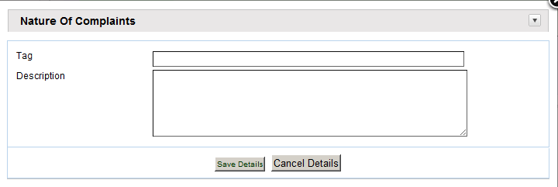

1. Type Tag
2. Type Description
3. Click on Save to enter the record into the database
4. Click the x button to close the screen

**EDITING A COMPLAINTS NATURE**

To edit a complaints nature, click on the edit button and a screen such as the one below will appear.

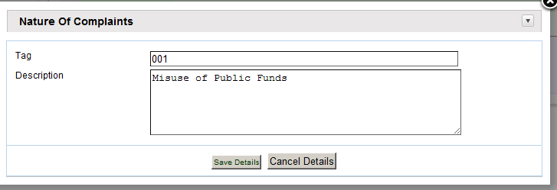

1. Select the field to be edited and type new data
2. Click on Save to enter the record into the database
3. Click the x button to close the screen

**COMPLAINTS CHANNEL**

These are the methods of recording complaint e.g. telephone, mail, etc. To setup complaints channel click on the complaints channel tab. The screen below will appear: -

**ADD NEW COMPLAINTS CHANNEL**

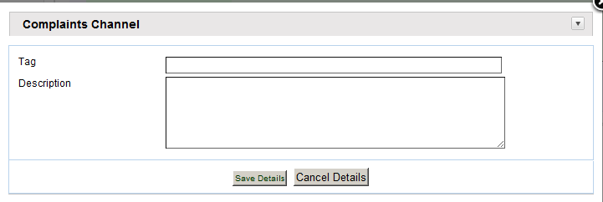

1. Enter the Tag
2. Enter the Description
3. Click on Save to enter the record into the database
4. Click on the x button to close the screen

**EDITING A COMPLAINTS CHANNEL**

To edit a complaints channel, click Edit and a screen as the ne below will appear.

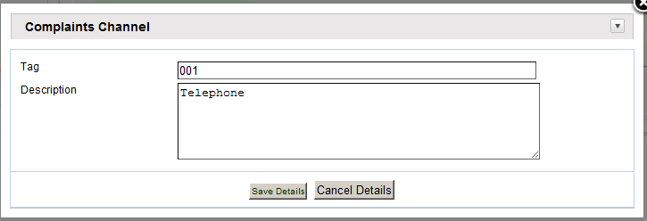

1. Select the field you want to edit and type new data
2. Click on Save to enter the record into the database
3. Click the x button to close the screen

# FUNDS MANAGEMENT

The system administrator is now able to allocate and disburse monies to the constituencies. This is done from the Budget and Finance menu from the System menu as shown below: -

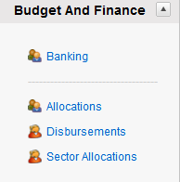

# ALLOCATIONS

The first step is to do an allocation to the constituency. To do this, click Allocations on the Budget and Finance menu. The below will appears;

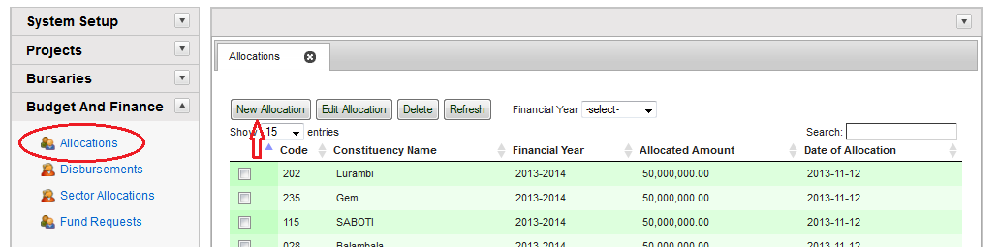

**ADD NEW ALLOCATIONS**

To make a new allocation to a constituency, click on new allocation button. The screen below will appear.

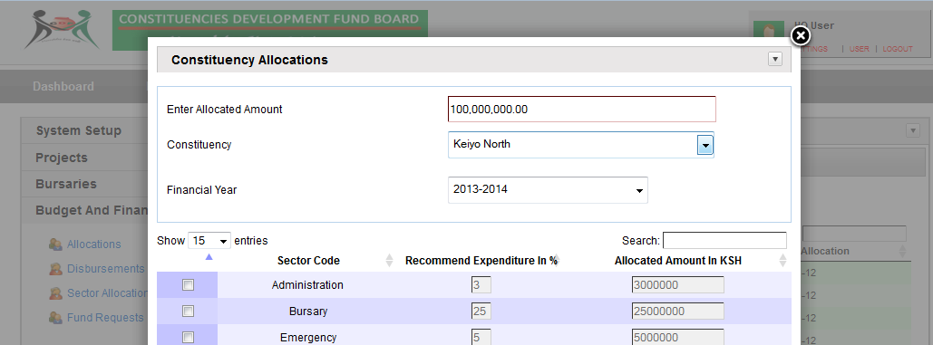

1. Enter the amount allocated annually from the government
2. Select the constituency you are allocating to
3. Select the financial year
4. Click on Save to enter the record into the database

**NB:** The check boxes will display the suggested amounts that each sector is allocated to for each constituency. They are not editable but are for a general view.

**EDITING SECTOR ALLOCATIONS**

You can edit the sector allocations. This is done from the Budget and Finance menu from the systems menu as shown below: -

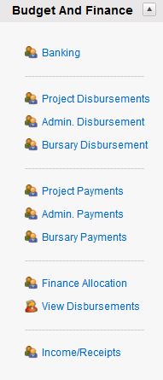

**NOTE: It is important to note that you can only edit the sector allocations before sending the project proposals.**

To edit the allocations, click Finance Allocation and a screen such as the one below will appear.

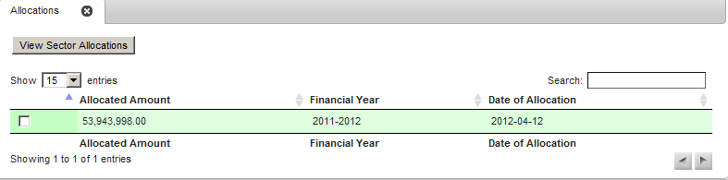

Click on the check box and then click the View Sector Allocations to edit the allocations. The screen below will appear.

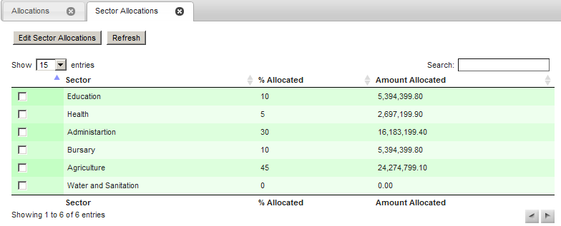

To edit the sector allocations, click on the edit sector allocations button, the screen below will appear: -

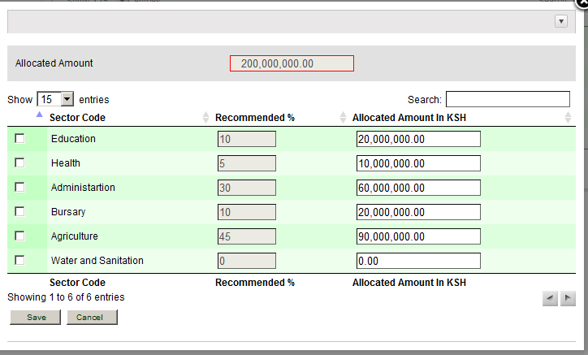

To edit the amount you want to allocate for each sector, follow the following procedure: -

1. Select the field you want to edit on allocated amount in Ksh field.
2. Enter the amount of money you want to allocate to each of the sectors
3. Click on Save button to enter the record into the database.

The screen will close and on clicking refresh will show the new data with new percentages as shown below: -

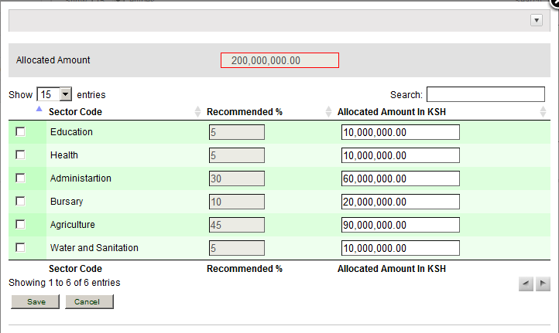

## **DISBURSEMENTS**

To be done in Solomon

# PROJECT MANAGEMENT

## **PROJECT LIFE CYCLE**

The normal project life cycle starts with preparation of project proposal at Constituency level then flows through Approval at Head Office then back to Constituency for Tendering, Payments for Implementation and Monitoring & Evaluation.

Rejected (not approved) project proposals require resubmission to be reconsidered for approval once reason(s) for rejection is addressed.

Funds for approved project propsals may be reallocated to another project(s) through a new approval process.

The project from which the fund is reallocated is terminated.

The chart below ilustrates the proceeses in summary.

**INTRODUCTION**

The Project Information Menu allows you to access the various functions required to browse, create, modify, and delete the new project information record, including a screen to track the progress of the project and a screen to identify the projects life cycle.

To access the Project Information Menu, press **Projects** on the **Main Menu**. The following screen will appear:

There are different views for the users at the Constituency Level and the Headquarters level as shown below;

At the constituency:

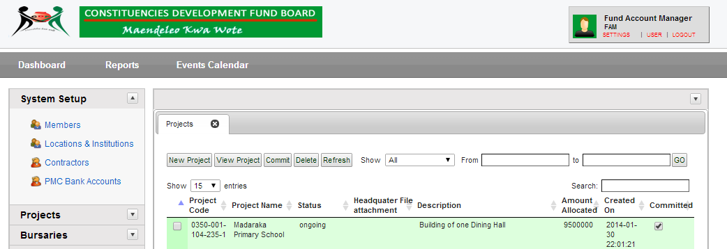

At the Headquarter Level:

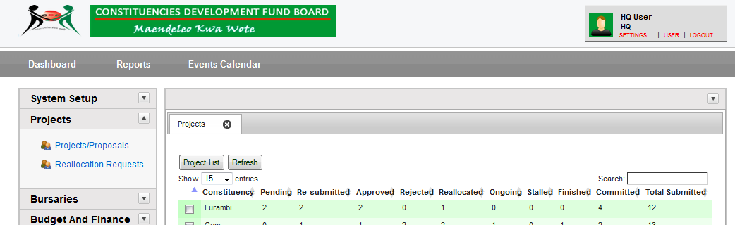

**KEYS TO THE PROJECT INFORMATION MENU**

**New Project -** Creates a new project Proposal

**View Project -** Accesses the Project Information Screen, on which you can view the life cycle of the project.

**Submit**: This button is used when you are ready to send the projects to the headquarters for approval

**Delete -** Deletes a project

**Refresh** - Refreshes the current screen

**Show** - Gives a drop down box where you can select the criteria of the proposals/projects you want to search for; for example ongoing projects, stalled projects etc.

**From – to** gives a date range from which you can select a period to view projects.

## **ADDING A NEW PROJECT**

On the Project Screen, you can create the project information record, thus establishing the project in the database. The project information record also establishes the ownership of the project. To add a new project, click New **Project** and the following screen will appear.

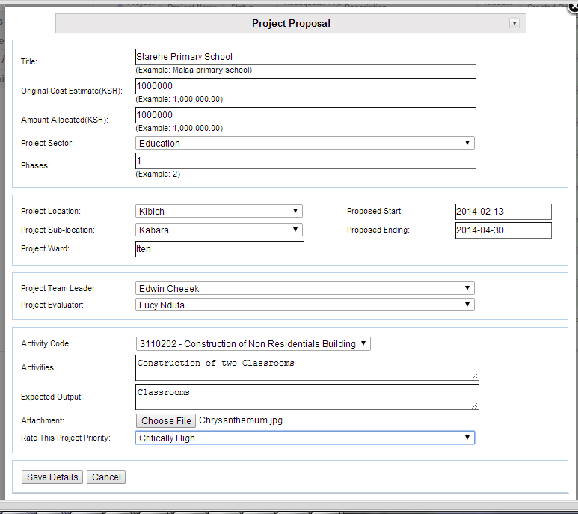

To add a new project information record to the database, from the Project Screen

1. Enter project title: - Enter specific proposal details. Do not enter ambiguous text.
2. Enter project phases
3. Enter estimated cost of the project.
4. Select the sector that the project falls in.
5. Select the location where the project will take place
6. Enter the ward where the project will take place
7. From the date picker, select the proposed start and ending date
8. Select the proposed PMC to take charge of the project when it commences.
9. Select the proposed person to be in charge of monitoring and evaluation of the project
10. Enter the activities that will occur in the stages of the project
11. Enter the expected output for the project
12. Attach any documents that constitute the proposal. These documents are: minutes of the CDF committee, maps and relevant documents relating to the proposal. It is advisable to make a ZIP (compressed file) of the documents so that they can be sent as a batch.
13. Select the priority setting for the proposal, e.g. HIGH

When you have entered all of the information, press the **Save Details** to add the record to the database. If all of the data you entered passed the various edit checks built into the system, the record is saved successfully and the screen closes.

Repeat the process until you have added all the necessary records. Press the **Refresh** key to refresh the Project Information

**NOTE**: The Project Identification Number or Project Code is generated automatically by the system.

**View Project Screen**

The Project Progress Information Screen allows the user to track and update the major milestones associated with each project as it progresses through its life cycle. Other system users can browse the screen to check the latest major accomplishment for a project or to see if any problems have occurred that will interfere with any aspect of the project.

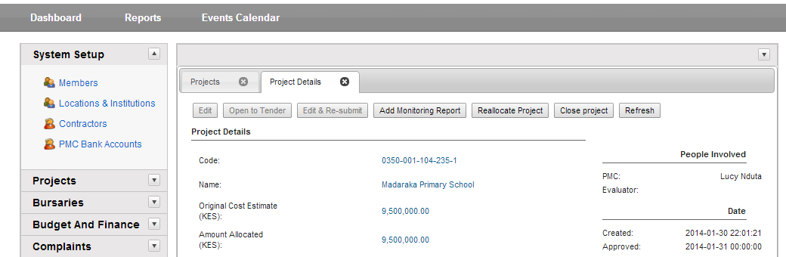



**KEYS ON-THE VIEW PROJECT INFORMATION MENU**

The keys on the view project information screen are enabled or disabled according to the task and authorization given to the project. They will only work only when the current stage of the proposal/project has changed. For example, the open to tender button will only be enabled when the proposal has been approved by the Headquarters and the project is ready to be bid on.

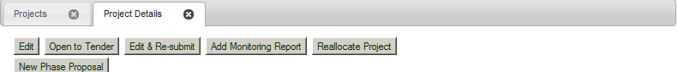

**EDIT: -** Allows you to edit the proposal. This is enabled only when the proposal has not been approved by the headquarters. After approval, this button is unavailable.

**OPEN TO TENDER:** This button allows you to open the project to bidding. It is not enabled on proposals but only when the proposal has been approved by the headquarters

**EDIT & RESUBMIT:** This button is enabled when the proposal has been rejected by the headquarters. It allow you to edit and resubmit your proposal afresh

**ADD MONITORING REPORT: -** this button allows you to add a fresh monitoring and evaluation report

**REALLOCATE PROJECT: -** This button is used when you want to reallocate the current project.

**NEW PHASE PROPOSAL: -**. This allows you to add phases for your project

**VIEW PROJECT INFORMATION SCREEN**

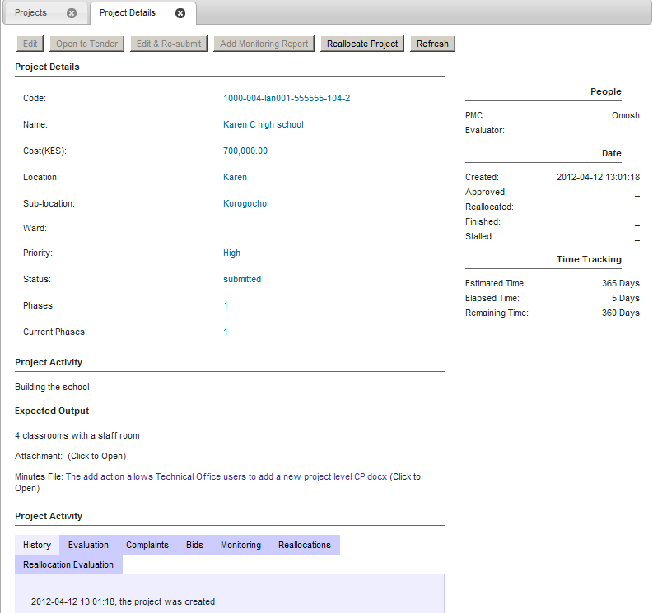

**Project Details:** This will show you the project details information from the code, title etc.

**Project Description**: This will show the project description details

**People**: Will show you the main people involved in the project, i.e. the project leader who is the PMC, and the person in charge of monitoring and evaluation

**Date**: Will show you any dates associated with the proposal from creation to finishing

**Time tracking:** Will show you how much time has elapsed on the project

## **SUBMITTING PROPOSALS TO THE HEADQUARTERS**

When you are satisfied that all the projects have met the correct criteria and no editing is needed to be done, then you are ready to Submit the proposal.

Once you submit the projects, one cannot edit the projects. You should ensure that you edit and check the projects before submitting them.

To commit, click on the Submit button shown below:

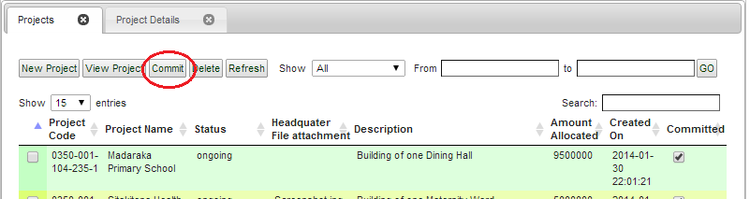

The following screen will then appear and prompt you whether you are ready to Submit the projects for approval at the headquarters.

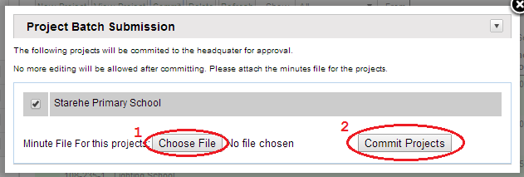

1. Click on the check box for the projects that you want to Submit
2. Click on Browse to select the attachments button to attach the minutes file, the second and third schedules.
3. Click on commit projects to send the projects to the headquarters. Note: **This is an irreversible action.**

## **APPROVING PROJECT PROPOSALS: HEADQUARTERS**

***Note****: Only Project Technical Officers at the Headquarters can add or modify data on this screen, and then, only for approval/rejection purposes.*

The Project Authorization screen allows the project technical officer to approve a project; to specify the terms and conditions that apply to the project; and to authorize funding for the project.

The Screen allows you to enter and track the necessary information so that the proposal is forwarded through the approval process

To access this screen, press the **Projects/Proposals** key on the main menu. The screen shown below will appear.

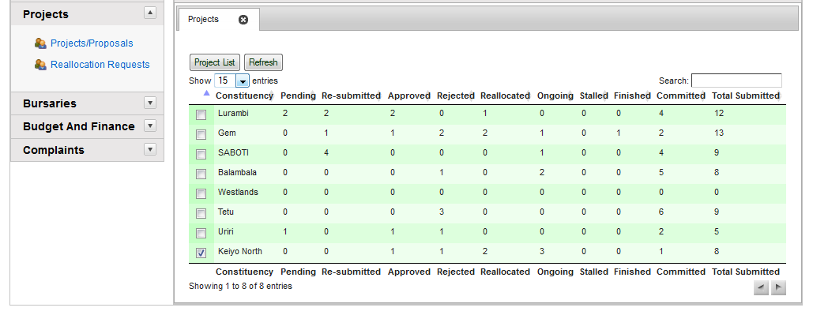

The screen displays a list of constituencies that have submitted proposals. It further gives a summary of the number of proposals submitted, approved, ongoing, stalled and finished.

To approve a project or view project details, select a constituency by clicking on the check box next to it, then click **Project List,** the screen below is displayed

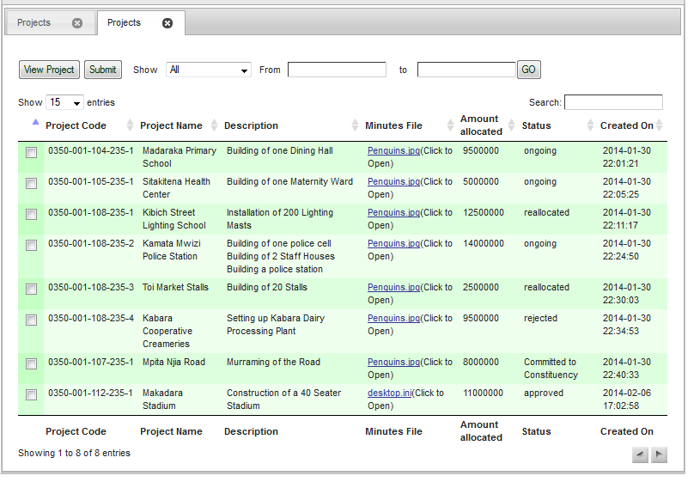

The screen will display a list of submitted proposals from the selected constituency.

1. **Project code** - Displays the project code of the proposal
2. **Project name / Title** - Is the project title of the proposal
3. **Financial Year: -** the current financial year the project is in
4. **Phases**: - the number of phases the project has
5. **Current phase**: - the current phase of the project
6. **Activity** - Gives a description of the proposal
7. **Minutes file**: - the minutes file associated with the proposal
8. **Status**: - the current approval status of the project
9. **Created on**: - the date the project was created

### APPROVING A PROPOSAL

To approve a proposal, you have to analyze it first.

Select a proposal from the list above and then click **View Project** button.

The screen below will appear: -

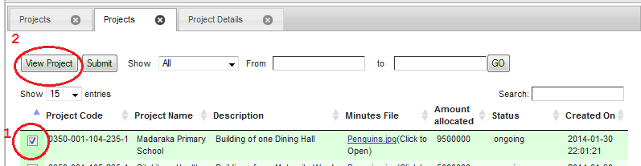

The proposal details as entered at the constituency will be shown in the project details and description.

The Project Activity tab History will also show the History of the Proposal/project

Click on the Evaluation tab to start the process of approving the proposal.

The following screen below will appear

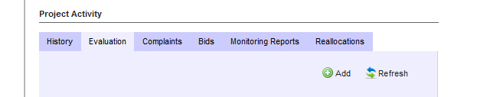

### PROJECT APPROVAL PROCESS

The process entails the following: -

1. Evaluation
2. Approval
3. Resubmission request- Comes after the Rejection of a project

**EVALUATION**

*At the Headquarters***;**

Evaluation is done before a proposal can be approved. It is done in three phases by: -

1. Secretariat
2. Project Technical Committee
3. CDF Board

Each of them enters their approval types which can either be: -

1. Conditional approval
2. Full approval
3. Rejected

They will then enter the remarks/conditions relating to the approval type

To access the Evaluation screen, Click on the Evaluation button to start the process of approving the proposal. The following screen below will appear: -

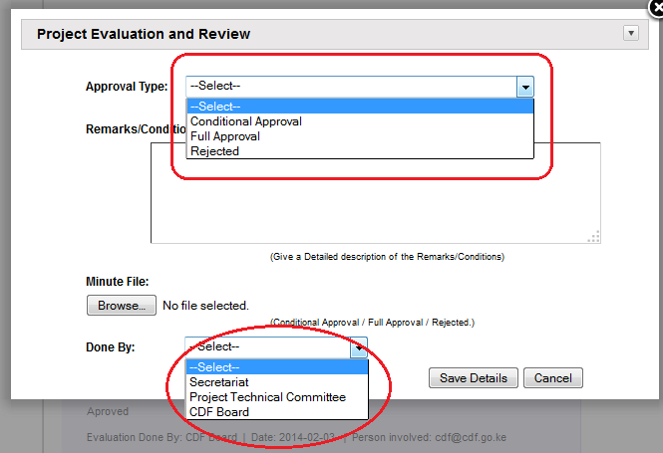

Enter the details as above and click on **Save Details**.

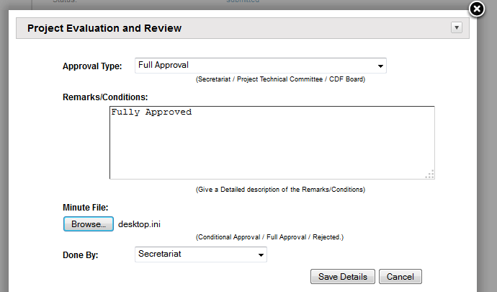

The record will be added to the database.

## **APPROVE PROJECT**

After evaluation has been done by the three levels, refresh the screen.

Click Approve/Reject to approve/reject the proposal

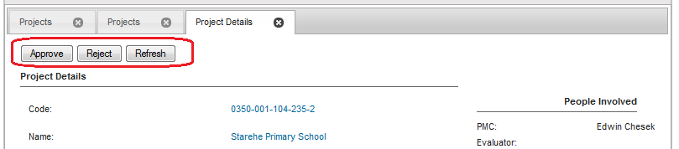

If the proposal has been approved by the CDF Board, click on the Approve button, the screen below appears:

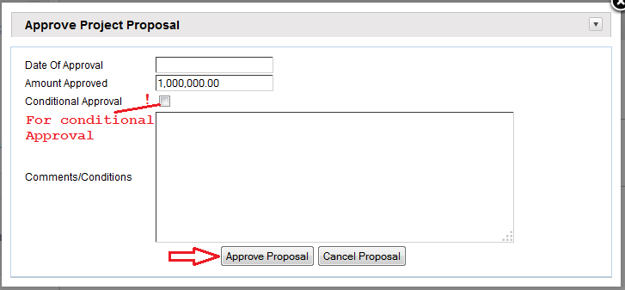

1. Enter the Date of submission
2. Enter comments on the approval
3. Click on Approve proposal, you will see the message ***“RECORD* SAVED** SUCCESSFULLY" on your screen.

The proposal will have then been saved successfully and the proposal status changes from ***Submitted*** to ***approved***

**Note:** to conditionally approve a project, check the conditional approval checkbox as shown above

**Committing the Proposal to Constituency**

To commit the approved/rejected proposals to the constituency;

On the projects list page, select the projects to submit to constituency

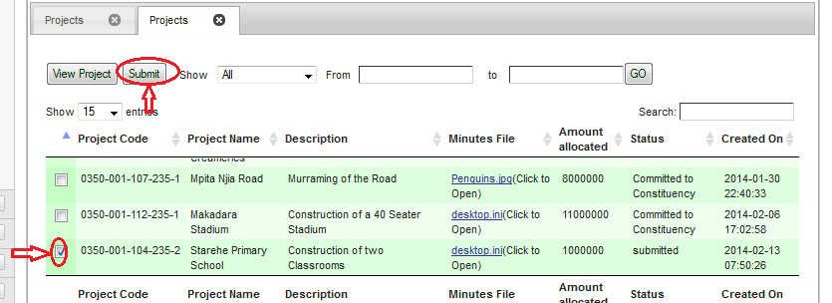

The following screen will appear:

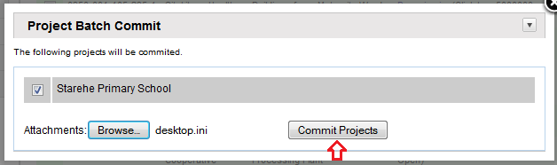

1. Click browse for related documents/minutes
2. Click Commit Projects to submit to constituency

## **REJECTION**

If the CDF Board does not approve the project then click on the REJECT button. The following screen below will appear

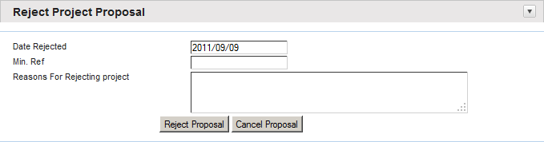

1. Enter the Date of rejection
2. Enter Minutes ref
3. Enter reasons for rejection
4. Click on Reject proposal, you will see the message ***“RECORD* SAVED** SUCCESSFULLY" on your screen.

The proposal will then be sent back for resubmission and the proposal status changes from ***Submitted*** to ***Rejected***.

**TABS ON THE VIEW PROJECT ACTIVITY**

**HISTORY**

This gives a history timeline of the project. The screen is shown below

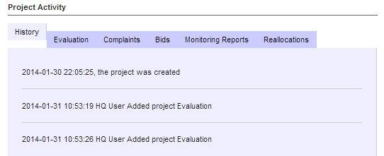

**EVALUATION**

These are remarks made by the headquarters regarding approval of the proposal. The screen is shown below

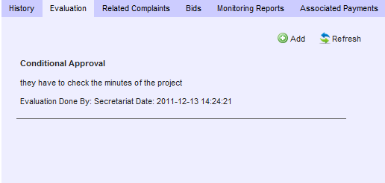

**RELATED COMPLAINTS**

This shows any related complaints related to the project. The screen is shown below

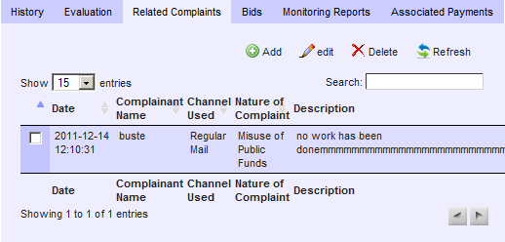

**BIDS**

This shows a list of all bidders for the project. The screen is shown below

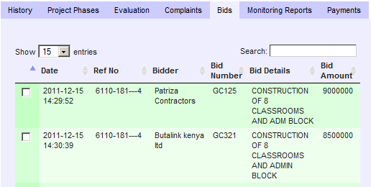

**MONITORING REPORTS**

This shows the monitoring and evaluation of reports done for the project. The screen is shown below

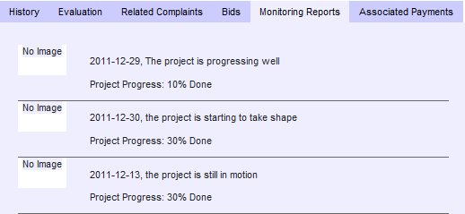

**Note:** By clicking on the image button, the details are enlarged.

**ASSOCIATED PAYMENTS**

This displays any payments made against the project. The screen is as shown below

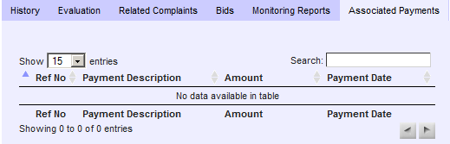

### HEADQUARTERS PROJECT CYCLE

The projects are sent to the constituency in batches. The project administrator at the head office will first have to click on the submit button on the project details page as shown below: -

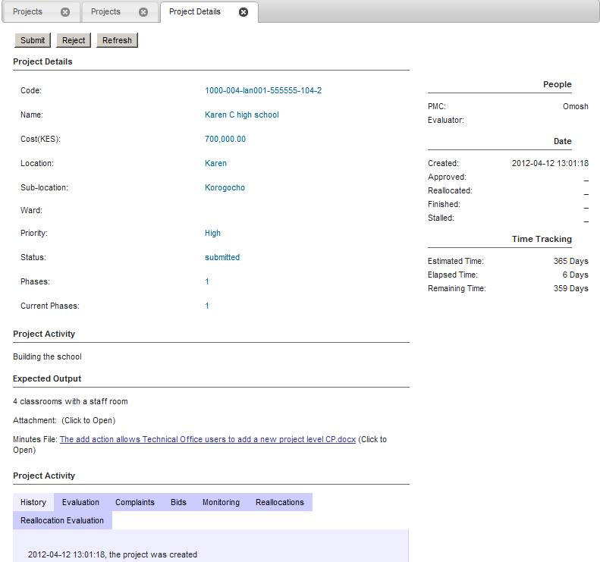

This will be after confirming that the project has complied with all the requirements. After clicking the submit button the following screen below will appear

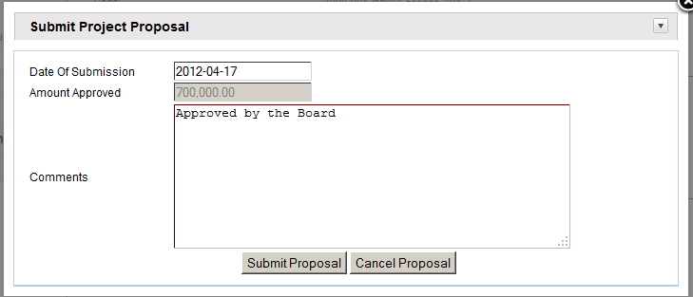

To submit a project: -

1. Enter the Date of submission
2. Enter comments
3. Enter reasons for rejection
4. Click on Submit proposal, you will see the message ***“RECORD* SAVED** SUCCESSFULLY" on your screen.

The proposal will then be sent to a batch for submission.

#### SUBMITTING APPROVED PROJECTS TO THE CONSTITUENCIES

To submit the projects to the constituincies, the project administrator will click on the Submit button.

The following screen below will appear: -

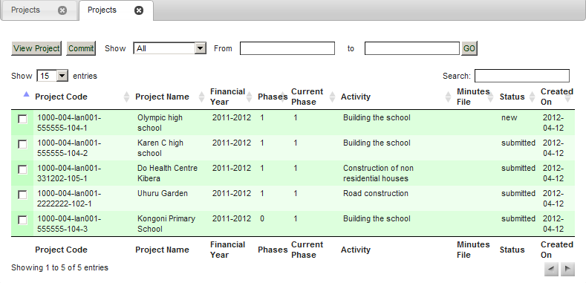

To comitt and send the projects back to the constituencies, click on the Submit button circled up above. A screen such as the one below will be displayed: -

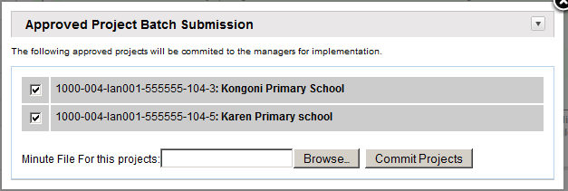

To do project batch submission a project: -

1. Select the projects
2. Attach the minutes or any word attachment with comments
3. Click on Submit Projects

The projects will then be sent to as a batch to the constituency

.

On the Projects menu at Headquarters, the screen below will show you the various status of projedts for each constituency.

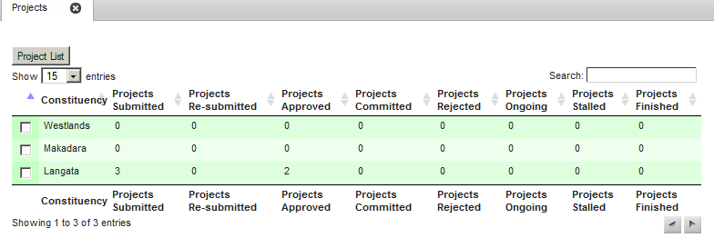

It displays: -

* Projects submitted
* Projects resubmitted
* Projects approved
* Projects Submiteed
* Projects rejected
* Projects ongoing
* Projects stalled
* Projects finished

### CONSTITUENCY PROJECT MANAGEMENT

Below is the process that a project goes through at the constituency level.

**PROJECT LIFE CYCLE STAGES**

The project life cycle consists of various stages that the project has to go through. The stages are as follows: -

1. **Project Disbursement**: This is the first step in the project life cycle. This allocates money to the project. It is found in the Budget & Finance Menu
2. **Tendering**: This is the second step in the project life cycle if there will be no reallocation to another project. This opens the project to tendering process
3. **Bidding**: This is the third step in the project life cycle. It officially makes the project an ongoing project.
4. **Monitoring and evaluation**: This is done as the project progresses and helps in letting project managers the various stages of the project
5. **Reallocation**: This is done when you want to move funds from one project to another.

To view the projects click on the Projects menu on the system main menu.

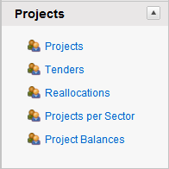

A screen such as the one below will appear listing all projects.

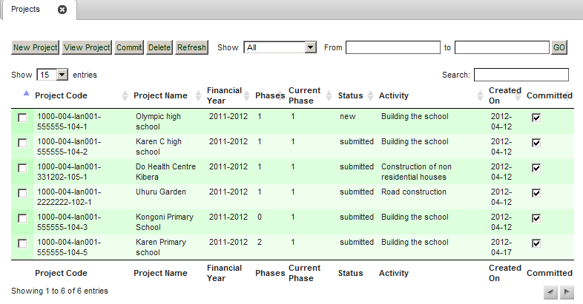

Clickon the show dropdown button to filter project by status. You may also filter by date.

## **PROJECT DISBURSEMENT**

This is the first step in the project management cycle at Constituency level. Once the project has been approved by the Head Office money is disbursed to it.

To do disbursement to a project, click on the system menu and the screen shown below will appear.

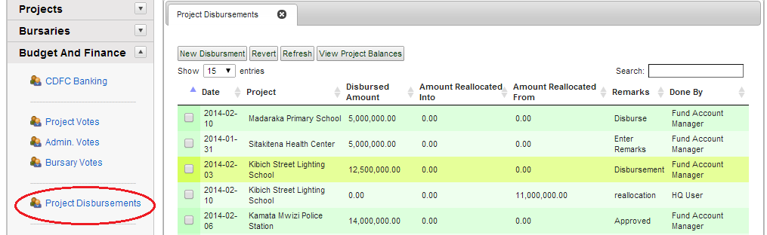

**NEW DISBURSEMENT**

### PMC Bank Accounts

Before disbursement, a PMC Bank account should be created to allow the transfer of monies

To create a new PMC Account

1. Under System Setup click on PMC Bank Accounts
2. Click New PMC Account

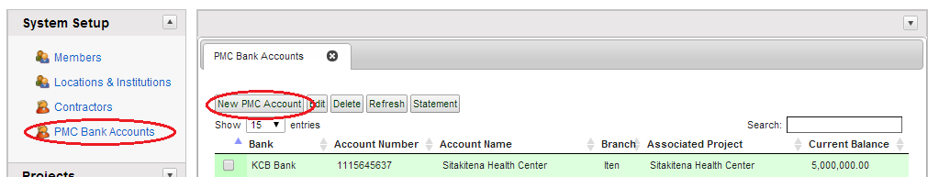

1. Enter details as shown below (Note: Account name must be the same as project name) and click Save

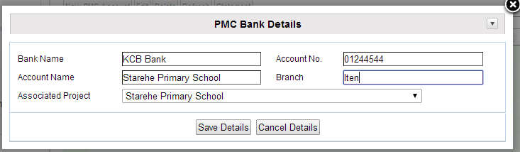

Your new PMC Bank Account is now created

### Project Disbursement Process

Once you click new disbursement, the screen below will appear: -

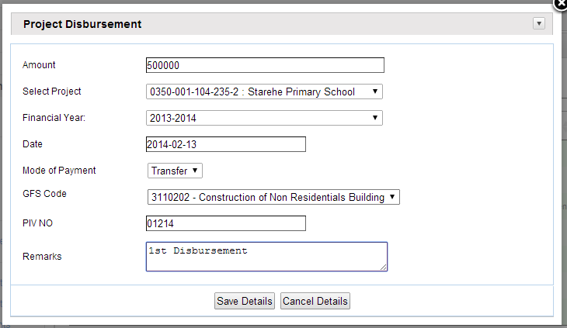

## **PROJECT TENDERING**

This is the second step in the project life cycle. It usually commences when the CDF Board has disbursed the first batch of funds to the constituency so that the projects can commence.

The CDFC will then decide on the priority projects that will go through competitive bidding for the projects.

To begin the process click on the **Open to tender** button on the top menu on the screen as shown below: (Who does the tendering function?)



The screen below will appear: -

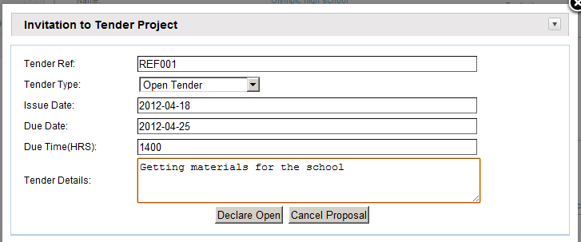

1. Enter the tender ref number
2. Select the tender type from the drop down box
3. Enter the date that you issued the tender
4. Enter the due date
5. Enter the due time
6. Enter the tender details
7. Click on the Declare open button. This will officially open the project to bidding.

If you want to clear the details and enter afresh, click on the Cancel proposal.

The project is now officially open to bidding.

## **BIDDING**

Once the project is tendered, the prequalified suppliers are now free to bid on the project.

To begin the bidding process, click on the **BIDS** tab as shown below

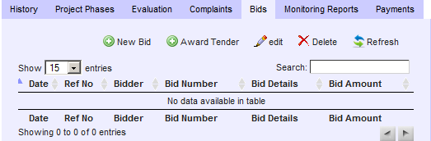

**Buttons on the Bids Tab**

* **New bid**: - This will open the project to bidding
* **Award tender**: - This is done after entering bids
* **Edit**: - Edits the bid
* **Delete**: - Deletes the bid
* **Refresh**: - Refreshes the bids page

**NEW BID**

Click on new bid to add a new bidder to the project. The following screen will appear

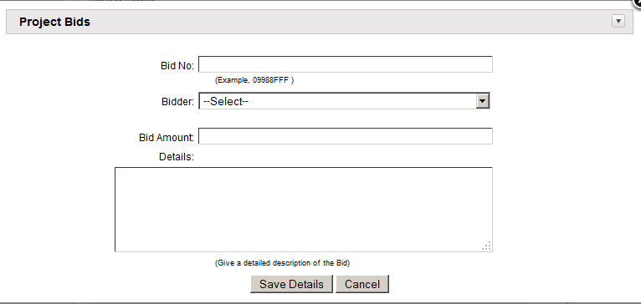

1. Enter the Bid no
2. Select the bidder from the drop down box. This can only be prequalified suppliers
3. Enter the bid amount
4. Enter the bid details
5. Click on the Save details button. This will add the bid to the database.

If you want to clear the details and enter afresh, click on the Cancel button.

After entering the new bid, the screen will look like the one below showing a list of the bidders and their bid amounts.

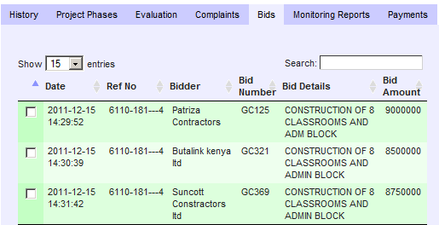

## **AWARD TENDER**

After you have entered the bidders, the next step is to award tender to the most competitive bidder.

Click on Award tender button to award the contractor for the project. The following screen will appear

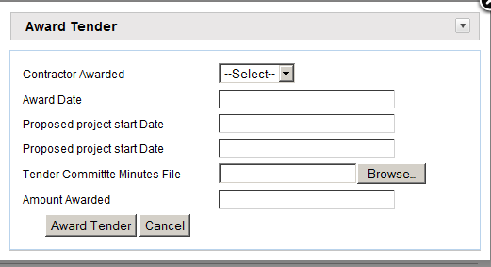

1. Select the contractor to award the tender from the drop down box. The list is only from the list of contractors who had bid
2. Enter the award date
3. Enter the proposed project start date the contractor had given
4. Enter the proposed project end date the contractor had given
5. Attach the tender committee minutes.
6. Enter the amount awarded
7. Click the Award tender button to save the record

If you want to clear the details and enter afresh, click on the Cancel button.

## **PROJECT REALLOCATION**

The Reallocation process involves four stages: -

It entails: -

1. Reallocation request from the constituency
2. Evaluation by the Headquarters
3. Approval
4. Rejection

The first step in reallocation is to do a reallocation request. To do this click on the **reallocate project** button on the view project screen as shown below: -

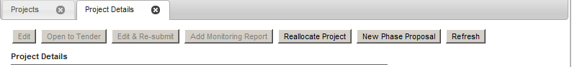

The screen below will appear: -

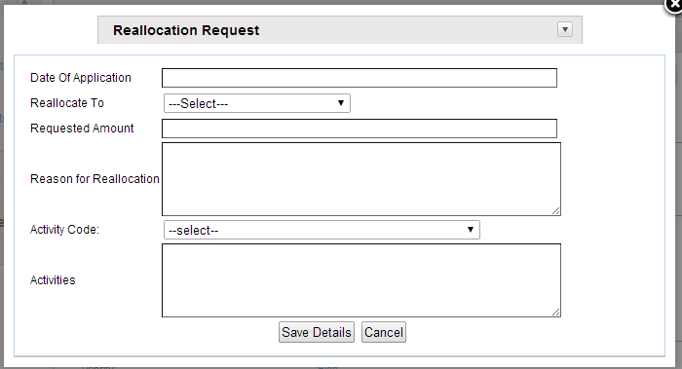

1. Enter the date of the reallocation request
2. Select the project you want to reallocate
3. Enter amount that you want to reallocate
4. Enter the reason for the reallocation
5. Click the Save button to save the record

If you want to clear the details and enter afresh, click on the Cancel button

**NOTE**:

1. You can only reallocate from a project that has been approved and monies disbursed to it.
2. You can do multiple allocations requests from one project to another one as long as it has enough money to support it. This is done from clicking on the reallocate project button before closing the view project form.

Once you have saved the record, click on the reallocations button as show below: -

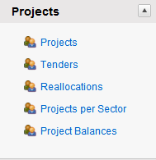

When you click on the reallocations button you will see the screen below: -

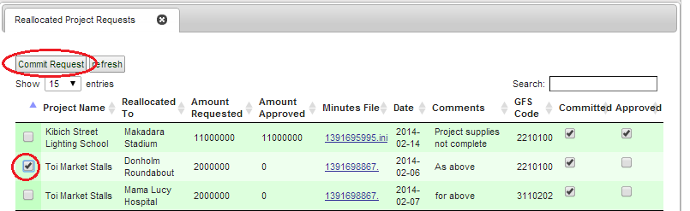

To reallocate the projects, click on the Submit request button. This will send the reallocation requests to the headquarters. When you click on the Submit request the following screen will appear: -

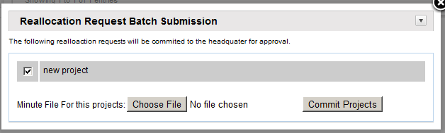

1. Select the project you want to submit for reallocation
2. Choose the minutes files for the projects
3. Click on the Submit projects button to save the record

Once you have submitted, the request is sent to the headquarters.

### PROCESSING REALLOCATION AT HEAD OFFICE

To view the reallocation requests that have come from the constituencies, click on the reallocation requests on the projects menu as shown below: -

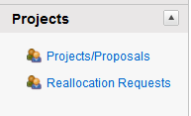

To reallocate, click on the reallocation requests button. The following screen will appear: -

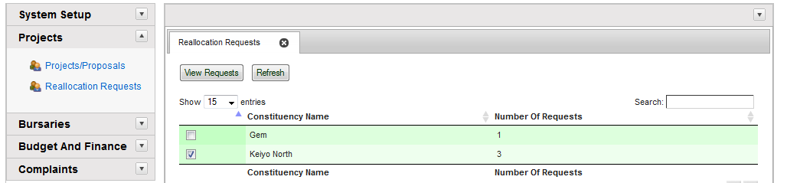

Each constituency shows the reallocation requests.

Click on the constituency to view the requests. The screen also shows the number of requests from the constituencies.

When you click on the view request the screen below will appear: -

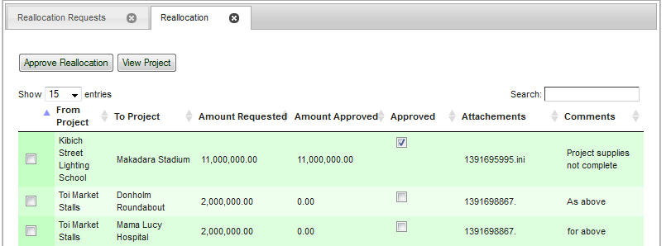

The user will now be able to view the project and add an evaluation report:

### EVALUATION

Evaluation is done before a request can be approved. It is done in three phases by: -

1. Secretariat
2. Project Technical Committee
3. CDF Board

Each of them enters their approval types which can either be: -

1. Conditional approval
2. Full approval
3. Rejected

They will then enter the remarks/conditions relating to the approval type

To access the Evaluation screen, Click on the Evaluation button to start the process of approving the proposal. The following screen below will appear

## **PROJECT PAYMENTS**

Once the project is up and running, you can start making payments to the project. To do this click on the projects payments on the Budget and finance menu as shown below: -

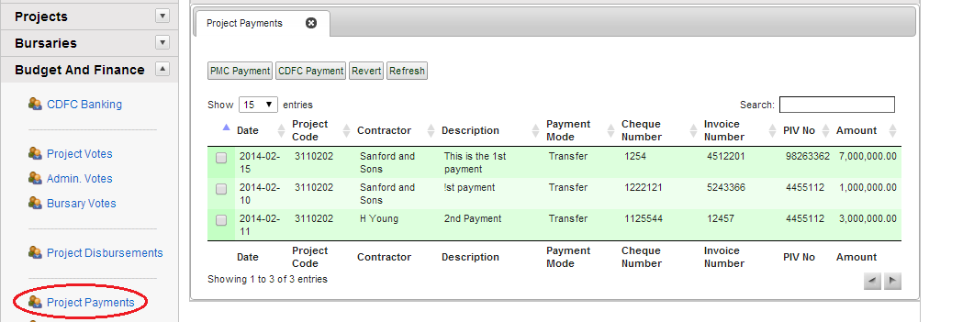

To do a new payment, click on the new button. The following screen will appear: -

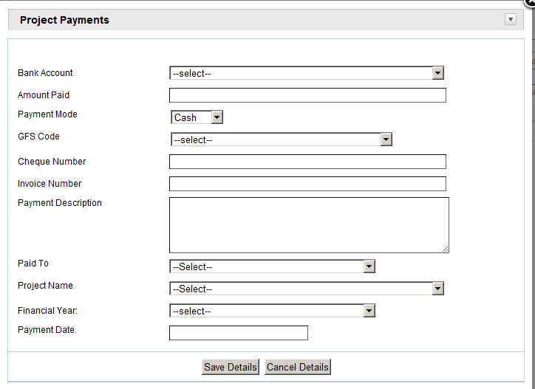

To make a new payment, follow the steps below

1. Select the Bank account from where you are paying from
2. Enter the amount paid
3. Select the payment mode
4. Select the GFS code
5. Enter the Cheque number
6. Enter the invoice number
7. Enter the payment description
8. Select the contractor from paid to drop down box
9. Select the project to which you are paying to
10. Select the Financial year
11. Enter the payment date
12. Click the Save details button to save the record

If you want to clear the details and enter afresh, click on the Cancel button.

**PROJECT BALANCES**

You can view the project balances by clicking on project balances. To access this menu, click on “projects” on the system menu. The following screen will appear: -

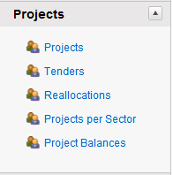

Click on project balances button. The following screen will appear: -

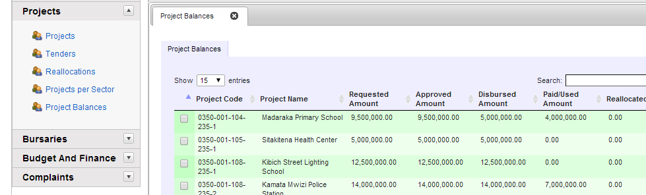

The project balances menu shows you: -

* Project code and project name
* The requested amount
* The approved amount
* The amount disbursed to the project
* The amount paid to the project
* The reallocated amount to or from the project
* The running balance

## **MONITORING AND EVALUATION**

This is used to monitor and evaluate the project at each stage of the project. When you click on the add monitoring reports button, the following screen appears

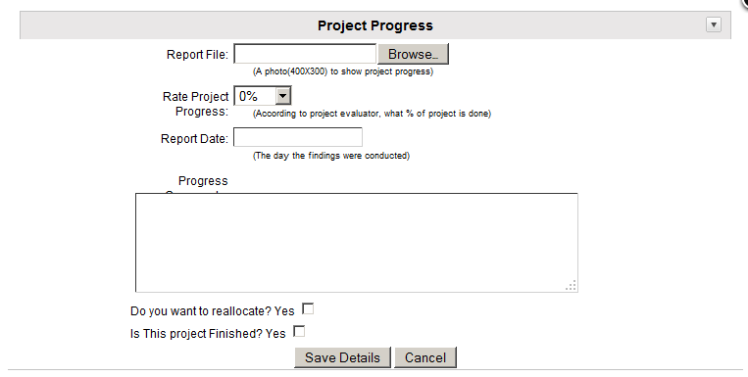

1. Attach a photo of the current stage of project
2. Rate the project based on percentage that has been done
3. Enter the report/ monitoring date
4. Give a brief description of the work that has been done
5. Click Save Details to save the report to the database.

If you want to clear the details and enter afresh, click on the Cancel button.

To view a summary of the monitoring and evaluation, click on the monitoring reports tab. The following screen will appear

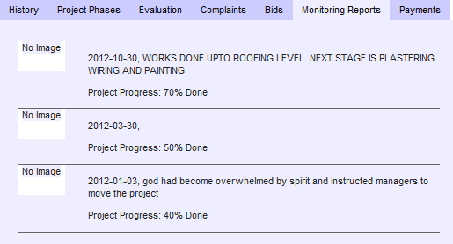

### TENDERS MENU

This screen allows you to view all the tenders that have been awarded for all projects. To access this screen, click on **Tenders** on the Projects Menu. A screen such as the one below will appear:

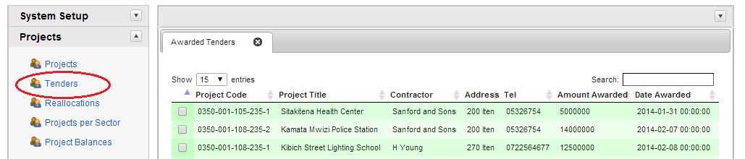

### PROJECTS BY SECTOR MENU

This screen allows you to view all projects per sector.

To access this screen, click on **Tenders** on the Projects Menu.

The following screen below will appear:

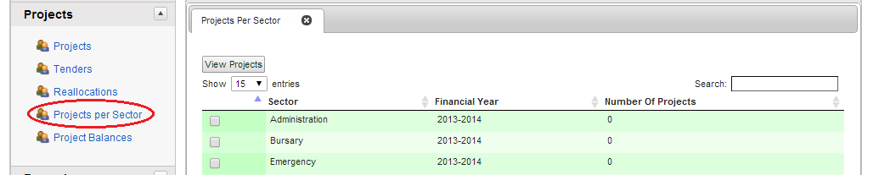

1. Click on the Sector you want to view projects
2. Click on View projects button to view the projects under that sector

The screen below is appears displaying the projects under that sector

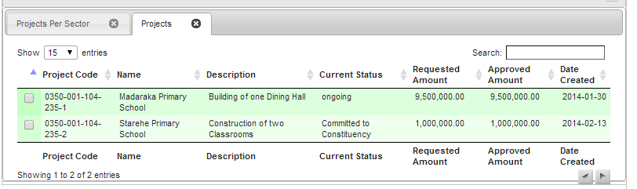

## **BURSARIES MENU**

**INTRODUCTION**

The Bursaries Menu allows the FAM to access screens that show the bursary information for a bursary applicant.

Constituencies have varying arrangements of financial support for students from their respective constituencies.

The criteria of the award are unclear but applicants fill a form as a way of confirming the information given by the applicant is correct. The minimum award per student varies from constituency to constituency.

Application for bursaries is done through the respective institutions. For both continuing and new students, the procedure for application can be obtained from the pertinent institutions.

Institutions play a very important role in the vetting of candidates and allocation of bursary. For continuing students, the institutions can provide information on the candidate's need situation.

To access the Bursary menu press the **Bursaries button** on the **Main Menu**.

The following screen will appear:

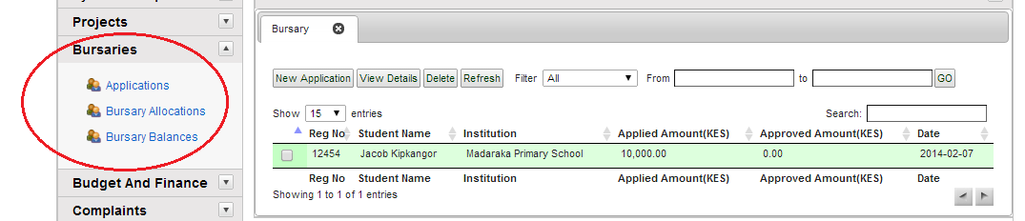

**Buttons on the Bursary Screen**

* **New Application**: - Click this to add a new bursary application
* **View Details**: - Click to view Bursary applicant details
* **Delete**: - Click to delete application
* **Refresh**: - Refreshes the form
* **Filter**: - used to search using given criteria
* **From-To**: - date range filter used to search

### NEW BURSARY APPLICATION

When entering a new bursary application, click on the **New application** button. The following screen below will appear:

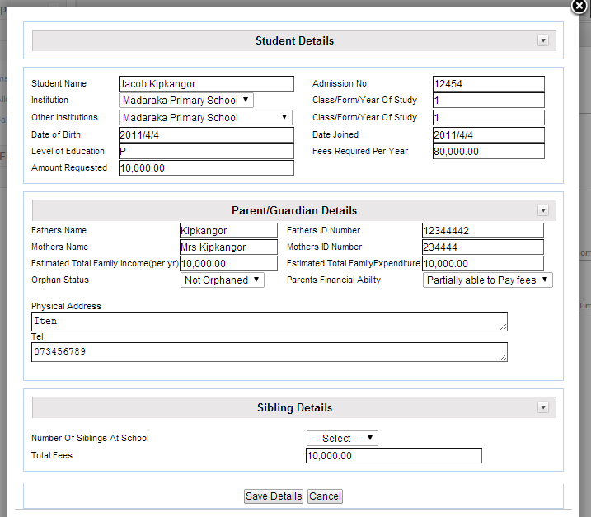

1. Enter the Names of the applicant
2. Enter the Admission No.
3. From the drop down list, select the Institution the applicant attends
4. Enter the year of study or the class the applicant is in.
5. Enter the date of birth
6. Enter the date the applicant joined the institution
7. Enter the course the applicant is in
8. Enter the fees required per year
9. Enter the amount requested
10. Enter fathers name and id number
11. Enter mothers name and id number
12. Enter estimated total family income per year
13. Enter estimated total family expenditure- optional
14. From the drop down box, select orphan status
15. Enter parents financial ability to pay fees
16. Enter physical address where the applicant resides
17. Enter telephone contact of the applicant or guardian
18. Select number of siblings at school the applicant has- optional
19. Enter their total fees- optional
20. Click on **Save Details** to save the record to the database. If you want to clear the details and enter afresh, click on the Cancel Details.

**VIEW BURSARY APPLICANT’S DETAILS**

Once you have entered the applicant details, you will want to view and process them. Click on **View Details** button. The following screen will appear:

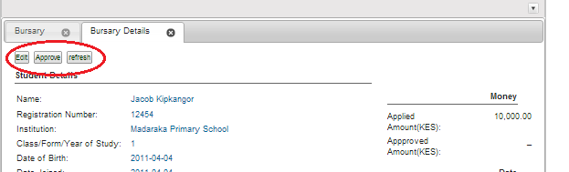

**Buttons on the screen**

* **Edit**: - Used to edit the application
* **Approve**: - used to approve the application
* **Payment**: - used to do payments for the applicant
* **Reapplication**: - used to do a reapplication for the applicant

**VIEW BURSARIES DETAILS SCREEN**

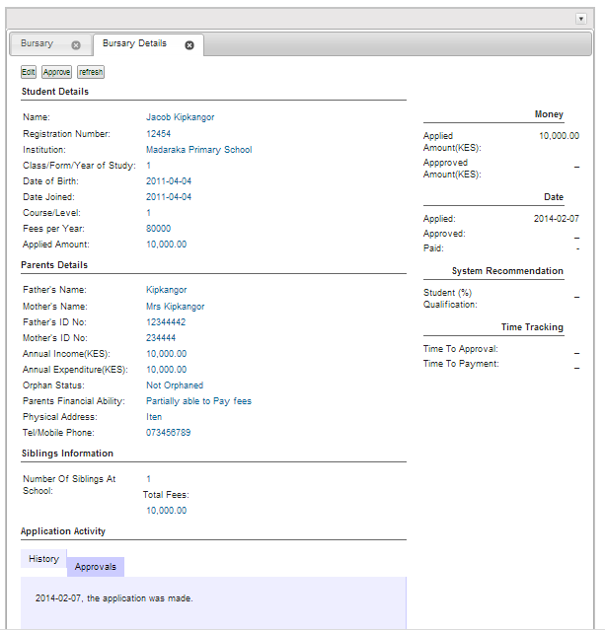

**Student Details: -**This will show you the applicant details information.

**Parent Details**: - This will show the parents details

**Siblings Information**: - Will show you the number of siblings the applicant has

**Money: -** Will show you applied amounts and approved amounts

**Dates**: - will show date applied and date approved

**Time tracking: -** Will show you how much time has elapsed from approval to payment

**TABS ON THE VIEW APPLICATION ACTIVITY**

**HISTORY**

This will show you a history of the application. The screen is shown below:

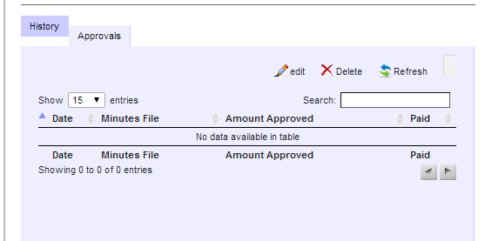

**APPROVALS**

This shows details of the approval. The screen is shown below:



### PAYMENTS

This shows details of payments for the application. The screen is shown below:

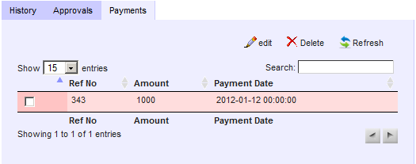

**APPROVING AN APPLICATION**

When you click on the Approve button, the following screen below appears:

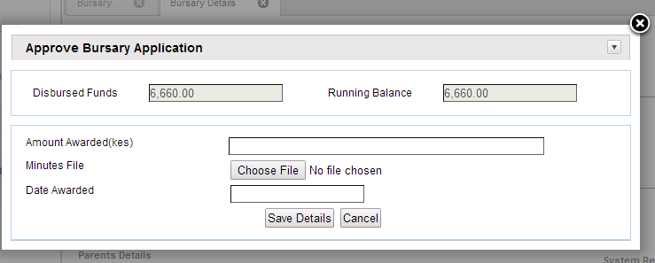

The screen shows:

* **Approved bursary funds**: - This is derived from the percentage that is setup
* **Amount approved**: - this is the amounts approved from the bursary fund
* **Balance**: this is the balance remaining in the bursary fund

1. Enter the amount awarded
2. Enter minutes file
3. Enter date awarded
4. Click on Save Details to save in database.

### BURSARY ALLOCATIONS

This screen gives a list of all approved bursaries and the approved amounts. To access this screen, click on Bursary allocations button on the Bursaries menu. The following screen below will appear:

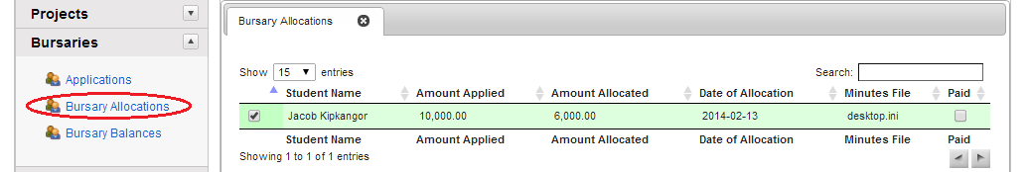

# BUDGET AND FINANCE MENU

The Budget and Finance Menu allows you to establish, track, and control project budgeting and payment information, Finance Allocations and Disbursements.

The menu options allow designated users to:

* review the proposed budget for a particular project;
* handle administrative expenses
* setup banks
* handle project payments
* handle income

To access the Budget and Finance Menu, at the CDF MIS Main Menu, click on **Budget and Finance**. The following are the main items on the menu:

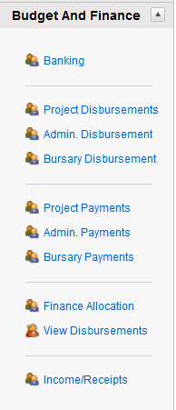

**BUTTONS ON THE BUDGET AND FINANCE MENU**

* **Banking**: - This is used to setup the constituency bank account
* **Project Disbursements**: - This will be used to transfer money from the bank account to a particular project
* **Admin. Disbursements**: This will be used to transfer money from the bank account to the office account
* **Bursary Disbursements**: - This will be used to transfer money from the bank account to institutions
* **Finance allocations**: - This will alert you on the yearly financial allocation from the CDF Board
* **Project payments**: Will be used for payments done from the PMC to contractor
* **Admin payments**: Will be used to handle administrative expenses for the constituency office
* **Bursary payments**: Will be used for payments done for bursary from CDFC to Institutions
* **Project balance inquiry**: Will show the balance on a particular project
* **Admin. Expenses**: Will be used to handle administrative expenses for the constituency office
* **Income**: Will be used to record any incomes earned in the constituency

**CDFC Banking**

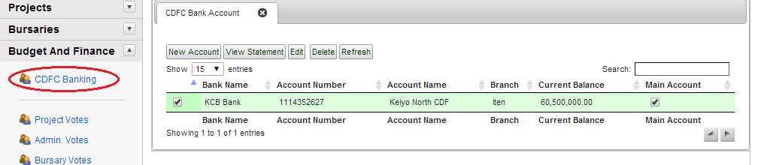

1. Enter the bank name e.g. Kenya commercial bank
2. Enter account name e.g. Embakasi cdf account
3. Enter current balance-
4. Enter Account no. e.g. 234 444 343
5. Enter Branch e.g. KCB Embakasi branch
6. Click on Save details to save record in the database

**VIEW/EDIT ACCOUNT**

To view or modify the bank account you have created, click on the **View/Edit** button. The screen below will appear

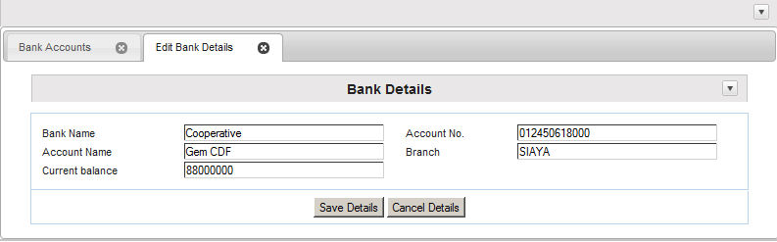

The screen will give you details of what you had previously entered. You can then edit the details using the steps above.

**DELETE**

This will delete the current selected bank account. When clicked it will ask you for confirmation as shown below

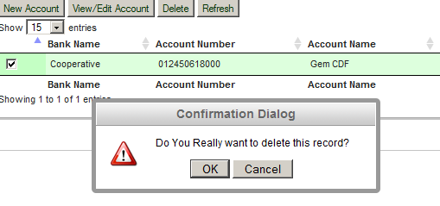

## **FINANCE ALLOCATIONS MENU**

This allows the user to view the **finance allocations** for the financial year.

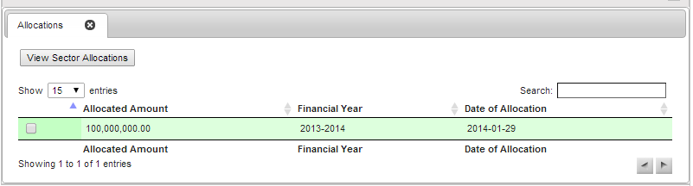

When you click on Allocations breakdown tab, the screen below will appear. It gives a breakdown on allocations per sector.

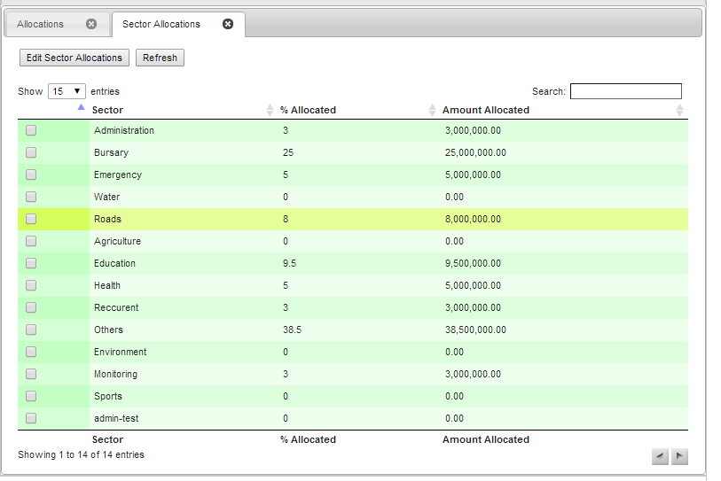

## **DISBURSEMENTS**

When headquarters disburses money on quarterly basis, click on disbursements to view the amounts disbursed

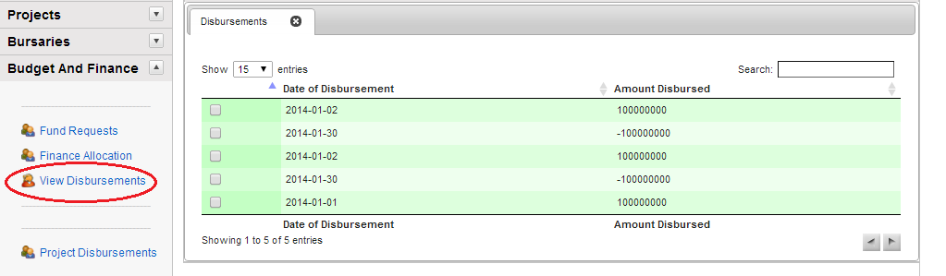

The screen displays the sector, description and the amount allocated for the sector, project code, the date of payment, the payee (supplier) details of payment and the amount.

## **OFFICE PAYMENTS**

This is used for office expenditure and administrative expenses incurred at the CDF offices

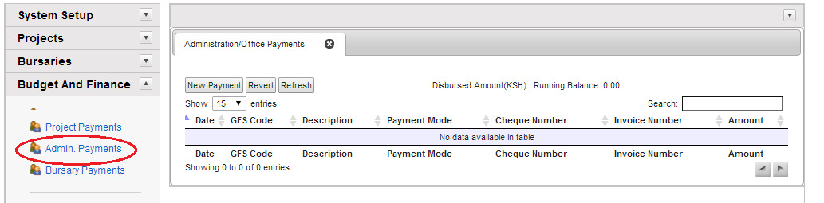

**NEW OFFICE PAYMENT**

Click on new payment to enter new office expenditure

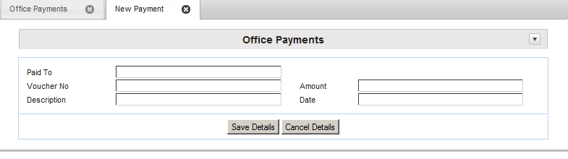

1. Enter who you are paying
2. Enter voucher no
3. Give a brief description for the payment
4. Enter the amount
5. Enter the date of payment
6. Click on save details to save the record in the database

**EDIT PAYMENT**

You can also edit a payment after you have entered it. Click on edit payment button and follow the steps above to edit the payment

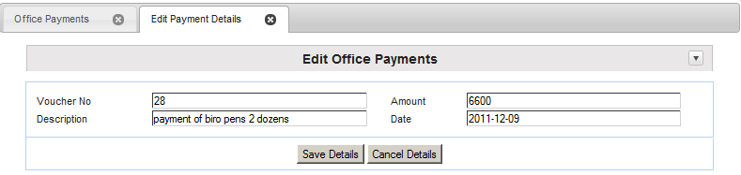

**DELETE PAYMENT**

You can delete a payment

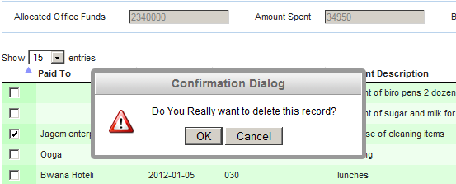

**INCOME MENU**

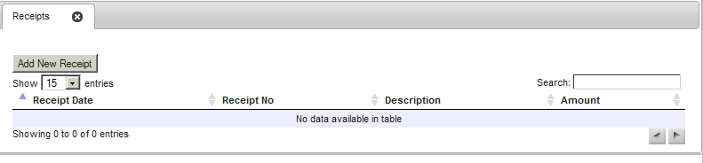

**ADD NEW RECEIPT**

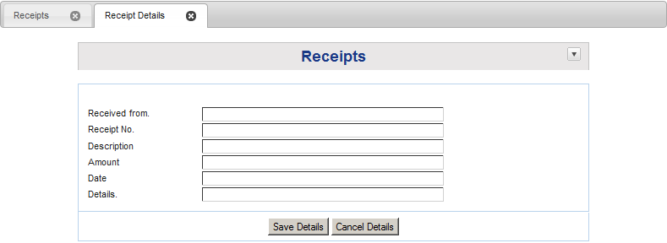

# COMPLAINTS

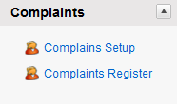

## **COMPLAINTS REGISTER**

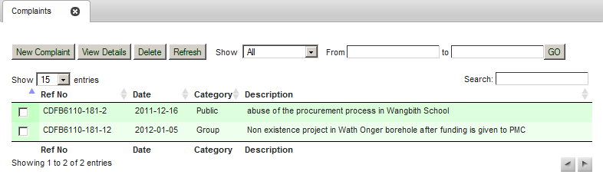

## **NEW COMPLAINT**

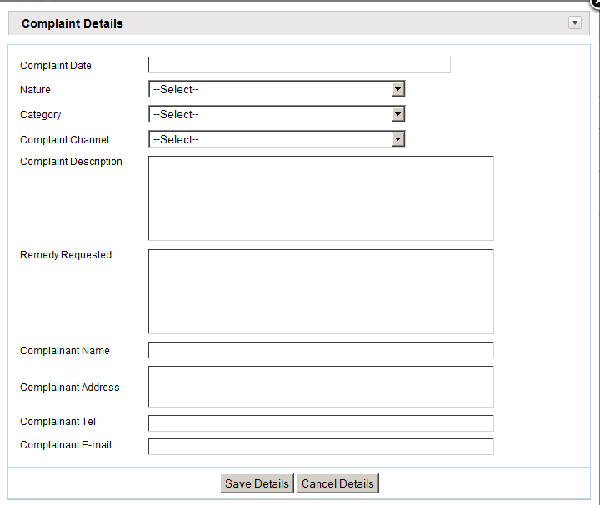

## **VIEW COMPLAINT DETAILS**

# APPENDIX

## **PROJECTS REPORTS CHECKLIST**

**As per the blueprint**

|  |  |  |  |
| --- | --- | --- | --- |
| **No.** | **Report Name** | **Indicate if Original (pre-CDFMIS) or New** | **Changes from Original, if any** |
| 1 | Employee List Report | New |  |
| 2 | PMC List Report | New | Had PMCs but no report on the same |
| 3 | Regions List Report | New | Had Regions but no report on the same |
| 4 | CDFC Member Role Report | New | Had Act but no report |
| 5 | Constituencies List report | Original | Format change |
| 6 | Sector list report | Original | Format change |
| 7 | Project Status report | Original | Standardized across all constituencies |
| 8 | Project implementation Status report | Original | Standardized across all constituencies |
| 9 | First Schedule | New |  |
| 10 | Second Schedule | Original | Modified as per the Act 2013. Was previously the Third Schedule |
| 11 | Third schedule | Original | Dropped as per the Act 2013 |
| 12 | Fourth Schedule | Original | Dropped as per the Act 2014 |
| 13 | Fifth Schedule | Original | Dropped as per the Act 2015 |
| 14 | Re-allocation Report | Original | Standardized across all constituencies |
| 15 | Reallocation Revaluation report | Original | Standardized across all constituencies |
| 16 | Project Evaluation Report | Original | Standardized across all constituencies |
| 17 | Project Per Sector Report | New |  |
| 18 | Bursary Applicants Report | Original | No change |
| 19 | Approved Bursary List Report | New |  |
| 20 | Institution List Report | Original | No change |
| 21 | Project Allocation Report | Original | Standardized across all constituencies |
| 22 | Disbursement Status Report | New | Was contained in manual file |
| 23 | Constituency Bank Balance report | New |  |
| 24 | Sector Allocation report | Original | No change |
| 25 | Project Allocation Report | Original | No change |
| 26 | Complaints Report | New |  |

## **PROJECT SECTOR CODES**

To be inserted to provide quick reference to Users

| **Code** | **Description** |
| --- | --- |
| 000 | Default |
| 100 | Administration |
| 101 | Emergency |
| 102 | Agriculture |
| 103 | Bursary |
| 104 | Education |
| 105 | Health |
| 106 | Water |
| 107 | Roads |
| 108 | Others |
| 109 | Recurrent |
| 110 | Environment |
| 111 | Capacity building / monitoring and evaluation |
| 112 | Sports |
| 113 | Constituency office |

## **OPERATIONS POLICIES**

Relevant policies to be inserted by CDF to guide users