|  |  |
| --- | --- |
| CDF logo 4 MsWord  **NG-CDF EMGWEN** | **National Government Constituencies Development Fund**  **Emgwen Constituency**  **P.O Box 1215-30300,**  **Kapsabet, Kenya.**  **Tel:0768667258| Cell: 0207865222**  **Email**: [cdfemgwen@cdf.go.ke](mailto:cdfemgwen@cdf.go.ke) | **Website:** [www.](http://www.cdf.go.ke)cdf.go.ke |

**EMGWEN NGCDFC FULL MEETING HELD ON 4TH DECEMBER 2024 AT 10:30 AM IN CDF BOARDROOM.**

**MEMBERS PRESENT**

1. JOHN BUSIENEI CHAIRMAN
2. ALFET JILLO DCC
3. MATHEW TANUI FAM
4. MARGARET BUSIENEI SECRETARY
5. SAMSON KOSGEY MEMBER
6. WINNIE JEPTOO BII MEMBER
7. EUSILAH JEPNGETICH MEMBER
8. BEN KIPKORIR MEMBER
9. RODAH CHEBET MEMBER

**MEMBERS ABSENT**

1. DENNIS ANGAYA MEMBER

**AGENDA**

1. Preambles
2. Declaration of Conflict of interest
3. Reading and Confirmation of the previous meeting
4. Appointment of Account Assistant
5. Ward Open Forum public meeting report
6. List of ongoing projects
7. Project Proposal FY 2024/2025
8. Approval for payment
9. Adjournment

**MIN 01/04/DECEMBER/2024: PREAMBLES**

The meeting started at 10.30am followed by a word of prayer from Ben Kipkorir. The chairperson welcomed members to the meeting, then introduced the new Fund Account Manager Mr. Mathew Tanui.

**MIN 02/04/DECEMBER/2024: DECLARATION OF CONFLICT OF INTEREST**

The chairperson gave a brief introduction on the agendas of the meeting. There being no conflict of interest, the meeting proceeded.

**MIN 03/04/DECEMBER/2024: READING AND CONFIRMATION OF THE PREVIOUS MINUTES**

Secretary read the minutes and it was confirmed by Samson Kosgei seconded by Winny Cheptoo.

**MIN 04/04/DECEMBER/2024: APPOINTMENT OF ACCOUNT ASSISTANT**

The chairperson informed members that a panel comprising of the Human Resource, Fund Account Manager and D.A interviewed the six shortlisted applicants and the results were as follows:

|  |  |  |
| --- | --- | --- |
| **Name of applicant** | **Average score %** | **Position** |
| Linus Kipchumba Rotich | 75.63 | 1 |
| Vincent Angose | 43.25 | 6 |
| Usilah Jepng’etich | 43.75 | 5 |
| Carolyne Jeruto | 47.13 | 4 |
| Limo Kevin Kiptoo | 57.37 | 2 |
| Jepkoech Prudence | 48.25 | 3 |

After deliberation the committee agreed that Linus Kipchumba Rotich should be appointed as accounts assistant

**MIN 05/04/DECEMBER/2024: WARD OPEN FORUM MEETING REPORT**

The Chairperson thanked all the members for attending the ward open forum public meeting. It was pointed out that the turnout was good and most of the school principals, headteachers and project secretaries attended in person. The public participation was carried out between 14th October, 2024 to 18th October, 2024.

The chairperson took the members through the ward open forum public meeting report. After deliberation, members confirmed that the report was a true reflection of the public meetings and agreed to adopt as attached;

| **S/NO** | **PROJECT NAME** | **PROJECT ACTIVITY** | **AMOUNT ALLOCATED** | **STATUS** |
| --- | --- | --- | --- | --- |
| **KAPKANGANI WARD** | | | | |
| 1 | Sirwa Yala Primary School | Completion of 2 classrooms | 679,000.00 | ongoing |
| 2 | Sirwa Yala Primary School | Completion of 2 classrooms | 480,000.00 | ongoing |
| 3 | Kapkatoi Primary School | Completion of 2 classrooms | 750,000.00 | ongoing |
| 4 | Kapkatoi Primary School | Completion of 2 classrooms | 750,000.00 | ongoing |
| 5 | ACK Kipsugur secondary School | Purchase and installation of energy saving jiko | 300,000.00 | New |
| 6 | Kiborgok Mixed Secondary School | Completion of dining hall | 700,000.00 | ongoing |
| 7 | Kapkangani Primary School | Renovation of 10 classrooms | 2,000,000 | new |
| 8 | St Patrick Chepsonoi Primary School | Renovation of 8 classrooms | 1,312,977.02 | new |
|  | **2. Chepkumia Ward** | | | |
| 1 | Holy Rosary Girls High School | Completion of 35 capacity laboratory | 2,000,000.00 | ongoing |
| 2 | Holy Rosary Girls High School | Completion of 80 beds Girls Dormitory | 1,500,000.00 | ongoing |
| 3 | Kimnyoasis Secondary School | Purchase of a School bus | 10,000,000.00 | new |
| 4 | ACK St Andrews Chepkoiyo Primary School | construction of 1 classroom to completion at 1,350,000 and purchase of 20 lockers and chairs at 100,000 | 1,450,000.00 | New |
| 5 | Chepkumia secondary school | Purchase and planting of tree seedlings | 100,000.00 | New |
| 6 | Koibem primary school | Purchase and planting of tree seedlings | 100,000.00 | New |
| 5 | Cheboite Chief's Office | Construction of 3  roomed chief's office to completion | 2,300,000 | new |
| 6 | Cheboite Chief's Office | purchase of 0.3 acres land | 700,000 | new |
|  | **3. Kilibwoni Ward** | | |  |
| 1 | Chebarus Border Primary School | Completion of 1 classroom | 500,000.00 | Ongoing |
| 2 | CDF logo 4 MsWordCDF logo 4 MsWordCDF logo 4 MsWord  Kipsotoi Primary School | renovation of 8 classrooms | 1,400,000.00 | New |
| 3 | St Georges Kabirirsang Primary School | construction of 2 classrooms at 2,700,000 and purchase of 50 lockers and chairs at 250,000 | 2,950,000.00 |  |
| 4 | St Pauls Arwos Primary School | construction of 1 classroom to completion at 1,350,000 and purchase of 20 lockers and chairs at 100,000 | 1,450,000.00 | New |
| 5 | AIC Olong'ata Primary School | construction of 1 classroom to completion at 1,350,000 and purchase of 20 lockers and chairs at 100,000 | 1,450,000.00 | New |
| 6 | Mberia Toleltany Primary School | renovation of 10 classrooms | 2,000,000.00 | New |
| 7 | Katanin Primary School | construction of 5 roomed administration block  to completion | 3,500,000.00 | **New** |
| 8 | Kiptilalon Primary School | construction of 1 classroom to completion at 1,350,000 and purchase of 20 lockers and chairs at 100,000 | 1,450,000.00 | New |
| 9 | Cheplasgei Primary School | construction of 2 classrooms at 2,700,000 and purchase of 40 lockers and chairs at 200,000 | 2,900,000.00 | New |
| 10 | Sinendo Primary School | renovation of 10 classrooms | 2,000,000.00 | New |
| 11 | ACK Kaibeyo Primary School | construction of 1 classroom to completion at 1,350,000 and purchase of 20 lockers and chairs at 100,000 | 1,450,000.00 | New |
| 12 | Kapchepsir Primary School | Renovation of 10 classrooms | 2,000,000.00 | New |
| 13 | Kipkeibon Secondary School | Completion of storey building of twin science laboratory of 80 students’ capacity | 1,500,000.00 | ongoing |
| 14 | Barngetuny Secondary School | Completion of 45 students' capacity Science laboratory; | 2,500,000.00 | ongoing |
| 15 | ACK St Thomas Kapchumba Secondary School | Completion of 45 students' capacity Science laboratory; | 2,500,000.00 | ongoing |
| 16 | Kapkagaon Secondary School | Completion of girls dormitory; | 2,000,000.00 | ongoing |
| 17 | Songoliet Secondary School | Completion of 35 capacity Science laboratory | 2,000,000.00 | ongoing |
| 18 | St Michael's Terige Secondary School | construction of dining hall-co funding | 5,000,000.00 | New |
| 19 | Kipture secondary School | Installation of 400 ltr energy saving jiko | 450,000.00 | New |
| 20 | Kabirirsang Secondary School | Purchase and installation of 400 litres stainless steel saving jiko | 450,000.00 | New |
| 21 | Lolminingai chief’s office | Completion of chief’s office | 650,000.00 | ongoing |
| 22 | Pr Misoi Primary School | construction of 1 classroom to completion at 1,350,000 and purchase of 20 lockers and chairs at 100,000 | 1,450,000.00 | New |
| 23 | Ict Hub-Kabore Polytechnic | Construction to Completion of ICT Hub | 5,200,000.00 | New |
|  | **4. Kapsabet Ward** | | | |
| 1 | Kapsabet Muslim Primary School | Renovation of 10 classrooms | 2,000,000.00 | New |
| 2 | St Barnabas Tegat High School | Completion of a kitchen | 3,000,000.00 | ongoing |
| 3 | Kamobo Secondary School | Purchase and installation of 400 litres stainless steel saving jiko | 450,000.00 | new |
| 4 | ACK St Mark Kiminda Secondary School | Purchase of a School bus | 10,000,000.00 | new |

**MIN 06/04/DECEMBER/2024: LIST OF ONGOING PROJECTS**

The chairperson informed the committee on the progress of ongoing project as attached:

| **Financial Year when the project was first funded** | **Project Name** | **Initial Approved Activities** | **Pending Activities Requiring Funding** | **Contract Sum/ Estimated Cost (Kshs.) of the entire project** | **Cumulative allocation to the project (Kshs.)** | | **Balance** | **Level of Completion** | **Remarks** |
| --- | --- | --- | --- | --- | --- | --- | --- | --- | --- |
| **Financial Year** | **Amount Allocated** |
| 2020/2021 | kipkeibon secondary school | Construction of storey building of twin science laboratory of 80 students capacity (40 students on ground floor and 40 students on first floor) walling, roofing, plastering, windows and doors, fixing of gas, tiles and working tables | Construction of Ramp | 13,500,000 | 2021/2022 2020/2021 2022/2023 2023/2024 | 2,000,000 2,000,000 1,000,000 7,000,000 | 1,500,000 | Ramp not done | Additional funds are for construction of ramp |
| 2022/2023 | Barngetuny Secondary School | Construction to roofing level of a 45 students' capacity Science laboratory | ceiling, worktop and floor finishes, mechanical works, gas installation and equipping, painting and electrical works | 5,500,000 | 2022/2023 2023/2024 | 1000000 2000000 | 2,500,000 | Tendering completed | Additional funds are for ceiling, worktops and floor finishes, mechanical works, gas installation and equipping, painting and electrical works |
| 2023/2024 | CDF logo 4 MsWordCDF logo 4 MsWordCDF logo 4 MsWordCDF logo 4 MsWordACK St Thomas Kapchumba secondary school | CDF logo 4 MsWordCDF logo 4 MsWordConstruction to roofing level of a 45 students' capacity Science laboratory | ceiling, worktop and floor finishes, mechanical works, gas installation and equipping, painting and electrical works | 5,500,000 | 2023/2024 | 3,000,000 | 2,500,000 | at procurement stage | Additional funds are for ceiling, worktops and floor finishes, mechanical works, gas installation and equipping, painting and electrical works |
| 2015/2016 | Holy Rosary girls high school | Construction of laboratory | Paving slab, floor finish, concrete worktops, mechanical installations, electrical works | 6,000,000 | 2015/2016 2017/2018 2018/2019 2021/2022 | 1,000,000 1,000,000 1,000,000 1,000,000 | 2,000,000 | roofing level | Additional funds is for Paving slab, floor finish, concrete worktops, mechanical installations, electrical works |
| 2019/2020 | Holy Rosary girls high school | Construction of 80 beds Girls Dormitory to roofing | paving slab, external wall keying, 1 window, 2 steel doors, mechanical works electrical and painting | 5,500,000 | 2019/2020 2020/2021 2021/2022 | 1,000,000 2,000 000 1,000,000 | 1,500,000 | 80% complete | Additional funds will do paving slab, external wall keying, 1 window, 2 steel doors, mechanical works electrical and painting |
| 2019/2020 | Sirwa yala primary school | Construction of 2 classrooms to completion | electrical works, painting, window glazing, fascia board, verandah, wall finishes, floor finishes and paving slab | 1,879,000 | 2019/2020 | 1,200,000 | 679,000 | roofing level | roofing level |
| 2015/2016 | Sirwa yala primary school | Construction of 2 classrooms | electrical works, painting, window glazing, fascia board and paving slab | 1,480,000 | 2015/2016 | 1,000,000 | 480,000 | roofing level | roofing level |
| 2018/2019 | Kapkatoi primary school | Construction of 2 classrooms | paving slab, electrical works, painting, glazing and fascia board | 1,750,000 | 2018/2019 | 1,000,000 | 750,000 | 80% complete | Additional funds are for construction of paving slab, electrical works, painting, glazing and fascia board |
| 2013/2014 | Kapkatoi primary school | Construction of 1 classroom, renovation of 2 classrooms | plaster works, painting, fascia board and electrical works | 1,450,000 | 2013/2014 | 700,000 | 750,000 |  | Additional funds are for plaster works, painting, fascia board and electrical works |
| 2017/2018 | Kiborgok mixed secondary school | construction of dormitory to roofing level | paving slab, window glazing, electrical works and painting | 4,700,000 | 2017/2018 2018/2019 2019/2020 2021/2022 | 1,000,000 1,000,000 1,000,000 1,000,000 | 700,000 | 90% complete | Additional funds are for paving slab, window glazing, electrical works, painting |
| 2018/2019 | Lolminingai chief's office | construction of chief's office to roofing | Re-roofing, doors and painting | 1,150,000 | 2018/2019 | 500,000 | 650,000 | 70% complete | 70% complete |
| 2017/2018 | Kapkagaon secondary school | construction of dormitory to roofing level | Paving slab, keying, doors, mechanical works, floor finishes, glazing, painting and electrical works | 7,000,000 | 2017/2018 2018/2019 2019/2020 2020/2021 2021/2022 | 1,000,000 1,000,000 1,000,000 1,000,000 1,000,000  1,000,000 | 2,000,000 | 73% complete | Additional funds are for Paving slab, keying, doors, mechanical works, floor finishes, glazing, painting and electrical works |
| 2018/2019 | Songoliet secondary school | Construction of Science laboratory to roofing level | floor finishes, keying, ceiling, electrical, mechanical works and painting | 5,000,000 | 2018/2019 2020/2021 2021/2022 | 1000000 1000000 1000000 | 2,000,000 | 75% complete | Additional funds are for floor finishes, keying, ceiling, electrical, mechanical works and painting |
| 2018/2019 | Chebarus Border primary school | construction of classroom to completion | internal and external plaster, paving slab, electrical works, fascia board and painting | 1,500,000 | 2015/2016 | 1,000,000 | 500,000 | 65% complete | Additional funds are for plaster works, paving slab, glazing, fascia board and painting |
| 2015/2016 | St Barnabas Tegat high school | construction to completion of dining hall and kitchen | kitchen-walling, plastering, keying, flooring, electrical and painting | 7,000,000 | 2015/2016 2017/2018 2018/2019 2019/2020 | 1,000,000 1,000,000 1,000,000 1,000,000 | 3,000,000 | Kitchen -paving slab, walling, slab, plaster, doors, windows and finishes | kitchen-walling, plastering, keying, flooring, electrical and painting |
| 2022/2023 | NG-CDF OFFICE | Construction of Emgwen constituency office | Mechanical works, doors and electrical works | 15,275,695 | 2022/2023 | 12,000,000 | 3,275,695 | not yet started | Additional funds are for mechanical works, doors and electrical works |

**MIN 07/04/DECEMBER/2024: PROPOSAL FOR 2024/2025 FINANCIAL YEAR**

The members were informed that the constituency budget ceiling allocation for the financial year 2024/2025 was given to be **Kshs.170,469,856**. The Fund Account Manager took the members through the Board’s circular on call for proposals item by item.

Regarding the **Junior Secondary Schools (JSS)** listed by the Ministry of Education, the committee allocated funds to 6 schools in the current financial year out of 54 schools. This decision was guided by the need to prioritize the completion of numerous ongoing projects from previous financial years that required additional funding. However, the committee resolved that these schools will be considered for funding in the next financial year.

The committee also noted that the allocation of 5% of climate mitigation projects within the constituency be limited due to prioritization of ongoing projects.

After a lengthy discussions and considerations, the committee resolved to approve the projects for funding in the financial year 2024/25 as below: -

| **Project Number** | **Project Name** | **Project Activity** | **Original Cost** | **Cumulative Allocation** | **Amount Allocated** | **Current Status** |
| --- | --- | --- | --- | --- | --- | --- |
| **ADMINISTRATION AND RECURRENT EXPENDITURE** | | | | |  |  |
| **COMPENSATION OF EMPLOYEES** | | |  |  |  |  |
| 4-029- 155-2110201-100-2024-2025-1 | Contractual Employees | Payment of 5 staff Basic salaries | 1,534,800 |  | 1,534,800 | New |
| 4-029-155-2110202-100-2024-2025-2 | Casual Labour and Internship | Payment of staff 4 Basic Wages | 876,000 |  | 876,000 | New |
| 4-029-155-2110301-100-2024-2025-3 | House Allowance | Payment of House allowances to 5 NG-CDFC staff | 277,800 |  | 277,800 | New |
| 4-0279-155-2110314-100-2024-2025-4 | Transport Allowance | Payment of Transport allowances to 5 NG-CDFC staff | 240,000 |  | 240,000 | New |
| 4-029-155-2110320-100-2024-2025-5 | Leave Allowance | Payment of Leave allowances to 5 NG-CDFC staff | 28,000 |  | 28,000 | New |
| 4-029-155-2120201-100-2024-2025-6 | NSSF | Employer contribution to NSSF for both contracted staff | 222,000 |  | 222,000 | New |
| 4-029-155-2710102-100-2024-2025-7 | Gratuity-Contractual Employees | Payment of gratuity to 5 contracted NG-CDFC staff. | 475,787 |  | 475,787 | New |
| 4-029-155-2710102-100-2024-2025-8 | Housing Levy | Employer Contribution to Housing Levy 5 contracted staff | 53,400 |  | 53,400 | New |
| 4-029-155-2710102-100-2024-2025-9 | National Industrial Training Authority(NITA) | Employer contribution to NITA for 5 NG-CDFC Staff | 3,600 |  | 3,600 | New |
| **USE OF GOODS AND SERVICES** | | | |  |  |  |
| 4-029-155-2210101-100-2024-2025-1 | Electricity | Payment of Electricity charges | 60,000 |  | 60,000 | New |
| 4-029-155-2210201-100-2024-2025-2 | Telephone, Telex, Facsmile and Mobile Phone Service | Payment of Telephone Expenses | 150,000 |  | 150,000 | New |
| 4-029-155-2210202-100-2024-2025-3 | Internet Connections | Payment of Internet Connections Expenses | 69,588 |  | 69,588 | New |
| 4-029-155-2210203-100-2024-2025-4 | Courier and Postal Services | Payment of Courier and Postal Services | 400,000 |  | 400,000 | New |
| 4-029-155-2210204-100-2024-2025-12 | Maintenance of Building and stations- office rent | Payment of maintenance of NG-CDFC Office Non Residential | 600,000 |  | 600,000 | New |
| 4-029-155-2210301-100-2024-2025-6 | Travel Costs (Airlines, Bus, Railway | Payment of Travel Costs | 200,000 |  | 200,000 | New |
| 4-029-155-2210302-100-2024-2025-7 | Accommodation - Domestic Travel | Payment of Accommodation Domestic Travel for NG-CDFCs | 400,000 |  | 400,000 | New |
| 4-029-155-2210303-100-2024-2025-8 | Daily Subsistence Allowance | Payment of Daily Subsistence Allowance | 200,000 |  | 200,000 | New |
| 4-029-155-2210502-100-2024-2025-9 | Publishing and Printing Services | Payment of Publishing and Printing Services | 100,000 |  | 100,000 | New |
| 4-029-155-2210504-100-2024-2025-10 | Advertising, Awareness and Publicity Campaigns | Payment of Advertising, Awareness and Publicity Campaigns | 100,000 |  | 100,000 | New |
| 4-029-155-2210801-100-2024-2025-11 | Catering Services: Food and Drinks | Payment of catering Services; Food and Drinks | 200,000 |  | 200,000 | New |
| 4-029-155-2210802-100-2024-2025-12 | Other Committee Expenses | Payment of Other committee expenses | 600,000 |  | 600,000 | New |
| 4-029-155-2210811-100-2024-2025-13 | NG-CDFC Allowance | Payment of NG-CDFC sitting allowances | 1,128,000 |  | 1,128,000 | New |
| 4-029-155-2210904-100-2024-2025-14 | Motor Vehicle Insurance | Payment of Motor Vehicle Insurance Pick Up GKB 956F | 100,000 |  | 100,000 | New |
| 4-029-155-2211101-100-2024-2025-15 | General Office Supplies (Papers, Pencils, Forms, Small Office Equipment etc.) | Purchase of General Office Supplies (papers, pencils, forms, small office equipment) | 659,215 |  | 659,215 | New |
| 4-029-155-3111000-100-2024-2025-25 | Supplies and Accessories for Computers and printers | Purchase of Supplies and Accessories for Computers and Printers | 200,000 |  | 200,000 |  |
| 4-029-155-2211103-100-2024-2025-17 | Sanitary and Cleaning Materials, Supplies and Services | Payment of Sanitary and Cleaning Materials, Supplies and Services | 100,000 |  | 100,000 | New |
| 4-029-155-2211201-100-2024-2025-18 | Refined Fuels and Lubricants for Transport | Purchase of Refined Fuels and Lubricants for GK Vehicles | 400,000 |  | 400,000 | New |
| 4-029-155-2211204-100-2024-2025-32 | Other fuel. Wood, charcoal, cooking gas | Payment of other fuels (wood, charcoal, cooking gas expenses) | 20,000 |  | 20,000 |  |
| 4-029-155-2211301-100-2024-2025-20 | Bank Service Commission and Charges | Payment of Bank service commission and charges | 80,000 |  | 80,000 | New |
| 4-029-155-2211305-100-2024-2025-21 | Contracted Guards and Cleaning Services | Payment of Contracted Guards and Cleaning Services | 400,000 |  | 400,000 | New |
| 4-029-155-2220101-100-2024-2025-22 | Maintenance Expenses - Motor Vehicles | Payment of Maintenance Expenses - Motor Vehicles Pick Up GKB 956F | 250,000 |  | 250,000 | New |
| 4-029-155-2220202-100-2024-2025-23 | Maintenance of Office Furniture and Equipment | Payment of Maintenance of Office Furniture and Equipment | 100,000 |  | 100,000 | New |
| **MONITORING EVALUATION AND CAPACITY BUILDING** | | |  |  |  |  |
| 4-029-155-2210301-111-2024-2025-1 | Travel Costs: Airlines, Bus, Railway. | Payment of Travel Costs | 100,000 |  | 100,000 | New |
| 4-029-155-2210302-111-2024-2025-2 | Accommodation - Domestic Travel | Payment of Accommodation - Domestic Travel for NG-CDFCs | 300,000 |  | 300,000 | New |
| 4-029-155-2210303-111-2024-2025-3 | Daily Subsistence Allowance | Payment of Daily Subsistence Allowance | 100,000 |  | 100,000 | New |
| 4-029-155-2210502-111-2024-2025-4 | Publishing and Printing Services | Payment of Publishing and Printing Services | 100,000 |  | 100,000 | New |
| 4-029-155-2210504-111-2024-2025-5 | Advertising, Awareness and Publicity Campaigns | Payment of Advertising, Awareness and Publicity Campaigns | 100,000 |  | 100,000 | New |
| 4-029-155-2210701-111-2024-2025-6 | Travel Allowance | Payment of Travel Allowance, accommodation for NG-CDF Staff & NG-CDFC, PMC during capacity building | 1,152,000 |  | 1,152,000 | New |
| 4-029-155-2210702-111-2024-2025-7 | Remuneration of Instructors and Contract Based Training Services- Drug and HIV trainings are mandatory. | Remuneration of Instructors and Contract Based Training Services during NG-CDF Staff, NG-CDFC and PMCs Training. | 300,000 |  | 300,000 | New |
| 4-029-155-2210703-111-2024-2025-8 | Production and Printing of Training Materials | Payment of Production and Printing of Training Materials | 138,095 |  | 138,095 | New |
| 4-029-155-2210704-111-2024-2025-9 | Hire of Training Facilities and Equipment | Payment of Hire of Training Facilities and Equipment | 400,000 |  | 400,000 | New |
| 4-029-155-2210801-111-2024-2025-11 | Catering Services: Food and Drinks | Payment of catering Services; Food and Drinks | 300,000 |  | 300,000 | New |
| 4-029-155-2210802-111-2024-2025-12 | Other Committee Expenses | Payment of Other committee expenses | 400,000 |  | 400,000 | New |
| 4-029-155-2210303-111-2024-2025-13 | NGCDFC Allowance | Payment of NG-CDFC allowances | 824,000 |  | 824,000 | New |
| 4-029-155-2211101-111-2024-2025-14 | General Office Supplies (Papers, Pencils, Forms, Small Office Equipment etc.) | Purchase of General Office Supplies (papers, pencils, forms, small office equipment) | 300,000 |  | 300,000 | New |
| 4-029-155-2211201-111-2024-2025-15 | Refined Fuels and Lubricants for Transport | Purchase of Refined Fuels and Lubricants for Transport | 600,000 |  | 600,000 | New |
| **PRIMARY SCHOOLS PROJECTS** | | | |  |  |  |
| 4-0029-155-2630204-104-2024-2025-1 | Sirwa Yala Primary School | Completion of 2 classrooms; paving slab, plastering, glazing, painting and electrical works | 1,879,000 | 1,200,000 | 679,000.00 | ongoing |
| 4-0029-155-2630204-104-2024-2025-2 | Sirwa Yala Primary School | Completion of 2 classrooms; paving slab, fascia board, roof painting, external painting, glazing and electrical works | 1,480,000 | 1,000,000 | 480,000.00 | ongoing |
| 4-0029-155-2630204-104-2024-2025-3 | Kapkatoi Primary School this was a reallocation from Purchase of one acre of land - changed to construction of classrooms | Completion of 2 classrooms: paving slab, roof painting, glazing, plastering, flooring, fascia board and painting | 1,750,000 | 1,000,000 | 750,000.00 | ongoing |
| 4-0029-155-2630204-104-2024-2025-4 | Kapkatoi Primary School | Additional funds for renovation to completion of 2 classrooms: paving slab, roof painting, glazing, plastering, flooring, fascia board and painting | 1,750,000 | 1,000,000 | 750,000.00 | ongoing |
| 4-0029-155-2630204-104-2024-2025-5 | Chebarus Border Primary School | Completion of 1 classroom; external and internal plaster, glazing, paving slab, roof re-decoration and painting | 1,500,000 | 1,000,000.00 | 500,000.00 | New |
| 4-0029-155-2630204-104-2024-2025-7 | St Georges Kabirirsang Primary School | Construction to completion of two classrooms at 2,700,000 and purchase of 40 lockers and chairs at 250,000 | 2,950,000.00 |  | 2,950,000.00 |  |
| 4-0029-155-2630204-104-2024-2025-8 | St Pauls Arwos Primary School | Construction to completion of one classroom at 1,350,000 and purchase of 20 lockers and chairs at 100,000 | 1,450,000.00 |  | 1,450,000.00 | New |
| 4-0029-155-2630204-104-2024-2025-9 | AIC Olong'ata Primary School | Construction to completion of one classroom at 1,350,000 and purchase of 20 lockers and chairs at 100,000 | 1,450,000.00 |  | 1,450,000.00 | New |
| 4-0029-155-2630204-104-2024-2025-10 | Mberia Toleltany Primary School | Renovation to completion of 10 classrooms; flooring, fixing of 10 steel doors, glazing, fixing of fascia board, plastering and painting | 2,000,000.00 |  | 2,000,000.00 | New |
| 4-0029-155-2630204-104-2024-2025-11 | Katanin Primary School | Construction to completion of 5 roomed administration block | 3,500,000.00 |  | 3,500,000.00 | **New** |
| 4-0029-155-2630204-104-2024-2025-12 | Kiptilalon Primary School | Construction to completion of one classroom at 1,350,000 and purchase of 20 lockers and chairs at 100,000 | 1,450,000.00 |  | 1,450,000.00 | New |
| 4-0029-155-2630204-104-2024-2025-13 | Cheplasgei Primary School | Construction to completion of two classrooms at 2,700,000 and purchase of 40 lockers and chairs at 200,000 | 2,900,000.00 |  | 2,900,000.00 | New |
| 4-0029-155-2630204-104-2024-2025-14 | Sinendo Primary School | Renovation to completion of 10 classrooms; flooring, fixing of 10 steel doors, glazing, fixing of fascia board, plastering and painting | 2,000,000.00 |  | 2,000,000.00 | New |
| 4-0029-155-2630204-104-2024-2025-15 | Kapkangani Primary | Renovation to completion of 10 classrooms; flooring, fixing of 10 steel doors, glazing, fixing of fascia board, plastering and painting | 2,000,000 |  | 2,000,000 | NEW |
| 4-0029-155-2630204-104-2024-2025-16 | St Patrick Chepsonoi Primary School | Renovation to completion of 8 classrooms; flooring, fixing of 8 steel doors, glazing, fixing of fascia board, plastering and painting | 1,312,977.02 |  | 1,312,977.02 | NEW |
| 4-0029-155-2630204-104-2024-2025-17 | ACK Kaibeyo Primary School | Construction of 1 classroom to completion at 1,350,000 and purchase of 20 lockers and chairs at 100,000 | 1,450,000.00 |  | 1,450,000.00 | New |
| 4-0029-155-2630204-104-2024-2025-18 | Kapchepsir Primary School | Renovation to completion of 10 classrooms; flooring, fixing of 10 steel doors, glazing, fixing of fascia board, plastering and painting | 2,000,000.00 |  | 2,000,000.00 | New |
| 4-0029-155-2630204-104-2024-2025-19 | Kipsotoi Primary School | Renovation to completion of 8 classrooms; flooring, fixing of 8 steel doors, glazing, fixing of fascia board, plastering and painting | 1,400,000.00 |  | 1,400,000.00 |  |
| 4-0029-155-2630204-104-2024-2025-20 | Pr Misoi Primary School | Construction to completion of one classroom at 1,350,000 and purchase of 20 lockers and chairs at 100,000 | 1,450,000.00 |  | 1,450,000.00 | New |
| 4-0029-155-2630204-104-2024-2025-21 | ACK St Andrews Chepkoiyo Primary School | Construction to completion of one classroom at 1,350,000 and purchase of 20 lockers and chairs at 100,000 | 1,450,000.00 |  | 1,450,000.00 | New |
| 4-0029-155-2630204-104-2024-2025-22 | Kapsabet Muslim Primary School | Renovation to completion of 10 classrooms; flooring, fixing of 10 steel doors, glazing, fixing of fascia board, plastering and painting | 2,000,000.00 |  | 2,000,000.00 | New |
| **SECONDARY SCHOOLS PROJECTS** | | |  |  |  |  |
| 4-0029-155-2630210-263-2024-2025-1 | Kipkeibon Secondary School | Completion of storey building of twin science laboratory of 80 students’ capacity ; ramp access. | 13,500,000 | 12,000,000 | 1,500,000.00 | Ongoing |
| 4-0029-155-2630210-263-2024-2025-2 | Barngetuny Secondary School | Completion of 45 students' capacity Science laboratory; ceiling, worktop and floor finishes, mechanical works, gas installation and equipping, painting and electrical works | 5,500,000 | 3,000,000 | 2,500,000.00 | Ongoing |
| 4-0029-155-2630210-263-2024-2025-3 | ACK St Thomas Kapchumba Secondary School | Completion of 45 students' capacity Science laboratory; ceiling, worktop and floor finishes, mechanical works, gas installation and equipping, painting and electrical works | 5,500,000 | 3,000,000 | 2,500,000.00 | Ongoing |
| 4-0029-155-2630210-263-2024-2025-4 | Kapkagaon Secondary School | Completion of 120 capacity girls dormitory; Paving slab, keying, doors, mechanical works, floor finishes, glazing, painting and electrical works | 7,000,000 | 5,000,000 | 2,000,000.00 | Ongoing |
| 4-0029-155-2630210-263-2024-2025-5 | St Barnabas Tegat High School | Completion of a kitchen; walling, plastering, keying, flooring, electrical and painting | 8,000,000 | 5,000,000 | 3,000,000.00 | Ongoing |
| 4-0029-155-2630210-263-2024-2025-6 | Songoliet Secondary School | Completion of 35 students capacity Science laboratory; floor finishes, keying, ceiling, electrical, mechanical works and painting | 5,000,000 | 3,000,000 | 2,000,000.00 | Ongoing |
| 4-0029-155-2630210-263-2024-2025-7 | Kiborgok Mixed Secondary School | Completion of 300 students capacity dining hall; paving slab, window glazing, electrical works, painting | 5,700,000 | 5,000,000 | 700,000.00 | Ongoing |
| 4-0029-155-2630210-263-2024-2025-8 | Holy Rosary Girls High School | Completion of 35 students’ capacity laboratory; Paving slab, floor finish, concrete worktops, mechanical installations, electrical works | 6,000,000 | 4,000,000 | 2,000,000.00 | Ongoing |
| 4-0029-155-2630210-263-2024-2025-9 | Holy Rosary Girls High School | Completion of 80 capacity Girls Dormitory; paving slab, external wall keying, 1 window, 2 steel doors, mechanical works electrical and painting | 5,500,000 | 4,000,000 | 1,500,000.00 | Ongoing |
| 4-0029-155-2630210-263-2024-2025-10 | Kimnyoasis Secondary School proforma invoice attached | Purchase of a 46-seater (ISUZU FRR90N) School bus | 10,000,000.00 |  | 10,000,000.00 | New |
| 4-0029-155-2630210-263-2024-2025-11 | St Michael's Terige Secondary School | Construction of dining hall -cofounding project | 5,000,000.00 |  | 5,000,000.00 | New |
| 4-0029-155-2630210-263-2024-2025-12 | ACK St Mark Kiminda Secondary School proforma invoice attached | Purchase of a 46-seater (ISUZU FRR90N) School bus | 10,000,000.00 |  | 10,000,000.00 | New |
| **EDUCATION BURSARY AND SOCIAL SECURITY PROGRAMS** | | |  |  |  |  |
| 4-029-155-2640101-103-2024-2025-1 | Bursary - Secondary Schools | Fees payments for needy students in secondary schools. |  |  | 42,807,802.00 | New |
| 4-029-155-2640102-103-2024-2025-2 | Bursary -Tertiary Schools | Fees payments for needy students in tertiary institutions. |  |  | 12,500,000.00 | New |
| 4-029-155-2640106-103-2024-2025-3 | Bursary- Special Schools | Fees payments for needy students in special schools. |  |  | 2,000,000 | New |
| **EMERGENCY RESERVE** |  |  |  |  |  |  |
| 4-029-155-2640204-101-2024-2025-1 | Emergency Projects | To cater for any unforeseen occurrences in the constituency during the financial year. |  |  | 8,972,097.72 | New |
| **SECURITY PROJECTS** |  |  |  |  |  |  |
| 4-0029-155-2640507-113-2024-2025-1 | Cheboite Chief's Office | Construction to completion of 3  roomed chief's office | 2,300,000.00 |  | 2,300,000.00 | New |
| 4-0029-155-2640507-113-2024-2025-2 | Cheboite Chief's Office. Submit land valuation documents | Purchase of 0.3 acres of land inclusive of title deed processing fee. | 700,000.00 |  | 700,000.00 | New |
| 4-0029-155-2640507-113-2024-2025-3 | Lolminingai Chief’s office | Completion of chief's office- Re-roofing, doors and painting | 1,150,000 | 500,000 | 650,000.00 | ongoing |
| **CLIMATE CHANGE MITIGATION ACTIVITIES PROJECTS** | | |  |  |  |  |
| 4-0029-155-2640510-110-2024-2025-1 | Kipture secondary School | Purchase and installation of 400 liters stainless steel saving jiko | 450,000.00 |  | 450,000.00 | New |
| 4-0029-155-2640510-110-2024-2025-2 | Chepkumia secondary School | Purchase, transportation and supply of 1,000 tree seedlings | 100,000.00 |  | 100,000.00 | New |
| 4-0029-155-2640510-110-2024-2025-3 | Koibem Primary School | Purchase, transportation and supply of 1,000 tree seedlings | 100,000.00 |  | 100,000.00 | New |
| 4-0029-155-2640510-110-2024-2025-4 | ACK Kipsugur primary School | Purchase, transportation and supply of 1000 tree seedlings | 100,000.00 |  | 100,000.00 | New |
| 4-0029-155-2640510-110-2024-2025-5 | Kabirirsang Secondary School | Purchase and installation of 400 liters stainless steel saving jiko | 450,000.00 |  | 450,000.00 | New |
| 4-0029-155-2640510-110-2024-2025-6 | Kamobo Secondary School | Purchase and installation of 400 liters stainless steel saving jiko | 450,000.00 |  | 450,000.00 | New |
| 4-0029-155-2640510-110-2024-2025-7 | ACK Kipsugur primary school | Purchase and installation of 400 liters stainless steel saving jiko | 450,000.000 |  | 450,000.00 | New |
| **OTHERS** | | |  |  |  |  |
| 4-0029-155-2630211-263-2024-2025-1 | Kabore Polytechnic Digital Hub | Construction to completion of a standard digital hub | 5,200,000.00 |  | 5,200,000.00 | New |
| 4-0029-155-2211311-108-2024-2025-1 | Emgwen NG-CDF Office | Completion of NG-CDF office; Mechanical works, doors and electrical works | 15,275,695.00 | 12,000,000 | 3,275,695.00 | Ongoing |
| **GRAND TOTAL** |  |  |  |  |  |  |
|  |  |  |  |  | **170,469,856.74** |  |

**MIN 08/04/DECEMBER/2024: APPROVAL FOR PAYMENT.**

The committee approved payment of the following:

1. NG-CDFC and staff public participation allowance- 335,000
2. Committee sitting allowance- 46,900

**MIN 09/04/DECEMBER/2024: ADJOURNEMENT**

The Fund Account Manager explained that the tenure of the committee ends 31st December 2024.

There being no other business, the chairman thanked every member for the successful meeting, and the prayer was made by Eusilah Jepng’etich.

**NGCDFC Chairperson: John Busienei ……………………. Date ………………….**

**NGCDFC Secretary: Margaret Busienei …………………... Date ….........................**

**ANNEXES**

**Annex 1: Breakdown for Staff Salaries, Allowances and Housing Levy**

1. **Contractual Employees**

|  |  |  |  |  |  |  |  |  |  |  |  |
| --- | --- | --- | --- | --- | --- | --- | --- | --- | --- | --- | --- |
| **Position** | **Scale** | **Monthly Basic Salary** | **Annual Basic Salary** | **House Allowance (p.a)** | **Leave Allowance (p.a)** | **Commuter Allowance (p.a)** | **Annual Gross Salary** | **Monthly Gratuity** | **Annual Gratuity** | **Housing Levy (p.a)** | **NITA Employer Contribution (Pa)** |
| Assistant Accountant | CSG 11 | 31,430 | 377,160 | 69,600 | 5,600 | 48,000 | 500,360 | 9,743 | 116,920 | 7,505 | 600 |
| Clerk of Works | CSG 11 | 31,430 | 377,160 | 69,600 | 5,600 | 48,000 | 500,360 | 9,743 | 116,920 | 7,505 | 600 |
| Records Management Assistant | CSG 12 | 25,650 | 307,800 | 46,200 | 5,600 | 48,000 | 407,600 | 7,952 | 95,418 | 6,114 | 600 |
| Receptionist | CSG 13 | 22,500 | 270,000 | 46,200 | 5,600 | 48,000 | 369,800 | 6,975 | 83,700 | 5,547 | 600 |
| Driver | CSG 13 | 22,500 | 270,000 | 46,200 | 5,600 | 48,000 | 369,800 | 6,975 | 83,700 | 5,547 | 600 |
| **Total** |  | **150,400.00** | **1,804,800** | **324,000** | **33,600** | **288,000** | **2,450,400** | **46,624** | **559,488** | **36,756** | **3,600** |

**Annex 3: Breakdown for NG-CDFC Allowances**

|  |  |  |  |  |
| --- | --- | --- | --- | --- |
| **Committee Expenses** | **No. of meetings** | **Number of persons** | **Rate** | **Total** |
| Chairperson | 24 | 1 | 7,000 | 168,000 |
| members | 24 | 9 | 5,000 | 1,080,000 |
| **Total** |  |  |  | **1,248,000** |



**NG-CDF EMGWEN**

**IEBC NUMBER 155**

**NATIONAL GOVERNMENT**

**CONSTITUENCY DEVELOPMENT FUND**

**WARD REPORT**

**2024/2025 FINANCIAL YEAR**

**SUBMITTED**

**2024.**

## Background

This section provides an overview of Emgwen Constituency in terms of the location; size; physiographic and natural conditions; demographic profiles; and the administrative and political units. It also highlights a summary of the socio-economic, development issues, mandate of NGCDF, National, Regional and Global context that has a bearing on the development of the Constituency.

### Position and size

Emgwen Constituency also referred to as Nandi Central is one of the six Constituencies in Nandi County, Kenya. The constituency is situated centrally in Nandi County with the larger part of Kapsabet Town Central Business District (CBD) being in Emgwen. Other growing centers include Arwos, Namgoi, Kamobo, Kapsasur, Chepkumia and Chepsonoi. It is bordered by Chesumei Constituency to the North, Kapseret Constituency to the North-East, Kesses Constituency to the East, Nandi Hills to the South-East, Aldai Constituency to the South, Hamisi and Shinyalu Constituencies to the West. The Constituency covers an area of approximately 362.4 km2.

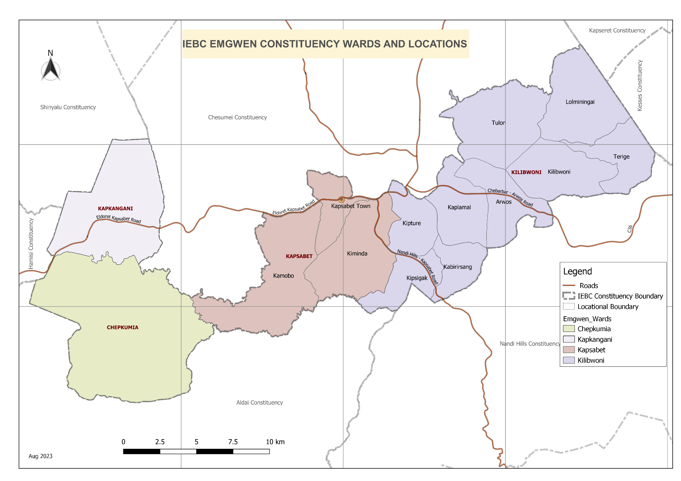

Figure 1. Emgwen Constituency Map

Source: Independent and Electoral Boundaries Commission

### **Administrative and Political Units**

Administratively, Emgwen Constituency covers the whole of Emgwen Sub County.

Emgwen Sub County is divided into four (4) divisions, which are divided into fourteen (14) locations. The fourteen locations are subdivided into thirty-nine (39) sub locations. Politically, Emgwen Constituency is divided into four (4) Wards. They include Chepkumia Ward, Kapkangani Ward, Kapsabet Ward and Kilibwoni Ward, as shown in Table 1 below:

|  |  |  |  |  |  |
| --- | --- | --- | --- | --- | --- |
| No | Wards | CAW Code | Area in km2 | No. of Locations | No. of Sub-Locations |
| 1 | CHEPKUMIA | 770 | 83.7 | 1 | 2 |
| 2 | KAPKANGANI | 771 | 44.4 | 1 | 3 |
| 3 | KAPSABET | 772 | 76.7 | 3 | 4 |
| 4 | KILIBWONI | 773 | 158.9 | 9 | 30 |
| **Total** | | | **363.7** | **14** | **39** |

Table 1. Emgwen Administrative and Political Units

**Emgwen Constituency- Chepkumia Ward**

* County Assembly Ward No.: 0770
* County Assembly Ward Name: Chepkumia ward
* County Assembly Ward Population (Approx.): 21,283
* County Assembly Ward Area In Sq. Km (Approx.): 83.7
* County Assembly Ward locations are: Comprises of Chepkumia and Cheboite

**Emgwen Constituency- Kapkangani Ward**

* County Assembly Ward No.: 0771
* County Assembly Ward Name: Kapkangani ward
* County Assembly Ward Population (Approx.): 23,994.00
* County Assembly Ward Area In Sq. Km (Approx.): 44.4
* County Assembly Ward Locations are**:** Chepsonoi, Tindinyo and Kiborgok sub locations

**Emgwen Constituency-Kapsabet Ward**

* County Assembly Ward No.: 0772
* County Assembly Ward Name: Kapsabet Ward
* County Assembly Ward Population (Approx.): 35,962
* County Assembly Ward Area In Sq. Km (Approx.): 76.7
* County Assembly Ward Locations are: Comprises of Kapsabet Town. Kiminda, Meswo and Kamobo sub locations

**Emgwen Constituency- Kilibwoni Ward**

* County Assembly Ward No.: 0723
* County Assembly Ward Name: Kilibwoni Ward
* County Assembly Ward Population (Approx.): 21,283
* County Assembly Ward Area In Sq. Km (Approx.): 158.9
* County Assembly Ward Locations Description: comprises of Terige, Tulon, Lolming’ai, Kilibwoni, Kipture, Kipsigak, Kabirirsang, Kaplamai and Arwos sub- Locations.

1. **Ward meetings**

**NG-CDF EMGWEN WARD OPEN FORUM PUBLIC MEETINGS REPORT FY 2024/2025- 2025/2026**

Emgwen NG- CDFC undertook Ward 0pen forum public meetings in order to identify the projects to be funded in 2024/2025-2025/2026 financial years.

**1. STAKEHOLDERS**

* NG-CDFC Members.
* NG-CDFC Staff.
* Member of National Assembly
* Project Management Committees.
* Sub-county Education officer
* Deputy county commissioner
* General public and residents.

**REMARKS FROM THE NG-CDF CHAIRMAN.**

The chairperson informed the members that the two years had elapsed and the law requires that NG-CDFC to carry out the public participation to identify the constituency needs. He thanked, the members who had attended for taking the exercise with the seriousness it deserved.

The chairperson also informed the members that the NG-CDF act under section 24 also provides for climate change mitigation activities and the members are required to include climate mitigation activities projects in their submissions. Such activities include reafforestation, afforestation, grassroot sensitization and tree seedlings production

**REMARKS FROM THE FUND ACCOUNT MANAGER**

The fund account manager welcomed the participation to open forum public meeting.

In her opening remarks, she brought to participant’s attention the importance of holding such meetings. This was in line with section the NG-CDF ACT OF 2015 as amended in 2023 which provides that the chairperson of the constituency committee shall within the first year of the commencement of a new parliament and at least once in every two years thereafter, convene open forum public meetings in every ward in the constituency to deliberate on the development matters in each ward and in the constituency.

She urged the project management committees to priorities their project proposals according to order of priority. She also noted that prioritization should be in areas that have not been devolved in conformity of the NG-CDF act. She also highlighted that the fund deals with projects in education, security and environment sector.

**REMARKS FROM THE DEPUTY COUNTY COMMISSIONER**

The deputy county commissioner thanked the government for supporting the existence of NG-CDF as it has been vital in improving the livelihoods of residents in the grassroot. She noted that the importance of NG-CDF is evident form the projects they implement.

**REMARKS FROM THE SUB-COUNTY DIRECTOR OF EDUCATION**

The sub-county director lauded the NG-CDFC for prioritizing ongoing projects form the previous financial year as most projects had now been completed and the value for money has been realized.

The project proposals from the four wards are as below:

**1. CHEPKUMIA WARD- EMGWEN SUB-COUNTY**

**DATE: 14TH OCTOBER 2024**

| **NO** | **School/Institution** | **PROPOSED PROJECT AS PER PRIORITY** |
| --- | --- | --- |
|  | Kalyet primary school | * Construction of pit latrines * Renovation of classrooms |
|  | Kamungei primary school | * Renovation of 8 classrooms * Construction of administration block * Construction of 6 door pit latrine |
|  | Ngerek primary school | * Construction of pit latrines * Purchase of land |
|  | Cheboite Chief’s camp | * Purchase of land * Construction of chief’s office |
|  | Chepkumia secondary school | * Construction of science laboratory * Furniture for the NG-CDF funded constructed dining hall * Purchase of tree seedlings |
|  | Kabaskei primary school | * Renovation of 4 classrooms * Construction of pit latrines for girls and boys |
|  | IPA Kaimosi primary school | * Construction of administration block * Construction of 2 No classrooms * Construction of pit latrines |
|  | Ack St Andrews Chepkoiyo primary school | * Construction of 2 classrooms * Renovation of 8 classrooms * Construction of boys and girls latrines |
|  | Kimyoasis primary school | * Installation of water tank * Construction of Administration block |
|  | Kimnyoasis secondary school | * Purchase of school bus * Installation of a water tank |
|  | Kabwareng secondary school | * Purchase of school bus * Construction of dining hall * Construction of a kitchen * Construction of a science laboratory * Construction of a library |
|  | Burende Hill primary school | * Installation of water tank |
|  | Senetwo primary school | * Construction of 3 No classrooms * Construction of administration block |
|  | Holy Rosary girls secondary school | * Completion of girl’s dormitory * Completion of 35 student capacity laboratory * Water harvesting * Fencing |
|  | Kaimosi tea primary school | * Renovation of 8 classrooms * Construction of administration block |
|  | Koibem primary school | * Renovation of 8 classrooms * Construction of boy’s toilets * Tree planting |
|  | Kamno primary school | * Renovation of 8 classrooms * Construction of Administration block |
|  | Chebonge primary school | * Renovation of 8 No classrooms * Administration block * Toilets for teachers * Desks and office furniture for NG-CDF constructed classrooms |

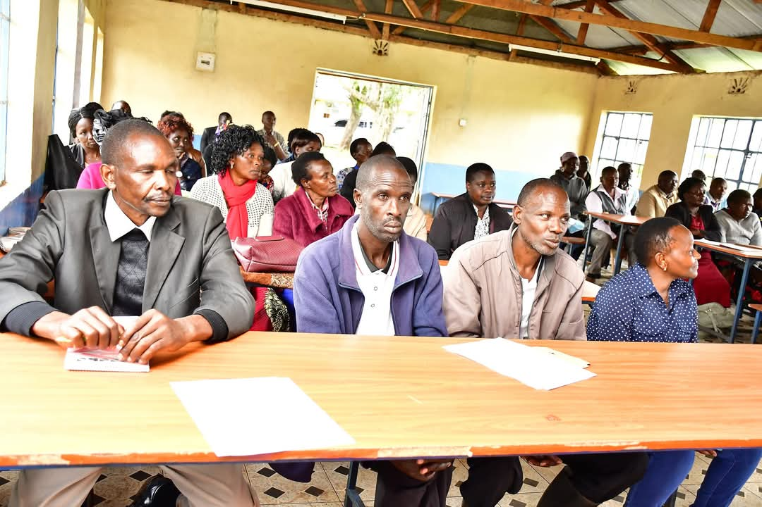

**Public participation in Chepkumia ward held on 14th October 2024 at Chepkumia Chief’s office**

**2. KAPKANGANI WARD**

**DATE: 15TH OCTOBER 2024**

|  |  |  |  |  |  |  |  |  |  |  |  |  |  |  |  |  |  |  |  |  |  |  |  |  |  |  |  |  |  |  |  |  |  |  |  |  |  |  |  |  |  |  |  |  |  |  |  |  |  |  |  |  |  |  |  |
| --- | --- | --- | --- | --- | --- | --- | --- | --- | --- | --- | --- | --- | --- | --- | --- | --- | --- | --- | --- | --- | --- | --- | --- | --- | --- | --- | --- | --- | --- | --- | --- | --- | --- | --- | --- | --- | --- | --- | --- | --- | --- | --- | --- | --- | --- | --- | --- | --- | --- | --- | --- | --- | --- | --- | --- |
| |  |  |  | | --- | --- | --- | | NO | SCHOOL | PROPOSED PROJECT AS PER PRIORITY | |  | Sirwa yala primary school | * Completion of 4 classrooms constructed by NG-CDF * Renovation of 8 classrooms | |  | Kapkatoi primary school | * Completion of classrooms * Renovation of 4 classrooms | |  | ADC Sasimon primary school | * Construction of 1 classroom * Construction of administration block * Installation of water tank | |  | Chepkoiyo primary school | * Purchase of land * Electricity connection | |  | Mombor primary school | * Renovation of 8 classrooms * Administration block | |  | Tebesonik primary school | * Renovation of 8 classrooms * Purchase of land | |  | Kamenon primary school | * Purchase of 1 acre land * Construction of administration block * Renovation of 8 classrooms * Levelling * Installation of water tank | |  | St Patrick Chepsonoi primary school | * Renovation of 8 No classrooms * Construction of administration block | |  | Kiborgok mixed secondary school | * Modern ablution block * Completion of dining hall | |  | Kapkangani primary school | * Installation of water tanks * Renovation of 10 classrooms * Construction of 2 classrooms | |  | Fr khun secondary school | * Purchase of water tank * Construction of laboratory * Construction of 2 classrooms * Construction of dining hall | |  | ACK Kipsugur primary school | * Purchase of desk * Planting of tree seedlings * Construction of administration block * Installation of water tank | |  | ACK Kipsugur secondary school | * Purchase of school bus * Installation of energy saving jiko * Construction of dining hall | |  | Kiborgok girls secondary school | * Construction of a science laboratory | |  | Mokwo primary school | * Renovation of 8 classrooms * Construction of administration block * Levelling of school field. | |  | Kiborgok Hill primary school | * Renovation of 8 classrooms. * Construction of 2 classrooms | |  | AIC Kiborgok girls secondary school | * Purchase of school bus | |  |

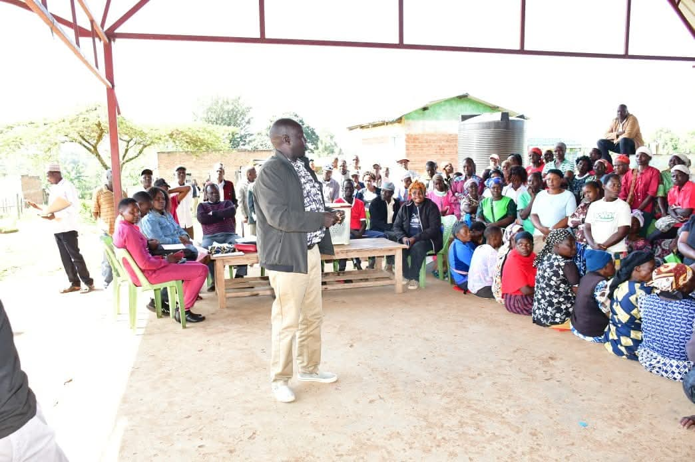

**Kapkangani ward public participation on 15th October 2024 at Chepsonoi Market**

**3. KAPSABET WARD**

**DATE: 16TH OCTOBER 2024**

| **NO** | **SCHOOL** | **PROPOSED PROJECT AS PER PRIORITY** |
| --- | --- | --- |
|  | Kamobo Primary School | * Renovation of 8 classrooms * Construction of pit latrines |
|  | St Barnabas Tegat Secondary school | * Completion of kitchen |
|  | AC Tegat primary school | * Renovation of 8 classrooms |
|  | ACK St Mark Kiminda secondary school | * Purchase of school bus * Construction of a library |
|  | St Joseph’s Kiptarei primary school | * Renovation of 8 No classrooms * Installation of water tank * Construction of administration block * Construction of pit latrines * Purchase of lockers |
|  | Kiropket primary school | * Renovation of 8 classrooms * Construction of administration block * Construction of pit latrines for girls * Construction of pit latrines for boys |
|  | Simteret Primary School | * Renovation of 8 classrooms * Construction of administration block |
|  | ACK Kolong primary Primary School | * Purchase of half acre of land * Construction of administration block * Construction of 1 classroom |
|  | Kapsabet school for the Deaf | * Construction pf pwd friendly pit latrines * Construction of pavements * Construction of dormitory |
|  | Kapsabet Muslim primary school | * Renovation of classrooms |
|  | Meswo Primary School | * Construction of administration block * Construction girls toilet * Construction of boys toilet |
|  | St Philips’s Kamatargui Primary School | * Renovation of 8 classrooms * Construction of 2 classrooms * Construction of administration block * Construction of pit latrines |
|  | Kamobo secondary school | * Construction of 2 classrooms * Installation of energy saving jiko |

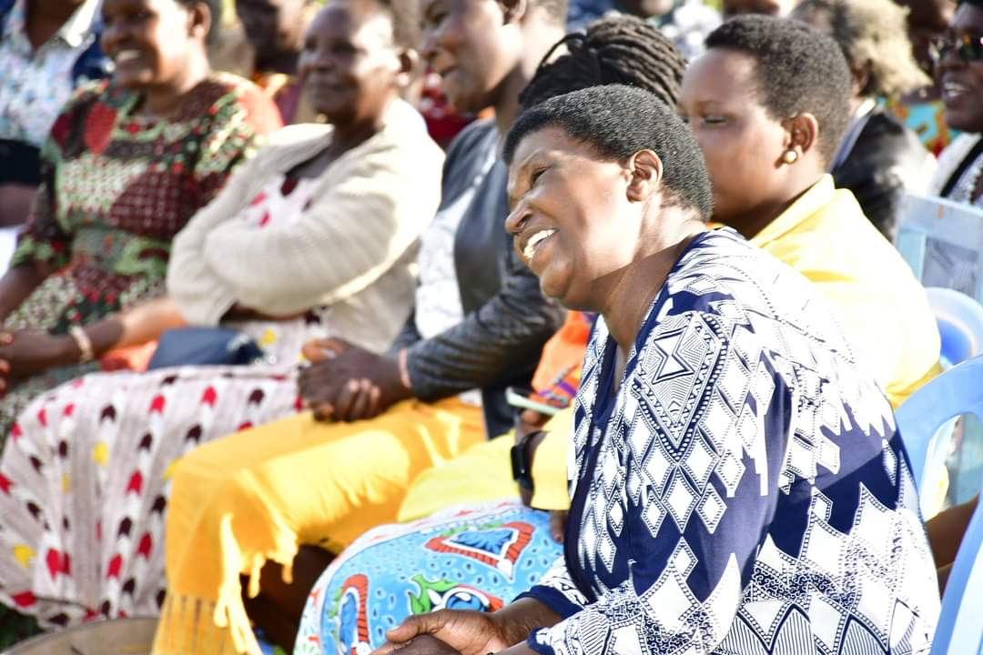

**Kapsabet ward public participation on 16th October 2024 at Iruru cattle dip**

**4. KILIBWONI WARD-UPPER KILIBWONI**

**DATE: 17TH OCTOBER 2024**

| **NO** | **SCHOOL** | **PROPOSED PROJECT AS PER PRIORITY** |
| --- | --- | --- |
|  | AIC Cheliliat primary school | * Installation of water tank * Installation of energy saving jiko * Construction of 2 classroom * Purchase of beds for the constructed dormitory * Construction of pit latrines. |
|  | SDA Tendwet primary school | * Construction of 4 classroom * Purchase of land * Construction of administration block * Construction of pit latrine for boys * Construction of teacher’s latrines |
|  | Kapchepsir primary school | * Renovation of classrooms * Construction of administration block |
|  | Kapkagaon Primary School | * Renovation of 8 No classrooms |
|  | Kapkagaon secondary school | * Completion of dormitory * Construction of modern ablution block |
|  | Kiptenden primary school | * Construction of 3 classrooms * Construction of pit latrines * Fencing of school land * Renovation of 5 classrooms |
|  | Kapnyeberai primary school | * Renovation of 8 No classrooms |
|  | Chebarus border primary school | * Completion of two classrooms * Construction of boys toilet * Construction of girls toilet |
|  | Songoliet Primary School | * Purchase of school land * Renovation of 8 No classroom |
|  | Songoliet secondary school | * Completion of science laboratory * Completion of administration block * Construction of 2 classrooms |
|  | Katanin primary school | * Construction of 5 roomed administration block * Renovation of 8 classrooms |
|  | Kilibwoni primary school | * Construction of 6 door pit latrine * Renovation of 8 classrooms |
|  | Mberia Toleltany Primary School | * Construction of pit latrines * Renovation of classrooms * Construction of administration block |
|  | Terige primary School | * Fencing and levelling of play ground |
|  | Lutiet primary school | * Construction of latrines * Purchase of land * Renovation of classrooms |
|  | Kiplolok primary school | * Renovation of classrooms * Construction of girls pit latrine |
|  | ACK Kaibeiyo primary school | * Purchase of land * Renovation of classrooms * Construction of girls pit latrine |
|  | Cheplasgei primary school | * Construction of 2 classrooms * Purchase of land |
|  | Kiptilalon primary school | * Construction of 6 door pit latrine * Renovation of 6 classrooms * Construction of 2 classrooms |
|  | Sinendo primary school | * Renovation of classrooms * Construction of latrines * Water harvesting |
|  | Lolmin’gai chief’s office | * Completion of Chief’s office |
|  | Tulon chief’s office | * Construction of pit latrines |

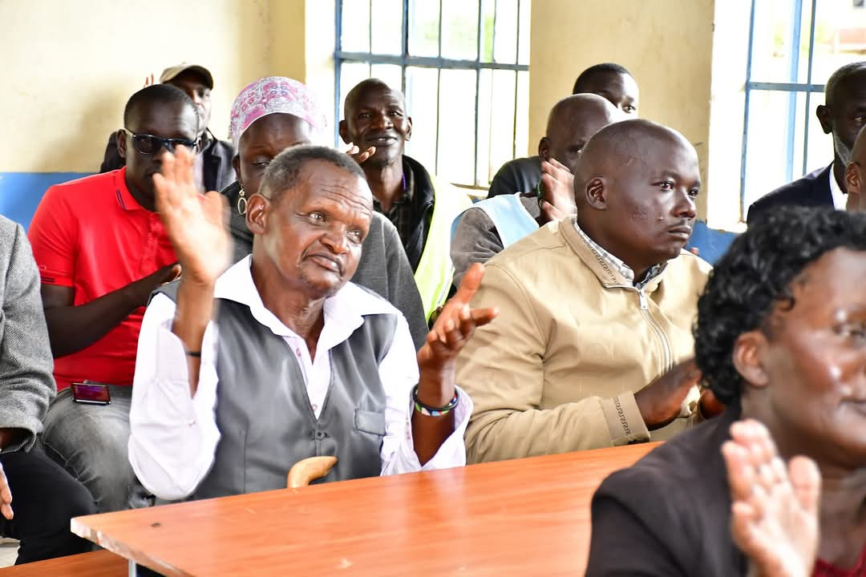

**Kilibwoni ward public participation held on 17th October 2024 at Songoliet primary school**

**5. KILIBWONI WARD-LOWER KILIBWONI**

**DATE: 18TH OCTOBER 2024**

|  |  |  |
| --- | --- | --- |
| **NO** | **SCHOOL** | * **PROPOSED PROJECT AS PER PRIORITY** |
|  | Kaptendon Primary School | * Renovation of 8 classrooms |
|  | Ng’omwo Primary School | * Construction of pit latrines |
|  | Kaptagunyo primary school | * Renovation of 8 classrooms |
|  | Tiryo Primary School | * Renovation of 10 No classrooms * Fencing of the school compound * Modern gate * Installation of water tank |
|  | AIC Cheribisi primary school | * Completion of dormitory * Construction of septic tank |
|  | Tiryo secondary School | * Construction of administration block * Construction of 2 classrooms |
|  | St Paul’s Arwos Primary school | * Construction of 4 No classroom * Construction of latrines * Construction of administration block |
|  | Pr Misoi primary school | * Construction of 2 classrooms |
|  | Emgwen technical and Vocational college | * Fencing * Construction of pit latrines |
|  | Kabirirsang primary school | * Renovation of 8 classrooms * Construction of girl’s pit latrines |
|  | Kabirirsang secondary school | * Installation of energy saving jiko * Completion of dining hall |
|  | St Georges kabirirsang primary school | * Construction of 4 classrooms * Construction of administration block * Construction of pit latrines |
|  | St Mary’s Sugut primary school | * Construction of pit latrines * Purchase of land |
|  | Mugunya primary school | * Purchase of land * Renovation of 8 classrooms |
|  | Kipkeibon Secondary School | * Completion of science laboratory * Construction of 4 door pit latrine |
|  | Kipkeibon Primary School | * Renovation of eight classrooms * Construction of administration block |
|  | Aic Kiptaragon primary school | * Construction of 2 classroom * Construction of administration block * Construction of dining hall |
|  | Kiptamuk primary school | * Construction of 1 classroom * Construction of administration block |
|  | AIC Olong’ata primary school | * Construction of 4 classrooms * Construction of administration block * Purchase of land * Construction of pit latrines |
|  | Kaplamai primary school | * Purchase of land * Renovation of 8 classrooms |
|  | AIC Kaptumoo primary school | * Construction of 6 door pit latrines * Purchase of land |
|  | AIC Kaboen primary school | * Renovation of 8 classrooms * Purchase of land |
|  | Kipture secondary school | * Construction of 2 classrooms * Installation of energy saving jiko |
|  | Kipsotoi primary school | * Renovation of classrooms |
|  | Kipsotoi secondary school | * Equipping of storied science laboratory |

**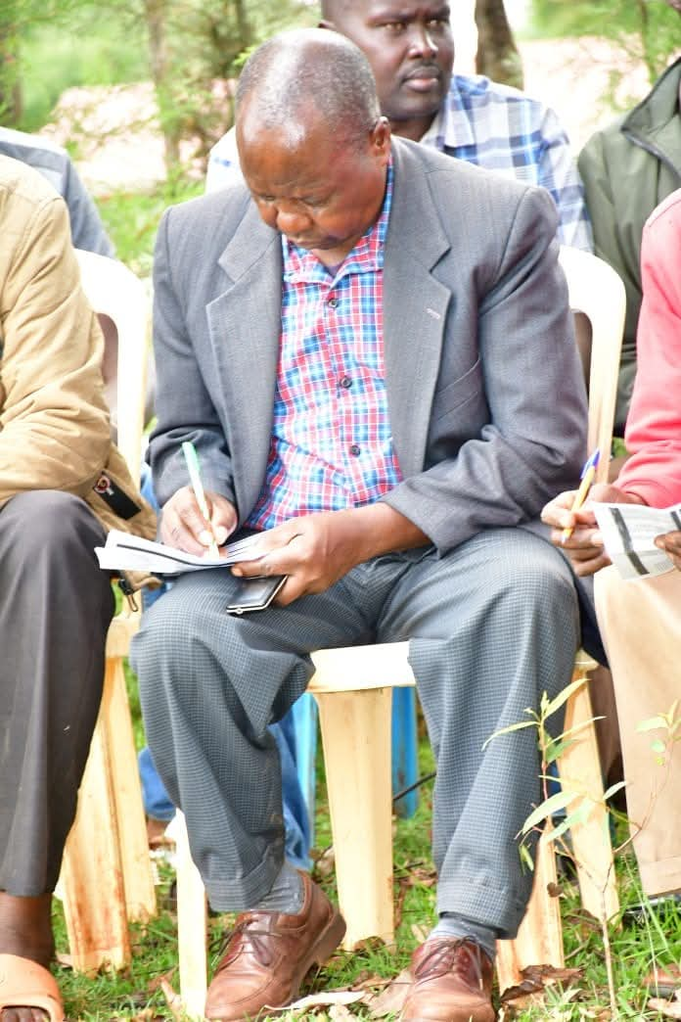***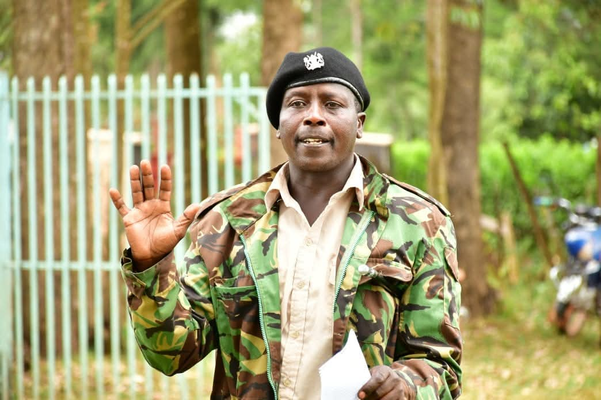*

***Lower KIlibwoni ward public participation held on 18th October 2024 at Arwos Chief’s office***

**CONCLUSION**

The ward open forum public meeting was carried out successfully. The meetings were carried out for five (5) days. The meetings were interactive and participatory. The Project Management Committees and other major stakeholders appreciated the good work done by the NG-CDFC for the past years.

The meetings concluded by resolving the following

* That the member of National Assembly should lobby the government to increase funding by the National Government Constituencies Development Fund and that funds should be disbursed timely to improve efficiency and effectiveness in project implementation.
* That the NG-CDFC should organize more public participation forums to help in project identification and prioritization.

**Compiled by**

1. Margaret Busienei Sign…………………….. Date…………………………...

**(NG-CDFC Secretary)**

**Confirmed by**

* 1. Tanui Mathew Sign………………………. Date…………………………....

**(Fund Account Manager)**

* 1. John Busieney Sign………………………. Date………………………….....

**(NG-CDFC Chairperson)**