

**NG-CDF BOARD**

**KINANGO CONSTITUENCY**

**IEBC NUMBER 010**

**NATIONAL GOVERNMENT CONSTITUENCY DEVELOPMENT FUND**

**PROJECT PROPOSAL BUDGET**

**2019/2020 FINANCIAL YEAR**

**SUBMITTED:**

**OCTOBER 2019**

|  |  |  |
| --- | --- | --- |
| National Government Constituency Development Fund | Kinango Constituency  2019 | |
| **Minutes of the Meeting held on Monday, October 14th, 2019 at KinangoNG-CDF Office Boardroom.** | | Kinango NG-CDF Committee |

**Present:**

1. Rashid BavuKurera **– Chairman**
2. BeatraceMbeyu Joto **- Secretary**
3. NgomeChitaphiKidilo– Member
4. Amina Hussein – Memeber
5. Kimani Lemna – Member
6. Lilian Nyanje – Member
7. Rebecca Mwaka – Member
8. AdhibanMugandiMunyika - Member
9. Beatrice Kulaphira - (FAM) - Member

**In attendance:**

1. Richard Itambo - Constituency Manager

**Agenda:**

1. Opening remarks by Chairman
2. Reading and Confirmation of minutes of previous meeting
3. FY 2019/2020 - Project Proposal Budget
4. Any Other Business (A.O.B).

**Preliminaries:**

Meeting begun at 1130 hours with a word of prayer by Beatrice Tembe.

The chairman begun by thanking members for attending the session in time and their devotion to serve selflessly

He recognized the presence of the sub-county works officer and thanked him for finding time to attend the sitting.

He urged all to remain focused in the day's agenda as it was long and loaded with weighty matters.

**Min.01/10/01/2018 – Reading and confirmation of Minutes of previous meetings**

Minutes of the previous meeting were read and confirmed by NgomeKidilo seconded by Rebecca Mwaka.

All minutes were unanimously adopted by the committee as a true record of those sittings’ deliberations.

**Min.03/10/01/2018 – FY 2019/2020 - Project Proposal Budget**

The chairman tabled the guidelines from the NG-CDF Board on the preparation of project proposal budget for the FY 2019/2020.

Members agreed to have all the projects which were underfunded to be given the priority to complete the projects. This was in reference to construction of classrooms whose engineer's estimate cost per classroom was at 1.3M.

The Fund manager tabled the Third schedule indicating the balance available for allocation to projects after charging the statutory deductions as follows;

907

***2015*** *National Government Constituencies Development Fund No. 30*

THIRD SCHEDULE *(s. 15)*

CONSTITUENCY PROJECTS SUBMISSION FORM

Constituency No 010 Constituency Name KINANGO CONSTITUENCY Financial Year 2018/2019

|  |  |  |
| --- | --- | --- |
| Serial | Name of Project | Amount Allocated |
| 010/AP1 | Administration & Recurrent (6%) | 8,242,063.45 |
| 010/AP2 | Monitoring & Evaluation and Capacity Building (3%) | 4,121,031.72 |
| 010/2640100 | Social Security Programs, Education Bursary, Mocks and Continuous Assessment Tests (35%) | 35,026,387.59 |
| 010/2630204 | Education - Primary School Projects | 82,780,000.00 |
| 010/2630205 | Education - Secondary School Projects |
| 010/2640507 | Security Projects |
| 010/2640509 | Sports (2%) |
| 010/2640505 | Environment (2%) |
| 010/2640200 | Emergency Reserve (5%) | 7,198,241.38 |
| Total | | 137,367,724.14 |

|  |  |  |  |  |  |  |
| --- | --- | --- | --- | --- | --- | --- |
| **CODELIST FINANCIAL YEAR 2019/2020** | | | | | | |
|  | | | | | | |
| **NAME OF PROJECT** | **PROJECT NUMBER** | **ORIGINAL COST ESTIMATE** | **CUMMALATIVE ALLOCATION** | **ACTIVITY** | **AMOUNT** | **STATUS** |
| **ADMINISTRATION/RECURRENT** |  |  |  |  |  |  |
| Employees’ Salaries | 4-002-010-2110000-100-2019/2020-001 | 2,587,200.00 | 0.00 | Payment of staff salaries and gratuity | 2,587,200.00 | New |
| Goods and Services | 4-001-010-2210000-100-2019/2020-002 | 2,500,000.00 | 0.00 | Purchase of fuel, repairs and maintenance, printing, stationery, telephone, travel and subsistence, office tea | 2,500,000.00 | New |
| NSSF | 4-002-010-2120101-100-2019/2020-003 | 492,800.00 | 0.00 | Payment of NSSF Deductions | 492,800.00 | New |
| NHIF | 4-002-010-2120201-100-2019/2020-004 | 60,000.00 | 0.00 | Payment of NHIF Deductions | 60,000.00 | New |
| Committee Expenses | 4-002-010-2210802-100-2019/2020-005 | 2,602,063.45 | 0.00 | Payment of Committee sitting allowances, transport, conferences | 2,602,063.45 | New |
| **MONITORING & EVALUATION** |  |  |  |  |  |  |
| Committee Expenses | 4-002-010-2210802-111-2018/2019-001 | 2,500,000.00 | 0.00 | Payment of Committee sitting allowances, transport, conferences | 2,500,000.00 | New |
| NG-CDFC, PMC & Staff Capacity Building | 4-002-010-2210700-111-2018/2019-002 | 1,621,031.72 | 0.00 | Undertake Training of the PMCs, NG- CDFCs and Office Staff on NG-CDF Related issues | 1,621,031.72 | New |
| **EMERGENCY** |  |  |  |  |  |  |
| Emergency | 4-002-010-2640200-101-2019/2020-001 | 7,198,241.38 | 0.00 | To cater for any unfore-seen occurrences in the constituency during the financial year | 7,198,241.38 | New |
| **BURSARY** |  |  |  |  |  |  |
| Secondary Schools Bursary | 4-002-010-2640101-103-2018/2019-001 | 17,026,387.59 | 0.00 | Cater for bright and needy students in secondary schools | 17,026,387.59 | New |
| Tertiary Institutions Bursary | 4-002-010-2640102-103-2018/2019-002 | 18,000,000.00 | 0.00 | Cater for bright and needy students in tertiary institutions | 18,000,000.00 | New |
| **PRIMARY SCHOOL PROJECTS** |  |  |  |  |  |  |
| Mazola Primary School | 4-002-010-2630204-104-2019/2020-001 | 2,400,000.00 | 0.00 | Construction of 2no. classroom to completion | 2,400,000.00 | New |
| Chizini Primary School | 4-002-010-2630204-104-2019/2020-002 | 2,400,000.00 | 0.00 | Construction of 2no. classroom to completion | 2,400,000.00 | New |
| Ng'onzini Primary School | 4-002-010-2630204-104-2019/2020-003 | 2,400,000.00 | 0.00 | Construction of 2no. classroom to completion | 2,400,000.00 | New |
| Dzivani Primary School | 4-002-010-2630204-104-2019/2020-004 | 2,400,000.00 | 0.00 | Construction of 2no. classroom to completion | 2,400,000.00 | New |
| Mwashanga Primary School | 4-002-010-2630204-104-2019/2020-005 | 2,400,000.00 | 0.00 | Construction of 2no. classroom to completion | 2,400,000.00 | New |
| Dzombo Primary School | 4-002-010-2630204-104-2019/2020-006 | 2,400,000.00 | 0.00 | Construction of 2no. classroom to completion | 2,400,000.00 | New |
| Kafuduni Primary School | 4-002-010-2630204-104-2019/2020-007 | 2,400,000.00 | 0.00 | Construction of 2no. classroom to completion | 2,400,000.00 | New |
| Mgandini Primary School | 4-002-010-2630204-104-2019/2020-008 | 2,400,000.00 | 0.00 | Construction of 2no. classroom to completion | 2,400,000.00 | New |
| Miyani Primary School | 4-002-010-2630204-104-2019/2020-009 | 2,400,000.00 | 0.00 | Construction of 2no. classroom to completion | 2,400,000.00 | New |
| Mbwaleni Primary School | 4-002-010-2630204-104-2019/2020-010 | 2,400,000.00 | 0.00 | Construction of 2no. classroom to completion | 2,400,000.00 | New |
| Mbita Primary School | 4-002-010-2630204-104-2019/2020-011 | 2,400,000.00 | 0.00 | Construction of 2no. classroom to completion | 2,400,000.00 | New |
| Mwangea Primary School | 4-002-010-2630204-104-2019/2020-012 | 2,400,000.00 | 0.00 | Construction of 2no. classroom to completion | 2,400,000.00 | New |
| Kituoni Primary School | 4-002-010-2630204-104-2019/2020-013 | 2,400,000.00 | 0.00 | Construction of 2no. classroom to completion | 2,400,000.00 | New |
| Taru Primary School | 4-002-010-2630204-104-2019/2020-014 | 2,400,000.00 | 0.00 | Construction of 2no. classroom to completion | 2,400,000.00 | New |
| Busho Primary School | 4-002-010-2630204-104-2019/2020-015 | 2,400,000.00 | 0.00 | Construction of 2no. classroom to completion | 2,400,000.00 | New |
| Kaluweni Primary School | 4/002/010/2630204/2019/2020/016 | 2,400,000.00 | 0.00 | Construction of 2no. classroom to completion | 2,400,000.00 | New |
| Kasageni Primary School | 4/002/010/2630204/2019/2020/017 | 2,200,000.00 | 0.00 | Renovation of 4no. classrooms to completion  - re-roofing  - plastering  - flooring | 2,200,000.00 | New |
| Mwalukombe Primary School | 4/002/010/2630204/2019/2020/018 | 2,200,000.00 | 0.00 | Renovation of 4no. classrooms to completion  - re-roofing  - plastering  - flooring | 2,200,000.00 | New |
| Gona Primary School | 4/002/010/2630204/2019/2020/019 | 2,200,000.00 | 0.00 | Renovation of 4no. classrooms to completion  - re-roofing  - plastering  - flooring | 2,200,000.00 | New |
| Kituu Primary School | 4/002/010/2630204/2019/2020/020 | 1,100,000.00 | 0.00 | Renovation of 2no. classrooms to completion  - re-roofing  - plastering  - flooring | 1,100,000.00 | New |
| Mbandi Primary School | 4/002/010/2630204/2019/2020/021 | 3,900,000.00 | 3,500,000 | Additional funds for roofing 3no classrooms to completion | 400,000.00 | On-going |
| Bishop Kalu Primary School | 4/002/010/2630204/2019/2020/022 | 1,000,000.00 | 0.00 | Construction of Admin block(three offices)to completion | 1,000,000.00 | New |
| Tumaini Primary School | 4/002/010/2630204/2019/2020/023 | 3,900,000.00 | 3,600,000.00 | Additional cost of construction of 3no classroom to completion  Additional funds for roofing | 300,000.00 | On-going |
|  |  |  |  |  |  |  |
| Gwadu Primary School | 4/002/010/2630204/2019/2020/026 | 140,000.00 | 0.00 | Purchase of twenty desks. | 140,000.00 | New |
| Bumani Primary School | 4/002/010/2630204/2019/2020/027 | 140,000.00 | 0.00 | Purchase of twenty desks. | 140,000.00 | New |
| Chengoni Primary School | 4/002/010/2630204/2019/2020/028 | 210,000.00 | 0.00 | Purchase of thirty desks | 210,000.00 | New |
| Matumbi Primary School | 4/002/010/2630204/2019/2020/029 | 200,000.00 | 0.00 | Purchase of thirty desks | 200,000.00 | New |
| Gandini South Primary School | 4/002/010/2630204/2019/2020/030 | 210,000.00 | 0.00 | Purchase of thirty desks | 210,000.00 | New |
| Pemba Primary School | 4/002/010/2630204/2019/2020/031 | 210,000.00 | 0.00 | Purchase of thirty desks | 210,000.00 | New |
| Mbilini Primary School | 4/002/010/2630204/2019/2020/032 | 210,000.00 | 0.00 | Purchase of thirty desks | 210,000.00 | New |
| Amani Primary School | 4/002/010/2630204/2019/2020/033 | 210,000.00 | 0.00 | Purchase of thirty desks | 210,000.00 | New |
| Mtaa Primary School | 4/002/010/2630204/2019/2020/034 | 210,000.00 | 0.00 | Purchase of thirty desks | 210,000.00 | New |
| Samburu Primary School | 4/002/010/2630204/2019/2020/035 | 210,000.00 | 0.00 | Purchase of thirty desks | 210,000.00 | New |
| Gulanze Primary School | 4/002/010/2630204/2019/2020/036 | 210,000.00 | 0.00 | Purchase of thirty desks | 210,000.00 | New |
| Kifyonzo Primary School | 4/002/010/2630204/2019/2020/037 | 210,000.00 | 0.00 | Purchase of thirty desks | 210,000.00 | New |
| Kituoni Primary School | 4/002/010/2630204/2019/2020/038 | 210,000.00 | 0.00 | Purchase of thirty desks | 210,000.00 | New |
| Mwanda Primary School | 4/002/010/2630204/2019/2020/039 | 210,000.00 | 0.00 | Purchase of thirty desks | 210,000.00 | New |
| Mulunguni Primary School | 4/002/010/2630204/2019/2020/040 | 210,000.00 | 0.00 | Purchase of thirty desks | 210,000.00 | New |
| Mabamani Primary School | 4/002/010/2630204/2019/2020/041 | 210,000.00 | 0.00 | Purchase of thirty desks | 210,000.00 | New |
| Gozani Primary School | 4/002/010/2630204/2019/2020/041 | 210,000.00 | 0.00 | Purchase of thirty desks | 210,000.00 | New |
| Mazeras Primary School | 4/002/010/2630204/2019/2020/042 | 210,000.00 | 0.00 | Purchase of thirty desks | 210,000.00 | New |
| Bofu Primary School | 4/002/010/2630204/2019/2020/043 | 210,000.00 | 0.00 | Purchase of thirty desks | 210,000.00 | New |
| Kibandaongo Primary School | 4/002/010/2630204/2019/2020/044 | 210,000.00 | 0.00 | Purchase of thirty desks | 210,000.00 | New |
| Chigutu Primary School | 4/002/010/2630204/2019/2020/045 | 210,000.00 | 0.00 | Purchase of thirty desks | 210,000.00 | New |
| Magale Primary School | 4/002/010/2630204/2019/2020/046 | 210,000.00 | 0.00 | Purchase of thirty desks | 210,000.00 | New |
| Egu Primary School | 4/002/010/2630204/2019/2020/047 | 210,000.00 | 0.00 | Purchase of thirty desks | 210,000.00 | New |
| **SECONDARY SCHOOL PROJECTS** |  |  |  |  |  |  |
| Vigurungani Secondary School | 4-002-010-2630205-104-2019/2020-001 | 1,600,000.00 | 0.00 | Renovation of single Science Laboratory to completion (50 seater)  -flooring  -painting  -repairs on the working tops | 1,600,000.00 |  |
| Ndavaya Secondary School | 4-002-010-2630205-104-2019/2020-002 | 5,000,000.00 | 0.00 | Additional and final Cost for Purchase of 51Seater School Bus - Co-funding between school PTA and NG-CDF  Attached is the bank statement of the school account | 5,000,000.00 | New |
| Makamini Secondary School | 4-002-010-2630205-104-2019/2020-003 | 4,000,000.00 | 0.00 | Construction of one-bedroom Staff Twin House to completion | 4,000,000.00 | New |
| Taru Girls Secondary School | 4-002-010--2630205-104-2019/2020-004 | 1,200,000.00 | 0.00 | Construction of 1no. Classroom to completion | 1,200,000.00 | New |
| Mwavumbo Secondary School | 4-002-010-2630205-104-2019/2020-005 | 1,000,000.00 | 0.00 | Construction of Kitchen Block two rooms | 1,000,000.00 | New |
| **NG-CDF OFFICES** |  |  |  |  |  |  |
| NG-CDF Office | 4-002-010/2640510-108-2019/2020-001 | 1,600,000.00 |  | Renovation of the whole Office block due to the ongoing heavy rains.  - re-roofing  - re-painting  - replacement of windows and doors | 1,600,000.00 |  |
| **SECURITY** | 4-002-010/2640510-108-2019/2020-002 |  |  |  |  |  |
| Mavirivirini Police Post | 4-002-010-2640510-108-2019/2020-003 |  |  | Completion of the office block  -fixing of windows and doors  -painting  -four offices | 400,000.00 | On-going |
| **OTHERS** | 4-002-010-2640510-108-2019/2020-004 |  |  |  |  |  |
| Kinango Sub-County Education Office | 4-002-010-2640510-108-2019/2020-005 | 16,000,000.00 | 0.00 | Construction of Education Office Complex(main ministry of education offices, sub county directors, TSC offices) | 9,000,000 | New |
| Kinango School for the Deaf | 4-002-010-2640510-108-2019/2020-006 | 2,500,00000 | 0.00 | Construction of Multi-purpose Hall to completion.  (Co-funding with the State Department of Gender) | 2,500,000.00 | New |
| **SPORTS** | 4-002-010-2640510-108-2019/2020-006 |  |  |  |  |  |
| Sports | 4-002-010-2640510-108-2019/2020-007 | 2,100,000.00 | 0.00 | Carry out Constituency sports tournaments and purchase of trophies, sports kits and balls for winning teams | 2,100,000.00 | New |
| **ENVIRONMENT** | 4-002-010-2640510-108-2019/2020-008 |  |  |  |  |  |
| Chizini Primary School | 4-002-010-2640510-108-2019/2020-009 | 100,000.00 | 0.00 | Purchase of 200 tree seedlings and Planting them | 100,000.00 | New |
| Ng'onzini Primary School | 4-002-010-2640510-108-2019/2020-010 | 100,000.00 | 0.00 | Purchase of 200 tree seedlings and Planting them | 100,000.00 | New |
| Dzivani Primary School | 4-002-010-2640510-108-2019/2020-011 | 100,000.00 | 0.00 | Purchase of 200 tree seedlings and Planting them | 100,000.00 | New |
| Mwashanga Primary School | 4-002-010-2640510-108-2019/2020-012 | 100,000.00 | 0.00 | Purchase of 200 tree seedlings and Planting them | 100,000.00 | New |
| Dzombo Primary School | 4-002-010-2640510-108-2019/2020-013 | 100,000.00 | 0.00 | Purchase of 200 tree seedlings and Planting them | 100,000.00 | New |
| Kafuduni Primary School | 4-002-010-2640510-108-2019/2020-014 | 100,000.00 | 0.00 | Purchase of 200 tree seedlings and Planting them | 100,000.00 | New |
| Mgandini Primary School | 4-002-010-2640510-108-2019/2020-015 | 100,000.00 | 0.00 | Purchase of 200 tree seedlings and Planting them | 100,000.00 | New |
| Miyani Primary School | 4-002-010-2640510-108-2019/2020-016 | 100,000.00 | 0.00 | Purchase of 200 tree seedlings and Planting them | 100,000.00 | New |
| Mbwaleni Primary School | 4-002-010-2640510-108-2019/2020-017 | 100,000.00 | 0.00 | Purchase of 200 tree seedlings and Planting them | 100,000.00 | New |
| Kasageni Primary School | 4-002-010-2640510-108-2019/2020-018 | 100,000.00 | 0.00 | Purchase of 200 tree seedlings and Planting them | 100,000.00 | New |
| Mwalukombe Primary School | 4-002-010-2640510-108-2019/2020-019 | 100,000.00 | 0.00 | Purchase of 200 tree seedlings and Planting them | 100,000.00 | New |
| Gona Primary School | 4-002-010-2640510-108-2019/2020-012 | 100,000.00 | 0.00 | Purchase of 200 tree seedlings and Planting them | 100,000.00 | New |
| Kaluweni Primary School | 4-002-010-2640510-108-2019/2020-013 | 100,000.00 | 0.00 | Purchase of 200 tree seedlings and Planting them | 100,000.00 | New |
| Taru Primary School | 4-002-010-2640510-108-2019/2020-014 | 100,000.00 | 0.00 | Purchase of 200 tree seedlings and Planting them | 100,000.00 | New |
| Kituoni Primary School | 4-002-010-2640510-108-2019/2020-015 | 100,000.00 | 0.00 | Purchase of 200 tree seedlings and Planting them | 100,000.00 | New |
| Mwache Primary School | 4-002-010-2640510-108-2019/2020-016 | 100,000.00 | 0.00 | Purchase of 200 tree seedlings and Planting them | 100,000.00 | New |
| Busho Primary School | 4-002-010-2640510-108-2019/2020-017 | 100,000.00 | 0.00 | Purchase of 200 tree seedlings and Planting them | 100,000.00 | New |
| Mbita Primary School | 4-002-010-2640510-108-2019/2020-018 | 100,000.00 | 0.00 | Purchase of 200 tree seedlings and Planting them | 100,000.00 | New |
| Mazola Primary School | 4-002-010-2640510-108-2019/2020-019 | 100,000.00 | 0.00 | Purchase of 200 tree seedlings and Planting them | 100,000.00 | New |
|  |  |  |  |  |  |  |
|  |  |  |  |  |  |  |
|  |  |  |  |  |  |  |

Guided by the data collected during the project proposal public participation in each ward, the committee allocated funds to projects as follows;

Projects Budget Allocations

The office was tasked to fine tune the project proposal budget as per the NG-CDF Board's standard format and submits to the NG-CDF Board as soon as possible

**Min.06/10/01/2018 – Any Other Business (A.O.B)**

There being no other business for deliberation, the meeting ended at 1523 hours with a word of prayer by Lilian Nyanje.

Minutes taken by:

Secretary ..………………………………………………. ………………………………………

Name Signature

Minutes confirmed by:

Chairperson ……..…….…………………………………… …………………………………………….

Name Signature

907

*2015 National Government Constituencies Development Fund No. 30*

THIRD SCHEDULE *(s. 15)*

CONSTITUENCY PROJECTS SUBMISSION FORM

Constituency No 010 Constituency Name KINANGO CONSTITUENCY Financial Year 2018/2019

|  |  |  |
| --- | --- | --- |
| Serial | Name of Project | Amount Allocated |
| 010/AP1 | Administration & Recurrent (6%) | 8,242,063.45 |
| 010/AP2 | Monitoring & Evaluation and Capacity Building (3%) | 4,121,031.72 |
| 010/2640100 | Social Security Programs, Education Bursary, Mocks and Continuous Assessment Tests (35%) | 35.026.387.59 |
| 010/2630204 | Education - Primary School Projects | 56,080,000.00 |
| 010/2630205 | Education - Secondary School Projects | 11,700,000.00 |
| 010/2640507 | Security | 400,000.00 |
| 010/2640509 | Sports (2%) | 2,100,000.00 |
| 010/2640510 | Environment | 1,900,000.00 |
| 010/ | Others | 10,600,000.00 |
| 010/2640200 | Emergency Reserve (5%) | 7,198,241.38 |
| Total | | 137,367,724.14 |

Chairman NG- CDF Committee ……………………… Signature…………………Date………………

Fund Account Manager …………………………… Signature……………………Date………………

907

***2015 National Government Constituencies Development Fund No. 30***

**FOURTH SCHEDULE (s. 16)**

**PROJECT DESCRIPTION FORM**

Constituency No: **010** Constituency Name **KINANGO** County **KWALE**

Project Number **010/AP1**

Project Title **6% Administration & Recurrent**

Sector **Administration**

Status of projects (tick one) New………Extension………On-going…√…..Rehabilitation ………

Brief statement on project status at time of submission

**The allocation is to cater for CDFC Allowance, staff salaries, vehicle expenses and operations expenses**

Financial year **2019 1st** July To 30th June **2020**

Original Cost estimates, in Kshs.8,242,063.45…………………

Amount allocated last financial year **Kshs.** 6,542,452.53

Amount allocated this financial year 8,242,063.53

|  |  |  |  |  |
| --- | --- | --- | --- | --- |
| **Project Name** | **Project Number** | **Activity** | **Amount** | **STATUS** |
| Employees Salaries | 4-002-010-2110000-100-2019/2020-001 | Payment of staff salaries and gratuity | 2,587,200.00 | Ongoing |
| Goods and Services | 4-001-010-2210000-100-2019/2020-002 | Purchase of fuel, repairs and maintenance, printing, stationery, telephone, travel and subsistence, office tea | 2,500,000.00 | Ongoing |
| NSSF | 4-002-010-2120101-100-2019/2020-003 | Payment of NSSF Deductions | 492,800.00 | Ongoing |
| NHIF | 4-002-010-2120201-100-2019/2020-004 | Payment of NHIF Deductions | 60,000.00 | Ongoing |
| Committee Expenses | 4-002-010-2210802-100-2019/2020-005 | Payment of Committee sitting allowances, transport, conferences | 2,602,063.45 | Ongoing |
| **TOTAL** | | | 8,242,063.45 |  |

Person completing form:

Name **……………………………………….............................………….** Position **Fund Account Manager**

Signature…………………………………………………………… Date…………………………………………………………………

907

***2015 National Government Constituencies Development Fund No. 30***

**FOURTH SCHEDULE (s. 16)**

**PROJECT DESCRIPTION FORM**

Constituency No: **010** Constituency Name **KINANGO** County **KWALE**

Project Number **010/AP2**

Project Title **3% Monitoring & Evaluation and Capacity Building**

Sector **Monitoring & Evaluation**

Status of projects (tick one) New………Extension………On-going…√…..Rehabilitation ………

Brief statement on project status at time of submission

**To cater for Monitoring and Evaluation of CDF projects and capacity building of CDFC, PMC and staff**

Financial year **2019**1st July To 30th June **2020**

Original Cost estimates, in Kshs. 4,121,031.72,dated…………………

Amount allocated last financial year Ksh. .3,271,226.27

Amount allocated this financial yearKsh. 4,121,031.72

|  |  |  |  |  |
| --- | --- | --- | --- | --- |
| **Project Name** | **Project Number** | **Activity** | **Amount** | **STATUS** |
| Committee Expenses | 4-002-010-2210802-111-2018/2019-001 | Payment of Committee sitting allowances, transport, conferences | 2,500,000.00 | Ongoing |
| NG-CDFC, PMC & Staff Capacity Building | 4-002-010-2210700-111-2018/2019-002 | Undertake Training of the PMCs, NG-CDFCs and Office Staff on CDF Related issues | 1,621,031.72 | Ongoing |
| **TOTAL** | | | 4,121,031.72 |  |

Person completing form:

Name **……........................……………………....................................**Position **Fund Account Manager**

Signature………………………………………….…………..… Date……………………………………………………………………

907

***2015 National Government Constituencies Development Fund No. 30***

**FOURTH SCHEDULE (s. 16)**

**PROJECT DESCRIPTION FORM**

Constituency No: **010** Constituency Name **KINANGO** County **KWALE**

Project Number**010/2640200**

Project Title **Emergency Reserve (5% of the fund)**

Sector **Emergency**

Status of projects (tick one) New…………Extension………On-going…√…..Rehabilitation …………

Brief statement on project status at time of submission

**Unallocated amount meant for emergencies that may occur within the Constituency**

Financial year **2019**1st July To 30th June **2020**

Original Cost estimates, in Kshs 7,198,241.38 dated…………………

Amount allocated last financial year 5,738,993.45

Amount allocated this financial year 7,198,241.38

|  |  |  |  |  |
| --- | --- | --- | --- | --- |
| **Project Name** | **Project Code** | **Project Activity** | **Amount Allocated** | **STATUS** |
| Emergency | 4-002-010-2640200-101-2019/2020-001 | To cater for any unforeseen occurrences in the constituency during the financial year | 7,198,241.38 | Ongoing |
| **Total** | | | 7,198,241.38 |  |

Person completing form:

Name **……………………………………………..…................................**Position **Fund Account Manager**

Signature…………………………………………………………… Date……………………………………………………….…………

907

***2015 National Government Constituencies Development Fund No. 30***

**FOURTH SCHEDULE (s. 16)**

**PROJECT DESCRIPTION FORM**

Constituency No: **010** Constituency Name **KINANGO** County **KWALE**

Project Number**010/2640100**

Project Title **Bursary**

Sector **Bursary**

Status of projects (tick one) New…………Extension………………On-going…√….. Rehabilitation …………

Brief statement on project status at time of submission

**Towards Bursary for payment of fees for needy students**

Financial year **2019**1st July To 30th June **2020**

Original Cost estimates, in Kshs. 35,026,387.59 dated…………………

Amount allocated last financial year **26,500,000.00**

Amount allocated this financial year 35,026,387.59

|  |  |  |  |  |
| --- | --- | --- | --- | --- |
| **Project Name** | **Project Code** | **Project Activity** | **Amount Allocated** | **STATUS** |
| Secondary Schools | 4-002-010-2640101-103-2018/2019-001 | Cater for bright and needy students in secondary schools | 17,026,387.59 | Ongoing |
| Tertiary Institutions | 4-002-010-2640102-103-2018/2019-002 | Cater for bright and needy students in tertiary institutions | 18,000,000.00 | Ongoing |
|  |  |  |  |  |
| **TOTAL** | | | 35,026,387.59 |  |

Person completing form:

Name **………………………..................................…………………….………..** Position **Fund Account Manager**

Signature……………………………………………………………… Date……………………………………………………………………

907

***2015 National Government Constituencies Development Fund No. 30***

**FOURTH SCHEDULE (s. 16)**

**PROJECT DESCRIPTION FORM**

Constituency No: **010** Constituency Name **KINANGO** County **KWALE**

Project Number **010/2630204**

Project Title **Primary School Projects**

Sector **Education**

Status of projects (tick one) New………Extension………On-going…√…..Rehabilitation …………

Brief statement on project status at time of submission

**To enhancing better learning conditions in the primary schools institutions by improving the infrastructure**

Financial year **2019**1st July To 30th June **2020**

Original Cost estimates, in Kshs.**56,180,000.00**dated…………………

Amount allocated last financial year **Kshs.44,000,000.00**

Amount allocated this financial year **Kshs.56,080,000.00**

| **Project Name** | **Project Code** | **Project Activity** | **Amount Allocated** | **Status** |
| --- | --- | --- | --- | --- |
| Mazola Primary School | 4-002-010-2630204-104-2019/2020-001 | Construction of 2no. classroom to completion. | 2,600,000.00 | **New** |
| Chizini Primary School | 4-002-010-2630204-104-2019/2020-002 | Construction of 2no. classroom to completion. | 2,600,000.00 | **New** |
| Ng'onzini Primary School | 4-002-010-2630204-104-2019/2020-003 | Construction of 2no. classroom to completion. | 2,600,000.00 | **New** |
| Dzivwani Primary School | 4-002-010-2630204-104-2019/2020-004 | Construction of 2no. classroom to completion. | 2,600,000.00 | **New** |
| Mwashanga Primary School | 4-002-010-2630204-104-2019/2020-005 | Construction of 2no. classroom to completion. | 2,600,000.00 | **New** |
| Dzombo Primary School | 4-002-010-2630204-104-2019/2020-006 | Construction of 2no. classroom to completion. | 2,600,000.00 | **New** |
| Kafuduni Primary School | 4-002-010-2630204-104-2019/2020-007 | Construction of 2no. classroom to completion. | 2,600,000.00 | **New** |
| Mgandini Primary School | 4-002-010-2630204-104-2019/2020-008 | Construction of 2no. classroom to completion. | 2,600,000.00 | **New** |
| Miyani Primary School | 4-002-010-2630204-104-2019/2020-009 | Construction of 2no. classroom to completion. | 2,600,000.00 | **New** |
| Mbwaleni Primary School | 4-002-010-2630204-104-2019/2020-010 | Construction of 2no. classroom to completion. | 2,600,000.00 | **New** |
| Mbita Primary School | 4-002-010-2630204-104-2019/2020-011 | Construction of 2no. classroom to completion. | 2,600,000.00 | **New** |
| Mwangea Primary School | 4-002-010-2630204-104-2019/2020-012 | Construction of 2no. classroom to completion. | 2,600,000.00 | **New** |
| Kituoni Primary School | 4-002-010-2630204-104-2019/2020-013 | Construction of 2no. classroom to completion. | 2,600,000.00 | **New** |
| Taru Primary School | 4-002-010-2630204-104-2019/2020-014 | Construction of 2no. classroom to completion | 2,600,000.00 | **New** |
| Busho Primary School | 4-002-010-2630204-104-2019/2020-015 | Construction of 2no. classroom to completion | 2,600,000.00 | **New** |
| Kaluweni Primary School | 4/002/010/2630204/2019/2020/016 | Construction of 2no. classroom to completion | 2,600,000.00 | **New** |
| Kasageni Primary School | 4/002/010/2630204/2019/2020/017 | Renovation of 4no. classrooms  - re-roofing  - plastering  - flooring | 2,400,000.00 | **New** |
| Mwalukombe Primary School | 4/002/010/2630204/2019/2020/018 | Renovation of 4no. classrooms  - re-roofing  - plastering  - flooring | 2,400,000.00 | **New** |
| Gona Primary School | 4/002/010/2630204/2019/2020/019 | Renovation of 4no. classrooms  - re-roofing  - plastering  - flooring | 2,400,000.00 | **New** |
| Kituu Primary School | 4/002/010/2630204/2019/2020/020 | Renovation of 2no. classrooms  - re-roofing  - plastering  - flooring | 1,200,000.00 | **New** |
| Mbandi Primary School | 4/002/010/2630204/2019/2020/021 | Additional cost of construction of 3no classroom | 400,000.00 | **On-going** |
| Bishop Kalu Primary School | 4/002/010/2630204/2019/2020/022 | Construction of Admin block | 1,000,000.00 | **New** |
| Tumaini Primary School | 4/002/010/2630204/2019/2020/023 | Additional cost of construction of 3no classroom | 300,000.00 | **On-going** |
| Lutsangani Primary School | 4/002/010/2630204/2019/2020/024 | Additional cost of construction of 2no classroom | 200,000.00 | **On-going** |
| Mwache Primary School | 4/002/010/2630204/2019/2020/025 | Additional cost for renovation of 4no classroom | 400,000.00 | **On-going** |
| Primary Schools | 4/002/010/2630204/2019/2020/026 | Supply and delivery of 540 desks to schools | 3,780,000.00 | **New** |
| TOTAL | | | **56,080,000.00** |  |

Person completing form:

Name **………………………………….………………….....................................**Position **Fund AccountManager**

Signature……………………………………………….………… Date………………………………………………………………..………

907

***2015 National Government Constituencies Development Fund No. 30***

**FOURTH SCHEDULE (s. 16)**

**PROJECT DESCRIPTION FORM**

Constituency No: **010** Constituency Name **KINANGO** County **KWALE**

Project Number **010/2630205**

Project Title **Secondary School Projects**

Sector **Education**

Status of projects (tick one) New………Extension………On-going…√…..Rehabilitation …………

Brief statement on project status at time of submission

**To enhancing better learning conditions in the Secondary schools institutions by improving the infrastructure**

Financial year **2019**1st July To 30th June **2020**

Original Cost estimates, in Kshs.11**,700,000.00**dated…………………

Amount allocated last financial year **Kshs. 9,000,000.00**

Amount allocated this financial year **Kshs. 11,700,000.00**

| **Project Name** | **Project Code** | **Project Activity** | **Amount Allocated** | **Status** |
| --- | --- | --- | --- | --- |
| Vigurungani Secondary School | 4-002-010-2630205-104-2019/2020-001 | Renovation of Science Lab | 1,600,000.00 | **New** |
| Ndavaya Secondary School | 4-002-010-2630205-104-2019/2020-002 | Additional Cost for Purchase of School Bus | 5,000,000.00 | **New** |
| Makamini Secondary School | 4-002-010-2630205-104-2019/2020-003 | Construction of Staff Twin House | 4,000,000.00 | **New** |
| Tsunza Secondary School | 4-002-010-2630205-104-2019/2020-004 | Completion of 2no classroom | 100,000.00 | **On-going** |
| Mwavumbo Secondary School | 4-002-010-2630205-104-2019/2020-005 | Construction of Kitchen Block | 1,000,000.00 | **New** |
| TOTAL | | | **11,700,000.00** |  |

Person completing form:

Name **………………………………….…………………. .................................**Position **Fund Account Manager**

Signature……………………………………………….………… Date………………………………………………………………..………

907

***2015 National Government Constituencies Development Fund No. 30***

**FOURTH SCHEDULE (s. 16)**

**PROJECT DESCRIPTION FORM**

Constituency No: **010** Constituency Name **KINANGO** County **KWALE**

Project Number **010/2630206**

Project Title **Sub-County Education Office Complex**

Sector **Education**

Status of projects (tick one) New………Extension………On-going…√…..Rehabilitation …………

Brief statement on project status at time of submission

**To enhancing better services at the sub-county level in one stop by improving the infrastructure**

Financial year **2019**1st July To 30th June **2020**

Original Cost estimates, in Kshs.**16,000,000.00**dated…………………

Amount allocated last financial year **Kshs. 0.00**

Amount allocated this financial year **Kshs. 9,000,000.00**

| **Project Name** | **Project Code** | **Project Activity** | **Amount Allocated** | **Status** |
| --- | --- | --- | --- | --- |
| Kinango Sub-County Education Office Complex | 4-002-010-2630206-104-2019/2020-001 | Construction of Office Complex | 9,000,000.00 | **New** |
| TOTAL | | | **9,000,000.00** |  |

Person completing form:

Name **…………………………….…………………............................................**Position **Fund Account Manager**

Signature……………………………………………….………… Date………………………………………………………………..………

907

***2015 National Government Constituencies Development Fund No. 30***

**FOURTH SCHEDULE (s. 16)**

**PROJECT DESCRIPTION FORM**

Constituency No: **010** Constituency Name **KINANGO** County **KWALE**

Project Number **010/2640507**

Project Title **Security Projects**

Sector **Others**

Status of projects (tick one) New………Extension……On-going…√……Rehabilitation ……

Brief statement on project status at time of submission

**Projects to ensure proper security in the constituency through establishing Police Post**

Financial year **2019**1st July To 30th June **2020**

Original Cost estimates, in Kshs.**400,000.00**dated…………………

Amount allocated last financial year Kshs.**0.00**

Amount allocated this financial year **Kshs. 400,000.00**

|  |  |  |  |  |
| --- | --- | --- | --- | --- |
| **Project Name** | **Project Number** | **Activity** | **Amount Allocated** | **Status** |
| Mavirivirini Police Post | 4-002-010-2640507-108-2019-2020-001 | Completion of the office | 400,000.00 | On-going |
| **Total** | | | 400,000.00 |  |

Person completing form:

Name **…………………………………..………….....................................…..** Position **Fund Account Manager**

Signature…………………………………………..…………… Date………………………………………………………………..……

907

***2015 National Government Constituencies Development Fund No. 30***

**FOURTH SCHEDULE (s. 16)**

**PROJECT DESCRIPTION FORM**

Constituency No: **010** Constituency Name **KINANGO** County **KWALE**

Project Number **010/2640509**

Project Title **Kinango Constituency Sports Activities**

Sector **Sports**

Status of projects (tick one) New…√……Extension……On-going……..Rehabilitation ……

Brief statement on project status at time of submission

**Projects to harness and promote sporting talents and foster national cohesiveness through sporting activities**

Financial year **2019**1st July To 30th June **2020**

Original Cost estimates, in Kshs.2,100,000.00dated…………………

Amount allocated last financial year Kshs.1,700,000**0.00**

Amount allocated this financial year **Kshs.2,100,000.00**

|  |  |  |  |  |
| --- | --- | --- | --- | --- |
| **Project Name** | **Project Number** | **Activity** | **Amount Allocated** | **Status** |
| Kinango Constituency Sports Activities | 4-002-010-2640509-112-2019/2020-001 | Carry out Constituency sports tournaments and purchase of trophies, sports kits and balls | 2,100,000.00 | New |
| **Total** | | | **2,100,000.00** |  |

Person completing form:

Name **…………………………………………...................................…………..** Position **Fund Account Manager**

Signature……………………………………………………………….…………Date…………………………………………………………

907

***2015 National Government Constituencies Development Fund No. 30***

**FOURTH SCHEDULE (s. 16)**

**PROJECT DESCRIPTION FORM**

Constituency No: **010** Constituency Name **KINANGO** County **KWALE**

Project Number 010/2640510

Project Title : **Environment**

Sector**Environment**

Status of projects (tick one) New…√……Extension……On-going……..Rehabilitation ……

Brief statement on project status at time of submission

**Projects to promote improved environmental conditions through plating tree activities**

Financial year **2019**1st July To 30th June **2020**

Original Cost estimates, in Kshs.1,900,000.00dated…………………

Amount allocated last financial year Kshs.**1,500,000.00**

Amount allocated this financial year **Kshs.1,900,000.00**

|  |  |  |  |  |
| --- | --- | --- | --- | --- |
| **Project Name** | **Project Number** | **Activity** | **Amount Allocated** | **Status** |
| Mazola Primary School | 4-002-010/2640510-108-2019/2020-001 | Purchase of tree seedlings and Planting of trees | 100,000.00 | New |
| Chizini Primary School | 4-002-010/2640510-108-2019/2020-002 | Purchase of tree seedlings and Planting of trees | **100,000.00** | **New** |
| Ng'onzini Primary School | 4-002-010-2640510-108-2019/2020-003 | Purchase of tree seedlings and Planting of trees | **100,000.00** | **New** |
| Dzivwani Primary School | 4-002-010-2640510-108-2019/2020-004 | Purchase of tree seedlings and Planting of trees | **100,000.00** | **New** |
| Mwashanga Primary School | 4-002-010-2640510-108-2019/2020-005 | Purchase of tree seedlings and Planting of trees | **100,000.00** | **New** |
| Dzombo Primary School | 4-002-010-2640510-108-2019/2020-006 | Purchase of tree seedlings and Planting of trees | **100,000.00** | **New** |
| Kafuduni Primary School | 4-002-010-2640510-108-2019/2020-007 | Purchase of tree seedlings and Planting of trees | **100,000.00** | **New** |
| Mgandini Primary School | 4-002-010-2640510-108-2019/2020-008 | Purchase of tree seedlings and Planting of trees | **100,000.00** | **New** |
| Miyani Primary School | 4-002-010-2640510-108-2019/2020-009 | Purchase of tree seedlings and Planting of trees | **100,000.00** | **New** |
| Mbwaleni Primary School | 4-002-010-2640510-108-2019/2020-010 | Purchase of tree seedlings and Planting of trees | **100,000.00** | **New** |
| Mbita Primary School | 4-002-010-2640510-108-2019/2020-011 | Purchase of tree seedlings and Planting of trees | **100,000.00** | **New** |
| Mwache Primary School | 4-002-010-2640510-108-2019/2020-012 | Purchase of tree seedlings and Planting of trees | **100,000.00** | **New** |
| Kituoni Primary School | 4-002-010-2640510-108-2019/2020-013 | Purchase of tree seedlings and Planting of trees | **100,000.00** | **New** |
| Taru Primary School | 4-002-010-2640510-108-2019/2020-014 | Purchase of tree seedlings and Planting of trees | **100,000.00** | **New** |
| Busho Primary School | 4-002-010-2640510-108-2019/2020-015 | Purchase of tree seedlings and Planting of trees | **100,000.00** | **New** |
| Kaluweni Primary School | 4-002-010-2640510-108-2019/2020-016 | Purchase of tree seedlings and Planting of trees | **100,000.00** | **New** |
| Kasageni Primary School | 4-002-010-2640510-108-2019/2020-017 | Purchase of tree seedlings and Planting of trees | **100,000.00** | **New** |
| Mwalukombe Primary School | 4-002-010-2640510-108-2019/2020-018 | Purchase of tree seedlings and Planting of trees | **100,000.00** | **New** |
| Gona Primary School | 4-002-010-2640510-108-2019/2020-019 | Purchase of tree seedlings and Planting of trees | **100,000.00** | **New** |
| **Total** | | | **1,900,000.00** |  |

Person completing form:

Name **……………………………………………………..........................**Position **Fund Account Manager**

Signature……………………………………………………………….…………Date……………………………………………………………………..

907

***2015 National Government Constituencies Development Fund No. 30***

**FOURTH SCHEDULE (s. 16)**

**PROJECT DESCRIPTION FORM**

Constituency No: **010** Constituency Name **KINANGO** County **KWALE**

Project Number **010/3110701**

Project Title **NG-CDF Offices**

Sector **Others**

Status of projects (tick one) New………Extension……On-going…√…..Rehabilitation ……

Brief statement on project status at time of submission

**Projects to harness and promote sporting talents and foster national cohesiveness through sporting activities**

Financial year **2019**1st July To 30th June **2020**

Original Cost estimates, in Kshs.2,500,000.00dated…………………

Amount allocated last financial year Kshs.**0.00**

Amount allocated this financial year **Kshs.1,600,000.00**

|  |  |  |  |  |
| --- | --- | --- | --- | --- |
| **Project Name** | **Project Number** | **Activity** | **Amount Allocated** | **Status** |
| Kinango NG-CDF Office | 4-002-010/2640510-108-2019/2020-001 | Renovation of the Office | 1,600,000.00 | Ongoing |
| **Total** | | | 4-002-010/2640510-108-2019/2020-002 |  |
|  | | | 4-002-010-2640510-108-2019/2020-003 |  |
|  | | | 4-002-010-2640510-108-2019/2020-004 |  |
|  | | | 4-002-010-2640510-108-2019/2020-005 |  |
|  | | | 4-002-010-2640510-108-2019/2020-006 |  |
|  | | | 4-002-010-2640510-108-2019/2020-007 |  |
|  | | | 4-002-010-2640510-108-2019/2020-008 |  |
|  | | | 4-002-010-2640510-108-2019/2020-009 |  |
|  | | | 4-002-010-2640510-108-2019/2020-010 |  |
|  | | | 4-002-010-2640510-108-2019/2020-011 |  |
|  | | | 4-002-010-2640510-108-2019/2020-012 |  |
|  | | | 4-002-010-2640510-108-2019/2020-013 |  |
|  | | | 4-002-010-2640510-108-2019/2020-014 |  |
|  | | | 4-002-010-2640510-108-2019/2020-015 |  |
|  | | | 4-002-010-2640510-108-2019/2020-016 |  |
|  | | | 4-002-010-2640510-108-2019/2020-017 |  |
|  | | | 4-002-010-2640510-108-2019/2020-018 |  |
|  | | | 4-002-010-2640510-108-2019/2020-019 |  |

Person completing form:

Name **………………………………………………...................................……..** Position **Fund Account Manager**

Signature……………………………………………………………….…………Date…………………………………………………………



**NG-CDF BOARD**

**KINANGO CONSTITUENCY**



**PROJECT PROPOSAL - WARD REPORTS**

**2019/2020 FINANCIAL YEAR**

**OCTOBER, 2019**

Kinango Constituency is geographically located in Kwale County in the southern region of Coastal Kenya. It covers a total area of 4,011 square kilometers and boarders Lunga-lunga in the South, Matuga and Changamwe in the East, Kaloleni, Ganze and Voi in the North and Mwatate constituencies in the West. Administratively, Kinango Constituency is comprised of 7 electoral wards namely: Kinango, Mwavumbo, Kasemeni, Puma, Samburu, Mackinnon road and Ndavaya wards.

**Kinango Constituency – NG-CDF**

National Government Constituencies Development Fund (NG-CDF) is among the National Government development funds channeled to the grassroots to fight poverty and bring equity to the constituencies. It was established by an Act of Parliament in 2003 and administered by the officer administering the fund under the direction of the NG-CDF Board. The money voted by parliament according to the Act is equal to not less than 2.5% of all government ordinary revenue collected in every financial year and any other monies accruing to or received by the NG-CDF Board from any other source.

The main role of the Constituency Development Fund Committee (CDFC) is to deliberate on projects proposals from all the wards in the constituency and any other projects which the committee considers beneficial to the constituency, including joint efforts with other constituencies.

*“Projects under the Act are community based in order to ensure that the prospective benefits are availed to a widespread cross- section of the inhabitants of a particular area.”*

The last few years have witnessed implementation of high impact projects which have improved Kinango citizenry livelihood and quality of lives and revolutionized development agenda in Kinango Constituency. KinangoConstituency NG-CDF is one of the most successful funds with high support rate from the locals. The constituency’s main focus has been on infrastructural improvement being in education, security, environment and sports.

**KinangoNG-CDF Total Allocations since inception of the Fund in 2003**

|  |  |
| --- | --- |
| FY ALLOCATIONS | AMOUNT (KSHS) |
| 2003/2004 | 6,000,000.00 |
| 2004/2005 | 31,214,488.00 |
| 2005/2006 | 40,693,823.00 |
| 2006/2007 | 56,373,805.00 |
| 2007/2008 | 56,721,999.00 |
| 2008/2009 | 56,721,999.00 |
| 2009/2010 | 86,620,386.00 |
| 2010/2011 | 86,620,386.00 |
| 2011/2012 | 102,102,862.00 |
| Conditional Grant | 17,442,857.00 |
| 2012/2013 | 129,351,446.00 |
| 2013/2014 | 110,038,096.00 |
| 2014/2015 | 160,757,031.00 |
| 2015/2016 | 170,798,644.00 |
| 2016/2017  2017/2018  2018/2019 | 81,896,551.72  98,189,655.17  109,040,875.92 |
| **Total** | **1,400,584,904.41** |

**KINANGO CONSTITUENCY**

**NATIONAL GOVERNMENT CONSTITUENCIES DEVELOPMENT FUND**

**(NG-CDF)**



**TANGAZO! TANGAZO! TANGAZO!**

KAMATI YA KINANGO NG-CDF INAWATANGAZIA MABARAZA YA KUPOKEA MAPENDEKEZO YA MIRADI (CONSTITUENCY STRATEGIC PLAN 2019-2021) KUTOKA KWA WANANCHI ITAKAYOFANYIKA KAMA IFUATAVYO:

**RATIBA YA MABARAZA HAYO NI KAMA IFUATAVYO**

|  |  |  |  |
| --- | --- | --- | --- |
| **TAREHE** | **KATA** | **MAHALI** | **SAA** |
| 07/10/2019 | MACKINNON ROAD  TARU  MAKAMINI | AFISI YA CHIFU- MAKAMINI  AFISI YA CHIFU -TARU  AFISI YA CHIFU - MACKINNON ROAD | MBILI ASUBUHI  SITA MCHANA  KUMI JIONI |
| 08/10/2019 | SAMBURU  CHENGONI | NDOHIVYO PRIMARY  AFISI YA CHIFU CHENGONI | MBILI ASUBUHI  NANE MCHANA |
| 09/10/2019 | MWATATE  MWAVUMBO | MAVIRIVIRINI PRIMARY SCHOOL  AFISI YA CHIFU KALALANI | MBILI ASUBUHI  NANE MCHANA |
| 10/10/2019 | KASEMENI  MTAA | AFISI YA CHIFU -KASEMENI  AFISI YA CHIFU -MTAA | MBILI ASUBUHI  NANE MCHANA |
| 11/10/2019 | VIGURUNGANI  PUMA | AFISI YA CHIFU -VIGURUNGANI  AFISI YA CHIFU-BANG’A | MBILI ASUBUHI  NANE MCHANA |
| 12/10/2019 | NDAVAYA  NDAVAYA | AFISI YA CHIFU NDAVAYA  MWAKIJEMBE PRIMARY SCHOOL | MBILI ASUBUHI  NANE MCHANE |
| 13/10/2019 | GANDINI  NZOVUNI  KINANGO | AFISI YA CHIFU- LUTSANGANI  NZOVUNI PRIMARY SCHOOL  BARAZA PARK | MBILI ASUBUHI  SITA MCHANA  KUMI JIONI |

Asanteni.

**BEATRICE TEMBE**

FUND MANAGER – Kinango NG-CDF

CC:

* Hon. Benjamin Tayari, MP
* Sub-County Commissioner
* Assistant County Commissioners
* Area Chiefs & Asst. Chiefs

**MACKINNON ROAD WARD**

**Kinango Constituency Development Fund (CDF) Project Proposals Consultative Forum for Mackinnon Road Ward Held at Makamini Chief’s Office (8:00am), Chief’s Office Taru (12:00noon) and at Chief’s OfficeMackinnon Road (4:00pm) respectively on October7th, 2019**

Attendance - Guests

1. Raphael Rurumo – Chief (Taru Location)
2. Bakari Dani– Ag. Chief (Mackinnon Road Location)
3. Salim N Chikophe – Chief (Makamini Location)
4. Rashid BavuKurera– Chairman CDF Committee (Men Rep – Ndavaya Ward Member)
5. Beatrice Mbeyu – Secretary CDF Committee (Youth Rep &Kinango Ward Member)
6. Amina Bulle – CDFC (Mackinnon Road Ward Member)
7. Stella Chaka – Constituency Office Rep (Samburu Ward)
8. MgandiMnyika – CDFC (Samburu Ward)
9. NgomeChitaphi – NG-CDF Rep (Kasemeni Ward Member)
10. Kimani Lemna – CDFC (Constituency Office Rep – Puma Ward Member)
11. Rebecca Mwaka – CDFC (Persons with Disabilities Rep)
12. Beatrice Tembe – Fund Manager
13. Henry Mwandary – Clerk of Works (Kinango CDF Office)

**Projects Proposed**

**Security:**

* Construction of Kilibasi Police post
* Makamini Chief’s Office
* Malomani Police Post - Offices
* Vinyunduni Assistant Chief’s Office
* Melikubwa Chief’s Office
* Kilibasi Assistant Chief’s Office
* Police post kilibasi

**Education**

* **Dzisuhuni Primary School**- classrooms, desks, office furniture, toilets
* **Maiyini primary School**- classrooms, desks, toilets, seedlings, fence
* **Dokata Primary School** – clssrooms, desks
* **Kijiweni Primary School–** classrooms, desks, office furniture, water tanks,
* **Bumburi Primary School**:classrooms,desks, toilets, fence, bookstore
* **Makamini Primary School**- classrooms, desks, toilets,fence,computer lab,2 water tanks
* **Kituu Primary School -**2 classrooms & 100 desks
* **Taru secondary school** – toilets, dormitory, classrooms, administration block
* **Mdomo Primary School** – classrooms, toilets, fence, administration block
* **Chigutu primary shool** – renovations,desks, 20 double deckers,
* **Mulunguni Primary School**: classrooms,fencing,dormitory,administration block, desks
* **vinyunduni Primary School** – classrooms,desks,toilets,fence, administration block
* **Fuleye Primary School:**classrooms,desks, renovation of the school
* **Egu primary school** - classrooms,desks
* **Sakake Primary School** – classrooms, toilets, desks
* **Mgalani Primary School** – classrooms, toilets, desks, fence
* **Kituu Primary School** – classrooms,desks, completion of the stalled cdf block, toilets
* **Busho Primary School** – desks,toilets
* **Magale Primary School** – desks,toilets, classroom
* **MetiPrimary School** – desks,toilets, classroom
* **GwasheniPrimary School** – desks,toilets, classroom
* **Melikubwa Primary School:**desks, toilets

**Environment**:

* Tree planting in all Public Institutions

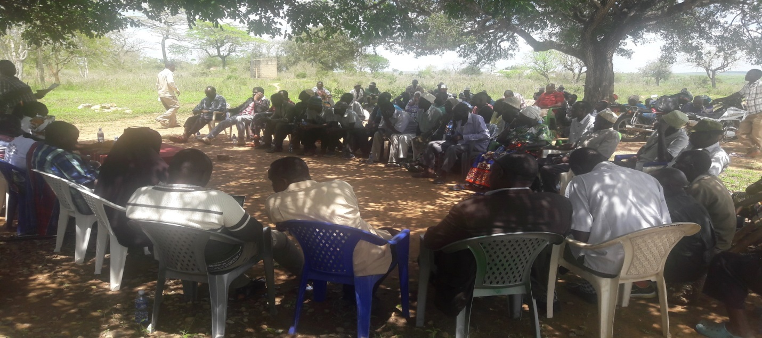Members of the public participating during the forum

**SAMBURU WARD**

**Kinango Constituency Development Fund (CDF) Project Proposals Consultative Forum for Samburu Ward Held at Ndohivyo Primary School (8:00am) and at Chengoni Chief’s Office (2:00pm) respectively on October8th, 2019**

Attendance – Guests

1. Suleiman Mundu – Chief (Samburu Location)
2. Lalo Lugwe - . Chief (ChengoniLocation)
3. Rashid BavuKurera– Chairman CDF Committee (Men Rep – Ndavaya Ward Member)
4. Beatrice Mbeyu – Secretary CDF Committee (Youth Rep &Kinango Ward Member)
5. Amina Bulle – CDFC (Mackinnon Road Ward Member)
6. MgandiMnyika – CDFC (Samburu Ward)
7. NgomeChitaphi – NG-CDF Rep (Kasemeni Ward Member)
8. Kimani Lemna – CDFC (Constituency Office Rep – Puma Ward Member)
9. Rebecca Mwaka – CDFC (Persons with Disabilities Rep)
10. Beatrice Tembe – Fund Manager
11. Henry Mwandary – Clerk of Works (Kinango CDF Office)

**Projects Proposed**

**Security**

* Construction of toilets at Chief’s office – Chengoni
* Assistant Chief’s Office-MajiyaChumvi
* Assistant Chief’s Office- Silaloni
* Police Station at Samburu
* Police post at Majiyachumvi
* Boundary issue at majiyachumvi to be addressed
* StreetsLights Samburu – Kinango road
* Rural electrification
* Completion of Kinagoni Police Station
* Silaloni Police post staff quarters

**Education**

* **Samburu primary school -**  classrooms, desks, fence
* **Samburu secondary school -**  classrooms, dormitory, lockers
* **Gora Primary School -**  school gate, fence
* **Mwangea primary School -** classrooms, desks, fence
* **Mtulu Primary School -** classrooms, desks, fence
* **Bofu Primary School -**  classrooms
* **Kinagoni primary School-**  renovation of 5no. classroom
* **Mwangaza Primary School –** classrooms, desks
* **Mwangoloto primary School -**  classrooms
* **Ng’onzini North Primary School –** access road to school, classrooms, desks
* **Marondo primary School –** 2no. classroom
* **Mwandoni Primary School**
* **Ndohivyo Primary School -** classrooms, renovation of 4no. classroom
* **Kituoni Primary School –** 2no. classroom
* **Mafufuni Primary School -**  school fence, desks, classrooms
* Construction of a Dormitory at Kinagoni Secondary School
* **MajiyaChumvi Primary** – desks
* **Mwarophesa Secondary School:** fence
* **Kanjaocha Primary School:**desks
* **Chengoni Primary School**:classrooms,desks
* **Chanzou Primary School**:desks
* **Mdomo Primary School** – classrooms, desks
* **Kazamoyo Primary School:**desks
* **ShauriMoyo Primary School:**desks
* Staff House at Kamale Youth Polytechnic and fencing
* **Proposed construction of a university in Samburu**
* Bursary funds disbursement schedule should be changed

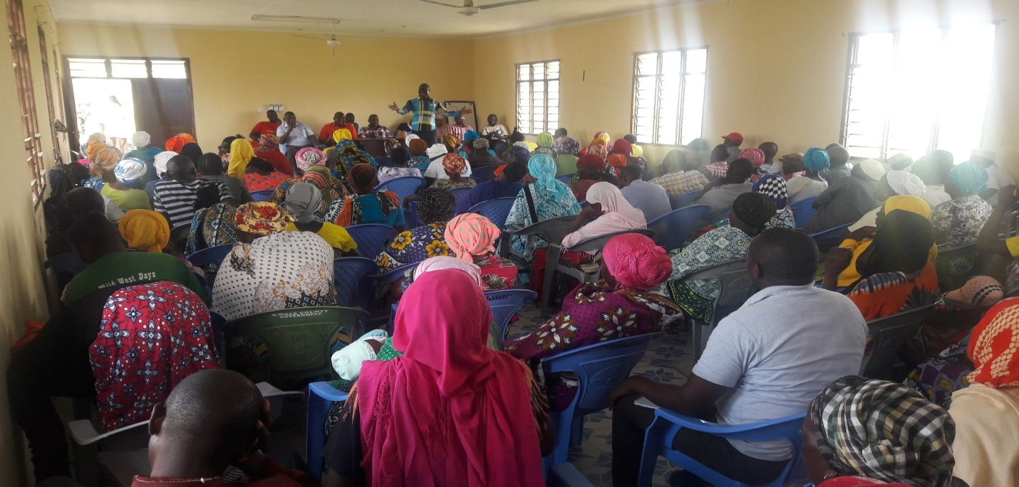

members of the public during the motions

**MWAVUMBO WARD**

**Kinango Constituency Development Fund (CDF) Project Proposals Consultative Forum for Mwavumbo Ward Held at Mavirivirini Primary School (8:00am) and at Kalalani Chief’s Office (2:00pm) respectively on October9th, 2019**

Attendance – Guests

1. Samson Chale – Chief (Mwatate Location)
2. Ndoro Benson - Ag. Chief (Kalalani Location)
3. Rashid BavuKurera– Chairman CDF Committee (Men Rep – Ndavaya Ward Member)
4. Beatrice Mbeyu – Secretary CDF Committee (Youth Rep &Kinango Ward Member)
5. Amina Bulle – CDFC (Mackinnon Road Ward Member)
6. MgandiMnyika – CDFC (Samburu Ward)
7. NgomeChitaphi – NG-CDF Rep (Kasemeni Ward Member)
8. Kimani Lemna – CDFC (Constituency Office Rep – Puma Ward Member)
9. Rebecca Mwaka – CDFC (Persons with Disabilities Rep)
10. Beatrice Tembe – Fund Manager
11. Henry Mwandary – Clerk of Works (Kinango CDF Office)

**Projects Proposed**

**Education**

* **Mubande Primary School:**  8 classrooms
* **Chidzipwa primary School:** 2 classrooms**,**
* **Lutsangani North primary School:** administration block
* **Vitsakaviri primary School:** 2 classrooms
* **Pemba pry Sch :**  classrooms**,**  toilets**,** desks
* **Kaluweni primary School:** 5 classrooms
* **Kafuduni Primary:** 4 classrooms**,**50 desks
* **Maweu Primary school:** 2 classrooms
* **Mavirivirini primary School:** 2 Classrooms
* **Mwashanga Primary School:** 2 classrooms
* **Mgandini primary School:** 2 classrooms
* **Dzombo Primary School:** 4 classrooms**,** desks, administration block
* **Kaphingo Primary School:** 4 classrooms**,** 6 toilets**,** 50 desks
* **Sega Primary School:** 6 classrooms**,** 4 toilets**,** 50 desks
* **Chigombero Primary School:** 3 classrooms**,** 5 toilets**,** 50 desks
* **Mlola Primary School:** 4 classrooms**,**3 toilets**,** 50 desks
* **Mwanda primary School:** Renovation of 6 classrooms,50desks
* **Gwasheni Primary School**: classrooms
* **Mwavumbo Secondary School:** Kitchen, Dining hall
* **Salim Mvurya Secondary School:**Dormitory, laboratory, 4classroom, administration block
* **MwabilaSeconndary School:** Girls Dormitory, classrooms
* Bursary allocation should be increased

**Security**

* Completion of mavirivirini police station and handingover
* Construction of new Chiefs office at Mwatate
* Renovation of asst. chiefs office Kafuduni
* Construction of new Asst.Chiefs office at Matumbi
* Construction of a police post in Matumbi

**Electricity**

* Rural electrification

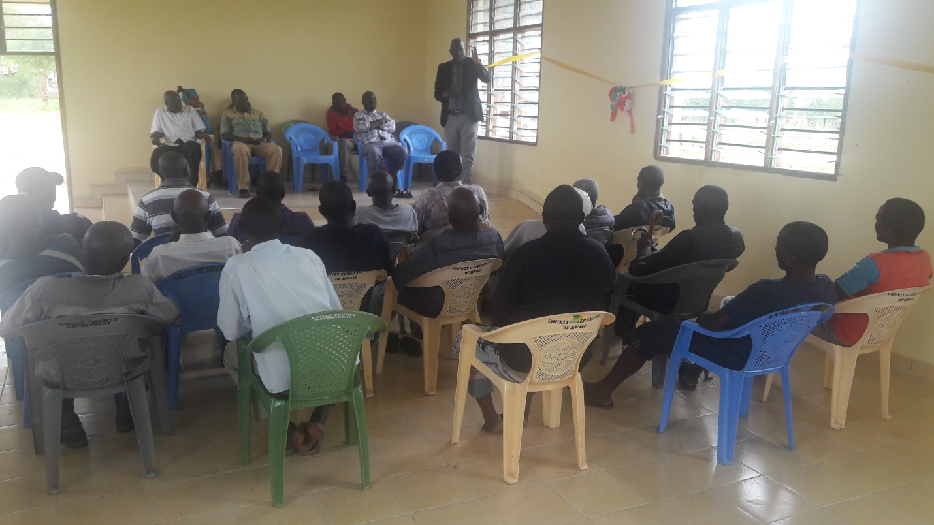

Chairman addressing issues to the public

**KASEMENI WARD**

**Kinango Constituency Development Fund (CDF) Project Proposals Consultative Forum for Kasemeni Ward Held at Kasemeni Chief’s Office (8:00am) and at Mtaa Chief’s Office (2:00pm) respectively on October 10th , 2019**

Attendance – Guests

1. Benson Kokoi – Chief (Kasemeni Location)
2. Joseph Nyae - Chief (Mtaa Location)
3. Salim N Chikophe – Chief (Makamini Location)
4. Rashid BavuKurera– Chairman CDF Committee (Men Rep – Ndavaya Ward Member)
5. Beatrice Mbeyu – Secretary CDF Committee (Youth Rep &Kinango Ward Member)
6. Amina Bulle – CDFC (Mackinnon Road Ward Member)
7. TungwaMwamvua – Constituency Office Rep (Kasemeni Ward)
8. MgandiMwakoga – Constituency Office Rep (Kasemeni Ward)
9. MgandiMnyika – CDFC (Samburu Ward)
10. NgomeChitaphi – NG-CDF Rep (Kasemeni Ward Member)
11. Kimani Lemna – CDFC (Constituency Office Rep – Puma Ward Member)
12. Rebecca Mwaka – CDFC (Persons with Disabilities Rep)
13. Beatrice Tembe – Fund Manager
14. Henry Mwandary – Clerk of Works (Kinango CDF Office)

**Projects Proposed**

**Education**

* **Mtaa Secondary School:** Administration Block, school bus, toilets, school fence, classrooms, Dormitory
* **Chikwakwani primary School:** classrooms, desks**,** toilets
* **Boyani Primary School:**  classrooms**,**  Toilets
* **Mkulung’ombe Primary School:** 4 classrooms**,** desks, toilets
* **Mtaa primary School:** Administration block**,** desks, renovation of classrooms
* **Muungano primary school:** completion of stalled cdf classrooms**,**  toilets
* **Mabesheni primary School:** 4classrooms**,**  toilets**,** Administration block
* **Bofu Secondary school:** Fencing**,** 2 classrooms, school bus, toilets
* **Bofu Primary School:**  classrooms, desks, toilets
* **Makuluni Primary School:** 4 classrooms, toilets and desks
* **GonaPrimary Schools:**  Renovation of 5no.Classrooms, desks
* **Mkanyeni Primary School:** 2 classrooms**,** fencing
* **Proposed Day Secondary School at Miyani**
* **Mazeras Primary School:** 2 Classrooms**,** desks**,** Fence
* **Fulugani Primary School: desks**
* **Mazeras High School:** to be upgraded to a national school
* **Mazeras Girls Memorial Secondary School:** Computer Laboratory**,** Dormitory**,** Twin staff House
* **Mnyenzeni Primary School:** classrooms**,** desks**,**  toilets
* **Chikuyu Primary School**:classrooms, desks
* **Vikolani Primary School:** 4 classrooms**,** desks**,** toilets
* **Miyani Primary School:** 4 classrooms**,** desks**,** toilets**,**
* **Miguneni Primary School:** 2 classrooms**,** desks**,**  toilets
* **Mnyenzeni Secondary School:** Girls Dormitory**,** Kitchen
* Proposed Mnyenzeni Boys Boarding School
* **Majengo Primary School:** desks**,** toilets**,**
* Proposed mixed day secondary School at Mazeras sub location
* **Mwache Primary school:**  desks
* **Chikomani Primary Sch:** classrooms**,** desks**,**
* **Bonje Primary School:** 2 classroom**,** desks, toilets, school fence
* **Bursary allocation for bodaboda riders**

**Security:**

* Construction of Chief’s office- Kasemeni
* Construction of Assistant Chief’s office –Mabesheni
* Construction of Chief’s office- Mtaa and toilets
* Construction of a police post – Mnyenzeni
* Construction of staff quarters for bofu police post and toilets
* **land demarcation and issue of title deeds**

**Tertiary Education/Institutions:**

* **technical institution to be constructed at Mazeras**

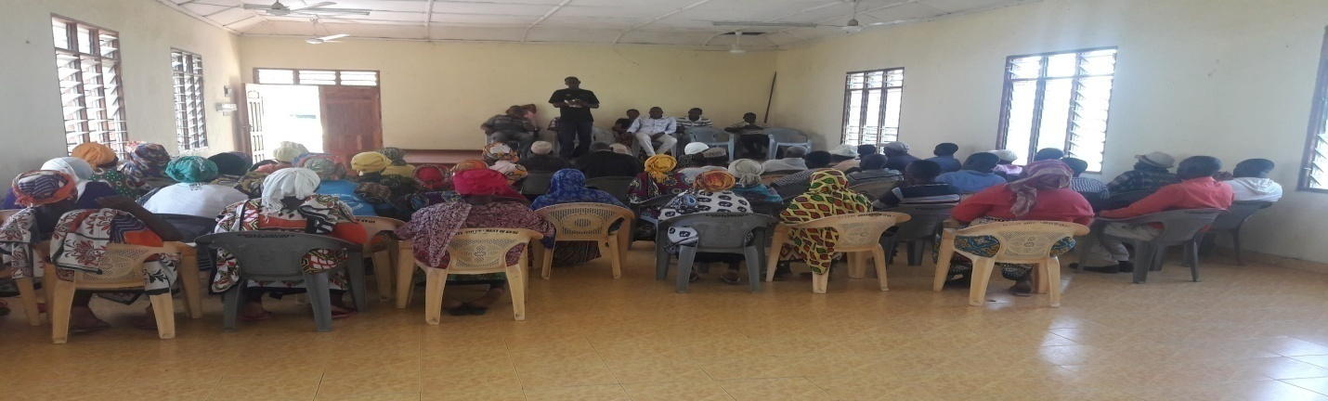

**Chief addressing members of the public**

**PUMA WARD**

**Kinango Constituency (NG-CDF) Project Proposals Consultative Forum for Puma Ward Held at Vingurungani Chief’s Office (8:00am) and Bang’a Chief’s Office (2:00pm) respectively on October 11th, 2019**

Attendance – Guests

1. Chikophe Mwanza – Ag.Chief (Vigurungani Location)

2. Saumkiroro- Ag. Chief (Puma Location)

3.RashidBavuKurera– Chairman CDF Committee (Men Rep – Ndavaya Ward Member)

4. Beatrice Mbeyu – Secretary CDF Committee (Youth Rep &Kinango Ward Member)

5. Amina Bulle – CDFC (Mackinnon Road Ward Member)

6. MgandiMnyika – CDFC (Samburu Ward)

7. NgomeChitaphi – NG-CDF Rep (Kasemeni Ward Member)

8. Kimani Lemna – CDFC (Constituency Office Rep – Puma Ward Member)

9. Rebecca Mwaka – CDFC (Persons with Disabilities Rep)

10. Beatrice Tembe – Fund Manager

11. Henry Mwandary – Clerk of Works (Kinango CDF Office)

**Project Proposed**

**Education**

* **Magongoni Primary School** -classrooms,desks
* **Maendeleo Primary School** -classrooms,desks
* **Gangani Primary School** - classrooms,desks
* **Gozani Primary School**-classrooms,desks
* **Vigurungani Primary School:**classrooms,desks
* **Kisimani Primary School**- classrooms,desks
* **Dzimanya Primary School**-classrooms,desks
* **Rorogi Primary School**-classrooms, desks
* **Kideri Primary School** – classrooms, desks
* **Chidzaya Primary School** – 2 classrooms, desks
* **Nyango Primary School** – 2classrooms, desks
* **Karyaka Primary School** – desks
* **Kasageni Primary school** – classrooms, Renovation of classrooms, desks
* **Bang’a Secondary School**- Laboratory, Dormitory, TSC teachers
* **Malungoniprimary:**classrooms,desks, Administration block
* **Mazola Primary School:**desks
* **Chirima cha UhaPrimary:**classrooms,desks
* **Bishop Kalu Primary School:** administration block,classrooms
* **Mabamaniprimary:**classrooms,desks
* **Mbilini Primary School** – classrooms, desks
* **Tumaini Primary School**:classrooms,desks
* Proposed construction of a secondary school in Dzimanya area

**Security**

* Construction of Police post at Kisimani / Mwamandi area
* Construction of Chief’s Office at Bang’a
* Construction of Chief’s Office at Vigurungani Centre
* Construction of Police post at Gangani / Gozani area
* Construction of Police post at Nyango
* Electricity installation of Vigurungani Police station
* Land cruiser for Vigurungani Police Station
* Construction of Chief’s Office at Busa

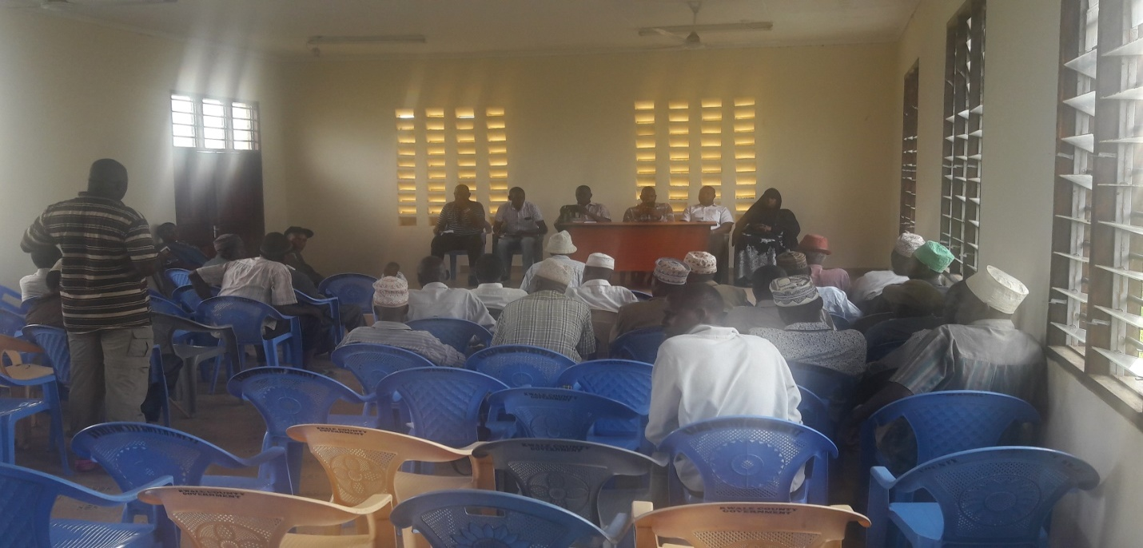

Members of the public contributing to the motion

**NDAVAYA WARD**

**Kinango Constituency (NG-CDF) Project Proposals Consultative Forum for Ndavaya Ward Held at Ndavaya Chief’s Office (8:00am) and at Mwakijembe Primary School (2:00pm) respectively October, 12th, 2019**

Attendance - Guests

1. Stanley Langat – ACC (Ndavaya Location)
2. Mkala Chai – Chief (Ndavaya Location)
3. Rashid BavuKurera– Chairman CDF Committee (Men Rep – Ndavaya Ward Member)
4. Beatrice Mbeyu – Secretary CDF Committee (Youth Rep &Kinango Ward Member)
5. Amina Bulle – CDFC (Mackinnon Road Ward Member)
6. MgandiMnyika – CDFC (Samburu Ward)
7. NgomeChitaphi – NG-CDF Rep (Kasemeni Ward Member)
8. Kimani Lemna – CDFC (Constituency Office Rep – Puma Ward Member)
9. Rebecca Mwaka – CDFC (Persons with Disabilities Rep)
10. Beatrice Tembe – Fund Manager
11. Henry Mwandary – Clerk of Works (Kinango CDF Office)

**Projects Proposed**

**Education**

* **Ndavaya Secondary School:** school bus, fence
* **Ndavaya Primary School**: classrooms, renovation of classrooms, desks
* **Mabanda primary School –** classrooms, desks
* **Tobora primary School -** classrooms
* **Bomani primary School -** desks
* **Gandini South primry school –** classrooms, desks, toilets
* **Ngauro primary School**– toilets, desks, classrooms
* **Bumani primary School –** classrooms, desks, toilets
* **Mwachanda primary School–**classrooms, renovations
* **Gulanze primary School -**  classrooms, desks
* **Mwalukombe Sec School -**  dormitory, school fence
* **Ziaradundo Primary School –** classrooms, completion of cdf stalled project, desks
* **Mbuluni Primary School -**  classrooms, desks
* **Jitegemee Primary School –** classrooms, desks
* **Mwalukombe Primary School -**  classrooms, desks
* Proposed Gulanze Secondary School
* Proposed Vyogato Youth polytechnic
* **Maphanga primary School**
* **Mafundani primary –** 4no. classroom, desks
* **Magodzoni Primary School -**  classrooms, desks
* **Mbita Pry School -**  classrooms, desks
* **Mbwaleni Pry School -**  classrooms, desks
* **Mwakijembe Pry School -**  classrooms, school fence, desks
* **Mwandimu Primary school -**  school fence, desks
* **Mwakijembe Secondary School:** 2 classrooms,dormitory
* Proposed Mwakijembe Youth Polytechnic

**Security**

* Construction of ACC staff Quarters at Ndavaya Divisional headquarters
* Construction of Asst. Chief’s Office –Mbwaleni
* Construction of Police Post –Mbwaleni
* Construction of Chief‘s offices at Mwakijembe
* Construction of Chief’s Office –Gulanze
* Construction of Chief’s Office -Mwandimu
* Construction of Chief’s Office -Kifyonzo

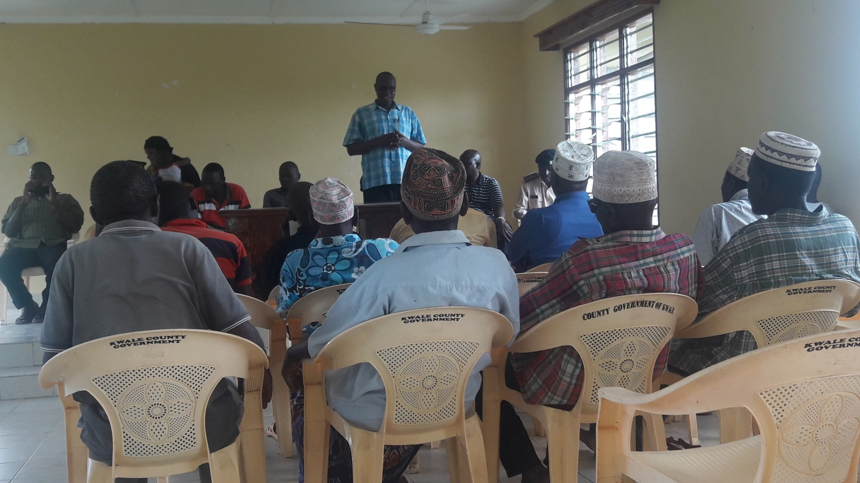

**ACC addressing Members of the Public contributing to the motions.**

**KINANGO WARD**

**Kinango Constituency Development Fund (CDF) Project Proposals Consultative Forum for Kinango Ward Held at Lutsangani Chief’s Office (8:00am), Nzovuni Primary School (12:00noon) and at Moyeni Primary School (4:00pm) respectively on October13th, 2019**

Attendance - Guests

1. TsumaMrinzi - Chief (Kinangolocation)
2. Haba Ali – Assistant Chief (Kibandaongo Sub-location)
3. Rashid Bavu – Chairman CDF Committee (Men Rep – Ndavaya Ward Member)
4. Beatrice Mbeyu – Secretary CDF Committee (Youth Rep &Kinango Ward Member)
5. Lilian Nyanje – CDFC (Mwavumbo Ward Member)
6. Amina Bulle – CDFC (Mackinnon Road Ward)
7. NgomeChitaphi – CDFC (Kasemeni Ward Member Rep)
8. MgandiMnyika– CDFC (Youth Rep – Samburu Ward Member)
9. Kimani Lemna – CDFC (Puma Ward Member Rep)
10. Rebecca Mwaka – CDFC (Persons with Disabilities Rep)
11. Beatrice Tembe – Fund Manager
12. Henry Mwandary – Clerk of Works (Kinango CDF Office)

**Projects Proposed**

**EDUCATION**

* **Amani primary Schools –** classrooms, desks, toilets
* **Mbandi Primary School -**  classrooms, desks, toilets
* **Gwadu primary School -**  desks
* **Kinango primary School -**  toilets, desks
* **Tsunza Secondary School:** classrooms, lockers,
* **Lutsangani Primary School:**classrooms, toilets, desks
* **Chizini Primary School:**classrooms, desks
* **Dzivani Primary School:**classrooms,desks
* **Tsunza Secondary School:** classrooms, lockers,
* **Lutsangani Primary School:**classrooms, toilets, desks
* **Chizini Primary School:**classrooms, desks
* **Dzivani Primary School:**classrooms,desks
* Construction of Youth Polytechnic at Nzovuni Centre
* **Sembe Primary School:**classrooms and desks
* **Nzovuni Primary School:**classrooms,
* **Mkilo Primary School:**classrooms and desk
* **Sagalato Primary School:**classrooms and desks
* Bursary allocation should be twice in a year
* **Dumbule Primary School:** complete the stalled CDF building
* **Kidogoweni Pry School**- 3 classrooms
* Construction of a Boys Secondary School at Kidogoweni
* Construction of Youth Polytechnic at Moyeni Centre
* **Moyeni Primary School:** classrooms, school fence and renovation
* **Ng’onzini Primary School:** complete the stalled CDF building and new classrooms
* **Moyeni Secondary School:** Dormitory, toilets, dining hall and kitchen

**Security**

* Construct a police post in Moyeni Centre
* Assistant chief’s office in Kidogoweni area
* Chief’s office in Dumbule area
* Rural electrification of Dumbule sub – location
* Kibandaongo to be a location of its own
* Assistant chief’s office to be constructed near nzovuni secondary
* Police post to be constructed between Gandini location and nzovuni
* Chief’s office at kibandaongo
* Chief’s office and Assistant chiefs office at Gandini

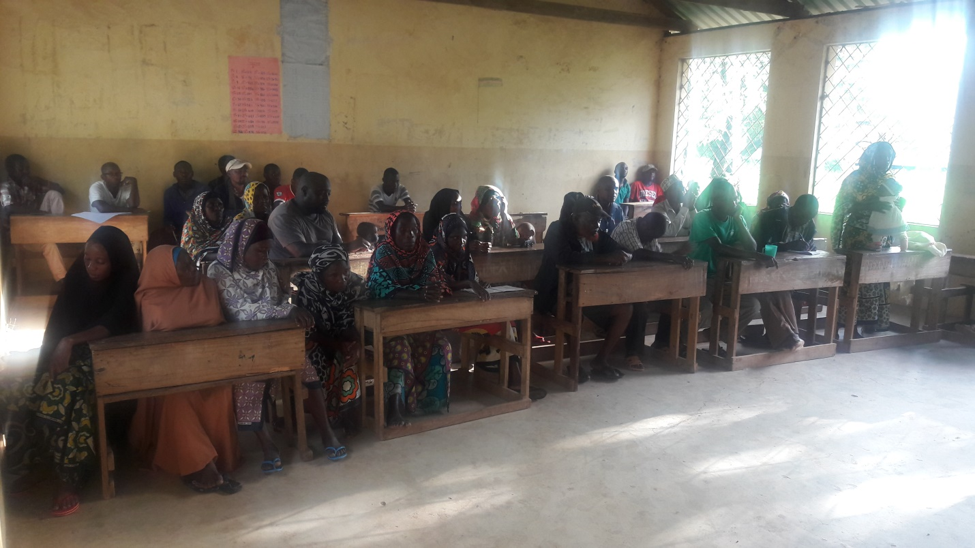

Members of the public contributing to the motions during the forum

**Comments by Leaders**

**Leaders commented variouslytouching on a myriad of challenges but notable issues included;**

1. **Poor education standards and inadequate skilled human resources**

Poor education standards as a result of the following:

1. Negative attitudes towards education by communities.
2. Inadequate trained teachers
3. Poor management of the schools
4. Student truancy and drop-out
5. Access to and quality of school infrastructure
6. **There’s generally very poor infrastructure for social and economic development in the constituency.**

The poor infrastructure in the constituency emanate from the following:

1. Poor Road Network
2. Shortage of and unreliable electricity
3. Unreliable Water Supply
4. Poor Sanitation and Solid Waste Management
5. **Cross Cutting Issues**
6. HIV and AIDS
7. Climate Change and Disasters
8. Gender Equality and Youth Empowerment
9. Vulnerable and excluded groups and communities
10. Retrogressive cultural practices, traditions and beliefs

**Way Forward**

Ensure Intensive, extensive and inclusive Community Involvement and Participation in all issues facing the constituents

One of the main strategies that will be applied in the tackling of the many challenges identified includes ensuring extensive and active participation of the Community. While NG-CDFC has made efforts to engage the communities in identifying and prioritizing projects, efforts to ensure participation at every point of implementation will be ensured.

Collaboration with other development partners such as the County Government, NGOs, donors, investors, technocrats etc is another strategy of choice for application as well.

In recognition of the devolution of government to the County level,the important roles played by the donors, NGOs, investors, etc, and in response to the newNG-CDF Act 2015, that demands enhanced coordination of activities by all development stakeholders, the CDFC shall establish positive linkages and collaboration not only with County government but with all other stakeholders in matters of fighting poverty, illiteracy, diseases and uplifting of the living standards of the constituents.

Notable challenges and the way forward summarized as follows;

**Summary Table**

|  |  |  |  |
| --- | --- | --- | --- |
| **Issues** | **Tools for Improvement** | **Action Plan** | **Expectations** |
| **1. Education Sector** | i. Primary Schools  ii. Secondary Schools  iii. Bursaries beneficiaries  iv. Tertiary Institutions  ➢ Youth Polytechnics  ➢ Kinango Technical University | • Infrastructure development &improvement of the existing ones  • Refurbishment of facilities  • Provision of Bursaries  • Provision of teachers/instructors | • Sustainability of projects  • Proper documentation& inventory control  • Good/Improved Performance in schools and colleges  • Maintenance of facilities and infrastructure |
| **2. Natural Resources**  **(Environment)** | Environment | • Conservation of the environment and reversal of degradation  • Control of charcoal burning and wanton destruction of environment | • Proper documentation  • Responsible utilization of natural resources  • Coordinated approach to protection of environment |
| **4 Security Docket** | (Administrative offices, Police Posts, police camps) | • Develop & construction Police posts  • Establish DO/Chiefs’ offices  • Support in equipping County Commissioners Offices | • Improved security of the area  • Care and protection of the facilities |

**Conclusion**

We Believe in **MAENDELEO KWANZA**, so we remain committed to implementation as Envisaged.

Signed………………………………………… Date………………………………

Chairman CDF Committee

Signed………………………………………… Date………………………………

Fund Account Manager

**Kinango National Government Constituency Development Fund**

**Project Proposal 2019/2020 Financial Year**

**Code-List**

**FINANCIAL YEAR...…20191ST JULY TO 30TH JUNE……2020**

| **Project Name** | **Project Number** | **Original Cost** | **Cumulative Allocation** | **Project activity** | **Amount Allocated** | **Current Status** |
| --- | --- | --- | --- | --- | --- | --- |
| Employees Salaries | 4-002-010-2110000-100-2019/2020-001 | 2,587,200.00 | 0.00 | Payment of staff salaries and gratuity | 2,587,200.00 | New |
| Goods and Services | 4-002-010-2210000-100-2019/2020-002 | 2,500,000.00 | 0.00 | Purchase of fuel, repairs and maintenance, printing, stationery, telephone, travel and subsistence, office tea | 2,500,000.00 | New |
| NSSF | 4-002-010-2120101-100-2019/2020-003 | 492,800.00 | 0.00 | Payment of NSSF Deductions | 492,800.00 | New |
| NHIF | 4-002-010-2120201-100-2019/2020-004 | 60,000.00 | 0.00 | Payment of NHIF Deductions | 60,000.00 | New |
| Committee Expenses | 4-002-010-2210802-100-2019/2020-005 | 2,602,063.45 | 0.00 | Payment of Committee sitting allowances, transport, conferences | 2,602,063.45 | New |
| Committee Expenses | 4-002-010-2210802-111-2019/2020-001 | 2,500,000.00 | 0.00 | Payment of Committee sitting allowances, transport, conferences | 2,500,000.00 | New |
| CDFC, PMC & Staff Capacity Building | 4-002-010-2210700-111-2019/2020-002 | 1,621,031.72 | 0.00 | Undertake Training of the PMCs, CDFCs and Office Staff on CDF Related issues | 1,621,031.72 | **New** |
| Emergency | 4-002-010-2640200-101-2019/2020-001 | 7,198,241.38 | 0.00 | To cater for any unforeseen occurrences in the constituency during the financial year | 7,198,241.38 | **New** |
| Secondary Schools Bursary | 4-002-010-2640101-103-2019/2020-001 | 17,026,387.59 | 0.00 | Cater for bright and needy students in secondary schools | 17,026,387.59 | **New** |
| Tertiary Institutions Bursary | 4-002-010-2640102-103-2019/2020-002 | 18,000,000.00 | 0.00 | Cater for bright and needy students in tertiary institutions | 18,000,000.00 | **New** |
| Mazola Primary School | 4-002-010-2630204-104-2019/2020-001 | 2,600,000.00 | 0.00 | Construction of 2no. classroom to completion | 2,600,000.00 | **New** |
| Chizini Primary School | 4-002-010-2630204-104-2019/2020-002 | 2,600,000.00 | 0.00 | Construction of 2no. classroom to completion | 2,600,000.00 | **New** |
| Ng'onzini Primary School | 4-002-010-2630204-104-2019/2020-003 | 2,600,000.00 | 0.00 | Construction of 2no. classroom to completion | 2,600,000.00 | **New** |
| Dzivwani Primary School | 4-002-010-2630204-104-2019/2020-004 | 2,600,000.00 | 0.00 | Construction of 2no. classroom to completion | 2,600,000.00 | **New** |
| Mwashanga Primary School | 4-002-010-2630204-104-2019/2020-005 | 2,600,000.00 | 0.00 | Construction of 2no. classroom to completion | 2,600,000.00 | **New** |
| Dzombo Primary School | 4-002-010-2630204-104-2019/2020-006 | 2,600,000.00 | 0.00 | Construction of 2no. classroom to completion | 2,600,000.00 | **New** |
| Kafuduni Primary School | 4-002-010-2630204-104-2019/2020-007 | 2,600,000.00 | 0.00 | Construction of 2no. classroom to completion | 2,600,000.00 | **New** |
| Mgandini Primary School | 4-002-010-2630204-104-2019/2020-008 | 2,600,000.00 | 0.00 | Construction of 2no. classroom to completion | 2,600,000.00 | **New** |
| Miyani Primary School | 4-002-010-2630204-104-2019/2020-009 | 2,600,000.00 | 0.00 | Construction of 2no. classroom to completion | 2,600,000.00 | **New** |
| Mbwaleni Primary School | 4-002-010-2630204-104-2019/2020-010 | 2,600,000.00 | 0.00 | Construction of 2no. classroom to completion | 2,600,000.00 | **New** |
| Mbita Primary School | 4-002-010-2630204-104-2019/2020-011 | 2,600,000.00 | 0.00 | Construction of 2no. classroom to completion | 2,600,000.00 | **New** |
| Mwangea Primary School | 4-002-010-2630204-104-2019/2020-012 | 2,600,000.00 | 0.00 | Construction of 2no. classroom to completion | 2,600,000.00 | **New** |
| Kituoni Primary School | 4-002-010-2630204-104-2019/2020-013 | 2,600,000.00 | 0.00 | Construction of 2no. classroom to completion | 2,600,000.00 | **New** |
| Taru Primary School | 4-002-010-2630204-104-2019/2020-014 | 2,600,000.00 | 0.00 | Construction of 2no. classroom to completion | 2,600,000.00 | **New** |
| Busho Primary School | 4-002-010-2630204-104-2019/2020-015 | 2,600,000.00 | 0.00 | Construction of 2no. classroom to completion | 2,600,000.00 | **New** |
| Kaluweni Primary School | 4/002/010/2630204/2019/2020/016 | 2,600,000.00 | 0.00 | Construction of 2no. classroom to completion | 2,600,000.00 | **New** |
| Kasageni Primary School | 4/002/010/2630204/2019/2020/017 | 2,400,000.00 | 0.00 | Renovation of 4no. Classroom | 2,400,000.00 | **New** |
| Mwalukombe Primary School | 4/002/010/2630204/2019/2020/018 | 2,400,000.00 | 0.00 | Renovation of 4no. Classroom | 2,400,000.00 | **New** |
| Gona Primary School | 4/002/010/2630204/2019/2020/019 | 2,400,000.00 | 0.00 | Renovation of 4no. Classroom | 2,400,000.00 | **New** |
| Kituu Primary School | 4/002/010/2630204/2019/2020/020 | 1,200,000.00 | 0.00 | Renovation of Classroom | 1,200,000.00 | **New** |
| Mbandi Primary School | 4/002/010/2630204/2019/2020/021 | 400,000.00 | 0.00 | Additional cost of construction of 3no classroom | 400,000.00 | **On-going** |
| Bishop Kalu Primary School | 4/002/010/2630204/2019/2020/022 | 1,000,000.00 | 0.00 | Construction of Admin block | 1,000,000.00 | **On-going** |
| Tumaini Primary School | 4/002/010/2630204/2019/2020/023 | 300,000.00 | 0.00 | Additional cost of construction of 3no classroom | 300,000.00 | **On-going** |
| Lutsangani Primary School | 4/002/010/2630204/2019/2020/024 | 200,000.00 | 0.00 | Additional cost of construction of 2no classroom | 200,000.00 | **On-going** |
| Mwache Primary School | 4/002/010/2630204/2019/2020/025 | 400,000.00 | 0.00 | Additional cost for renovation of 4no classroom | 400,000.00 | **On-going** |
| Primary Schools | 4/002/010/2630204/2019/2020/016 | 3,780,000.00 | 0.00 | Supply and delivery of 540 desks to schools | 3,780,000.00 | **New** |
| Vigurungani Secondary School | 4-002-010-2630205-104-2019/2020-001 | 1,600,000.00 | 0.00 | Renovation of Science Lab | 1,600,000.00 | **New** |
| Ndavaya Secondary School | 4-002-010-2630205-104-2019/2020-002 | 5,000,000.00 | 0.00 | Additional Cost for Purchase of School Bus | 5,000,000.00 | **New** |
| Makamini Secondary School | 4-002-010-2630205-104-2019/2020-003 | 4,000,000.00 | 0.00 | Construction of Staff Twin House | 4,000,000.00 | **New** |
| Tsunza Secondary School | 4-002-010-2630205-104-2019/2020-004 | 100,000.00 | 0.00 | Completion of 2no classroom | 100,000.00 | **On-going** |
| Mwavumbo Secondary School | 4-002-010-2630205-104-2019/2020-005 | 1,000,000.00 | 0.00 | Construction of Kitchen Block | 1,000,000.00 | **New** |
| NG-CDF Office | 4-002-010-3110701-104-2019/2020-001 | 1,600,000.00 | 0.00 | Renovation of the Offices | 1,600,000.00 | **New** |
| Mavirivirini Police Post | 4-002-010-2640507-108-2019-2020-001 | 400,000.00 | 0.00 | Completion of the office | 400,000.00 | **New** |
| Kinango Sub-County Education | 4-002-010-2640507-108-2019-2020-002 | 9,000,000.00 | 0.00 | Construction of Education Office Complex | 9,000,000.00 | **New** |
| Kinango Constituency Sports Activities | 4-002-010-2640509-112-2019/2020-001 | 2,100,000.00 | 0.00 | Carry out Constituency sports tournaments and purchase of trophies, sports kits and balls | 2,100,000.00 | **New** |
| Mazola Primary School | 4-002-010/2640510-108-2019/2020-001 | 100,000.00 | 0.00 | Purchase of tree seedlings and Planting of trees | 100,000.00 | **New** |
| Chizini Primary School | 4-002-010/2640510-108-2019/2020-002 | 100,000.00 | 0.00 | Purchase of tree seedlings and Planting of trees | 100,000.00 | **New** |
| Ng'onzini Primary School | 4-002-010-2640510-108-2019/2020-003 | 100,000.00 | 0.00 | Purchase of tree seedlings and Planting of trees | 100,000.00 | **New** |
| Dzivwani Primary School | 4-002-010-2640510-108-2019/2020-004 | 100,000.00 | 0.00 | Purchase of tree seedlings and Planting of trees | 100,000.00 | **New** |
| Mwashanga Primary School | 4-002-010-2640510-108-2019/2020-005 | 100,000.00 | 0.00 | Purchase of tree seedlings and Planting of trees | 100,000.00 | **New** |
| Dzombo Primary School | 4-002-010-2640510-108-2019/2020-006 | 100,000.00 | 0.00 | Purchase of tree seedlings and Planting of trees | 100,000.00 | **New** |
| Kafuduni Primary School | 4-002-010-2640510-108-2019/2020-007 | 100,000.00 | 0.00 | Purchase of tree seedlings and Planting of trees | 100,000.00 | **New** |
| Mgandini Primary School | 4-002-010-2640510-108-2019/2020-008 | 100,000.00 | 0.00 | Purchase of tree seedlings and Planting of trees | 100,000.00 | **New** |
| Miyani Primary School | 4-002-010-2640510-108-2019/2020-009 | 100,000.00 | 0.00 | Purchase of tree seedlings and Planting of trees | 100,000.00 | **New** |
| Mbwaleni Primary School | 4-002-010-2640510-108-2019/2020-010 | 100,000.00 | 0.00 | Purchase of tree seedlings and Planting of trees | 100,000.00 | **New** |
| Mbita Primary School | 4-002-010-2640510-108-2019/2020-011 | 100,000.00 | 0.00 | Purchase of tree seedlings and Planting of trees | 100,000.00 | **New** |
| Mwache Primary School | 4-002-010-2640510-108-2019/2020-012 | 100,000.00 | 0.00 | Purchase of tree seedlings and Planting of trees | 100,000.00 | **New** |
| Kituoni Primary School | 4-002-010-2640510-108-2019/2020-013 | 100,000.00 | 0.00 | Purchase of tree seedlings and Planting of trees | 100,000.00 | **New** |
| Taru Primary School | 4-002-010-2640510-108-2019/2020-014 | 100,000.00 | 0.00 | Purchase of tree seedlings and Planting of trees | 100,000.00 | **New** |
| Busho Primary School | 4-002-010-2640510-108-2019/2020-015 | 100,000.00 | 0.00 | Purchase of tree seedlings and Planting of trees | 100,000.00 | **New** |
| Kaluweni Primary School | 4-002-010-2640510-108-2019/2020-016 | 100,000.00 | 0.00 | Purchase of tree seedlings and Planting of trees | 100,000.00 | **New** |
| Kasageni Primary School | 4-002-010-2640510-108-2019/2020-017 | 100,000.00 | 0.00 | Purchase of tree seedlings and Planting of trees | 100,000.00 | **New** |
| Mwalukombe Primary School | 4-002-010-2640510-108-2019/2020-018 | 100,000.00 | 0.00 | Purchase of tree seedlings and Planting of trees | 100,000.00 | **New** |
| Gona Primary School | 4-002-010-2640510-108-2019/2020-019 | 100,000.00 | 0.00 | Purchase of tree seedlings and Planting of trees | 100,000.00 | **New** |
| **Total** |  | **137,367,724.14** |  |  | **137,367,724.1** |  |