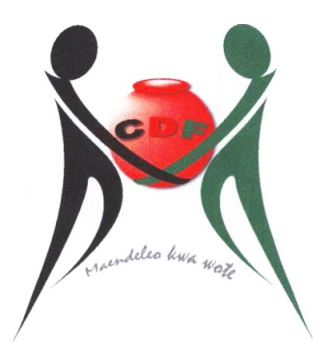



**KILIFI SOUTH CONSTITUENCY DEVELOPMENT FUND**

|  |  |  |  |  |  |  |  |  |  |  |  |  |  |  |
| --- | --- | --- | --- | --- | --- | --- | --- | --- | --- | --- | --- | --- | --- | --- |
| |  |  |  | | --- | --- | --- | | **Kilifi South CDF Office:**  **Kikambala-Posta**  **Off Mombasa/Malindi Road** |  | **Kilifi South CDFC**  **P.O. Box 1368**  **Kilifi**  **0721-355958** | |  | |  |  |  | | --- | --- | --- | |  |  | **Chairman** | |  |  | **Embakasi North CDF Committee** | |  |  | **P.O. Box 66984-00200**  **Nairobi** | |

# MINUTES OF THE KILIFI SOUTH CDFC MEETING HELD ON 13/12/2016 AT KILIFI SOUTH CDF OFFICE AT 10.00 AM

**MEMBERS PRESENT**

1. Ali Amani Rubea Chairman

2. Patrick Jambo Haron Secretary

3. Janet Sadaka Chengo Member

4. Lucas Mtsonga Vumbi Member

5. Patterson Finyange Mwamu Member

6. Caroline Bahati Wekesa Member

7. Mariam C. Jabal Member

8. Shaban Mwazani Salim Member

9. George Juma Onesmus Fund Account Manager

**AGENDA**

1. Preliminaries
2. Bursary
3. Inter-Constituency Visit
4. A.O.B

**CDFC/KILIFI SOUTH/ MIN 1/20/1/2017 PRELIMINARIES**

The Chairman brought the meeting to order at 10.34 am with a word of prayer from Janet Sadaka.

**CDFC/KILIFI SOUTH/ MIN 2/20/1/2017 BURSARY**

The Chairman bursary committee presented a list of bursary for approval. Members discussed the matter and approved the payment of kshs………………to the various institutions.

**CDFC/KILIFI SOUTH/MIN 3/20/1/2017 INTER-CONSTITUENCY VISIT**

Members discussed the need of bench marking. Members discussed the constituencies to visit and opted to Visit Voi and Wundanyi Constituencies to the bench marking from 30th January 2017 to 3rd February 2017. Members approved the following budget for the bench marking:

**Allowances**

Chairman=1* 5days*kshs.7,000=kshs. 35,000

Members=10*5days*kshs.5,000=kshs.250,000

**Per diem**

Chairman=1* 5days*kshs.7,000=kshs. 35,000

Members=10*5days*kshs.5,000=kshs.250,000

Transport =kshs. 20,000

Miscellaneous =kshs. 10,000

**Total =kshs.600,000**

**Members approved per diem equal to their sitting allowances.**

**CDFC/KILIFI SOUTH/MIN 4/20/1/2017 A.O.B**

There being no other business the meeting closed at 11.51 am with a word of prayer by Shaban Salim.

Chairman……………………………………….Sign………………………...Date……………….

Secretary……………………………………….Sign…………………………Date……………….