**KENYA POLICE SERVICE**



Telegrams: “POLICE”……….. UGUNJA SUB-COUNTY POLICE HQS,

Telephone: P.O BOX 250 – 40607,

Email: [ocpdugunja@gmail.com](mailto:ocpdugunja@gmail.com) **UKWALA.**

When replying please quote

REF: C/LEG/1/71/VOL.I/28 DATE: 1ST OCTOBER, 2021

**RE: PROPOSAL OF BUILDING A POLICE POST AT RAMBULA**

The above subject matter refers;

The reasons as to why we need a police post at the above mentioned place are:

1. The population is growing up since the area is good for agriculture and most people have settled there.
2. Most of the criminals committing crimes elsewhere go there as a hideout place with the stolen goods.
3. The distance between Rambula and Ugunja is quite far and when there is a crisis there it will take time before the area residents are assisted.
4. If Sidindi police station will be gazetted ,all the police posts of Ruwe, Okwako and Simenya will be under Sidindi leaving Ugunja police station with only one police patrol base Umina police post

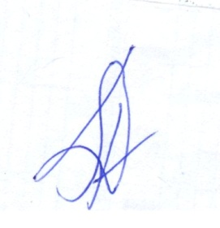

(LAZARUS TARUS (SSP)

SUB-COUNTY POLICE COMMANDER

**UGUNJA**