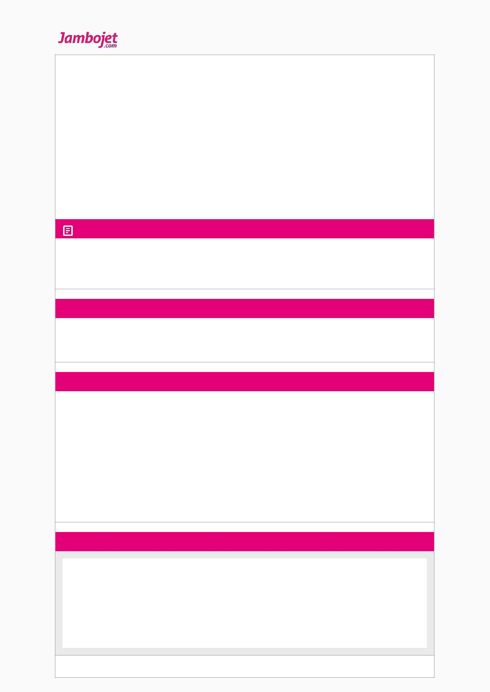

|  |  |  |  |  |
| --- | --- | --- | --- | --- |
| Your Itinerary |  |  | Booking Reference **P9ZHNT** |  |
| Booking Date: **26 Oct 2017** | |  |  |
|  |  |  |
| Booking Status: **Confirmed** | |  |  |  |
|  |  |  |  |  |
| Contact Details |  |  |  |  |
| Contact Name | **Ms Shebah Jerono** | Mobile | **+254 719533198** |  |
| Address | **2449 10100** | Home | **+254 719533198** |  |
|  | **Eldoret Kenya, Republic of 10100** | Destination | **+254 719533198** |  |
|  |  |  |
|  |  | Email | **shebah113@gmail.com** |  |
|  |  |  |  |  |

Itinerary Details

Check­in opens 2 hours and closes 40 minutes before departure. We recommend that you be at the airport at least 90 minutes before departure time. Extra time would be taken into consideration in case of congestion at the airport.

Itinerary Details

|  |  |  |  |  |  |  |  |  |
| --- | --- | --- | --- | --- | --- | --- | --- | --- |
|  |  |  |  |  |  |  |  |  |
|  | **FLIGHT NO.** | **DEPARTURE** |  |  | **ARRIVAL** |  |  |  |
|  |  | **Date** | **Time** | **Depart from** | **Date** | **Time** | **Arrive at** |  |
|  | JM 8670 | 27 Oct 2017 | 08:35 AM | Eldoret (EDL) | 27 Oct 2017 | 09:25 AM | Nairobi (JKIA) |  |
|  |  |  |  |  |  |  | (NBO) |  |
|  |  |  |  |  |  |  |  |  |
|  |  |  |  |  |  |  |  |  |

Passengers

|  |  |  |  |  |  |  |
| --- | --- | --- | --- | --- | --- | --- |
|  |  |  |  |  |  |  |
|  | **NAME** | **FLIGHT NUMBER** | **SEAT NUMBER** | **CHECKED BAGGAGE(S)** | **SPECIAL BAGGAGE** |  |
|  | Mr KIPCHUMBA OLIVER | JM 8670 |  |  |  |  |
|  | MUTAI |  |  |  |  |  |
|  |  |  |  |  |  |  |
|  |  |  |  |  |  |  |

Receipts & Payment Details

|  |  |  |  |  |  |  |
| --- | --- | --- | --- | --- | --- | --- |
|  |  |  |  |  |  |  |
|  | **DEPARTING FLIGHT** |  | **COST** |  |  |  |
|  | Fare |  | KES 5,500 |  |  |  |
|  | Fees & Taxes |  | KES 1,200 |  |  |  |
|  |  |  |  |  |  |  |
|  |  |  |  |  |  |  |
|  | **TOTAL** |  |  |  |  |  |
|  | KES 6,700 |  |  |  |  |  |
|  |  |  |  |  |  |  |
|  |  |  |  |  |  | |
|  | **MODE OF PAYMENT** | **PAYMENT DATE** | **PRICING CURRENCY** | **TRANSACTION CURRENCY** | **STATUS** |  |
|  | Mobile Payment | 26 Oct 2017 | KES 6,700 | KES 6,700 | Approved |  |
|  | ​XXXXXXX0000 |  |  |  |  |  |
|  |  |  |  |  |  |  |
|  |  |  |  |  |  |  |

Important Information

**FARE RULES DEPARTING FLIGHT**

1.All fares are Non­Refundable.

2.Itinerary changes must be made 40 Minutes prior to departure. If this is not done and the Passenger doesnt Travel then the entire Fare is Forfeited. 3.If at the time of change and the Original Fare is not available the Passenger will Up sell to a Higher Fare and Reservation Change Fee will also apply. 4.Name Changes & Updates allowed at a Fee.

5.A Passenger is allowed to Purchase a maximum of 64 Kilos of Checked in Baggage. Each piece cannot exceed 32kg. 6.The only free baggage is the 10 Kg hand luggage Dimensions : 55cm X 38cm X 20cm.

7.Buy Baggage in advance . Baggage bought at Check in will be charged DOUBLE the normal rates. 8.Check in CLOSES 40 minutes to Departure.

9.Credit Shells shall be valid upto six months from the creation date.

© Copyright 2013 JamboJet Limited. All rights reserved. Usage of this website states your compliance of our Terms of Use and Privacy Policy. Developed by MatchByte Consultants.

