NG-CDF BOARD | National Government CONSTITUENCIES DEVELOPMENT Fund
 | Homabay Town Constituency
 | Kabunde Multipurpose Hall
 | P.O BOX 240 Homabay, 40300
 | Email: cdfhomabaytown@ngcdf.go.ke | Website: www.ngcdf.go.ke
HOMA BARY TOWN NATIONAL GOVERNMENT CONSTITUENCY DEVELOPMENT FUND COMMITTEE 2ND MEETING HELD ON 3RD JANUARY 2023 AT THE NG-CDFC OFFICES – KABUNDE

MEMBERS PRESENT

- Harrison Ouko Chairperson
- Bugo Agoro Charles Secretary
- Betha Hildigard Owenga Member
- Richard Ochieng Askari Member
- Edith Awuor Obonyo Member
- John Onyango Member
- Lorna Awuor Okidi Member
- Teresa Ochieng Co -Opted Member
- Wilson Okumu Fund Account Manager
- Jude Wasonga Deputy County Commissioner

IN ATTENDANCE

- Donald Ochieng Account Assistant
- Scholastica Wanina Procurement Assistant
- Oliver Akinyi Clerk of Works
AGENDA

- Communication from the chairperson
- Reading and confirmation of the previous Meeting Minutes
- Matters arising
- Bursary
- Preparation, Presentation and Submission of Project Proposal – 2022/2023 FY
- A.O.B.

MIN.HBTC NG-CDFC 01/01/1/2022/2023: COMMUNICATION FROM THE CHAIRPERSON.

The Chairperson called the meeting to order at 9:30 am after confirming the quorum. He requested Mr. Richard Askari to lead the members in an opening prayer.

The Chairperson on his remarks commended the Fund Account Manager, Mr. Wilson Ogogo for the tireless efforts he has made to ensure Homabay Town Constituency gets a new face in terms of project management picking from where Mr. David Agong had left. He assured the Fund Manager of the NG-CDFC’s full support and asked for cooperation and proper communication when called upon by appropriate channels.

MIN.HBTC NG-CDFC 02/01/1/2022/2023: READING AND CONFIRMATION OF THE PREVIOUS MEETING MINUTES

The secretary read out the minutes of the previous meeting held on 20th December 2022. The minutes were confirmed and seconded by Mrs. Edith Awuor and Mr. John Onyango to be true minutes of the meeting held that day.

MIN.HBTC NG-CDFC 03/01/1/2022/2023: MATTERS ARISING

The chairperson commended the members for their tireless participation during the ward meeting as some of them dragged past office working hours.
He further appreciated the Deputy County Commissioner, Mr. Jude Wasonga for helping in mobilization of members of the public during the public participation exercise that was conducted as from 27th December, 2022 to 30th December, 2022. The DCC had also mobilized the area chiefs and their assistants who showed up for the exercise and greatly contributed to its success.

A report of the ward meeting was tabled to the members and they adopted the report as was presented.

MIN.HBTC NG-CDFC 04/1/1/2022/2023: BURSARY
The Fund Account Manager informed the members that the NG-CDF Board is yet to disburse funds for the 2022/2023 FY. However, the schools would soon be reopening and therefore he urged the members to be proactive and give the correct position to the members of the general public as the office might not be in a position to award bursary to the needy students at the beginning of the new term.

He also advised the members to be guided by the NG-CDF Act in identification of the needy students across the constituency by developing and issuing of bursary forms to the applicants after which the applicants are vetted and forwarded to the NG-CDFC for sponsorship. The members unanimously agreed to embrace the idea to avoid audit queries in the future.

In regards to the fully sponsored needy students’ in the constituency, the list is not up to date as some of the students sat for their national exams as some got transferred to different institutions amongst other reasons. The members resolved to send representatives from the committee to visit the beneficiary institutions for manual verification of the fully sponsored students.

MIN.HBTC NG-CDFC 05/1/1/2022/2023: PUBLIC PARTICIPATION.

The Fund Account Manager tabled before the committee a report on public participation conducted between 27th December, 2022 to 30th December, 2022. The members were in agreement that the exercise was successfully done and the report clearly outlines the needs of the constituents. It was therefore resolved that the report be used for prioritization of projects for funding in the 2022/23 and 2023/24 financial years. MIN.HBTC NG-CDFC 05/1/1/2022/2023: PUBLIC PARTICIPATION.

The Fund Account Manager tabled before the committee a report on public participation conducted as from 27th to 30th December 2022. The members were in agreement that the exercise was successfully done and the report clearly outlines the needs of the constituents as captured in the table below:

NO | SCHOOL | ACTIVITY | WARD
 | Nyanguu Primary School | Construction of administration block consisting of two offices | East Ward
 | Sinangi Primary School | - Construction of 4 door latrine  - Construction and equipping of 2No. Classrooms | East Ward
 | Nyauu Primary School | Renovation of 8no. Classrooms | East Ward
 | Ndiru Primary School | Renovation of administration block and 2No. Classrooms | East Ward
 | Roba Primary School | Construction of 2 No. Classrooms | East Ward
 | Achiero Primary School | Construction and equipping of 2 No classrooms | East Ward
 | St Pius Ndiru Secondary School | Construction of a Laboratory | East Ward
 | St. Theresa’s Nyauu Girls Secondary School | Construction of a dormitory | East Ward
 | St.Marys Marindi Girls Secondary School | Purchase of 51 seater school bus | East Ward
 | Otaro Primary School | Landscaping and fencing of the school compound | East Ward
 | Nyakune Primary School | Renovation of 3no. Classrooms | West Ward
 | Nyakahia Mixed Secondary School | Construction 0f 60 students capacity science laboratory: | West Ward
 | Opande Rarage Primary School | Construction 2No. Classrooms | Central Ward
 | Wiobiero Primary School | Renovation of 5 No. classrooms | Central Ward

It was therefore resolved that the report be used for prioritization of projects for funding in the 2022/23 and 2023/24 financial years.

MIN.HBTC NG-CDFC 06/1/1/2022/2023: ONGOING PROJECTS

The Fund Account Manager tabled before the committee the list of all ongoing projects as was submitted to the Board. The committee noted that some of the ongoing projects were allocated funds in the previous financial years for construction to completion but due to rise in cost of construction materials, the projects could not be completed as the amounts were not adequate since most competitive bidders quoted relatively higher amounts as compared to what were allocated to the projects. The Committee therefore resolved to allocate more funds to the projects for completion. It was agreed that the list is true representation of the status of projects. The members resolved to give first priority to the projects for funding to completion in 2022/23 financial year.

MIN.HBTC NG-CDFC 07/1/1/2022/2023: PREPARATION, PRESENTATION AND SUBMISSION OF PROJECT PROPOSAL FOR 2022/2023 FINANCIAL YEAR

The Fund Account Manager reminded the members, that as they prepare to compile the project proposals for submission to the NG-CDF Board, they should adhere to the directives of the NG-CDF Board circular dated 15th December, 2022, stating that the NG-CDFC should prioritize funding all the ongoing projects to completion before identifying new projects for implementation.

He further informed the members that the 1% of the Monitoring and Evaluation allocation that was set aside for the constituency oversight committee had been reviewed to 1% of the total constituency allocation.

The members deliberated on the status of the ongoing projects after which the members agreed to set aside adequate funds to complete the ongoing projects, guided by the report that had been forwarded to the NG-CDF Board.

The NG-CDFC further deliberated on the ward meetings report and thereafter culminated with the below as the final project proposal for the 2022/2023 FY;

S/No | Project Name | Activities | Original Cost | Cumulative Allocation | Amount Allocated | Project Status
 | ADMINISTRATION AND RECURRENT EXPENDTURE
1 | Employees' Salaries | Payment of staff salaries for 7 staff | 2,120,160.00 |  | 2,120,160.00 | New
2 | Staff Gratuity | Payment of staff gratuity for 7 staff | 657,250.00 |  | 657,250.00 | New
3 | NSSF | Payment of NSSF employer deductions for 7 staff | 16,800.00 |  | 16,800.00 | New
4 | Casual labour and Internship | Payment of staff Basic Wages | 360,000.00 |  | 360,000.00 | New
 | Goods and Services |  |  |  |  | New
5 | Electricity charges | Payment of Electricity charges | 72,000.00 |  | 72,000.00 | New
6 | Water & sewerage charges | Payment of Water & sewerage charges | 14,400.00 |  | 14,400.00 | New
7 | Telephone, Telex, Facsimile and Mobile Phone Service | Payment of Telephone expenses | 120,000.00 |  | 120,000.00 | New
8 | Internet Connections | Payment of Internet Connections | 60,000.00 |  | 60,000.00 | New
9 | Courier and Postal Services | Payment of Courier and Postal Services | 250,000.00 |  | 250,000.00 | New
10 | Publishing and Printing Services | Payment of Publishing and Printing Services | 300,000.00 |  | 300,000.00 | New
11 | Subscriptions to Newspapers, Magazines and Periodicals | Payment of Subscriptions to Newspapers, Magazines and Periodicals | 43,200.00 |  | 43,200.00 | New
12 | Advertising, Awareness and Publicity Campaigns | Payment of Advertising, Awareness and Publicity Campaigns | 250,000.00 |  | 250,000.00 | New
13 | Catering Services (receptions), Accommodation, Gifts, Food and Drinks | Payment of catering Services (receptions), Accommodation, Gifts, Food and Drinks | 240,000.00 |  | 240,000.00 | New
14 | Supplies and Accessories for Computers and Printers | Purchase of Supplies and Accessories for Computers and Printers | 300,000.00 |  | 300,000.00 | New
15 | Sanitary and Cleaning Materials, Supplies and Services | Purchase of Sanitary and Cleaning Materials, Supplies and Services | 55,000.00 |  | 55,000.00 | New
 | Travelling and Accommodation
16 | Daily Subsistence Allowance | Payment of Daily Subsistence Allowance | 635,000.00 |  | 635,000.00 | New
17 | Sundry Items (taxis) | Payment of sundry items (airport transfer, taxis, expenses) | 40,000.00 |  | 40,000.00 | New
18 | Hire of Transport | Payment of Hire of Transport | 846,920.00 |  | 846,920.00 | New
19 | Refined Fuels and Lubricants | Purchase of Refined Fuels and Lubricants | 300,000.00 |  | 300,000.00 | New
 | NG-CDF Committee Expenses
20 | Committee Expenses | Payment of committee sitting allowances, transport, conferences | 1,128,000.00 |  | 1,128,000.00 | New
21 | Other committee expenses | Payment of other committee expenses | 406,322.31 |  | 406,322.31 | New
 | MONITORING, EVALUATION AND CAPACITY BUILDING
22 | Travel Costs | Payment of Transport Expenses | 650,000.00 |  | 650,000.00 | New
23 | Daily Subsistence Allowance | Payment of Daily Subsistence Allowance | 366,000.00 |  | 366,000.00 | New
24 | Publishing and Printing Services | Payment of Publishing and Printing Services | 160,000.00 |  | 160,000.00 | New
25 | Hire of Transport | Payment of Hire of Transport | 300,000.00 |  | 300,000.00 | New
26 | Travel Allowance on training | Payment of Travel Allowance of NG-CDFC, National Government officers and PMC (project management, procurement and cross cutting issues) | 500,000.00 |  | 500,000.00 | New
27 | Remuneration of Instructors and Contract Based Training Services | Payment of Instructors and Contract Based Training Services NG-CDFC related issues and cross cutting issues) | 160,000.00 |  | 160,000.00 | New
28 | Production and Printing of Training Materials | Payment of Production and Printing of Training Materials (project management, procurement and cross cutting issues) | 96,000.00 |  | 96,000.00 | New
28 | Hire of Training Facilities and Equipment | Hire of Training Facilities and Equipment (project management, procurement and cross cutting issues) | 254,400.99 |  | 254,400.99 | New
30 | Accommodation Allowance | Payment of Accommodation Allowance of NGCDFC, National Government officers and PMC (project management, procurement and cross cutting issues) | 250,000.00 |  | 250,000.00 | New
31 | Catering Services (receptions), Accommodation, Gifts, Food and Drinks) | Payment of catering Services (receptions), Accommodation, Gifts, Food and Drinks | 224,000.00 |  | 224,000.00 | New
32 | Other committee expenses | Payment of Other committee expenses | 200,000.00 |  | 200,000.00 | New
33 | NGCDFC allowance | Payment of NG-CDFC allowances during M&E exercise | 416,000.00 |  | 416,000.00 | New
34 | Purchase of Uniforms and Clothing - Staff | Purchase of branded NG-CDFC attires | 150,000.00 |  | 150,000.00 | New
35 | General Office Supplies (papers, pencils, forms, small office equipment) | Purchase of General Office Supplies (papers, pencils, forms, small office equipment) | 170,000.00 |  | 170,000.00 | New
36 | Refined Fuels and Lubricants for Transport | Purchase of Refined Fuels and Lubricants for Transport of GK vehicles | 140,000.00 |  | 140,000.00 | New
37 | Maintenance Expenses - Motor Cycles | Payment of Maintenance Expenses - NG-CDFC - Motor Cycles | 110,000.00 |  | 110,000.00 | New
 | NG-CDF OFFICE
38 | NG-CDF Office | Renovation of NG-CDF Office: modification of office to create 2 internal flush toilets (in the Fund Account Manager’s Office and chairperson’s office), plumbing works and guttering at Kshs.1,883,156.66 and purchase and installation of 10,000 litres water tank at Kshs.150,000 | 1,883,306.66 |  | 1,883,306.66 | New
 | STRATEGIC PLAN
39 | Homa Bay Town NG-CDF Strategic plan | To facilitate development of 5-year constituency strategic plan | 2,000,000.00 |  | 2,000,000.00 | New
 | EMERGENCY
40 | Emergency | To cater for unforeseen occurrences in the Constituency during the Financial Year | 7,636,190.00 |  | 7,636,190.00 | New
 | CONSTITUENCY OVERSIGHT COMMITTEE EXPENSES
41 | Travel Costs | Payment of the Constituency Oversight Committee Travel Costs (Airlines, Bus, Railway) | 192,000 |  | 192,000 | New
42 | Accommodation - Domestic Travel | Payment of the Constituency Oversight Committee Domestic Travel accommodation expenses | 240,000 |  | 240,000 | New
43 | Daily Subsistence Allowance | Payment of the Constituency Oversight Committee daily subsistence allowances | 192,000 |  | 192,000 | New
44 | Constituency Oversight Committee Members Allowance | Payment of the Constituency Oversight Committee allowances | 240,000 |  | 240,000 | New
45 | Refined Fuels and Lubricants for Transport | To cater for Refined Fuels and Lubricants for Transport during Constituency Oversight Committee activities | 96,000 |  | 96,000 | New
 | BURSARY
46 | Bursary – Secondary Schools | Bursary to cater for needy students in Secondary Schools | 27,000,000.00 |  | 27,000,000.00 | New
47 | Bursary - Tertiary institutions (universities and Colleges) | Bursary funds to cater for needy students in tertiary Institutions. | 8,000,000.00 |  | 8,000,000.00 | New
48 | Bursary - Special Schools | Bursary funds to cater for needy students in special Schools and Institutions. | 700,000.00 |  | 700,000.00 | New
 | SPORTS ACTIVITIES
49 | Constituency Sports Tournament | Organizing sport tournaments whereby the winning teams will be awarded with balls, nets, games kits and trophies | 2,114,300.66 |  | 2,114,300.66 | New
50 | Regional Sports Tournament | facilitate regional sports tournament in partnership with other Constituencies within the Region. | 350,000.00 |  | 350,000.00
 | ENVIRONMENT
51 | Otaro Primary School | Landscaping of1.5 acres school compound (rough grades, drainage, hardscapes, Finish grades) to completion | 914,300.00 |  | 914,300.00 | New
 | PRIMARY SCHOOL
52 | Otaro Primary School | Fencing of 2.5 acres with concrete poles and six strands barbed wire complete with chainlink to completion | 1,350,000 |  | 1,350,000.00
53 | Shauri Yako Primary School | Completion of a storey building of 4 Classrooms: Construction of the superstructure wall, reinforced concrete superstructure, Roofing, fittings of windows and doors complete with glazing and iron mongery, electrical installation, plastering, painting and tiling | 7,841,295 | 4,000,000 | 3,841,295.00 | Ongoing
54 | Disii Primary School | Completion of administration block consisting of 3 offices and a staff room: Tiling and painting | 3,025,850 | 2,501,000 | 524,850.00 | Ongoing
55 | Ogande Primary School | Completion of 3No. Classrooms: Fixing of fascia board and painting | 3,208,900 | 3,000,000.00 | 208,900.00 | Ongoing
56 | Rodi Primary School | Completion of administration block consisting of 4 offices and a staff room: Tiling, painting, electrical works and project branding | 3997860 | 3,500,000 | 497,860.00 | Ongoing
57 | Ndori Primary School | Renovation of 2no. Classrooms (50 students per classroom) to completion: Tiling and painting | 200,000.00 |  | 200,000.00 | New
58 | Akele Primary School | Renovation of 2no. Classrooms (50 students per classroom): Tiling, painting and electrical installation | 400,000.00 |  | 400,000.00 | New
59 | Maguti Primary School | Completion of 2no. Classrooms (50 students per classroom): Tiling and painting | 2,309,560 | 1,800,000 | 509,960.00 | Ongoing
60 | Kuja Primary School | Completion of 2No. Classrooms: Tiling, Glazing and Painting | 2,086,900 | 1,500,000 | 586,900.00 | Ongoing
61 | Gogo Katuma Primary School | Completion of 2No. Classrooms ( 50 students per classroom): painting internally and externally | 1,931,294 | 1,900,000 | 31,294.00 | Ongoing
62 | Yao Primary School | Completion of 2No. Classrooms (50 students per classroom): electrical installation and painting internally and externally | 1,978,680 | 1,800,000 | 178,680.00 | Ongoing
63 | Magare Primary School | Completion of an administration block consisting of 2 offices and a staffroom: Roofing, fittings of windows and doors complete with glazing and iron mongery, plastering and painting and tilling to the floor and project branding | 3,899,200 | 1,200,000.00 | 1,899,200.00 | Ongoing
64 | Radiro Primary School | Completion of an administration block consisting of 3 offices and a staffroom: Roofing, fittings of windows and doors complete with glazing and iron mongery, plastering and painting and tilling to the floor and project branding | 3,055,000 | 1,353,430.00 | 1,701,570.00 | Ongoing
65 | Pala Masogo Primary School | Completion of an administration block consisting of 2 offices and a staffroom: Roofing, fittings of windows and doors complete with glazing and iron mongery, plastering and painting and tilling to the floor and project branding | 3,074,050 | 1,200,000.00 | 1,874,050.00 | Ongoing
66 | Sinangi Primary School | Completion of 2 No. Classrooms ( 50 students per classroom): glazing of the windows ,plastering and painting and tilling to the floor and project branding | 2,251,690.00 | 1,600,000.00 | 651,690.00 | Ongoing
67 | Nyauu Primary School | Renovation to completion of 8no. Classrooms (50 students per classroom): Reroofing 2No. Classrooms, tiling, painting and glazing of 8No. Classrooms to completion | 2,000,000.00 |  | 2,000,000.00 | New
68 | Nyakune Primary School | Renovation to completion of 3no. Classrooms (50 students per classroom): Plastering, painting, tiling and glazing to the three classrooms to completion | 800,000.00 |  | 800,000.00 | New
69 | Nyanguu Primary School | Construction of administration block consisting of two offices and a staffroom to roofing level.  The project will be allocated Kshs.1,600,000 in 2023/24 financial year for completion | 3,500,000.00 |  | 1,900,000.00 | new
70 | Sinangi Primary School | Construction to completion of 4 door latrine (with 2 doors reserved for PWDs) to completion | 800,000.00 |  | 800,000.00 | New
71 | Opande Primary School | Construction to completion of 2No. Classrooms (50 students per classroom) | 2,000,000.00 |  | 2,000,000.00 | New
72 | Wiobiero Primary School | Renovation to completion of 5 No. classrooms (50 students per classroom): Reroofing of 3 No. Classrooms, construction of the verandah area, tiling, painting and glazing to 5 No. Classrooms | 1,400,000.00 |  | 1,400,000.00 | New
73 | Ndiru Primary School | Completion of administration block consisting of a staffroom and 4 offices (Painting of the walls internally and externally and tiling) at kshs.1,100,000 and Renovation of 2No. Classrooms to completion (tiling, plastering and painting) at Kshs.400,000 | 4,356,400 | 2,856,400 | 1,500,000.00 | Ongoing/new
74 | Roba Primary School | Construction to completion of 2 No. Classrooms (50 students per classroom) | 2,000,000.00 |  | 2,000,000.00 | New
75 | Sinangi Primary School | Construction to completion of 2No. Classrooms (50 students per classroom)  The school is located in swampy area hence need for reinforcement of foundation with a beam thereby the high cost of project | 2,239,233.38 |  | 2,239,233.38 | New
76 | Achiero Primary School | Construction to completion of 2 No classrooms at Kshs.2,279,017 and equipping with 50 desks at Kshs. 250,000; construction of a 4-door pit latrine (with 2 doors for PWDs) at Kshs. 790,083 and fencing of the school compound 3 acres with concrete poles and six strands of barbed wire and chain link at Kshs. 1,480,900 | 4,800,000.00 |  | 4,800,000.00 | New
 | SECONDARY SCHOOLS
77 | Bishop Okulu Magare Girls school | Completion of 2 classrooms ( 50 students per classroom): Plastering and painting | 1,800,000 | 1,500,000.00 | 300,000.00 | Ongoing
78 | Wiobiero Secondary School | Completion of a Laboratory of 45 students’ capacity: painting and gas installation | 4,500,000 | 4,000,000 | 500,000.00 | Ongoing
79 | Chiga Mixed Secondary School | Completion of 200 students’ capacity library: Glazing of the windows, Plastering and painting of the walls and project branding | 4,900,000 | 4,000,000 | 900,000.00 | Ongoing
80 | St. Camillus Ojunge Mixed Sec School | Completion of 60 students’ capacity Laboratory: General laboratory fittings, fittings of windows and doors, painting and project branding. | 5,000,000 | 4,000,000.00 | 1,000,000.00 | Ongoing
81 | St Dominic Wiga Mixed Secondary School | Completion of 2 No. Classrooms(50 students per classroom): plastering, Fittings of windows and doors complete with glazing, painting ,floor screed with smooth finish and project branding | 1,950,000.00 | 1,700,000.00 | 250,000.00 | Ongoing
82 | Ogande Girls High School  The balance of Kshs.10 million shall be catered for in 2023/24 financial year. The Committee is also waiting for disbursement of previous financial years' funds amounting to Kshs.13 million from the Board for this particular project. The committee therefore deemed it fit to allocate Kshs.10 million to the project so that the cumulative of the Kshs.23 million be used in this financial year (funds pending release inclusive). | Additional funds for construction of modern library (Dr. Ida Odinga Library Research Innovation and Resource Centre); fittings, fixtures and finishes of the library wing and reinforced concrete superstructure of the entrance canopy, finishes of the flat roof and finishes of the columns with marine board | 50,000,000.00 | 30,000,000.00 | 10,000,000.00 | Ongoing
83 | St.Marys Marindi Girls Secondary School | Purchase of 51-seater school bus (Isuzu FRR 33L, 51-Seater semi luxury institution bus with diesel propelled engine | 8,700,000.00 | 0.00 | 8,700,000.00 | New
84 | St Pius Ndiru Secondary School | Completion of 60 students’ capacity laboratory: Fittings of windows and doors and plastering of the walls, Tiling of the floor, electrical installation and laboratory fittings. | 5,000,000.00 | 3,500,000.00 | 1,500,000.00 | Ongoing
85 | St, Theresas Nyauu Girls Secondary School | Construction of a 50 students capacity dormitory to completion | 3,500,000.00 |  | 3,500,000.00 | New
86 | Nyakahia Mixed Secondary School | Construction of 50 students’ capacity Library: Substructure works, Reinforced Concrete Superstructure, Walling, roofing, fittings of windows and doors  The project will be allocated Kshs.1,800,000 in 2023/2024 financial year | 4,800,000.00 |  | 3,000,000.00 | New
87 | Got Kokech Mixed Secondary School | Construction to completion of 2No. Classrooms | 2,000,000.00 |  | 2,000,000.00 | New
88 | St Peters Disii Mixed Secondary School | Construction to completion of 4 No. Classrooms (using terrazzo floor)  The school is located in an area with poor topography hence the high cost of project | 5,000,000.00 |  | 5,000,000.00 | New
 | SECURITY PROJECTS
89 | East Kanyada Location Chiefs Office | Completion of chiefs office consisting of 2 offices, conference and waiting bay: Superstructure works, roofing, fittings and plastering, painting, electrical works and project branding. | 1,950,000.00 | 700,000.00 | 1,250,000.00 | Ongoing
90 | Kanyach Kachar Location Chiefs Office | Completion of chief’s office consisting of 2 offices, conference and waiting bay Superstructure works, roofing, fittings and plastering, painting, electrical works and project branding | 1,950,000.00 | 700,000.00 | 1,250,000.00 | Ongoing
91 | Komollo Location Chiefs Office | Completion of chief’s office consisting of 2 offices, conference and waiting bay: Superstructure works, roofing, fittings and plastering, painting, electrical works and project branding | 1,950,000.00 | 700,000.00 | 1,250,000.00 | Ongoing
 | Total |  |  |  | 138,215,033.00

MIN.HBTC NG-CDFC 08/1/1/2022/2023: JUSTIFICATION FOR ALLOCATION OF FUNDS TO KEY STATUTORY VOTE HEADS

The Fund Account Manager informed the members that as per the Board’s circular on preparation and submission of project proposals for 2022/23 FY, there is need to provide justification for allocation of funds to some statutory votes such as administration and recurrent expenditure, monitoring and evaluation, COC and strategic plan among others. The committee therefore resolved to provide the breakdowns as below: -

- ADMINISTRATION AND RECURRENT EXPENITURE

- Employees’ Salaries and Gratuity
The Committee will engage the following staff on contractual basis during the year hence the justification for allocation of funds to staff salaries and gratuity. The basic salary for the staff indicated herein is inclusive of their house allowances in line with Section 31(2) (a) of the Employment Act 2007.

S/no | Position | Scale | Salary per Month | Salary per year | Gratuity per Month | Gratuity per Year | NSSF (Employer contribution per year) | Responsibility
 | Accounts Assistant | CSG 11 | 32,170.00 | 386,040 | 9,973 | 119,672 | 2,400 | Responsible for preparation of budget for office operation, maintenance and updating of all books of account and PMC financial returns.
 | Clerk of works | CSG 11 | 32,170.00 | 386,040 | 9,973 | 119,672 | 2,400 | Responsible for routine monitoring of projects and maintenance of projects database
 | Records management officer | CSG 14 | 18,890.00 | 226,680 | 5,856 | 70,271 | 2,400 | Responsible for maintaining and updating all NG-CDF Committee and PMC Records
 | Project Coordinator | CSG 13 | 23,500.00 | 282,000 | 7,285 | 87,420 | 2,400 | Responsible for assisting the Clerk of Works in the routine monitoring of projects and analysis of projects data.
 | Procurement Assistant | CSG 11 | 32,170.00 | 386,040 | 9,973 | 119,672 | 2,400 | Responsible for drafting of procurement plans and all other statutory reports related to procurement for submission to the PPRA
 | Grounds man | CSG 14 | 18,890.00 | 226,680 | 5,856 | 70,271 | 2,400 | Responsible for maintaining the general cleanliness of the NG-CDF Office including the compound.
 | Office Assistant | CSG 14 | 18,890.00 | 226,680 | 5,856 | 70,271 | 2,400 | Responsible for all clerical tasks and any other duty as assigned by the Fund Account Manager
 | Total |  | 176,680 | 2,120,160 | 54,772 | 657,250 | 16,800

The committee also agreed to engage three interns during the year to be paid at a rate of Kshs.20,000 per month in line with the Public Service Commission Circular Ref. PSC/ADM/14 V (108) dated 16th December, 2016 on approved stipend and subsistence allowance for interns in the public service. The committee also resolved to allocate a lumpsum of Kshs.180,000 for hiring of casual employees on NEED BASIS without contravening the provision of Employment Act 2007 and all other labor laws.

Casual Labour and Internship | Number | Rate Per Month | Total pm | Total Pa.
Interns | 3 | 20,000 | 60,000 | 180,000
Casual employees |  |  |  | 180,000
Total |  |  |  | 360,000

- Travelling and Accommodation

Items | No. of persons | No of days | Rate | Amount
Daily Subsistence Allowance
Daily Subsistence allowance for members | 8 | 8 | 5,000 | 320,000
Daily Subsistence allowance for chairperson | 1 | 15 | 7,000 | 105,000
Daily Subsistence allowance for FAM | 1 | 15 | 14,000 | 210,000
 |  |  |  | 635,000
Sundry Items (taxis) |  |  |  | 40,000
Hire of Transport |  |  |  | 846,920
Refined Fuels and Lubricants |  |  |  | 300,000
Total |  |  |  | 1,821,920
***Number of days for FAM and chairperson was agreed to be higher than the rest since they will have to make several follow ups on different issues relating to operations of the NG-CDFC including attending meetings convened by the Board and regional office
***The Committee undertakes to allocate funds for motor vehicle in the next financial year

- NG-CDF Committee Expenses
The committee also resolved that they intend to hold 24 meetings during the financial year including meetings for sub-committees. It was therefore agreed that Kshs.1,128,000 be allocated for committee sitting allowances and Kshs.406,322.31 for any other expenses that will be incurred during the meetings include cost of water.

Items | No. of persons | No Meetings | Rate | Amount
Daily Subsistence allowance for members | 8 | 24 | 5,000 | 960,000
Daily Subsistence allowance for chairperson | 1 | 24 | 7,000 | 168,000
 |  |  |  | 1,128,000
Other Committee Expenses |  |  |  | 406,322.31
Total |  |  |  | 1,534,322.31

- MONITORING, EVELUATION AND CAPACITY BUILDING
Items | No. of persons | Number of days | Rate | Amount
NG-CDFC allowances during M&E
Allowance for chairperson | 1 | 8 | 7,000 | 56,000
Allowance for members | 9 | 8 | 5,000 | 360,000
PMC trainings
Payment of travel costs during PMC trainings | 130 | 2 | 2,500 | 650,000
NGCDFC, Staff and National Government officers Trainings
Daily Subsistence | 1 | 6 | 7,000 | 42,000
Daily Subsistence allowance for FAM | 1 | 6 | 14,000 | 84,000
Daily Subsistence allowance for members | 8 | 6 | 5,000 | 240,000
Accommodation Allowance for National Government Officers | 5 | 2 | 10,000 | 100,000
Accommodation Allowance for staff | 5 | 6 | 5,000 | 150,000
Travel Allowances | 100 | 2 | 2,500 | 500,000
Remuneration of Instructors and Contract Based Training Services | 5 | 2 | 16,000 | 160,000
Publishing and Printing Services |  |  |  | 160,000
Hire of transport during NG-CDFC and staff training |  |  |  | 300,000
Production and Printing of Training Materials |  |  |  | 96,000
Hire of Training Facilities and Equipment |  |  |  | 254,400.99
Catering Services (receptions), Accommodation, Gifts, Food and Drinks |  |  |  | 224,000
Purchase of branded NG-CDF attires |  |  |  | 150,000
General Office Supplies (papers, pencils, forms, small office equipment) |  |  |  | 170,000
Fuel |  |  |  | 140,000
Maintenance Expenses for NG-CDFC - Motor Cycles |  |  |  | 110,000
Other committee expenses |  |  |  | 200,000
 |  |  |  | 4,146,400.99

- CONSTITUENCY OVERSIGHT COMMITTEE
Description | Number | Rate | No. of days | Total Amount
Domestic Travel and Subsistence & Other Transport Costs
Travel Costs (Airlines, Bus, Railway, Mileage Allowances) | 4 | 4,000 | 12 | 192,000
Accommodation - Domestic Travel | 4 | 5,000 | 12 | 240,000
Daily Subsistence Allowance | 4 | 4,000 | 12 | 192,000
COC Members Allowance | 4 | 5,000 | 12 | 240,000
Refined Fuels and Lubricants for Transport |  |  |  | 96,000
Total |  |  |  | 960,000

- STRATEGIC PLAN
NO. | ITEM | NO. OF PAX | NO OF WARDS/FREQ | RATE (KSHS) | TOTAL
1 | Refreshments and Facilitation for Stakeholders consultations | 50 | 4 | 500 | 100,000
2 | Technical and support team Facilitation & Logistics |  |  |  | 100,000
3 | Consultancy Fee |  |  |  | 1,400,000
4 | Refreshments and Facilitation Stakeholders Validation Forums | 30 | 4 | 1000 | 120,000
5 | Fact Sheet Data Collection |  |  |  | 30,000
6 | Printing of Final Document |  |  |  | 100,000
7 | Launching |  |  |  | 150,000
 | TOTAL |  |  |  | 2,000,000
MIN.HBTC NG-CDFC 09/01/1/2022/2023: AOB

There being no any other business, the meeting ended by a word of prayer from Mr. John Onyango at 1308 hrs. The date for the next meeting will be communicated by the Chairperson through the secretary.

Signed by;

Chairperson:……………………………………Date:……………………………

Secretary:……………………………………….Date:…………………………….

Table of Contents
INTRODUCTION 3
WHY PUBLIC PARTICIPATION? 3
About NGCDF 3
Eligible Projects Fundable by Homabay Town NG-CDF 4
The ineligible projects include: 4
BACKGROUND INFORMATION OF HOMA BAY TOWN CONSTITUENCY 4
THE GEOGRAPHY 5
ADMINISTRATIVE AND POLITICAL UNITS 5
Homabay Town Constituency Geographical Map 6
NOTICE OF THE MEETINGS 7
DAY ONE: HOMABAY EAST WARD 8
Members Present 8
Preliminaries 8
Comments by the Area Assistant Chief 8
Comments by the Secretary of NG-CDFC. 8
Comments by the Chairperson of NG-CDFC 8
Project Priorities Identified In the Ward 8
Comments by the Area Member of National Assembly 9
Photos 10
DAY TWO: HOMABAY WEST WARD 10
Members Present 10
Preliminaries 10
Comments by the Area Chief 10
Comments by the Fund Account Manager 10
Comments by the Chairperson of NG-CDFC. 10
Project Priorities Identified In the Ward 11
Closing Remarks by the Chairperson of NG-COC. 11
Photos 11
DAY THREE: HOMABAY ARUJO WARD 12
Members Present 12
Preliminaries 12
Comments by the Deputy County Commissioner 12
Comments by the NG-CDFC Chairperson 12
Project priorities identified in Arujo Ward 12
Challenges 13
Photos 13
DAY FOUR: HOMABAY CENTRAL WARD 13
Members Present 13
Preliminaries 13
Comments by the NG-CDFC Chairperson 13
Comments by the NG-CDFC Secretary 14
Project Priorities Identified In the Ward 14
Challenges 14
Way Forward 14
Closing Remarks by the Area Member to the National Assembly 14
Photos 15

INTRODUCTION
The National Government Constituencies Development Act 2015 stipulates in section 27 (1) that the Chairperson of the Constituency Committee shall, within the first year of the commencement of a new Parliament and at least once every two years thereafter, convene open forum public meetings in every ward in the constituency to deliberate on development matters in the ward and in the constituency.

WHY PUBLIC PARTICIPATION?
Public participation is a constitutional requirement specifically; Article 1 that states that sovereign power belongs to the people. Public participation is a structured way of consulting with persons, groups and entities before decisions are made. It is designed to give a voice to the voiceless and cements the concept of agency by the Government, that is, the government becomes an agent of the people.
Public participation is not meant to convey decisions already made, but to generate and confirm decisions. It is not a political process but a non-partisan process that involves the agent going to ‘take instruction and direction’ from the people.
Public participation is having an open, accountable and structured process where citizens or people or segment of a community can interact, exchange views and influence decision making. It is critical that all stakeholders are involved in the development of projects and not just direct beneficiaries of an initiative.

Homabay Town NG CDF committee in compliance with the law gave out notices and followed by having public participation forums in all the four wards in the constituency as from 27th December, 2022 to 30th December, 2022.

About NGCDF
The National Government Constituencies Development Fund (NG-CDF) was established by the Constituencies Development Fund Act, 2003, which was later repealed and replaced with the National Government Constituencies Development Fund Act, 2013.

This NGCDF Act 2015 (Amended 2016) came into force in February of 2016, after the now repealed CDF Act, 2013 which was declared unconstitutional on 17th February, 2015, but the unconstitutionality was deferred for one year to give the legislature time to amend or pass a new law as well as for the purposes of the transition as there were still contracts being executed.

The primary objective of the Fund is to reduce poverty by dedicating a minimum of 2.5% of the national government ordinary revenue to all constituencies in Kenya to promote infrastructural development and socio-economic growth.

Specifically, the mandate of the Fund as derived from sec (3) of NG-CDF Act, 2015 is to:
- Recognize the constituency as a platform for identification, performance and implementation of national government functions;
- Facilitate the performance and implementation of national government functions in all parts of the Republic pursuant to Article 6(3) of the Constitution;
- Provide for the participation of the people in the determination and implementation of identified national government development projects at the constituency level pursuant to Article 10(2)(a) of the Constitution;
- Promote the national values of human dignity, equity, social justice, inclusiveness, equality, human rights, non-discrimination and protection of the marginalized pursuant to Article 10 (2) (b) of the Constitution;
- Provide for the sustainable development of all parts of the Republic pursuant to Article 10 (2) (d) of the Constitution;
- Provide a legislative and policy framework pursuant to Article 21 (2) of the Constitution for the progressive realization of the economic and social rights guaranteed under Article 43 of the Constitution;
- Provide mechanisms for the National Assembly to deliberate on and resolve issues of concern to the people as provided for under Article 95 (2) of the Constitution;
- provide for a public finance system that promotes an equitable society and in particular expenditure that promotes equitable development of the country by making special provisions for marginalized groups and areas pursuant to Article 201 (b) (iii) of the Constitution;
- Authorize withdrawal of money from the Consolidated Fund as provided ' under Article 206 (2) (c) of the Constitution;
- Provide mechanisms for the National Assembly to facilitate the involvement of the people in the identification and implementation of projects for funding by the national government at the constituency level; and
- Provide for mechanisms for supplementing infrastructure development at the constituency level in matters falling within the functions of the national government at that level in accordance with the Constitution

Eligible Projects Fundable by Homabay Town NG-CDF
The eligible projects fundable by NG-CDF as stipulated in section 24 of the NG-CDF (amendment) Act, 2016 as those that are in:
- Respect of works and services falling within the functions of the National Government under the constitution
- Must be community based to ensure that the prospective benefits are available to a widespread cross-section of the inhabitants of a particular area.

The ineligible projects include:
- Projects supporting religious bodies or religious activities
- Projects supporting political bodies or political activities
- Recurrent costs of completed projects
- Personal awards
- Projects targeting a specific club or group of people to the exclusion of others
- Projects addressing devolved functions as outlined in the fourth schedule of the constitution of Kenya

BACKGROUND INFORMATION OF HOMA BAY TOWN CONSTITUENCY
Homa Bay Town Constituency was established following electoral boundary delimitation in the year 2012.It is one of the eight (8) constituencies constituting Homa Bay County. The Constituency hosts the headquarters of Homa Bay County. The other seven constituencies in Homa Bay County are: Suba South, Suba North, Ndhiwa, Rangwe, Karachuonyo, Kasipul and Kabondo-Kasipul constituencies.
The Member of Parliament for this constituency, since its establishment is Honorable George Peter Opondo Kaluma.

THE GEOGRAPHY
It is located 105km South West of Kisumu City and 405km North West of Nairobi the capital city of Kenya.

ADMINISTRATIVE AND POLITICAL UNITS
The constituency has a population of approximately 97,500 according to the Kenya Population and Housing Census 2019. It is divided into nine (9) locations and fourteen (14) sub location. The administrative units are as shown in table 1 below:
S/N | LOCATION | SUB-LOCATION
 | Komollo | Komollo
 | Kothidha | Kothidha
 | Kanyach/Kachar | Kanyach/Kachar
 | East Kanyada | Kubuola/Kagwang’
 | Kanyango/Kalanya | Kanyango/Kalanya
 | Homa Bay Town | - Homa Bay Township  - Asego
 | Arujo | Arujo
 | West | - Kotieno  - Katuma
 | Kanyabala | - Kanyabala North  - Kanyabala Southn

The constituency is divided into four (4) county assembly wards as outlined in the table below:
S/N | WARD | WARD NO. | AREA(KM2)
 | Homa Bay Central Ward | 1241 | 25.90
 | Homa Bay Arujo Ward | 1242 | 13.30
 | Homa Bay West Ward | 1243 | 90.20
 | Homa Bay East Ward | 1244 | 69.20

Homabay Town Constituency Geographical Map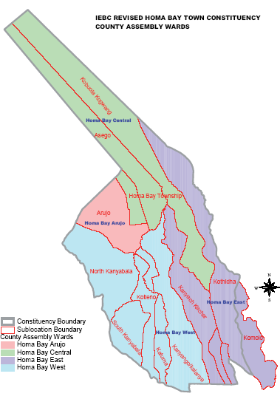

NG-CDF BOARD | National Government Constituencies Development Fund
 | Homabay Town Constituency
 | Kabunde Multipurpose Hall
 | P.O BOX 240 Homabay, 40300
 | Email: cdfhomabaytown@ngcdf.go.ke | Website: www.ngcdf.go.ke
Our Ref: HBTC/NG-CDF/P.PARTICIPATION/01/2022/2023 21ST DECEMBER, 2022

NOTICE OF THE MEETINGS

HOMABAY TOWN NG-CDF INVITES ALL ITS CONSTITUENTS AND DEVELOPMENT STAKEHOKLDERS TO THE NG-CDF PUBLIC PARTICIPATION FOR PURPOSES OF PROJECTS IDENTIFICATION, PREPARATION AND SUBMISSION OF PROPOSALS.

THE ACTIVITY IS SCHEDULED ACROSS ALL THE FOUR WARDS AS UNDER:

DATE/DAY | VENUE | WARD | TIME (EAT)
Tuesday 27th December, 2022 | Ndiru Primary School | East Ward | 9.00 am
Wednesday 28th December, 2022 | Olodo Chief’s Camp | West Ward | 9.00 am
Thursday 29th December, 2022 | Kabunde Multipurpose Hall | Arujo Ward | 9.00 am
Friday 30th December, 2022 | Muche Primary School | Central Ward | 9.00 am

KINDLY MOBILIZE PEOPLE FROM YOUR AREAS OF REPRESENTATION AND WARD DEVELOPMENT COMMITTEE SHOULD COME UP WITH A PRIORITY LIST OF PROJECTS THAT THEY WOULD HOMABAY TOWN NG-CDF TO UNDERTAKE IN THE NEXT TWO FINANCIAL YEARS.

ALL ARE WELCOME.

Signed,

WILSON OKUMU OGOGO
FUND ACCOUNT MANAGER.
+254-722-700-485

DAY ONE: HOMABAY EAST WARD

The meeting took place on Tuesday 27th December, 2022 at Ndiru Primary School as from 10:00am.

Members Present
- NG-CDF Committee Members
- NG-CDF Staff
- Constituency Oversight Committee Members
- Area Chiefs
- Secondary Schools Heads Representative
- Primary Schools Heads Representative
- Members of the Public

Preliminaries

Comments by the Area Assistant Chief
The area assistant chief welcomed members to the meeting after an opening prayer on behalf of his senior (the area chief) who was committed on other official duties, she thanked the NG-CDFC team, Member of Parliament and Constituency Oversight Committee Members for presenting the constituents with an opportunity of identifying projects to be funded by NG-CDF, for this was going to promote ownership of the projects before, during and after implementation. The Assistant Chief told members that NG-CDF had proved to be the only entity whose projects can be singled as having been fully implemented and help the entire community and urged the Members of Parliament to continue with the good work in order to reach all ends of the community.

Comments by the Secretary of NG-CDFC.
The Secretary was impressed by the turnout of members after such a short notice of invitation. He appreciated the members for honoring the invitation to be part of the exercise.

Comments by the Chairperson of NG-CDFC
The Chairman thanked the constituents for attending the meeting, he explained the relevance of the meeting and the need for NG-CDFC to convene open forum public meetings at in every ward in the constituency to deliberate on development matters and project priorities in the ward and the constituency.
The Chairperson further explained to the general public the relevance of the forum as stipulated in the NG-CDF ACT 2015, and the nature of projects fundable by NG-CDF to include projects that are communal and benefit a wide cross section of the inhabitants, leaving out project that benefit individuals, supporting political and religious bodies and those that are in respect of works and services falling within the devolved functions of the County Government.

Project Priorities Identified In the Ward
Below is a summary of proposal request for the East ward as highlighted by various participants

NO | SCHOOL | SECTOR | ACTIVITY
 | Disii Primary School | Education | Completion of administration block
 | Ogande Primary School | Education | Completion of 3No. Classrooms
 | Ndori Primary School | Education | Completion of 2no. Classrooms
 | Nyanguu Primary School |  | Construction of administration block consisting of two offices
 | Sinangi Primary School | Education | - Completion of 2 No. Classrooms  - Construction of 4 door latrine  - Construction and equipping of 2No. Classrooms
 | Nyauu Primary School | Education | Renovation of 8no. Classrooms
 | Ndiru Primary School | Education | Renovation of administration block and 2No. Classrooms
 | Roba Primary School | Education | Construction of 2 No. Classrooms
 | Achiero Primary School | Education | Construction and equipping of 2 No classrooms
 | Pala Masogo Primary School | Education | Construction of an administration block consisting of 2 offices
 | Chiga Mixed Secondary School | Education | Completion of a library block
 | Ogande Girls High School | Education | Construction of Modern Library (Dr. Ida Odinga Library, innovation and Resource Centre
 | St Pius Ndiru Secondary School | Education | Construction of a Laboratory
 | St. Theresa’s Nyauu Girls Secondary School | Education | Construction of a dormitory
 | St. Peters Disii Mixed Secondary School | Education | Construction of 4 No. Classrooms
 | St.Marys Marindi Girls Secondary School |  | Purchase of 51 seater school bus
 | Otaro Primary School | Environment | Landscaping and fencing of the school compound
 | East Kanyada Location Chiefs Office | Security | Construction of chiefs office
 | Kanyach Kachar Location Chiefs Office | Security | Construction of chiefs office
 | Komollo Location Chiefs Office | Security | Construction of chiefs office

Comments by the Area Member of National Assembly
The area Member of National Assembly, Hon Peter Opondo Kaluma thanked the residents of Homabay East Ward for showing up in large numbers and voting him in as their preferred candidate for three terms in a row. He emphasised on his ability to deliver to the constituents the much he promised them during the campaigns. He further encouraged them to prioritise their wants for easy planning.

After a lengthy chat with members present, Mheshimiwa thanked everyone who showed up for that crucial activity and assured them that the NG-CDF committee in conjunction with the Constituency oversight committee, guided by with their requests, will deliberate on the project proposal and prioritize them on the need basis. He further assured the public that once the project proposal is complete, the NG-CDF team will present a copy of the same to the area chief so that it can be accessed by the members of the members’ public.

Photos
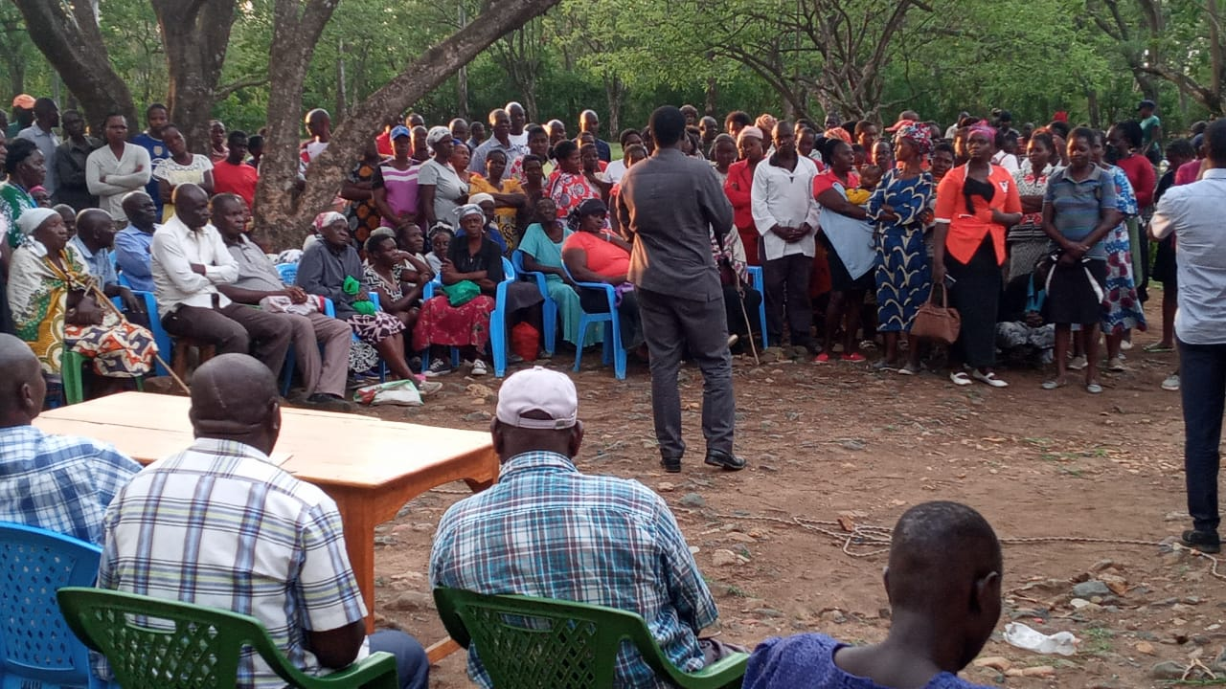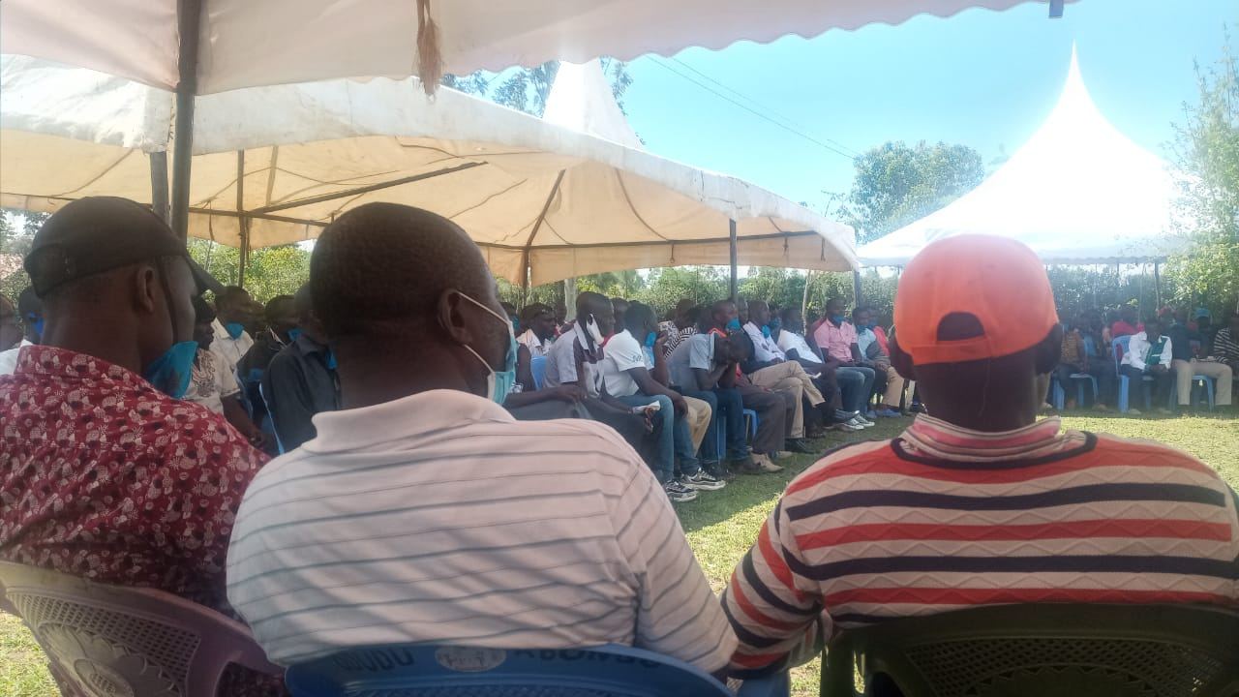

DAY TWO: HOMABAY WEST WARD

The meeting took place on Wednesday 28th December, 2022 at Olodo Chief’s Camp as from 10:00am.

Members Present
- NG-CDF Committee Members
- Constituency Oversight Committee Members
- Area Chiefs
- Secondary Schools Heads Representative
- Primary Schools Heads Representative
- Members of the Public

Preliminaries

Comments by the Area Chief
The area chief welcomed called the meeting to order and requested a volunteer to lead the members in an opening prayer. He welcomed all the participants to Olodo Chiefs Camp and urged the general public to actively participate in the forum as it will greatly impact them once their proposals have been implemented.
He further thanked the management of Homabay Town NG-CDF for organizing the forum where the public have the opportunity to front the projects that they would like to be implemented within the framework of NG-CDF.

Comments by the Fund Account Manager
He informed the meeting on the nature of eligible projects fundable by NG-CDF as community based to ensure that the prospective benefits are available to a widespread cross-section of the inhabitants of a particular area and those in respect of works and services falling within the functions of the National Government under the constitution.

Further to this, He also highlighted the ineligible projects which include: Projects supporting religious bodies or religious activities, projects supporting political bodies or political activities, recurrent costs of a completed projects, personal projects, private projects and projects targeting a specific club or group of people to the exclusion of others. He encouraged members to make proposals within the mandate of NG-CDF.

Comments by the Chairperson of NG-CDFC.
The Chairman encouraged the members present to reach out to their neighbors who had not shown up for the meeting to come as the turnout of the residents of Homabay West Ward was very low.
He stressed on the NG-CDF committees commitment on sensitizing the public on bursary applications and focus on development issues. He further informed the members that all the projects cannot be implemented at once but gradually hence the need of setting priorities. The law requires that ongoing projects be given first priority in funding before starting new ones.

Project Priorities Identified In the Ward
The summary of project for the ward as highlighted in the venue is listed as under;
NO | SCHOOL | SECTOR | ACTIVITY
 | Akele Primary School | Education | Construction of 2no. Classrooms
 | Maguti Primary School | Education | Construction of 2no. Classrooms
 | Magare Primary School | Education | Construction of an administration block consisting of 2 offices
 | Radiro Primary School | Education | Construction of an administration block consisting of 2 offices
 | Nyakune Primary School | Education | Renovation of 3no. Classrooms
 | Bishop Okulu Magare Girls school | Education | Construction of 2 new classrooms
 | Nyakahia Mixed Secondary School | Education | Construction of library  Construction 0f 60 students capacity science laboratory:

Closing Remarks by the Chairperson of NG-COC.
Mr. Leonard Owuor, representing the Constituency Oversight informed members of Honorable Kalumas commitment to Homa bay Town Constituency where he mentioned that the Member of Parliament in collaboration with NG-CDFC had ensured a wide spread and even distribution of projects across all the wards in the Constituency. He thanked the area Chiefs and Assistant Chiefs Present for their commitment to attend the meeting and their commitment to serve the wananchi of Homabay Town Constituency.

Photos
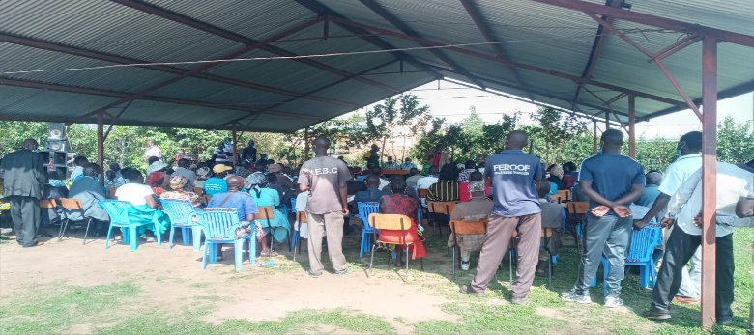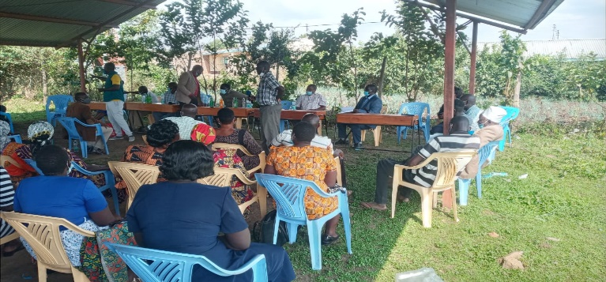

DAY THREE: HOMABAY ARUJO WARD

The meeting took place on Thursday 29th December, 2022 at Kabunde Multipurpose Hall at 10:00 AM

Members Present
- NG-CDF Committee Members
- Area Chiefs and Assistant Chiefs
- Secondary Schools Heads Representatives
- Primary Schools Heads Representatives
- Members of the public
- Constituency Oversight Committee Members

Preliminaries
The area chief welcomed members to the meeting after an opening prayer, he thanked the NG-CDFC and Member of Parliament for presenting the constituents with an opportunity of identifying projects for implementation by the NG-CDF.

Comments by the Deputy County Commissioner
The DCC commended the area MP and the management of the NG-CDFC for their excellent work in ensuring the constituents of Homabay Town Constituency gets nothing but the best, always. He went ahead to applaud the participants for their attendance and appealed the meeting to encourage all development stakeholders to have a positive attitude and dedication towards development, since development cannot be initiated and owned by foreigners but by the residents themselves.

Mr. Wasonga further mentioned how much the fund had impacted the livelihoods of the constituents as there are several needy cases he’d referred to the NG-CDF offices for bursary assistance whom had been successfully sponsored through secondary schools into the tertiary institutions.

He pleaded with the NG-CDFC to consider funding to completion all the ongoing projects in the constituency so that they could benefit the constituents as had been earlier intended.
As he concluded, the DCC informed the participants that NG-CDF has proved to be the only entity whose projects can be singled as having been fully implemented, audited and help the entire community and urged the Members of Parliament to continue with the good work in order to reach all ends of the community and the technical teams to ensure that the those projects are properly branded.

Comments by the NG-CDFC Chairperson
The chairman thanked the residents of Arujo Ward for attending the meeting, he explained the relevance of the meeting and the need for NG-CDFC to convene open forum public meetings at in every ward in the constituency to deliberate on development matters and project priorities in the ward and the constituency. He encouraged the member of the public to be free to make their proposals.

Project priorities identified in Arujo Ward
The summary of project for the ward as highlighted in the venue is listed as under;

NO | SCHOOL | SECTOR | ACTIVITY
 | Shauri Yako Primary School | Education | Construction of 4 No. Classrooms storey building
 | Opande Rarage Primary School | Education | Construction 2No. Classrooms

Challenges
Members expressed concern on the restrictive nature of the projects fundable by NG-CDF, especially in the agricultural, health and roads sectors, but the NG-CDF Chairperson urged them to forward the projects to the area member of county assembly who was also present in the meeting.

Photos
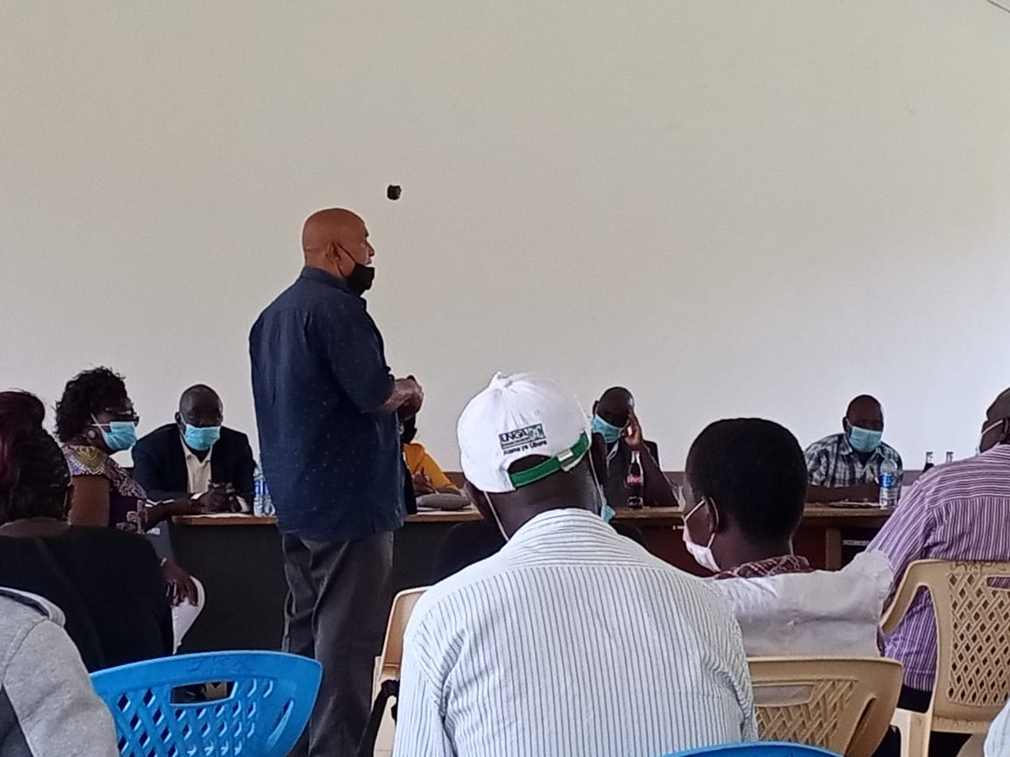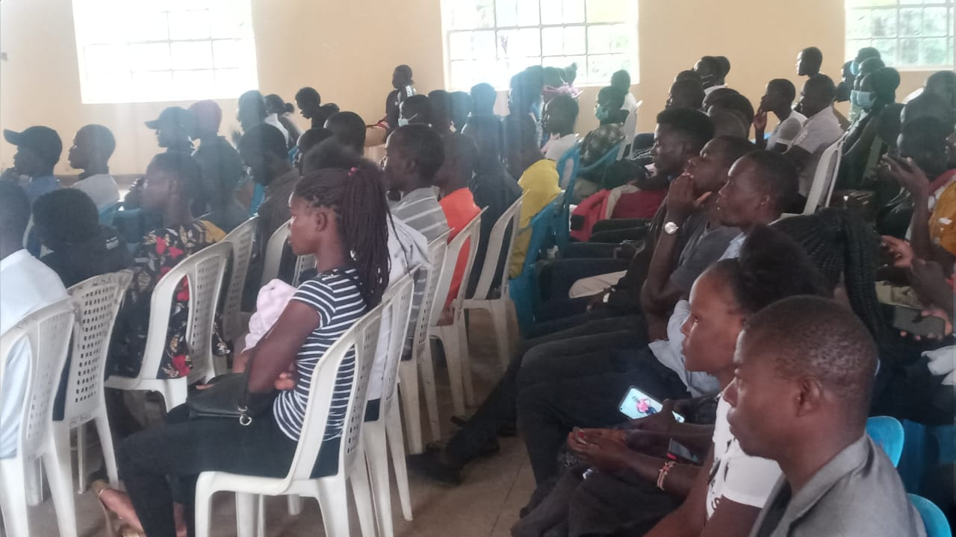

DAY FOUR: HOMABAY CENTRAL WARD
The meeting took place on Friday 30th December, 2022 at Muche Primary School starting from 10:00am.

Members Present
- NG-CDF Committee
- Constituency Oversight Committee Members
- Area Chief
- Secondary Schools Heads Representative
- Primary Schools Heads Representative
- Community members
- Invited Stakeholders

Preliminaries
The area chief brought the meeting to order after which he requested a volunteer to lead the group in a word of prayer. He then requested the NG-CDFC Chairperson to take charge after welcoming all the members present.

Comments by the NG-CDFC Chairperson
The chairperson appreciated the members for their positive response towards the call to be part of the participation. He informed the members that the exercise that was ongoing is clearly stated in Section 27 of the NG-CDF Act 2015 amended 2016; that the chairperson of the constituency committee within the 1st year of the commencement of a new parliament and at least once at every two years thereafter convene open forum public meetings in every ward in the constituency to deliberate on development matters in the ward and in the constituency. He went ahead to encourage the members that they should free to outline all the pressing development issues from their areas of representation as this was the right forum.

Comments by the NG-CDFC Secretary
The NG-CDFC Secretary Mr. Charles Bugo emphasized that public participation is very essential in decision making by the NG-CDFC to enhance equitable distribution of resources across the wards depending on their needs and improve quality of service delivery.

Project Priorities Identified In the Ward
The identified projects were presented as follows:
NO | SCHOOL | SECTOR | ACTIVITY
 | St Dominic Wiga Mixed Secondary School | Education | Completion of 2 No. Classrooms
 | Wiobiero Secondary School | Education | Construction of a Laboratory
 | St. Camillus Ojunge Mixed Sec School | Education | Construction of a Laboratory
 | Wiobiero Primary School | Education | Renovation of 5 No. classrooms
 | Kuja Primary School | Education | Construction of 2No. Classrooms to completion

Challenges
The NG-CDFC Chairperson explained to the members that the NG-CDF only funds bursary, education, environment, sports and security projects. However, the members had presented some proposals that were outside the NG-CDF docket and were advised to redirect them to the area members of national assembly as devolved projects like construction of health centers are being funded by the county governments.

Way Forward
The meeting resolved that all the funds disbursed to projects be spent judiciously to promote value for money and boost the livelihood of the residents.

Closing Remarks by the Area Member to the National Assembly
The Area Member of Parliament took the opportunity to thank all leaders especially the Members of public for taking their time and showing commitment towards developing Homabay Town Constituency. He urged the members of the public to cooperate with the NG-CDFCs so as to make the Constituency the best in terms of development in the County and Region.

He further enlightened the meeting of the various devolved funds in the constituency, and stressed the need of all the stakeholders to come together during planning to avoid duplication and double funding of projects. He called upon the County Government and KeRRA to share their development projects publicly to enable the constituents be aware of projects being implemented in their areas. He also mentioned about bursary program which was being offered by both Affirmative Action fund, Ward bursary by County Government, Children’s Office and NG –CDF, a fund which if all parties shared their ideas will benefit a wide cross section of the constituent’s needy cases in terms of School fees. He thanked members of the public for showing up during the meeting in honor of the invite and public notice so as to participate in project identification process as required by NG-CDF regulations and guidelines.

In conclusion, he requested the Constituency Chairperson to close the meeting with a word of prayer at 5:48pm after which members dispersed at their own pleasure.
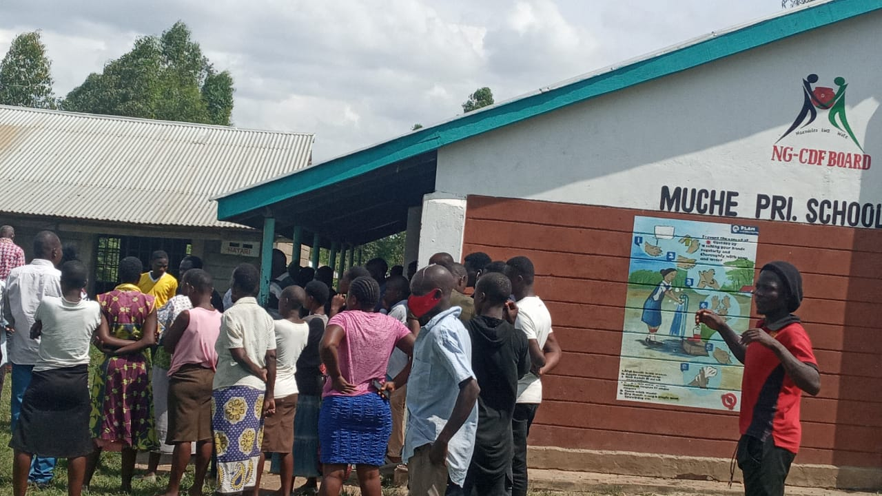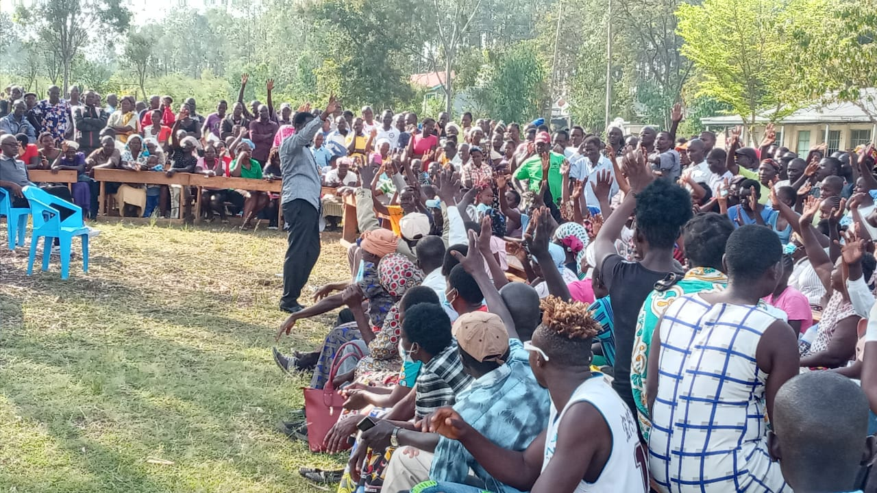

Report compiled by

…………………………….

FUND ACCOUNT MANAGER

Confirmed by

…………………………….

NG-CDFC CHAIRPERSON

