**CDF logo 4 MsWord**

**SAMBURU WEST**

**IEBC NUMBER 133**

**NATIONAL GOVERNMENT CONSTITUENCY DEVELOPMENT FUND**

**RESUBMISSION**

**2018/2019 FINANCIAL YEAR**

**SUBMITTED**

**JANUARY 2019**

|  |  |
| --- | --- |
| CDF logo 4 MsWord  **NG-CDF BOARD** | **National Government Constituencies Development Fund**  **Samburu West Constituency**,  P.O Box 450  Maralal, Kenya  **Email**: [cdfsamburuwest@ngcdf.go.ke](mailto:cdfsamburuwest@ngcdf.go.ke) | **Website:** [www.ngcdf.go.ke](http://www.ngcdf.go.ke) |

**MINUTES FOR SAMBURU WEST NGCDF HELD AT THE OFFICE BOARDROOM ON 24/01/2019 AT 3.00 PM**

**MEMBERS PRESENT**

1. ESSAU LENEMIRIA -CHAIRMAN
2. WILSON MWANGI -FUNDS MANAGER
3. DAVID LOLKITEKUI -CONSTITUENCY MANAGER
4. VIOLET LELEKONG -SECRETARY
5. ISAIAH LETUNTA -MEMBER
6. SCHOLASTICA APEYO -MEMBER
7. SIMON LEMARIMBE -MEMBER
8. IRENE LENAIYARA -MEMBER

**MEMBERS ABSENT**

1. DOUGLAS LEBOUYARE

**AGENDAS**

1. OPENING REMARKS
2. RESUBMISSION OF PROJECTS
3. CHANGE OF ACTIVITY
4. AOB

**MIN: 1/24/01/2019: OPENING REMARKS**

The chairman welcomed the members and requested Bshp. Lemarimbe to lead in prayers. He briefed the members of the day’s activities and thanked the members for their timely attendance.

**MIN: 2/24/01/2019: RESUBMISSION OF PROJECTS**

|  |  |  |  |  |  |  |
| --- | --- | --- | --- | --- | --- | --- |
| **Project Name** | **Project Number** | **Original Cost** | **Cumulative allocation** | **Project activity** | **Amount Allocated** | **Current Status** |
| Tamiyoi primary school | 4-025-133-2630204-104-2018/2019-001 | 1,200,000.00 | 1,200,000.00 | Construction of one classroom | 1,200,000.00 | New |
| Kelele primary school | 4-025-133-2630204-104-2018/2019-002 | 1,200,000.00 | 1,200,000.00 | Construction of one classroom | 1,200,000.00 | New |
| Lorian primary school | 4-025-133-2630204-104-2018/2019-003 | 1,200,000.00 | 1,200,000.00 | Construction of one classroom | 1,200,000.00 | New |
| Lkurum primary school | 4-025-133-2630204-104-2018/2019-004 | 200,000.00 | 200,000.00 | Purchase of 36 desks @ Ksh.5,555.56 | 200,000.00 | New |
| Morijoi Primary School | 4-025-133-2630204-104-2018/2019-005 | 1,200,000.00 | 1,200,000.00 | Construction of one classroom | 1,200,000.00 | New |
| **TOTAL** |  |  |  |  | **5,000,000.00** |  |

The fund account manager informed the members that one project from the 2018/19 proposal was declined by the NGCDF Board and a resubmission of new projects had to be done. The project declined was Sirata Technical Training Institute amounting to Kshs. 5,000,000.00.

The members however decided to fund the below projects:

* Tamiyoi primary school
* Kelele primary school
* Lorian primary school
* Lkurum primary school
* Morijoi primary school

**MIN: 3/24/01/2019: CHANGE OF ACTIVITY**

After receiving requests from schools, the members discussed that Lorrok Primary School needed a classroom more than a dormitory and Suguta Mar Mar Mixed Secondary School was in more dire need of classrooms.

One member pointed out that the pupils are more than capacity in the classrooms especially in Suguta Mar Mar Mixed Secondary School due to the 100% transition. Therefore the member requested that:

* Kshs. 1,000,000.00 for a construction of a dormitory to slab level to be used to construct a classroom in Lorrok Primary School.
* Kshs. 1,200,000.00 for a construction of a laboratory at Longewan secondary school to be given to Suguta Mar Mar Mixed Secondary School to construct a classroom.

Therefore seeking authority from the NG-CDF Board for an authority to change the activities.

The members requested the FAM to attach the requests from the schools show how the schools are in dire need of classrooms.

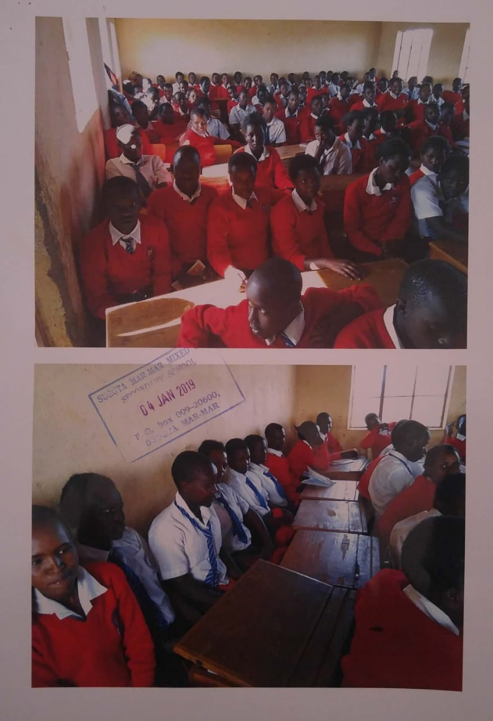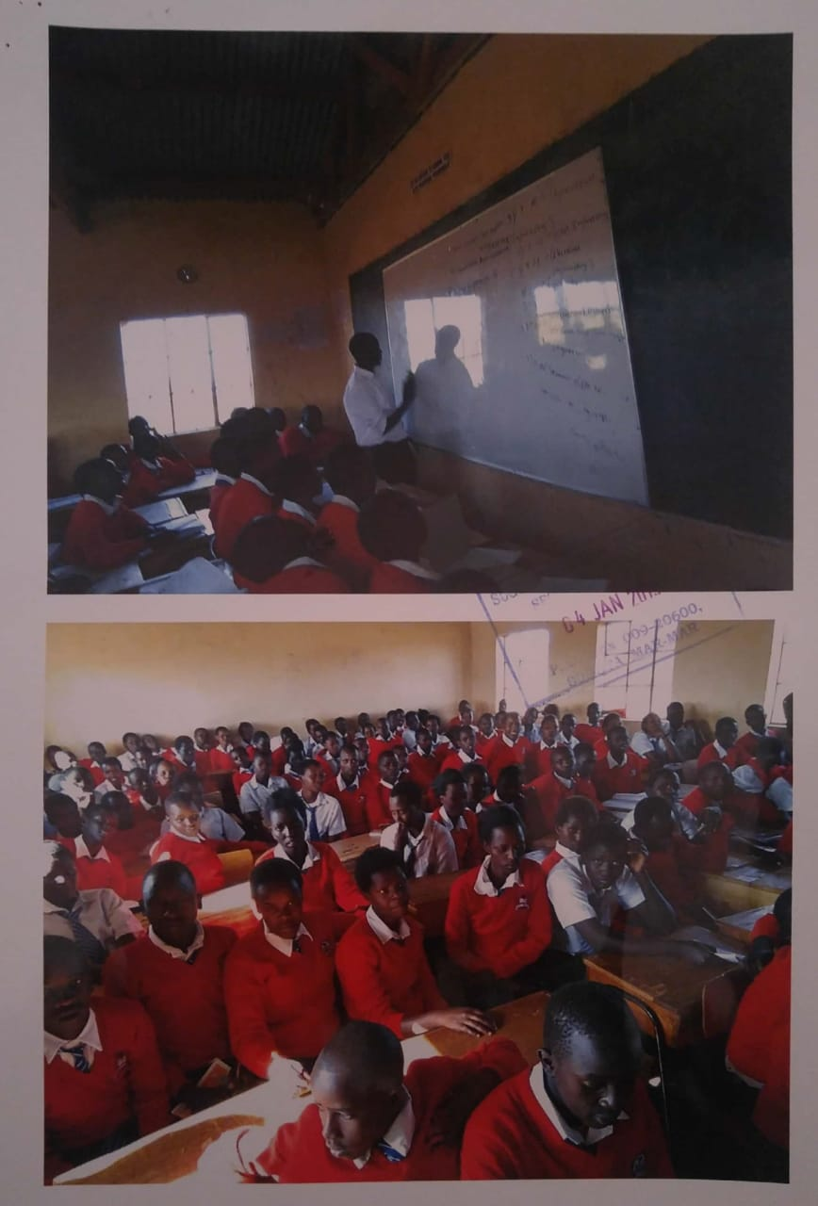

**MIN: 4/24/01/2019: AOB**

There being no other activity the meeting ended at 5.30 pm with prayers from Bshp. Lemarimbe.

Minutes written by**: Violet lelekong** Secretary

Signature……………………………………..

Date……………………………………………..

Confirmed by: **Essau Lenemiria** Chairman

Signature……………………………………..

Date……………………………………………..

Confirmed by: **Wilson Mwangi** Fund Account manager

Signature……………………………………..

Date……………………………………………..

***2015 National Government Constituencies Development Fund No. 30***

**THIRD SCHEDULE** *(s. 15)*

**CONSTITUENCY PROJECTS SUBMISSION** FORM

Constituency No **133** Constituency Name **SAMBURU WEST** Financial Year **2018/2019**

|  |  |  |
| --- | --- | --- |
| **Serial** | **Name of Project** | **Amount Allocated** |
| 133/2630204 | Primary School Projects | 5,000,000.00 |
| **Total** | | **5,000,000.00** |

Chairman NG- CDF Committee **Essau Lenemiria…**Signature………………….. Date………………

Fund Account Manager **…Wilson Mwangi……** Signature…………………….Date………………

***2015 National Government Constituencies Development Fund No. 30***

**FOURTH SCHEDULE (s. 16)**

**PROJECT DESCRIPTION FORM**

Constituency No: **133** Constituency Name **SAMBURU WEST** County **SAMBURU**

Project Number **133/2630204**

Project Title **Primary Education Projects**

Sector **Education**

Status of projects (tick one) New………………. Extension……………….. On-going…√…..

Rehabilitation ………………….

Brief statement on project status at time of submission

**To enhancing better learning conditions in the primary schools institutions by improving the infrastructure**

Financial year **2018** 1st July To 30th June **2019**

Original Cost estimates, in Kshs. **32,000,000** dated…………………

Amount allocated last financial year **14,150,000.00**

Amount allocated this financial year **32,000,000.00**

|  |  |  |  |
| --- | --- | --- | --- |
| **PROJECT NAME** | **PROJECT CODE** | **PROJECT ACTIVITY** | **AMOUNT ALLOCATED** |
| Tamiyoi primary school | 4-025-133-2630204-104-2018/2019-001 | Construction of one classroom | 1,200,000.00 |
| Kelele primary school | 4-025-133-2630204-104-2018/2019-002 | Construction of one classroom | 1,200,000.00 |
| Lorian primary school | 4-025-133-2630204-104-2018/2019-003 | Construction of one classroom | 1,200,000.00 |
| Lkurum primary school | 4-025-133-2630204-104-2018/2019-004 | Purchase of 36 desks @ Ksh.5,555.56 | 200,000.00 |
| Morijoi Primary School | 4-025-133-2630204-104-2018/2019-005 | Construction of one classroom | 1,200,000.00 |
|  |  |  | **5,000,000.00** |

Person completing form: Name **Wilson Mwangi.** Position **Fund Account Manager** Signature…………………… Date………………………

**Samburu West National Government Constituency Development Fund**

**Project Proposal 2018/2019 Financial Year**

**Code List**

**FINANCIAL YEAR: 1ST JULY 2018 TO 30TH JUNE 2019**

|  |  |  |  |  |  |  |
| --- | --- | --- | --- | --- | --- | --- |
| **Project Name** | **Project Number** | **Original Cost** | **Cumulative allocation** | **Project activity** | **Amount Allocated** | **Current Status** |
| Tamiyoi primary school | 4-025-133-2630204-104-2018/2019-001 | 1,200,000.00 | 1,200,000.00 | Construction of one classroom | 1,200,000.00 | New |
| Kelele primary school | 4-025-133-2630204-104-2018/2019-002 | 1,200,000.00 | 1,200,000.00 | Construction of one classroom | 1,200,000.00 | New |
| Lorian primary school | 4-025-133-2630204-104-2018/2019-003 | 1,200,000.00 | 1,200,000.00 | Construction of one classroom | 1,200,000.00 | New |
| Lkurum primary school | 4-025-133-2630204-104-2018/2019-004 | 200,000.00 | 200,000.00 | Purchase of 36 desks @ Ksh.5,555.56 | 200,000.00 | New |
| Morijoi Primary School | 4-025-133-2630204-104-2018/2019-005 | 1,200,000.00 | 1,200,000.00 | Construction of one classroom | 1,200,000.00 | New |
| **TOTAL** |  |  |  |  | **5,000,000.00** |  |